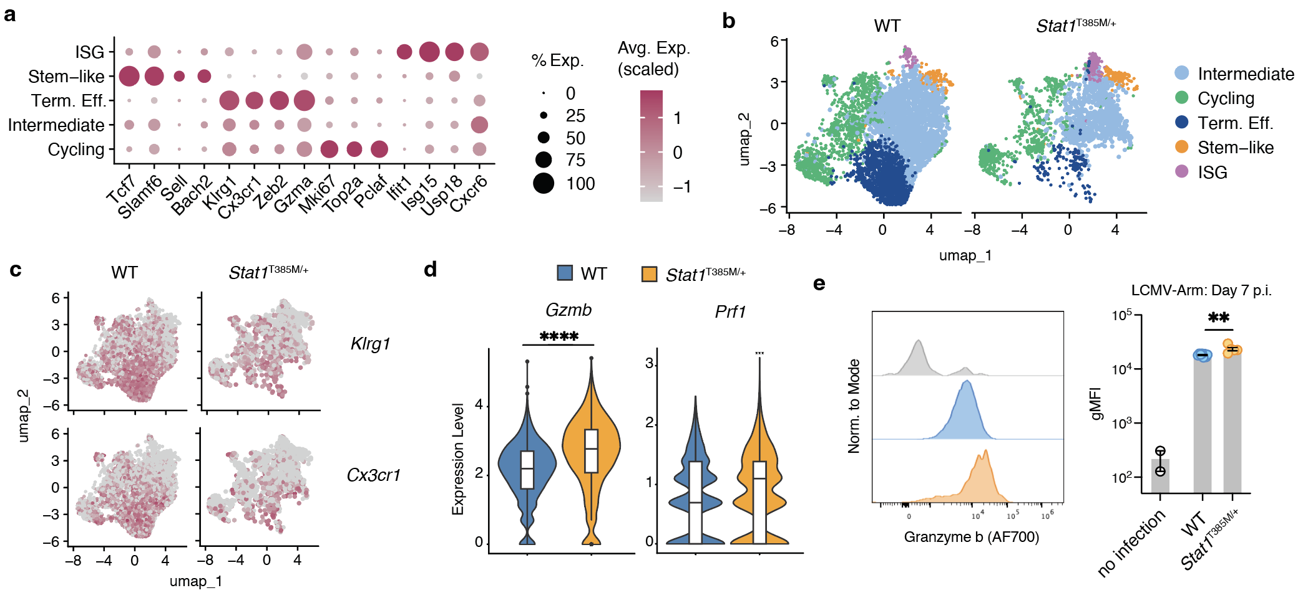
Extended Data 1. scRNA-seq analysis of CD8 T cells from Stat1 GOF mice after LCMV-Arm infection.
a, Dot plot of scRNA-seq cluster identifying genes for Fig. 2a.
b, UMAP projection and cluster identification of scRNA-seq data, split by genotype.
c, Feature plot of Klrg1 and Cx3cr1 expression on WT and Stat1^{T385M/+} samples.
d, Gzmb and Prf1 transcript levels on total WT and Stat1^{T385M/+} GP33-specific T cells.
e, Granzyme b protein levels in GP33-specific CD8 T cells day 7-8 post LCMV-Arm infection, measured ex vivo by flow cytometry. n = 5 WT and Stat1^{T385M/+} mice pooled from two independent experiments.
Significance was determined with unpaired Student’s t test for pairwise comparisons of flow cytometry experiments, and Wilcoxon test for comparisons of scRNA-seq data. **P < 0.01 and ****P < 0.0001.

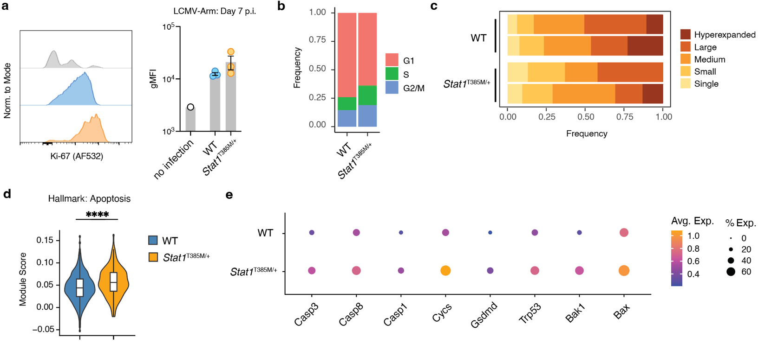

Extended data 2. Proliferation and cell death of GP33-specific CD8 T cells from Stat1 GOF mice.
a, Ki-67 expression of GP33-specific CD8 T cells day 7-8 post LCMV-Arm infection, measured ex vivo by flow cytometry. n = 3 WT and Stat1^{T385M/+} mice.
b, Proportion of GP33-specific CD8 T cells in G1, S, and G2/M phases of the cell cycle. Plots are generated from scRNA-seq (Fig. 2a) where cells were assigned cell cycle phase based on the expression of G2/M and S phase markers.
c, Distribution of clonal expansion for each WT and Stat1^{T385M/+} sample. Plots show the relative abundance of the clonotype expansion groups: single, small (1-5 cells), medium (6-20 cells), large (21-100 cells), and hyperexpanded (> 101 cells).
d, Module score of apoptosis genes in terminal effector cells from Fig. 2a from WT and Stat1^{T385M/+} mice.
e, Expression of cell death related genes.
Significance was determined with Wilcoxon test for comparisons of scRNA-seq data. ****P < 0.0001.

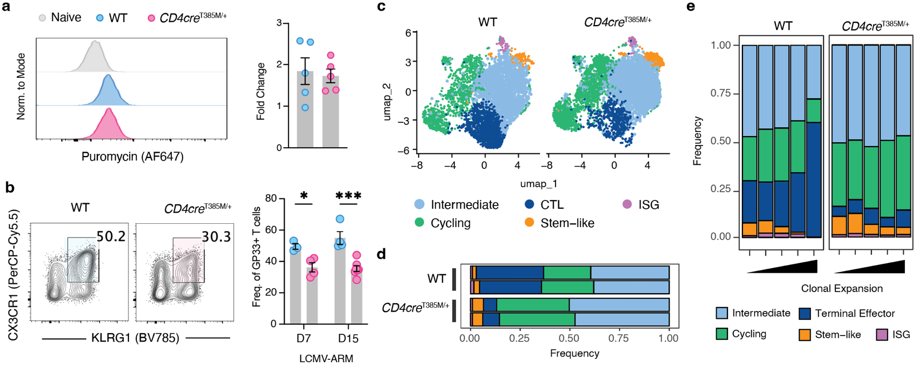

Extended Data 3. CD4cre^{T385M/+} GP33 T cells after LCMV-Arm infection.
a, Representative histograms (left) and quantification (right) anti-puromycin geometric Mean Fluorescence Intensity (gMFI) in primary cells cultured ex vivo for 30 minutes with puromycin. Bar plots depict relative levels of GP33-specific cells over WT naïve cells from uninfected mice, with n = 5 mice per group pooled from three independent experiments.
b, Frequency of CX3CR1⁺KLRG1⁺ GP33-specific CD8 T cells at days 7 and 15 post LCMV-Arm infection, with n = 3-7 mice per group pooled from two independent experiments.
c, UMAP projection and cluster identification of scRNA-seq data, split by genotype.
d, Proportions of scRNA-seq clusters from WT and CD4cre^{T385M/+} mice, with n = 2 mice per group.
e, Proportions of scRNA-seq clusters from WT and CD4cre^{T385M/+} mice, split by clonal expansion group. From low to high expansion, clonotypes were identified as single (1), small (2-5 cells), medium (6-20 cells), large (21-100 cells), and hyperexpanded (> 101 cells).
Significance was determined with unpaired Student’s t test for pairwise comparisons of flow cytometry experiments. **P < 0.01 and ***P < 0.001.
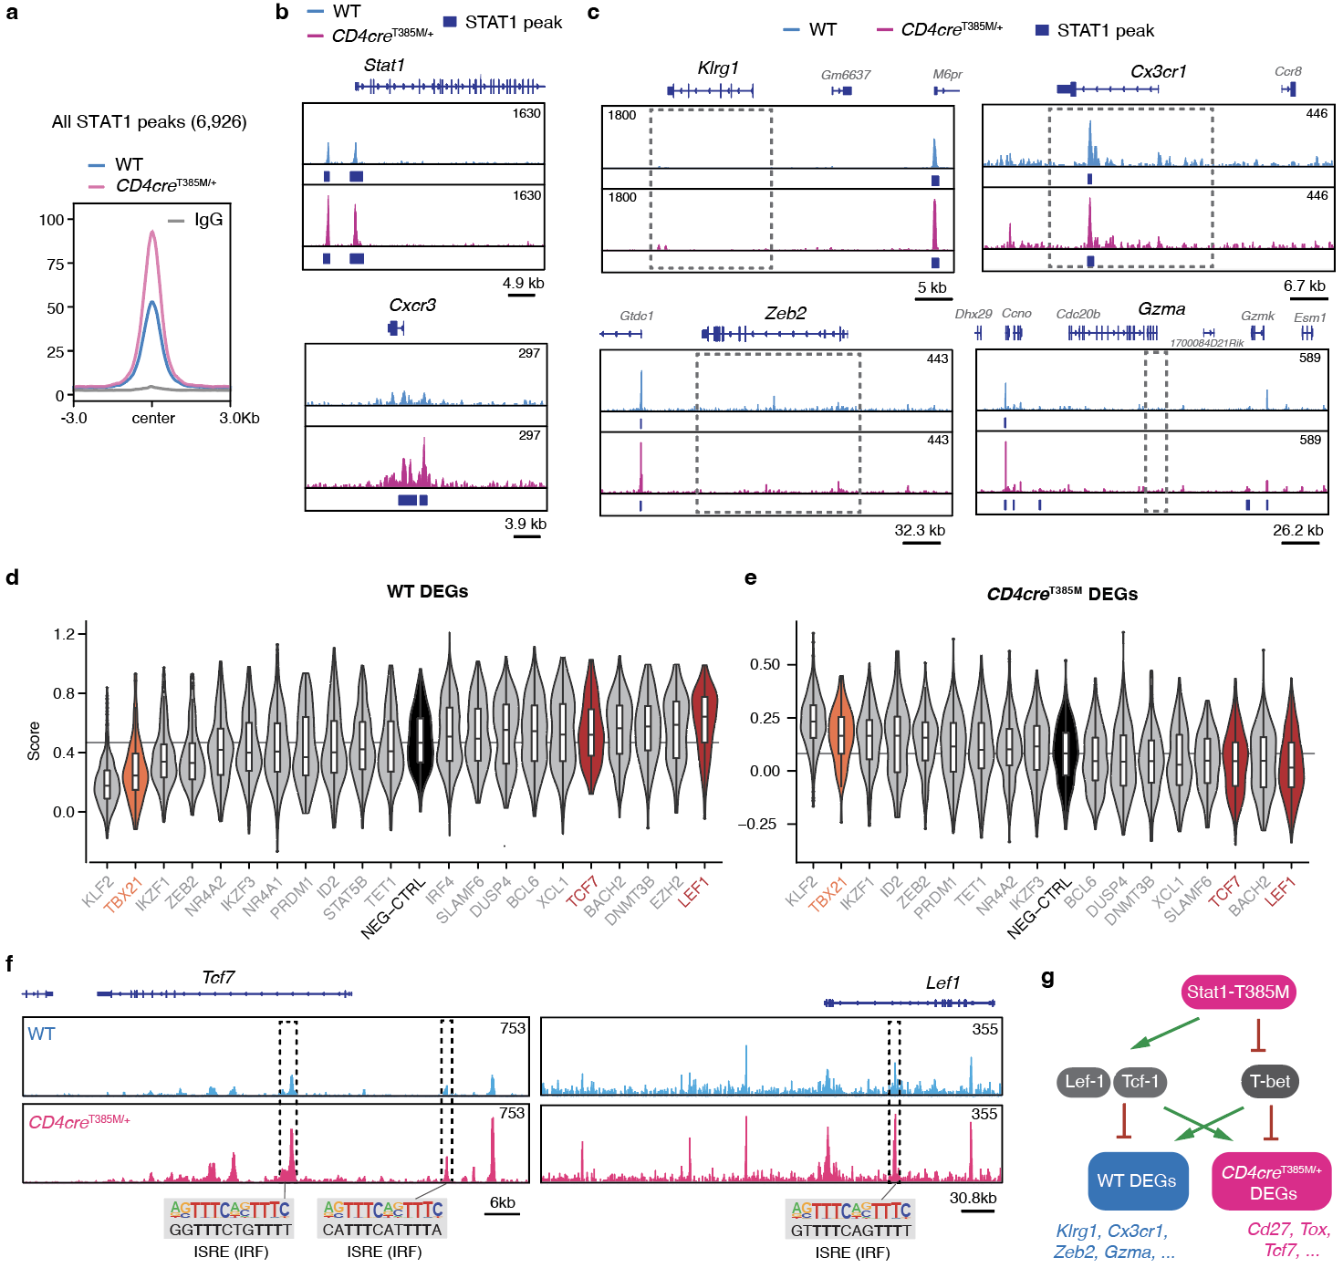

Extended Data 4. STAT1 CUT&Tag and upstream regulators of effector cells in CD4cre^{T385M/+} mice.
a, Average STAT1 CUT&Tag peak height for all STAT1 called peaks for WT, CD4cre^{T385M/+}, and IgG samples.
b-c, Tracks of STAT1 signal and SEACR-called peaks at the CD4cre^{T385M/+} DEGs Stat1 and Cxcr3 (b) and the WT DEGs Klrg1, Cx3cr1, Zeb2, and Gzma (c). Dotted boxes highlight terminal effector genes with absent or similar STAT1 peak signal.
d-e, Published pertrubSEQ of P14 cells after LCMV-Arm infection was interrogated for expression of DEGs identified in Fig. 5d. Plots depict average expression of WT DEGs (d) and CD4cre^{T385M/+} DEGs (e) for each sgRNA target. Plots include only sgRNAs that showed a significant difference compared to NEG-CTRL.
f, Tracks of STAT1 signal at Tcf7 and Lef1. Dotted boxes highlight peaks with ISRE motifs that overlap with increased STAT1 peak signal in CD4cre^{T385M/+}.
g, Model for how Stat1-T385M alters the transcription factor network in CD8 T cells after LCMV-Arm infection.
Significance was determined with unpaired Student’s t test for pairwise comparisons of flow cytometry experiments, and Wilcoxon test for comparisons of scRNA-seq data. **P < 0.01 and ***P < 0.001.

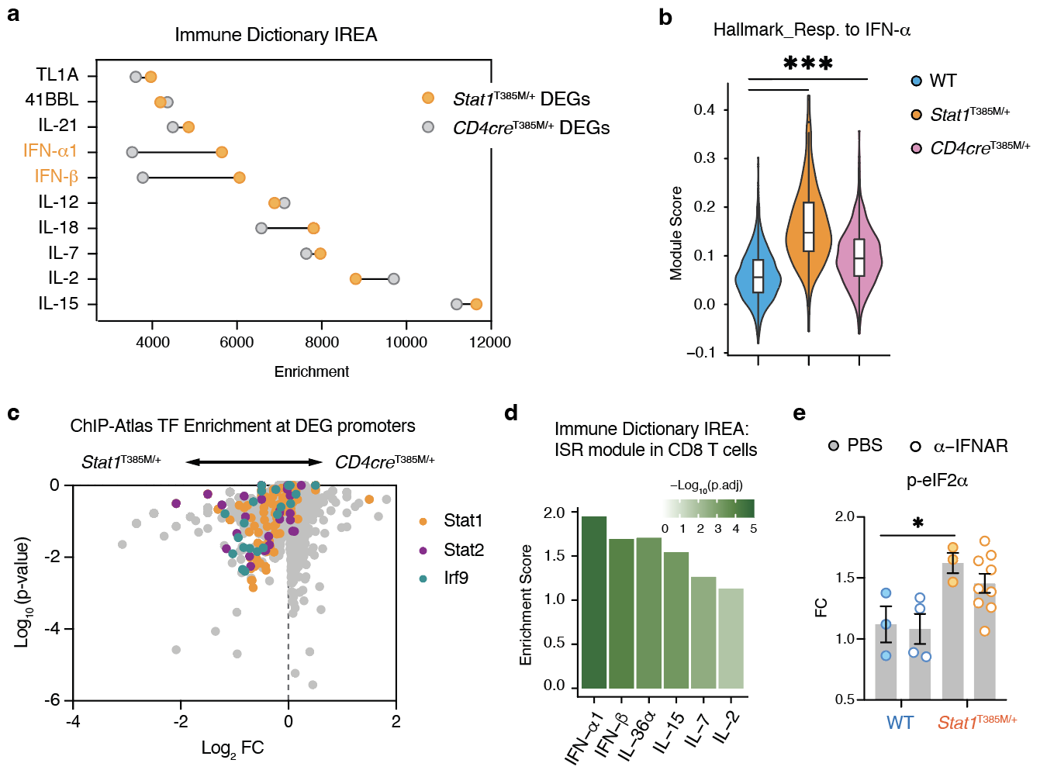

Extended Data 5. Type I IFN signature in Stat1 GOF models.
a, Immune Response Enrichment Analysis (IREA) cytokine enrichment plot for DEGs upregulated in Stat1^{T385M/+} or CD4cre^{T385M/+} cells compared to WT. Plot shows the enrichment score for the top 10 cytokines with an FDR-adjusted P value < 0.05. Type I IFNs are highlighted as predicted signals that show differing enrichments between Stat1^{T385M/+} or CD4cre^{T385M/+} cells.
b, Module score of genes that respond to type I IFNs (Hallmark: Response to IFN-α) in terminal effector cells from scRNA-seq data in Fig. 2a from WT, CD4cre^{T385M/+}, and Stat1^{T385M/+} mice.
c, Transcription factor (TF) enrichment analysis was performed by ChIP-ATLAS on DEGs upregulated in Stat1^{T385M/+} or CD4cre^{T385M/+} cells compared to WT. Volcano plot depicts all target antigens surveyed, with ISGF3 components (Stat1, Stat2, Irf9) highlighted.
d, IREA cytokine enrichment plot for ISR genes in CD8 T cells. Plot shows the enrichment score for only cytokines with an FDR-adjusted P value < 0.05. Plots indicate type I IFNs, IL-36, IL-15, IL-7, and IL-2 are cytokines able to induce the ISR Module in CD8 T cells.
e, Normalized p-eIF2α levels day 7.5 post LCMV-Arm infection in GP33-specific CD8 T cells from WT and Stat1^{T385M/+} mice after PBS or anti-IFNAR administration on days 5.5 and 7 post infection. n = 3-4 WT and n = 4-8 Stat1^{T385M/+} mice pooled from three independent experiments.
Significance was determined with unpaired Student’s t test for pairwise comparisons of flow cytometry experiments, and Wilcoxon test for comparisons of scRNA-seq data. *P < 0.05 and ***P < 0.001.

Supplementary Table 1. Antibodies, dye, and tetramer for flow cytometry and immunofluorescence

Target | Clone | Fluorochrome | Dilution | Company | Cat. #
CD4 | GK1.5 | BUV496 | 1:500 | BD Biosciences | 612952
CD62L | MEL-14 | BUV737 | 1:500 | BD Biosciences | 612833
CD44 | IM7 | BV570 | 1:300 | BioLegend | 103037
CD8α | 53-6.7 | BV421 | 1:300 | BioLegend | 100738
TCRb | H57-597 | BV480 | 1:300 | BD Biosciences | 746385
CD19 | ID3 | BV650 | 1:300 | BioLegend | 152427
KLRG1 | MAFA | BV785 | 1:200 | BioLegend | 138429
ATF4 | polyclonal | FITC | 1:1000 | ThermoFisher Scientific | FITC-10835
CD45 | 30-F11 | Alexa Fluor 532 | 1:300 | ThermoFisher Scientific | 58-0451-82
Tim3 | RMT3-23 | PerCP-eFluor 710 | 1:100 | ThermoFisher Scientific | 46-5870-82
IL-7R | A7R34 | PE-Cy5 | 1:500 | ThermoFisher Scientific | 25-1271-82
CX3CR1 | SA011F11 | PerCP-Cy5.5 | 1:100 | BioLegend | 149010
Lag3 | LAG-3 | PE/Dazzle 594 | 1:100 | BioLegend | 369218
TIGIT | 1G9 | APC-R700 | 1:100 | BD Biosciences | 565474
Live/Dead | n/a | Zombie NIR | 1:2000 | BioLegend | 423106
PD-1 | J43 | APC-eFluor 780 | 1:100 | ThermoFisher Scientific | 47-9985-82
puromycin | 2A4 | Alexa Fluro 647 | 1:1000 | BioLegend | 381508
TNF-α | MP6-XT22 | BV510 | 1:300 | BioLegend | 506339
IFN-γ | XMG1.2 | BV650 | 1:100 | BioLegend | 505831
pSTAT1 | 4a | Alexa Fluor 488 | 1:50 | BD Biosciences | 612597
T-bet | eBio4B10 | PE-Cy7 | 1:200 | ThermoFisher Scientific | 25-5825-82
Granzyme b | GB11 | Alexa Fluor 700 | 1:200 | BD Biosciences | 561016
Ki-67 | SolA15 | Alexa Fluor 532 | 1:300 | ThermoFisher Scientific | 58-5698-82
p-eIF2α | SZ01-06 | unconjugated | 1:1000 | ThermoFisher Scientific | MA5-32021
p-PKR | polyclonal | unconjugated | 1:1000 | ThermoFisher Scientific | BS-3337R
Donkey Anti-Rabbit IgG | Poly4064 | PE | 1:200 | BioLegend | 406421
G3BP1 | F6X8V | unconjugated | 1:100 | Cell Signaling Technology | 48372
Anti-Mouse Ig | -- | Alexa Fluor 568 | 1:500 | ThermoFisher Scientific | A-11004
D^{b} GP33⁺ tetramer | Peptide sequence: KAVYNFATC | APC | 1:100 | NIH Tetramer Core Facility | LCMV gp 33-41

Supplementary Table 2. Antibodies used for scRNA-seq

Target | Clone | Dilution | Company | Cat. #
TotalSeq C0301 anti-mouse Hashtag 1 | M1/42; 30-F11 | 1:100 | BioLegend | 155861
TotalSeq C0302 anti-mouse Hashtag 2 | M1/42; 30-F11 | 1:100 | BioLegend | 155863

