Association of zoonotic protozoan parasites with microplastics in seawater: Implications for human and wildlife health

Emma Zhang ¹, Minji Kim ¹, Lezlie Rueda ¹, Chelsea Rochman ², Elizabeth VanWormer ³, James Moore ⁴, Karen Shapiro ^{1,} *

Supplemental data
Table S1: Parasite recoveries for the microbead experiments in Experiment 1 (See Fig. 2). The recovery was calculated as the total numbers of parasites recovered (sum of parasites in seawater and on the plastics) divided by the total number of spiked (oo)cysts (N=1000).
 | Toxoplasma gondii | Giardia enterica | Cryptosporidium parvum
Day 1 | 39.6% | 19.2% | 8.4%
Day 3 | 38.0% | 19.9% | 9.1%
Day 7 | 37.0% | 23.5% | 11.1%

Table S2: Parasite recoveries for the microfiber experiments in Experiment 1 (See Fig. 3). The recovery was calculated as the total numbers of parasites recovered (sum of parasites in seawater and on the plastics) divided by the total number of spiked (oo)cysts (N=1000).
 | Toxoplasma gondii | Giardia enterica | Cryptosporidium parvum
Day 1 | 23.0% | 21.0% | 18.6%
Day 3 | 17.4% | 11.3% | 5.8%
Day 7 | 30.0% | 18.5% | 6.8%

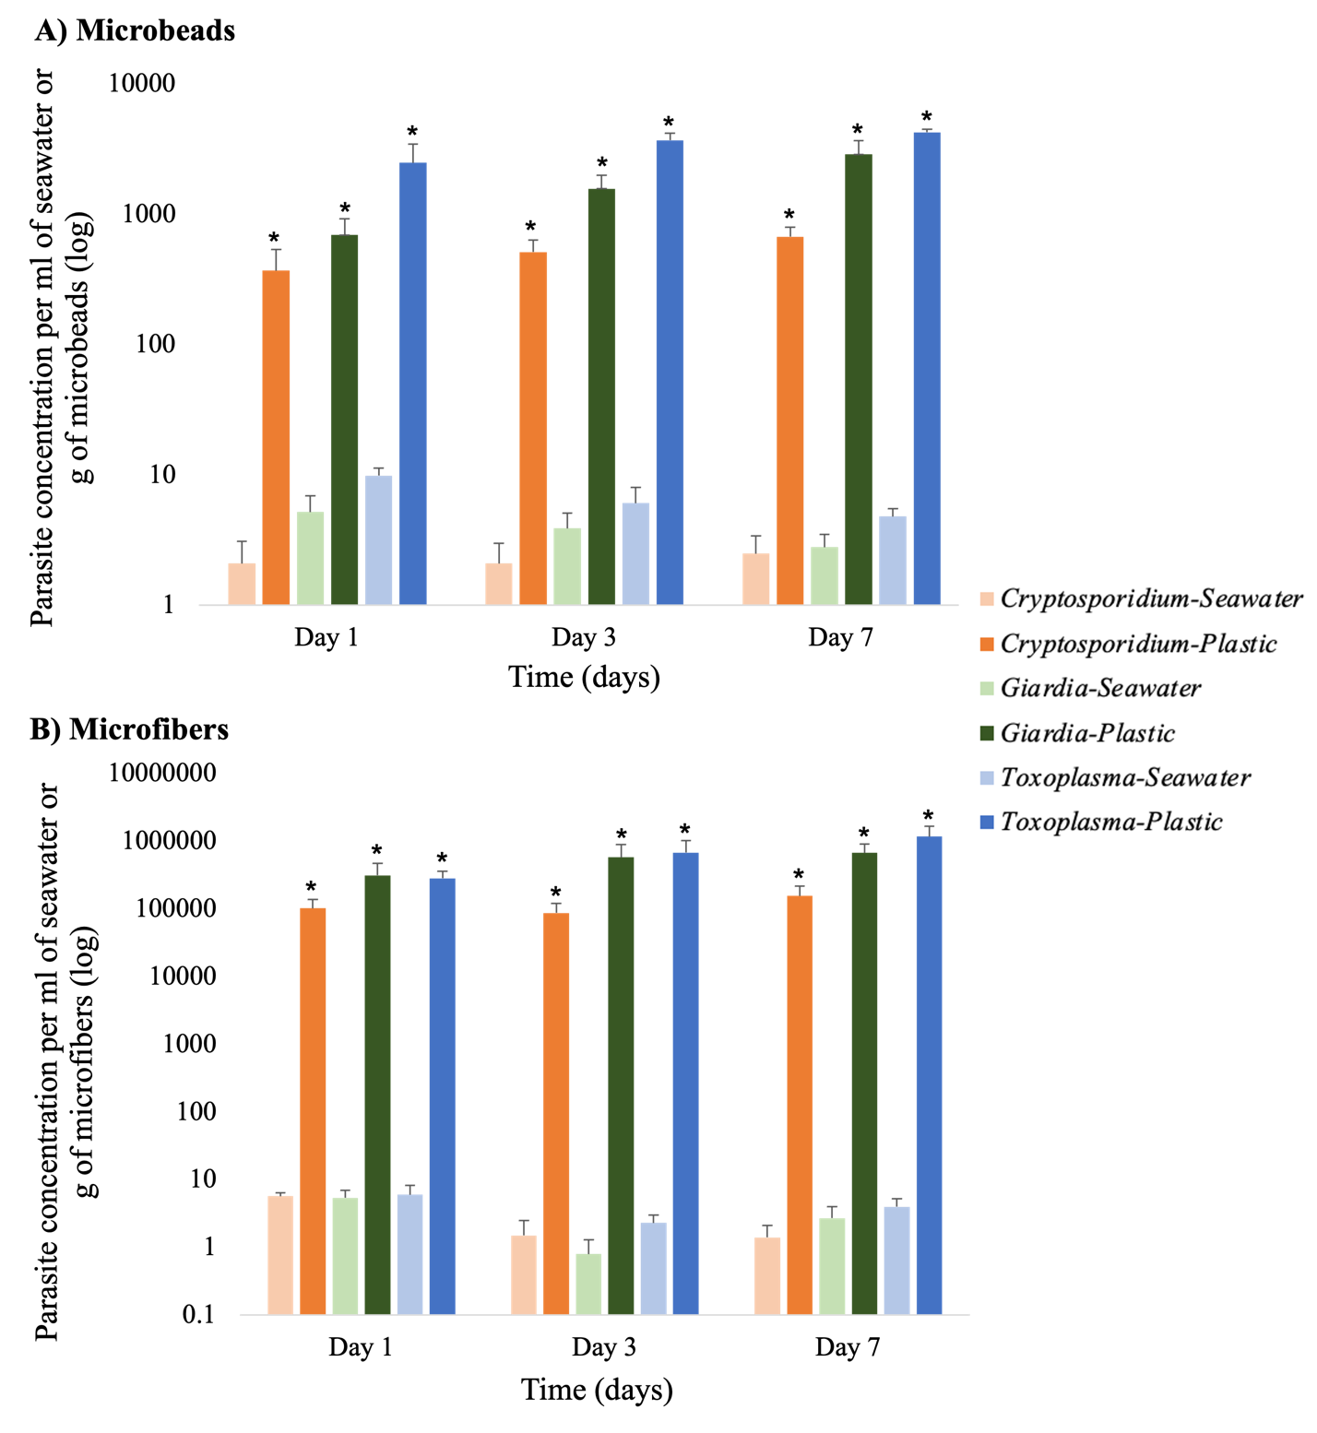
Figure S1: Parasite concentration associated with 500 μm polyethylene microbeads (A) or 800-1200 μm polyester microfibers (B) compared to surrounding seawater for Experiment 1 (Fig. 2). Lighter colors represent parasite concentrations in the seawater fraction while darker colors represent plastic associated concentrations. Error bars indicate one standard deviation from the mean. Asterisks indicate significance (P < 0.05) when comparing parasite concentrations in seawater vs. associated with microplastics. The concentration of parasites in the seawater fraction was calculated based on the 30 ml volume in each bottle while the concentration of parasites associated with microplastics was calculated based on the grams of microplastics in each bottle.

