Graphical abstract
Design, Synthesis, and Catalytic Performance of CoFe₂O₄@SiO₂PB@M (M = Ni or Cu) Nanocatalysts for Efficient Sulfide Oxidation: Statistical Optimization Using Response Surface Methodology
Rozita Zangeneh,ª Taiebeh Tamoradi,^{b} Mohammad Ghadermazi,^{a, ∗} Tahereh Sedaghat ^{b,}
ª Department of Chemistry, University of Kurdistan, 66135-416, Sanandaj, Iran
^{b} Department of Chemistry, Faculty of Science, Shahid Chamran University of Ahvaz, 6135783151, Ahvaz, Iran.
Correspondence: Mohammad Ghadermazi (E-mail: mghadermazi@yahoo.com)

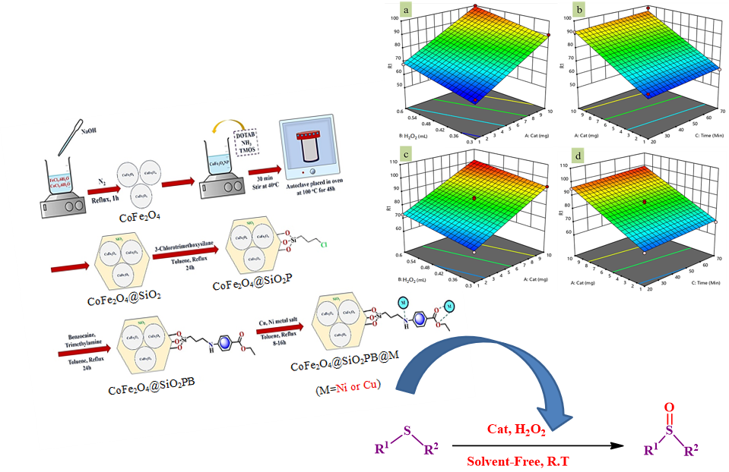

∗ Address correspondence to University of Kurdistan, Department of Chemistry, Faculty of Science, Sanandaj, Iran.; e-mail: mghadermazi@yahoo.com (M. Ghadermazi)

