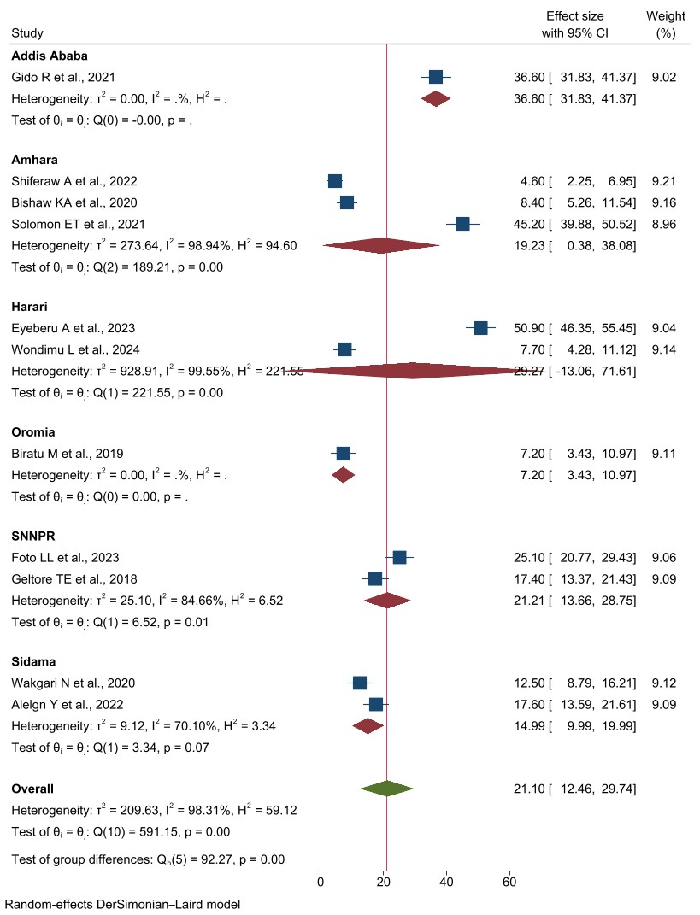
Supplementary Figure 3a: Forest plot of the subgroup analysis to assess pooled prevalence of pharmacological labor pain management practices among different regions in Ethiopia, 2025.
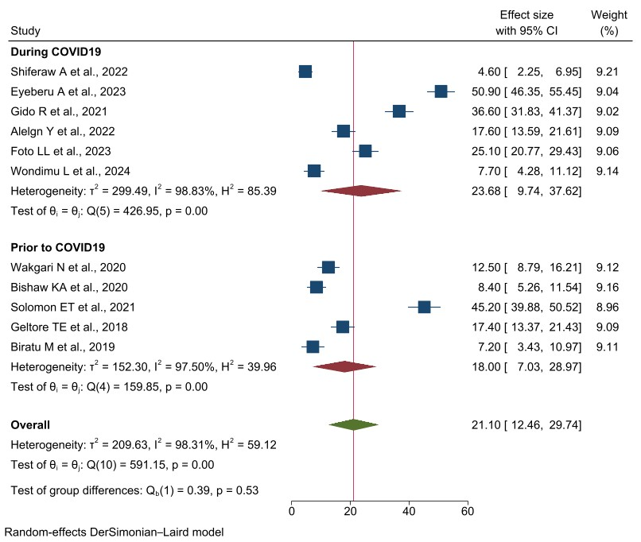
Supplementary Figure 3b: Forest plot of the subgroup analysis to assess pooled prevalence of pharmacological labor pain management practices in relation to COVID-19 in Ethiopia, 2025.

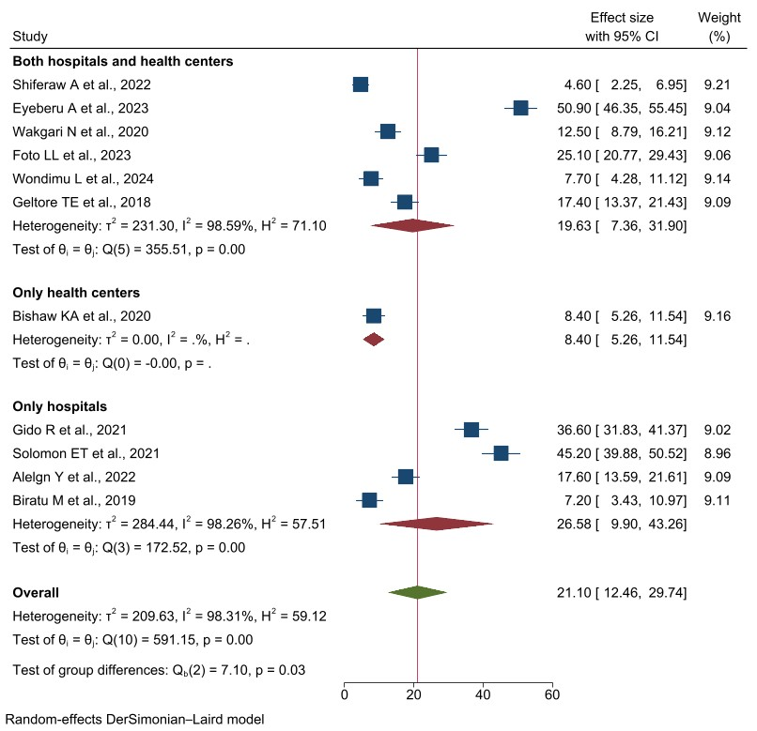
Supplementary Figure 3c: Forest plot of the subgroup analysis to assess pooled prevalence of pharmacological labor pain management practices based on the type of health facility in Ethiopia, 2025.
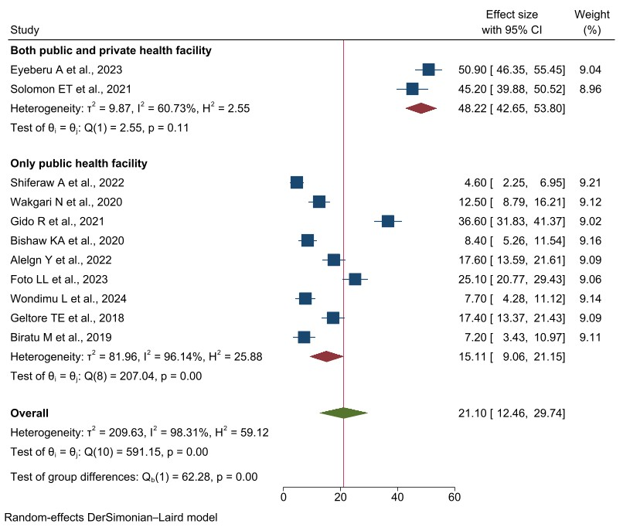
Supplementary Figure 3d: Forest plot of the subgroup analysis to assess pooled prevalence of pharmacological labor pain management practices based on the type of health sector in Ethiopia, 2025.
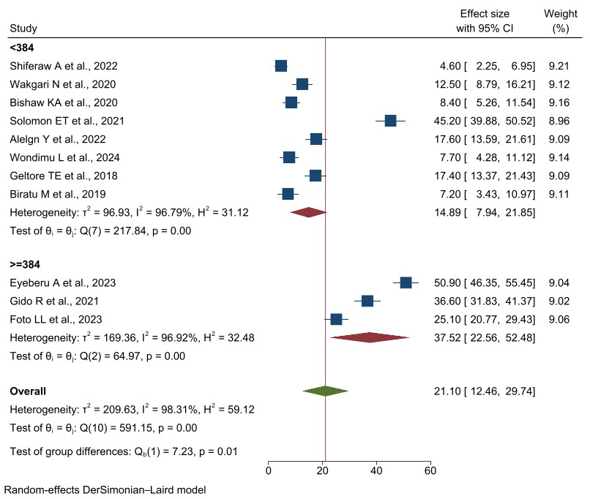
Supplementary Figure 3e: Forest plot of the subgroup analysis to assess pooled prevalence of pharmacological labor pain management practices based on the sample size in Ethiopia, 2025.

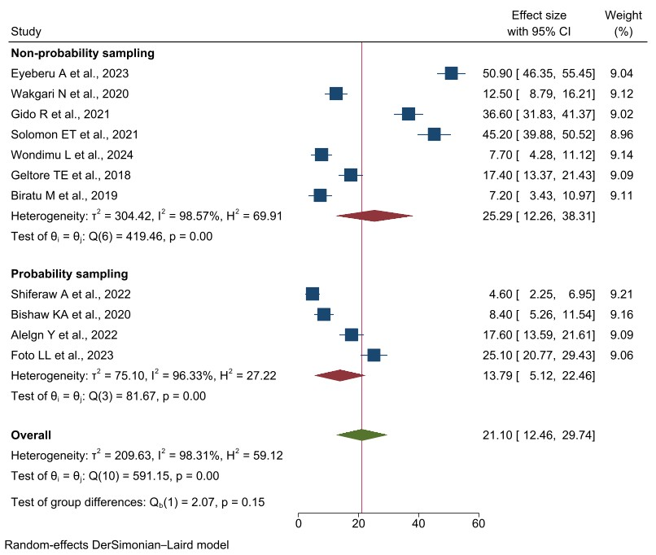
Supplementary Figure 3f: Forest plot of the subgroup analysis to assess pooled prevalence of pharmacological labor pain management practices based on the sampling methods in Ethiopia, 2025.
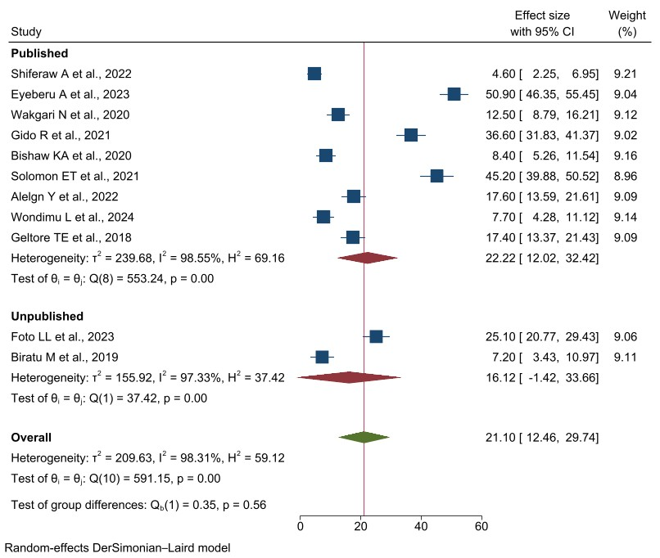
Supplementary Figure 3g: Forest plot of the subgroup analysis to assess pooled prevalence of pharmacological labor pain management practices based on the publication status in Ethiopia, 2025.
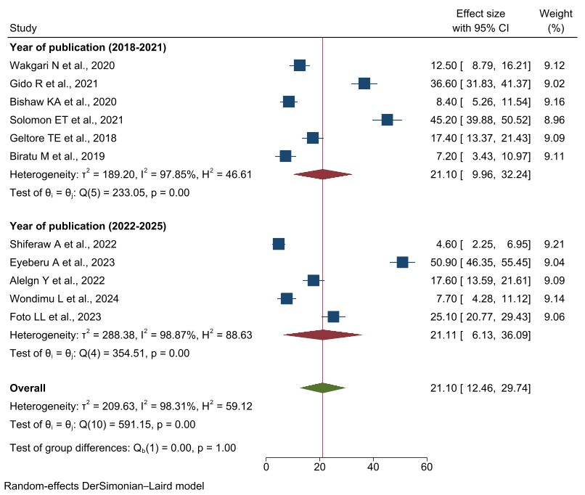
Supplementary Figure 3h: Forest plot of the subgroup analysis to assess pooled prevalence of pharmacological labor pain management practices based on the publication year in Ethiopia, 2025.

