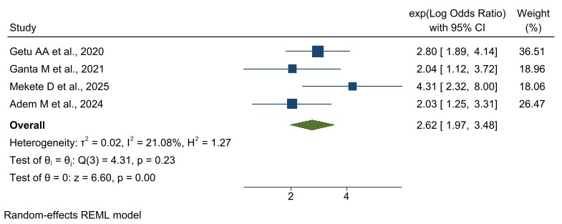
Supplementary Figure 4a1: Forest plot showing the association between knowledge of OCPs and the N-PLPMP in Ethiopia, 2025. We used both the random and the fixed effect model to identify the heterogeneity level
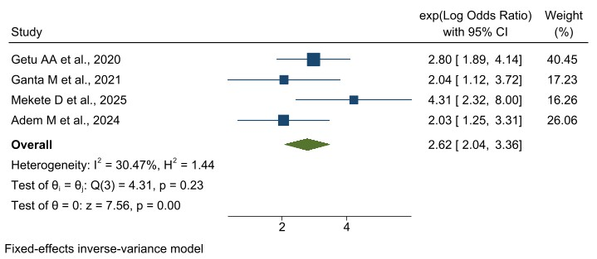
Supplementary Figure 4a2: Forest plot showing the association between knowledge of OCPs and the N-PLPMP in Ethiopia, 2025.
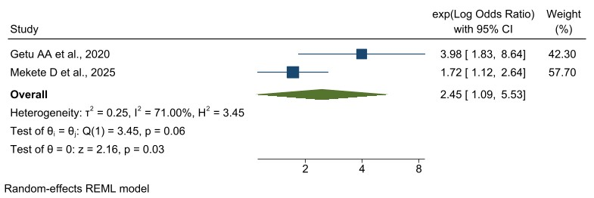
Supplementary Figure 4b: Forest plot showing the association between availability of labor pain management protocol and the N-PLPMP in Ethiopia, 2025.
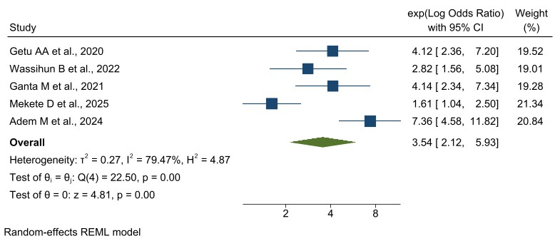
Supplementary Figure 4c: Forest plot showing the association between attitudes of OCPs towards labor pain management and the N-PLPMP in Ethiopia, 2025.
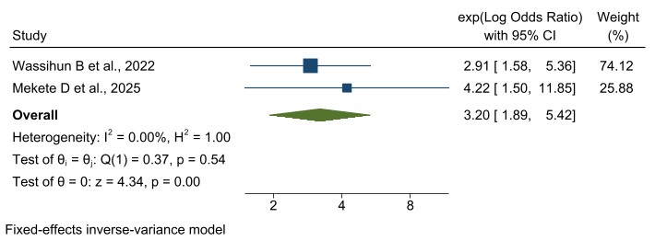
Supplementary Figure 4d: Forest plot showing the association between clinical work experiences of 6-9 years and the N-PLPMP in Ethiopia, 2025.
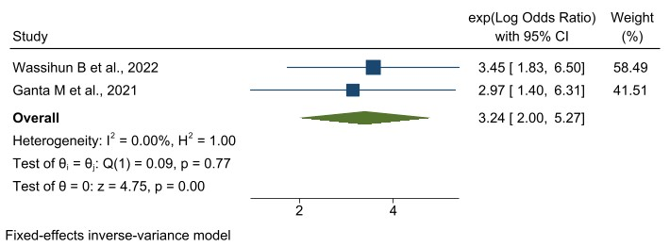
Supplementary Figure 4e: Forest plot showing the association between working in a favorable environment and the N-PLPMP in Ethiopia, 2025.

