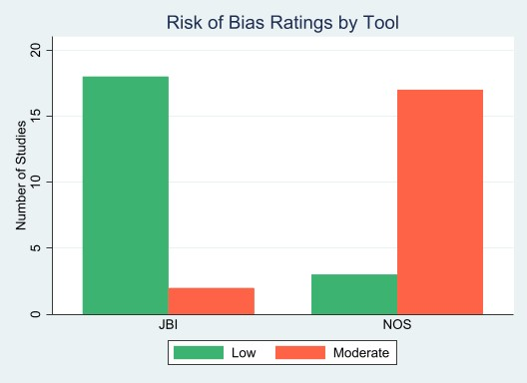
Supplementary Figure 1a: Bar graph showing the frequency of RoB ratings assigned by the JBI and modified NOS (NOS-xs and NOS-xs2) tools across 20 included studies.

