Overall, Labor Pain Management among Licensed Obstetric Care Providers in Ethiopia: Evidence from a Systematic Review and Meta-Analysis
Results
Meta-analysis
Licensed Obstetric Care Providers` Labor Pain Management Practice
Based on twenty studies (1-20) the pooled overall LPMP among licensed OCPs was estimated at 46.93% (95% CI: 42.73–51.14), with substantial heterogeneity observed across studies (I² = 92.35%, P < 0.001) (Figure 1). Accordingly, a random-effects meta-analysis model was applied to account for between-study variability. To further explore the source of heterogeneity, a Galbraith plot was constructed (Figure 2), which plots standardized effect sizes (i.e., the ratio of effect size to its standard error) against study precision (inverse of the standard error). The majority of studies found within the 95% CI, indicating a moderate level of consistency. However, one study fell outside the CI, suggesting the presence of an outlier and reinforcing the evidence of heterogeneity. In response to the high I² value and these visual findings, meta-regression, sensitivity analysis, and subgroup analyses were conducted based on study-level characteristics, including data collection period, sample size, geographic region, study setting (type of health facility), study sector, sampling method, publication status, and year. Furthermore, a subgroup analysis was performed according to the type of LPMP practiced, categorized as both N-PLPMP and P-LPMP, only N-PLPMP, or only P-LPMP.
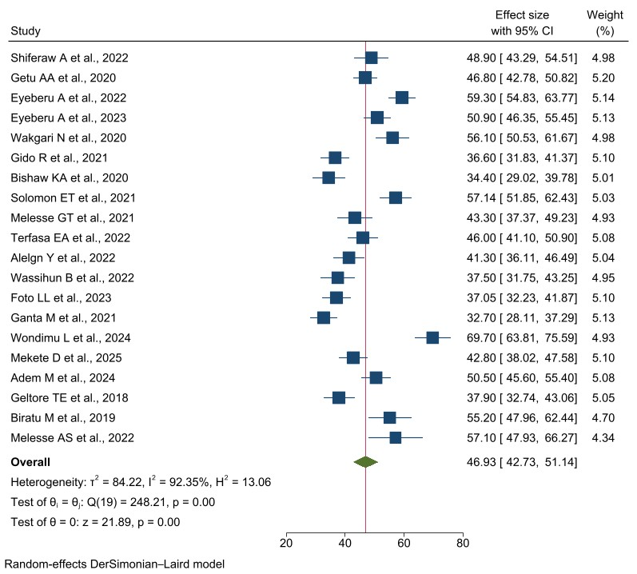
Figure 1: Forest plot of the overall LPMP among OCPs in Ethiopia, 2025.
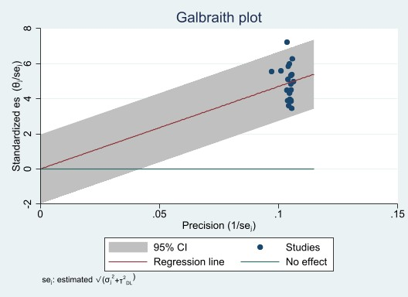
Figure 2: Galbraith plot of the overall LPMP among OCPs in Ethiopia, 2025.
Meta-Regression of the overall LPMP
To explore sources of heterogeneity in the pooled overall prevalence of LPMP, two random-effects meta-regression models were conducted using study-level covariates reported by at least two of the twenty included studies (1-20). Encoded and labeled covariates included publication year, publication status, sampling method, sample size category, health sector type, type of LPMP studied, and RoB score. In the first model, RoB was assessed using the NOS framework. This model explained 28.3% of the between-study variance (τ² = 64.1; I² = 89.5%) and approached statistical significance (Wald χ²(8) = 14.95; P = 0.060). Studies employing non-probability sampling reported significantly higher adjusted prevalence estimates (β = +9.9 percentage points; 95% CI: 1.4 to 18.4; P = 0.023). Studies published after 2021 showed a marginal increase (β = +7.25; P= 0.089), while those conducted exclusively in public health facilities and those focusing solely on P-LPMP tended to report lower prevalence estimates (β = –6.73; P = 0.276 and β = –7.20; P = 0.455, respectively). Studies with moderate NOS-based RoB score showed higher adjusted prevalence (β = +10.39; 95% CI: –7.20 to +27.98; P = 0.247), though this was not statistically significant. The intercept indicated an estimated prevalence of 36.4% for the reference group. Substantial residual heterogeneity remained (Q_res = 114.3; P < 0.001), suggesting the influence of additional unmeasured factors (Table 1).
In comparison, the second model used the JBI-based RoB score. This model explained 23.4% of the between-study variance (τ² = 68.5; I² = 90.5%) and was not statistically significant (Wald χ²(8) = 13.32; P = 0.101). The direction and magnitude of associations were similar to the NOS-based model, with non-probability sampling showing a borderline significant increase in prevalence (β = +8.5; 95% CI: –1.0 to 18.0; P = 0.080). Moderate RoB was associated with a higher prevalence (β = +5.7; 95% CI: –10.3 to 21.6; P = 0.486), but with wider uncertainty. The intercept indicated a higher baseline prevalence (49.9%) for the reference group. Residual heterogeneity remained substantial (Q_res = 118.6; P < 0.001), reinforcing the need for further exploration of contextual and methodological moderators (Table S1).
Table 1: Meta-regression results for covariates of the overall LPMP among OCPs in Ethiopia, 2025
Covariates | Category | No of studies | Coefficient (β) | Std. errs. | z | P- value | 95% CI
Publication status | Published | 15
Publication status | Unpublished | 5 | +1.73 | 6.004999 | 0.29 | 0.774 | −10.04 to 13.50
Type of health sector | Both public & private | 3
Type of health sector | Only public | 17 | −6.73 | 6.179726 | −1.09 | 0.276 | −18.84 to 5.38
Sampling methods | Probability | 8
Sampling methods | Non-probability | 12 | +9.90 | 4.358764 | 2.27 | 0.023 | 1.35 to 18.44
Sample size | <384 | 11
Sample size | >384 | 9 | −5.97 | 6.637085 | −0.90 | 0.369 | −18.98 to 7.04
Type of LPM practiced | Both P and N-PLPM | 12
Type of LPM practiced | Only N-PLPM | 6 | +1.98 | 8.403156 | 0.24 | 0.814 | −14.49 to18.45
Type of LPM practiced | Only P-LPM | 2 | −7.20 | 9.649254 | −0.75 | 0.455 | −26.11 to 11.71
Year of publication | <2021 -2018 | 9
Year of publication | >2021 | 11 | +7.25 | 4.262773 | 1.70 | 0.089 | −1.10 to 15.61
NOS RoB | Low | 3
NOS RoB | Moderate | 17 | +10.39 | 8.976449 | 1.16 | 0.247 | −7.20 to 27.98
_Cons (Intercept) |  |  | 36.40 | 13.36142 | 2.72 | <0.001 | 10.18 to 62.56
Sensitivity analysis
To evaluate the influence of individual studies on the overall meta-analysis, a leave-one-out sensitivity analysis was conducted using a random-effects model. The resulting forest plot demonstrated that the exclusion of any single study did not substantially affect the pooled estimate of the overall LPMP, indicating that no individual study exerted a disproportionate influence on the meta-analytic outcome (Figure 3).
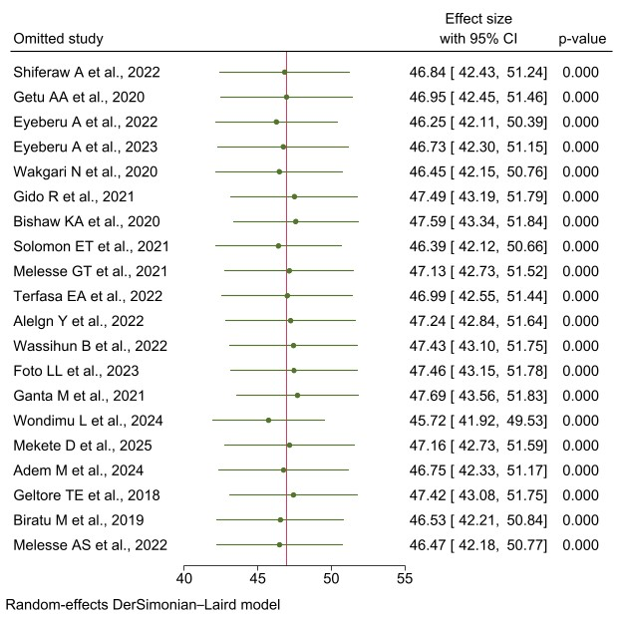
Figure 3: Forest plot of sensitivity analysis for the overall LPMP among OCPs in Ethiopia, 2025.
Sub-group analysis for the overall LPMP
Subgroup analysis based on geographic region revealed notable variation in the pooled estimates of the overall LPMP among OCPs. The highest pooled LPMP was observed in the Harari region at 59.82% (95% CI: 49.81–69.82), with substantial heterogeneity (I² = 91.9%, P < 0.001). In contrast, the lowest estimate was found in the SNNPR at 36.03% (95% CI: 33.52–38.55), with no observed heterogeneity (I² = 0.0%, P = 0.400). The pooled overall LPMP estimates were relatively comparable across studies conducted in Amhara [47.94% (95% CI: 42.45–53.43), I² = 86.7%, P < 0.001], Oromia [47.78% (95% CI: 41.54–54.03), I² = 69.6%, P = 0.037], and Sidama [48.66% (95% CI: 34.16–63.17), I² = 93.1%, P < 0.001] (Table 2; Figure S1a-i). One study conducted in Addis Ababa with a sample size of 391 reported LPMP of 36.6%; however, heterogeneity statistics and pooled estimates were not computed for this study, as Stata requires at least two studies per subgroup to calculate heterogeneity (I², τ²) and generate a pooled effect size.
The pooled estimates of LPMP among OCPs in relation to the COVID-19 pandemic revealed similar findings across study periods. Before the pandemic, the pooled prevalence was 46.36% (95% CI: 39.37–53.34; I² = 91.6%; P < 0.001), while during the COVID-19 period it was 46.99% (95% CI: 41.07–52.91; I² = 93.7%; P < 0.001). One study conducted after the official cessation of the COVID-19 pandemic in 2024 with a sample size of 400 and reported a LPMP of 50.5%. However, the heterogeneity statistics and pooled estimates were not computed for this study. The pooled overall prevalence of LPMP among OCPs, stratified by type of health facility, was slightly higher in studies conducted across both hospitals and health centers (48.48%; 95% CI: 42.83–54.13; I² = 92.7%; P < 0.001) compared to those conducted exclusively in hospital settings (46.34%; 95% CI: 39.81–52.87; I² = 91.4%; P < 0.001). One study conducted solely in a health center setting with a sample size of 299 reported LPMP of 34.4%. Similarly, the pooled prevalence of LPMP was higher in studies conducted across both public and private health facilities (55.75%; 95% CI: 50.59–60.91; I² = 71.7%; P < 0.001) compared to studies conducted exclusively in public health facilities (45.32%; 95% CI: 40.95–49.69; I² = 91.3%; P < 0.001) (Table 2; Figure S1a-i).
Subgroup analysis by sample size showed minimal variation in the pooled prevalence of the overall LPMP among OCPs. Studies with fewer than 384 participants reported a prevalence of 48.84% (95% CI: 42.25–55.42; I² = 92.9%; P < 0.001), while those with larger sample sizes (≥384) reported 44.76% (95% CI: 39.24–50.27; I² = 92.2%; P < 0.001). Subgroup analysis by sampling method revealed that studies employing non-probability sampling reported a higher pooled prevalence of the overall LPMP (50.36%; 95% CI: 44.06-56.65) with substantial heterogeneity (I² = 94.2%; P < 0.001), whereas studies using probability sampling reported a lower pooled prevalence (41.97%; 95% CI: 38.33–45.61) with moderate heterogeneity (I² = 75.1%; P < 0.001) (Table 2; Figure S1a-i).
Studies that assessed both N-PLPMP and P-LPMP reported a slightly higher pooled overall LPMP of 48.52% (95% CI: 42.56–54.48; I² = 92.5%, P < 0.001), whereas studies assessing only N-PLPMP reported 44.98% (95% CI: 37.33–52.63; I² = 93.7%, P < 0.001), and those assessing only P-LPMP reported 43.77% (95% CI: 29.76–57.78; I² = 94.5%, P < 0.001). The subgroup meta-analysis indicated that published studies reported a slightly higher pooled prevalence of overall LPMP at 48.06% (95% CI: 43.18% to 52.94%; I² = 92.5%; p < 0.001), compared to 43.53% (95% CI: 35.56% to 51.50%; I² = 91.1%; p < 0.001) among unpublished studies. Subgroup analysis was conducted based on publication year or the manuscript upload date for unpublished and preprint studies. Studies published between 2018 and 2021 reported a slightly lower level of the overall LPMP at 44.34% (95% CI: 38.15–50.53; I² = 92.2%, p < 0.001), compared to those published between 2022 and 2025, which reported a LPMP of 49.06% (95% CI: 43.44–54.69; I² = 92.1%, p < 0.001) (Table 2; Figure S1a-i).
Table 2: Subgroup analysis of the overall LPMP among obstetric care providers in Ethiopia, 2025.
Groups | Outcome | Sub-group | No. of studies | Sample size | Model | Subgroup effect estimate | I² (%) | P-value
Region | LPMP | Amhara | 7 | 2455 | Random | 47.94% (CI: 42.45-53.43) | 86.7 | <0.001
Region | LPMP | Oromia | 3 | 847 | Random | 47.78% (CI: 41.54-54.03) | 69.6 | 0.040
Region | LPMP | SNNPR | 4 | 1399 | Random | 36.03% (CI: 33.52-38.55) | 0.0 | 0.400
Region | LPMP | Sidama | 2 | 651 | Random | 48.66% (CI: 34.16-63.17) | 93.1 | <0.001
Region | LPMP | Harari | 3 | 1162 | Random | 59.82% (CI: 49.81–69.82) | 91.9 | <0.001
Data collection year | LPMP | Prior to COVID-19 | 7 | 2325 | Random | 46.36% (CI: 39.37–53.34) | 91.6 | <0.001
Data collection year | LPMP | During COVID-19 | 12 | 4180 | Random | 46.99% (CI:41.07–52.91) | 93.7 | <0.001
Type of health facility | LPMP | Both hospitals and health centers | 11 | 4028 | Random | 48.48% (CI: 42.83–54.13) | 92.7 | <0.001
Type of health facility | LPMP | Only hospitals | 8 | 2578 | Random | 46.34% (CI: 39.81–52.87) | 91.4 | <0.001
Health sector | LPMP | Only public health facilities | 17 | 5461 | Random | 45.32% (CI: 40.95–49.69) | 91.3 | <0.001
Health sector | LPMP | Both public & private | 3 | 1264 | Random | 55.75% (CI: 50.59–60.91) | 71.7 | <0.001
Sample size | LPMP | <384 | 11 | 2998 | Random | 48.84% (CI: 42.25–55.42) | 92.9 | <0.001
Sample size | LPMP | >384 | 9 | 3907 | Random | 44.76% (CI: 39.24–50.27) | 92.2 | <0.001
Sampling method | LPMP | Probability | 8 | 2866 | Random | 41.97% (CI: 38.33-45.61) | 75.1 | <0.001
Sampling method | LPMP | Non-probability | 12 | 4039 | Random | 50.36% (CI: 44.06-56.65) | 94.2 | <0.001
Type of LPM practiced | LPMP | Both N & PLPMP | 12 | 3510 | Random | 48.52% (CI: 42.56-54.48) | 92.5 | <0.001
Type of LPM practiced | LPMP | Only N-PLPMP | 6 | 2540 | Random | 44.98% (CI: 37.33-52.63) | 93.7 | <0.001
Type of LPM practiced | LPMP | Only P-LPMP | 2 | 855 | Random | 43.77% (CI: 29-76-57.78) | 94.5 | <0.001
Publication status | LPMP | Published | 15 | 5269 | Random | 48.06% (CI:43.18-52.94) | 92.5% | <0.001
Publication status | LPMP | Unpublished | 5 | 1636 | Random | 43.53% (CI: 35.56-51.50) | 90.1% | <0.001
Publication year | LPMP | 2018-2021 | 9 | 3113 | Random | 44.34% (CI: 38.15-50.53) | 92.2% | <0.001
Publication year | LPMP | 2022-2025 | 11 | 3792 | Random | 49.06% (CI: 43.44-54.69) | 92.1% | <0.001

Publication bias among the studies for the overall LPMP
Visual inspection of the funnel plot suggested asymmetry in the distribution of studies around the pooled effect estimate of the overall LPMP (Figure 4). Egger’s weighted regression test revealed a statistically significant intercept (β₀ = 30.50; p = 0.006), indicating funnel plot asymmetry and potential publication bias, despite a non-significant slope (β₁ = 6.01; p = 0.1304) (Table 3). In contrast, Begg’s rank correlation test showed no statistically significant evidence of small-study effects (Kendall’s tau = 0.1789; z = 1.07; p = 0.2843). As a result of publication bias from Egger’s test, a trim-and-fill analysis was conducted to obtain a more conservative and potentially less biased pooled prevalence estimate.

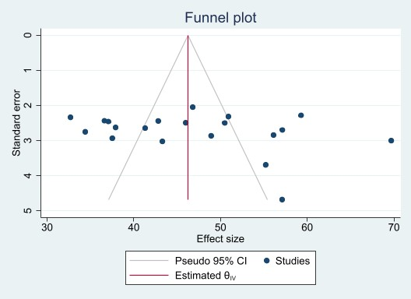
Figure 4: Funnel plot of the included studies on the overall LPMP among OCPs in Ethiopia, 2025.

Table 3: Egger’s test for the overall LPMP among OCPs in Ethiopia, 2025.
Egger's test
Std_Eff | Coefficient | Std. Err. | Z-value | P>|z| | 95% confidence interval
 |  |  |  |  | Lower | Upper
Slope (β₁) | 6.01 | 3.97 | 1.51 | 0.130 | −1.78 | 13.80
Intercept (β₀) | 30.50 | 11.08 | 2.75 | 0.006 | 8.78 | 52.20

Trim-and-Fill analysis for the overall LPMP
Given the statistically significant Egger’s intercept (β₀ = 30.50; p = 0.006), a trim-and-fill analysis was conducted to adjust for potential publication bias, using the Linear (L₀) estimator and imputing studies on the left side of the funnel plot. However, the procedure did not impute any additional studies, indicating that the observed asymmetry did not substantially affect the pooled estimate. The adjusted prevalence remained unchanged at 46.94% (95% CI: 42.62% to 51.26%), suggesting that the risk of publication bias may be limited and the original summary estimate is robust (Figure 5).
Figure 5: Trim-and-fill funnel plot of the included studies assessing the overall LPMP among OCPs in Ethiopia, 2025.
Factors Associated with Obstetric Care Providers’ Overall LPMP
To assess factors associated with OCPs implementation of LPMP, pooled analyses were conducted across multiple studies. A meta-analysis of ten studies (1, 2, 6, 7, 9, 11, 15, 17-19) examining the association between OCPs knowledge of LPM and their implementation of LPMP revealed that knowledgeable providers were significantly more likely to implement LPM than their less informed counterparts (AOR = 2.98, 95% CI: 2.36–3.75, p < 0.001). Using a random-effects model with REML estimation, moderate heterogeneity was observed (I² = 36.86%, τ² = 0.05, H² = 1.58), and the Q-test indicated borderline non-significant heterogeneity across studies (p = 0.07). All included studies reported statistically significant individual effects, reinforcing the consistency and robustness of the pooled estimate (Table 6; Figure S2a-n). Publication bias was evaluated using both visual and statistical approaches. The funnel plot demonstrated a symmetrical distribution of studies around the pooled effect size, with most falling within the pseudo 95% CI (Figure 6). Egger’s test for small-study effects yielded a non-significant intercept (bias = 2.70, 95% CI: –1.98 to 7.37, p = 0.220), indicating no substantial asymmetry (Table 4). These findings suggest minimal risk of publication bias in the reported association. The observed moderate heterogeneity further supports the appropriateness of pooling and the reliability of bias diagnostics.
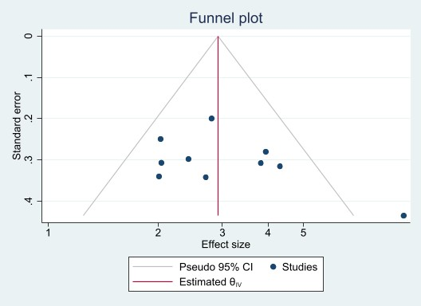
Figure 6: Funnel plot assessing publication bias in studies examining the association between OCPs’ knowledge of LPM and its practice in Ethiopia, 2025
Table 4: Egger’s test for small-study effects in the meta-analysis of OCPs’ knowledge of LPM and its practice in Ethiopia, 2025.
Egger's test
Std_Eff | Coefficient | Std. Err. | Z-value | P>|z| | 95% confidence interval
 |  |  |  |  | Lower | Upper
Slope (β₁) | 0.31 | 0.59 | 0.52 | 0.617 | –1.05 | 1.66
Intercept (bias=β₀) | 2.70 | 2.03 | 1.33 | 0.220 | –1.98 | 7.37

Based on four studies (10, 12, 13, 16), the pooled effect size indicated that midwives were significantly more likely to practice LPM compared to other OCPs (AOR = 2.43, 95% CI: 1.44–4.11, p < 0.001). Moderate heterogeneity was observed across studies (I² = 41.8%), supporting the use of a random-effects model. Although two studies (5, 16) reported a positive association between physician status and LPMP, the pooled estimate was not statistically significant (AOR = 1.05; 95% CI: 0.03, 34.48; I² = 95.3%; P = 0.980). This may reflect limited study power, wide confidence intervals, and substantial heterogeneity, warranting cautious interpretation. Four studies (4, 10, 11, 15) found that OCPs` LPMP was associated with having received training on LPM. Accordingly, the random-effects meta-analysis indicated that OCPs who had LPM training were 2.74 times more likely to practice LPM than those without training (AOR = 2.74; 95% CI: 1.66–4.52; I² = 62.0%; P < 0.001). Based on two studies (1, 10), the pooled odds ratio estimated using a fixed-effect inverse-variance model indicated that obstetric care providers (OCPs) who allow mothers to choose their preferred labor pain management (LPM) method or to have a preferred companion in the labor ward were 2.41 times more likely to practice LPM than their counterparts (AOR = 2.41; 95% CI: 1.58–3.69; I² = 0.0%; P < 0.001) (Table 6; Figure S2a-n).
The association between OCPs LPMP, and the availability of drugs and equipment was assessed by five studies (1, 6, 11, 13, 19). Using a fixed-effect model, the pooled analysis indicated that the presence of drugs and equipment in the labor ward increased OCPs’ practice of LPM by 2.77 times compared with wards lacking these resources (AOR = 2.77; 95% CI: 2.13–3.60; I² = 0.0%; P < 0.001). Similarly, two studies (2, 17) reported that the availability of LPM protocol in the labor ward was associated with OCPs’ LPMP. Using a random-effects model, the pooled effect showed that having LPM protocol significantly increased the likelihood of practicing LPM by 2.45 times (AOR = 2.45; 95% CI: 1.09–5.53; I² = 71.0%; P < 0.001) (Table 6; Figure S2a-n).
To assess the association between OCPs implementation of LPMPs and their attitude towards LPM, eleven studies (2, 4, 5, 7, 10, 12, 13, 15, 17-19) were included in the meta-analysis. The pooled analysis revealed that OCPs with a favorable attitude towards LPM were significantly more likely to implement LPMP compared to those with an unfavorable attitude (AOR = 3.51; 95% CI: 2.50–4.93; p < 0.001). A random-effects model was applied, and substantial heterogeneity was observed across studies (I² = 74.2%), indicating variability in effect sizes that may be attributable to contextual or methodological differences (Table 6; Figure S2a-n). Publication bias was assessed using both visual and statistical methods. The funnel plot displayed a generally symmetrical distribution of studies around the pooled effect size (AOR = 3.51), with most studies falling within the pseudo 95% confidence limits. Although two studies lay outside the funnel boundaries on either side, this pattern is consistent with the substantial heterogeneity observed (I² = 74.2%) and does not necessarily indicate bias (Figure 7). Egger’s test for small-study effects yielded a non-significant intercept (β₀ = 0.56; p = 0.871), indicating no statistically significant asymmetry (Table 5). Together, these findings suggest minimal risk of publication bias in the reported association between OCPs’ attitude and their practice of LPM.
Figure 7: Funnel plot assessing publication bias in studies examining the association between OCPs’ attitudes towards LPM and its practice in Ethiopia, 2025
Table 5: Egger’s test for small-study effects in the meta-analysis of OCPs’ attitude towards LPM and its practice in Ethiopia, 2025.
Egger's test
Std_Eff | Coefficient | Std. Err. | Z-value | P>|z| | 95% confidence interval
 |  |  |  |  | Lower | Upper
Slope (β₁) | 1.09 | 0.97 | 1.12 | 0.290 | – 1.10 | 3.27
Intercept (bias=β₀) | 0.56 | 3.39 | 0.17 | 0.871 | – 7.10 | 8.23

Sex of the OCPs and their implementation of LPMP were assessed in two studies (4, 16). Using a fixed-effect model, the pooled analysis indicated that female OCPs were significantly more likely to practice LPM than their male counterparts (AOR = 2.13; 95% CI: 1.44–3.16; I² = 0.0%; p < 0.001). In this review, three studies (5, 11, 16) reported that having a BSc or higher educational level was positively associated with OCPs LPMP. The pooled analysis indicated that OCPs with a BSc or higher were 3.90 times more likely to practice LPM compared with those holding a diploma (AOR = 3.90; 95% CI: 2.41–6.32; P < 0.01), with no observed heterogeneity (I² = 0.0%) (Table 6; Figure S2a-n).
Three studies (6, 7, 17) reported that OCPs` LPMP was significantly associated with having more than 10 years of clinical experience. Using a fixed-effect model, the pooled analysis indicated that OCPs with more than 10 years of clinical experience were 3.64 times more likely to practice LPM compared with those with less than five years of experience (AOR = 3.64; 95% CI: 2.18–6.08; I² = 0.0%; P < 0.001). In contrast, four studies (5, 7, 12, 17) examined the association between LPMP and having 6 to 9 years of clinical experience. Due to substantial heterogeneity (I² = 84.7%), a random-effects model was applied. The pooled analysis did not yield a statistically significant association (AOR = 1.85; 95% CI: 0.66–5.22; p = 0.243). This lack of significance may reflect small sample sizes, wide CI, limited study power, methodological differences, or residual confounding (Table 6; Figure S2a-n).
The association between OCPs LPMP, and their working environment was assessed by three studies (8, 12, 15). Using a fixed-effect model, the pooled analysis showed that OCPs working in a favorable environment such as having a satisfactory delivery room, reduced workload, or working in private primary hospitals were 3.56 times more likely to practice LPM compared with those in less favorable environments (AOR = 3.56; 95% CI: 2.26–5.61; P < 0.001), with no observed heterogeneity (I² = 0.0%). Likewise, four studies (9, 10, 16, 17) examined the association between OCPs’ LPM practice and their perception of labor pain. A fixed-effect model was applied because heterogeneity was low (I² = 7.2%). The pooled analysis indicated that OCPs who had positive perceptions of LPM, such as recognizing labor pain as severe or understanding the benefits of labor pain, were 3.86 times more likely to practice LPM than those with negative perceptions (AOR = 3.86; 95% CI: 2.50–5.95; P < 0.001) (Table 6; Figure S2a-n).
In addition to the pooled factors associated with overall LPMP, some variables were found to be significant only in individual studies and were therefore not included in the meta-analysis due to limited data availability. For instance, one study (10) reported that having information about the WHO pain ladder was significantly associated with increased likelihood of practicing LPMP (AOR = 2.95; 95% CI: 1.73–5.01). Conversely, another study found that OCPs with a diploma qualification were significantly less likely to practice LPMP compared to those with higher qualifications (AOR = 0.30; 95% CI: 0.20–0.60) (9).
Table 6: Factors associated with the overall LPMP among OCPs in Ethiopia, 2025.
Variables (Factors) | Comparator | Outcome | No. of studies | Sample size | Model | Pooled Effect Size (95% CI) | I² | P-value
Having adequate knowledge of LPM | Poor knowledge | Factor | 10 | 3753 | Random | 2.98 (2.36 - 3.75) | 36.9% | <0.001
Being Midwife | Other OCPs | Factor | 4 | 1290 | Random | 2.43 (1.44-4.11) | 41.8% | <0.001
Being Physician | Other OCPs | Factor | 2 | 539 | Random | 1.05 (0.03-34.48) | 95.3% | 0.980
Having training on LPM | Non-trained on LPM | Factor | 4 | 1609 | Random | 2.74 (1.66-4.52) | 62.0% | <0.001
Giving the mother to choose LPM option | Not giving chance | Factor | 2 | 703 | Fixed | 2.41 (1.58-3.69) | 0.0% | <0.001
Availability of drug and equipment | Lack of supplies | Factor | 5 | 1768 | Fixed | 2.77 (2.13-3.60) | 0.0% | <0.001
Availability of labor pain management protocol | Lack of LPM protocol | Factor | 2 | 1003 | Random | 2..45 (1.09-5.53) | 71.0% | 0.030
Favorable attitude LPM | Unfavorable attitude | Factor | 11 | 4268 | Random | 3.51 (2.50-4.93) | 74.2% | <0.001
Being female | Male | Factor | 2 | 698 | Fixed | 2.13 (1.44-3.16) | 0.0% | <0.001
BSc and above educational level | Diploma | Factor | 3 | 885 | Fixed | 3.90 (2.41-6.32) | 0.0% | <0.001
Clinical experience of >10 years | <5 years | Factor | 3 | 1101 | Fixed | 3.64 (2.18-6.08) | 0.0% | <0.001
Clinical experience of 6-9 years | <2 years | Factor | 4 | 1288 | Random | 1.85 (0.66-5.22) | 84.7% | 0.243
Working in a favorable environment | Unfavorable environment | Factor | 3 | 1009 | Fixed | 3.56 (2.26-5.61) | 0.0% | <0.001
Positive perceptions of LPM | Negative perception | Factor | 4 | 1311 | Fixed | 3.86 (2.50-5.95) | 7.2% | <0.001

Certainty of Evidence (GRADE Assessment)
The certainty of evidence for the pooled prevalence of overall LPMP was rated as low due to substantial heterogeneity (I² = 92.4%), moderate RoB, and evidence of publication bias. For associated factors, the certainty of evidence varied depending on the number of contributing studies, effect size consistency, and heterogeneity. Factors such as provider knowledge, favorable attitude, availability of drugs and equipment, and supportive working environments were generally rated as moderate-certainty when supported by consistent and precise pooled estimates with low heterogeneity. Conversely, factors with moderate to substantial heterogeneity or limited data were rated as low or very low certainty.
References
- Shiferaw A, Temesgen B, Alamirew NM, Wube T, Worku Y. Utilization of labor pain management methods and associated factors among obstetric care givers at public health institutions of East Gojjam Zone, Amhara region, Ethiopia, 2020: a facility based cross–sectional study. BMC Pregnancy and Childbirth. 2022;22(1):803.
- Getu AA, Getie SA, Gela GB, Maseresha EA, Feleke BE, Muna AM. Non-pharmacological labor pain management and associated factor among skilled birth attendants in Amhara Regional State health institutions, Northwest Ethiopia. Reproductive Health. 2020;17(1):183.
- Eyeberu A, Debela A, Getachew T, Dheresa M, Alemu A, Dessie Y. Obstetrics care providers attitude and utilization of non-pharmacological labor pain management in Harari regional state health facilities, Ethiopia. BMC Pregnancy and Childbirth. 2022;22(1):389.
- Eyeberu A, Getachew T, Debella A, Balis B, Eshetu B, Mesfin S, et al. Utilization of pharmacological labour analgesia: a survey of obstetric care providers in eastern Ethiopia. International Health. 2023;15(3):335-41.
- Wakgari N, Mekonnen M, Lema B, Negasu A, Lulu B, Abebe E. Labour pain management practices among obstetric care providers in Hawassa city, Ethiopia. African Journal of Midwifery and Women's Health. 2020;14(2):1-12.
- Gido R, Yadeta TA, Tura AK. Utilization of obstetric analgesia for labor pain management and associated factors among obstetric care providers in public hospitals of Addis Ababa, Ethiopia: a cross‐sectional study. Obstetrics and gynecology international. 2021;2021(1):9973001.
- Bishaw KA, Sendo EG, Abebe WS. Knowledge, and use of labour pain relief methods and associated factors among obstetric caregivers at public health centers of East Gojjam zone, Amhara region, Ethiopia: a facility based cross-sectional study. BMC pregnancy and childbirth. 2020;20(1):180.
- Solomon ET, Kassie FY, Mekonnen DG, Mihret MS, Abate AT, Dessie AA. Knowledge, attitude, and practice towards labor pain management and associated factors among skilled birth attendants working at hospitals found in central, west, and north Gondar zones, Northwest Ethiopia, 2019: a multicenter cross‐sectional study. Pain Research and Management. 2021;2021(1):8835677.
- Melesse GT, Wayessa ZJ, Bonkiye AJ. Labor Pain Mangement Practice and Associated Factors Among Obstetric Care Workers in Public Health Facilities of West Guji Zone, Southern Ethiopia, 2020. 2021.
- Terfasa EA, Bulto GA, Irenso DY. Obstetric analgesia utilization in labor pain management and associated factors among obstetric care providers in the West Shewa Zone, Central Ethiopia. SAGE Open Medicine. 2022;10:20503121221088705.
- Alelgn Y, Abeje A, Tsegaye BT, Andargachew AK, Belay BA, Abebaw AA, et al. Magnitude and factors associated with utilization of labor analgesia among obstetric caregivers at public hospitals in Sidama region, Southern Ethiopia. 2022.
- Wassihun B, Alemayehu Y, Gultie T, Tekabe B, Gebeyehu B. Non-pharmacological labor pain management practice and associated factors among skilled attendants working in public health facilities in Gamo and Gofa zone, Southern Ethiopia: A cross-sectional study. PloS one. 2022;17(4):e0266322.
- Foto LL, Zenebe WA, Ali Y, Geltore TE. Perceptions and practice of labor pain-relief methods and its perceived barriers among obstetric care providers in public health facilities of Gedeo Zone, Southern Ethiopia: mixed study, 2021. 2023.
- Melesse AS, Bayable SD, Ashebir YG, Ayenew NT, Fetene MB. Survey on knowledge, attitude and practice of labor analgesia among health care providers at Debre Markos Comprehensive Specialized Hospital, Ethiopia 2021. A cross-sectional study. Annals of Medicine and Surgery. 2022;74.
- Ganta M, Tura AK, Assebe T, Deyaso ZF, Mengesha SH. Non-Pharmacologic Labor Pain Management Practice and Its Associated Factors Among Midwives Working in Selected Public Hospitals of South Nation Nationalities and Peoples’ Region, Ethiopia. 2021.
- Wondimu L, Bekana M, Tura AK, Getachew T. Perception, practice and associated factors of labour pain management among obstetric care providers in public health facilities in Harari Region, Ethiopia: a multicentre cross-sectional study. International Health. 2025;17(4):481-8.
- Mekete D, Magegnet T, Tsegaw B, Sisay M, Negese S, Degefa BD, et al. Non-Pharmacological Labor Pain Management Utilization and Its Associated Factors Among Skilled Birth Attendants in North Showa, Ethiopia: A Cross-Sectional Study. Mathews Journal of Gynecology & Obstetrics. 2025;9(1):1-10.
- Adem M. Practice of non-pharmacological labor pain management and associated factors among skilled birth attendants at hospitals found in Gondar province, northwest Ethiopia, 2024 2025.
- Geltore TE, Taye A, Kelbore AG. Utilization of obstetric analgesia in labor pain management and associated factors among obstetric caregivers in public health facilities of Kembata Tembaro Zone, Southern Ethiopia. Journal of pain research. 2018:3089-97.
- Biratu M, Tesfaye M, Desalegn N. Biratu M. Practice of labor pain management, its perceived barriers and associated factors among obstetric care providers working in Jimma Zone Hospitals Ethiopia. 2019. Jimma University Open access Institutional Repository. 2019:1-46.
Supplementary table 1. Meta-regression results for covariates of the overall LPMP among OCPs in Ethiopia, 2025 by including JBI-based RoB score as a covariates
Covariates | Category | No of studies | Coefficient (β) | Std. errs. | z | P- value | 95% CI
Publication status | Published | 15
Publication status | Unpublished | 5 | −3.10 | 5.280861 | −0.59 | 0.557 | −13.45 to 7.25
Type of health sector | Both public & private | 3
Type of health sector | Only public | 17 | −8.97 | 6.294324 | −1.43 | 0.154 | −21.31 to 3.36
Sampling methods | Probability | 8
Sampling methods | Non-probability | 12 | 8.51 | 4.855375 | 1.75 | 0.080 | −1.01 to 18.03
Sample size | <384 | 11
Sample size | >384 | 9 | −1.30 | 6.140727 | −0.21 | 0.832 | −13.33 to 10.74
Type of LPM practiced | Both P and N-PLPM | 12
Type of LPM practiced | Only N-PLPM | 6 | −4.66 | 5.896719 | −0.79 | 0.429 | −16.22 to 6.89
Type of LPM practiced | Only P-LPM | 2 | −11.64 | 9.05381 | −1.29 | 0.199 | −29.38 to 6.11
Year of publication | <2021 -2018 | 9
Year of publication | >2021 | 11 | + 5.50 | 4.295008 | 1.28 | 0.200 | −2.91 to 13.92
NOS RoB | Low | 18
NOS RoB | Moderate | 2 | + 5.66 | 8.133454 | 0.70 | 0.486 | −12.24 to 23.56
_Cons (Intercept) |  |  | 49.91 | 7.743588 | 6.45 | <0.001 | 34.7 to 65.09

Supplementary figures 1a-i
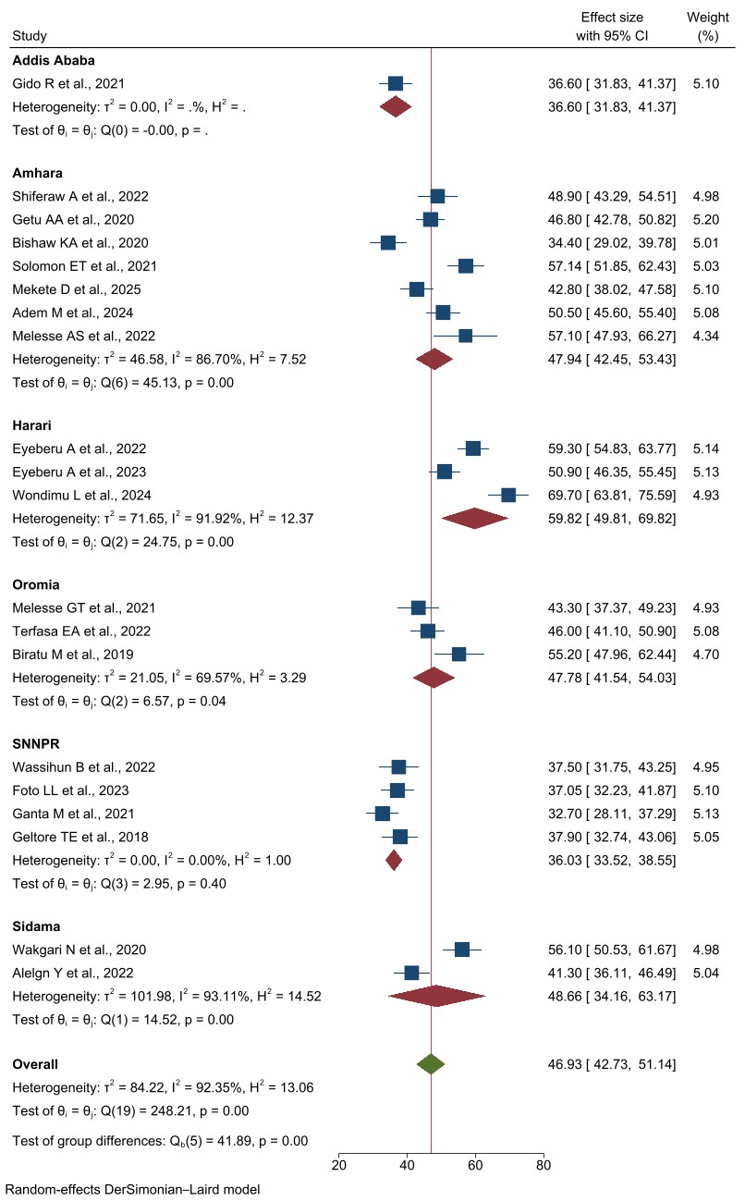
Supplementary Figure 1a: Forest plot of the subgroup analysis to assess pooled overall prevalence of labor pain management practices among different regions in Ethiopia, 2025.
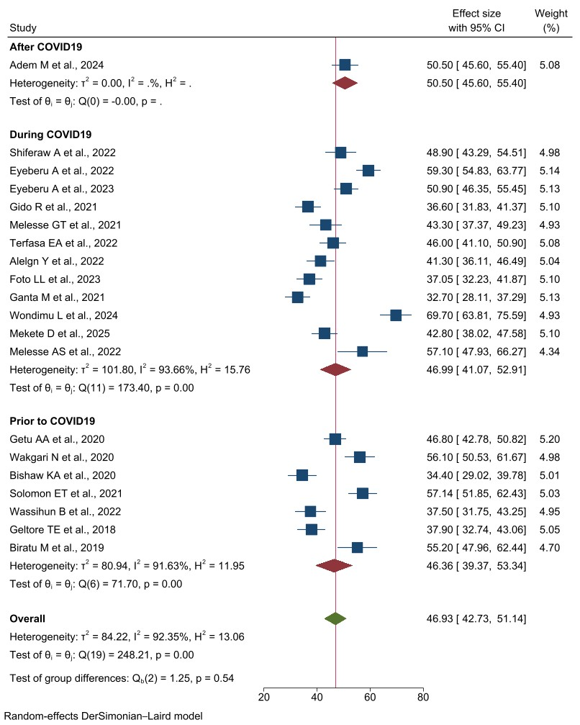
Supplementary Figure 1b: Forest plot of the subgroup analysis to assess pooled overall prevalence of labor pain management practices in relation to COVID-19 in Ethiopia, 2025.
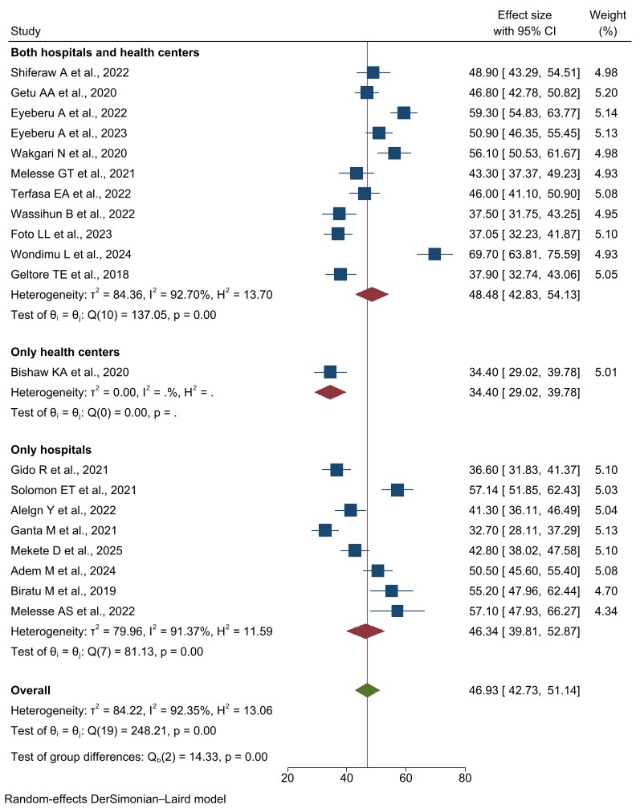
Supplementary Figure 1c: Forest plot of the subgroup analysis to assess pooled overall prevalence of labor pain management practices among the type of health facility in Ethiopia, 2025.
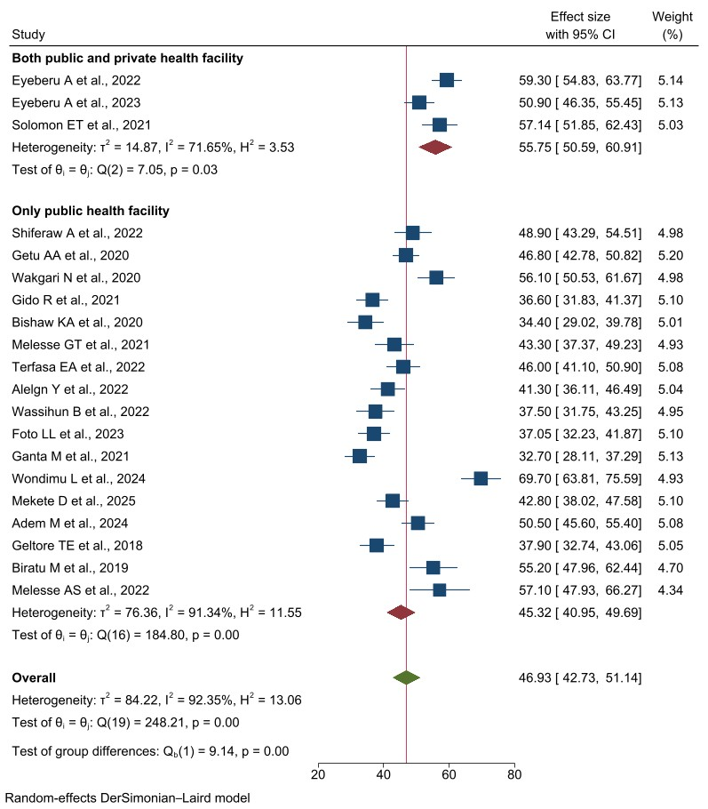
Supplementary Figure 1d: Forest plot of the subgroup analysis to assess pooled overall prevalence of labor pain management practices among the type of health sector in Ethiopia, 2025.

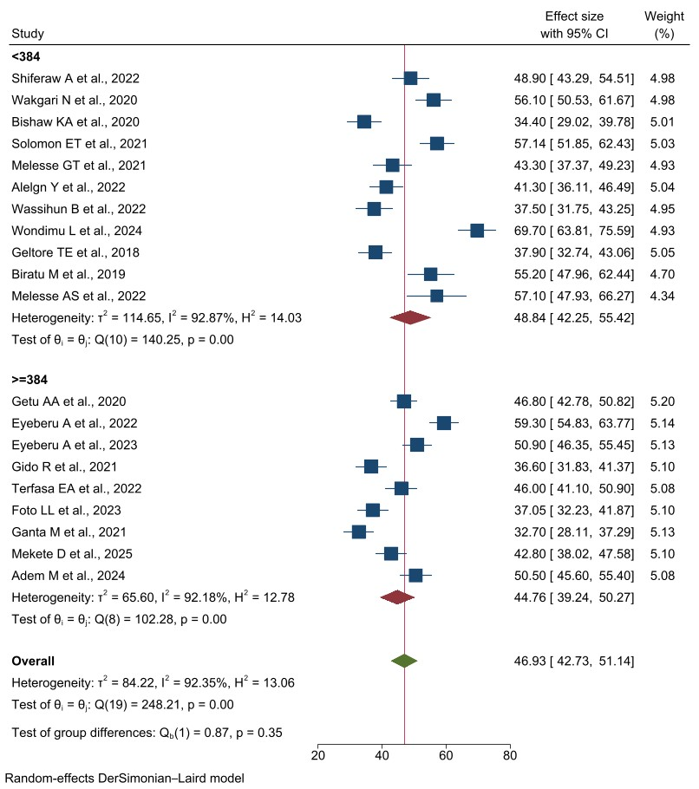
Supplementary Figure 1e: Forest plot of the subgroup analysis to assess pooled overall prevalence of labor pain management practices based on the achieved sample size in Ethiopia, 2025.

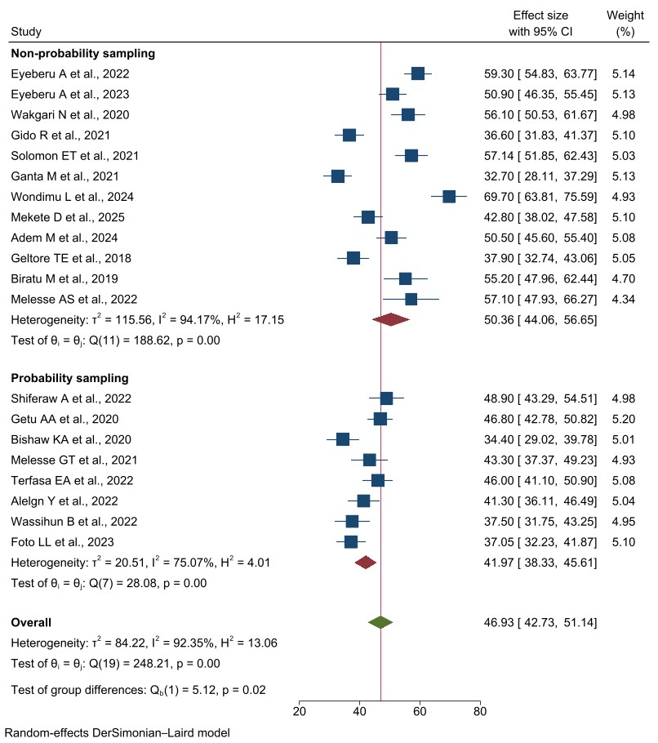
Supplementary Figure 1f: Forest plot of the subgroup analysis to assess pooled overall prevalence of labor pain management practices based on the sampling methods in Ethiopia, 2025.

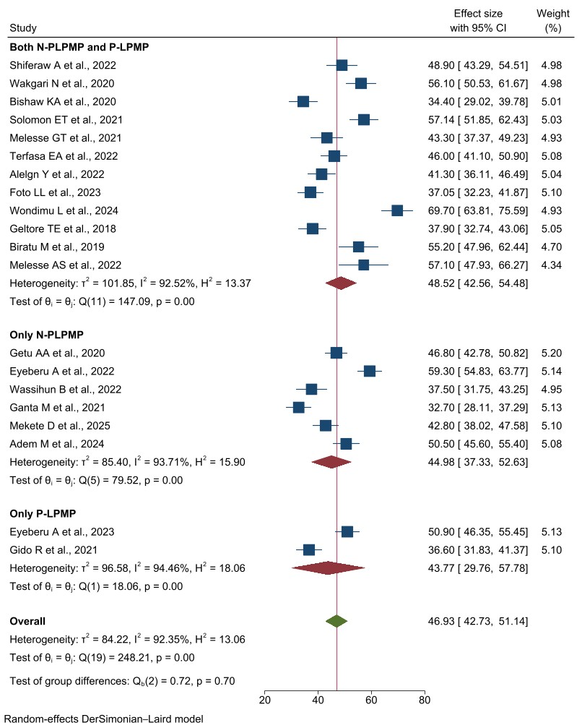
Supplementary Figure 1g: Forest plot of the subgroup analysis to assess pooled overall prevalence of labor pain management practices based on the type of labor management practiced in Ethiopia, 2025.
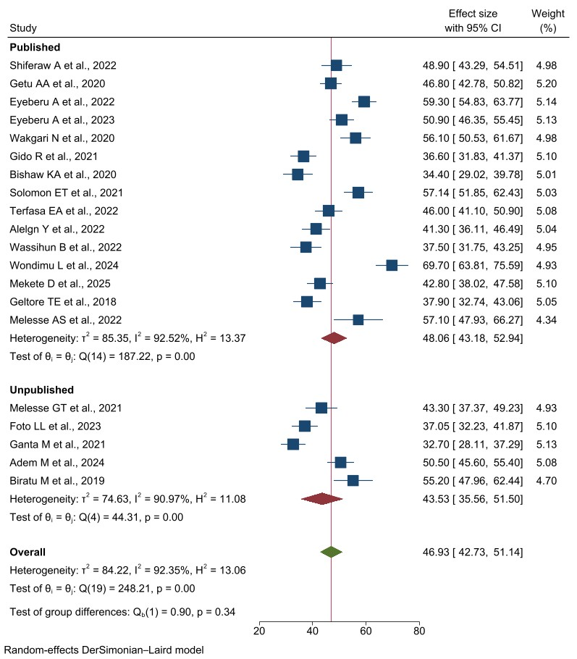
Supplementary Figure 1h: Forest plot of the subgroup analysis to assess pooled overall prevalence of labor pain management practices based on publication status in Ethiopia, 2025.

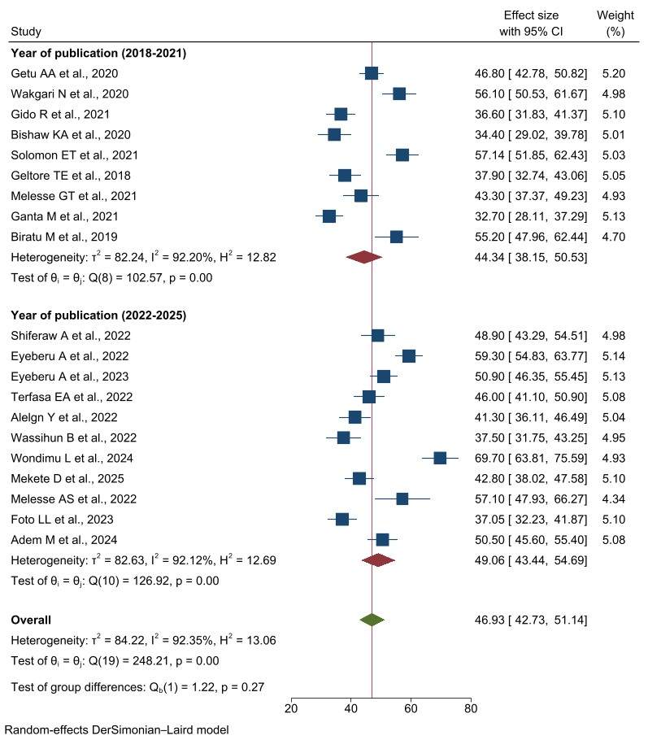
Supplementary Figure 1i: Forest plot of the subgroup analysis to assess pooled overall prevalence of labor pain management practices based on year of publication in Ethiopia, 2025.

Supplementary Figures 2a-n
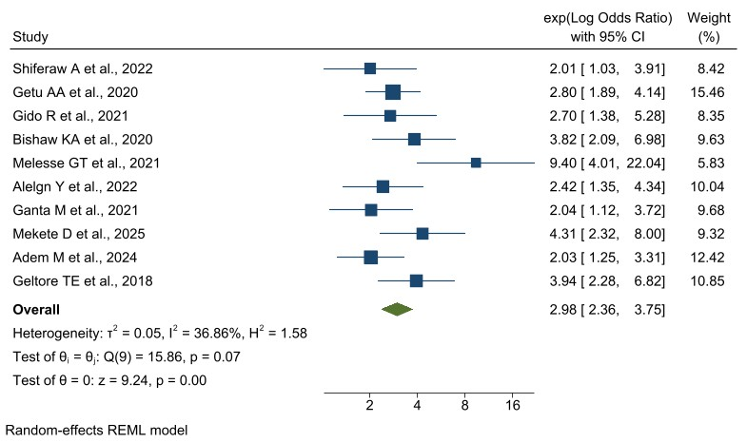
Supplementary Figure 2a: Forest plot showing the association between knowledge of OCPs and the overall LPMP in Ethiopia, 2025.
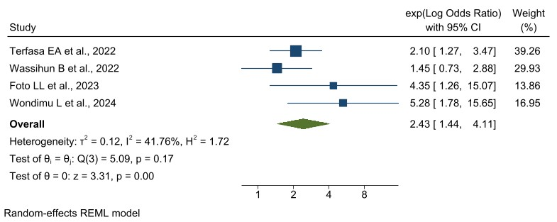
Supplementary Figure 2b: Forest plot showing the association between being midwife and the overall LPMP in Ethiopia, 2025.
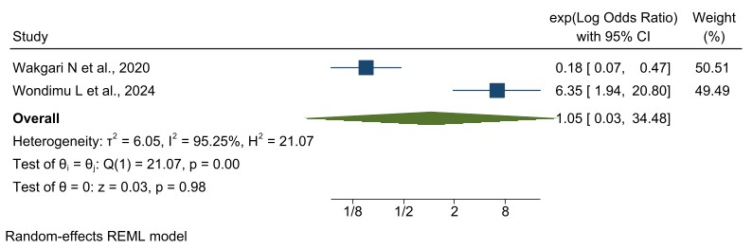
Supplementary Figure 2c: Forest plot showing the association between being physician and the overall LPMP in Ethiopia, 2025.
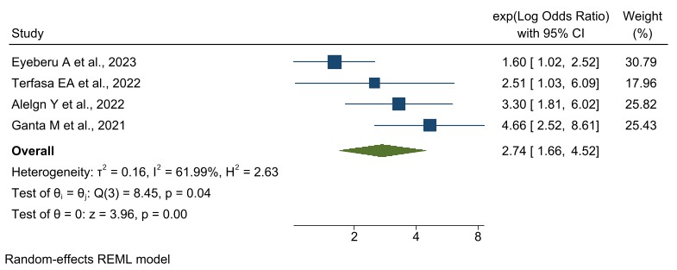
Supplementary Figure 2d: Forest plot showing the association between having training on labor pain management and the overall LPMP in Ethiopia, 2025.
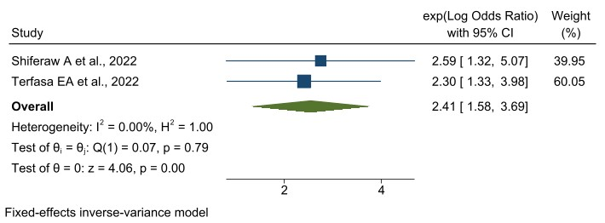
Supplementary Figure 2e: Forest plot showing the association between giving the mother option to choose the type of labor pain management and the overall LPMP in Ethiopia, 2025.
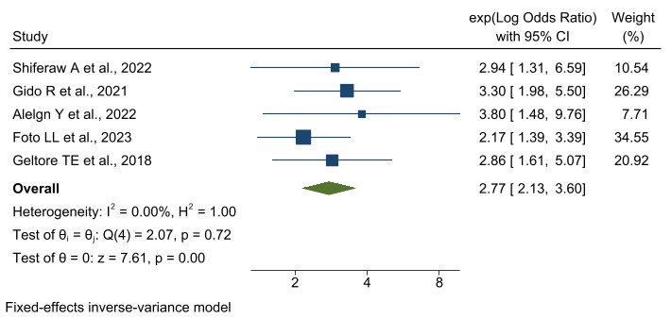
Supplementary Figure 2f: Forest plot showing the association between availability of adequate drugs and equipment and the overall LPMP in Ethiopia, 2025.
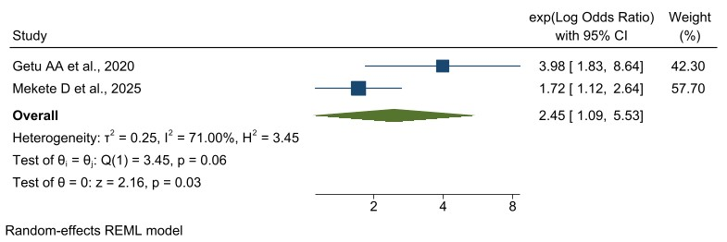
Supplementary Figure 2g: Forest plot showing the association between availability of labor pain management protocol and the overall LPMP in Ethiopia, 2025.
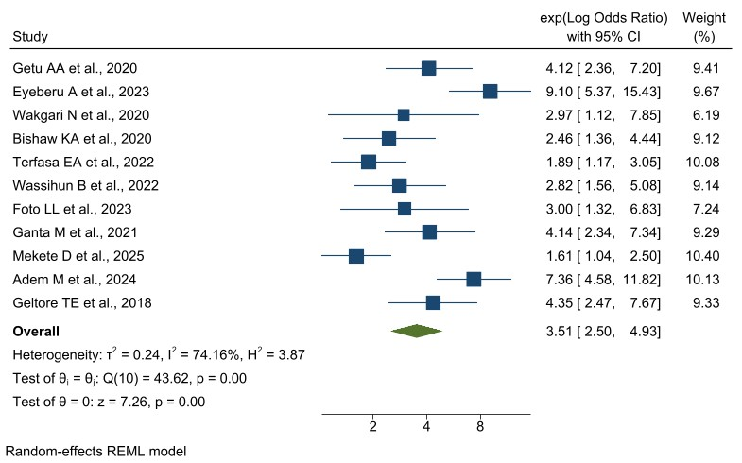
Supplementary Figure 2h: Forest plot showing the association between attitudes of the obstetric care providers towards labor pain management and the overall LPMP in Ethiopia, 2025.
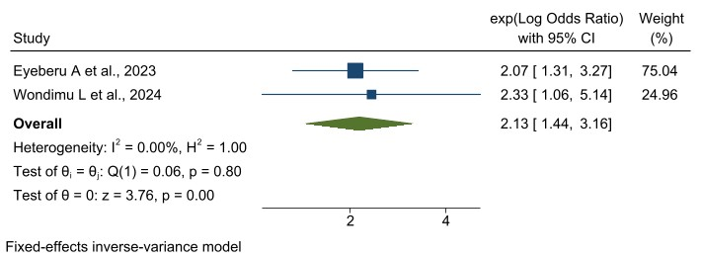
Supplementary Figure 2i: Forest plot showing the association between being female obstetric care providers and the overall LPMP in Ethiopia, 2025.
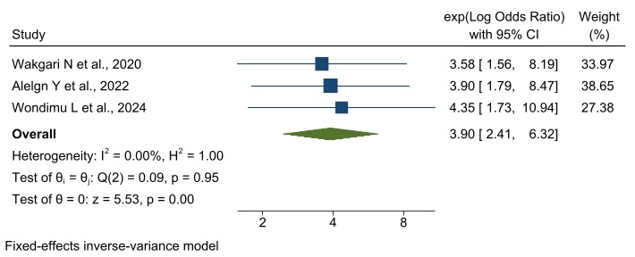
Supplementary Figure 2j: Forest plot showing the association between having BSc and above educational level and the overall LPMP in Ethiopia, 2025.
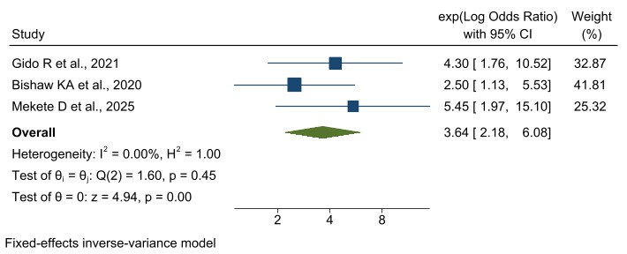
Supplementary Figure 2k: Forest plot showing the association between having clinical work experiences of more than 10 years and the overall LPMP in Ethiopia, 2025.

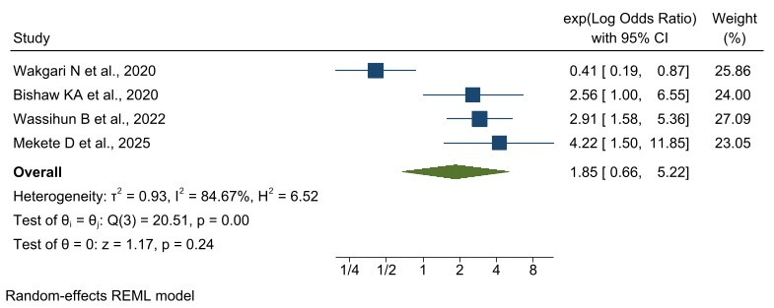
Supplementary Figure 2l: Forest plot showing the association between having clinical work experiences of 6-9 years and the overall LPMP in Ethiopia, 2025.
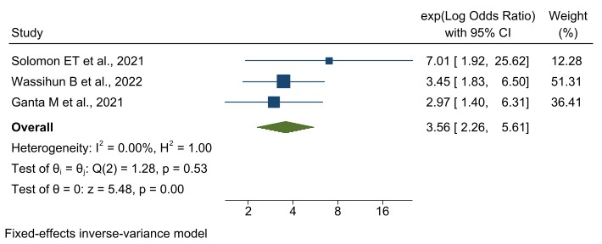
Supplementary Figure 2m: Forest plot showing the association between working in favorable environment and the overall LPMP in Ethiopia, 2025.
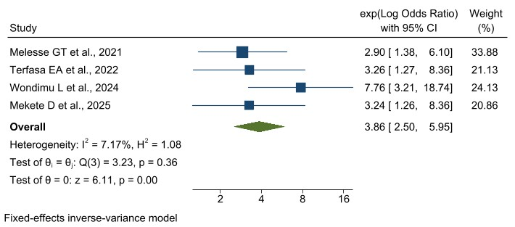
Supplementary Figure 2n: Forest plot showing the association between having positive perceptions of labor pain management and the overall LPMP in Ethiopia, 2025.

