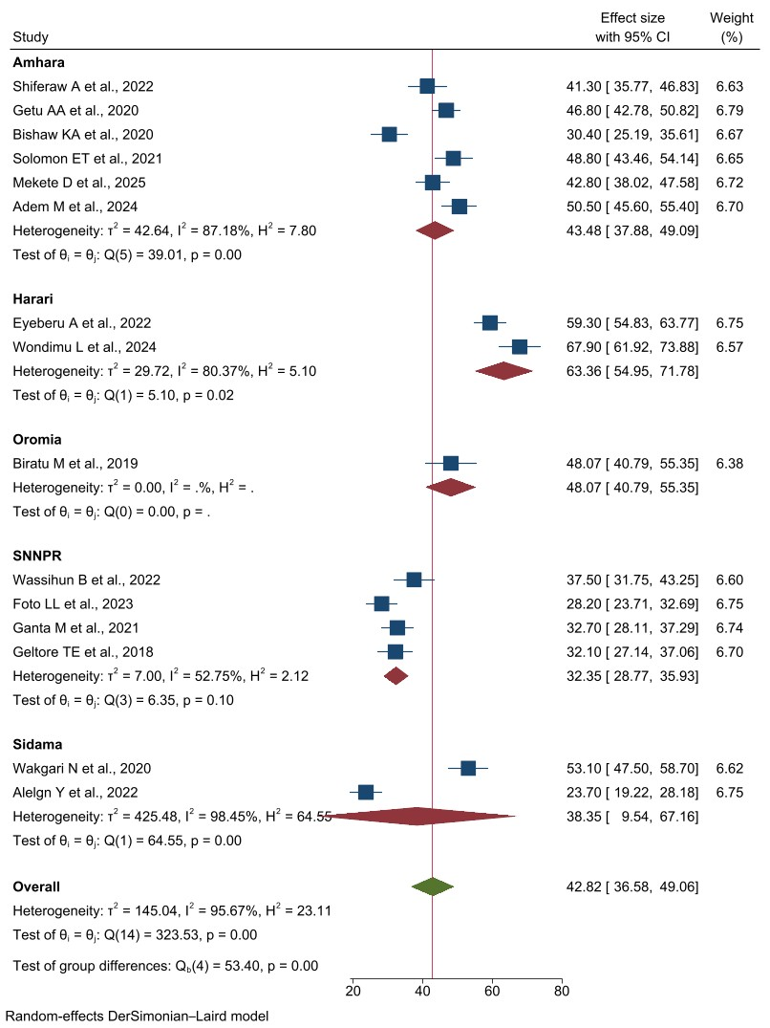
Supplementary Figure 2a: Forest plot of the subgroup analysis to assess pooled prevalence of non-pharmacological labor pain management practices among different regions in Ethiopia, 2025.
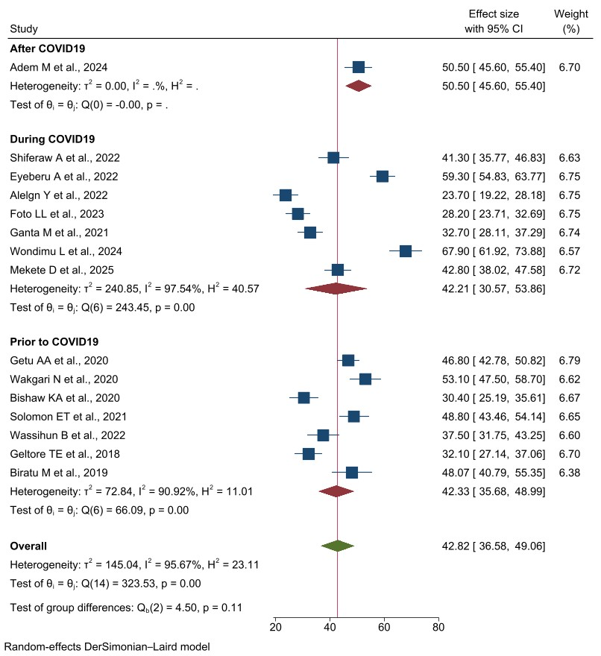
Supplementary Figure 2b: Forest plot of the subgroup analysis to assess pooled prevalence of non-pharmacological labor pain management practices in relation to COVID-19 in Ethiopia, 2025.
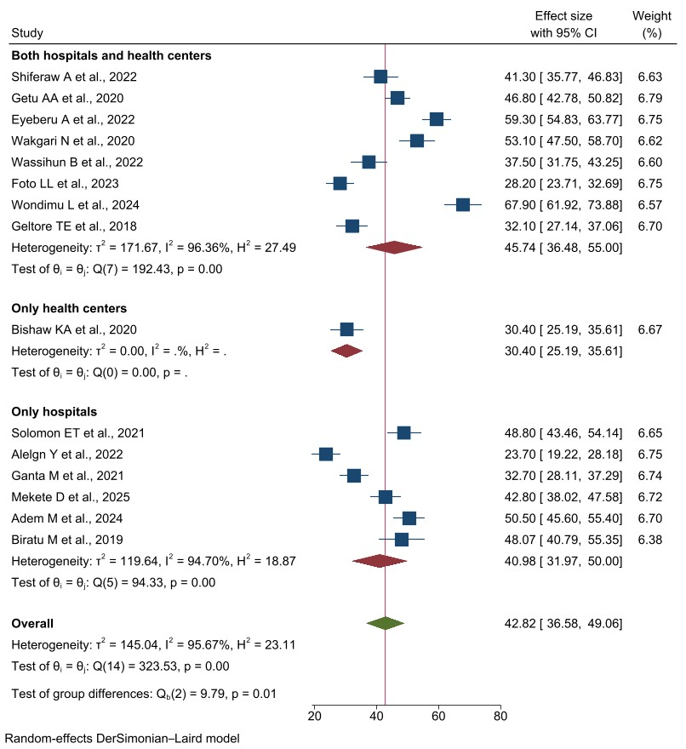
Supplementary Figure 2c: Forest plot of the subgroup analysis to assess pooled prevalence of non-pharmacological labor pain management practices based on the type of health facility in Ethiopia, 2025.
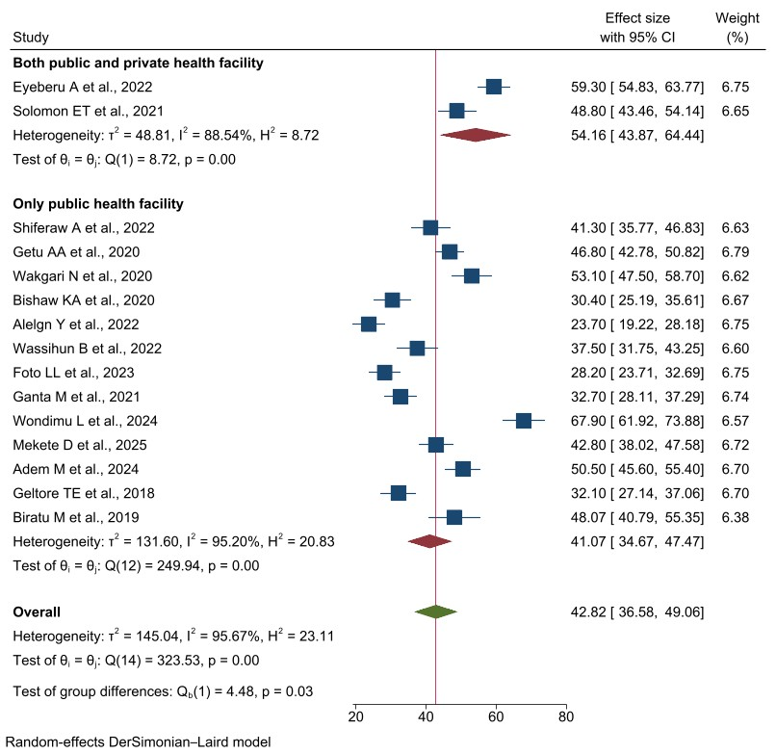

Supplementary Figure 2d: Forest plot of the subgroup analysis to assess pooled prevalence of non-pharmacological labor pain management practices based on the type of health sector in Ethiopia, 2025.
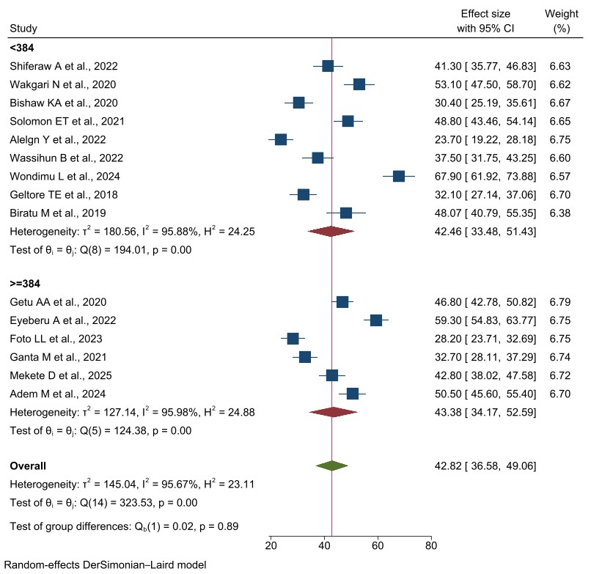
Supplementary Figure 2e: Forest plot of the subgroup analysis to assess pooled prevalence of non-pharmacological labor pain management practices based on the sample size in Ethiopia, 2025.
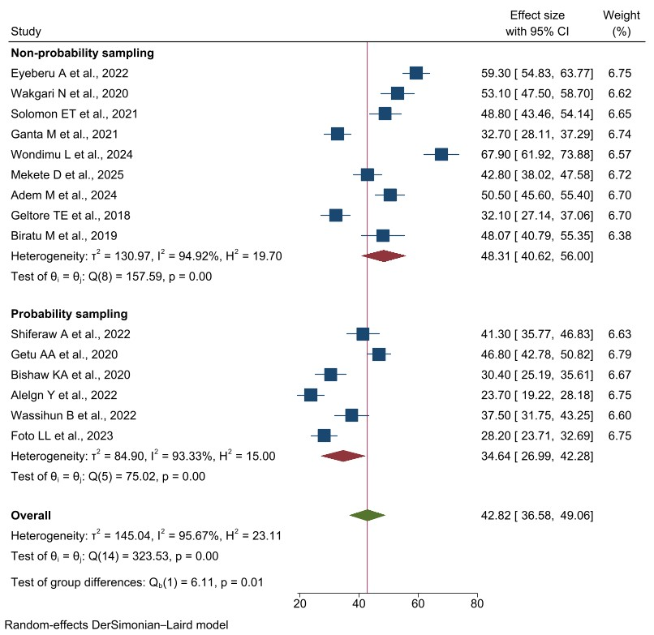
Supplementary Figure 2f: Forest plot of the subgroup analysis to assess pooled prevalence of non-pharmacological labor pain management practices based on the sampling methods in Ethiopia, 2025.
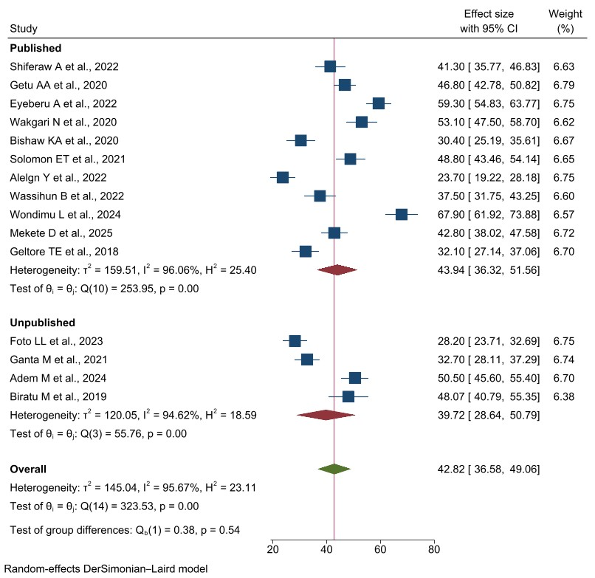
Supplementary Figure 2g: Forest plot of the subgroup analysis to assess pooled prevalence of non-pharmacological labor pain management practices based on the publication status in Ethiopia, 2025.
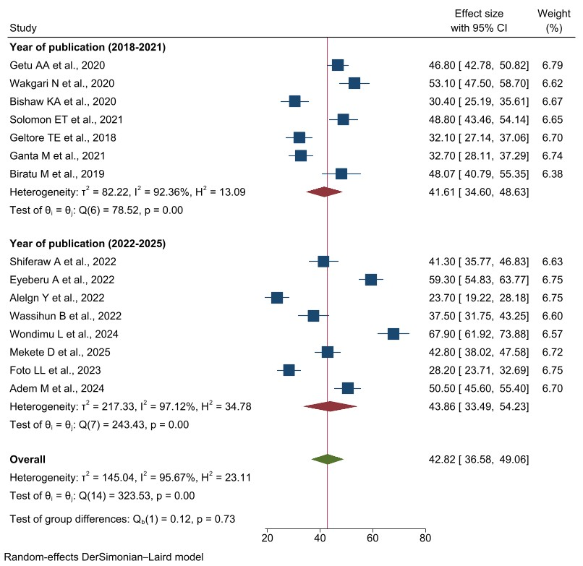
Supplementary Figure 2h: Forest plot of the subgroup analysis to assess pooled prevalence of non-pharmacological labor pain management practices based on the publication year in Ethiopia, 2025.

