Supplementary Materials for: PRDX4 Alleviates Ovarian Aging by Suppressing Endoplasmic Reticulum Stress‑Related Ferroptosis in Granulosa Cells

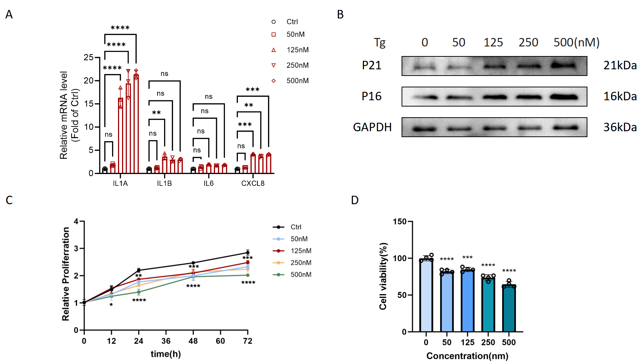
Figure S1. Model of Induced Senescence in KGN Cells. (A, B) Markers of senescence in Tg-induced senescent KGN cells. (A) KGN cells were treated with Tg at the indicated concentration for 24 h, and qPCR analysis of mRNA levels of IL1A, IL1B, IL6, and CXCL8. N = 3 for each group. (B) western blot analysis of the protein levels of P16 and P21. N = 3 for each group. (C) Optical density value of KGN cells determined by a CCK8 assay. Cells treated with Tg (0, 50, 125, 250, 500nM) for 0, 12, 24, 48 or 72 h. N = 4 wells per group. (D) Cell viability of KGN treated with D-gal for 72 h. N = 4 wells per group. Data are presented as the mean ± SD. P < 0.05 was considered statistically significant.
Figure S2. Overview of proteomic changes in normal and senescent human ovarian granulosa cells. (A) Differentially expressed proteins (DEPs) in senescent versus normal KGN cells (Q value ≤ 0.05, |log2FC| ≥ 1). (B, C) GO and KEGG pathway enrichment analysis of all DEPs in senescent versus normal KGN cells. (D) The key DEPs were visualized in a heatmap. Red represents the control group, and blue represents the senescent group. Enrichment significance was assessed using Fisher’s exact test.
Figure S3. Increased sensitivity to ferroptosis in D-gal-induced senescent KGN cells. (A) Optical density value of KGN cells determined by a CCK8 assay. Cells treated with D-gal (0, 1, 10, 50, 100mM) for 0, 12, 24, 48 or 72 h. N = 4 wells per group. (B) Cell viability of KGN treated with D-gal for 72 h. N = 4 wells per group. (C) western blot analysis of the protein levels of GPX4 and P21. N = 3 for each group. (D) MDA level in senescent KGN cells. N = 3 for each group. Data are presented as the mean ± SD. P < 0.05 was considered statistically significant.
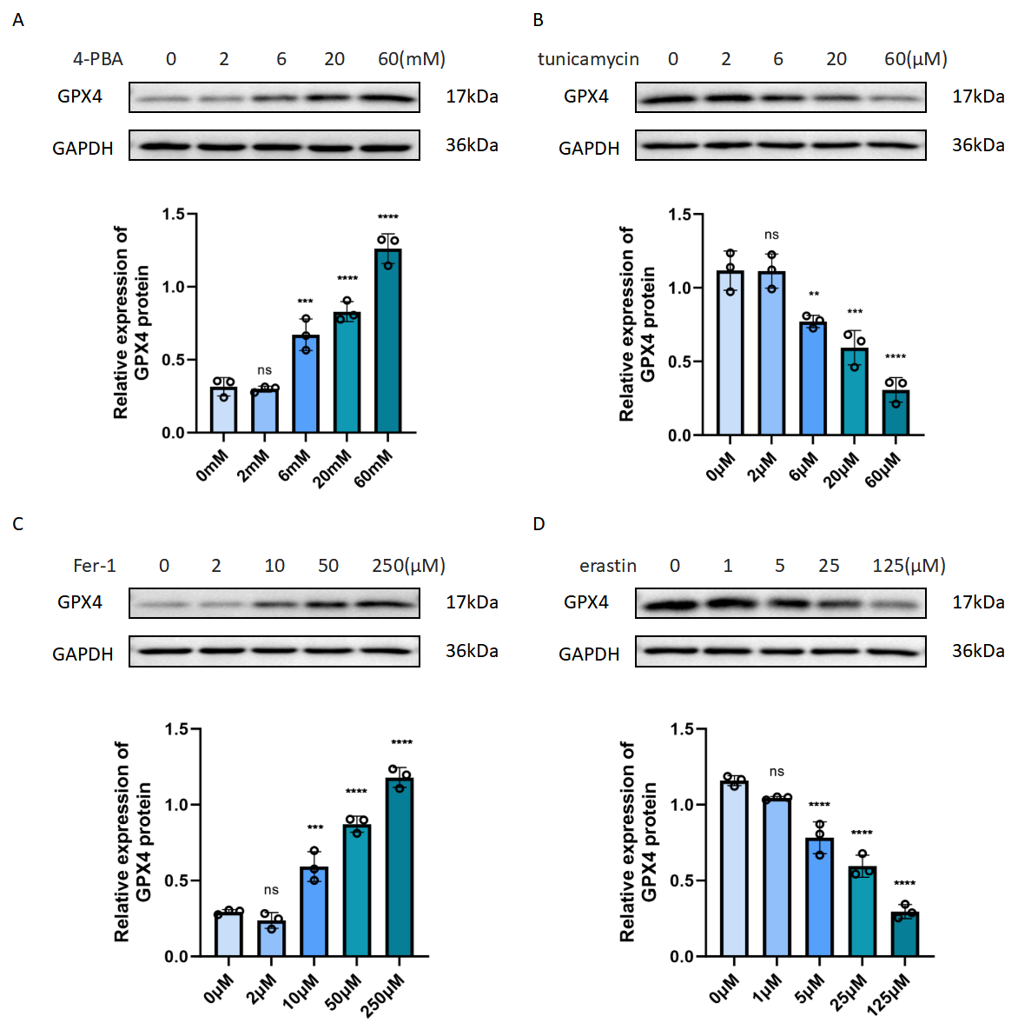
Figure S4. Optimal working concentrations of 4-PBA, tunicamycin, Fer-1, and erastin in KGN cells. (A) The expression level of GPX4 protein in KGN cells treated with different concentrations of 4-PBA (0, 2, 6, 20, 60 mM) for 24 hours was detected by Western blotting. (B) The expression level of GPX4 protein in KGN cells treated with different concentrations of tunicamycin (0, 2, 6, 20, 60 μM) for 24 hours was detected by Western blotting. (C) The expression level of GPX4 protein in KGN cells treated with different concentrations of Fer-1 (0, 2, 10, 50, 250 μM) for 24 hours was detected by Western blotting. (C) The expression level of GPX4 protein in KGN cells treated with different concentrations of erastin (0, 1, 5, 25, 125 μM) for 24 hours was detected by Western blotting. Data are presented as the mean ± SD. N = 3 for each group. P < 0.05 was considered statistically significant.

Figure S5. KGN cell lines with PRDX4 knockdown (Ad-Prdx4/siRNA) or overexpression (Ad-Prdx4) was generated using adenoviral vectors. (A) PRDX4 protein expression in KGN cells transfected with Ad-Prdx4/siRNA was detected by Western blotting. (B) PRDX4 protein expression in KGN cells transfected with Ad-Prdx4 was detected by Western blotting. Data are presented as the mean ± SD. N = 3 for each group. P < 0.05 was considered statistically significant.

