Supplemental Materials
This study performed standardized CBCT quantitative measurements to assess condylar morphometric parameters and temporomandibular joint gaps. Measured bony parameters included mediolateral condylar diameter, anteroposterior condylar diameter, condylar head height, and condylar height. Reconstructed sagittal slices were used to obtain anterior, superior, and posterior gap values for comprehensive morphological analysis (Supplementary Figure 1).
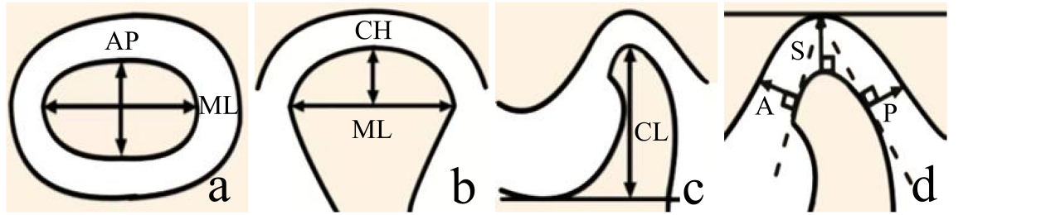
Supplementary Figure 1. Measurements of condylar morphometric parameters and joint spaces on cone-beam computed tomography (CBCT). (a) Mediolateral (ML) and anteroposterior (AP) condylar diameters. (b) Condylar head height (CH). (c) Condylar height (CL). (d) Anterior (A), superior (S), and posterior (P) joint gaps.
Condylar articular surfaces were subdivided using a dual-plane grid partitioning method to evaluate cortical bone changes following occlusal splint treatment. On coronal images, the condyle was segmented into medial, central, and lateral regions; on sagittal images, it was divided into anterior, middle, and posterior zones, producing nine subregions across the whole articular surface. Representative CBCT images were used to compare cortical bone continuity and integrity at baseline and follow-up, and condyles were classified into deterioration, stable, and improvement subgroups (Supplementary Figure 2).
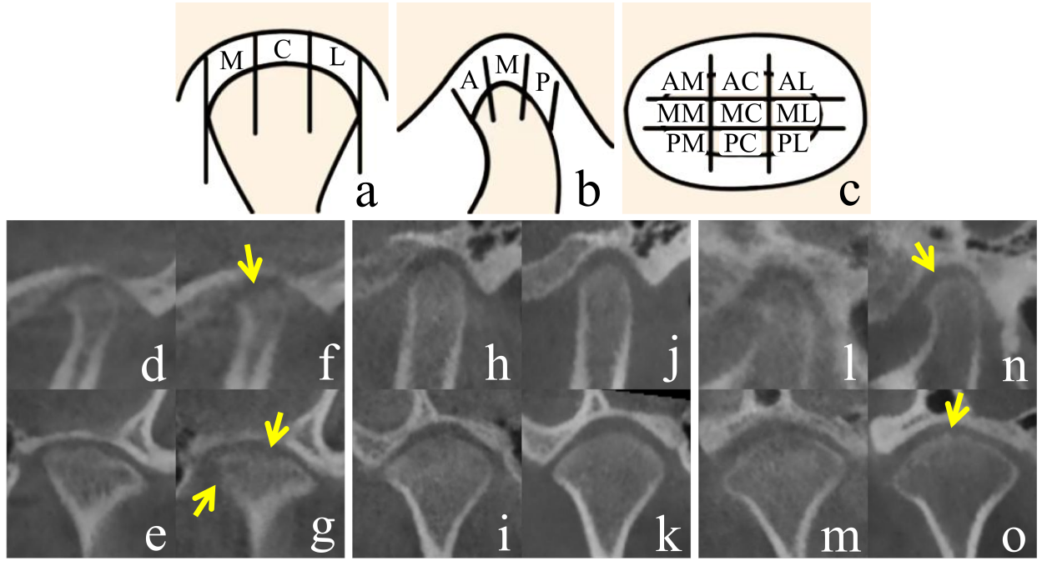
Supplementary Figure 2. (a-o) Grid partitioning method for condylar articular surface division and representative CBCT images of condylar cortical bone changes following occlusal splint treatment. (a) In the coronal view, the condyle was segmented into medial (M), central (C), and lateral (L) regions along the mediolateral axis. (b) In the sagittal view, the condyle was divided into anterior (A), middle (M), and posterior (P) regions along the anteroposterior axis. (c) This method resulted in a total of nine surface subdivisions: anterior-medial (AM), anterior-central (AC), anterior-lateral (AL), middle-medial (MM), middle-central (MC), middle-lateral (ML), posterior-medial (PM), posterior-central (PC), and posterior-lateral (PL). (d-g) Deterioration group: (d and e) Relatively continuous cortical bone lines at baseline in coronal and sagittal planes; (f and g) post-treatment images display disrupted cortical continuity and evident bone destruction. (h-k) No-change group: (h and i) Cortical bone destruction in coronal and sagittal views at baseline; (j and k) post-treatment images reveal no observable change in cortical integrity. (l-o) Improvement group: (l and m) Condylar cortical bone destruction observed in coronal and sagittal planes at baseline; (n and o) cortical bone repair evident in the same planes post-treatment.
Baseline clinical characteristics at T0 were compared between follow-up completers and dropouts. Clinical variables including age, gender, MMO, joint noises, ICL, and multiple TMD-related symptoms were analyzed, with corresponding p values calculated to evaluate potential selection bias due to participant attrition (Supplementary Table 1).

Supplementary Table 1. Comparison of baseline (T0) characteristics between completers and dropouts at the T3 assessment
Parameter | Completers  (n = 37) | Dropouts  (n = 11) | p
Age | 15.99 ± 1.83 | 15.32 ± 1.79 | 0.286
Gender (Female) | 30 | 6 | 0.113
MMO | 42.89 ± 7.60 | 49.45 ± 7.81 | 0.016*
Joint noises (positive) | 23 | 8 | 0.723
ICL (positive) | 2 | 0 | 1.000
Spontaneous pain(positive) | 12 | 3 | 1.000
Muscle pain (positive) | 3 | 1 | 1.000
Joint tenderness (positive) | 9 | 2 | 1.000
Push-back mandibular test (positive) | 3 | 3 | 0.124
Mouth opening pattern (Straight) | 26 | 8 | 1.000

