Supplementary Appendix

Comparative efficacy and safety of stem cell-based therapies for diabetes mellitus: a systematic review and Bayesian network meta-analysis of randomized controlled trials

Table of contents
Appendix 1. PRISMA 2020 Checklist of Items to Include. 2
Appendix 2: Search Strategy. 5
Appendix 3: Characteristics of included studies. 15
Appendix 4: List of data extracted from the included randomized clinical trials. 20
Appendix 5: CINeMA Assessment. 21
Appendix 6: League table for interventions derived from network Meta-analysis. 30
Appendix 7: SUCRA and cumulative probability plots. 32
Appendix 8: Assessment of inconsistency and heterogeneity in the network meta‑analysis. 33
Appendix 9: Assessment of the transitivity assumption. 36
Appendix 10: Network meta-regression according to diabetes type. 37
Appendix 11: Publication Bias Assessment. 39
Appendix 12: Sensitivity analyses. 40
Appendix 13: Convergence diagnostics and model fit assessment for the network meta‑analysis. 41

Appendix 1. PRISMA 2020 Checklist of Items to Include.
Section and Topic | Item # | Checklist item | Location where item is reported
TITLE
Title | 1 | Identify the report as a systematic review. | p. 1
ABSTRACT
Abstract | 2 | See the PRISMA 2020 for Abstracts checklist. | pp. 2-3
INTRODUCTION
Rationale | 3 | Describe the rationale for the review in the context of existing knowledge. | pp. 4-6
Objectives | 4 | Provide an explicit statement of the objective(s) or question(s) the review addresses. | p. 6
METHODS
Eligibility criteria | 5 | Specify the inclusion and exclusion criteria for the review and how studies were grouped for the syntheses. | pp. 8-9, 12-13
Information sources | 6 | Specify all databases, registers, websites, organisations, reference lists and other sources searched or consulted to identify studies. Specify the date when each source was last searched or consulted. | pp. 7-8
Search strategy | 7 | Present the full search strategies for all databases, registers and websites, including any filters and limits used. | Appendix 2, pp. 5-9
Selection process | 8 | Specify the methods used to decide whether a study met the inclusion criteria of the review, including how many reviewers screened each record and each report retrieved, whether they worked independently, and if applicable, details of automation tools used in the process. | pp. 9-10
Data collection process | 9 | Specify the methods used to collect data from reports, including how many reviewers collected data from each report, whether they worked independently, any processes for obtaining or confirming data from study investigators, and if applicable, details of automation tools used in the process. | pp. 10-11
Data items | 10a | List and define all outcomes for which data were sought. Specify whether all results that were compatible with each outcome domain in each study were sought (e.g. for all measures, time points, analyses), and if not, the methods used to decide which results to collect. | pp. 9-10; Appendix 4, p. 15
Data items | 10b | List and define all other variables for which data were sought (e.g. participant and intervention characteristics, funding sources). Describe any assumptions made about any missing or unclear information. | p. 10; Appendices 3-4, pp. 10-15
Study risk of bias assessment | 11 | Specify the methods used to assess risk of bias in the included studies, including details of the tool(s) used, how many reviewers assessed each study and whether they worked independently, and if applicable, details of automation tools used in the process. | p. 11; Figures 2-3, pp. 39-40
Effect measures | 12 | Specify for each outcome the effect measure(s) (e.g. risk ratio, mean difference) used in the synthesis or presentation of results. | p. 13
Synthesis methods | 13a | Describe the processes used to decide which studies were eligible for each synthesis (e.g. tabulating the study intervention characteristics and comparing against the planned groups for each synthesis (item #5)). | pp. 8-9, 12-13
Synthesis methods | 13b | Describe any methods required to prepare the data for presentation or synthesis, such as handling of missing summary statistics, or data conversions. | pp. 10-12; Appendix 4, p. 15
Synthesis methods | 13c | Describe any methods used to tabulate or visually display results of individual studies and syntheses. | pp. 13-14; Figures 4-6, pp. 41-44; Appendices 6-7, pp. 26-27
Synthesis methods | 13d | Describe any methods used to synthesize results and provide a rationale for the choice(s). If meta-analysis was performed, describe the model(s), method(s) to identify the presence and extent of statistical heterogeneity, and software package(s) used. | pp. 11-15; Appendix 13, pp. 37-38
Synthesis methods | 13e | Describe any methods used to explore possible causes of heterogeneity among study results (e.g. subgroup analysis, meta-regression). | pp. 14-15; Appendices 8-10, pp. 28-33
Synthesis methods | 13f | Describe any sensitivity analyses conducted to assess robustness of the synthesized results. | pp. 14-15; Appendix 12, p. 35
Reporting bias assessment | 14 | Describe any methods used to assess risk of bias due to missing results in a synthesis (arising from reporting biases). | p. 15; Appendix 11, p. 34
Certainty assessment | 15 | Describe any methods used to assess certainty (or confidence) in the body of evidence for an outcome. | p. 11; Appendix 5, pp. 16-25
RESULTS
Study selection | 16a | Describe the results of the search and selection process, from the number of records identified in the search to the number of studies included in the review, ideally using a flow diagram. | pp. 15-16; Figure 1, p. 38
Study selection | 16b | Cite studies that might appear to meet the inclusion criteria, but which were excluded, and explain why they were excluded. | Figure 1, p. 38
Study characteristics | 17 | Cite each included study and present its characteristics. | pp. 15-16; Appendix 3, pp. 10-14
Risk of bias in studies | 18 | Present assessments of risk of bias for each included study. | pp. 16-17; Figures 2-3, pp. 39-40
Results of individual studies | 19 | For all outcomes, present, for each study: (a) summary statistics for each group (where appropriate) and (b) an effect estimate and its precision (e.g. confidence/credible interval), ideally using structured tables or plots. | Not reported
Results of syntheses | 20a | For each synthesis, briefly summarise the characteristics and risk of bias among contributing studies. | pp. 16-20; Appendix 3, pp. 10-14; Figures 2-3, pp. 39-40
Results of syntheses | 20b | Present results of all statistical syntheses conducted. If meta-analysis was done, present for each the summary estimate and its precision (e.g. confidence/credible interval) and measures of statistical heterogeneity. If comparing groups, describe the direction of the effect. | pp. 17-23; Figures 5-6, pp. 43-44; Appendices 6-12, pp. 26-35
Results of syntheses | 20c | Present results of all investigations of possible causes of heterogeneity among study results. | pp. 20-22; Appendices 8-10, pp. 28-33
Results of syntheses | 20d | Present results of all sensitivity analyses conducted to assess the robustness of the synthesized results. | pp. 22-23; Appendix 12, p. 35
Reporting biases | 21 | Present assessments of risk of bias due to missing results (arising from reporting biases) for each synthesis assessed. | p. 23; Appendix 11, p. 34
Certainty of evidence | 22 | Present assessments of certainty (or confidence) in the body of evidence for each outcome assessed. | pp. 16-20, 23; Appendix 5, pp. 16-25
DISCUSSION
Discussion | 23a | Provide a general interpretation of the results in the context of other evidence. | pp. 23-28
Discussion | 23b | Discuss any limitations of the evidence included in the review. | pp. 28-29
Discussion | 23c | Discuss any limitations of the review processes used. | pp. 28-29
Discussion | 23d | Discuss implications of the results for practice, policy, and future research. | pp. 27-30
OTHER INFORMATION
Registration and protocol | 24a | Provide registration information for the review, including register name and registration number, or state that the review was not registered. | p. 7
Registration and protocol | 24b | Indicate where the review protocol can be accessed, or state that a protocol was not prepared. | p. 7 (PROSPERO record)
Registration and protocol | 24c | Describe and explain any amendments to information provided at registration or in the protocol. | No amendments.
Support | 25 | Describe sources of financial or non-financial support for the review, and the role of the funders or sponsors in the review. | p. 32
Competing interests | 26 | Declare any competing interests of review authors. | p. 32
Availability of data, code and other materials | 27 | Report which of the following are publicly available and where they can be found: template data collection forms; data extracted from included studies; data used for all analyses; analytic code; any other materials used in the review. | p. 32

PRISMA NMA Checklist of Items to Include When Reporting A Systematic Review Involving a Network Meta-analysis

Section/Topic | Item # | Checklist Item | Reported on Page #
TITLE
Title | 1 | Identify the report as a systematic review incorporating a network meta-analysis (or related form of meta-analysis). | p. 1
ABSTRACT
Structured summary | 2 | Provide a structured summary including, as applicable:  Background: main objectives  Methods: data sources; study eligibility criteria, participants, and interventions; study appraisal; and synthesis methods, such as network meta-analysis.  Results: number of studies and participants identified; summary estimates with corresponding confidence/credible intervals; treatment rankings may also be discussed. Authors may choose to summarize pairwise comparisons against a chosen treatment included in their analyses for brevity.  Discussion/Conclusions: limitations; conclusions and implications of findings.  Other: primary source of funding; systematic review registration number with registry name. | pp. 2-3 (funding and registration are not reported in the abstract)
INTRODUCTION
Rationale | 3 | Describe the rationale for the review in the context of what is already known, including mention of why a network meta-analysis has been conducted. | pp. 4-7
Objectives | 4 | Provide an explicit statement of questions being addressed, with reference to participants, interventions, comparisons, outcomes, and study design (PICOS). | p. 6
METHODS
Protocol and registration | 5 | Indicate whether a review protocol exists and if and where it can be accessed (e.g., Web address); and, if available, provide registration information, including registration number. | p. 7
Eligibility criteria | 6 | Specify study characteristics (e.g., PICOS, length of follow-up) and report characteristics (e.g., years considered, language, publication status) used as criteria for eligibility, giving rationale. Clearly describe eligible treatments included in the treatment network, and note whether any have been clustered or merged into the same node (with justification). | pp. 8-9, 12-13
Information sources | 7 | Describe all information sources (e.g., databases with dates of coverage, contact with study authors to identify additional studies) in the search and date last searched. | pp. 7-8, 10-11
Search | 8 | Present full electronic search strategy for at least one database, including any limits used, such that it could be repeated. | Appendix 2, pp. 5-9 (Supplementary file)
Study selection | 9 | State the process for selecting studies (i.e., screening, eligibility, included in systematic review, and, if applicable, included in the meta-analysis). | pp. 9-10; Figure 1, p. 38
Data collection process | 10 | Describe method of data extraction from reports (e.g., piloted forms, independently, in duplicate) and any processes for obtaining and confirming data from investigators. | pp. 10-11
Data items | 11 | List and define all variables for which data were sought (e.g., PICOS, funding sources) and any assumptions and simplifications made. | p. 10; Appendices 3-4, pp. 10-15 (Supplementary file)
Geometry of the network | S1 | Describe methods used to explore the geometry of the treatment network under study and potential biases related to it. This should include how the evidence base has been graphically summarized for presentation, and what characteristics were compiled and used to describe the evidence base to readers. | pp. 12-14; Figure 4, pp. 41-42
Risk of bias within individual studies | 12 | Describe methods used for assessing risk of bias of individual studies (including specification of whether this was done at the study or outcome level), and how this information is to be used in any data synthesis. | p. 11; Figures 2-3, pp. 39-40
Summary measures | 13 | State the principal summary measures (e.g., risk ratio, difference in means). Also describe the use of additional summary measures assessed, such as treatment rankings and surface under the cumulative ranking curve (SUCRA) values, as well as modified approaches used to present summary findings from meta-analyses. | pp. 13-14; Figure 5, p. 43; Appendix 7, p. 27
Planned methods of analysis | 14 | Describe the methods of handling data and combining results of studies for each network meta-analysis. This should include, but not be limited to:  - Handling of multi-arm trials;  - Selection of variance structure;  - Selection of prior distributions in Bayesian analyses; and  - Assessment of model fit. | pp. 12-15; Appendix 13, pp. 37-38
Assessment of Inconsistency | S2 | Describe the statistical methods used to evaluate the agreement of direct and indirect evidence in the treatment network(s) studied. Describe efforts taken to address its presence when found. | p. 14; Appendix 8, pp. 28-30
Risk of bias across studies | 15 | Specify any assessment of risk of bias that may affect the cumulative evidence (e.g., publication bias, selective reporting within studies). | pp. 11, 15; Figures 2-3, pp. 39-40; Appendix 11, p. 34
Additional analyses | 16 | Describe methods of additional analyses if done, indicating which were pre-specified. This may include, but not be limited to, the following:  - Sensitivity or subgroup analyses;  - Meta-regression analyses;  - Alternative formulations of the treatment network; and  - Use of alternative prior distributions for Bayesian analyses (if applicable). | pp. 14-15; Appendices 10 and 12, pp. 32-35
RESULTS†
Study selection | 17 | Give numbers of studies screened, assessed for eligibility, and included in the review, with reasons for exclusions at each stage, ideally with a flow diagram. | pp. 15-16; Figure 1, p. 38
Presentation of network structure | S3 | Provide a network graph of the included studies to enable visualization of the geometry of the treatment network. | Figure 4, pp. 41-42
Summary of network geometry | S4 | Provide a brief overview of characteristics of the treatment network. This may include commentary on the abundance of trials and randomized patients for the different interventions and pairwise comparisons in the network, gaps of evidence in the treatment network, and potential biases reflected by the network structure. | pp. 17-20, 27; Figure 4, pp. 41-42
Study characteristics | 18 | For each study, present characteristics for which data were extracted (e.g., study size, PICOS, follow-up period) and provide the citations. | pp. 15-16; Appendix 3, pp. 10-14
Risk of bias within studies | 19 | Present data on risk of bias of each study and, if available, any outcome level assessment. | pp. 16-17; Figures 2-3, pp. 39-40
Results of individual studies | 20 | For all outcomes considered (benefits or harms), present, for each study: 1) simple summary data for each intervention group, and 2) effect estimates and confidence intervals. Modified approaches may be needed to deal with information from larger networks. | Not reported
Synthesis of results | 21 | Present results of each meta-analysis done, including confidence/credible intervals. In larger networks, authors may focus on comparisons versus a particular comparator (e.g. placebo or standard care), with full findings presented in an appendix. League tables and forest plots may be considered to summarize pairwise comparisons. If additional summary measures were explored (such as treatment rankings), these should also be presented. | pp. 17-23; Figures 5-6, pp. 43-44; Appendices 6-7, pp. 26-27
Exploration for inconsistency | S5 | Describe results from investigations of inconsistency. This may include such information as measures of model fit to compare consistency and inconsistency models, P values from statistical tests, or summary of inconsistency estimates from different parts of the treatment network. | pp. 20-21; Appendix 8, pp. 28-30
Risk of bias across studies | 22 | Present results of any assessment of risk of bias across studies for the evidence base being studied. | p. 23; Appendix 11, p. 34
Results of additional analyses | 23 | Give results of additional analyses, if done (e.g., sensitivity or subgroup analyses, meta-regression analyses, alternative network geometries studied, alternative choice of prior distributions for Bayesian analyses, and so forth). | pp. 21-23; Appendices 10 and 12, pp. 32-35
DISCUSSION
Summary of evidence | 24 | Summarize the main findings, including the strength of evidence for each main outcome; consider their relevance to key groups (e.g., healthcare providers, users, and policy-makers). | pp. 23-29
Limitations | 25 | Discuss limitations at study and outcome level (e.g., risk of bias), and at review level (e.g., incomplete retrieval of identified research, reporting bias). Comment on the validity of the assumptions, such as transitivity and consistency. Comment on any concerns regarding network geometry (e.g., avoidance of certain comparisons). | pp. 21, 27-29
Conclusions | 26 | Provide a general interpretation of the results in the context of other evidence, and implications for future research. | pp. 23-30
FUNDING
Funding | 27 | Describe sources of funding for the systematic review and other support (e.g., supply of data); role of funders for the systematic review. This should also include information regarding whether funding has been received from manufacturers of treatments in the network and/or whether some of the authors are content experts with professional conflicts of interest that could affect use of treatments in the network. | p. 32

PICOS = population, intervention, comparators, outcomes, study design.
* Text in italics indicateS wording specific to reporting of network meta-analyses that has been added to guidance from the PRISMA statement.
† Authors may wish to plan for use of appendices to present all relevant information in full detail for items in this section.

Appendix 2: Search Strategy.
PubMed
Search terms/strategy | No of hits
("Diabetes Mellitus"[MeSH Terms] OR diabetes mellitus[tiab] OR diabetes[tiab]) OR(" Diabetes Mellitus, Type 1 "[MeSH Terms] OR "type 1 diabetes"[tiab] OR T1DM[tiab] OR "Type 1 Diabetes Mellitus"[tiab]OR "Insulin-Dependent Diabetes Mellitus"[tiab]) OR "Diabetes Mellitus, Type 2"[MeSH Terms] OR "type 2 diabetes"[tiab] OR T2DM[tiab] OR NIDDM[tiab]) | 936,482
("Stem Cell*" OR "Progenitor Cell*" OR "Mesenchymal Stem Cell*"[tiab] OR "Mesenchymal Stromal Cell*"[tiab] OR "Mesenchymal Progenitor Cell*"[tiab] OR "Hematopoietic Stem Cell*" OR " Mesenchymal Precursor Cell*"[tiab] OR "bone marrow mononuclear cell*"[tiab] OR "peripheral blood mononuclear cell*"[tiab]) | 671,310
(Randomized Controlled Trial[pt] OR randomized[tiab] OR randomised[tiab] OR randomly[tiab] OR placebo[tiab] OR trial[tiab] OR controlled clinical trial[pt]) | 2,035,512
((( "Diabetes Mellitus"[MeSH Terms] OR diabetes mellitus[tiab] OR diabetes[tiab] ) OR ( " Diabetes Mellitus, Type 1 "[MeSH Terms] OR "type 1 diabetes"[tiab] OR T1DM[tiab] OR "Type 1 Diabetes Mellitus"[tiab] OR "Insulin-Dependent Diabetes Mellitus"[tiab] ) OR ( "Diabetes Mellitus, Type 2"[MeSH Terms] OR "type 2 diabetes"[tiab] OR T2DM[tiab] OR NIDDM[tiab] )) AND (("Stem Cell*" OR "Progenitor Cell*" OR "Mesenchymal Stem Cell*"[tiab] OR "Mesenchymal Stromal Cell*"[tiab] OR "Mesenchymal Progenitor Cell*"[tiab] OR "Hematopoietic Stem Cell*" OR " Mesenchymal Precursor Cell*"[tiab] OR "bone marrow mononuclear cell*"[tiab] OR "peripheral blood mononuclear cell*"[tiab]))) AND ((Randomized Controlled Trial[pt] OR randomized[tiab] OR randomised[tiab] OR randomly[tiab] OR placebo[tiab] OR trial[tiab] OR controlled clinical trial[pt])) | 930

WOS
Search terms/strategy | No of hits
#1  TS=(("Diabetes Mellitus" OR diabetes mellitus OR diabetes) OR ("Diabetes Mellitus, Type 1" OR "type 1 diabetes" OR T1DM OR "Type 1 Diabetes Mellitus" OR "Insulin-Dependent Diabetes Mellitus") OR ("Diabetes Mellitus, Type 2" OR "type 2 diabetes" OR T2DM OR NIDDM)) | 364,773
#2  TS=("Stem Cell*" OR "Progenitor Cell*" OR "Mesenchymal Stem Cell*" OR "Mesenchymal Stromal Cell*" OR "Mesenchymal Progenitor Cell*" OR "Hematopoietic Stem Cell*" OR "Mesenchymal Precursor Cell*" OR "bone marrow mononuclear cell*" OR "peripheral blood mononuclear cell*") | 755,092
#3  TS=("Randomized Controlled Trial" OR randomized OR randomised OR randomly OR placebo OR trial OR "controlled clinical trial") | 3,221,685
#4  #1 AND #2 AND #3 | 741

EMBASE
Search terms/strategy | No of hits
#1  (("Diabetes Mellitus"/exp OR "Diabetes Mellitus":ti,ab OR diabetes mellitus:ti,ab OR diabetes:ti,ab) OR ("Diabetes Mellitus, Type 1"/exp OR "Diabetes Mellitus, Type 1":ti,ab OR "type 1 diabetes":ti,ab OR T1DM:ti,ab OR "Type 1 Diabetes Mellitus":ti,ab OR "Insulin-Dependent Diabetes Mellitus":ti,ab) OR ("Diabetes Mellitus, Type 2"/exp OR "Diabetes Mellitus, Type 2":ti,ab OR "type 2 diabetes":ti,ab OR T2DM:ti,ab OR NIDDM:ti,ab)) | 1,381,665
#2  ("Stem Cell*"/exp OR "Stem Cell*":ti,ab OR "Progenitor Cell*":ti,ab OR "Mesenchymal Stem Cell*":ti,ab OR "Mesenchymal Stromal Cell*":ti,ab OR "Mesenchymal Progenitor Cell*":ti,ab OR "Hematopoietic Stem Cell*":ti,ab OR "Mesenchymal Precursor Cell*":ti,ab OR "bone marrow mononuclear cell*":ti,ab OR "peripheral blood mononuclear cell*":ti,ab) | 1,056,145
#3  ("Randomized Controlled Trial"/exp OR "randomized":ti,ab OR "randomised":ti,ab OR "randomly":ti,ab OR "placebo":ti,ab OR "trial":ti,ab OR "controlled clinical trial":ti,ab) | 3,136,568
#4  #1 AND #2 AND #3 | 1,881
#5  #4 NOT ("animal"/exp NOT "human"/exp) | 1,594

Cochrane library
Search terms/strategy | No of hits
#1 Diabetes Mellitus | 95,013
#2 "Diabetes Mellitus, Type 1":ti,ab,kw OR "type 1 diabetes":ti,ab,kw OR T1DM:ti,ab,kw OR "Type 1 Diabetes Mellitus":ti,ab,kw OR "Insulin-Dependent Diabetes Mellitus":ti,ab,kw | 37,436
#3 "Diabetes Mellitus, Type 2":ti,ab,kw OR "type 2 diabetes":ti,ab,kw OR T2DM:ti,ab,kw OR NIDDM:ti,ab,kw | 59,143
#4 #1 OR #2 OR #3 | 102,810
#5 Stem Cell* | 19,351
#6 Stem Cell*:ti,ab,kw OR Progenitor Cell*:ti,ab,kw OR Mesenchymal Stem Cell*:ti,ab,kw OR Mesenchymal Stromal Cell*:ti,ab,kw OR Mesenchymal Progenitor Cell*:ti,ab,kw OR Hematopoietic Stem Cell*:ti,ab,kw OR Mesenchymal Precursor Cell*:ti,ab,kw OR bone marrow mononuclear cell*:ti,ab,kw OR peripheral blood mononuclear cell*:ti,ab,kw | 24,767
#7 Randomized Controlled Trial | 1,250,307
#8 randomized:ti,ab,kw OR randomised:ti,ab,kw OR randomly:ti,ab,kw OR placebo:ti,ab,kw OR trial:ti,ab,kw OR "controlled clinical trial":ti,ab,kw | 1,704,774
#9 #4 AND (#5 OR #6) AND (#7 OR #8) | 699

ClinicalTrials.gov
Search terms/strategy | No of hits
("stem cell*" OR "progenitor cell*" OR "mesenchymal stem cell*" OR "mesenchymal stromal cell*" OR "mesenchymal progenitor cell*" OR "hematopoietic stem cell*" OR "mesenchymal precursor cell*" OR "bone marrow mononuclear cell*" OR "peripheral blood mononuclear cell*") | Diabetes | 243

Appendix 3: Characteristics of included reports and corresponding randomized controlled trials.
NO. | First author | Publish year | Study ID | Nation | Phase | Registered number | Sample size | Type of DM | Follow up period (months)
N0.1 | Zhixian Wu | 2024 | Zhixian Wu2024 | China | Phase 1/2 | NCT01719640 | 96 | T2DM | 96
N0.2 | Norberto Perico | 2023 | Norberto Perico2023 | Ireland, Italy and UK | Phase 1b/2a | NCT02585622 | 16 | T2DM | 18
N0.3 | Per-Ola Carlsson | 2023 | Per-Ola Carlsson2023 | Sweden | Phase 1/2 | NCT03406585 | 15 | T1DM | 12
N0.4 | Li Zang | 2022 | Li Zang2022 | China | Phase 2 | NCT02302599 | 91 | T2DM | 12
N0.5 | Zhixian Wu | 2022 | Zhixian Wu2022 | China | Phase 1/2 | NCT01374854 | 42 | T1DM | 96
N0.6 | Mahmoud Izadi | 2022 | Mahmoud Izadi2022 | Iran | Phase 1/2 | NCT04078308 | 21 | T1DM | 12
N0.7 | Mahboubeh Mirzaei | 2021 | Mahboubeh Mirzaei2021 | Iran | Phase 3 | IRCT20190517043609N1 | 20 | NM | 6
N0.8 | Esteban J. Estrada | 2019 | Esteban J. Estrada2019 | Argentina | Phase 1/2 | NCT03343782 | 23 | T2DM | 12
N0.9 | Vikas Sood | 2017 | Vikas Sood2017 | India | Phase 2/3 | NCT01694173 | 28 | T2DM | 6
N0.10 | Shobhit Bhansali | 2016 | Shobhit Bhansali2016 | India | Phase 2/3 | NCT01759823 | 30 | T2DM | 12
N0.11 | David K. Packham | 2016 | David K. Packham2016 | Australia | Phase 1/2 | NCT01843387 | 30 | T2DM | 3
N0.12 | Jianxia Hu | 2016 | Jianxia Hu2016 | China | Phase 1/2 | / | 61 | T2DM | 36
N0.13 | Jinquan Cai | 2016 | Jinquan Cai2016 | China | Phase 1/2 | NCT01374854 | 42 | T1DM | 12
N0.14 | Jay S. Skyler | 2015 | Jay S. Skyler2015 | USA | Phase 1/2 | NCT01576328 | 61 | T2DM | 3
N0.15 | Ensieh Nasli-Esfahani | 2015 | Ensieh Nasli-Esfahani2015 | Iran | / | IRCT138811071414N10 | 56 | Both | 36
N0.16 | Per-Ola Carlsson | 2015 | Per-Ola Carlsson2015 | Sweden | / | NCT01068951 | 18 | T1DM | 12
N0.17 | Anil Bhansali | 2014 | Anil Bhansali2014 | India | / | / | 21 | T2DM | 12
N0.18 | Jianxia Hu | 2013 | Jianxia Hu2013 | China | / | / | 19 | T1DM | 21
N0.19 | Michael J. Haller | 2013 | Michael J. Haller2013 | USA | Phase 1 | NCT00873925 | 15 | T1DM | 12
N0.20 | Maryam Ghodsi | 2012 | Maryam Ghodsi2012 | Iran | / | / | 56 | Both | 12
N0.21 | Pingping Huang | 2005 | Pingping Huang2005 | China | / | / | 28 | Both | 3

Appendix 3. (Continued)
NO. | Interventions | Stem cell count | Route of administration | Sample-size | Baseline
 |  |  |  |  | Duration since diagnosis  (years) | Age  (years) | BMI  (kg/m²) | HbA_{1c}  (%) | FPG  (mmol/L) | Fasting C-peptide  (nmol/L) | TDD  (U/kg/day)
N0.1 | auto BM-MSC+auto BM-MNC | 1 million cells/kg 2 doses+512.6 million cells/kg | IA (dorsal pancreatic artery)+IV | 33 | 8.9±4.2 | 52.8±4.5 | 25.2±2.1 | 8.6±1.1 | 8.79±1.80 | 0.40±0.11 | 0.68±0.21
N0.1 | auto BM-MNC | 496.1million cells/kg | IV | 32 | 8.6±5.3 | 53.2±6.1 | 25.6±3.2 | 8.7±1.2 | 9.02±1.64 | 0.43±0.12 | 0.64±0.19
N0.1 | SMT | / | / | 31 | 9.1±4.8 | 54.6±5.0 | 25.3±2.6 | 8.7±1.0 | 8.66±2.11 | 0.43±0.11 | 0.71±0.23
N0.2 | allo BM-MSC | 80 million | IV (a peripheral arm vein) | 12 | >3 | 69(66–73) | NA | 7.10(6.51–8.26) | 7.28(6.50–8.78) | NA | NA
N0.2 | placebo | / | IV (a peripheral arm vein) | 4 | >3 | 59(54–66) | NA | 7.28(6.29–8.14) | 10.17(7.67–11.94) | NA | NA
N0.3 | allo UC-MSC | 200 million | IV | 10 | 1.0±0.7 | 31±4 | 24.2±2.9 | 6.5±1.4 | 6.3±1.5 | 0.32±0.19 | 0.23±0.09
N0.3 | placebo | / | IV | 5 | 1.0±0.3 | 31±9 | 23.5±2.2 | 6.6±0.7 | 6.3±1.4 | 0.16±0.05 | 0.46±0.20
N0.4 | allo UC-MSC | 1×10 million cells/kg 3 doses | IV (at the elbow joint) | 45 | 11.44 ± 4.78 | 50.00 ± 9.38 | 28.69 ± 3.35 | 9.02 ± 1.27 | 8.71 ± 2.16 | 0.67±0.23 | 0.72 ± 0.20
N0.4 | placebo | / | IV (at the elbow joint) | 46 | 11.70 ± 3.96 | 50.45 ± 8.03 | 28.13 ± 3.04 | 8.89 ± 1.11 | 8.58 ± 1.93 | 0.64±0.22 | 0.71 ± 0.15
N0.5 | allo UC-MSC + auto BM-MNC | 1.1 million cells/kg+6100 million cells/kg | IA (dorsal pancreatic artery) | 21 | 16.50±4.65 | 34.21±5.18 | 21.91±1.82 | 8.57±0.97 | 11.10±3.29 | 0.03±0.02 | 0.90±0.24
N0.5 | SMT | / | / | 21 | 15.40±3.38 | 35.47±5.82 | 22.25±2.46 | 8.54±0.94 | 10.88±2.11 | 0.05±0.02 | 0.88±0.22
N0.6 | auto BM-MSC | 1 million cells/kg 2 doses | IV | 11 | NA | 10.27±1.67 | 16.75±2.57 | 8.63±2.19 | 9.18±5.42 | 0.24±0.13 | 0.78±0.44
N0.6 | placebo | / | IV | 10 | NA | 11.50±2.63 | 18.91±3.41 | 7.85±1.45 | 8.3±2.89 | 0.31±0.19 | 0.71±0.30
N0.7 | auto oral mucosa MSC | 50-60 million | intracavernosal injection | 10 | 10.4±3.5 | 63.8±7.4 | NA | NA | NA | NA | NA
N0.7 | placebo | / | intracavernosal injection | 10 | 10.1±3.1 | 65.6±5.1 | NA | NA | NA | NA | NA
N0.8 | auto BM-MNC | NM | IA (dorsal pancreatic artery) | 13 | 5-15 | 59±9 | 27.0+4.0 | 8.30±0.67 | 9.75±2.03 | 0.48±0.20 | NA
N0.8 | SMT | / | / | 10 | 5-15 | 59±6 | 23.1+2.5 | 8.50±0.69 | 10.76±1.50 | 0.34±0.23 | NA
N0.9 | auto BM-MNC | 4.9 ± 3.10 × 10^8 | IA (pancreaticoduodenal artery) | 7 | 19.5±5.54 | 57.83±5.84 | 28.83±4.26 | 6.8±0.48 | 5.92±2.12 | 0.98±1.32 | NA
N0.9 | auto BM-MNC | 12.04 ± 4.84 × 10^8 | IA (splenic artery) | 7 | 14.28±6.77 | 49.85±9.63 | 26.57±2.63 | 6.4±0.42 | 5.74±2.49 | 0.42±0.13 | NA
N0.9 | auto BM-MNC | 6.88±2.30×10^8 | IV (peripheral intravenous route) | 7 | 14.28±5.64 | 53.28±7.29 | 26.85±3.97 | 6.7±0.40 | 4.98±1.35 | 0.47±0.21 | NA
N0.9 | placebo | / | sham procedure | 7 | 19.6±6.4 | 55.7±7.7 | 29.6±1.9 | 6.6±0.63 | 5.74±0.87 | 0.36±0.19 | NA
N0.10 | auto BM-MSC | 1×10^9/kg | IA (superior pancreatico-duodenal (SPD)) | 10 | 15.0(8.0-22.8) | 50.5(36.0-58.0) | 28.1(26.5-31.6) | 6.9(6.6-7.0) | 5.8 (5.3-6.2) | 0.4(0.3-0.4) | NA
N0.10 | auto BM-MNC | 1×10^9 | IA (superior pancreatico-duodenal (SPD)) | 10 | 13.0(8.5-15.0) | 44.5(39.5-49.8) | 28.9(25.0-30.2) | 6.7(6.4 -7.3) | 6.3(5.5-6.4) | 0.5(0.4-0.6) | NA
N0.10 | placebo | / | sham procedure | 10 | 14.0(9.0-15.0) | 53.5(43.3-58.8) | 25.7(24.5-28.9) | 6.5(6.2-6.8) | 6.0(5.5-6.7) | 0.5(0.4-0.7) | NA
N0.11 | allo BM-MPC | 150 million cells | IV | 10 | NA | 70.5±7.4 | 32.7±6.2 | 7.5±1.2 | NA | NA | NA
N0.11 | allo BM-MPC | 300 million | IV | 10 | NA | 64.8±10.1 | 34.2±5.9 | 7.9±2.1 | NA | NA | NA
N0.11 | placebo | / | IV | 10 | NA | 74.8±7.9 | 30.3±6.4 | 6.8±1.3 | NA | NA | NA
N0.12 | allo UC-MSC | 1 million cells/kg 2doses | IV (infused through the veins in the back of the hand) | 31 | 8.93±5.67 | 52.43±4.88 | 26.74±5.41 | 7.67±1.23 | 8.24±1.55 | 0.58±0.21 | 0.79±0.23
N0.12 | placebo | / | IV (infused through the veins in the back of the hand) | 30 | 8.3±6.07 | 53.21±8.22 | 27.03±6.68 | 7.54±1.31 | 7.91±1.44 | 0.61±0.20 | 0.74±0.19
N0.13 | allo UC-MSC + auto BM-MNC | 1.0million cells/kg+106.8 million cells/kg | IA (dorsal pancreatic artery) | 21 | 9.24±4.75 | NA | 21.99±1.78 | 8.6±0.81 | 11.11±2.84 | 0.03±0.02 | 0.9±0.2
N0.13 | SMT | / | / | 21 | 7.00±3.26 | NA | 22.06±2.46 | 8.7±0.90 | 10.69±1.96 | 0.02±0.02 | 0.9±0.2
N0.14 | allo BM-MPC | 0.3×10^6/kg | IV | 15 | 10.8±7.3 | 57.7±8.2 | 34.8±6.5 | 8.3±0.8 | 10.8±3.7 | NA | NA
N0.14 | allo BM-MPC | 1.0×10^6/kg | IV | 15 | 10.2±5.7 | 55.3±11.4 | 34.4±4.7 | 8.6±1.1 | 11.0±1.7 | NA | NA
N0.14 | allo BM-MPC | 2.0×10^6/kg | IV | 15 | 9.6±4.5 | 55.3±11.4 | 32.4±4.5 | 7.9±1.1 | 9.2±2.2 | NA | NA
N0.14 | placebo | / | IV | 16 | 9.8±6.7 | 58.7±7.3 | 32.6±6.2 | 8.2±0.8 | 10.2±3.2 | NA | NA
N0.15 | allo HSC | 35-55 million | IV | 28 | 5.19±2.52 | 35.92±16.81 | NA | 10.10±1.94 | NA | NA | NA
N0.15 | placebo | / | IV | 28 | 4.87±3.12 | 29.79±15.48 | NA | 9.80±1.45 | NA | NA | NA
N0.16 | autoBM-MSC | 2.1-3.6 million cells/kg | IV | 9 | NA | 24±6 | 23.3±3.3 | 6.5±1.2 | NA | 0.29±0.15 | 0.43±0.15
N0.16 | SMT | / | / | 9 | NA | 27±6 | 22.5±2.7 | 6.9±1.2 | NA | 0.28±0.06 | 0.39±0.39
N0.17 | auto BM MNC | 2.9 (2.2–3.8)×10^8 | IA | 11 | 12.0(10.0-15.5) | 51.0(46.5-56.0) | 28.5(26.3-30.3) | 6.9(6.4-7.1) | 5.25(4.87-5.74) | 0.23(0.10-0.40) | NA
N0.17 | placebo | / | IA | 10 | 20.0(16.3-20.8) | 54.0(52.5-55.8) | 28.9(26.3-30.3) | 6.9(6.2-7.0) | 5.72(5.27-6.24) | 0.40(0.23-0.53) | NA
N0.18 | allo UC-MSC | (2.6±1.2)×10^7*2 | IV | 15 | New onset | 17.6±33.70 | 20.9±14.33 | 6.85±0.74 | 5.7±1.71 | NA | NA
N0.18 | placebo | / | IV | 14 | New onset | 18.2±29.56 | 21.3±15.71 | 6.79±0.81 | 5.4±1.64 | NA | NA
N0.19 | auto UCB | 1.1×10^7 cells/kg | IV | 10 | NA | 7.2 | NA | 7.1 (6.3–7.8) | NA | NA | 0.34 (0.23–0.46)
N0.19 | SMT | / | / | 5 | NA | 6.6 | NA | 6.5 (6.4–6.9) | NA | NA | 0.30 (0.29–0.32)
N0.20 | allo HSC | 35-55 million | IV | 13 | 4.23±2.21 | 21.61±10.53 | NA | 10.8±2.0 | 12.17±7.02 | 0.28±0.60 | NA
N0.20 | placebo | / | IV | 17 | 4.11±2.86 | 21.35±9.80 | NA | 10.1±1.4 | 12.40±6.95 | 0.27±0.49 | NA
N0.20 | allo HSC | 35-55 million | IV | 15 | 6.03±2.55 | 48.33±9.75 | NA | 9.4±1.6 | 9.22±3.14 | 2.2±0.9 | NA
N0.20 | placebo | / | IV | 11 | 6.04±3.27 | 42.81±13.63 | NA | 9.2±1.2 | 8.43±3.87 | 2.2±0.9 | NA
N0.21 | auto BM-MNC | 3×10^9 | IM | 14 | 12.9±8.9 | 71.1±5.9 | NA | NA | 9.00±0.95 | NA | NA
N0.21 | SMT | / | IM | 14 | 11.6±8.0 | 70.9±6.0 | NA | NA | 8.42±1.20 | NA | NA
Note：Data are presented as mean (SD), median (IQR), or a range. Twenty-one reports represented 19 independent RCTs. The report by Zhixian Wu et al. (2022) and the report by Jinquan Cai et al. (2016) described the same parent trial, while the report by Ensieh Nasli-Esfahani et al. (2015) and the report by Maryam Ghodsi et al. (2012) described the same parent trial. Report-level rows were retained for descriptive purposes, but duplicate participant data were not entered more than once in any outcome-specific synthesis.
Abbreviation: allo, allogeneic; auto, autologous; BM-, bone marrow-derived ; UC-, umbilical cord-derived; MSC, mesenchymal stem/stromal cells; MNC, mononuclear cells; HSC, hematopoietic stem cells; MPC, mesenchymal precursor cells; SMT, standard medical therapy; UCB, umbilical cord blood-derived cells; IA, intra-arterial; IV, intravenous; NA, not available; NM, not mentioned; DM, diabetes mellitus; T1DM, type 1 diabetes mellitus; T2DM, type 2 diabetes mellitus; HbA1c, glycated hemoglobin; FPG, fasting plasma glucose; TDD, total daily insulin dose; AE, adverse events.

Appendix 4: List of data extracted from the included randomized clinical trials.
Data category | List of variables
Study | First author, year of publication, country, duration of follow-up, sample size in each group
Patients | Age, nationality, BMI, HbA1c, FPG, fasting C-peptide, and TDD at baseline; Time since diagnosis
Interventions | Stem cell type, cell source, cell dose, route of administration, treatment frequency, concomitant therapy, and comparator (standard medical therapy, placebo, or another stem cell-based therapy)
Efficacy outcome | Mean change in HbA1c (%), FPG (mmol/L), fasting C-peptide(nmol/L), and TDD (U/kg/day), with respective standard deviation from baseline
Adverse events | Various adverse events reported in included trials
Note: Outcome values reported in different units were converted to common units before quantitative synthesis. HbA1c was expressed as a percentage, FPG as mmol/L, fasting C-peptide as nmol/L, and TDD as U/kg/day.
Abbreviations: BMI, body mass index; HbA1c, glycated hemoglobin; FPG, fasting plasma glucose; TDD, total daily insulin dose.

Appendix 5: CINeMA Assessment.
We used the Confidence in Network Meta-Analysis (CINeMA) framework to assess confidence in each network estimate across six domains: within-study bias, reporting bias, indirectness, imprecision, heterogeneity, and incoherence.
Within-study bias: The risk of bias of each randomized controlled trial (RCT) was assessed using the Cochrane Risk of Bias 2 (RoB 2) tool (Figures 2 and 3). CINeMA assessments of within-study bias were based on the contribution of studies with different levels of risk of bias to each network estimate.
Reporting bias: Reporting bias was assessed by visually examining comparison-adjusted funnel plots for asymmetry (Appendix 11 (Supplementary file)).
Indirectness: The transitivity assumption was evaluated by visually comparing the distributions of potential effect modifiers across intervention comparisons, including baseline age, body mass index (BMI), glycated hemoglobin (HbA1c), fasting plasma glucose (FPG), and fasting C-peptide (Appendix 9 (Supplementary file)).
Imprecision: Imprecision was assessed by examining whether the 95% interval of each network estimate crossed the prespecified thresholds for clinically important effects. The level of concern was graded in accordance with the judgments generated using the CINeMA framework.
Heterogeneity: Heterogeneity was assessed by comparing the 95% interval of the network estimate with its corresponding prediction interval and determining whether heterogeneity could lead to different conclusions regarding clinically important effects. The same prespecified thresholds for clinical importance as those used for the assessment of imprecision were applied, and the level of concern was graded in accordance with the CINeMA recommendations.
Incoherence: Incoherence was assessed using node-splitting analyses (Appendix 8 (Supplementary file)). A node-splitting P value below 0.10 was considered indicative of important disagreement between direct and indirect evidence.

eFigure 5.1: Network plot of the available treatment comparisons for HbA1c.
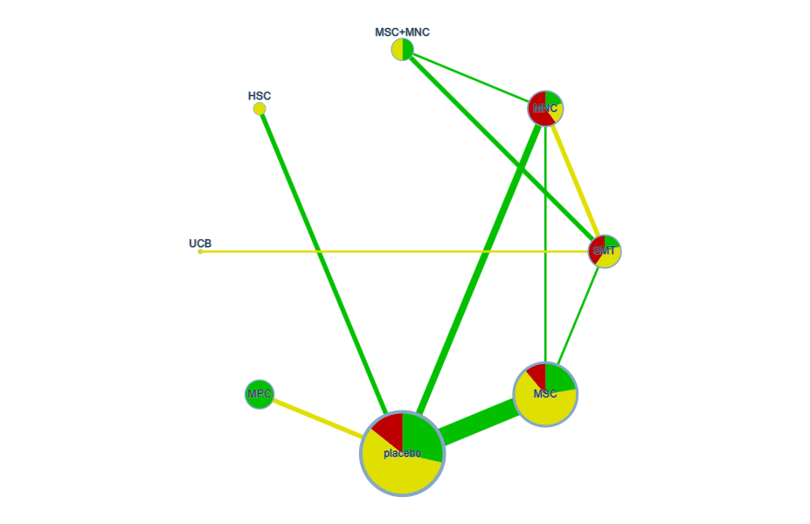
Note: Node size is proportional to the total sample size, and edge width is proportional to the number of studies contributing to each direct comparison. Node color indicates the risk of bias, whereas edge color represents the average indirectness of the direct evidence.
Abbreviations: HbA1c, glycated hemoglobin.
eFigure 5.2: Risk-of-bias contributions to network estimates for HbA1c.
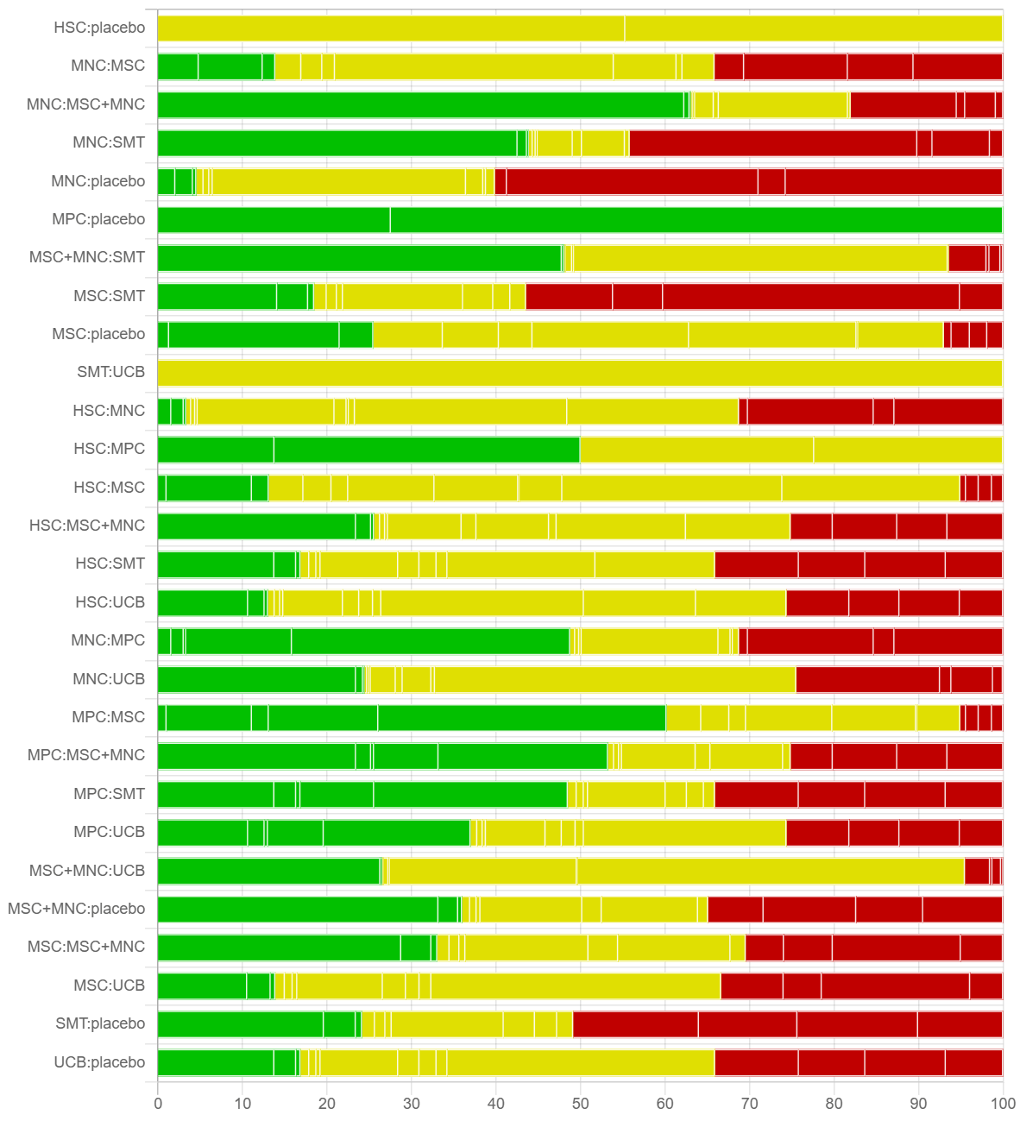
Note: The stacked bars show the percentage contribution of studies at low, moderate, and high risk of bias to each network treatment comparison. Green, yellow, and red indicate low, moderate, and high risk of bias, respectively.
Abbreviations: HbA1c, glycated hemoglobin.

eFigure 5.3: Network plot of the available treatment comparisons for FPG.
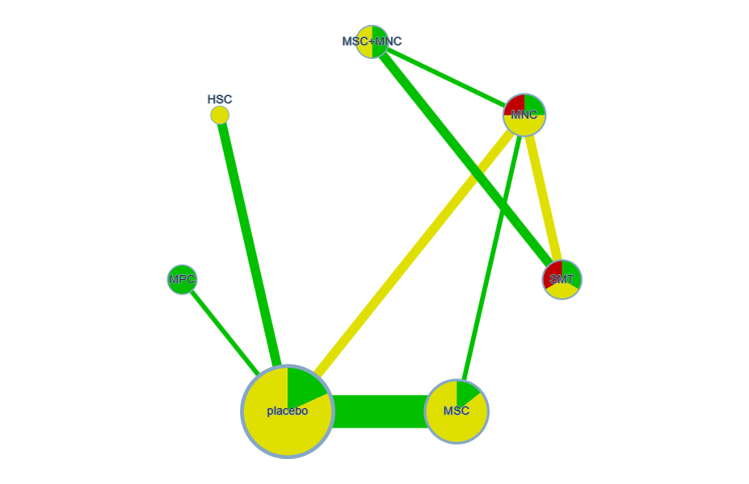
Note: Node size is proportional to the total sample size, and edge width is proportional to the number of studies contributing to each direct comparison. Node color indicates the risk of bias, whereas edge color represents the average indirectness of the direct evidence.
Abbreviations: FPG, fasting plasma glucose.

eFigure 5.4: Risk-of-bias contributions to network estimates for FPG.
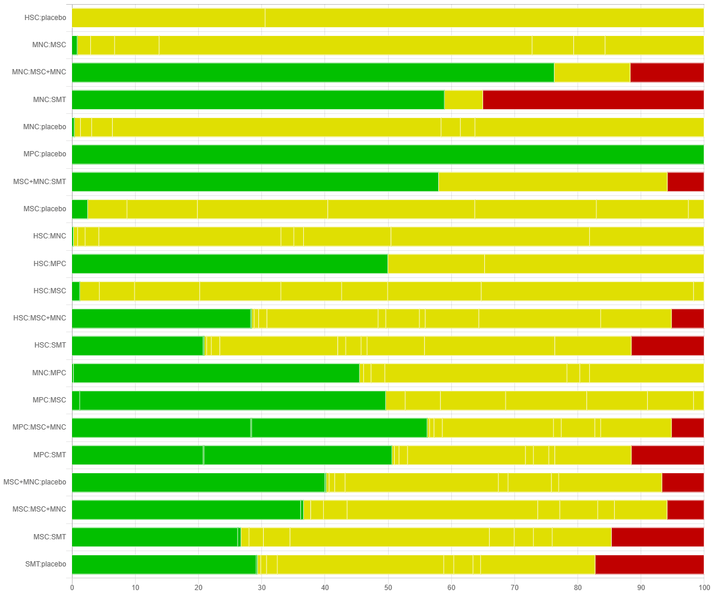
Note: The stacked bars show the percentage contribution of studies at low, moderate, and high risk of bias to each network treatment comparison. Green, yellow, and red indicate low, moderate, and high risk of bias, respectively.
Abbreviations: FPG, fasting plasma glucose.
eFigure 5.5: Network plot of the available treatment comparisons for Fasting C-peptide.
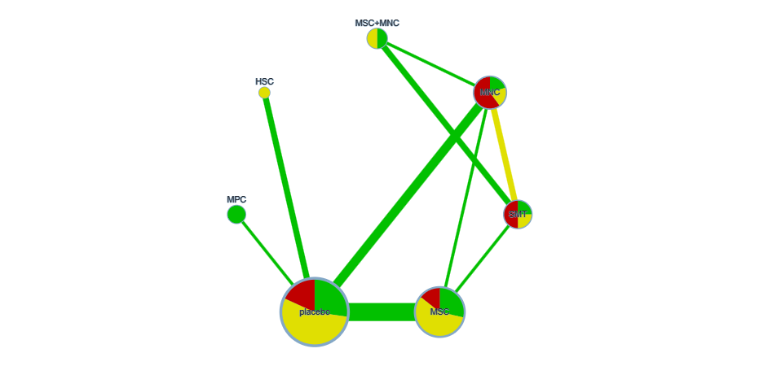
Note: Node size is proportional to the total sample size, and edge width is proportional to the number of studies contributing to each direct comparison. Node color indicates the risk of bias, whereas edge color represents the average indirectness of the direct evidence.

eFigure 5.6: Risk-of-bias contributions to network estimates for Fasting C-peptide.
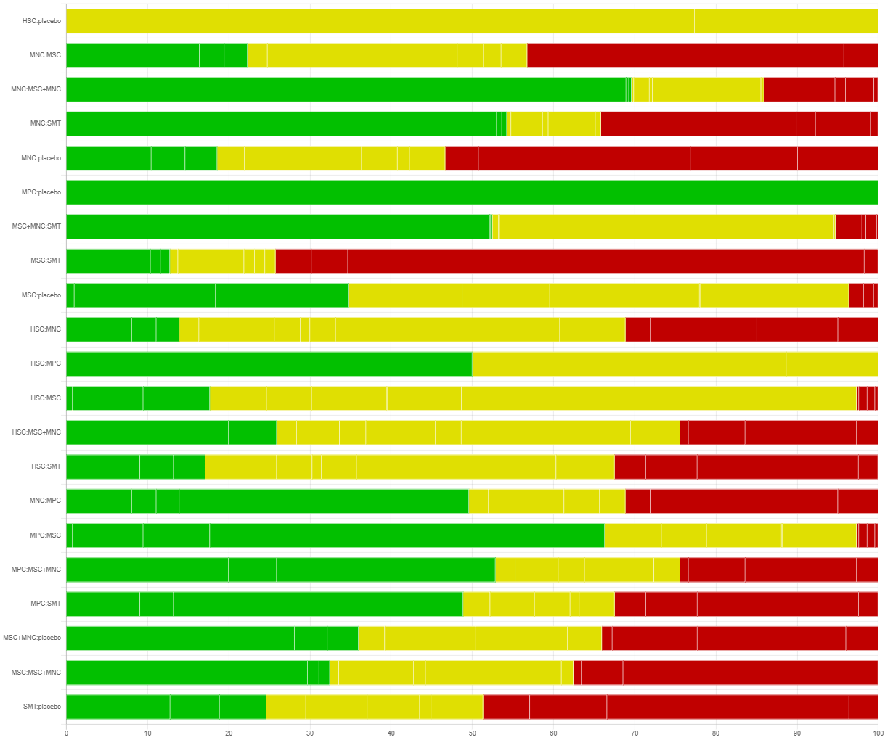
Note: The stacked bars show the percentage contribution of studies at low, moderate, and high risk of bias to each network treatment comparison. Green, yellow, and red indicate low, moderate, and high risk of bias, respectively.
eFigure 5.7: Network plot of the available treatment comparisons for TDD.
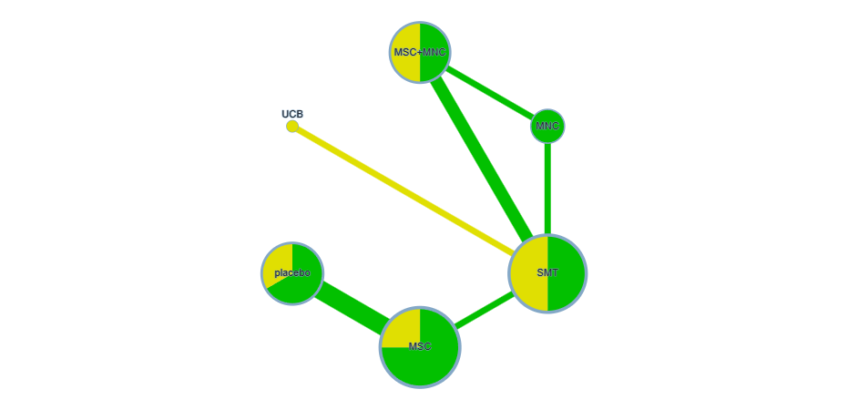
Note: Node size is proportional to the total sample size, and edge width is proportional to the number of studies contributing to each direct comparison. Node color indicates the risk of bias, whereas edge color represents the average indirectness of the direct evidence.
Abbreviations: TDD, total daily insulin dose.

eFigure 5.8: Risk-of-bias contributions to network estimates for TDD.
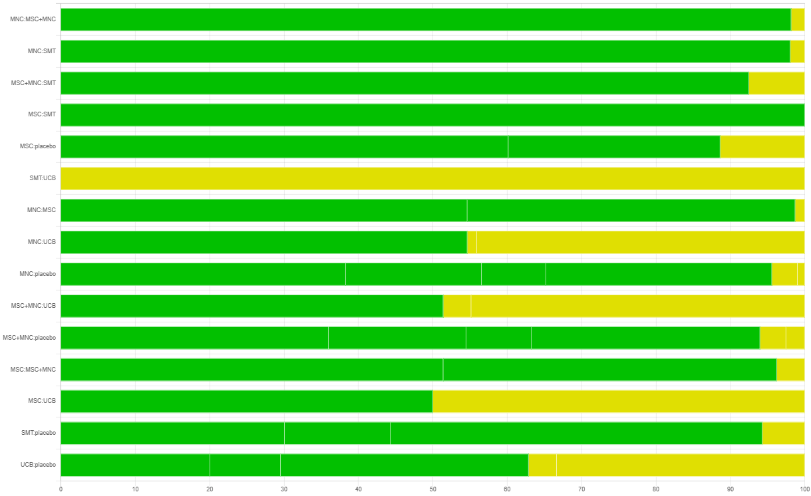
Note: The stacked bars show the percentage contribution of studies at low, moderate, and high risk of bias to each network treatment comparison. Green, yellow, and red indicate low, moderate, and high risk of bias, respectively.
Abbreviations: TDD, total daily insulin dose.
eFigure 5.9: Network plot of the available treatment comparisons for AE.
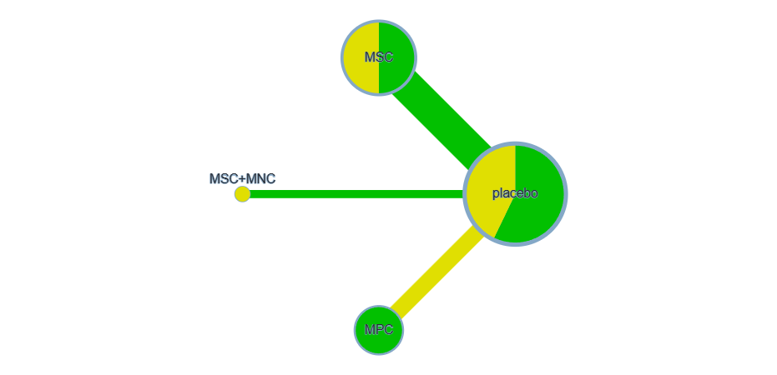
Note: Node size is proportional to the total sample size, and edge width is proportional to the number of studies contributing to each direct comparison. Node color indicates the risk of bias, whereas edge color represents the average indirectness of the direct evidence.
Abbreviations: AE, adverse events.

eFigure 5.10: Risk-of-bias contributions to network estimates for AE.
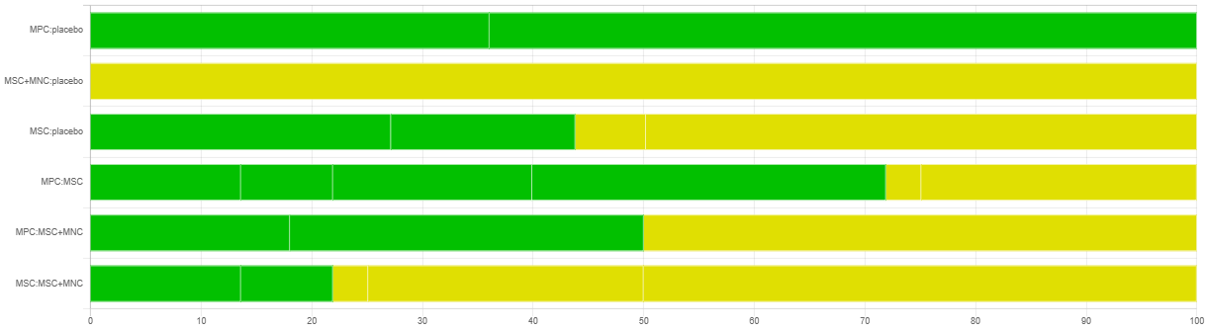
Note: The stacked bars show the percentage contribution of studies at low, moderate, and high risk of bias to each network treatment comparison. Green, yellow, and red indicate low, moderate, and high risk of bias, respectively.
Abbreviations: AE, adverse events.

Table 5.1 Grading the evidence of network meta-analysis using CINeMA for HbA1c.
Comparison | Number of studies | Within-study bias | Reporting bias | Indirectness | Imprecision | Heterogeneity | Incoherence | Confidence rating | Reason(s) for downgrading
HSC:placebo | 2 | Some concerns | Low risk | No concerns | Major concerns | No concerns | Major concerns | Very low | ["Within-study bias","Imprecision","Incoherence"]
MNC:MSC | 1 | Some concerns | Low risk | No concerns | Some concerns | No concerns | No concerns | Low | ["Within-study bias","Imprecision"]
MNC:MSC+MNC | 1 | Some concerns | Low risk | No concerns | No concerns | Some concerns | No concerns | Low | ["Within-study bias","Heterogeneity"]
MNC:SMT | 2 | Some concerns | Low risk | No concerns | Some concerns | No concerns | Some concerns | Low | ["Within-study bias","Imprecision","Incoherence"]
MNC:placebo | 3 | Major concerns | Low risk | No concerns | Some concerns | Some concerns | Major concerns | Very low | ["Within-study bias","Imprecision","Heterogeneity","Incoherence"]
MPC:placebo | 2 | No concerns | Low risk | No concerns | Some concerns | Some concerns | Major concerns | Low | ["Imprecision","Heterogeneity","Incoherence"]
MSC:SMT | 1 | Some concerns | Low risk | No concerns | No concerns | Some concerns | Major concerns | Very low | ["Within-study bias","Heterogeneity","Incoherence"]
MSC:placebo | 8 | Some concerns | Low risk | No concerns | No concerns | Some concerns | No concerns | Low | ["Within-study bias","Heterogeneity"]
MSC+MNC:SMT | 2 | Some concerns | Low risk | No concerns | No concerns | No concerns | No concerns | Moderate | ["Within-study bias"]
SMT:UCB | 1 | Some concerns | Low risk | Some concerns | Some concerns | Some concerns | Major concerns | Very low | ["Within-study bias","Indirectness","Imprecision","Heterogeneity","Incoherence"]
HSC:MNC | 0 | Some concerns | Low risk | No concerns | Major concerns | No concerns | Major concerns | Very low | ["Within-study bias","Imprecision","Incoherence"]
HSC:MPC | 0 | Some concerns | Low risk | No concerns | Major concerns | No concerns | Major concerns | Very low | ["Within-study bias","Imprecision","Incoherence"]
HSC:MSC | 0 | Some concerns | Low risk | No concerns | Major concerns | No concerns | Major concerns | Very low | ["Within-study bias","Imprecision","Incoherence"]
HSC:MSC+MNC | 0 | Some concerns | Low risk | No concerns | Major concerns | No concerns | Major concerns | Very low | ["Within-study bias","Imprecision","Incoherence"]
HSC:SMT | 0 | Some concerns | Low risk | No concerns | Major concerns | No concerns | Major concerns | Very low | ["Within-study bias","Imprecision","Incoherence"]
HSC:UCB | 0 | Some concerns | Low risk | No concerns | Major concerns | No concerns | Major concerns | Very low | ["Within-study bias","Imprecision","Incoherence"]
MNC:MPC | 0 | Some concerns | Low risk | No concerns | Major concerns | No concerns | Major concerns | Very low | ["Within-study bias","Imprecision","Incoherence"]
MNC:UCB | 0 | Some concerns | Low risk | Some concerns | Major concerns | No concerns | Major concerns | Very low | ["Within-study bias","Indirectness","Imprecision","Incoherence"]
MPC:MSC | 0 | No concerns | Low risk | No concerns | Some concerns | Some concerns | Major concerns | Low | ["Imprecision","Heterogeneity","Incoherence"]
MPC:MSC+MNC | 0 | Some concerns | Low risk | No concerns | Some concerns | Some concerns | Major concerns | Very low | ["Within-study bias","Imprecision","Heterogeneity","Incoherence"]
MPC:SMT | 0 | Some concerns | Low risk | No concerns | Some concerns | Some concerns | Major concerns | Very low | ["Within-study bias","Imprecision","Heterogeneity","Incoherence"]
MPC:UCB | 0 | Some concerns | Low risk | No concerns | Major concerns | No concerns | Major concerns | Very low | ["Within-study bias","Imprecision","Incoherence"]
MSC:MSC+MNC | 0 | Some concerns | Low risk | No concerns | Major concerns | No concerns | Major concerns | Very low | ["Within-study bias","Imprecision","Incoherence"]
MSC:UCB | 0 | Some concerns | Low risk | No concerns | Major concerns | No concerns | Major concerns | Very low | ["Within-study bias","Imprecision","Incoherence"]
MSC+MNC:UCB | 0 | Some concerns | Low risk | No concerns | Major concerns | No concerns | Major concerns | Very low | ["Within-study bias","Imprecision","Incoherence"]
MSC+MNC:placebo | 0 | Some concerns | Low risk | No concerns | No concerns | Some concerns | Major concerns | Very low | ["Within-study bias","Heterogeneity","Incoherence"]
SMT:placebo | 0 | Some concerns | Low risk | No concerns | Some concerns | Some concerns | Major concerns | Very low | ["Within-study bias","Imprecision","Heterogeneity","Incoherence"]
UCB:placebo | 0 | Some concerns | Low risk | No concerns | Major concerns | No concerns | Major concerns | Very low | ["Within-study bias","Imprecision","Incoherence"]
eTable 5.2 Grading the evidence of network meta-analysis using CINeMA for FPG.
Comparison | Number of studies | Within-study bias | Reporting bias | Indirectness | Imprecision | Heterogeneity | Incoherence | Confidence rating | Reason(s) for downgrading
HSC:placebo | 2 | Some concerns | Low risk | No concerns | Major concerns | No concerns | No concerns | Very low | ["Within-study bias","Imprecision"]
MNC:MSC | 1 | Some concerns | Low risk | No concerns | Some concerns | Some concerns | No concerns | Low | ["Within-study bias","Imprecision","Heterogeneity"]
MNC:MSC+MNC | 1 | No concerns | Low risk | No concerns | Major concerns | No concerns | No concerns | Low | ["Imprecision"]
MNC:SMT | 2 | Some concerns | Low risk | No concerns | No concerns | Some concerns | No concerns | Low | ["Within-study bias","Heterogeneity"]
MNC:placebo | 2 | Some concerns | Low risk | No concerns | Some concerns | Some concerns | No concerns | Low | ["Within-study bias","Imprecision","Heterogeneity"]
MPC:placebo | 1 | No concerns | Low risk | No concerns | Major concerns | No concerns | No concerns | Low | ["Imprecision"]
MSC:placebo | 7 | Some concerns | Low risk | No concerns | Major concerns | No concerns | Some concerns | Very low | ["Within-study bias","Imprecision","Incoherence"]
MSC+MNC:SMT | 2 | No concerns | Low risk | No concerns | No concerns | Some concerns | No concerns | Moderate | ["Heterogeneity"]
HSC:MNC | 0 | Some concerns | Low risk | No concerns | Some concerns | Some concerns | No concerns | Low | ["Within-study bias","Imprecision","Heterogeneity"]
HSC:MPC | 0 | Some concerns | Low risk | No concerns | Major concerns | No concerns | No concerns | Very low | ["Within-study bias","Imprecision"]
HSC:MSC | 0 | Some concerns | Low risk | No concerns | Major concerns | No concerns | No concerns | Very low | ["Within-study bias","Imprecision"]
HSC:MSC+MNC | 0 | Some concerns | Low risk | No concerns | Major concerns | No concerns | No concerns | Very low | ["Within-study bias","Imprecision"]
HSC:SMT | 0 | Some concerns | Low risk | No concerns | Major concerns | No concerns | No concerns | Very low | ["Within-study bias","Imprecision"]
MNC:MPC | 0 | Some concerns | Low risk | No concerns | Major concerns | No concerns | No concerns | Very low | ["Within-study bias","Imprecision"]
MPC:MSC | 0 | Some concerns | Low risk | No concerns | Major concerns | No concerns | No concerns | Very low | ["Within-study bias","Imprecision"]
MPC:MSC+MNC | 0 | No concerns | Low risk | No concerns | Major concerns | No concerns | No concerns | Low | ["Imprecision"]
MPC:SMT | 0 | Some concerns | Low risk | No concerns | Major concerns | No concerns | No concerns | Very low | ["Within-study bias","Imprecision"]
MSC:MSC+MNC | 0 | Some concerns | Low risk | No concerns | Major concerns | No concerns | No concerns | Very low | ["Within-study bias","Imprecision"]
MSC:SMT | 0 | Some concerns | Low risk | No concerns | Major concerns | No concerns | No concerns | Very low | ["Within-study bias","Imprecision"]
MSC+MNC:placebo | 0 | Some concerns | Low risk | No concerns | Major concerns | No concerns | No concerns | Very low | ["Within-study bias","Imprecision"]
SMT:placebo | 0 | Some concerns | Low risk | No concerns | Major concerns | No concerns | No concerns | Very low | ["Within-study bias","Imprecision"]
eTable 5.3 Grading the evidence of network meta-analysis using CINeMA for Fasting C-peptide.
Comparison | Number of studies | Within-study bias | Reporting bias | Indirectness | Imprecision | Heterogeneity | Incoherence | Confidence rating | Reason(s) for downgrading
HSC:placebo | 2 | Some concerns | Low risk | No concerns | Major concerns | No concerns | Major concerns | Very low | ["Within-study bias","Imprecision","Incoherence"]
MNC:MSC | 1 | Some concerns | Low risk | No concerns | Major concerns | No concerns | No concerns | Very low | ["Within-study bias","Imprecision"]
MNC:MSC+MNC | 1 | No concerns | Low risk | No concerns | Major concerns | No concerns | No concerns | Low | ["Imprecision"]
MNC:SMT | 2 | Some concerns | Low risk | No concerns | Some concerns | Some concerns | No concerns | Low | ["Within-study bias","Imprecision","Heterogeneity"]
MNC:placebo | 3 | Some concerns | Low risk | No concerns | No concerns | Major concerns | No concerns | Very low | ["Within-study bias","Heterogeneity"]
MPC:placebo | 1 | No concerns | Low risk | No concerns | Major concerns | No concerns | Major concerns | Low | ["Imprecision","Incoherence"]
MSC:SMT | 1 | Major concerns | Low risk | No concerns | Major concerns | No concerns | No concerns | Very low | ["Within-study bias","Imprecision"]
MSC:placebo | 6 | Some concerns | Low risk | No concerns | No concerns | Major concerns | No concerns | Very low | ["Within-study bias","Heterogeneity"]
MSC+MNC:SMT | 2 | Some concerns | Low risk | No concerns | Some concerns | Some concerns | No concerns | Low | ["Within-study bias","Imprecision","Heterogeneity"]
HSC:MNC | 0 | Some concerns | Low risk | No concerns | Major concerns | No concerns | Major concerns | Very low | ["Within-study bias","Imprecision","Incoherence"]
HSC:MPC | 0 | Some concerns | Low risk | No concerns | Major concerns | No concerns | Major concerns | Very low | ["Within-study bias","Imprecision","Incoherence"]
HSC:MSC | 0 | Some concerns | Low risk | No concerns | Major concerns | No concerns | Major concerns | Very low | ["Within-study bias","Imprecision","Incoherence"]
HSC:MSC+MNC | 0 | Some concerns | Low risk | No concerns | Major concerns | No concerns | Major concerns | Very low | ["Within-study bias","Imprecision","Incoherence"]
HSC:SMT | 0 | Some concerns | Low risk | No concerns | Major concerns | No concerns | Major concerns | Very low | ["Within-study bias","Imprecision","Incoherence"]
MNC:MPC | 0 | Some concerns | Low risk | No concerns | Some concerns | Some concerns | Major concerns | Very low | ["Within-study bias","Imprecision","Heterogeneity","Incoherence"]
MPC:MSC | 0 | No concerns | Low risk | No concerns | Major concerns | No concerns | Major concerns | Low | ["Imprecision","Incoherence"]
MPC:MSC+MNC | 0 | Some concerns | Low risk | No concerns | Some concerns | Some concerns | Major concerns | Very low | ["Within-study bias","Imprecision","Heterogeneity","Incoherence"]
MPC:SMT | 0 | Some concerns | Low risk | No concerns | Major concerns | No concerns | Major concerns | Very low | ["Within-study bias","Imprecision","Incoherence"]
MSC:MSC+MNC | 0 | Some concerns | Low risk | No concerns | Major concerns | No concerns | Major concerns | Very low | ["Within-study bias","Imprecision","Incoherence"]
MSC+MNC:placebo | 0 | Some concerns | Low risk | No concerns | Some concerns | Some concerns | Major concerns | Very low | ["Within-study bias","Imprecision","Heterogeneity","Incoherence"]
SMT:placebo | 0 | Some concerns | Low risk | No concerns | Major concerns | No concerns | Major concerns | Very low | ["Within-study bias","Imprecision","Incoherence"]
eTable 5.4 Grading the evidence of network meta-analysis using CINeMA for TDD.
Comparison | Number of studies | Within-study bias | Reporting bias | Indirectness | Imprecision | Heterogeneity | Incoherence | Confidence rating | Reason(s) for downgrading
MNC:MSC+MNC | 1 | No concerns | Low risk | No concerns | Some concerns | Some concerns | No concerns | Moderate | ["Imprecision","Heterogeneity"]
MNC:SMT | 1 | No concerns | Low risk | No concerns | No concerns | Major concerns | No concerns | Low | ["Heterogeneity"]
MSC:SMT | 1 | No concerns | Low risk | No concerns | Major concerns | No concerns | No concerns | Low | ["Imprecision"]
MSC:placebo | 3 | No concerns | Low risk | No concerns | Some concerns | Some concerns | No concerns | Moderate | ["Imprecision","Heterogeneity"]
MSC+MNC:SMT | 2 | No concerns | Low risk | No concerns | No concerns | Major concerns | No concerns | Low | ["Heterogeneity"]
SMT:UCB | 1 | Some concerns | Low risk | Some concerns | Major concerns | No concerns | No concerns | Very low | ["Within-study bias","Indirectness","Imprecision"]
MNC:MSC | 0 | No concerns | Low risk | No concerns | Some concerns | Some concerns | No concerns | Moderate | ["Imprecision","Heterogeneity"]
MNC:UCB | 0 | No concerns | Low risk | No concerns | Major concerns | No concerns | No concerns | Low | ["Imprecision"]
MNC:placebo | 0 | No concerns | Low risk | No concerns | Major concerns | No concerns | No concerns | Low | ["Imprecision"]
MSC:MSC+MNC | 0 | No concerns | Low risk | No concerns | Some concerns | Some concerns | No concerns | Moderate | ["Imprecision","Heterogeneity"]
MSC:UCB | 0 | Some concerns | Low risk | Some concerns | Major concerns | No concerns | No concerns | Very low | ["Within-study bias","Indirectness","Imprecision"]
MSC+MNC:UCB | 0 | No concerns | Low risk | No concerns | Some concerns | Some concerns | No concerns | Moderate | ["Imprecision","Heterogeneity"]
MSC+MNC:placebo | 0 | No concerns | Low risk | No concerns | Some concerns | Some concerns | No concerns | Moderate | ["Imprecision","Heterogeneity"]
SMT:placebo | 0 | No concerns | Low risk | No concerns | Major concerns | No concerns | No concerns | Low | ["Imprecision"]
UCB:placebo | 0 | No concerns | Low risk | No concerns | Major concerns | No concerns | No concerns | Low | ["Imprecision"]
eTable 5.5 Grading the evidence of network meta-analysis using CINeMA for AE.
Comparison | Number of studies | Within-study bias | Reporting bias | Indirectness | Imprecision | Heterogeneity | Incoherence | Confidence rating | Reason(s) for downgrading
MPC:placebo | 2 | No concerns | Low risk | No concerns | Major concerns | No concerns | No concerns | Low | ["Imprecision"]
MSC:placebo | 4 | Some concerns | Low risk | No concerns | Major concerns | No concerns | No concerns | Very low | ["Within-study bias","Imprecision"]
MSC+MNC:placebo | 1 | Some concerns | Low risk | No concerns | Major concerns | No concerns | No concerns | Very low | ["Within-study bias","Imprecision"]
MPC:MSC | 0 | No concerns | Low risk | No concerns | Major concerns | No concerns | No concerns | Low | ["Imprecision"]
MPC:MSC+MNC | 0 | Some concerns | Low risk | No concerns | Major concerns | No concerns | No concerns | Very low | ["Within-study bias","Imprecision"]
MSC:MSC+MNC | 0 | Some concerns | Low risk | No concerns | Major concerns | No concerns | No concerns | Very low | ["Within-study bias","Imprecision"]
Abbreviations: HbA1c, glycated hemoglobin; FPG, fasting plasma glucose; TDD, total daily insulin dose; AE, adverse events.

Appendix 6: League table for interventions derived from network Meta-analysis.
eTable 6.1: Network meta-analysis league table for glycated HbA1c.
SMT
-0.46 (-1.80, 0.95) | HSC
-0.50 (-1.13, 0.19) | -0.03 (-1.31, 1.21) | MNC
-0.60 (-1.66, 0.60) | -0.14 (-1.50, 1.25) | -0.10 (-1.04, 0.91) | MPC
-0.95 (-1.70, -0.09) | -0.48 (-1.69, 0.73) | -0.45 (-1.06, 0.21) | -0.35 (-1.26, 0.56) | MSC
-1.26 (-1.97, -0.54) | -0.80 (-2.31, 0.65) | -0.76 (-1.62, 0.06) | -0.66 (-1.97, 0.53) | -0.31 (-1.34, 0.63) | MSC+MNC
-0.34 (-1.08, 0.49) | 0.12 (-1.00, 1.25) | 0.16 (-0.38, 0.73) | 0.26 (-0.55, 1.03) | 0.61 (0.15, 1.04) | 0.92 (-0.01, 1.92) | placebo
-0.76 (-2.01, 0.49) | -0.30 (-2.19, 1.51) | -0.27 (-1.69, 1.11) | -0.16 (-1.90, 1.46) | 0.18 (-1.34, 1.62) | 0.50 (-0.95, 1.93) | -0.43 (-1.93, 1.00) | UCB
Note: The lower-left triangle presents the relative treatment effects between interventions. Effect estimates are expressed as mean differences (MDs) with corresponding 95% credible intervals (CrIs). A negative MD favors the intervention listed in the row, whereas a positive MD favors the intervention listed in the column. Comparisons with 95% CrIs that do not include zero are considered statistically significant. For example, compared with SMT, the estimated MD for MSC+MNC was −1.26% (95% CrI, −1.97 to −0.54), indicating a greater reduction in HbA1c with MSC+MNC therapy.
eTable 6.2: Network meta-analysis league table for FPG.
SMT
0.60 (-3.13, 4.36) | HSC
-2.03 (-3.75, -0.35) | -2.63 (-5.99, 0.70) | MNC
-0.85 (-4.52, 2.75) | -1.45 (-5.55, 2.64) | 1.19 (-2.06, 4.38) | MPC
-1.17 (-3.53, 1.27) | -1.78 (-4.88, 1.38) | 0.86 (-0.79, 2.59) | -0.33 (-3.26, 2.72) | MSC
-2.24 (-3.93, -0.56) | -2.84 (-6.74, 1.05) | -0.21 (-2.19, 1.78) | -1.40 (-5.14, 2.41) | -1.07 (-3.72, 1.49) | MSC+MNC
-1.05 (-3.36, 1.23) | -1.65 (-4.62, 1.32) | 0.98 (-0.58, 2.53) | -0.20 (-3.01, 2.63) | 0.13 (-0.93, 1.07) | 1.19 (-1.34, 3.71) | placebo
Note: The lower-left triangle presents the relative treatment effects between interventions. Effect estimates are expressed as mean differences (MDs) with corresponding 95% credible intervals (CrIs). A negative MD favors the intervention listed in the row, whereas a positive MD favors the intervention listed in the column. Comparisons with 95% CrIs that do not include zero are considered statistically significant.
Abbreviations: FPG, fasting plasma glucose.
eTable 6.3: Network meta-analysis league table for Fasting C-peptide.
SMT
0.02 (-0.55, 0.58) | HSC
0.13 (-0.06, 0.33) | 0.11 (-0.45, 0.67) | MNC
-0.65 (-1.49, 0.19) | -0.67 (-1.62, 0.27) | -0.78 (-1.62, 0.05) | MPC
0.03 (-0.21, 0.27) | 0.02 (-0.51, 0.53) | -0.10 (-0.34, 0.14) | 0.68 (-0.13, 1.50) | MSC
0.11 (-0.09, 0.31) | 0.09 (-0.50, 0.68) | -0.02 (-0.26, 0.22) | 0.76 (-0.10, 1.62) | 0.08 (-0.22, 0.37) | MSC+MNC
-0.09 (-0.34, 0.17) | -0.10 (-0.61, 0.40) | -0.22 (-0.46, 0.02) | 0.56 (-0.24, 1.37) | -0.12 (-0.24, 0.01) | -0.20 (-0.50, 0.11) | placebo
Note: The lower-left triangle presents the relative treatment effects between interventions. Effect estimates are expressed as mean differences (MDs) with corresponding 95% credible intervals (CrIs). A positive MD favors the intervention listed in the row, whereas a negative MD favors the intervention listed in the column. Comparisons with 95% CrIs that do not include zero are considered statistically significant.
eTable 6.4: Network meta-analysis league table for TDD.
SMT
-0.28 (-0.74, 0.19) | MNC
-0.02 (-0.53, 0.50) | 0.26 (-0.44, 0.95) | MSC
-0.39 (-0.80, 0.03) | -0.11 (-0.57, 0.35) | -0.37 (-1.03, 0.30) | MSC+MNC
0.00 (-0.63, 0.58) | 0.28 (-0.51, 1.02) | 0.02 (-0.32, 0.32) | 0.39 (-0.37, 1.09) | placebo
-0.08 (-0.58, 0.43) | 0.20 (-0.49, 0.89) | -0.06 (-0.78, 0.67) | 0.32 (-0.35, 0.96) | -0.08 (-0.84, 0.73) | UCB
Note: The lower-left triangle presents the relative treatment effects between interventions. Effect estimates are expressed as mean differences (MDs) with corresponding 95% credible intervals (CrIs). A negative MD favors the intervention listed in the row, whereas a positive MD favors the intervention listed in the column. Comparisons with 95% CrIs that do not include zero are considered statistically significant.
Abbreviations: TDD, total daily insulin dose.
eTable 6.5: Network meta-analysis league table for AE.
placebo
2.62 (0.30, 10.65) | MPC
0.86 (0.13, 2.67) | 0.75 (0.03, 3.50) | MSC
5.66 (0.23, 28.75) | 5.10 (0.07, 28.97) | 12.96 (0.26, 74.18) | MSC+MNC
Note: Effect estimates are expressed as odds ratios (ORs) with corresponding 95% credible intervals (CrIs). An OR above 1 favors the intervention listed in the column, whereas an OR below 1 favors the intervention listed in the row. Comparisons with 95% CrIs that do not include 1 are considered statistically significant.
Abbreviations: AE, adverse events.

Appendix 7: SUCRA and cumulative probability plots.
eFigure 7: Plots of rankogram. (a) HbA1c; (b) FPG; (c) fasting C-peptide; (d) TDD; (e) AE.
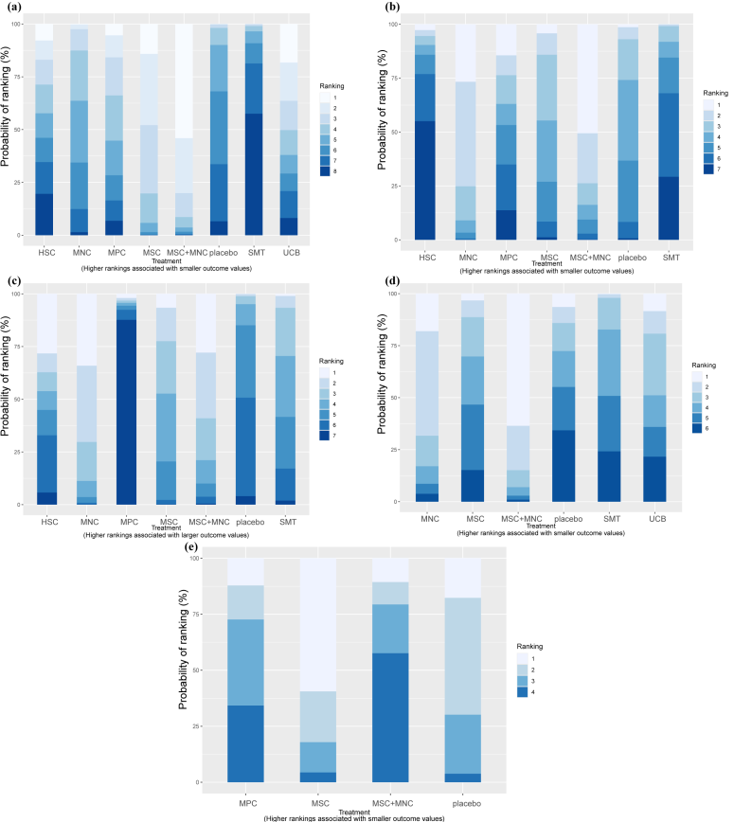
eTable 7: SUCRA value of all outcomes.
HbA1c |  | FPG |  | Fasting C-peptide
intervention | SUCRA | intervention | SUCRA | intervention | SUCRA
MSC+MNC | 88.53 | MSC+MNC | 82.62 | MNC | 81.45
MSC | 76.4 | MNC | 81.48 | MSC+MNC | 75.28
UCB | 58.42 | MSC | 54.41 | HSC | 58.94
MPC | 51.23 | placebo | 48.07 | MSC | 54.69
MNC | 43.37 | MPC | 45.54 | SMT | 46.09
HSC | 42.23 | SMT | 21.22 | placebo | 27.72
placebo | 29.1 | HSC | 16.68 | MPC | 5.84
SMT | 10.71
TDD |  | AE
intervention | SUCRA | intervention | SUCRA
MSC+MNC | 87.53 | MSC | 79.06
MNC | 71.41 | placebo | 61.26
UCB | 43.81 | MPC | 35.11
MSC | 36.61 | MSC+MNC | 24.57
placebo | 31.76
SMT | 28.89
Abbreviations: SUCRA, surface under the cumulative ranking curve; HbA1c, glycated hemoglobin; FPG, fasting plasma glucose; TDD, total daily insulin dose; AE, adverse events.

Appendix 8: Assessment of inconsistency and heterogeneity in the network meta‑analysis.
eTable 8.1 Assessment of global consistency using the deviance information criterion (DIC).
Outcome | Consistency model |  |  | Inconsistency model |  |  | |ΔDIC|
Outcome | pD | Dres | DIC | pD | Dres | DIC | |ΔDIC|
HbA1c | 32.75 | 41 | 73.75 | 31.23 | 39.85 | 71.08 | 2.67
FPG | 26.47 | 28.69 | 55.16 | 26.83 | 28.75 | 55.59 | 0.43
Fasting C-peptide | 28.03 | 30.68 | 58.71 | 28.84 | 30.92 | 59.77 | 1.06
TDD | 13.59 | 14.37 | 27.96 | 13.59 | 14.4 | 27.99 | 0.03
AE | NaN | 12.53 | NaN | NaN | 12.49 | NaN | Na
Note: An absolute difference in DIC (|ΔDIC|) of less than 5 between the consistency and inconsistency models was considered to indicate no important inconsistency, and the consistency model was selected for the final analysis. For the AE outcome, the DIC could not be estimated because the effective number of parameters (pD) was not estimable; therefore, DIC-based comparison was not performed.
Abbreviations: pD, effective number of parameters; Dres, posterior mean residual deviance; DIC, deviance information criterion; HbA1c, glycated hemoglobin; FPG, fasting plasma glucose; TDD, total daily insulin dose; AE, adverse events; NA, not available; NaN, Not a Number.

eTable 8.2.1 Node-splitting of HbA1c. Inconsistency test between direct and indirect treatment comparisons in mixed treatment comparison.
Comparison | Direct Estimate (95% CrI) | Indirect Estimate (95% CrI) | Network Estimate (95% CrI) | P-value
MSC vs MNC | -0.58 (-1.7, 0.55) | -0.34 (-1.0, 0.51) | -0.46 (-1.0, 0.21) | 0.70623
MSC+MNC vs MNC | -0.50 (-1.6, 0.57) | -1.1 (-2.5, 0.21) | -0.76 (-1.6, 0.053) | 0.45011
Placebo vs MNC | -0.069 (-0.54, 0.39) | 1.7 (0.40, 3.1) | 0.15 (-0.37, 0.73) | 0.0171
SMT vs MNC | 0.84 (0.19, 1.5) | -0.83 (-2.1, 0.48) | 0.50 (-0.18, 1.1) | 0.03001
Placebo vs MSC | 0.71 (0.29, 1.1) | -0.80 (-2.2, 0.65) | 0.62 (0.16, 1.0) | 0.05123
SMT vs MSC | -0.094 (-1.2, 1.0) | 1.5 (0.70, 2.3) | 0.97 (0.10, 1.7) | 0.02509
Note: Mean difference (or Odds Ratio) as defined in the original analysis. Estimates represent posterior medians. Node-splitting P-value assessing inconsistency between direct and indirect evidence. A value < 0.10 (in bold) indicates significant local inconsistency.
Abbreviations: P-value, Probability Value; CrI, Bayesian 95% credible interval; HbA1c, glycated hemoglobin.

eTable 8.2.2 Node-splitting of FPG. Inconsistency test between direct and indirect treatment comparisons in mixed treatment comparison.
Comparison | Direct Estimate (95% CrI) | Indirect Estimate (95% CrI) | Network Estimate (95% CrI) | P-value
MSC vs MNC | 0.40 (-1.6, 2.4) | 2.0 (-0.16, 4.4) | 0.85 (-0.77, 2.6) | 0.22338
MSC+MNC vs MNC | -0.29 (-3.0, 2.5) | -0.049 (-4.2, 4.1) | -0.23 (-2.2, 1.8) | 0.91433
Note: Mean difference (or Odds Ratio) as defined in the original analysis. Estimates represent posterior medians. Node-splitting P-value assessing inconsistency between direct and indirect evidence. A value < 0.10 (in bold) indicates significant local inconsistency.
Abbreviations: P-value, Probability Value; CrI, Bayesian 95% credible interval; FPG, Fasting plasma glucose.

eTable 8.2.3 Node-splitting of Fasting C-peptide. Inconsistency test between direct and indirect treatment comparisons in mixed treatment comparison.
Comparison | Direct Estimate (95% CrI) | Indirect Estimate (95% CrI) | Network Estimate (95% CrI) | P-value
MSC vs MNC | -0.16 (-0.62, 0.29) | -0.084 (-0.39, 0.21) | -0.098 (-0.34, 0.14) | 0.76102
MSC+MNC vs MNC | 0.066 (-0.27, 0.40) | -0.19 (-0.63, 0.25) | -0.021 (-0.26, 0.22) | 0.30587
placebo vs MNC | -0.15 (-0.48, 0.18) | -0.26 (-0.71, 0.17) | -0.22 (-0.46, 0.032) | 0.66432
SMT vs MNC | -0.17 (-0.42, 0.077) | -0.10 (-0.58, 0.37) | -0.13 (-0.33, 0.058) | 0.79639
placebo vs MSC | -0.12 (-0.26, 0.032) | -0.059 (-0.67, 0.54) | -0.12 (-0.24, 0.015) | 0.83546
SMT vs MSC | -0.019 (-0.36, 0.32) | -0.050 (-0.45, 0.35) | -0.033 (-0.28, 0.20) | 0.89964
Note: Mean difference (or Odds Ratio) as defined in the original analysis. Estimates represent posterior medians. Node-splitting P-value assessing inconsistency between direct and indirect evidence. A value < 0.10 (in bold) indicates significant local inconsistency.
Abbreviations: P-value, Probability Value; CrI, Bayesian 95% credible interval.

eTable 8.3.1 Heterogeneity analysis (mtc.anohe) result of HbA1c.
t1 | t2 | i2.pair | i2.cons | incons.p
HSC | placebo | 57.6392 | 57.70028 | NA
MNC | MSC | NA | 0 | 0.823117
MNC | MSC+MNC | NA | 0 | 0.370464
MNC | placebo | 8.320296 | 41.9734 | NA
MNC | SMT | 18.66727 | 61.39754 | NA
MPC | placebo | 0 | 0 | NA
MSC | placebo | 22.53881 | 31.07074 | NA
MSC | SMT | NA | 87.81106 | 0.008518
MSC+MNC | SMT | 0 | 0 | NA
SMT | UCB | NA | NA | NA
Note: “NA” indicates the quantity could not be estimated (e.g., comparison informed by a single study). I² pair: heterogeneity I² from pairwise meta‑analysis; I² cons: heterogeneity I² under the consistency model. The inconsistency P‑value is the Bayesian P‑value testing disagreement between direct and indirect evidence. Values below 0.10 indicate statistically significant inconsistency. All analyses used a random‑effects model with normal likelihood and identity link, consistent with the primary analysis.
Abbreviations: HbA1c, Glycated hemoglobin.

eTable 8.3.2 Heterogeneity analysis (mtc.anohe) result of FPG.
t1 | t2 | i2.pair | i2.cons | incons.p
HSC | placebo | 0 | 0 | NA
MNC | MSC | NA | 42.51314 | 0.611467
MNC | MSC+MNC | NA | 0 | 0.940452
MNC | placebo | 93.40019 | 93.39459 | NA
MNC | SMT | 0 | 0 | NA
MPC | placebo | NA | NA | NA
MSC | placebo | 77.51219 | 75.16457 | NA
MSC+MNC | SMT | 0 | 0 | NA
Note: “NA” indicates the quantity could not be estimated (e.g., comparison informed by a single study). I² pair: heterogeneity I² from pairwise meta‑analysis; I² cons: heterogeneity I² under the consistency model. The inconsistency P‑value is the Bayesian P‑value testing disagreement between direct and indirect evidence. All P‑values are non‑significant (threshold < 0.10). All analyses used a random‑effects model with normal likelihood and identity link, consistent with the primary analysis.
Abbreviations: FPG, Fasting plasma glucose.

eTable 8.3.3 Heterogeneity analysis (mtc.anohe) result of Fasting C-peptide.
t1 | t2 | i2.pair | i2.cons | incons.p
HSC | placebo | 0 | 0 | NA
MNC | MSC | NA | 0 | 0.750817
MNC | MSC+MNC | NA | 76.43822 | 0.455059
MNC | placebo | 0 | 0 | 0.810956
MNC | SMT | 75.75795 | 29.47261 | 0.609274
MPC | placebo | NA | NA | NA
MSC | placebo | 85.11386 | 82.29726 | 0.950247
MSC | SMT | NA | 0 | 0.917092
MSC+MNC | SMT | 98.95982 | 99.33936 | NA
Note: “NA” indicates the quantity could not be estimated (e.g., comparison informed by a single study). I² pair: heterogeneity I² from pairwise meta‑analysis; I² cons: heterogeneity I² under the consistency model. The inconsistency P‑value is the Bayesian P‑value testing disagreement between direct and indirect evidence. All P‑values are non‑significant (threshold < 0.10). All analyses used a random‑effects model with normal likelihood and identity link, consistent with the primary analysis.

eTable 8.3.4 Heterogeneity analysis (mtc.anohe) result of TDD.
t1 | t2 | i2.pair | i2.cons | incons.p
MNC | MSC+MNC | NA | NA | NA
MNC | SMT | NA | NA | NA
MSC | placebo | 66.578 | 66.93741 | NA
MSC | SMT | NA | NA | NA
MSC+MNC | SMT | 0 | 0 | NA
SMT | UCB | NA | NA | NA
Note: “NA” indicates the quantity could not be estimated (e.g., comparison informed by a single study). I² pair: heterogeneity I² from pairwise meta‑analysis; I² cons: heterogeneity I² under the consistency model. The inconsistency P‑value is the Bayesian P‑value testing disagreement between direct and indirect evidence. All P‑values are non‑significant (threshold < 0.10). All analyses used a random‑effects model with normal likelihood and identity link, consistent with the primary analysis.
Abbreviations: TDD, total daily insulin dose.

eTable 8.3.5 Heterogeneity analysis (mtc.anohe) result of AE.
t1 | t2 | i2.pair | i2.cons | incons.p
MPC | placebo | 0 | 0 | NA
MSC | placebo | 49.85116 | 50.22295 | NA
MSC+MNC | placebo | NA | NA | NA
Note: “NA” indicates the quantity could not be estimated (e.g., comparison informed by a single study). I² pair: heterogeneity I² from pairwise meta‑analysis; I² cons: heterogeneity I² under the consistency model. The inconsistency P‑value is the Bayesian P‑value testing disagreement between direct and indirect evidence. All P‑values are non‑significant (threshold < 0.10). All analyses used a random-effects model with a binomial likelihood and logit link, consistent with the primary AE analysis.
Abbreviations: AE, adverse events.

eTable 8.4 Posterior estimates of between-study heterogeneity from random-effects consistency models.
Outcome | Scale of τ | τ mean | τ SD | τ median | 95% CrI for τ | τ² mean | τ² SD | τ² median | 95% CrI for τ²
HbA1c | MD scale (%) | 0.39 | 0.19 | 0.37 | (0.05, 0.81) | 0.19 | 0.18 | 0.14 | (0.00, 0.65)
FPG | MD scale (mmol/L) | 1.03 | 0.35 | 0.98 | (0.49, 1.89) | 1.20 | 0.85 | 0.96 | (0.24, 3.57)
Fasting C-peptide | MD scale (nmol/L) | 0.14 | 0.05 | 0.13 | (0.07, 0.25) | 0.02 | 0.02 | 0.02 | (0.00, 0.06)
TDD | MD scale (U/kg/day) | 0.19 | 0.10 | 0.18 | (0.02, 0.39) | 0.05 | 0.04 | 0.03 | (0.00, 0.15)
AE | log OR scale | 0.86 | 0.45 | 0.87 | (0.05, 1.63) | 0.95 | 0.79 | 0.76 | (0.00, 2.65)
Abbreviations: CrI, credible interval; HbA1c, glycated hemoglobin; FPG, fasting plasma glucose; TDD, total daily insulin dose; AE, adverse event; OR, odds ratio. τ denotes the between-study standard deviation and τ² the between-study variance. For AEs, τ is reported on the log-odds-ratio scale.

Appendix 9: Assessment of the transitivity assumption.
eFigure 9: Box plots of baseline characteristics used to assess the transitivity assumption across intervention groups.
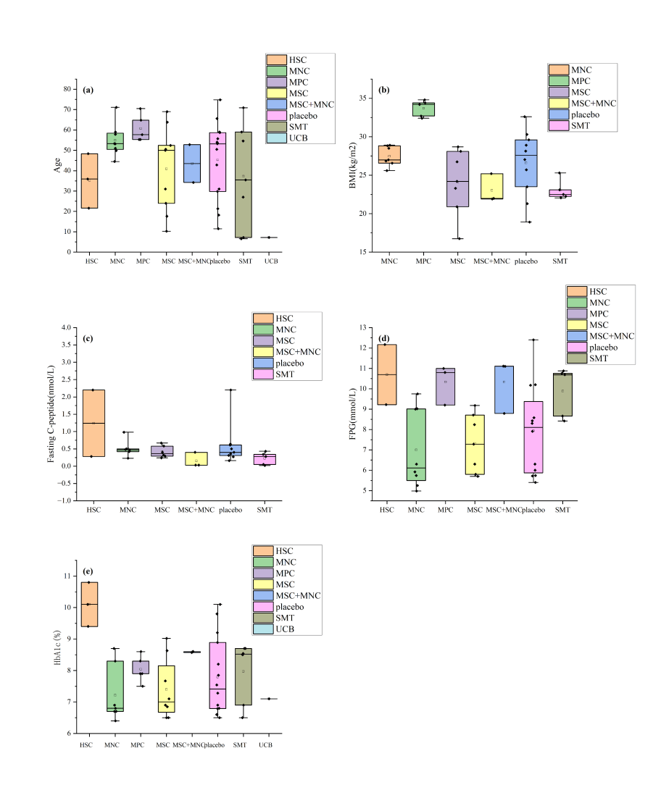
Note: (a) age; (b) BMI; (c) fasting C-peptide; (d) FPG; (e) HbA1c.
Abbreviations: BMI, body mass index; HbA1c, glycated hemoglobin; FPG, fasting plasma glucose.

Appendix 10: Network meta-regression according to diabetes type.
eTable 10.1 Unrelated- coefficient meta-regression for continuous outcomes.
Intervention (vs SMT) | Adjusted Mean Difference | Diabetes Type Coefficient (β, 95% CrI)
HbA1c
HSC | -0.08 (-1.44, 1.28) | 0.13 (-1.88, 2.19)
MNC | -0.69 (-4.89, 6.12) | -0.70 (-17.63, 10.74)
MPC | -0.97 (-7.71, 2.63) | 0.28 (-8.98, 17.28)
MSC | -0.94 (-1.64, -0.16) | -1.14 (-2.44, 0.18)
MSC+MNC | -1.34 (-1.97, -0.68) | -0.19 (-1.28, 0.93)
placebo | -0.2 (-0.94, 0.59) | -1.30 (-2.73, 0.08)
UCB | -0.75 (-6.92, 7.68) | 0.23 (-10.04, 13.61)
FPG
HSC | -0.28 (-4.9, 4.2) | 0.40 (-4.20, 5.48)
MNC | -2.14 (-7.62, 2.24) | 0.56 (-9.35, 13.01)
MPC | -1.8 (-11.97, 6.51) | 0.41 (-17.61, 22.95)
MSC | -1.84 (-5.14, 1.6) | -0.34 (-4.23, 3.10)
MSC+MNC | -2.24 (-4.14, -0.34) | 0.00 (-2.88, 2.85)
placebo | -1.9 (-5.3, 1.47) | -0.06 (-3.80, 3.30)
Fasting C-peptide
HSC | 0.11 (-0.55, 0.8) | 0.20 (-0.67, 1.22)
MNC | 0.19 (-0.55, 1.15) | -0.13 (-2.42, 1.71)
MPC | -0.62 (-2.39, 1.57) | -0.08 (-5.15, 4.08)
MSC | 0.05 (-0.24, 0.35) | 0.03 (-0.38, 0.45)
MSC+MNC | 0.12 (-0.11, 0.37) | 0.16 (-0.22, 0.66)
placebo | -0.07 (-0.35, 0.24) | 0.00 (-0.43, 0.43)
TDD
MNC | -0.37 (-3.09, 0.8) | 0.30 (-1.45, 3.91)
MSC | -0.06 (-0.73, 0.51) | -0.19 (-1.57, 0.68)
MSC+MNC | -0.37 (-0.9, 0.17) | -0.05 (-0.75, 0.64)
placebo | -0.12 (-0.87, 0.58) | 0.04 (-1.27, 0.96)
UCB | -0.08 (-1.07, 0.76) | -0.07 (-3.07, 2.54)

eTable 10.2 Shared-coefficient meta-regression for adverse events.
Intervention (vs placebo) | Adjusted OR (95% CrI) | Diabetes Type Coefficient (β, 95% CrI)
AE
MPC | 1.09 (0.18, 7.46) | 0.003 (-1.05, 4.69)
MSC | 0.62 (0.13, 2.29) | 0.003 (-1.05, 4.69)
MSC+MNC | 7.1 (0.36, 157.09) | 0.003 (-1.05, 4.69)

eTable 10.3 Covariate-specific treatment effects for T1DM and T2DM.
Diabetes Type
Intervention (vs SMT) | Main analysis | T2DM Population  MD (95% CrI) | T1DM Population  MD (95% CrI)
HbA1C
HSC | -0.46 (-1.80, 0.95) | -0.04 (-1.65, 1.6) | -0.16 (-1.91, 1.58)
MNC | -0.50 (-1.13, 0.19) | -0.74 (-1.35, -0.06) | -0.63 (-11.42, 16.86)
MPC | -0.60 (-1.66, 0.60) | -1 (-1.98, 0.17) | -0.92 (-18.29, 8.03)
MSC | -0.95 (-1.70, -0.09) | -1.39 (-2.21, -0.4) | -0.24 (-1.32, 0.84)
MSC+MNC | -1.26 (-1.97, -0.54) | -1.42 (-2.22, -0.56) | -1.22 (-2.07, -0.37)
placebo | -0.34 (-1.08, 0.49) | -0.71 (-1.46, 0.15) | 0.6 (-0.7, 1.93)
UCB | -0.76 (-2.01, 0.49) | -0.75 (-10.8, 12.95) | -0.75 (-1.9, 0.4)
FPG
HSC | 0.60 (-3.13, 4.36) | -0.11 (-4.86, 4.45) | -0.5 (-6.31, 5.06)
MNC | -2.03 (-3.75, -0.35) | -2.02 (-3.97, -0.07) | -2.25 (-15.08, 7.52)
MPC | -0.85 (-4.52, 2.75) | -1.72 (-6.19, 2.58) | -1.85 (-24.96, 16.15)
MSC | -1.17 (-3.53, 1.27) | -1.98 (-5.04, 1.17) | -1.69 (-6.11, 3.19)
MSC+MNC | -2.24 (-3.93, -0.56) | -2.24 (-4.51, 0.04) | -2.24 (-4.72, 0.26)
placebo | -1.05 (-3.36, 1.23) | -1.9 (-5.11, 1.14) | -1.9 (-6.32, 2.85)
Fasting C-peptide
HSC | 0.02 (-0.55, 0.58) | 0.19 (-0.68, 1.14) | -0.01 (-0.66, 0.66)
MNC | 0.13 (-0.06, 0.33) | 0.16 (-0.08, 0.41) | 0.22 (-1.56, 2.59)
MPC | -0.65 (-1.49, 0.19) | -0.63 (-1.52, 0.26) | -0.61 (-4.73, 4.6)
MSC | 0.03 (-0.21, 0.27) | 0.07 (-0.31, 0.44) | 0.03 (-0.28, 0.36)
MSC+MNC | 0.11 (-0.09, 0.31) | 0.19 (-0.11, 0.52) | 0.03 (-0.32, 0.34)
placebo | -0.09 (-0.34, 0.17) | -0.07 (-0.42, 0.3) | -0.06 (-0.42, 0.31)
TDD
MNC | -0.28 (-0.74, 0.19) | -0.29 (-0.75, 0.18) | -0.39 (-4.2, 1.19)
MSC | -0.02 (-0.53, 0.50) | -0.15 (-1.65, 0.8) | -0.02 (-0.54, 0.5)
MSC+MNC | -0.39 (-0.80, 0.03) | -0.41 (-0.83, 0.04) | -0.36 (-1.04, 0.34)
placebo | 0.00 (-0.63, 0.58) | -0.04 (-1.51, 0.93) | -0.15 (-0.77, 0.55)
UCB | -0.08 (-0.58, 0.43) | -0.08 (-3.17, 2.47) | -0.08 (-0.58, 0.43)
Diabetes Type
Intervention (vs placebo) | Main analysis | T2DM Population  OR (95% CrI) | T1DM Population  OR (95% CrI)
AE
MPC | 2.62 (0.30, 10.65) | 1.67 (0.33, 9.12) | 0.41 (0.01, 9)
MSC | 0.86 (0.13, 2.67) | 0.95 (0.17, 3.81) | 0.23 (0.01, 2.23)
MSC+MNC | 5.66 (0.23, 28.75) | 10.47 (0.33, 489) | 2.51 (0.27, 24.42)

Appendix 11: Publication Bias Assessment.
eFigure 11: The comparison-adjusted funnel plot.
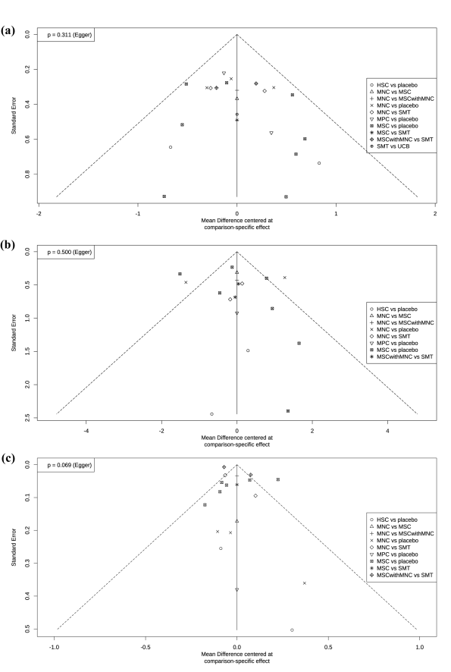
Note: (a) HbA1c; (b) FPG; (c) fasting C-peptide.
Publication bias was not formally assessed for TDD or AEs because fewer than 10 independent studies contributed to these outcomes.
Abbreviations: P-value, Probability Value; HbA1c, glycated hemoglobin; FPG, fasting plasma glucose; TDD, total daily insulin dose.
eTable 11: Publication Bias Assessment Using Egger’s Regression Test.
Outcome Measure | Egger's Test
Outcome Measure | Coefficient (b) | P-value
HbA1c | 0.5620 | 0.3114
FPG | 0.5672 | 0.5000
Fasting C-peptide | 1.0422 | 0.0689
Note: Egger’s regression test was used to assess funnel-plot asymmetry, with P < 0.05 considered suggestive of small-study effects. The test was not performed for TDD or AEs because fewer than 10 independent RCTs contributed to these outcomes.
Abbreviations: P-value, Probability Value; HbA1c, glycated hemoglobin; FPG, fasting plasma glucose.

Appendix 12: Sensitivity analyses.
Intervention (vs SMT) | Main analysis | Fixed model | Restricted analysis
HbA1c
HSC | -0.46 (-1.80, 0.95) | -0.61 (-1.66, 0.46) | -0.33 (-1.93, 1.38)
MNC | -0.50 (-1.13, 0.19) | -0.56 (-0.96, -0.17) | -0.41 (-1.36, 0.63)
MPC | -0.60 (-1.66, 0.60) | -0.8 (-1.42, -0.18) | -0.62 (-2.18, 1.07)
MSC | -0.95 (-1.70, -0.09) | -1.13 (-1.63, -0.63) | -0.91 (-1.91, 0.20)
MSC+MNC | -1.26 (-1.97, -0.54) | -1.28 (-1.68, -0.89) | -1.23 (-2.10, -0.34)
placebo | -0.34 (-1.08, 0.49) | -0.46 (-0.93, 0.01) | -0.22 (-1.24, 0.92)
UCB | -0.76 (-2.01, 0.49) | -0.75 (-1.65, 0.14) | NA
FPG
HSC | 0.60 (-3.13, 4.36) | 0.65 (-2, 3.28) | -0.12 (-4.65, 4.30)
MNC | -2.03 (-3.75, -0.35) | -1.98 (-2.72, -1.23) | -1.88 (-4.30, 0.54)
MPC | -0.85 (-4.52, 2.75) | -0.85 (-2.86, 1.17) | -1.55 (-6.03, 2.85)
MSC | -1.17 (-3.53, 1.27) | -1.44 (-2.34, -0.55) | -1.88 (-5.12, 1.43)
MSC+MNC | -2.24 (-3.93, -0.56) | -2.23 (-2.97, -1.49) | -2.19 (-4.09, -0.29)
placebo | -1.05 (-3.36, 1.23) | -1.04 (-1.94, -0.15) | -1.76 (-5.09, 1.50)
Fasting C-peptide
HSC | 0.02 (-0.55, 0.58) | -0.06 (-0.52, 0.4) | -0.01 (-0.58, 0.56)
MNC | 0.13 (-0.06, 0.33) | 0.06 (0.01, 0.11) | 0.07 (-0.16, 0.31)
MPC | -0.65 (-1.49, 0.19) | -0.71 (-1.46, 0.04) | -0.68 (-1.52, 0.16)
MSC | 0.03 (-0.21, 0.27) | 0.01 (-0.09, 0.12) | 0.01 (-0.25, 0.26)
MSC+MNC | 0.11 (-0.09, 0.31) | 0.03 (0.01, 0.04) | 0.09 (-0.11, 0.30)
placebo | -0.09 (-0.34, 0.17) | -0.15 (-0.27, -0.03) | -0.12 (-0.38, 0.15)
TDD
MNC | -0.28 (-0.74, 0.19) | -0.29 (-0.39, -0.19) | -0.28 (-0.74, 0.19)
MSC | -0.02 (-0.53, 0.50) | -0.02 (-0.26, 0.22) | -0.02 (-0.54, 0.49)
MSC+MNC | -0.39 (-0.80, 0.03) | -0.41 (-0.51, -0.3) | -0.39 (-0.80, 0.03)
placebo | 0.00 (-0.63, 0.58) | 0.07 (-0.19, 0.33) | -0.01 (-0.63, 0.58)
UCB | -0.08 (-0.58, 0.43) | -0.08 (-0.3, 0.15) | NA
Intervention (vs placebo) | Main analysis | Fixed model | Restricted analysis
AE
MPC | 2.62 (0.30, 10.65) | 1.61 (0.58, 4.59) | 3.07 (0.11, 16.32)
MSC | 0.86 (0.13, 2.67) | 0.89 (0.39, 2.03) | 0.84 (0.12, 2.75)
MSC+MNC | 5.66 (0.23, 28.75) | 2.52 (0.66, 10.47) | 6.23 (0.20, 33.87)
Note: Cells with a light grey background indicate that the statistical significance status differed from that in the primary random-effects analysis. The restricted analysis excluded trials that primarily targeted diabetes-related complications or included major non-cellular co-interventions that could independently influence metabolic outcomes. Background glucose-lowering therapy routinely administered to both treatment groups was not considered a major co-intervention. NA indicates that the corresponding treatment node was no longer represented after the restricted trials were excluded.
Abbreviations: HbA1c, glycated hemoglobin; FPG, fasting plasma glucose; TDD, total daily insulin dose; AE, adverse events; NA, not available.

Appendix 13: Convergence diagnostics and model fit assessment for the network meta‑analysis.
This appendix summarizes the diagnostic assessments used to evaluate the convergence of the Bayesian network meta-analysis and the adequacy of model fitting. The following graphical diagnostics are presented: (1) Trace and density plots, which allow visual evaluation of chain mixing, sampling stability, and the posterior distributions of model parameters; (2) Brooks–Gelman–Rubin convergence diagnostic plots (potential scale reduction factor, PSRF), which were used to assess whether multiple Markov chain Monte Carlo (MCMC) chains converged to a common stationary distribution; (3) Deviance residual (leverage) plots, which were used to assess model fit and to identify studies with relatively high leverage or potential lack of fit.
eFigure 13.1. Trace and density plots for the MCMC chains.
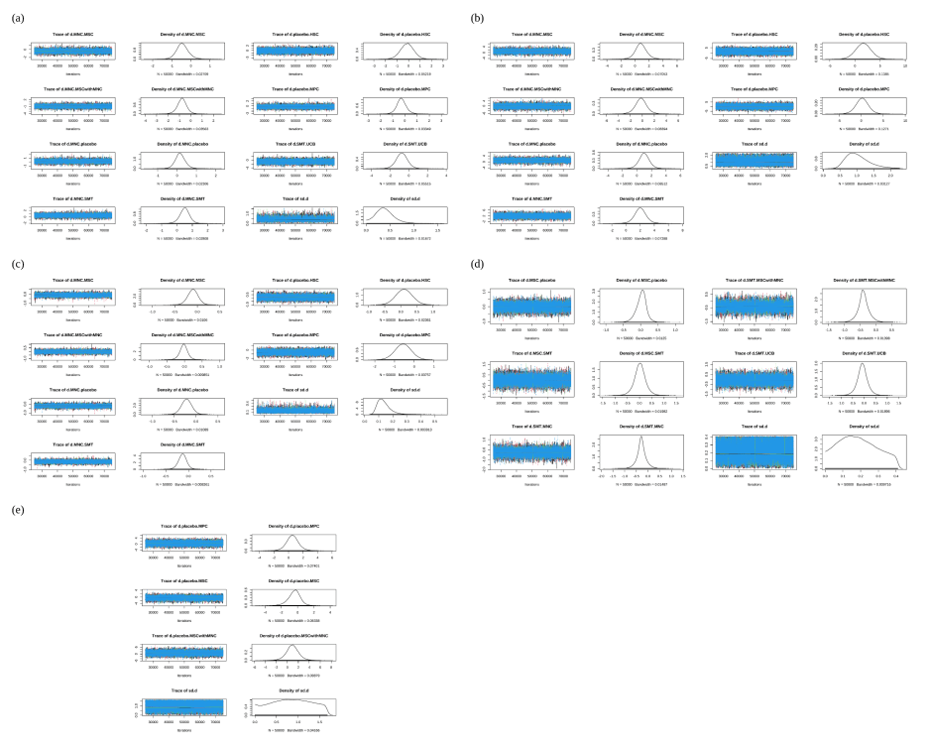
Note: (a) HbA1c; (b) FPG; (c) fasting C-peptide; (d) TDD; (e) AE.
Trace plots (left panels) illustrate the sampled values of each model parameter across successive iterations for the four parallel Markov chain Monte Carlo (MCMC) chains, with each chain represented by a different color. Density plots (right panels) present the estimated posterior distributions obtained by pooling samples from all chains. Adequate convergence is indicated by trace plots showing good mixing without obvious trends or separation between chains, together with smooth and stable posterior density distributions. Conversely, systematic trends, poor chain mixing, pronounced autocorrelation, or separation of the parallel chains may indicate insufficient convergence and warrant further model assessment.
Abbreviations: HbA1c, glycated hemoglobin; FPG, fasting plasma glucose; TDD, total daily insulin dose; AE, adverse events.

eFigure 13.2. Brooks–Gelman–Rubin convergence diagnostic (PSRF) plot.
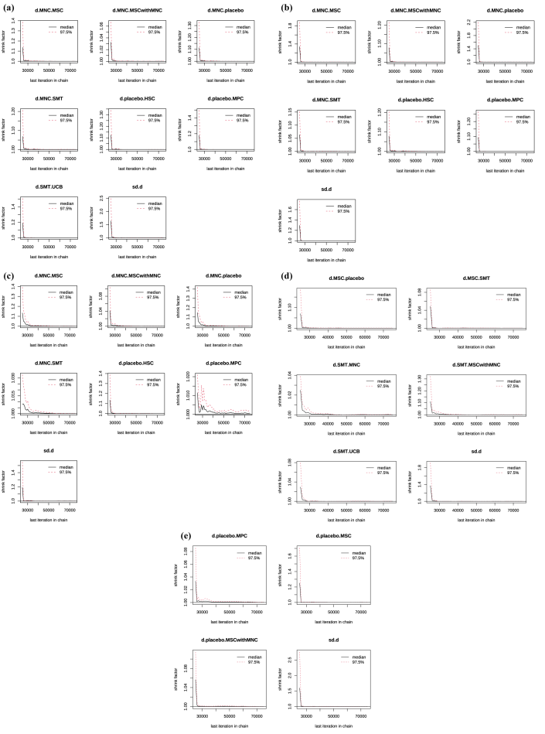
Note: (a) HbA1c; (b) FPG; (c) fasting C-peptide; (d) TDD; (e) AE.
The potential scale reduction factor (PSRF; Gelman–Rubin statistic, √R̂) was monitored throughout the MCMC simulations for all model parameters. The PSRF curves were plotted against the iteration number to assess convergence across the parallel chains. Values close to 1.0 indicate satisfactory convergence, whereas persistently elevated values suggest that convergence has not yet been achieved. A reference line at 1.05 was used as the commonly accepted convergence threshold.
Abbreviations: HbA1c, glycated hemoglobin; FPG, fasting plasma glucose; TDD, total daily insulin dose; AE, adverse events.

eFigure 13.3. Deviance residual plot (leverage plot).
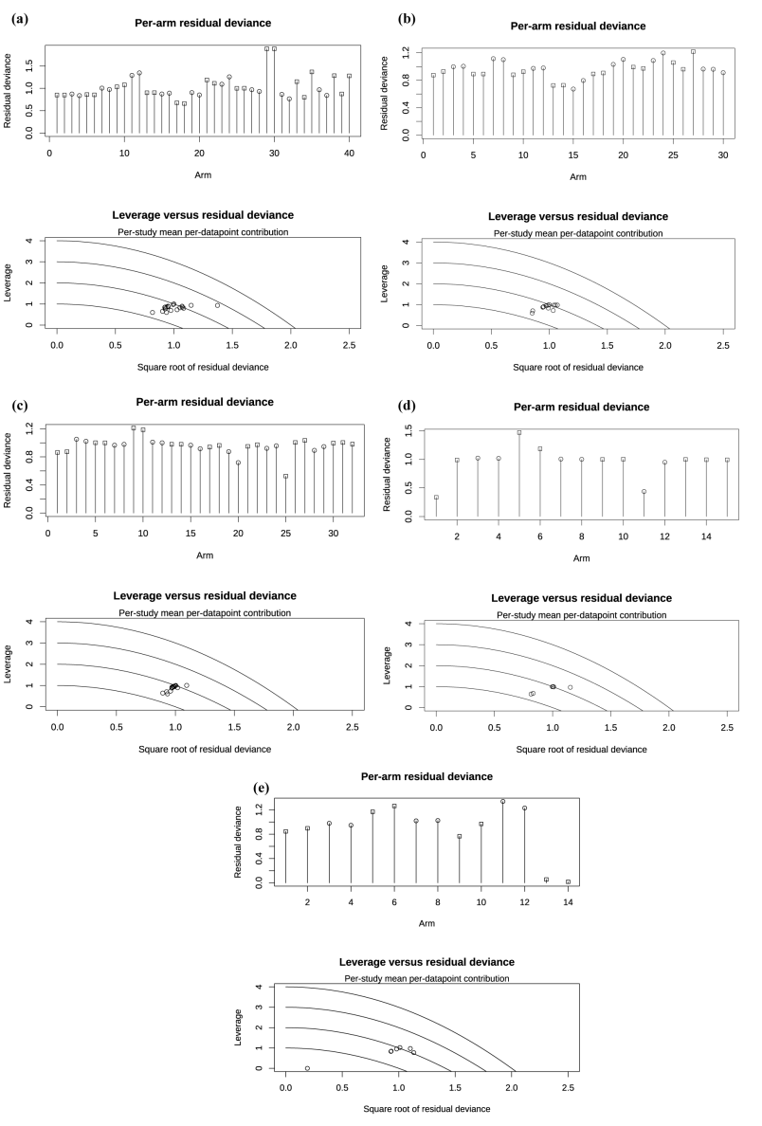
Note: (a) HbA1c; (b) FPG; (c) fasting C-peptide; (d) TDD; (e) AE.
The posterior mean deviance residuals were plotted against the corresponding study leverages to evaluate model fit and identify influential observations. Study leverage reflects the extent to which an individual study contributes to its own fitted value within the network meta-analysis model. Studies exhibiting both relatively large deviance residuals and high leverage may indicate potential outliers or observations that are not well explained by the model. A locally weighted scatterplot smoothing (LOESS) curve was added to facilitate visual assessment of the overall relationship. Points located substantially away from the main cluster were considered worthy of further investigation.
Abbreviations: HbA1c, glycated hemoglobin; FPG, fasting plasma glucose; TDD, total daily insulin dose; AE, adverse events.

