Association between adverse childhood experiences and age at menopause: a cross-national analysis of the UK Biobank and Health and Retirement Study
Supplementary Materials
Supplementary Table S1. Questions and responses for variables included in the adverse childhood experiences in UK Biobank 2
Supplementary Table S2. Questions and responses for variables included in the adverse childhood experiences in US HRS 3
Supplementary Table S3. Assessment of Covariate in UK Biobank 5
Supplementary Table S4. Assessment of Covariate in US HRS 12
Supplementary Table S5. Association between ACE variables and age at menopause in linear regression models, UK Biobank and US HRS 15
Supplementary Table S6. Association between ACE variables and early menopause defined at three age thresholds (<40, <45, and <48 years) in logistic regression models, UK Biobank and US HRS 17
Supplementary Figure S1. Directed Acyclic Graph of this study 19
Supplementary Figure S2. Spearman correlations between ACE variables and covariates 20

Table S1: Questions and responses for variables included in the adverse childhood experiences in UK Biobank.
Filed ID | Childhood maltreatment questions |  | Responses/description | Cut off
20491 | Physical neglect | Someone to take to doctor when needed as a child | 0, Never true;  1, Rarely true;  2, Sometimes true;  3, Often;  4, Very often true | ≤ 3 (Yes)
20489 | Emotional neglect | Felt loved as a child |  | ≤ 2 (Yes)
20490 | Sexual abuse | Sexually molested as a child |  | ≥ 1 (Yes)
20488 | Physical abuse | Physically abused by family as a child |  | ≥ 1 (Yes)
20487 | Emotional abuse | Felt hated by family member as a child |  | ≥ 1 (Yes)
Footnotes: The definition of ACE variables in UKB specifically referred to the methods outlined in previous publications.
Yu J, Pu F, Yang G, Hao M, Zhang H, Zhang J, Cao X, Zhu L, Wan Y, Wang X, et al. Sex-Specific Association Between Childhood Adversity and Accelerated Biological Aging. Adv Sci (Weinh) 2024;11:e2309346. Germany.
Jiang W, He Y, Liu Q, Peng S, Ni Y, Zhong X, Guo L. Associations between childhood maltreatment, peripheral immune biomarkers, and psychiatric symptoms in adults: A cohort study of over 138,000 participants. Brain Behav Immun 2025;123:840–850. Netherlands.
Abbreviations: UKB, UK Biobank; ACE, Adverse Childhood Experiences.
Table S2: Questions and responses for variables included in the adverse childhood experiences in US HRS.
Filed ID | Childhood maltreatment questions |  | Responses/description | Cut off
ramomeducl/radadeducl | Parental education | What is the highest grade of school your mother/father completed? | 1, Less than upper secondary;  2, Upper secondary&vocational training;  3, Tertiary | 1 (Yes)
r8pabused-r11pabused | Parental physical abuse | Before you were 18 years old, were you ever physically abused by either of your parents? | 0, No;  1, Yes | 1 (Yes)
r8padrug-r11padrug | Parental alcohol and drug use | Before you were 18 years old, did either of your parents drink or use drugs so often that it caused problems in the family? | 0, No;  1, Yes | 1 (Yes)
rasepmom/rasepdad | Childhood separation from either parent | Before you were age 16, were you ever separated from your mother/father for 6 months or longer? | 0, No;  1, Yes | 1 (Yes)
rapadiech | Death of a parent | Before you were age 16, did one or both parents die? | 0, No;  1, Yes | 1 (Yes)
LH2A_15 | Living in a children's home or orphanage | Before you were age 16, did you ever live in a children’s home or orphanage？ | 0, No;  1, Yes | 1 (Yes)
rafinanch | Childhood poverty | Would you say your family during that time was pretty well off financially,about average, or poor? | 1, Pretty well off financially;  2, About average;  3, Poor | 3 (Yes)
rapadivch | Parental separation or divorce | Before you were age 16, did your biological or adoptive parents separate or divorce? | 0, No;  1, Yes | 1 (Yes)
Footnotes: The definition of ACE variables in HRS specifically referred to the methods outlined in previous publications.
Klopack ET, Crimmins EM, Cole SW, Seeman TE, Carroll JE. Accelerated epigenetic aging mediates link between adverse childhood experiences and depressive symptoms in older adults: Results from the Health and Retirement Study. SSM - Population Health 2022;17:101071.
Abbreviations: HRS, Health and Retirement Study; ACE, Adverse Childhood Experiences.

Table S3. Assessment of Covariate in UK Biobank.
Covariate | Variables | Field ID | Description | Definition
BMI |  | 21001 | Body mass index (BMI) | Directly adopted this variable
Income |  | 738 | Average total household income before tax | Those who reported an income below 31,000 were classified as "Low", those who reported an income between 31,000 and 51,999 were classified as "Medium", and those who reported an income above 52,000 were classified as "High".
University education |  | 6138 | Qualifications | Those who reported a college or university degree were classified as "Yes", while others were designated as "No".
Career |  | 6142 | Current employment status | Those who reported in paid employment or self-employed, retired, doing unpaid or voluntary work and full or part-time student were classified as "Yes", while others were designated as "No".
TDI |  | 22189 | Townsend deprivation index at recruitment | Directly adopted this variable
Ethnicity/race |  | 21000 | Ethnic background | Those who reported White ethnicity were classified as "White", while others were designated as "Other".
Smoking |  | 20116 | Smoking status | Those who reported previous or current smoking were classified as "Yes", while who reported never smoking were designated as "No".
Drinking |  | 20117 | Alcohol drinker status | Those who reported previous or current drinking were classified as "Yes", while who reported never drinking were designated as "No".
Comorbidity | Cardiovascular disease | 131296 | Date I20 first reported (angina pectoris) | Those who were diagnosed with any of the following conditions prior to recruitment — I20, I21, I25, I48, I50, I60, I61, I63, or I64 — were classified as having cardiovascular disease, while others were designated as not having cardiovascular disease. | Those who reported a diagnosis of any of the following conditions prior to recruitment — cardiovascular disease, diabetes, hypertension, cancer, or lung diseases — were classified as having comorbidity ("Yes"), while those without any of these diagnoses were designated as not having comorbidity ("No").
Comorbidity | Cardiovascular disease | 131298 | Date I21 first reported (acute myocardial infarction)
Comorbidity | Cardiovascular disease | 131306 | Date I25 first reported (chronic ischaemic heart disease)
Comorbidity | Cardiovascular disease | 131350 | Date I48 first reported (atrial fibrillation and flutter)
Comorbidity | Cardiovascular disease | 131354 | Date I50 first reported (heart failure)
Comorbidity | Cardiovascular disease | 131360 | Date I60 first reported (subarachnoid haemorrhage)
Comorbidity | Cardiovascular disease | 131362 | Date I61 first reported (intracerebral haemorrhage)
Comorbidity | Cardiovascular disease | 131366 | Date I63 first reported (cerebral infarction)
Comorbidity | Cardiovascular disease | 131368 | Date I64 first reported (stroke, not specified as haemorrhage or infarction)
Comorbidity | Diabetes | 120007 | Ever had diabetes (Type I or Type II) | Participants were classified as having diabetes if they met any of the following criteria: (1) answered "Yes" to ever having had diabetes (Type I or Type II) or a doctor's diagnosis of diabetes (2443); (2) reported age at diabetes diagnosis was less than their recruitment age; (3) had a recorded diagnosis of E10, E11, E12, E13, or E14 prior to recruitment; or (4) reported taking insulin in either variable 6177 or 6153. All other participants were designated as not having diabetes.
Comorbidity | Diabetes | 2443 | Diabetes diagnosed by doctor
Comorbidity | Diabetes | 2976 | Age diabetes diagnosed
Comorbidity | Diabetes | 130706 | Date E10 first reported (insulin-dependent diabetes mellitus)
Comorbidity | Diabetes | 130708 | Date E11 first reported (non-insulin-dependent diabetes mellitus)
Comorbidity | Diabetes | 130710 | Date E12 first reported (malnutrition-related diabetes mellitus)
Comorbidity | Diabetes | 130712 | Date E13 first reported (other specified diabetes mellitus)
Comorbidity | Diabetes | 130714 | Date E14 first reported (unspecified diabetes mellitus)
Comorbidity | Diabetes | 6177 | Medication for cholesterol, blood pressure or diabetes
Comorbidity | Diabetes | 6153 | Medication for cholesterol, blood pressure, diabetes, or take exogenous hormones
Comorbidity | Hypertension | 4079 | Diastolic blood pressure, automated reading | Participants were classified as having hypertension if they met any of the following criteria: (1) systolic blood pressure ≥ 140 or diastolic blood pressure ≥ 90; (2) reported high blood pressure in Vascular/heart problems diagnosed by doctor; or (3) reported taking blood pressure medication in either variable 6177 or 6153. All other participants were designated as not having hypertension.
Comorbidity | Hypertension | 4080 | Systolic blood pressure, automated reading
Comorbidity | Hypertension | 6150 | Vascular/heart problems diagnosed by doctor
Comorbidity | Hypertension | 6177 | Medication for cholesterol, blood pressure or diabetes
Comorbidity | Hypertension | 6153 | Medication for cholesterol, blood pressure, diabetes, or take exogenous hormone
Comorbidity | Cancer | 40008 | Age at cancer diagnosis | Those who were diagnosed with cancer prior to recruitment were classified as having cancer, while others were designated as not having cancer.
Comorbidity | Lung diseases | 131486 | Date J41 first reported (simple and mucopurulent chronic bronchitis) | Those who were diagnosed with any of the following conditions prior to recruitment — J41, J42, J43, or J44 — were classified as having lung diseases, while others were designated as not having lung diseases.
Comorbidity | Lung diseases | 131488 | Date J42 first reported (unspecified chronic bronchitis)
Comorbidity | Lung diseases | 131490 | Date J43 first reported (emphysema)
Comorbidity | Lung diseases | 131492 | Date J44 first reported (other chronic obstructive pulmonary disease)
Depression |  | 20510 | Recent feelings of depression | Depression was defined by the total score on the PHQ-9, which was computed by adding the scores from each of the nine items (each scored 0 to 3), giving a total ranging from 0 to 27.
Depression |  | 20518 | Recent changes in speed/amount of moving or speaking
Depression |  | 20507 | Recent feelings of inadequacy
Depression |  | 20519 | Recent feelings of tiredness or low energy
Depression |  | 20514 | Recent lack of interest or pleasure in doing things
Depression |  | 20511 | Recent poor appetite or overeating
Depression |  | 20513 | Recent thoughts of suicide or self-harm
Depression |  | 20508 | Recent trouble concentrating on things
Depression |  | 20517 | Trouble falling or staying asleep, or sleeping too much
Age at menarche |  | 2714 | Age when periods started (menarche) | Directly adopted this variable
live birth |  | 2734 | Number of live births | Directly adopted this variable
Abbreviation: BMI, Body Mass Index; TDI, Townsend Deprivation Index

Table S4. Assessment of Covariate in US HRS.
Covariate | Field ID | Description | Definition
BMI | r9pmbmi-r14pmbmi | physical measure body mass index=kg/m² | Directly adopted this variable
Income | r9iearn-r15iearn | Earnings | Those who reported an income below $18,000 were classified as "Low", those who reported an income between $18,000 and $51,999 were classified as "Medium", and those who reported an income above $52,000 were classified as "High".
University education | raeduc | Education | Those who reported a some college or college and above were classified as "Yes", while others were designated as "No".
Career | r9work-r15work | Working for pay | Directly adopted this variable
Ethnicity/race | raracem | Race-masked | Directly adopted this variable
Smoking | r9smokev-r15smokev | Ever smoke | Directly adopted this variable
Drinking | r9drink-r15drink | Ever drinks any alcohol | Directly adopted this variable
Comorbidity | r9hearte-r15hearte  r9stroke-r15stroke  r9diabe-r15diabe  r9hibpe-r15hibpe  r9cancre-r15cancre  r9lunge-r15lunge | Ever had heart problems  Ever had stroke  Ever had diabetes  Ever had high blood pressure  Ever had cancer  Ever had lung problems | Those who reported a diagnosis of any of the following conditions — heart problems, stroke, diabetes, high blood pressure, cancer, or lung diseases — were classified as having comorbidity ("Yes"), while those without any of these diagnoses were designated as not having comorbidity ("No").
Depression | r9depres-r15depres  r9enlife-r15enlife  r9whappy-r15whappy  r9flone-r15flone  r9fsad-r15fsad  r9effort-r15effort  r9sleepr-r15sleepr  r9going-r15going | Felt depressed  Enjoyed life  Was happy  Felt lonely  Felt sad  Everything an effort  Sleep was restless  Could not get going | Depression was defined by the CES-D8 score, the sum of six "negative" indicators plus the inverse (one minus the variable value) of two "positive" indicators
Abbreviation: BMI, Body Mass Index

Table S5: Association between ACE variables and age at menopause in linear regression models, UK Biobank and US HRS.
 |  | Age at menopause
 |  | Crude model |  | Model 1
 |  | β (95%CI) | P | β (95%CI) | P
UKB | Emotional neglect | 0.079 (0.033, 0.126) | < 0.001 | 0.023 (-0.025, 0.070) | 0.347
 | Physical neglect | 0.060 (-0.001, 0.121) | 0.0537 | 0.050 (-0.011, 0.111) | 0.107
 | Physical abuse | -0.262 (-0.335, -0.189) | < 0.001 | -0.211 (-0.284, -0.137) | < 0.001
 | Sexual abuse | -0.158 (-0.238, -0.079) | < 0.001 | -0.104 (-0.184, -0.025) | 0.010
 | Emotional abuse | -0.177 (-0.236, -0.119) | < 0.001 | -0.092 (-0.152, -0.033) | 0.002
HRS | Parental education | -0.942 (-1.378, -0.506) | < 0.001 | -0.157 (-0.625, 0.312) | 0.512
 | Parental physical abuse | -0.490 (-1.031, 0.051) | 0.076 | -0.334 (-0.876, 0.209) | 0.228
 | Parental alcohol and drug use | -0.220 (-0.602, 0.162) | 0.258 | -0.148 (-0.530, 0.233) | 0.446
 | Childhood separation from either parent | -0.530 (-0.857, -0.203) | 0.002 | -0.223 (-0.556, 0.110) | 0.189
 | Death of parent | -0.818 (-1.168, -0.467) | < 0.001 | -0.442 (-0.797, -0.087) | 0.015
 | Living in children's home or orphanage | -2.045 (-3.318, -0.771) | 0.002 | -1.635 (-2.898, -0.372) | 0.011
 | Childhood poverty | -0.671 (-1.153, -0.189) | 0.006 | -0.172 (-0.662, 0.317) | 0.491
 | Parental separation or divorce | -0.494 (-0.880, -0.107) | 0.012 | -0.267(-0.655, 0.121) | 0.172

Footnotes: Linear regression was used for the continuous outcome, age at menopause. Crude model was an un-adjusted model. In UKB Model 1, adjustments were made for BMI, income, university education, career, TDI, ethnicity/race, smoking, drinking, comorbidity, depression, age at menarche, and live birth. In HRS Model 1, adjustments were made for BMI, income, university education, career, ethnicity/race, smoking, drinking, comorbidity, and depression. The results show the regression coefficients (β), their 95% confidence intervals (95% CI), and P. Bold values indicate statistical significance (P < 0.05 or P < 0.001).
Abbreviations: BMI, Body Mass Index; TDI, Townsend Deprivation Index; CI, Confidence interval; UKB, UK Biobank; HRS, Health and Retirement Study; ACE, Adverse Childhood Experiences.

Table S6: Association between ACE variables and early menopause defined at three age thresholds (<40, <45, and <48 years) in logistic regression models, UK Biobank and US HRS.
 |  | Early menopause (< 40 years old) |  |  |  | Early menopause (< 45 years old) |  |  |  | Early menopause (< 48 years old)
 |  | Crude model |  | Model 1 |  | Crude model |  | Model 1 |  | Crude model |  | Model 1
 |  | OR (95%CI) | P | OR (95%CI) | P | OR (95%CI) | P | OR (95%CI) | P | OR (95%CI) | P | OR (95%CI) | P
UKB | Emotional neglect | 0.923 (0.848, 1.004) | < 0.001 | 0.923 (0.848, 1.004) | 0.065 | 0.928 (0.893, 0.964) | < 0.001 | 0.964 (0.927, 1.003) | 0.066 | 0.953 (0.927, 0.979) | < 0.001 | 0.987 (0.959, 1.015) | 0.360
 | Physical neglect | 0.908 (0.818, 1.009) | 0.073 | 0.934 (0.838, 1.040) | 0.213 | 1.109 (1.042, 1.180) | < 0.001 | 0.933 (0.888, 0.979) | 0.005 | 0.945 (0.912, 0.979) | 0.002 | 0.960 (0.926, 0.996) | 0.029
 | Physical abuse | 1.388 (1.249, 1.543) | < 0.001 | 1.310 (1.174, 1.461) | < 0.001 | 1.188 (1.125, 1.256) | < 0.001 | 1.150 (1.086, 1.216) | < 0.001 | 1.117 (1.072, 1.165) | < 0.001 | 1.082 (1.037, 1.130) | < 0.001
 | Sexual abuse | 1.225 (1.081, 1.388) | 0.002 | 1.150 (1.013, 1.306) | 0.032 | 1.109 (1.042, 1.180) | 0.001 | 1.069 (1.004, 1.139) | 0.039 | 1.108 (1.059, 1.159) | < 0.001 | 1.072 (1.024, 1.123) | 0.003
 | Emotional abuse | 1.237 (1.130, 1.354) | < 0.001 | 1.141 (1.038, 1.255) | 0.007 | 1.115 (1.064, 1.166) | < 0.001 | 1.063 (1.014, 1.114) | 0.011 | 1.092 (1.056, 1.129) | < 0.001 | 1.044 (1.008, 1.080) | 0.016
HRS | Parental education | 2.675 (1.651, 4.335) | < 0.001 | 1.781 (1.058, 2.998) | 0.030 | 1.447 (1.123, 1.862) | 0.004 | 0.985 (0.744, 1.304) | 0.918 | 1.484 (1.222, 1.801) | < 0.001 | 1.114 (0.900, 1.380) | 0.321
 | Parental physical abuse | 0.844 (0.476, 1.497) | 0.563 | 0.830 (0.464, 1.485) | 0.530 | 1.106 (0.825, 1.483) | 0.502 | 1.076 (0.797, 1.453) | 0.632 | 1.179 (0.941, 1.476) | 0.152 | 1.146 (0.911, 1.442) | 0.245
 | Parental alcohol and drug use | 0.965 (0.657, 1.416) | 0.854 | 1.013 (0.686, 1.495) | 0.949 | 1.037 (0.839, 1.282) | 0.736 | 1.054 (0.849, 1.308) | 0.634 | 1.040 (0.884, 1.224) | 0.635 | 1.037 (0.879, 1.223) | 0.670
 | Childhood separation from either parent | 1.554 (1.156, 2.090) | 0.004 | 1.338 (0.987, 1.814) | 0.061 | 1.353 (1.137, 1.611) | < 0.001 | 1.353 (1.137, 1.611) | 0.048 | 1.269 (1.107, 1.455) | < 0.001 | 1.149 (0.998, 1.324) | 0.053
 | Death of parent | 2.340 (1.742, 3.141) | < 0.001 | 1.851 (1.368, 2.504) | < 0.001 | 1.627 (1.358, 1.949) | < 0.001 | 1.359 (1.128, 1.637) | 0.001 | 1.410 (1.220, 1.630) | < 0.001 | 1.229 (1.059, 1.427) | 0.007
 | Living in children's home or orphanage | 3.442 (1.622, 7.304) | 0.001 | 3.215 (1.487, 6.951) | 0.003 | 1.917 (1.073, 3.426) | 0.028 | 1.657 (0.916, 2.999) | 0.095 | 1.994 (1.222, 3.254) | 0.006 | 1.761 (1.071, 2.894) | 0.026
 | Childhood poverty | 1.319 (0.858, 2.028) | 0.208 | 1.034 (0.662, 1.616) | 0.882 | 1.307 (1.005, 1.700) | 0.046 | 1.073 (0.817, 1.409) | 0.614 | 1.303 (1.061, 1.600) | 0.012 | 1.120 (0.904, 1.388) | 0.299
 | Parental separation or divorce | 1.200 (0.839, 1.717) | 0.316 | 1.107 (0.768, 1.594) | 0.586 | 1.147 (0.931, 1.414) | 0.198 | 1.147 (0.931, 1.414) | 0.613 | 1.202 (1.023, 1.412) | 0.025 | 1.119 (0.949, 1.319) | 0.183
Footnotes: Logistic regression was used for the binary outcome early menopause, defined at three age thresholds (<40, <45, and <48 years). Crude model was an un-adjusted model. In UKB Model 1, adjustments were made for BMI, income, university education, career, TDI, ethnicity/race, smoking, drinking, comorbidity, depression, age at menarche, and live birth. In HRS Model 1, adjustments were made for BMI, income, university education, career, ethnicity/race, smoking, drinking, comorbidity, and depression. The results show the odds ratios (OR), their 95% confidence intervals (95% CI), and P. Bold values indicate statistical significance (P < 0.05 or P < 0.001). P for trend indicates the statistical significance of the trend across categories of the ACE level.
Abbreviations: BMI, Body Mass Index; TDI, Townsend Deprivation Index; CI, Confidence interval; UKB, UK Biobank; HRS, Health and Retirement Study; ACE, Adverse Childhood Experiences.

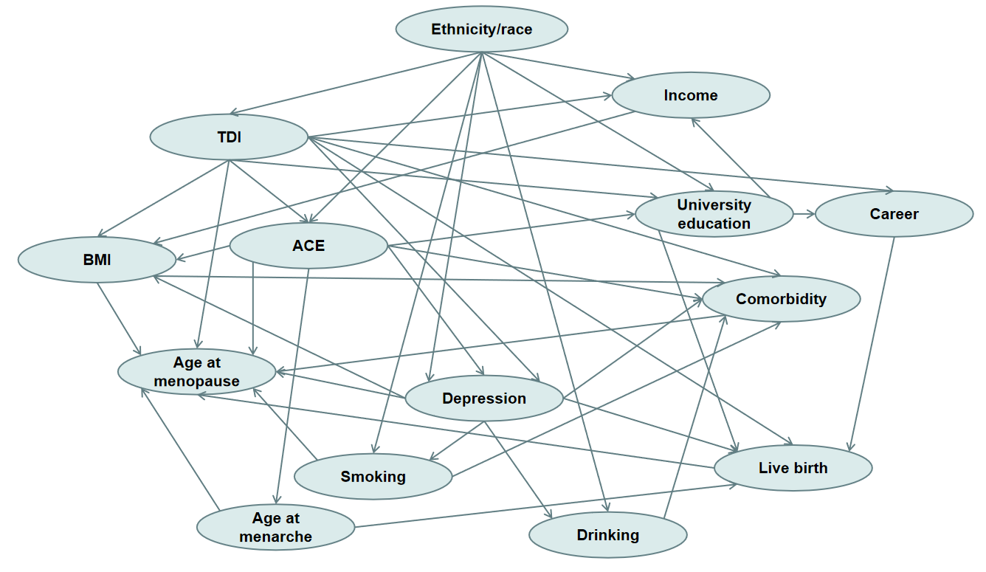
Figure S1: Directed Acyclic Graph of this study. This graph represents the hypothesized relationships among various factors related to age at menopause. Abbreviations: BMI, Body Mass Index; TDI, Townsend Deprivation Index; ACE, Adverse Childhood Experiences.
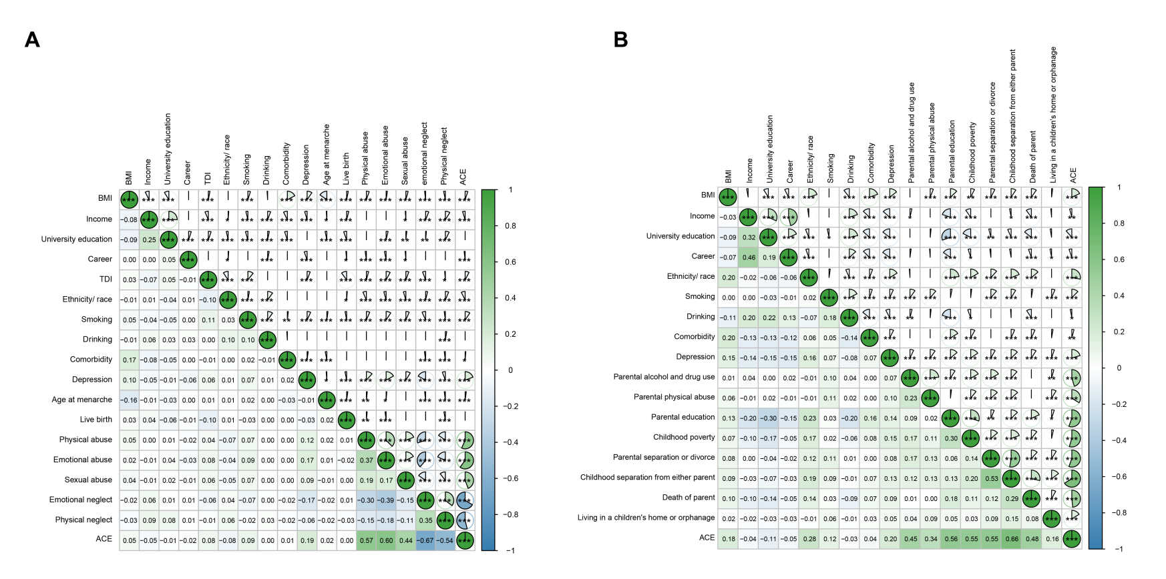
Figure S2: Spearman correlations between ACE variables and covariates. (A) UK Biobank; (B) US HRS. Green to blue: Correlation coefficients from 1
(strong positive, green) to -1 (strong negative, blue); *P < 0.05, **P < 0.01, ***P < 0.001; Numeric values show Spearman’s ρ (e.g. 0.12 = weak positive correlation). Larger absolute values indicate stronger associations (e.g. 0.66).
Abbreviations: BMI, Body Mass Index; TDI, Townsend Deprivation Index; ACE, Adverse Childhood Experiences; HRS, Health and Retirement Study.

