Supplementary Information for “Flood-scale shifts in effective sediment source zones and signal transmission through a gated-weir cascade”
Siyoon Kwon, Jun Song Kim

Supplementary Figures
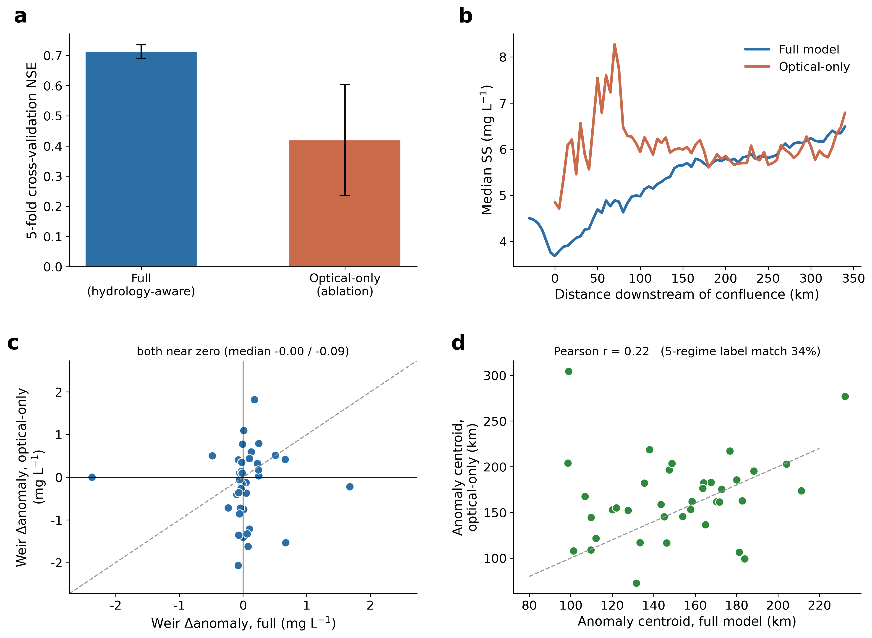
Supplementary Figure S1 | Optical-only retrieval ablation. a, Cross-validated performance of the full hydrology-aware retrieval versus a reflectance-and-season-only model. b, Median longitudinal TSS from both over common scene dates. c, Per-event anomalychange across weirs. d, Per-event anomaly centroid.
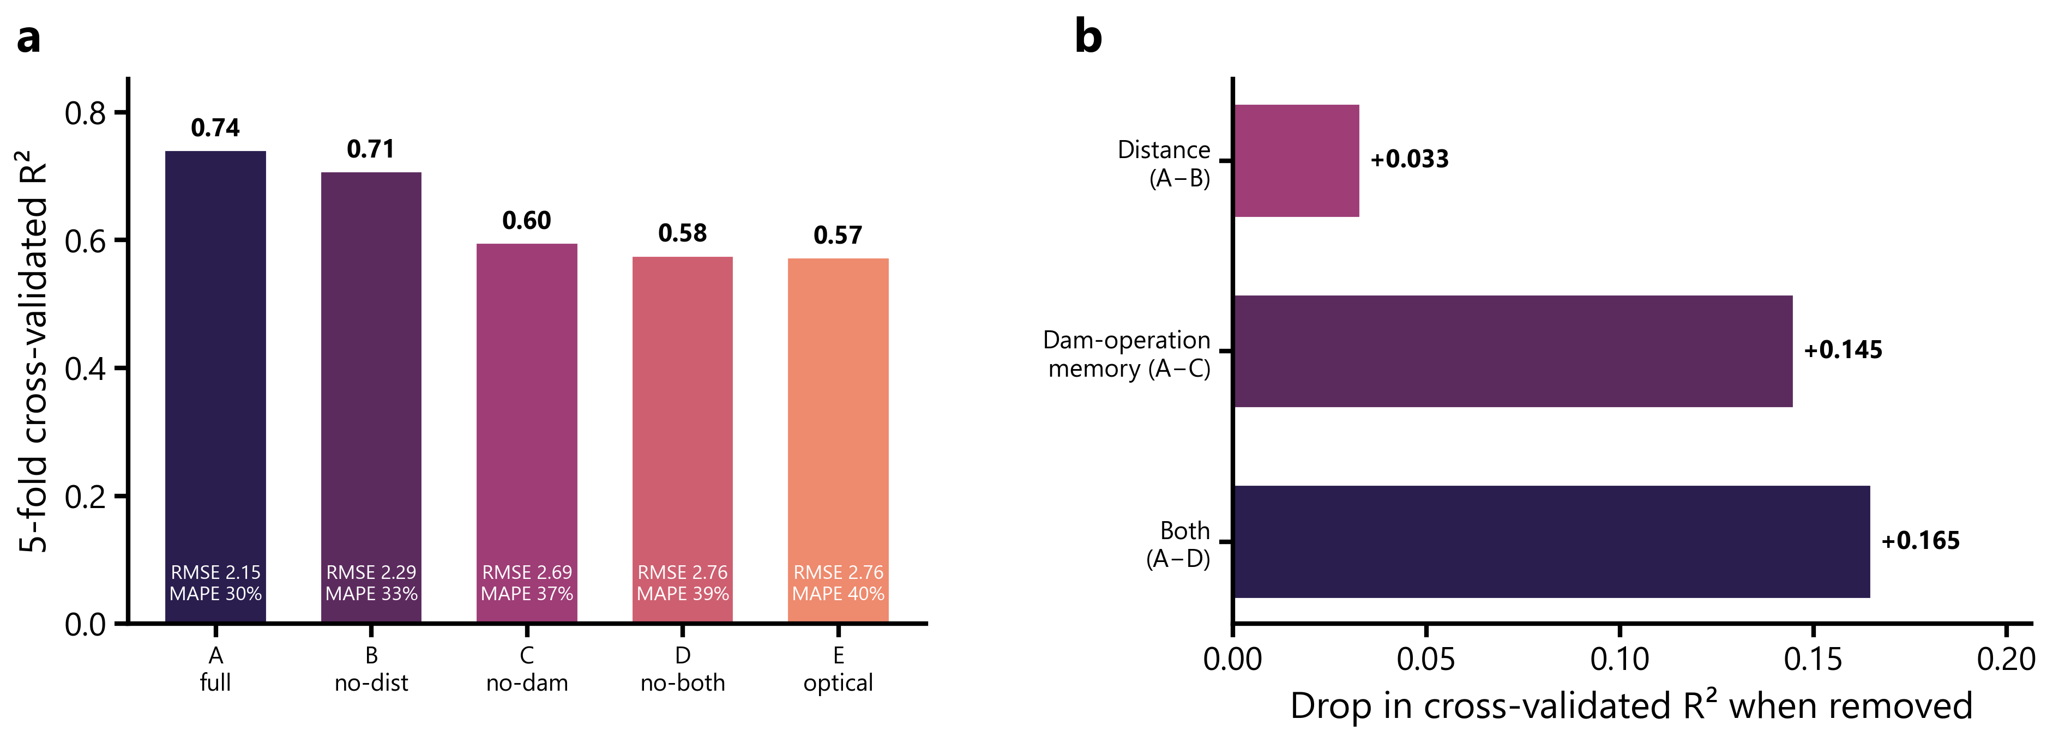
Supplementary Figure S2 | Predictor-ablation performance. a, Five-fold cross-validated R² (with RMSE and MAPE annotated) for the full retrieval (A) and models with along-river distance removed (B), dam-operation memory removed (C), both removed (D), or all non-optical predictors removed (E).b, Decrease in cross-validated R² after removal of each predictor family.

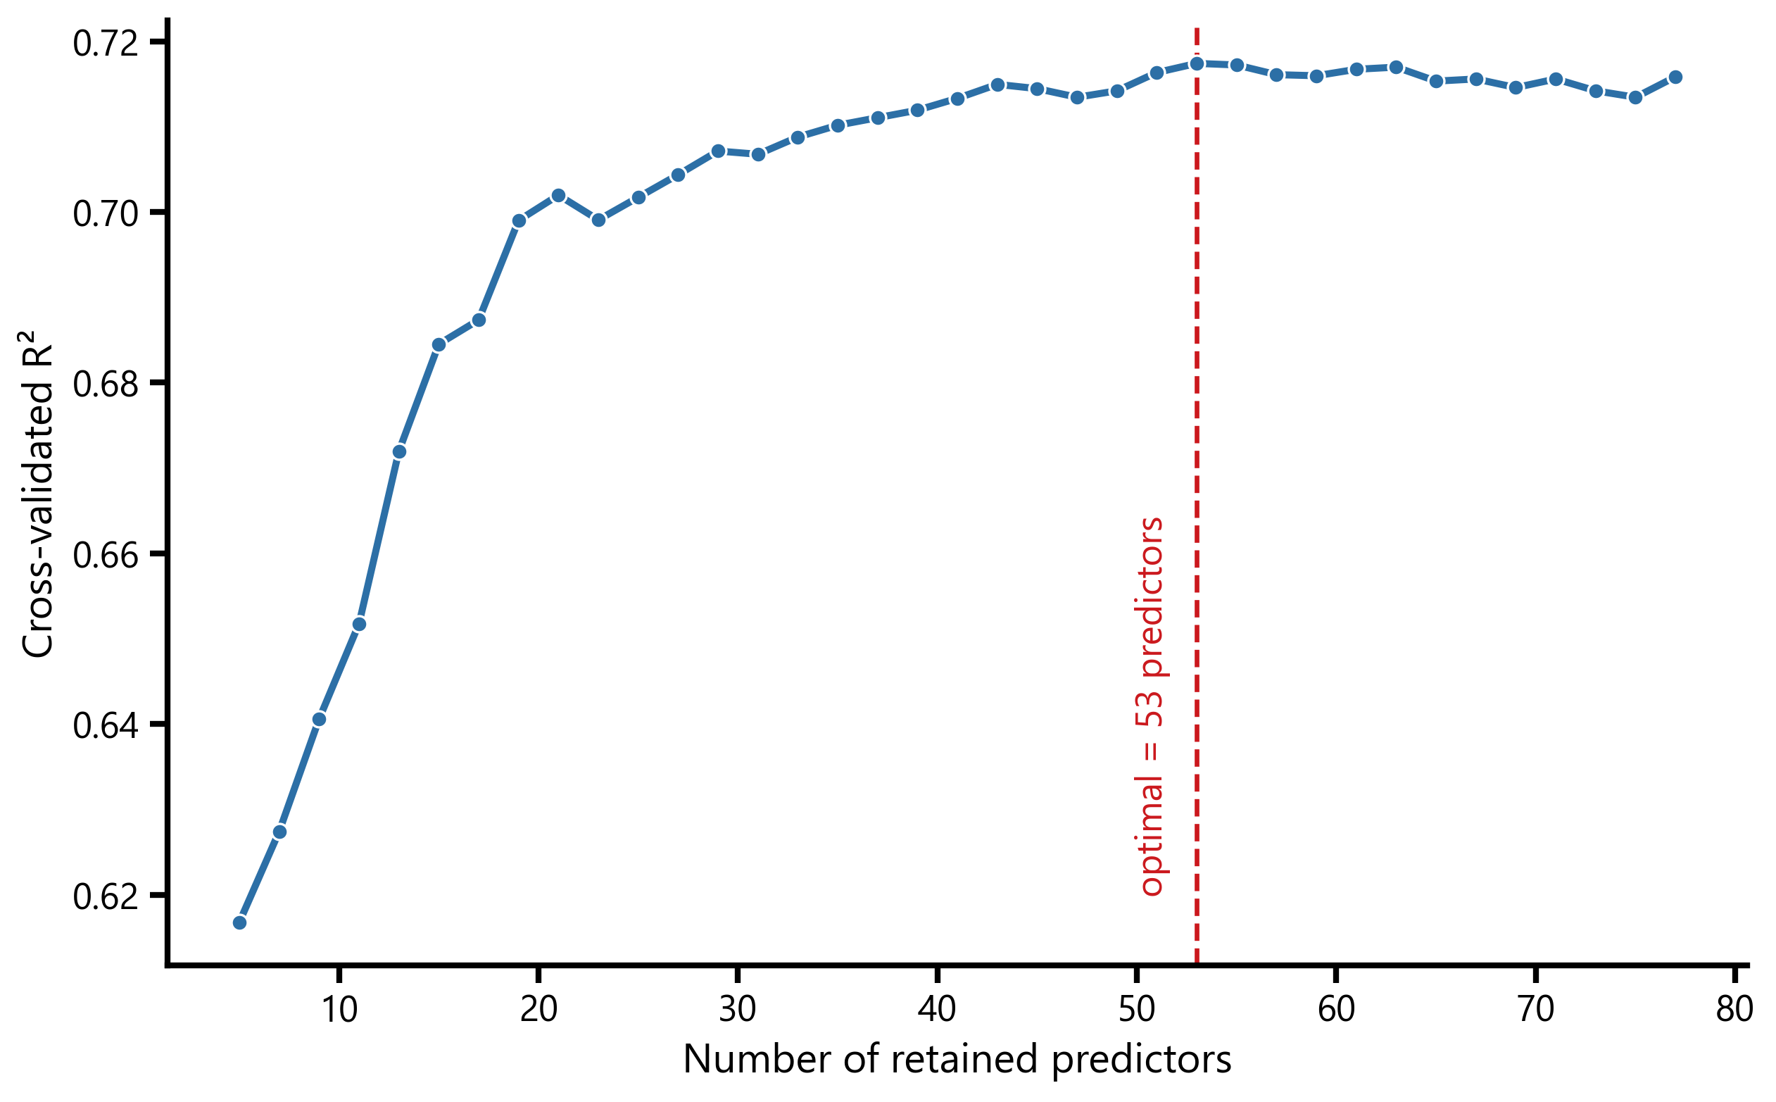
Supplementary Figure S3 |Predictor selection by recursive feature elimination. Five-fold cross-validated R² as a function of the number of retained predictors (RFECV, extremely randomized-trees estimator, step = 2). Performance increases steeply to approximately 20 predictors and plateaus beyond approximately 40; the optimal 53-predictor subset (dashed line) performs essentially identically to the full 77-predictor set (NSE 0.712 versus 0.711; RMSE 2.25 mg L⁻¹ for both),indicating that predictor redundancy does not measurably degrade retrieval performance.

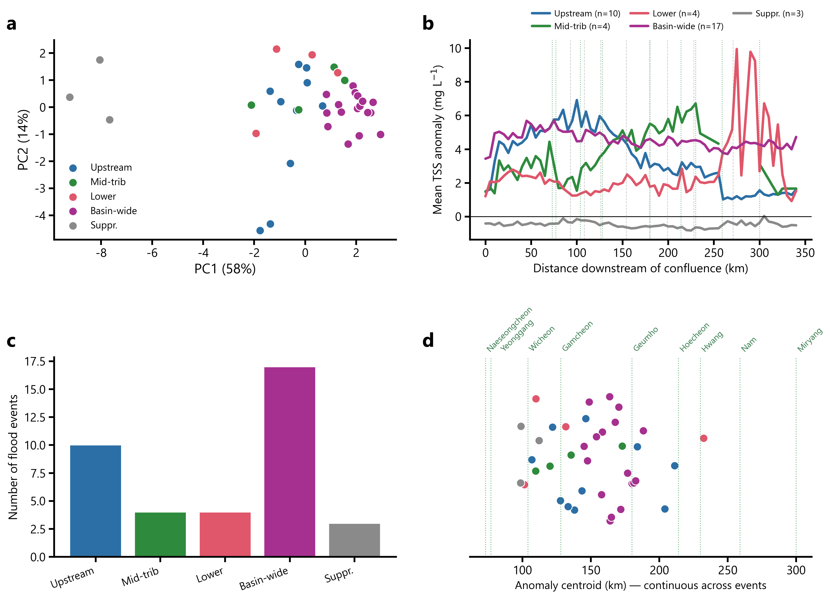
Supplementary Figure S4 | Source-zone continuum and five-regime summary.a, Principal-component ordination of shape-normalized anomaly profiles, coloured by regime. b, Regime-mean longitudinal profiles. c, Regime frequencies (n = 38). d, Anomaly centroid of every event. Events spread along one dominant axis rather than forming separatedclusters. k-means silhouette coefficients were 0.65 at k = 2 and 0.37–0.41 at k = 3–6, supporting a continuum rather than discrete clusters.
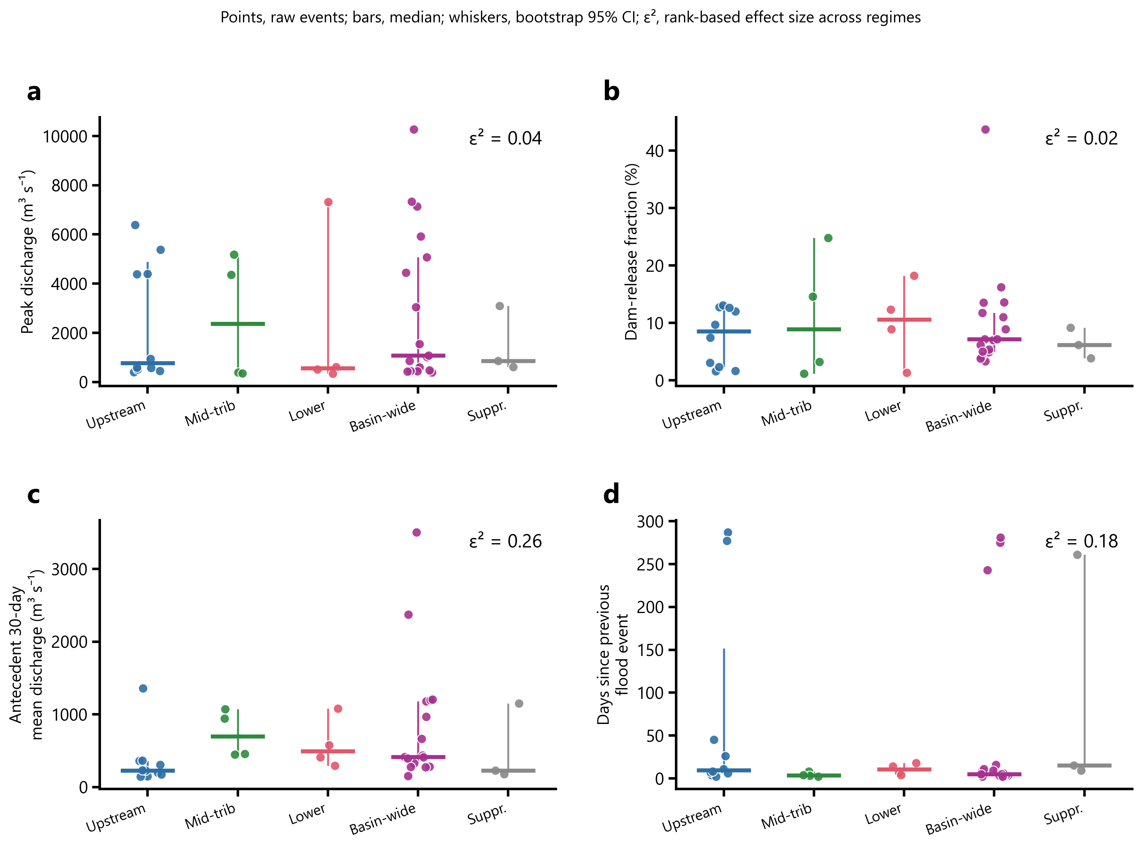
Supplementary Figure S5 | Hydrologic conditions across connectivity regimes. (a) Peak discharge, (b) dam-release fraction of main-stem discharge, (c) antecedent 30-day mean discharge, and (d) days since the previous flood. Points, events; bars, regime medians; whiskers, bootstrap 95% confidence intervals; ε², rank-based effect size.
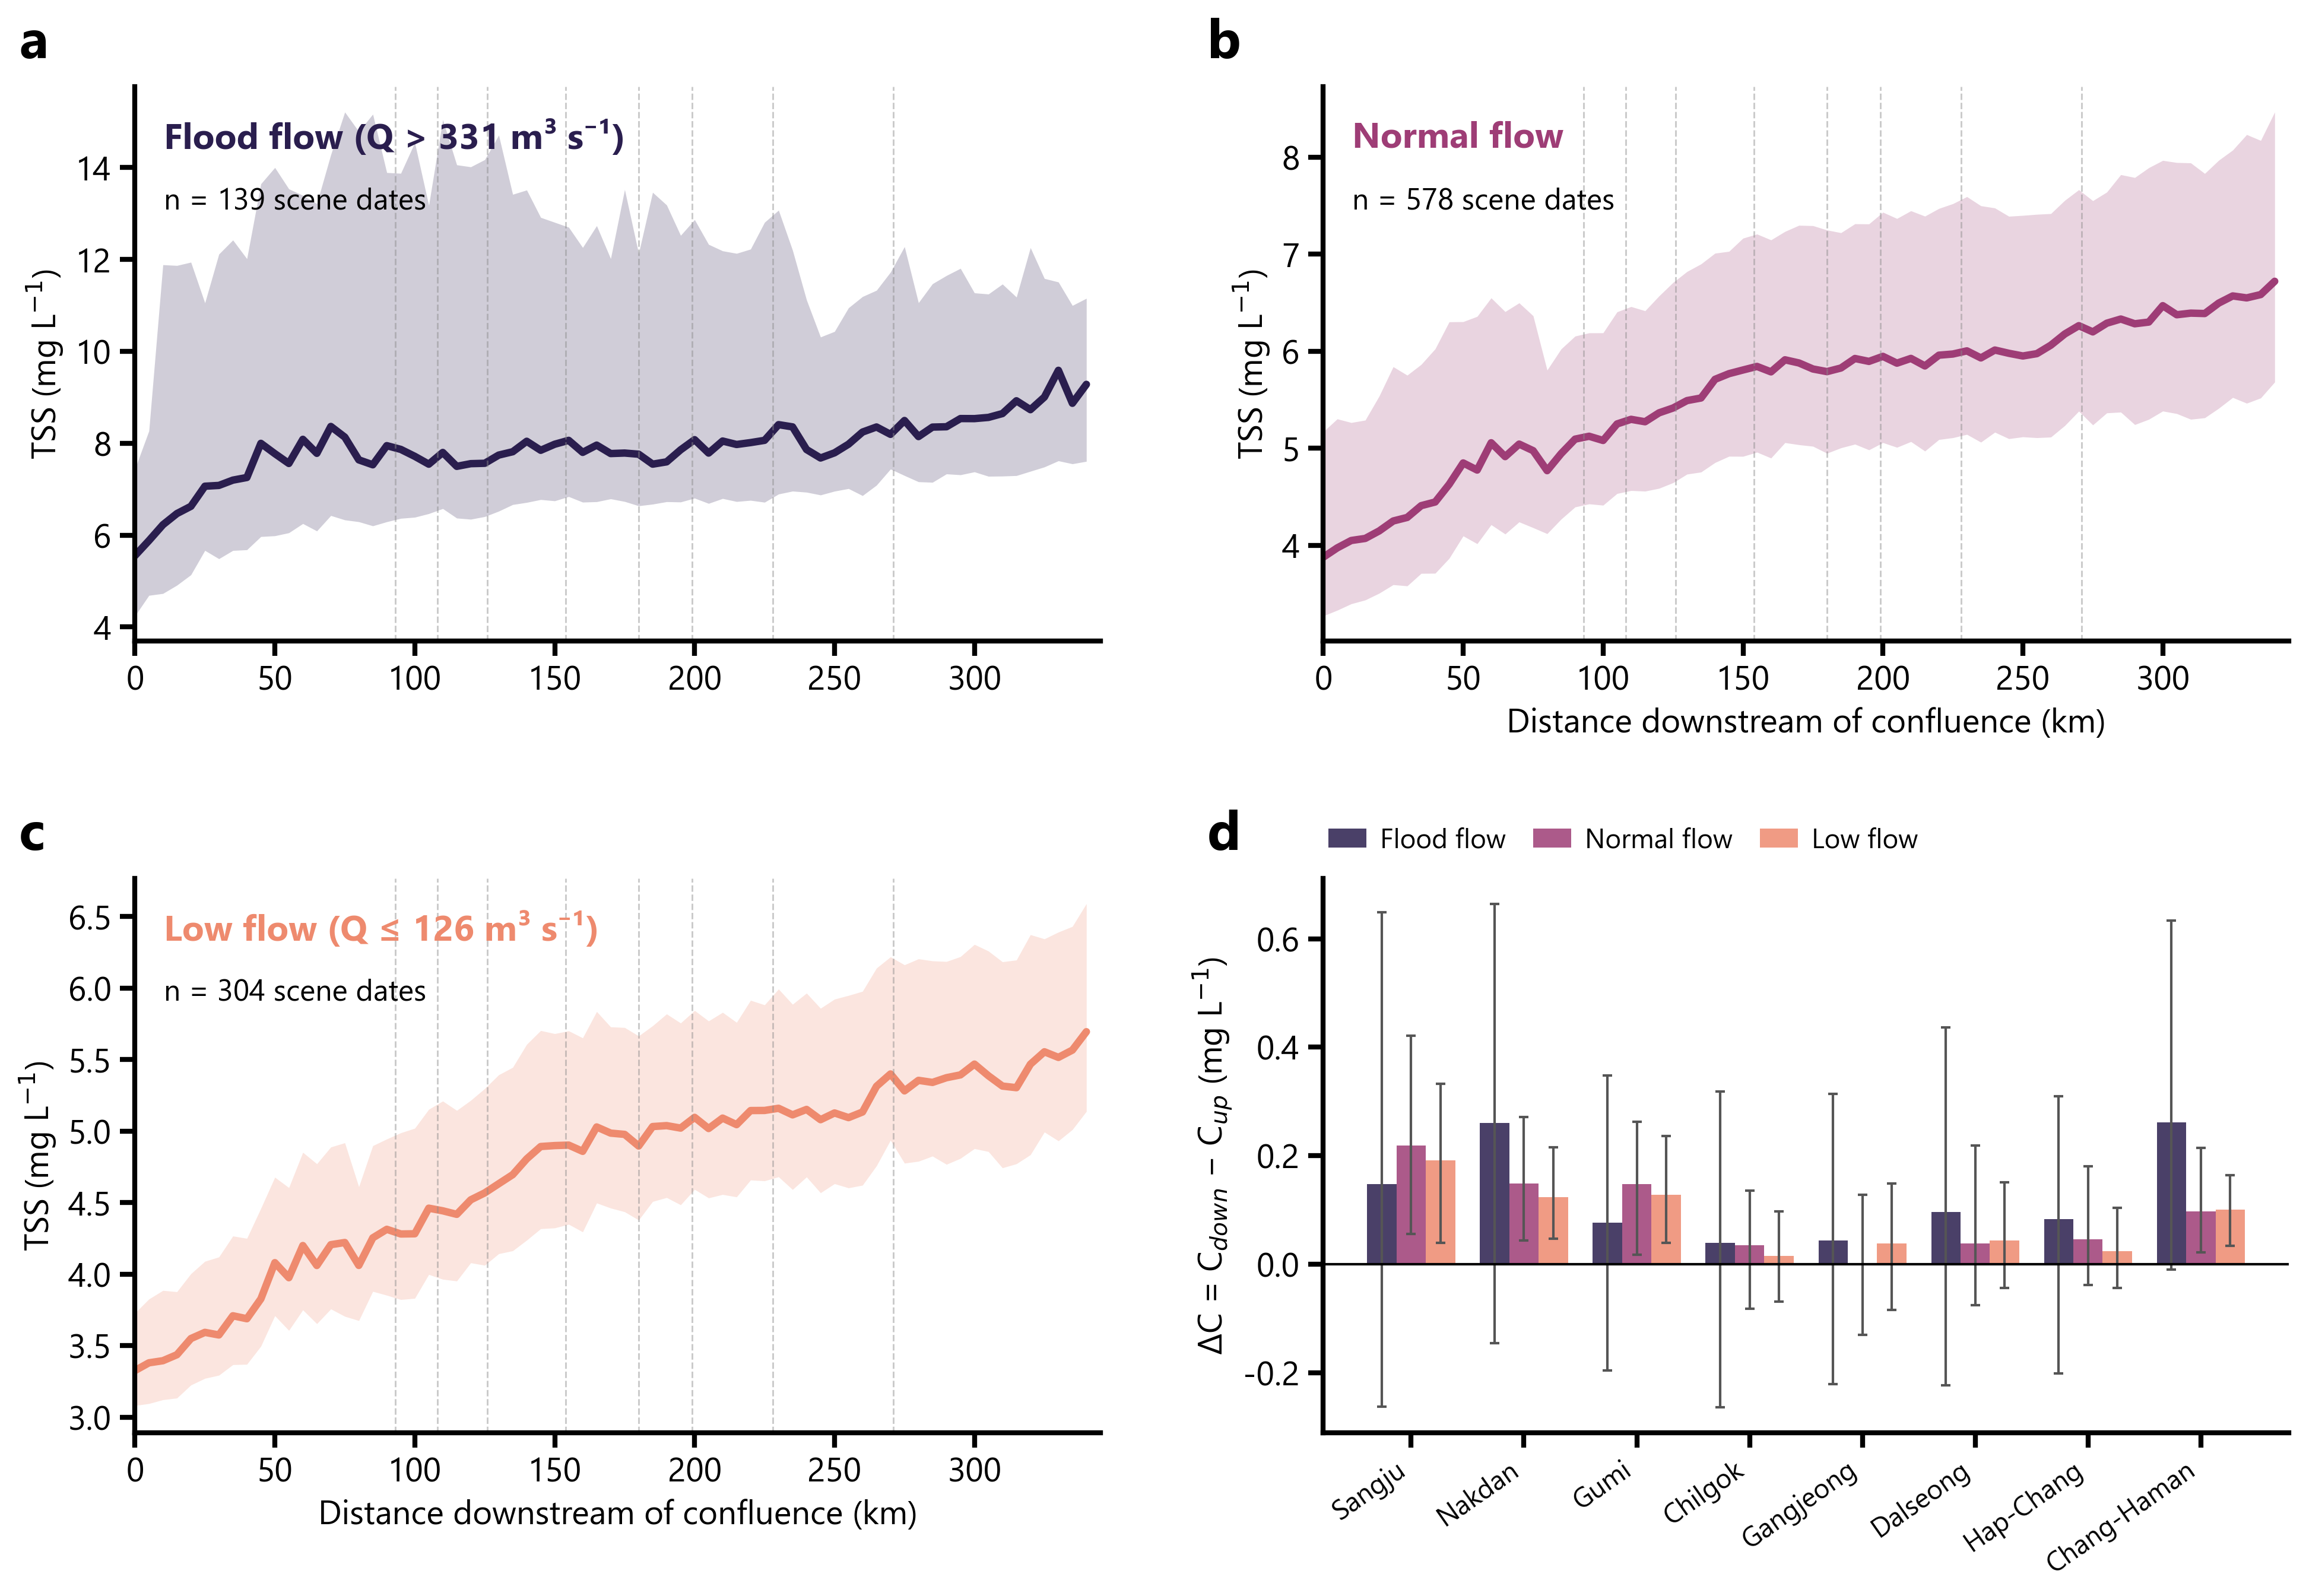
Supplementary Figure S6 | Sediment dynamics across flow regimes. a–c, Median longitudinal TSS (line) with the interquartile rangefor flood (Q > 331 m³ s⁻¹), normal and low (Q ≤ 126 m³ s⁻¹) flows. d, Absolute concentration change across each weir by flow regime (median ± interquartile range).

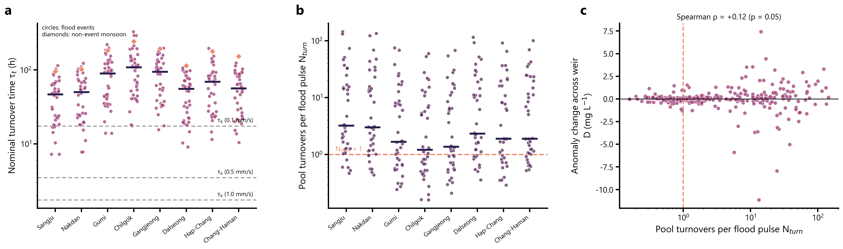
Supplementary Figure S7 | Per-weir hydraulic metrics. a, Nominal turnover time for each weir across the 38 floods (circles, floods; diamonds, non-event monsoon reference); dashed lines, scenario settling times. b, Flushing number per weir. c, Anomalychangeacross weirs versus flushing number, showing no detectable association.
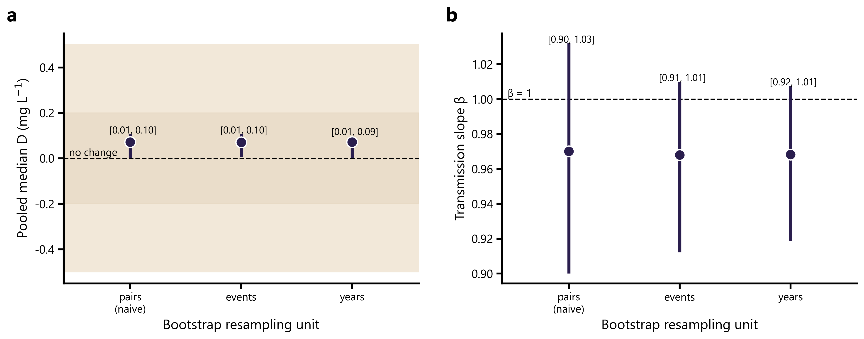
Supplementary Figure S8 | Cluster-bootstrap uncertainty. Bootstrap 95% confidence intervals fora, the pooled median paired difference D and b, the transmission slope β, resampling weir–event pairs, whole events, or whole years.

Supplementary Tables
Supplementary Table S1 | Data sources, variables, periods, resolution, and roles in this study.
Source | Variable | Period | Resolution / scale | Role in this study
NASA HLS v2.0 (L30 + S30) | Six-band surface reflectance | 2017–2026 | 30 m; 3,156 scenes | Optical predictors; per-scene centreline TSS retrieval
NIER water-quality network | Total suspended solids (TSS) | 2017–2026 | Grab samples; 37 stations used | Retrieval training and validation
HRFCO dam records (WAMIS before 2019) | Reservoir level, inflow, total outflow | 2017–2026 | Daily; Andong, Imha, Yeongju | Dam-operation-memory predictors; dam-release fraction
WAMIS stream gauges | Stage and discharge | 2017–2026 | Daily; six primary main-stem gauges, ten acoustic-Doppler main-stem stations, and eight tributary gauges | Flood-event definition; hydraulic metrics (τ_{t}, N_{turn}, S); runoff-supply centroid
HRFCO weir-operation records | Weir pool level and total release | 2019–2026 | Daily; eight weirs | Weir-release robustness checks (τ_{t}, N_{turn}; 24-node runoff-supply centroid)
VWorld 1:5,000 hydrography | Sub-basins, tributaries, river centrelines | Static | 1:5,000 | River-network geometry, confluence positions, reach delimitation
K-water / MOLIT weir records | Management pool volume V, surface area A, crest position | Static (design values) | Eight multifunction weirs | Pool geometry for the hydraulic metrics

