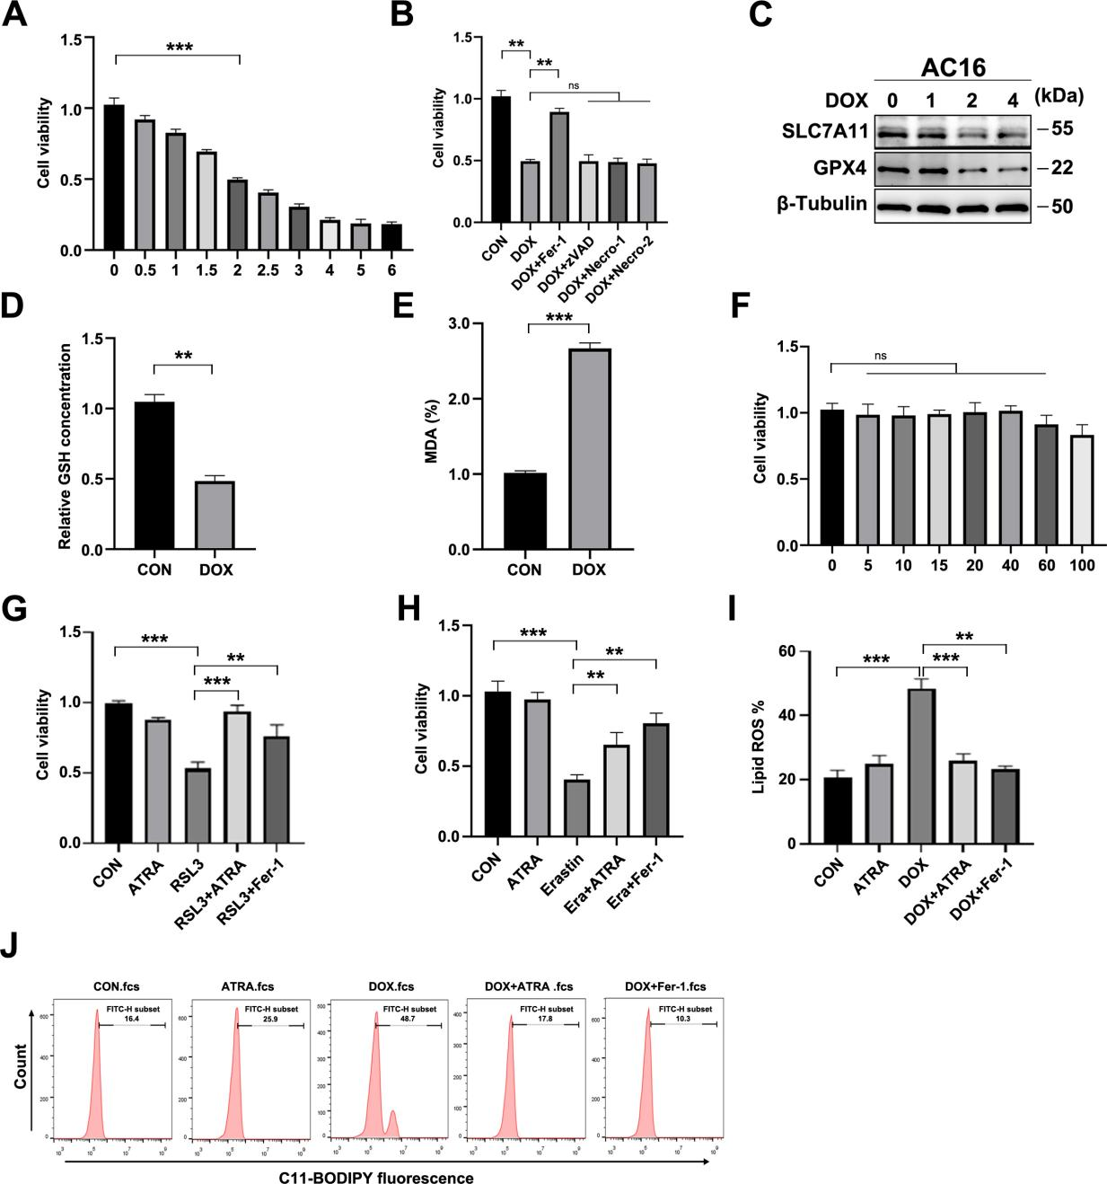
Supplementary Fig. 1. DOX induces ferroptosis in AC16 cardiomyocytes and ATRA suppresses ferroptotic lipid peroxidation.
(A) CCK-8 analysis of AC16 cell viability following treatment with increasing concentrations of DOX. (B) CCK-8 analysis of cell viability after DOX treatment combined with Fer-1, z-VAD-FMK, necrostatin-1, or necrostatin-2. (C) Western blotting of SLC7A11 and GPX4 after treatment with increasing concentrations of DOX. (D, E) GSH (D) and MDA (E) levels in control and DOX-treated AC16 cells. (F) CCK-8 analysis of AC16 cell viability following treatment with increasing concentrations of ATRA. (G, H) CCK-8 analysis of cell viability after RSL3 (G) or erastin (H) treatment combined with ATRA or Fer-1. (I, J) Quantification (I) and representative C11-BODIPY flow cytometry histograms (J) of lipid ROS in AC16 cells after CON, ATRA, DOX, DOX + ATRA, or DOX + Fer-1 treatment. Data are mean ± SD. Statistical tests are described in Methods. ns, not significant; *p < 0.05, **p < 0.01, ***p < 0.001.

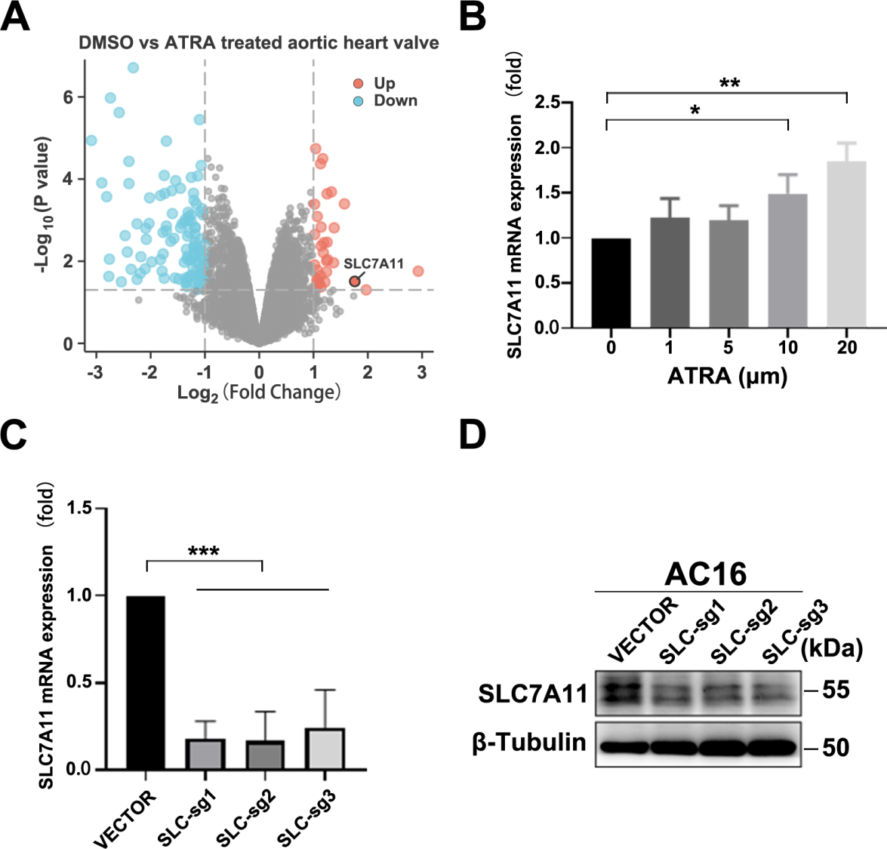
Supplementary Fig. 2. Screening and validation of SLC7A11 as an ATRA-responsive ferroptosis-related gene.
(A) Volcano plot of differentially expressed ferroptosis-related genes in the ATRA-treated dataset; SLC7A11 is highlighted. (B) qRT-PCR analysis of SLC7A11 mRNA expression in AC16 cells treated with increasing concentrations of ATRA. (C, D) qRT-PCR (C) and western blotting (D) validation of SLC7A11 knockout efficiency in AC16 cells; β-Tubulin served as the loading control. Data are mean ± SD. Statistical tests are described in Methods. ns, not significant; *p < 0.05, **p < 0.01, ***p < 0.001.
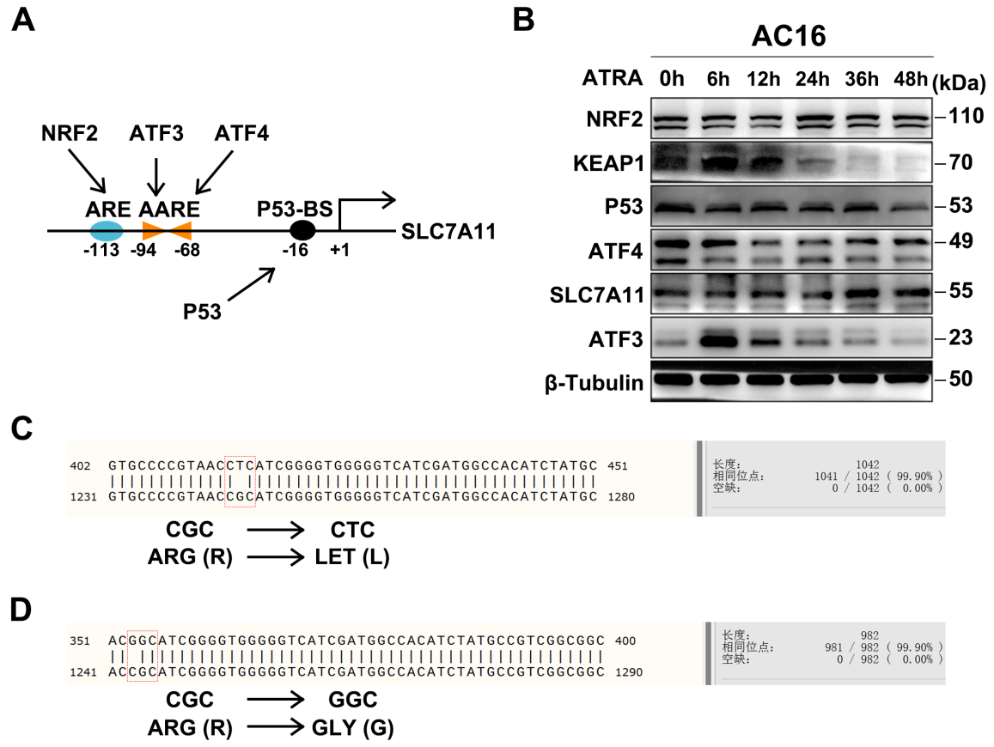
Supplementary Fig. 3. Candidate regulators of SLC7A11 and validation of KEAP1 Arg415 mutations.
(A) Schematic representation of predicted regulatory elements in the SLC7A11 promoter, including antioxidant response elements (AREs), amino acid response elements (AAREs), and a p53-binding site (p53-BS). (B) Western blotting of NRF2, KEAP1, p53, ATF4, SLC7A11, and ATF3 in AC16 cells following ATRA treatment for the indicated time points; β-Tubulin served as the loading control. (C, D) Sanger sequencing validation of KEAP1 R415L (C) and R415G (D) point-mutant plasmids. Data are mean ± SD. Statistical tests are described in Methods. ns, not significant; *p < 0.05, **p < 0.01, ***p < 0.001.
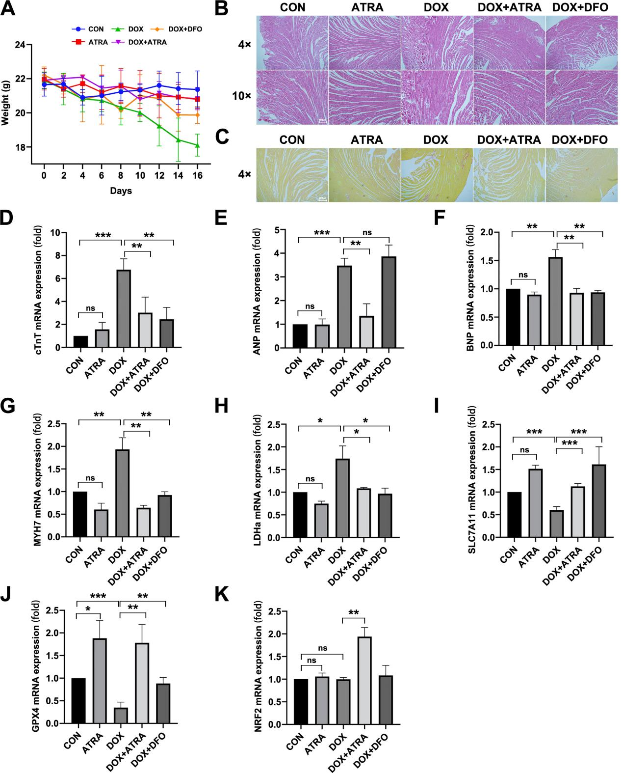
Supplementary Fig. 4. ATRA alleviates DOX-induced cardiac injury and restores ferroptosis-related gene expression in vivo.
(A) Body-weight changes of mice during the treatment period. (B) H&E staining of myocardial tissue at 4× and 10× magnifications. (C) Sirius Red staining of myocardial collagen deposition and fibrosis. (D-H) qRT-PCR analysis of cardiac injury markers cTnT (D), ANP (E), BNP (F), MYH7 (G), and LDHa (H). (I-K) qRT-PCR analysis of ferroptosis-related genes SLC7A11 (I), GPX4 (J), and NRF2 (K). Data are mean ± SD. Statistical tests are described in Methods. ns, not significant; *p < 0.05, **p < 0.01, ***p < 0.001.

