Supplementary Material
Differentiated Emphasis, Shared Silences: A Tension-Aware Academic Balanced Scorecard Analysis of the Strategic Plans of the World’s Top-50 Universities

Part A. Supplementary Methods
Supplementary S1. Source register. The complete register of analyzed documents (institution, document title, type, publication year, source URL, and retrieval date for each of the 50 universities) is provided as a separate spreadsheet file.
Supplementary S2. Segmentation protocol. The written protocol governing the one-time segmentation of all source documents into the frozen list of 3,982 verbatim coding units, including unit-boundary rules, verbatim-fidelity requirements, and the opaque unit-identifier scheme.
Supplementary S3. Codebook and coding prompts. The full perspective codebook (beneficiary-based decision rule, sub-code anchor examples, and noncodability criteria) and the verbatim prompts used for the two auxiliary coding dimensions under the mandatory-completeness protocol (lead–lag recoding prompt v2; tension coding prompt v2).
Supplementary S4. Isometric log-ratio transformation. The ilr coordinates were computed under the fixed sequential binary partition FND | EDU | RES | ENG:
z081 = 21a(3/4) 0b7 ln( FND / (EDU 0b7 RES 0b7 ENG)^(1/3) )
z082 = 21a(2/3) 0b7 ln( EDU / (RES 0b7 ENG)^(1/2) )
z083 = 21a(1/2) 0b7 ln( RES / ENG )
The basis is orthonormal; total dispersion (the trace of the covariance matrix of z081–z083) is invariant across orthonormal bases, which is why the basis is fixed a priori.
Supplementary S5. Sensitivity procedures. Full procedural detail for the three pre-specified robustness analyses: the FND deflation stress test (levels 12%, 20%, 30%, 40%, 50%; complete pipeline re-estimated at each level), the low-confidence exclusion run (four universities with fewer than ten codable units), and the construction of the two-component Silence Index.

Part B. Supplementary Tables
Supplementary Table S1. Compositional dispersion (orthonormal ilr coordinates).
Coordinate | Contrast | Variance
z081 | FND vs {EDU, RES, ENG} | 0.693
z082 | EDU vs {RES, ENG} | 0.450
z083 | RES vs ENG | 0.653
Total dispersion (trace) |  | 1.796

Supplementary Table S2. Structural determinants of strategic composition.
Test | Statistic | p | Effect size
Spearman: QS rank vs p_RES | 3c1 = +0.313 | 0.027 | –
Spearman: QS rank vs balance index | 3c1 = +0.264 | 0.064 | –
Spearman: QS rank vs p_FND / p_EDU / p_ENG / z081–z083 | all \ | 3c1\ | 264 0.31
MANOVA: ilr coordinates ~ region | Wilks’ 3bb = 0.847, F = 1.30 | 0.267 | –
3c70b2: cluster 0d7 QS rank category | 3c70b2 = 1.49 | 0.828 | Cram0e9r’s V = 0.12
3c70b2: cluster 0d7 region | 3c70b2 = 6.63 | 0.157 | Cram0e9r’s V = 0.26

Supplementary Table S3. Kruskal–Wallis tests: QS 2027 indicators across archetypes (n = 50, k = 3).
QS Indicator | H | p | 3b70b2
Intl. Faculty Ratio | 4.02 | 0.134 | 0.043
Academic Reputation | 3.80 | 0.150 | 0.038
Citations per Faculty | 3.33 | 0.190 | 0.028
Employer Reputation | 3.16 | 0.206 | 0.025
Intl. Student Ratio | 2.56 | 0.279 | 0.012
Intl. Research Network | 1.95 | 0.377 | 0.000
Employment Outcomes | 1.60 | 0.449 | 0.000
Sustainability Score | 1.22 | 0.544 | 0.000
Overall Score | 1.21 | 0.547 | 0.000
Faculty/Student Ratio | 0.74 | 0.691 | 0.000
Descriptive archetype means (not significant after Bonferroni correction): the Foundation-dominant group recorded the highest mean Academic Reputation (98.4) and Employer Reputation (97.9), and the lowest Intl. Faculty Ratio (72.9) and Intl. Student Ratio (67.5).

Supplementary Table S4. Lead–lag classification: agreement structure.
Metric | Value
LEAD share per coder | 88.3% / 94.6% / 95.3%
LEAD share, ensemble majority | 96.8% (LAG: 126 units, 3.2%)
Unanimous units | 81.7%
Mean pairwise raw agreement | 0.878
Gwet’s AC1 (prevalence-robust) | 0.859
Specific agreement, LEAD | 0.934
Specific agreement, LAG | 0.147
Krippendorff’s 3b1 | 0.095
Unanimous LAG units | 7

Supplementary Table S5. Tension classification: agreement structure.
Metric | Value
Tension detection rate per coder | 0.60% / 0.20% / 0.18%
Raw pairwise agreement | 0.995–0.999
Unanimous units | 99.5%
Gwet’s AC1 (prevalence-robust) | 0.997
Krippendorff’s 3b1 (5 categories) | 0.473
Positive specific agreement (detection) | 0.518
Agreement on tension type, given joint detection | 83–100%
Majority-vote tension units | 8 of 3,982 (0.20%)
Unanimous among the eight | 5

Supplementary Table S6. Breaking-point test: FND count deflation and archetype stability.
FND deflation | FND-dominant cluster size | Original 12 members retained | Cluster center p_FND
0% (baseline) | 12 | 12/12 | 0.53
12% | 12 | 12/12 | 0.50
20% | 12 | 12/12 | 0.48
30% | 12 | 12/12 | 0.44
40% | 14 | 12/12 | 0.40
50% | 14 | 12/12 | 0.36
Supplementary Table S7. Silence Index for universities at the ends of the distribution (overall mean = 0.91).
 | University | LAG share | Tension share | Silence Index
Most disclosing | Universit0e9 PSL | 0.167 | 0.083 | 0.150
 | NUS | 0.238 | 0.000 | 0.500
 | British Columbia | 0.200 | 0.000 | 0.580
 | Edinburgh | 0.134 | 0.000 | 0.718
 | King’s College London | 0.118 | 0.000 | 0.753
Complete silence (index = 1) | 14 universities | 0.000 | 0.000 | 1.000

Supplementary Table S8. Coding reliability and validity.
Metric | Value
Krippendorff’s 3b1, three model coders (noncodable treated as missing) | 0.725
Krippendorff’s 3b1 (noncodable as a fifth category) | 0.680
Blind human validation sample (fixed random seed = 42) | 200 units
Ensemble–human agreement, all sampled units | 76.5%
Ensemble–human agreement, mutually codable units (n = 170) | 90.0%
Human-noncodable units assigned a substantive code by the ensemble | 26 of 29 (15 to FND)

Supplementary Table S9. Spearman correlations: QS indicators vs emphasis proportions (n = 50). \p < 0.05; \\*p < 0.01, two-tailed.
QS Indicator | p_FND | p_EDU | p_RES | p_ENG
Intl. Faculty Ratio | +0.12 | 2120.43\\ | 2120.34\* | +0.38\\
Intl. Student Ratio | +0.02 | 2120.30\* | 2120.19 | +0.32\*
Overall Score | +0.16 | 2120.23 | 2120.31\* | +0.06
Academic Reputation | +0.09 | 2120.00 | 2120.21 | 2120.13
Sustainability Score | +0.07 | 2120.17 | 2120.24 | +0.16
(remaining five indicators) | all n.s.

Part C. Supplementary Figures
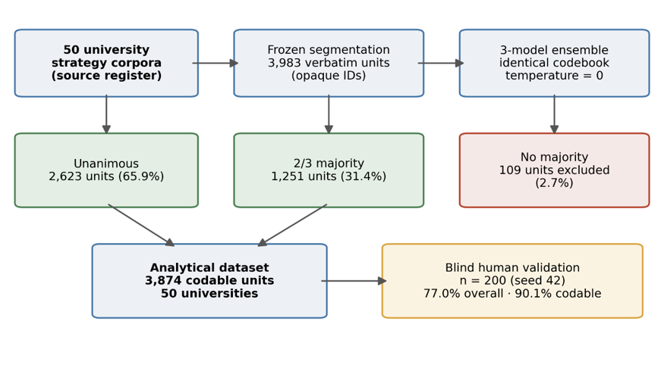
Supplementary Figure S1. Coding pipeline and validation: the three-model ensemble applied a frozen codebook to 3,982 verbatim units; units without a substantive majority (2.7%) were excluded, and output was validated against a blind human gold standard (n = 200, fixed seed).
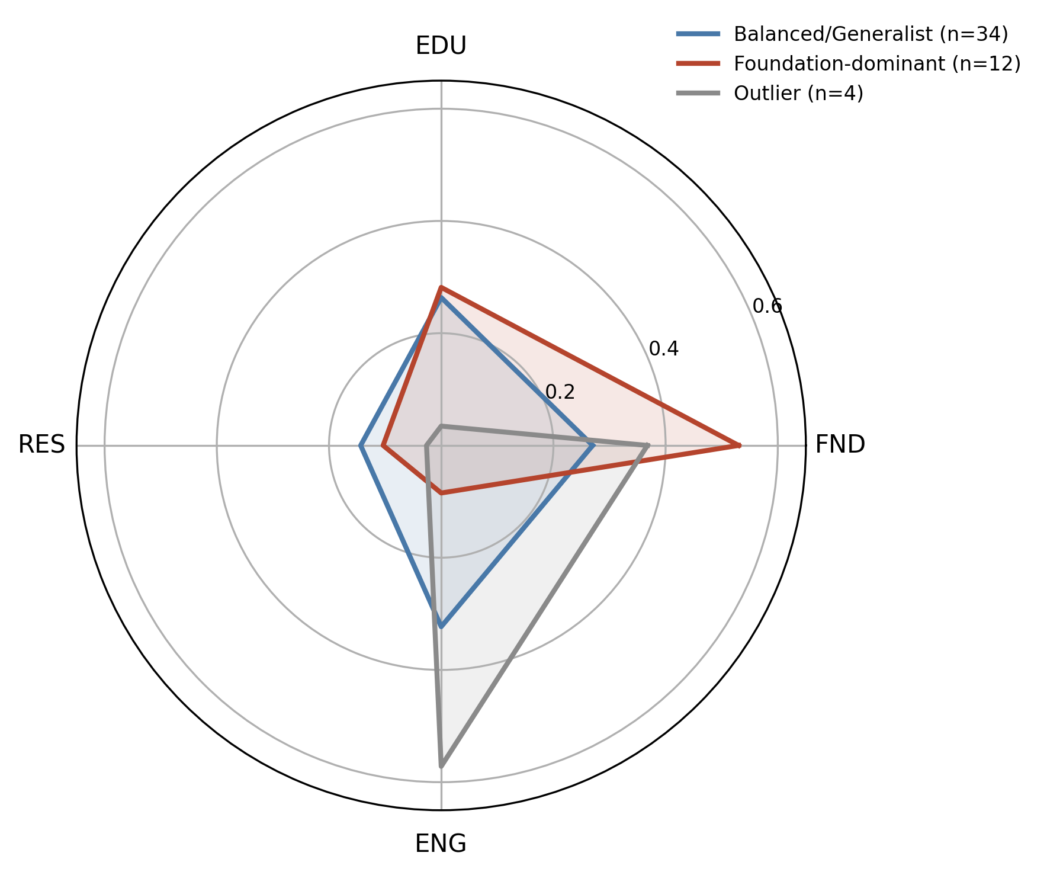
Supplementary Figure S2. Archetype profiles: back-transformed cluster centers across the four perspectives.
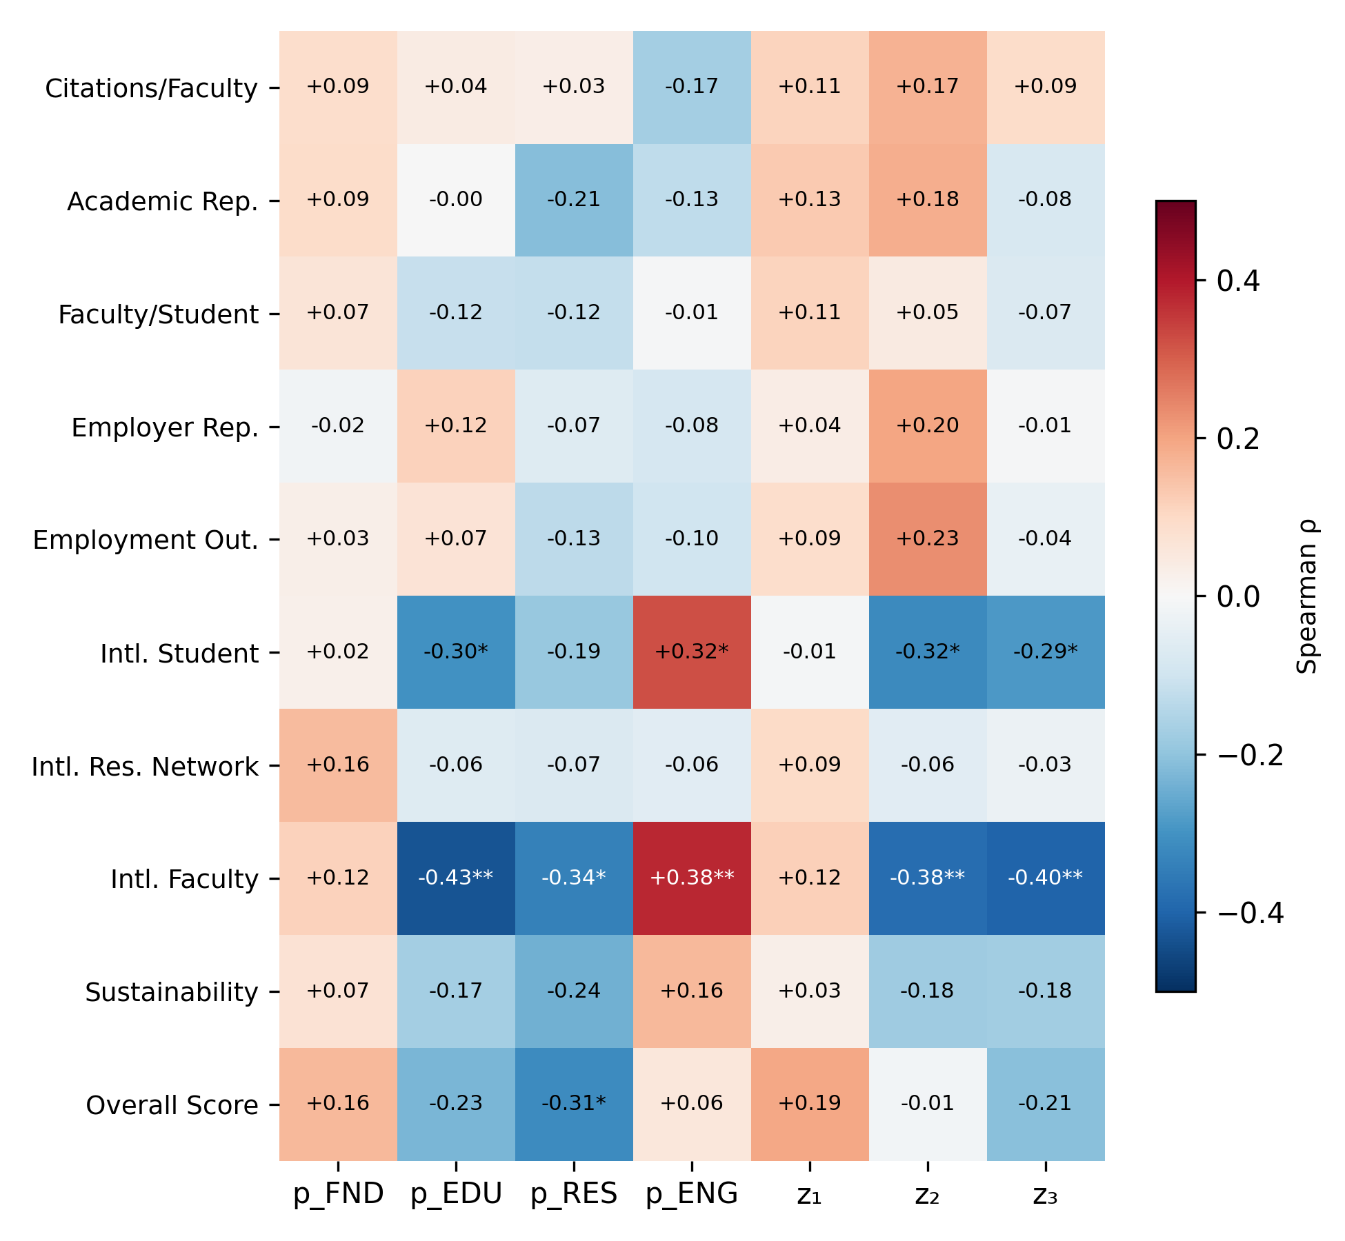
Supplementary Figure S3. Spearman correlations between QS 2027 indicators and strategic composition (proportions and ilr coordinates). \p < 0.05, \\*p < 0.01; the internationalization block is the only significant region.
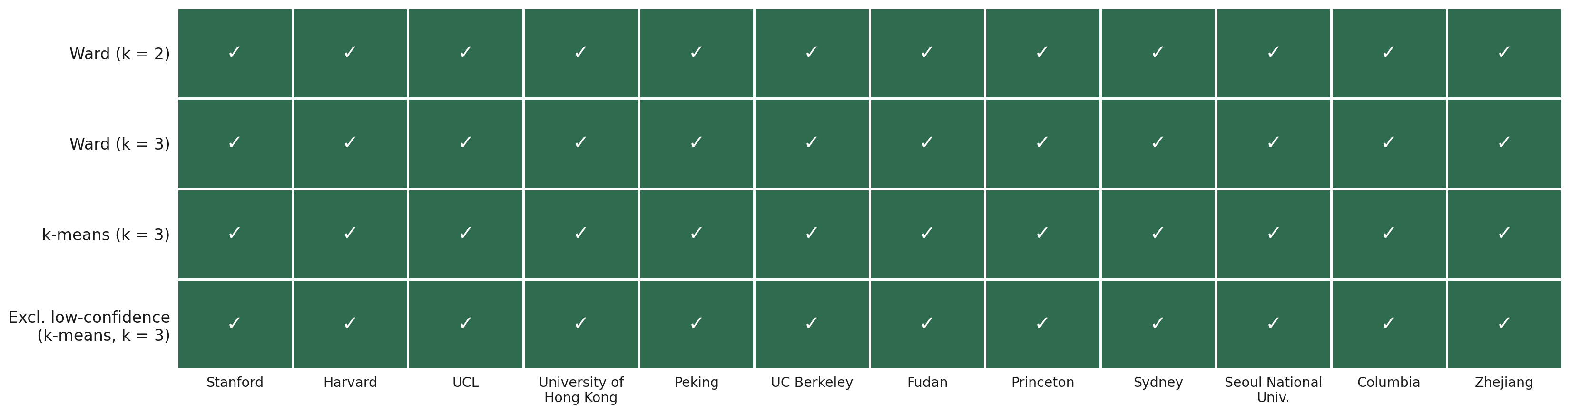
Supplementary Figure S4. Robustness of the Foundation-dominant archetype: cluster membership across Ward (k = 2, k = 3), k-means (k = 3), and the sensitivity run excluding low-confidence institutions; the twelve-member block is constant across all runs.

Part D. Supplementary Note S1: Clustering specification
For the hierarchical solution, Ward’s linkage was applied to squared Euclidean distances without variable standardization. Standardization was not used because the ilr coordinates are already commensurable in the Aitchison geometry, and further scaling would artificially inflate the influence of lower-variance contrasts, particularly z082 (Supplementary Table S1). Squared Euclidean distance was chosen because Ward’s (1963) minimum-variance method is defined in terms of increases in within-cluster sums of squares; as Murtagh and Legendre (2014) show, applying unsquared distances under a “Ward” label does not reproduce the original algorithm. As an independent replication, the same specification was reproduced in Minitab 21: the replicated solution matched the primary result exactly for the Foundation-dominant cluster (all 12 members) and differed in a single borderline case between the Balanced/Generalist and Outlier clusters, consistent with the reported adjusted Rand index of 0.94.
The stability of the Foundation-dominant archetype under FND deflation (Supplementary Table S6) has a geometric explanation: multiplying every university’s FND component by a common factor approximately translates all observations along the first ilr coordinate while preserving their relative positions; the translation is not perfectly uniform because smoothing precedes the log-ratio transformation, but the separation between the Foundation-dominant group and the remaining universities is large enough to survive these adjustments.

Supplementary references
Murtagh, F., & Legendre, P. (2014). Ward’s hierarchical agglomerative clustering method: Which algorithms implement Ward’s criterion? Journal of Classification, 31(3), 274–295. https://doi.org/10.1007/s00357-014-9161-z
Ward, J. H., Jr. (1963). Hierarchical grouping to optimize an objective function. Journal of the American Statistical Association, 58(301), 236–244. https://doi.org/10.1080/01621459.1963.10500845

