Figures

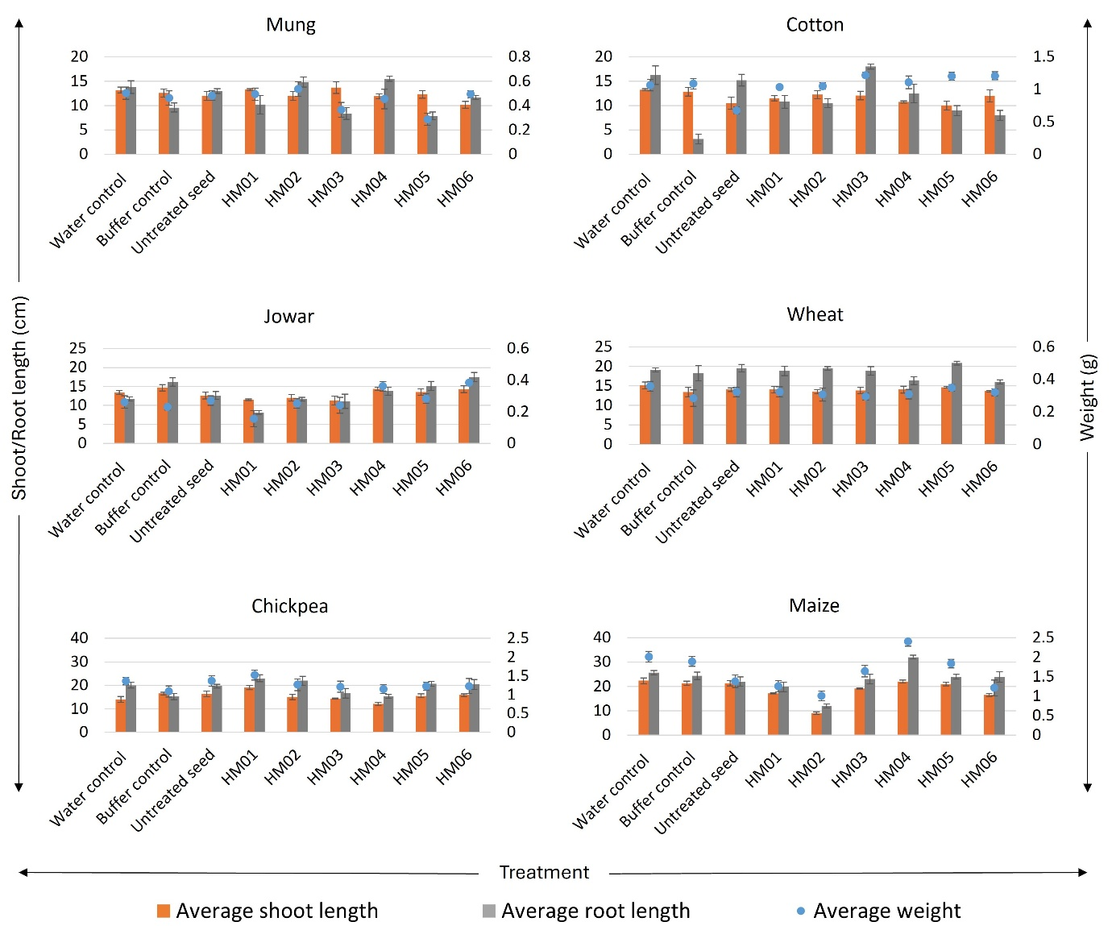
Fig. S1 Comparative assessment of the effect of different B. subtilis isolates on growth performance of six crop species under controlled conditions. Each panel shows one crop, respectively: mung, cotton, jowar, wheat, chickpea, and maize. Seeds from the respective crops have been bioprimed with six B. subtilis strains (HM01-HM06) and compared to water-treated, buffer-treated, and untreated controls. Bars depict the mean shoot length (orange) and average root length (gray); the plant average fresh weight is represented by blue points (g). All the data recorded on 5th d post-germination are represented in this dual-axis plot showing relative variation for vegetative growth parameters (p < 0.05).

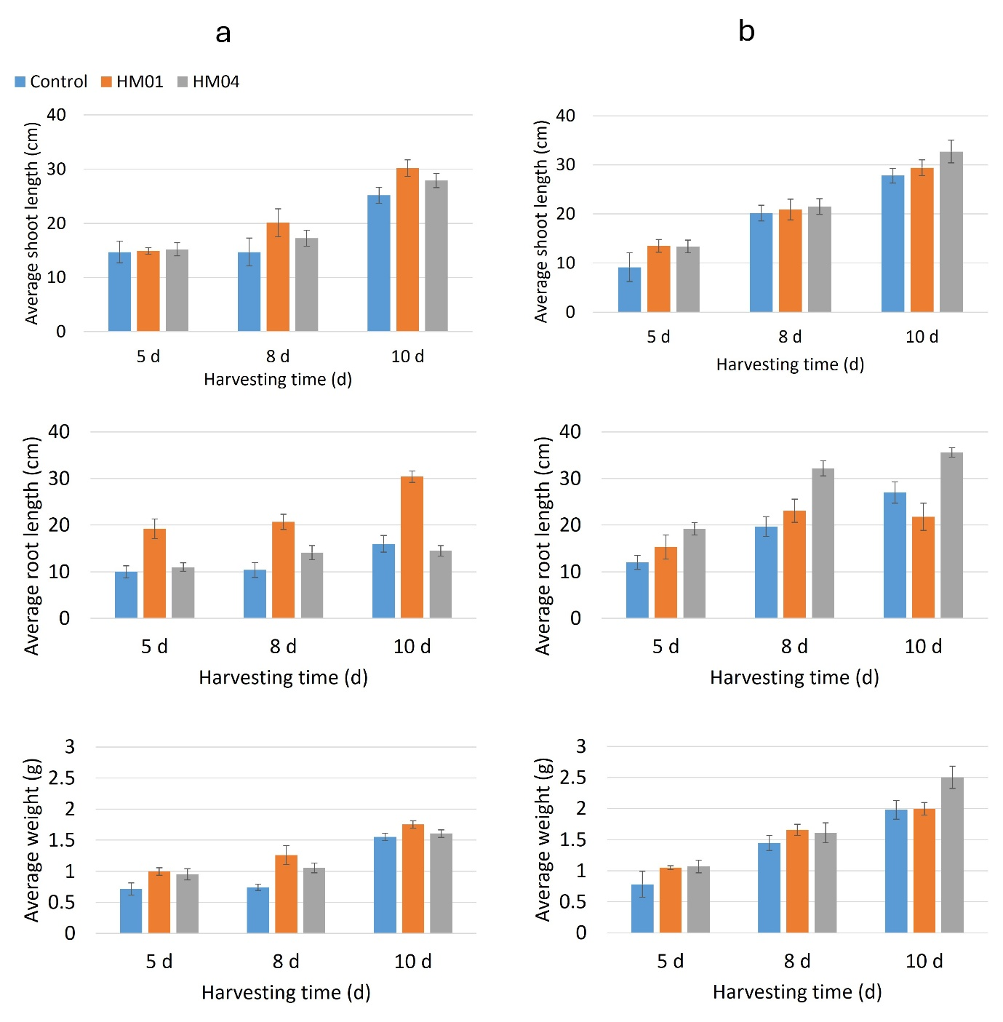
Fig. S2 Comparative assessment of the effect of strain HM01 and HM04 on growth performance of chickpea and maize under soil-grown conditions. Seeds from the respective crops have been bioprimed with B. subtilis strains and compared to untreated seed control. Bars depict the average shoot length (cm), average root length (cm) and the plant average fresh weight (g). All the data recorded on 5th, 8th, and 10th d post-germination are represented in this dual-axis plot showing relative variation for vegetative growth parameters.

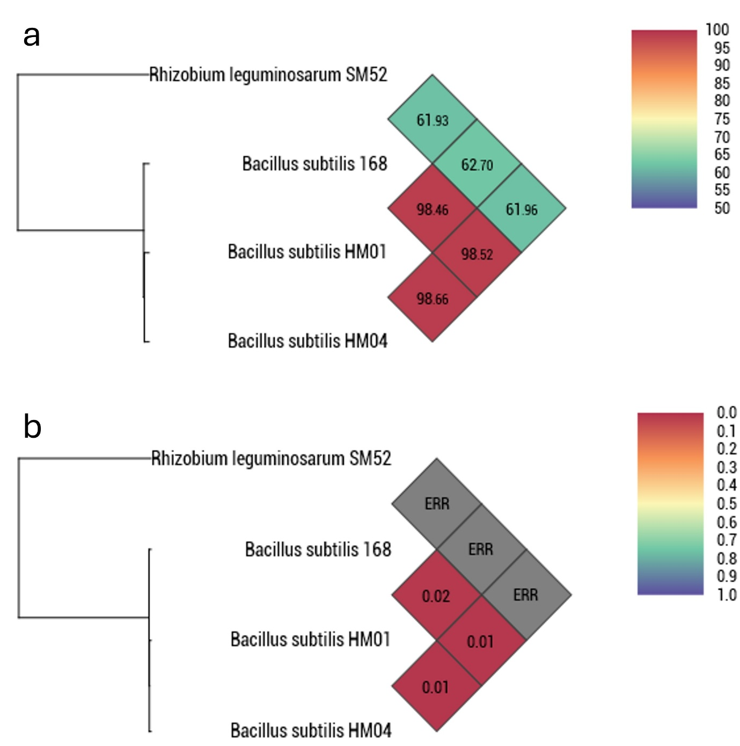
Fig. S3 Heatmap illustrating (a) average nucleotide identity by orthology (OrthoANI) and (b) genome-to genome distance calculation (GGDC) between the B. subtilis genome and reference genome, represented by the type strains of the respective genera calculated by OAT software. High OrthoANI values and low GGDC values between the strains indicate greater genomic similarity. The "ERR" value in GGDC showed that the organism (taken as an outgroup) is genetically distant from the B. subtilis strains.
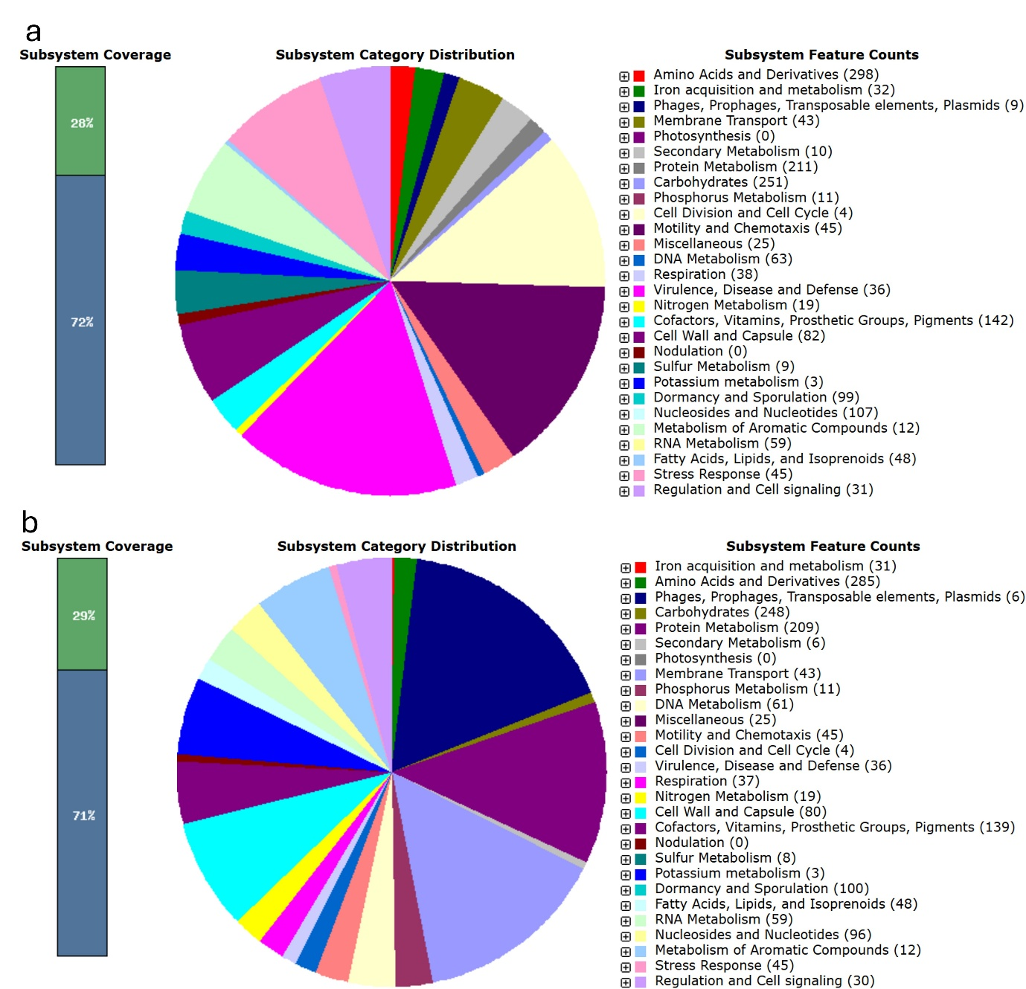
Fig. S4 Subsystem category distribution and the biological function of B. subtilis strain (a) HM01 and (b) HM04 as determined by RAST genome analysis. Gene distributions are depicted with different colours, and their corresponding genes are numerically shown within parentheses.
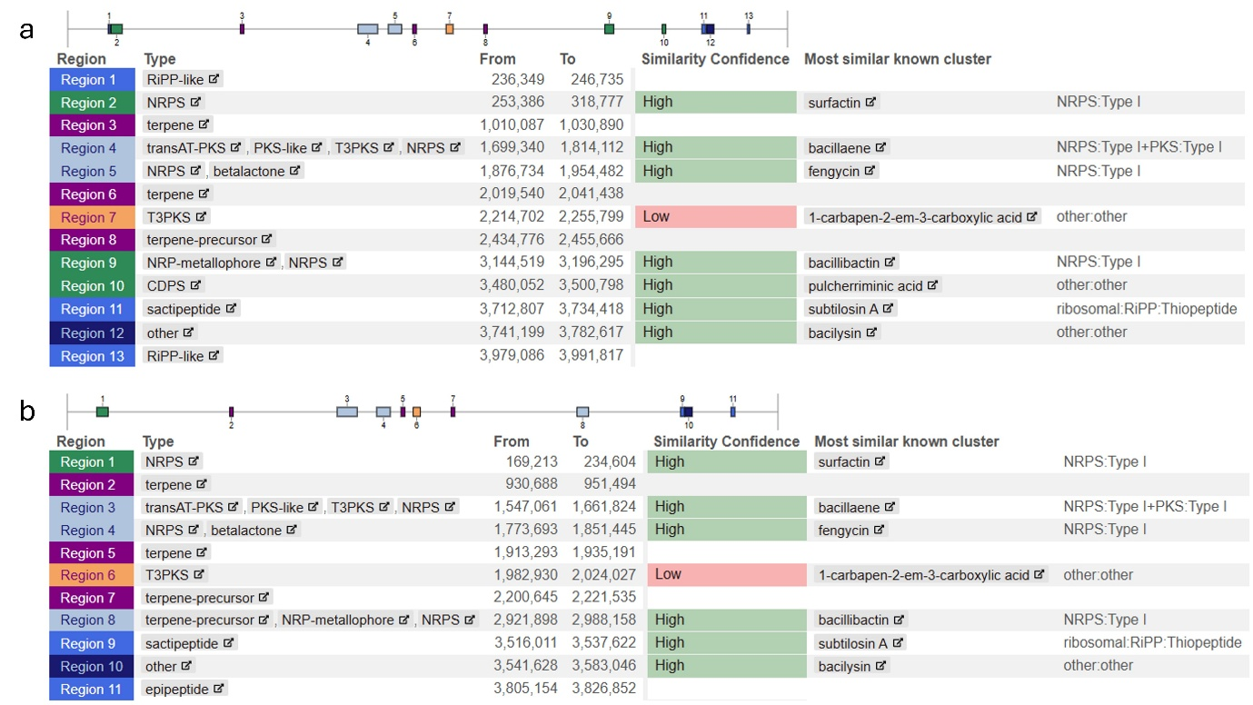
Fig. S5 Organization of secondary metabolite biosynthetic gene clusters in B. subtilis strains a) HM01 and b) HM04.

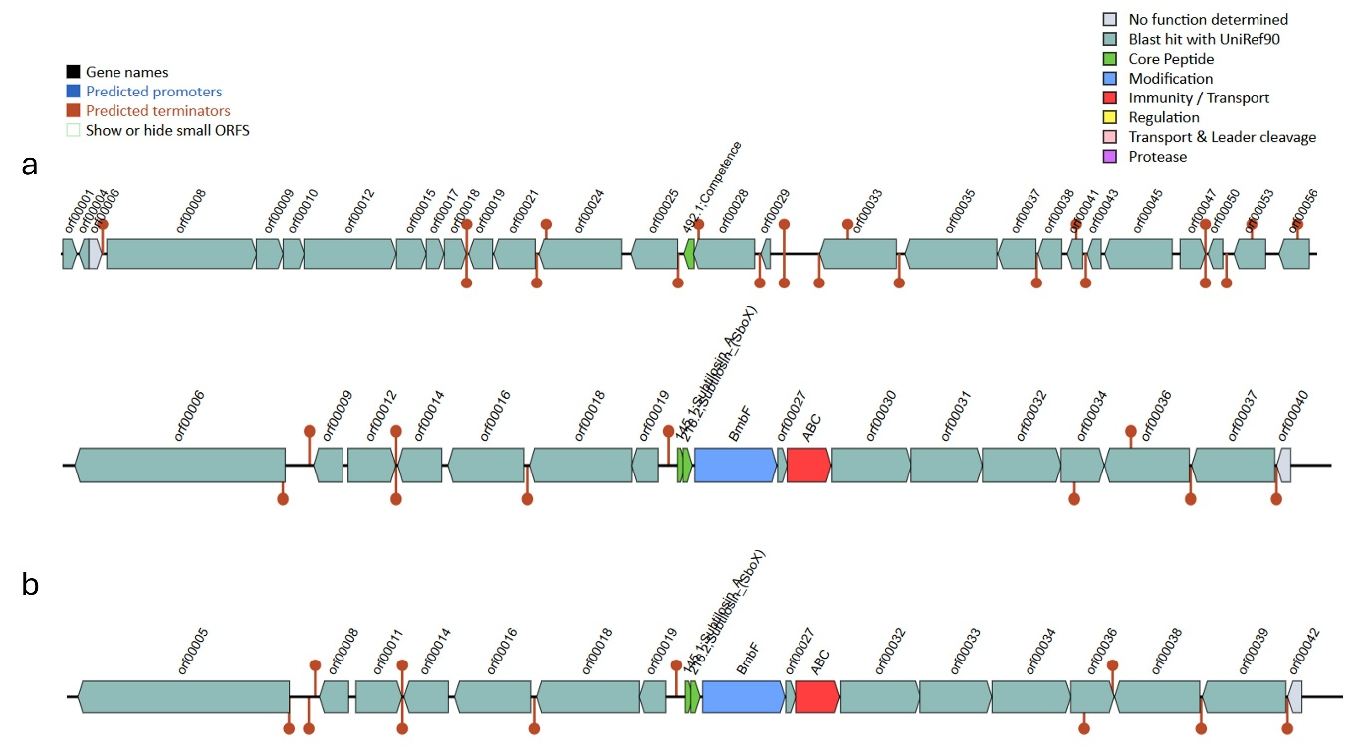
Fig. S6 Organization of bacteriocin in B. subtilis strains: (a) HM01 and (b) HM04.

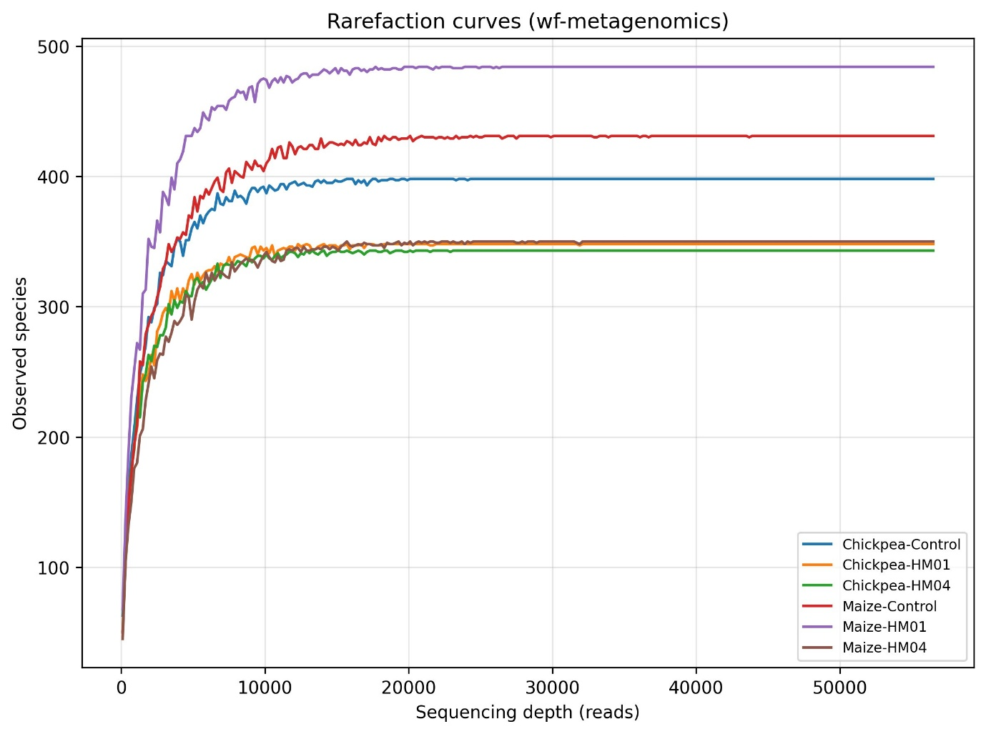
Fig. S7 Rarefaction curves showing the relationship between sequencing depth and observed microbial taxa across rhizosphere samples. Curves were generated using species-level read count tables obtained from the wf-metagenomics pipeline and repeated subsampling without replacement to the minimum sequencing depth. Each curve represents an individual sample, and the plateauing of curves indicates adequate sequencing depth for capturing community diversity.
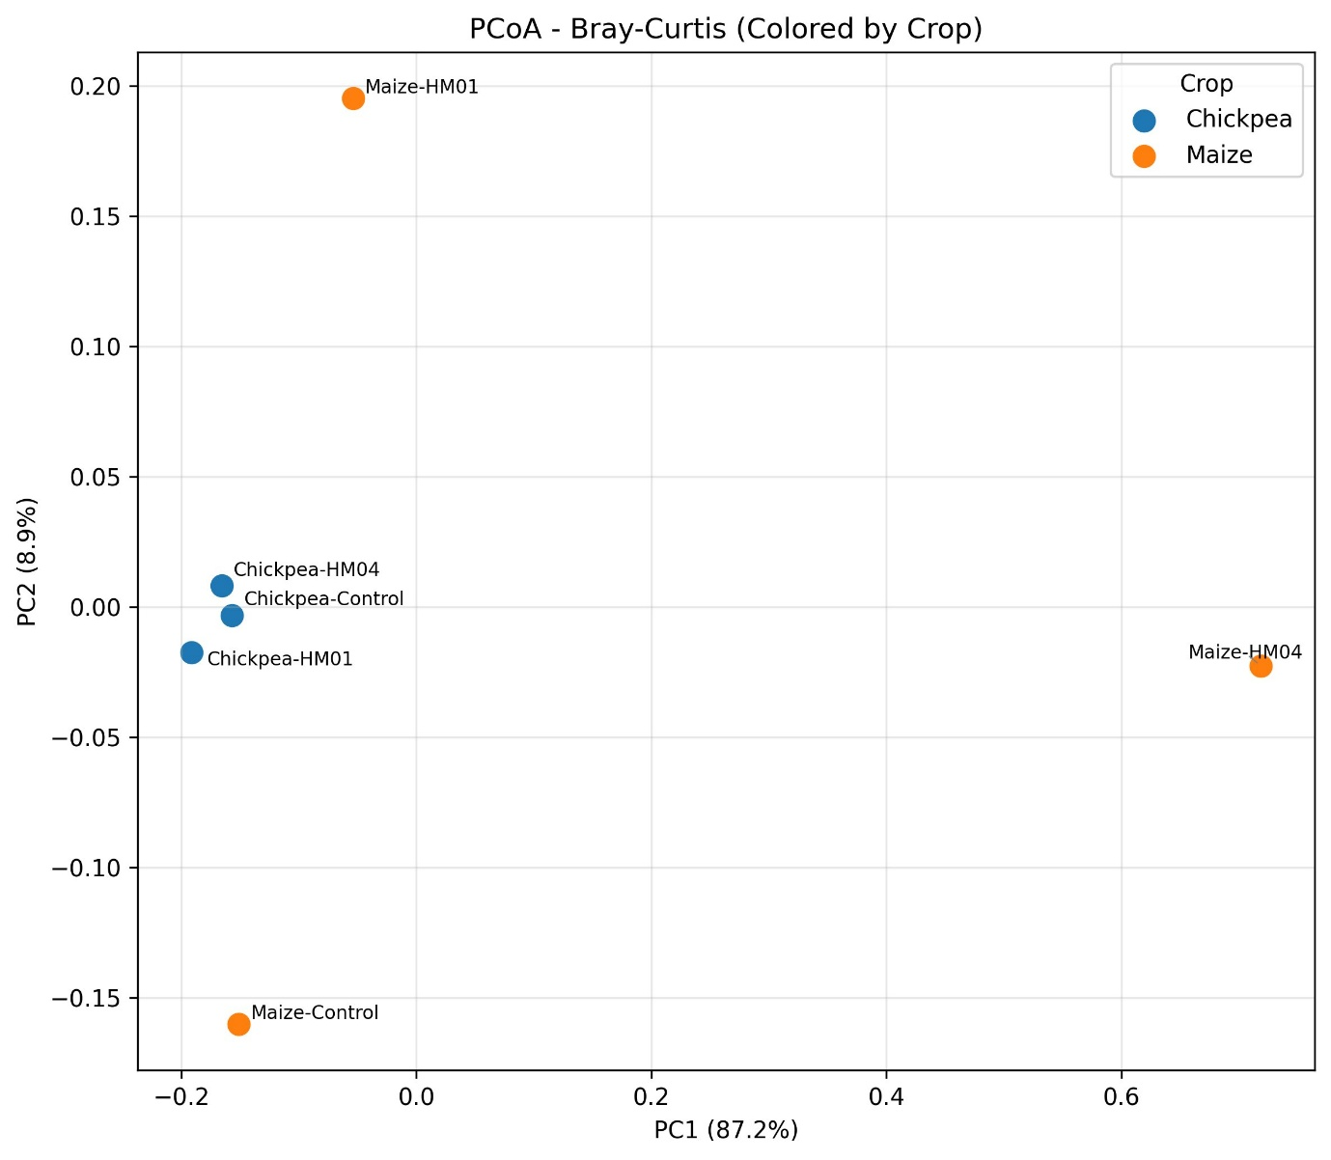
Fig. S8 Principal coordinate Analysis (PCoA) based on Bray–Curtis matrix showing variation in bacterial community structure among chickpea- and maize-based treatments.
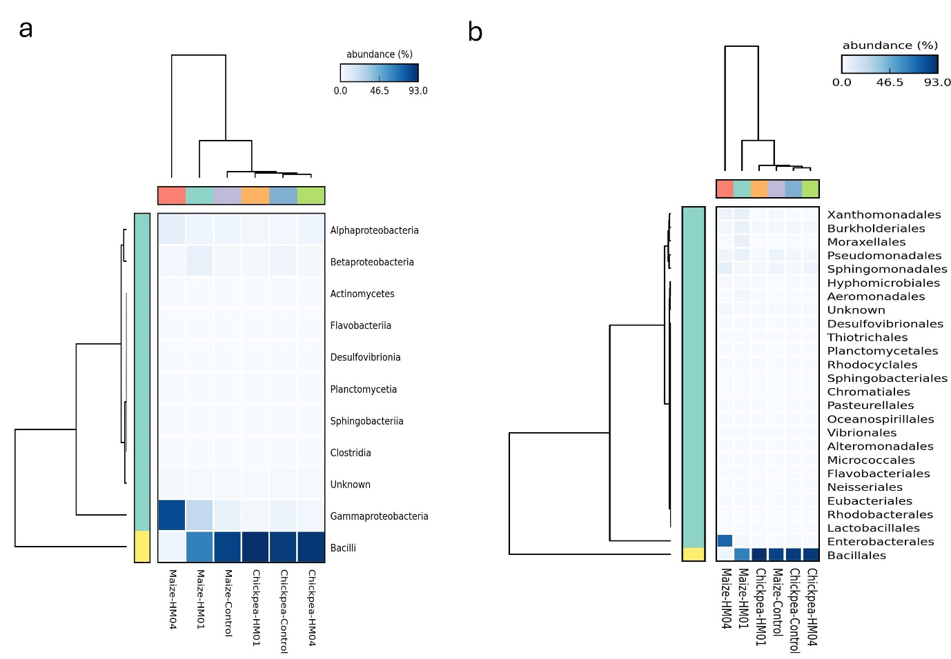
Fig. S9 Hierarchical clustered heatmaps showing the relative abundance of dominant bacterial classes (a) and orders (b) across chickpea- and maize-based treatments.

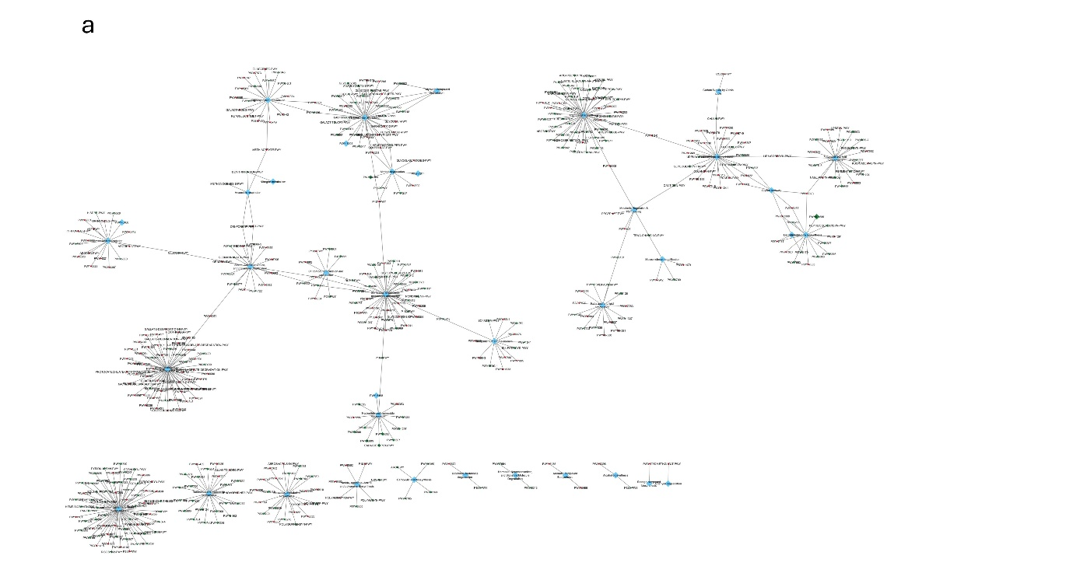

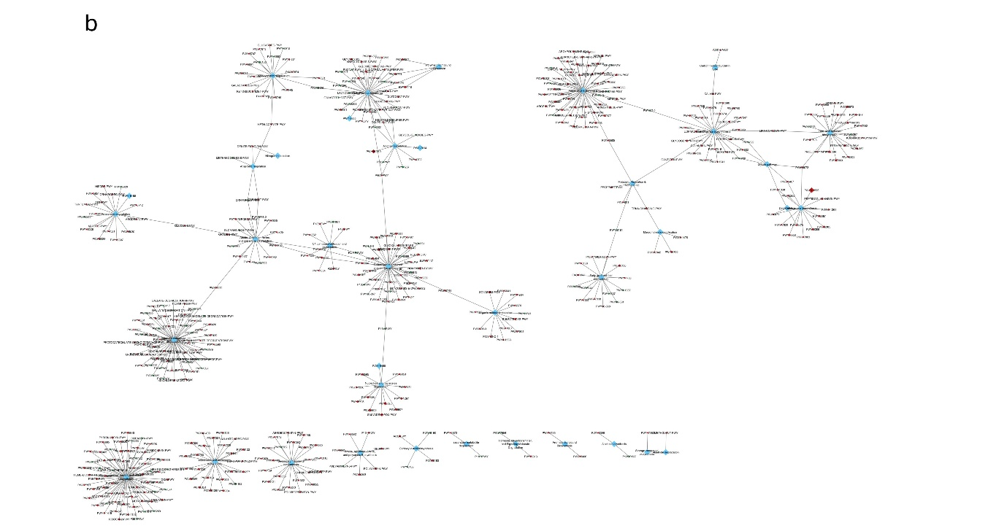

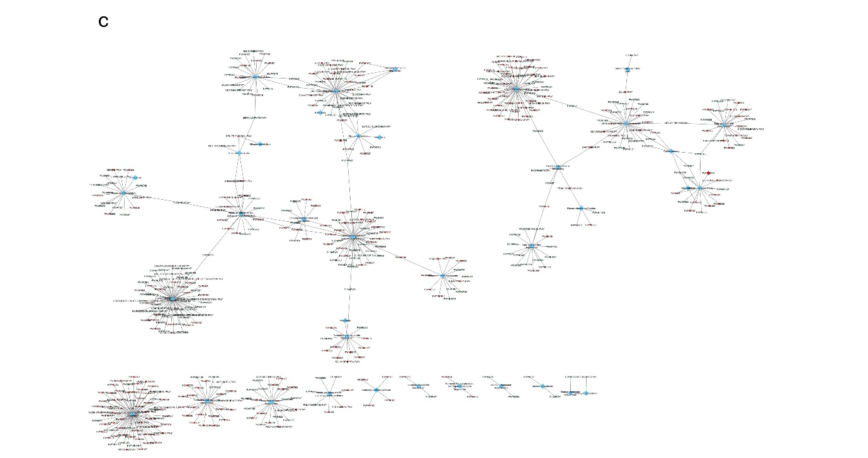

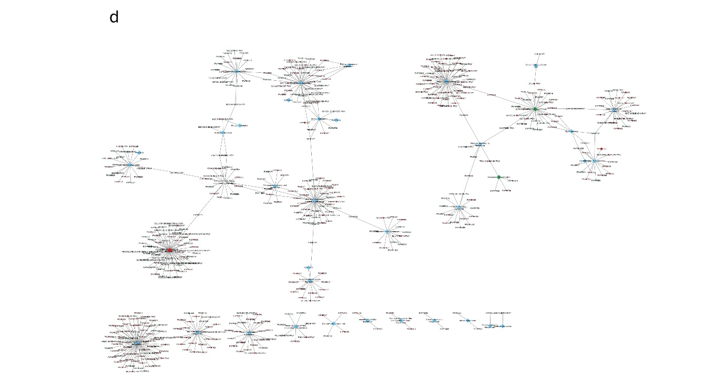
Fig. S10 MetaCyc pathway interaction networks illustrating the functional organization of rhizosphere microbial communities associated with chickpea and maize under HM01 and HM04 treatments. Central nodes represent functional categories, to which individual metabolic pathways are connected as nodes. Pathway nodes are colored green when their abundance increased and red when their abundance decreased relative to the control, based on log₂ fold-change (log₂FC) values. Node size is proportional to the relative abundance of each pathway. Edges indicate shared reactions or functional overlap among pathways. The diagrams represent: (a) HM01-treated chickpea rhizosphere, (b) HM04-treated chickpea rhizosphere, (c) HM01-treated maize rhizosphere, and (d) HM04-treated maize rhizosphere.

Tables
Table S1. Comparison of six Bacillus subtilis strains (HM01–HM06) for their effects on shoot growth, root growth, and total seedling weight in agar-based assays. To evaluate the relative improvement in plant growth metrics, GSF was computed in relation to three control treatments: water, buffer, and untreated seeds. The table illustrates crop-specific variations in response to strain inoculation, with the two crops (chickpea and maize) showing opposing effects when inoculated with strains HM01 and HM04, which are highlighted in bold.
Strain | Control | HM01 | HM02 | HM03 | HM04 | HM05 | HM06
Mung | Water | 33 | 67 | 33 | 33 | 0 | 0
Mung | Buffer | 100 | 67 | 33 | 33 | 0 | 67
Mung | Untreated | 67 | 67 | 33 | 33 | 33 | 33
Cotton | Water | 0 | 0 | 67 | 33 | 33 | 33
Cotton | Buffer | 33 | 33 | 67 | 67 | 67 | 67
Cotton | Untreated | 67 | 67 | 100 | 67 | 33 | 67
Jowar | Water | 0 | 0 | 0 | 100 | 100 | 100
Jowar | Buffer | 0 | 33 | 33 | 33 | 33 | 67
Jowar | Untreated | 0 | 0 | 0 | 100 | 100 | 100
Wheat | Water | 0 | 33 | 0 | 0 | 33 | 0
Wheat | Buffer | 100 | 100 | 100 | 67 | 100 | 67
Wheat | Untreated | 33 | 0 | 0 | 0 | 100 | 0
Chickpea | Water | 100 | 67 | 33 | 0 | 67 | 67
Chickpea | Buffer | 100 | 67 | 67 | 67 | 67 | 67
Chickpea | Untreated | 100 | 33 | 0 | 0 | 33 | 33
Maize | Water | 0 | 0 | 0 | 67 | 0 | 0
Maize | Buffer | 0 | 0 | 0 | 100 | 0 | 0
Maize | Untreated | 0 | 0 | 67 | 100 | 67 | 33

Table S2. Detailed genomic characteristics and functional subsystem distributions of B. subtilis strains HM01 and HM04.
Features | HM01 | HM04
Taxonomy | Bacteria; Bacillati; Bacillota; Bacilli; Bacillales; Bacillaceae; Bacillus; Bacillus subtilis
Total data (Mb) | 4.2 | 4
Completeness score (%) | 99.80 | 99.75
Contamination score (%) | 0.28 | 0.57
GC content (%) | 43.7 | 43.8
Number of Contigs (with PEGs) | 1 | 1
N50 (bp) | 4213538 | 4074150
L50 (bp) | 1 | 1
Number of Coding Sequences | 4419 | 4203
Number of RNAs | 115 | 110
Number of Subsystems | 332 | 331
Subsystem classification (Feature count)
phosphorus metabolism | 11 | 11
potassium metabolism | 3 | 3
sulphur metabolism | 9 | 8
iron acquisition and metabolism | 32 | 31
secondary metabolism | 10 | 6
motility and chemotaxis | 45 | 45
Stress response | 45 | 45

Table S3. Functional annotation of genes associated with PGP pathways in strains HM01 and HM04. Genes that are uniquely present in the isolates are highlighted in bold.
Pathway | HM01 | HM04
Phosphate solubilization | pstA, pstB, pstS | pstA, pstB, pstS
Potassium solubilization | ktrA, ktrB | ktrA, ktrB
Zinc solubilization | znuA, znuB, znuC, zur | znuA, znuB, znuC, zur
Iron sequetration and metabolism | efeM, efeN, efeU, fecD, fur | efeM, efeN, efeU, fecD, fur
Nitrogen fixation | nifS | nifS
Siderophore production | fhuD, mbtH | fhuD
Assimilatory sulphate reduction | cysC, cysE, cysH, cysI, cysJ, cysK, cysL, cysS, cysP | cysC, cysE, cysH, cysI, cysJ, cysL, cysS, cysP
Dissimilatory sulphate reduction | dsrE, sat | dsrE, sat
Chemotaxis | cheA, cheB, cheC, cheD, cheR, cheV, cheW, cheY, dppA, fliD, fliE, fliF, fliG, fliJ, fliM, fliP, fliQ, fliR, fliS, fliT, fliW, malG, mcpA, mcpB, mcpC, mglA, motB, rbsA, rbsB, rbsC, rbsD, rbsK | cheA, cheB, cheC, cheD, cheR, cheV, cheW, cheY, dppA, dppB, dppC, fliD, fliE, fliF, fliG, fliJ, fliM, fliP, fliQ, fliR, fliS, fliT, fliW, malG, mcpA, mcpB, mcpC, mglA, motB, rbsA, rbsB, rbsC, rbsD, rbsK
Nitrification | -- | narT, narX
Auxin production | padC, patB | PadC, patB
Cytokinin production | miaB | miaB
Denitrification | narG, narH, norR | narG, norR
Assimilatory nitrate reduction | nasA, nasB, nasC, nasD, nasE, nirC | nasA, nasB, nasC, nasD, nasE, nasF
Dissimilatory nitrate reduction | narH | narH, narX

Table S4. Accessory genes in B. subtilis HM01 and their PGP/rhizospheric relevance
Plant Growth–Promoting (PGP) Genes
Gene | Annotation | Role | PGP relevance | References
strE | dTDP-glucose 4,6-dehydratase | Precursor for exopolysaccharides (EPS) | Produces activated sugar precursors required for EPS biosynthesis; EPS forms a protective and adhesive matrix that enhances bacterial attachment to roots, promotes microcolony formation, retains moisture, and stabilizes beneficial bacterial populations in the rhizosphere. | https://doi.org/10.3389/fmicb.2025.1572117
wbpA | UDP-N-acetyl-D-glucosamine 6-dehydrogenase | EPS & cell-wall precursor synthesis | Generates key substrates for peptidoglycan and EPS production, strengthening biofilm architecture; supports robust surface adhesion to roots, protects bacteria from desiccation and root-secreted antimicrobials, and enhances persistence in the rhizosphere. | https://doi.org/10.1093/ismejo/wraf114
gmuG | Endo-1,4-β-mannanase | Breaks down plant hemicellulose mannans | Degrades mannans in root mucilage and plant cell wall fragments, improving nutrient access and promoting bacterial colonization; breakdown products can stimulate root exudation and enhance plant–microbe interaction, indirectly promoting plant growth. | https://doi.org/10.1016/j.ijbiomac.2020.10.235
group_5210 | Periplasmic nitrate reductase | Nitrate respiration | Enhances plant growth by converting nitrate into bioavailable reduced nitrogen forms under low-oxygen rhizosphere conditions; supports nitrogen turnover in the root zone, reduces competition with plants for nitrate, and promotes nutrient accessibility in the rhizosphere. | https://doi.org/10.1016/j.ijbiomac.2022.04.082
group_5228 | Chitosanase | Chitin/chitosan hydrolysis | Breaks down chitin in fungal cell walls, inhibiting pathogenic fungi; releases chitooligosaccharides that can stimulate plant immune responses; contributes to biological control and reduces disease pressure, enhancing plant vigor. | https://doi.org/10.3390/molecules26071863
Rhizosphere Fitness/ Colonization Genes
Gene | Annotation | Role | Rhizosphere relevance | References
sotB | Sugar efflux transporter | Prevents intracellular sugar overload | Protects cells from osmotic stress caused by high sugar concentrations in root exudates; maintains cytoplasmic balance and supports survival under fluctuating carbon-rich rhizosphere conditions. | https://doi.org/10.1038/s42003-025-08749-7
tarQ | Ribitol-phosphate β-glucosyltransferase | Teichoic-acid modification | Enhances adhesion to root surfaces by optimizing WTA charge and structure; increases resistance to plant antimicrobial peptides and phenolics through improved cell-wall shielding. | https://doi.org/10.3390/jof11110813
tarF | Glycerol-phosphate polymerase | WTA biosynthesis | Contributes to robust WTA backbone synthesis required for stable biofilm anchoring, root surface colonization, and protection from rhizosphere pH and osmotic shifts. | https://doi.org/10.12688/f1000research.51874.1
bcrC | Undecaprenyl-diphosphatase | Resistance to antimicrobial peptides | Provides defense against plant-derived antimicrobial peptides and saponins by maintaining lipid carrier pools necessary for cell-wall repair and remodeling. | https://doi.org/10.3390/biology12121519
tagU | Teichoic acid transferase | WTA anchoring to peptidoglycan | Strengthens physical adhesion to plant roots by anchoring WTAs firmly to peptidoglycan, supporting initial attachment and persistent colonization. | https://doi.org/10.1111/1751-7915.14118
emrB | Multidrug exporter | Detoxification | Pumps out toxic plant secondary metabolites, flavonoids, and antimicrobials present in root exudates, enhancing survival in hostile rhizosphere niches. | https://doi.org/10.2478/am-2022-009
mdaB | Quinone oxidoreductase | Oxidative stress defense | Neutralizes quinones and reactive oxygen species generated by plant defense responses; protects cells from oxidative bursts around the root zone. | https://doi.org/10.1128/JB.00421-21
fabG | Fatty-acid reductase | Membrane adaptation | Maintains membrane fluidity and integrity under root-induced stresses (phenolics, pH shifts, osmotic gradients), enabling sustained colonization. | https://doi.org/10.1128/mmbr.00069-23
comP | Sensor histidine kinase | Biofilm & competence regulation | Detects root exudate signals (flavonoids, organic acids) and activates biofilm formation, competence, and stress-response pathways essential for rhizosphere establishment. | https://doi.org/10.1042/BSR20220352

Table S5. Accessory genes in B. subtilis HM04 and their PGP/rhizospheric relevance
Plant Growth–Promoting (PGP) Genes
Gene | Annotation | Role | PGP Relevance | References
Periplasmic nitrate reductase | Nitrate respiration enzyme | Nitrogen cycling | Enhances plant growth by converting nitrate into bioavailable reduced nitrogen forms under low-oxygen rhizosphere conditions; supports nitrogen turnover in the root zone, reduces competition with plants for nitrate, and promotes nutrient accessibility in the rhizosphere. | https://doi.org/10.1186/s12866-023-02941-7
Chitosanase | Chitin/chitosan degradation enzyme | Antifungal activity | Breaks down chitin in fungal cell walls, inhibiting pathogenic fungi; releases chitooligosaccharides that can stimulate plant immune responses; contributes to biological control and reduces disease pressure, enhancing plant vigor. | https://doi.org/10.14720/abs.66.1.13510
Mannanase | Endo-1,4-β-mannanase | Plant polysaccharide degradation | Degrades mannans in root mucilage and plant cell wall fragments, improving nutrient access and promoting bacterial colonization; breakdown products can stimulate root exudation and enhance plant–microbe interaction, indirectly promoting plant growth. | https://doi.org/10.1016/j.ijbiomac.2020.10.235
Rhizosphere Fitness/ Colonization Genes
Gene | Annotation | Role | Rhizosphere Relevance | References
tagA/B/D/G, tarI/J/K/L/M | Teichoic acid biosynthesis proteins | Cell wall assembly, adhesion | Enhance adhesion to mucilage-rich maize roots; optimize surface charge for sticking to sugars and polysaccharides. | https://doi.org/10.1093/femsre/fuaa064
lytA | Cell-wall hydrolase | Cell-wall remodeling | Enables biofilm initiation on carbohydrate-rich maize surfaces by controlled remodeling of peptidoglycan. | https://doi.org/10.3390/jof9050547
walR | Two-component regulator | Cell-wall regulation | Activates adhesion and biofilm genes in response to maize organic acids and mucilage contact. | https://doi.org/10.3390/jcm12030767
bcrC | Bacitracin resistance protein | Recycles lipid carriers | Supports cell-wall repair during mild antimicrobial stress from benzoxazinoid-derived compounds. | https://doi.org/10.1038/s41598-025-08736-2
bmrA | Multidrug efflux transporter | Detoxification | Pumps out benzoxazinoids, weak lipophilic antimicrobials, and phenolics secreted by maize roots. | https://doi.org/10.3390/ijms24065239
des_1 | Fatty acid desaturase | Membrane fluidity modulation | Maintains membrane integrity under osmotic shifts created by sugar-rich exudates. | https://doi.org/10.3390/ijms24032765
sasA | Sensor kinase | Stress sensing | Detects osmotic, pH, and acid–sugar gradients in maize exudates and activates adaptive responses. | https://doi.org/10.3390/ijms25115785
cmpR | Transcriptional activator | Carbon and amino acid metabolism | Enables utilization of maize amino acids, organic acids (malate, citrate) ,sugar-derived carbon sources. | https://doi.org/10.1111/ppl.14140
yueB | ESX secretion-associated protein | Protein secretion | Enhances competitive fitness and colonization on maize epidermal surfaces. | https://doi.org/10.3390/ijms26062592
strE | dTDP-glucose dehydratase | EPS precursor synthesis | Supports EPS matrix formation needed for stable colonization of mucilage-coated maize roots. | https://doi.org/10.3389/fmicb.2022.956332
wbpA | EPS precursor enzyme | EPS biosynthesis | Enhances biofilm cohesion and root-surface stability in sugar-rich exudate environments. | https://doi.org/10.1186/s12934-025-02846-2
fabF | Fatty acid synthase component | Membrane lipid synthesis | Supports membrane adaptation under osmotic stress and exposure to maize-derived fatty acids. | https://doi.org/10.3390/plants13091227
nhoA | Arylamine acetyltransferase | Detoxification of aromatics | Neutralizes aromatic intermediates and phenolic derivatives present in maize exudates. | https://doi.org/10.1038/s41591-023-02217-7
arnB | Lipid A modification enzyme | Antimicrobial peptide resistance | Provides protection against plant immune-derived peptides triggered by benzoxazinoids. | https://doi.org/10.1021/acs.biochem.3c00293
yvcA | Lipoprotein | Cell envelope maintenance | Contributes to envelope stability and colony morphology under fluctuating soil moisture in maize rhizosphere. | https://doi.org/10.3390/microorganisms9030633
yeeK | Spore coat protein | Sporulation | Supports persistence in the maize root zone during dry–rewet cycles. | https://doi.org/10.1038/s42003-025-08522-w
rapA / rapH / spo | Sporulation phosphatases | Sporulation decision | Coordinate nutrient-rich maize cues to regulate timely sporulation, colonization, or persistence. | https://doi.org/10.1007/s00894-023-05664-8

Table S5. Summary of total reads, detected species, and Shannon diversity indices for chickpea and maize rhizosphere samples under control and B. subtilis-treated conditions
Crops | Treatment | Total reads | Total species | Shannon Index
Chickpea | Control | 61550 | 398 | 4.5933
Chickpea | B. subtilis HM01 | 60037 | 348 | 4.4772
Chickpea | B. subtilis HM04 | 56616 | 343 | 4.4937
Maize | Control | 85565 | 431 | 4.5627
Maize | B. subtilis HM01 | 68549 | 484 | 4.9479
Maize | B. subtilis HM04 | 80417 | 350 | 4.2009

