Table S1 | Relative EDS elemental compositions of the three regions of M632:1 after exclusion of C and O (wt%).
Element  Region | Pb | Ba | Cu | Si | Ca | S | Na | Mg | Al | Cl | K | Fe | Ni
Center | 29.97 | 38.24 | 8.10 | 18.32 | 0.97 | 0.38 | 1.10 | 0.20 | 0.93 | 0.89 | 0.22 | 0.54 | 0.14
Transition | 29.18 | 38.81 | 10.14 | 17.14 | 0.60 | 1.68 | - | 0.17 | 1.28 | - | 0.06 | 0.81 | 0.14
Edge | 29.74 | 38.57 | 8.60 | 18.42 | 0.82 | 1.21 | - | 0.17 | 1.43 | - | 0.06 | 0.82 | 0.14

Table S2 | Area fractions of indexed phases within the EBSD fields of view in different regions of M632:1 (%).
Phase  Region | BaCuSi₂O₆ | BaPbSi₂O₆ | Ba₂PbSSi₂O₁₀ | BaSi₂O₅ | Ba₅Si₈O₂₁ | BaCa₂Si₃O₉ | PbCO₃ | BaSO₄ | Unindexed
Center | 35.27 | 22.25 | 5.36 | 2.82 | 3.13 | 3.01 | - | - | 28.16
Transition | 38.80 | 12.20 | 6.07 | 0.31 | 1.15 | 2.21 | 2.17 | 3.65 | 33.44
Edge | 29.62 | 26.68 | 8.72 | 0.31 | 0.91 | 3.07 | 2.91 | 1.35 | 26.43

Table S3 pXRF-determined oxide compositions of the central and marginal measurement areas of sample M632:1 (wt%)
Oxide  Region | Center |  |  | Edge
Oxide  Region | 1 | 2 | 3 | 1 | 2 | 3
MgO | 0.22 | 0.33 | 0.30 | 0.31 | 0.31 | 0.35
Al₂O₃ | 1.51 | 1.43 | 1.49 | 1.88 | 1.87 | 1.90
SiO₂ | 26.49 | 26.56 | 26.44 | 25.25 | 25.29 | 25.11
P₂O₅ | 0.08 | 0.08 | 0.08 | 0.15 | 0.15 | 0.15
K₂O | 0.19 | 0.19 | 0.20 | 0.13 | 0.13 | 0.13
CaO | 1.06 | 1.07 | 1.06 | 0.98 | 0.99 | 0.98
TiO₂ | 0.22 | 0.27 | 0.25 | / | / | /
V₂O₅ | 0.34 | 0.34 | 0.37 | 0.33 | 0.34 | 0.35
MnO | 0.14 | 0.14 | 0.15 | 0.13 | 0.14 | 0.13
Fe₂O₃ | 0.70 | 0.71 | 0.70 | 0.81 | 0.82 | 0.82
CoO | 0.06 | 0.06 | 0.06 | 0.05 | 0.04 | 0.04
NiO | 0.02 | 0.02 | 0.02 | 0.03 | 0.03 | 0.02
CuO | 6.02 | 6.03 | 6.06 | 6.71 | 6.70 | 6.74
ZnO | 0.04 | 0.04 | 0.04 | 0.04 | 0.04 | 0.04
GeO₂ | 0.03 | 0.02 | 0.02 | 0.02 | 0.02 | 0.02
As₂O₃ | 0.10 | 0.10 | 0.09 | 0.10 | 0.10 | 0.10
SrO | 0.21 | 0.21 | 0.21 | 0.20 | 0.19 | 0.20
SnO₂ | 0.04 | 0.04 | 0.04 | 0.12 | 0.12 | 0.12
BaO | 34.45 | 34.29 | 34.37 | 34.03 | 33.90 | 34.03
PbO | 28.08 | 28.05 | 28.06 | 28.73 | 28.81 | 28.77
Note: The transition zone was not measured independently because its width was smaller than the effective spot size of pXRF.

Table S4 Crystallographic parameters and identification evidence for the phases identified by EBSD in sample M632:1
Phase | Crystal System | Laue Group | Space group No. | Unit-cell parameters |  |  |  |  |  | Representative EDS spectrum | Representative Kikuchi pattern
 |  |  |  | a / Å | b / Å | c / Å | α / ° | β / ° | γ / ° | Representative EDS spectrum | Representative Kikuchi pattern
BaCuSi₂O₆ | Tetragonal | 4/mmm | 119 | 7.04 | 7.04 | 11.13 | 90.00 | 90.00 | 90.00 | 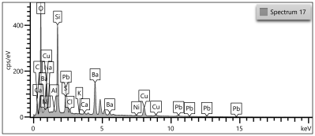 | 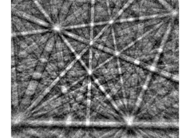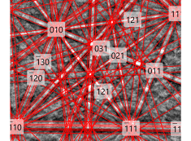
BaPbSi₂O₆ | Orthorhombic | mmm | 63 | 5.51 | 15.45 | 7.29 | 90.00 | 90.00 | 90.00 | 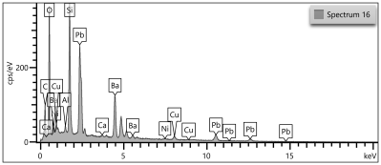 | 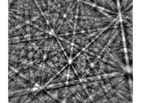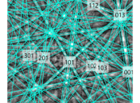
Ba₂PbSSi₂O₁₀ | Orthorhombic | mmm | 62 | 7.25 | 5.48 | 24.35 | 90.00 | 90.00 | 90.00 | 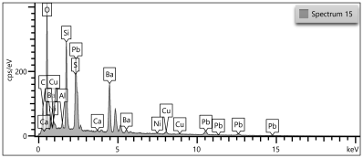 | 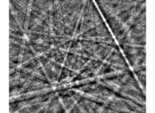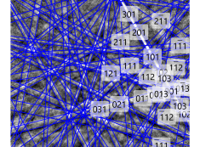
BaSi₂O₅ | Orthorhombic | mmm | 62 | 4.63 | 7.69 | 13.51 | 90.00 | 90.00 | 90.00 | 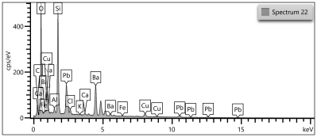 | 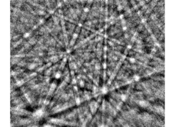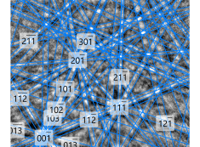
Ba₅Si₈O₂₁ | Monoclinic | 2/m | 15 | 32.68 | 4.70 | 13.89 | 90.00 | 98.10 | 90.00 | 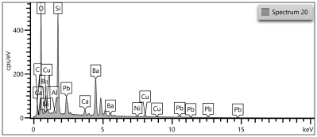 | 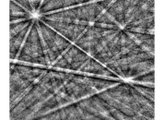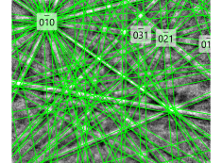
BaCa₂Si₃O₉ | Triclinic | -1 | 2 | 6.73 | 9.62 | 6.72 | 69.62 | 102.33 | 96.90 | 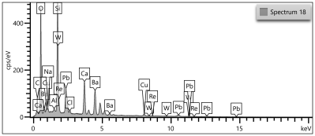 | 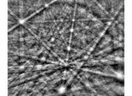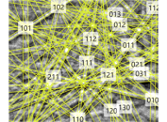
PbCO₃ | Orthorhombic | mmm | 62 | 5.18 | 8.49 | 6.14 | 90.00 | 90.00 | 90.00 | 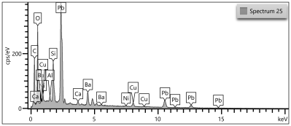 | 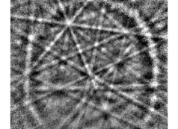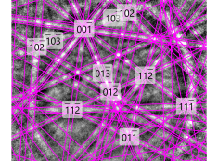
BaSO₄ | Orthorhombic | mmm | 62 | 8.88 | 5.46 | 7.15 | 90.00 | 90.00 | 90.00 | 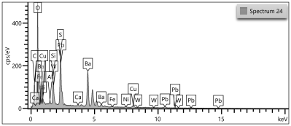 | 