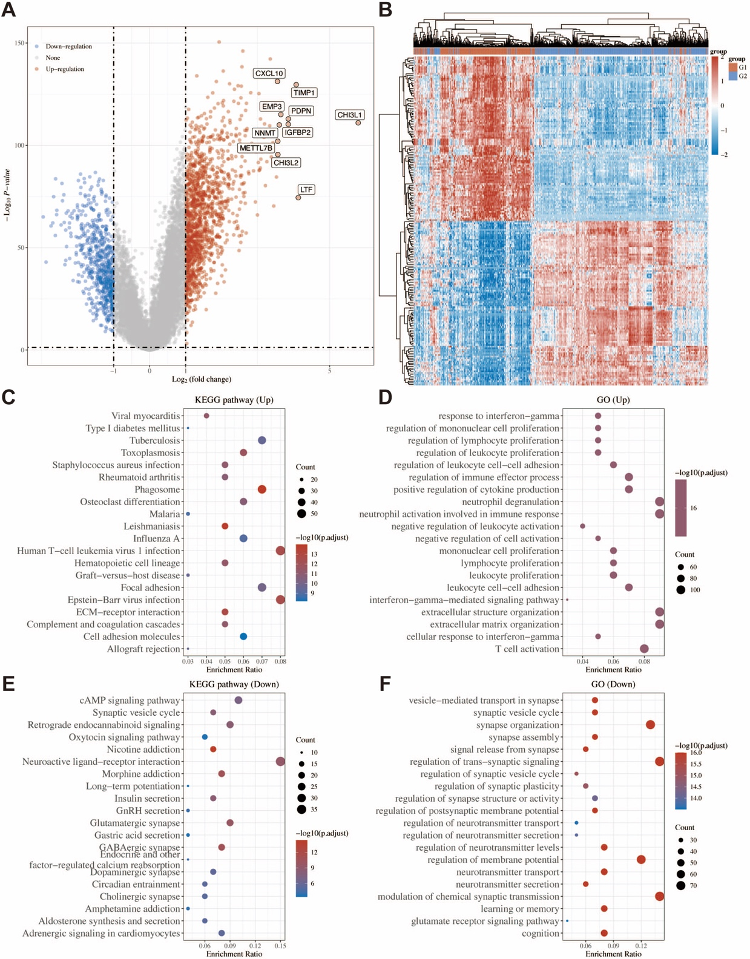
Supplementary Figure 1. Identification of DEGs between two clusters and functional enrichment analysis. (A) Exhibition of DEGs in the TCGA-GBMLGG dataset between two clusters using volcano plot. (B) The heatmap displaying the expression of DEGs. (C) GO and (D) KEGG pathway enrichment results for differentially upregulated genes, as well as (E) GO and (F) KEGG pathway enrichment results for differentially downregulated genes.
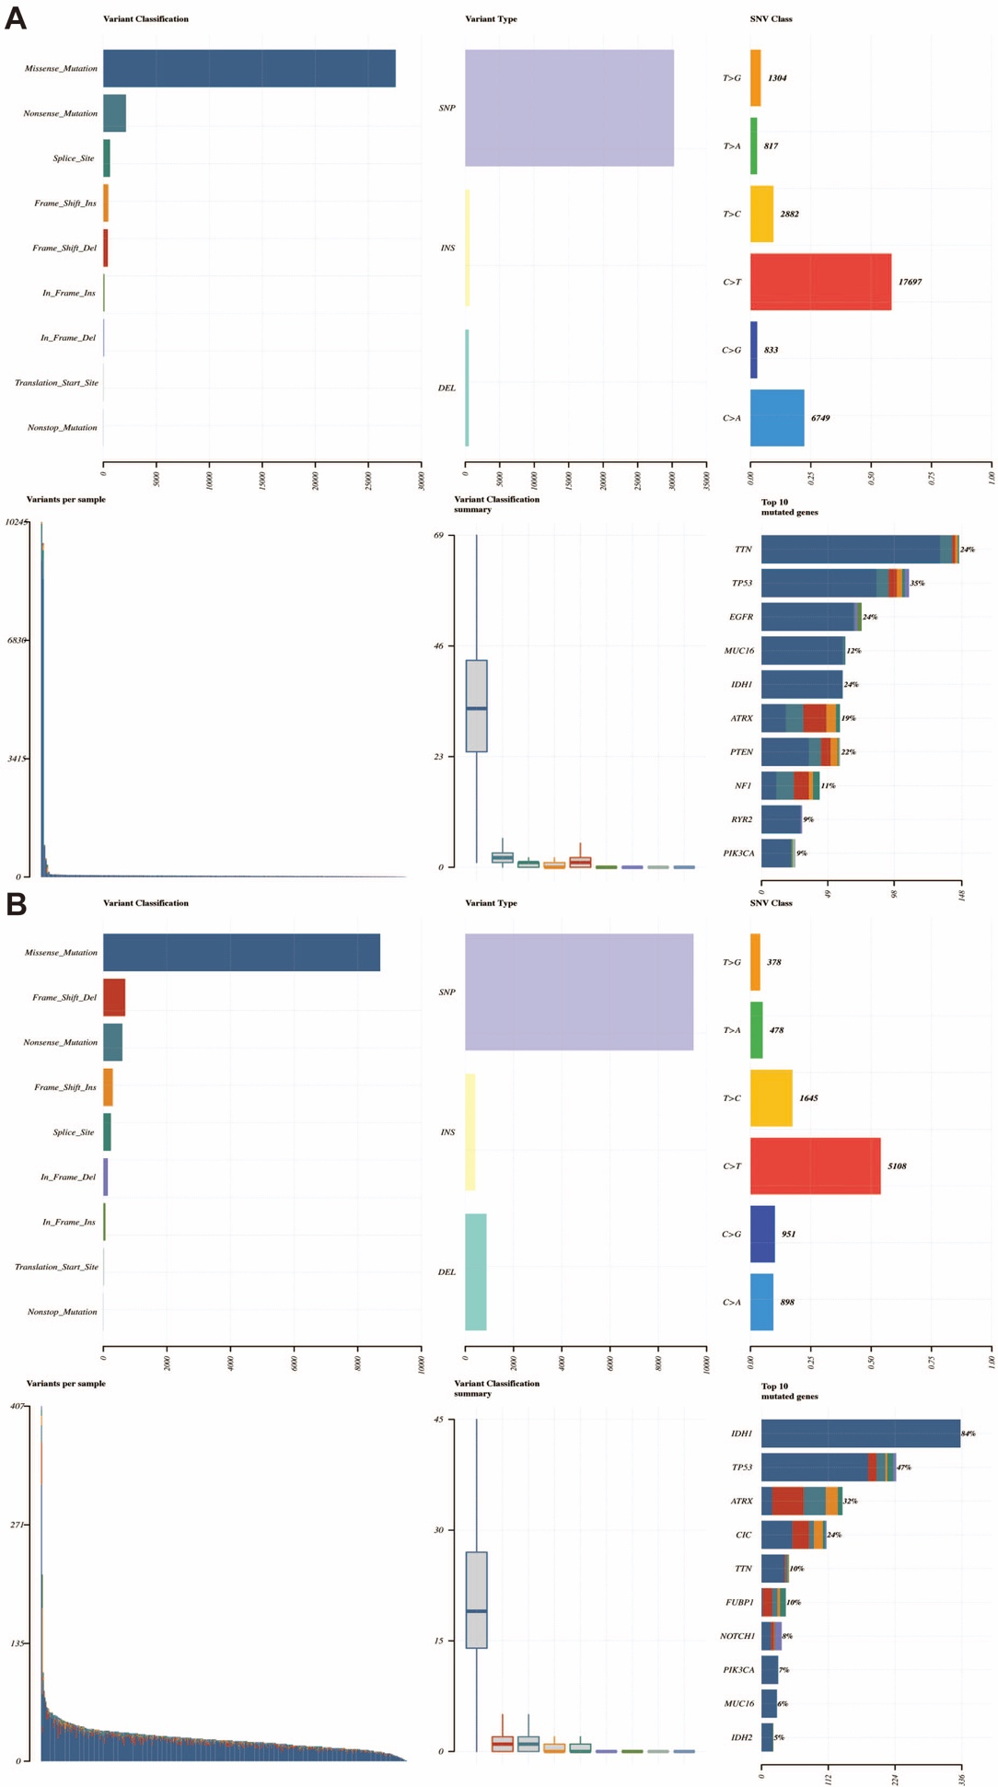
Supplementary Figure 2. (A-B) Cohort summary plot portraying the distribution of variants according to their classification, variant type, and single-nucleotide variant (SNV) category. The lower part (progressing from left to right) denotes the mutation load for each sample as well as the type of variant classification. Moreover, a stacked bar plot demonstrates the 10 genes with the highest mutation counts.
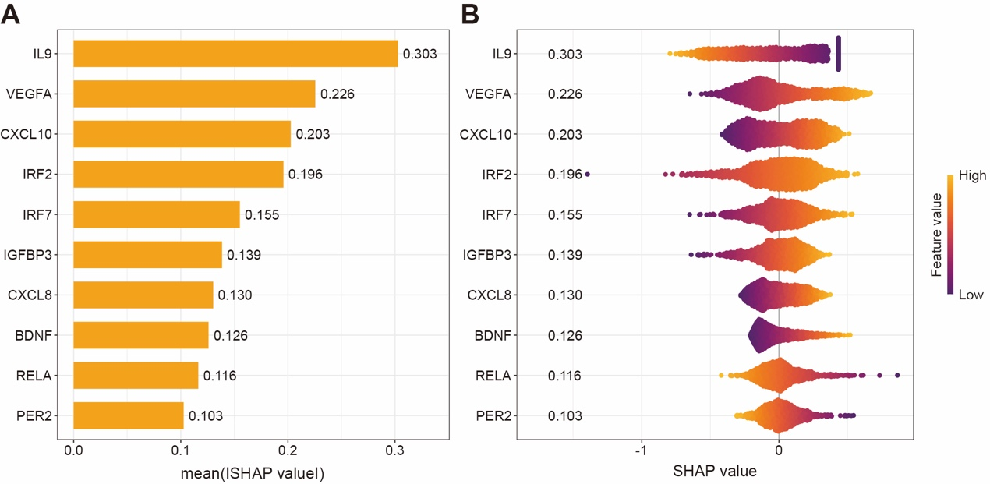
Supplementary Figure 3. SHAP interpretability analysis. (A) Bar graph presenting the relative importance of 10 CRF-associated genes (CAGs). (B) The beeswarm plot showing gene expression distributions across conditions.

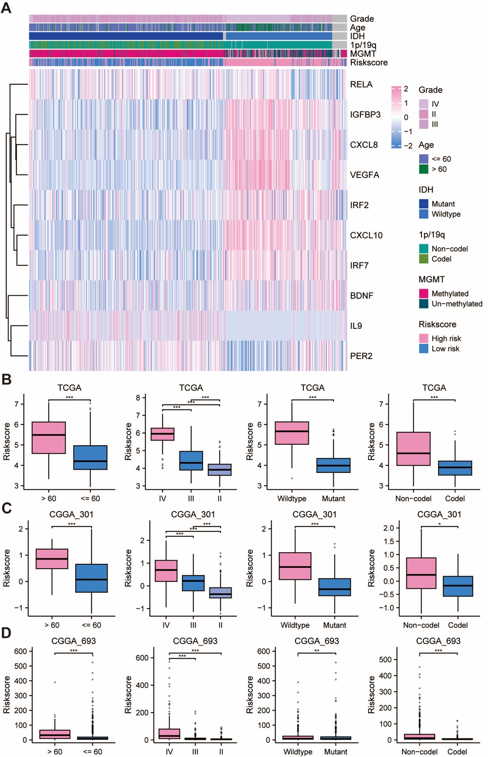
Supplementary Figure 4. The CRRS exhibited a correlation with the clinicopathological features of glioma patients in the TCGA-GBMLGG dataset. (A) Heatmap for the CRRS and clinicopathological manifestation. Boxplot of CRRS in glioma patients with different ages, WHO grades, IDH mutation status, and 1p/19q codeletion status among (B) TCGA-GBMLGG, (C) CGGA_301, and (D) CGGA_693 datasets. * p < 0.05, ** p < 0.01, *** p < 0.001.

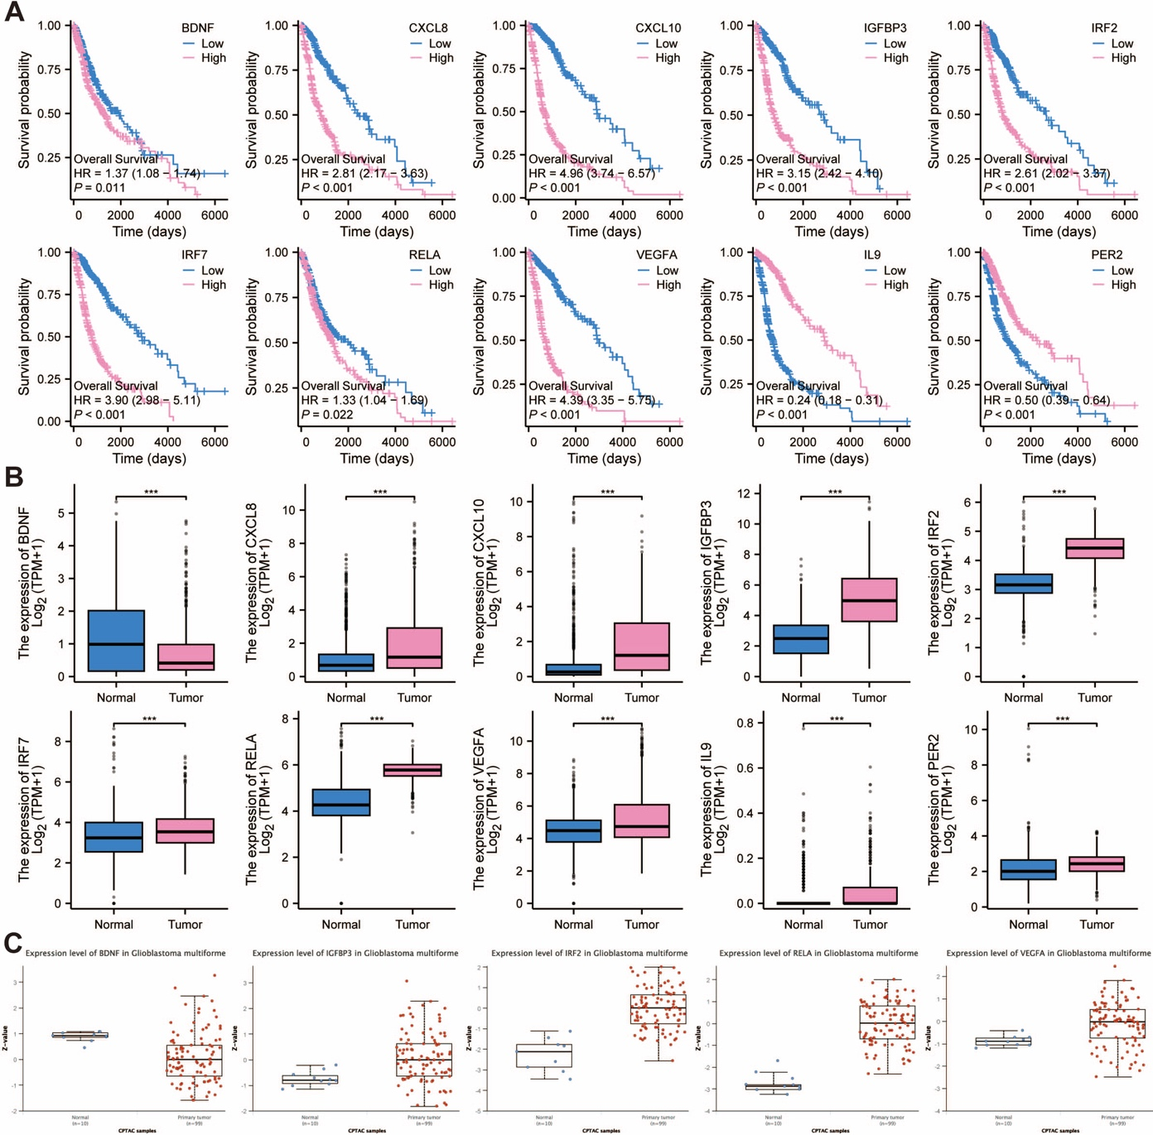
Supplementary Figure 5. Kaplan–Meier survival and differential expression analysis of 10 CAGs. (A) A Kaplan–Meier survival analysis of the 10 genes, showing significant associations with overall survival in the TCGA-GBMLGG cohort. (B) Comparison of mRNA expression levels of 10 CAGs in glioma. (C) Comparison of protein expression levels of CAGs in GBM. *** p < 0.001.

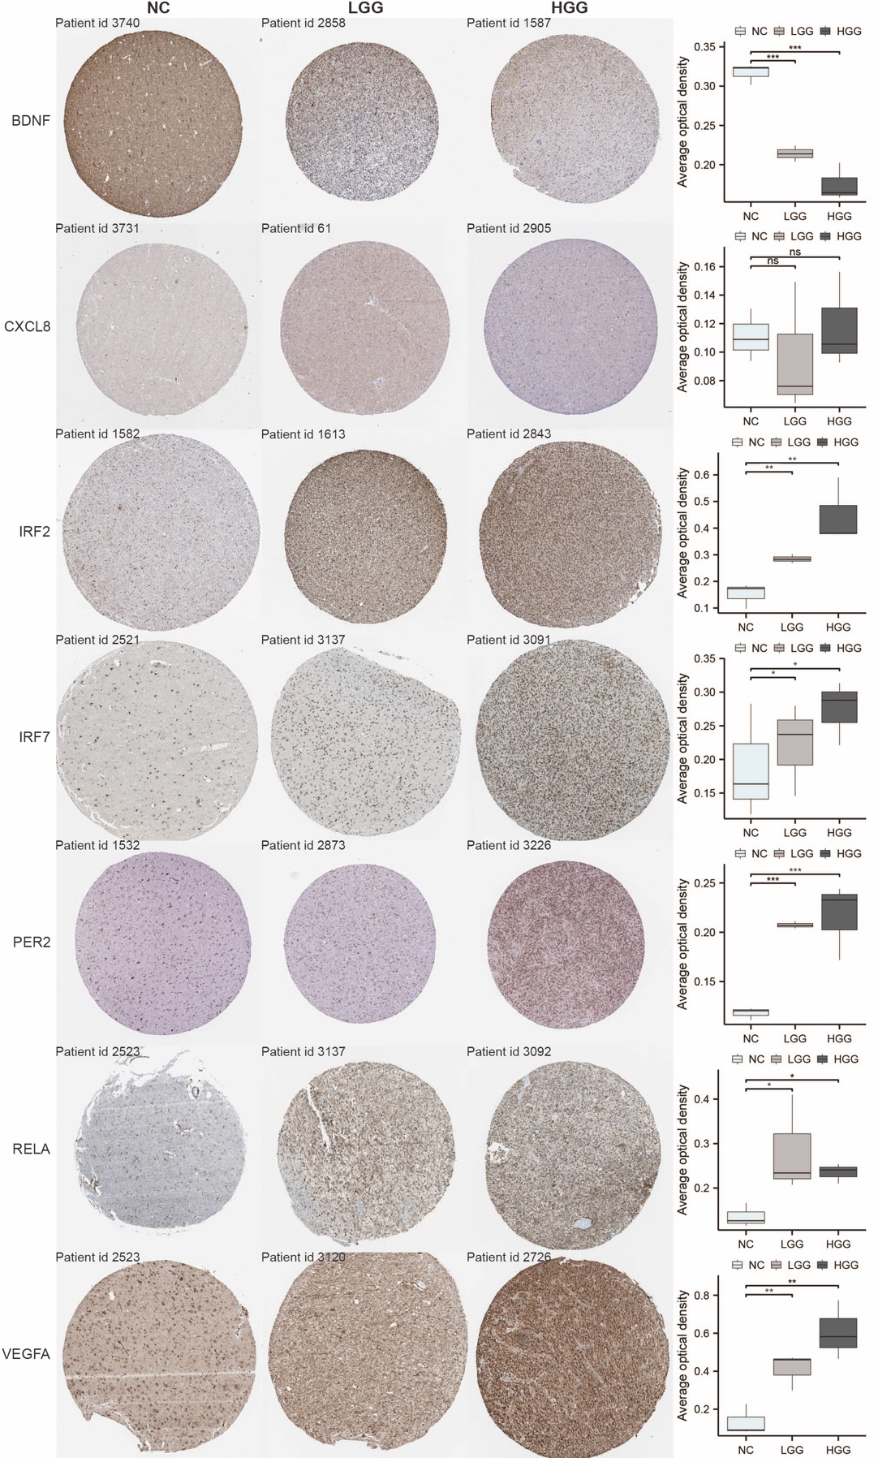
Supplementary Figure 6. Immunohistochemistry revealed differential expression of CAGs-corresponding proteins in normal brain tissue, lower-grade glioma (LGG), and high-grade glioma (HGG)
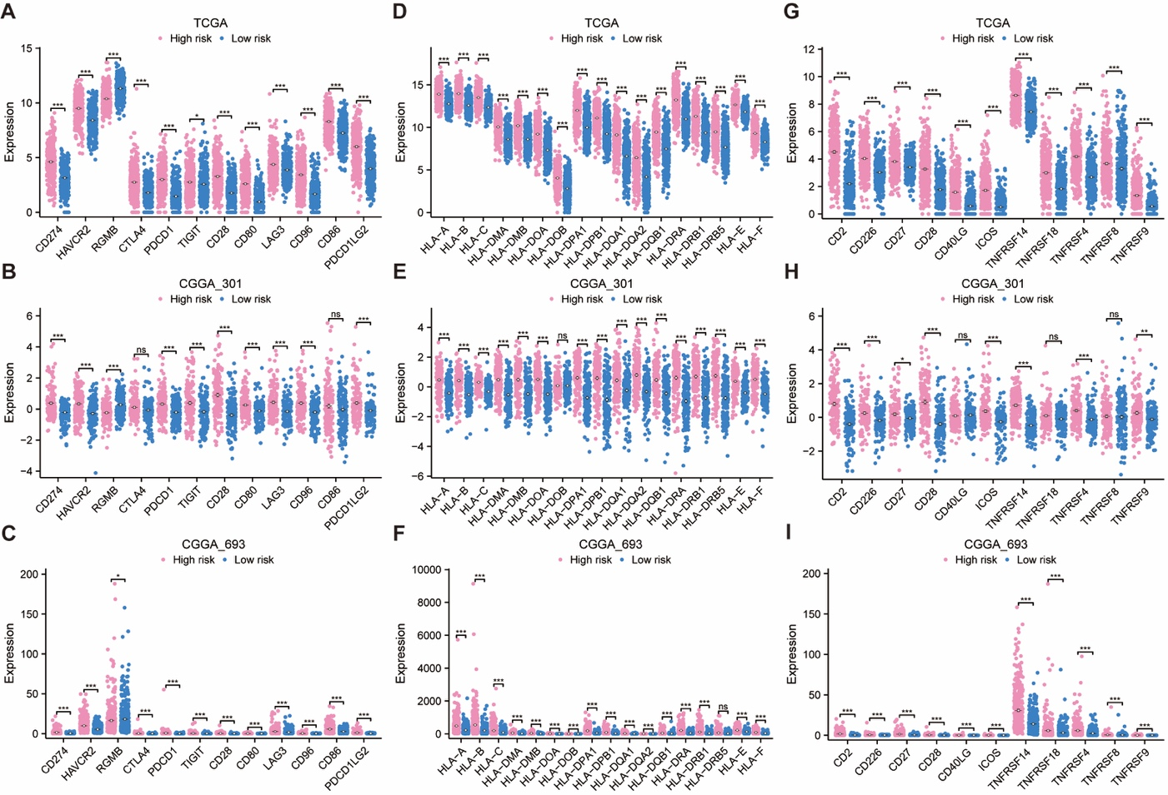
Supplementary Figure 7. Differential expression analysis of immune checkpoint genes between low- and high-risk groups based on the (A) TCGA-GBMLGG, (B) CGGA_301, and (C) CGGA_693 cohorts. Differential expression analysis of MHC between low- and high-risk groups based on the (D) TCGA-GBMLGG, (E) CGGA_301, and (F) CGGA_693 cohorts. Differential expression analysis of T-cell stimulators between low- and high-risk groups based on the (G) TCGA-GBMLGG, (H) CGGA_301, and (I) CGGA_693 cohorts. * p < 0.05, ** p < 0.01, *** p < 0.001, NS, not significant.
Supplementary Figure 8. Relationships between CAGs expression profiles and the infiltration levels of 24 immune cell types.

Supplementary Figure 9. Correlations between CAGs and cancer functional status. (A) Heatmap showing the correlation of CAGs with functional status in GBM. The correlation of (B) BDNF, (C) CXCL8, (D) CXCL10, (E) IRF2, (F) IGFBP3, (G) IL9, (H) IRF7, (I) PER2, (J) RELA, and (K) VEGFA with the functional state in GBM. * p < 0.05, ** p < 0.01, *** p < 0.001.

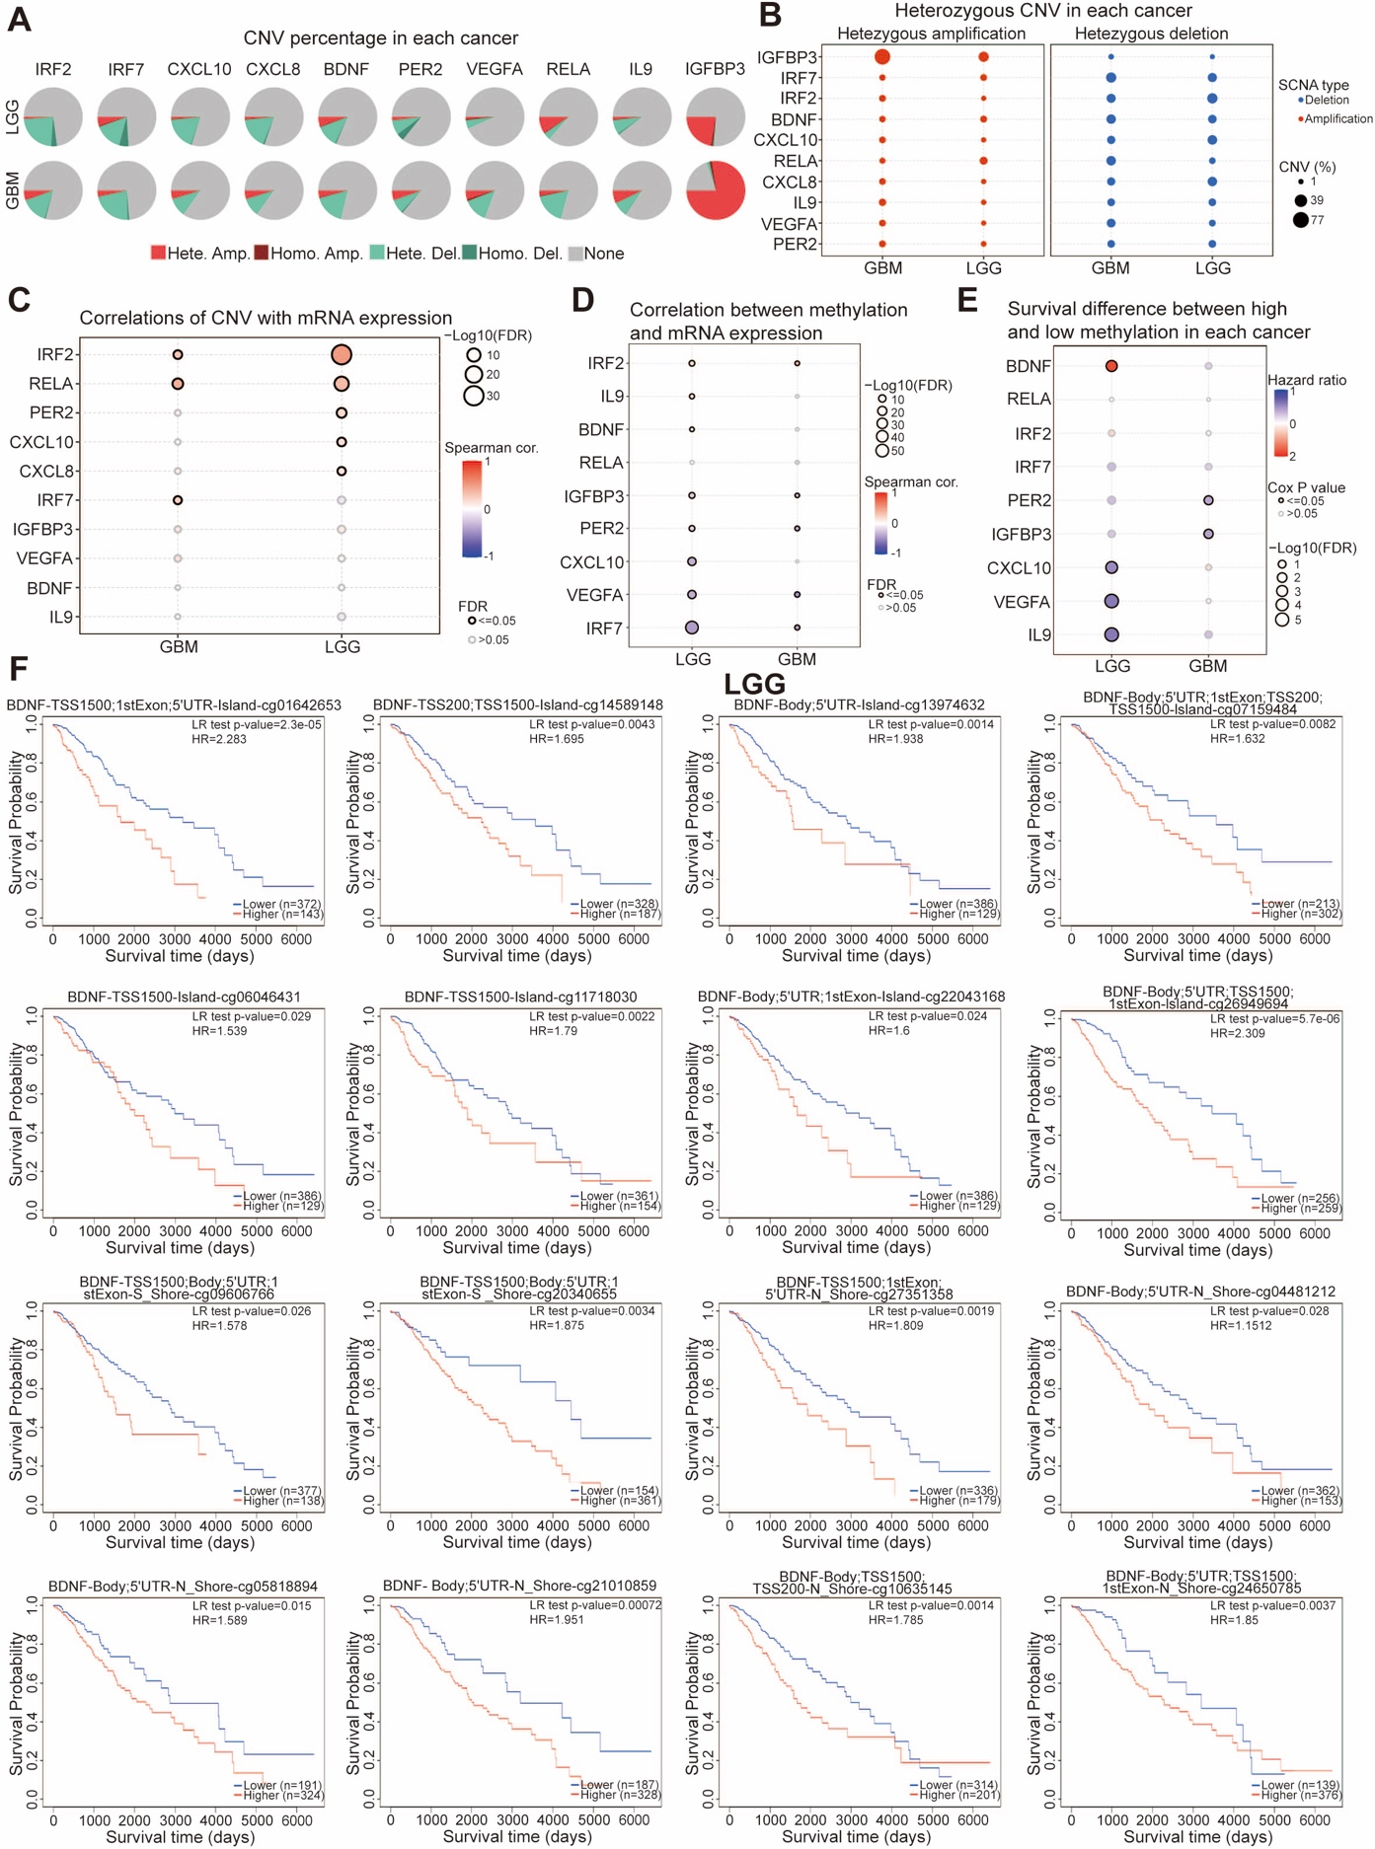
Supplementary Figure 10. Analysis of mutation and methylation levels of CAGs in glioma. (A) Homozygous or heterozygous CNV of CAGs in glioma. Homo Amp: homozygous amplification; Hete Amp: heterozygous amplification; Homo Del: homozygous deletion; Hete Del: heterozygous deletion; None: without CNV. (B) The heterozygous CNV of CAGs in glioma. (C) The correlation between CNV of CAGs and mRNA expression. (D) The correlation between methylation and CAGs expression in LGG and GBM. (E) The difference in overall survival between LGG and GBM caused by hypermethylation and hypomethylation of CAGs. (F) The Kaplan–Meier survival analysis of the promoter methylation of BDNF in LGG.
Supplementary Figure 11. The Kaplan–Meier survival analysis of the promoter methylation of (A) CXCL10, (B) IL9, and (C) VEGFA in LGG. The Kaplan–Meier survival analysis of the promoter methylation of (D) IFI30 and (E) ZCCHC12 in GBM.
Supplementary Figure 12. Correlation analysis between 10 CAGs and (A) MSI score and (B) TMB score.

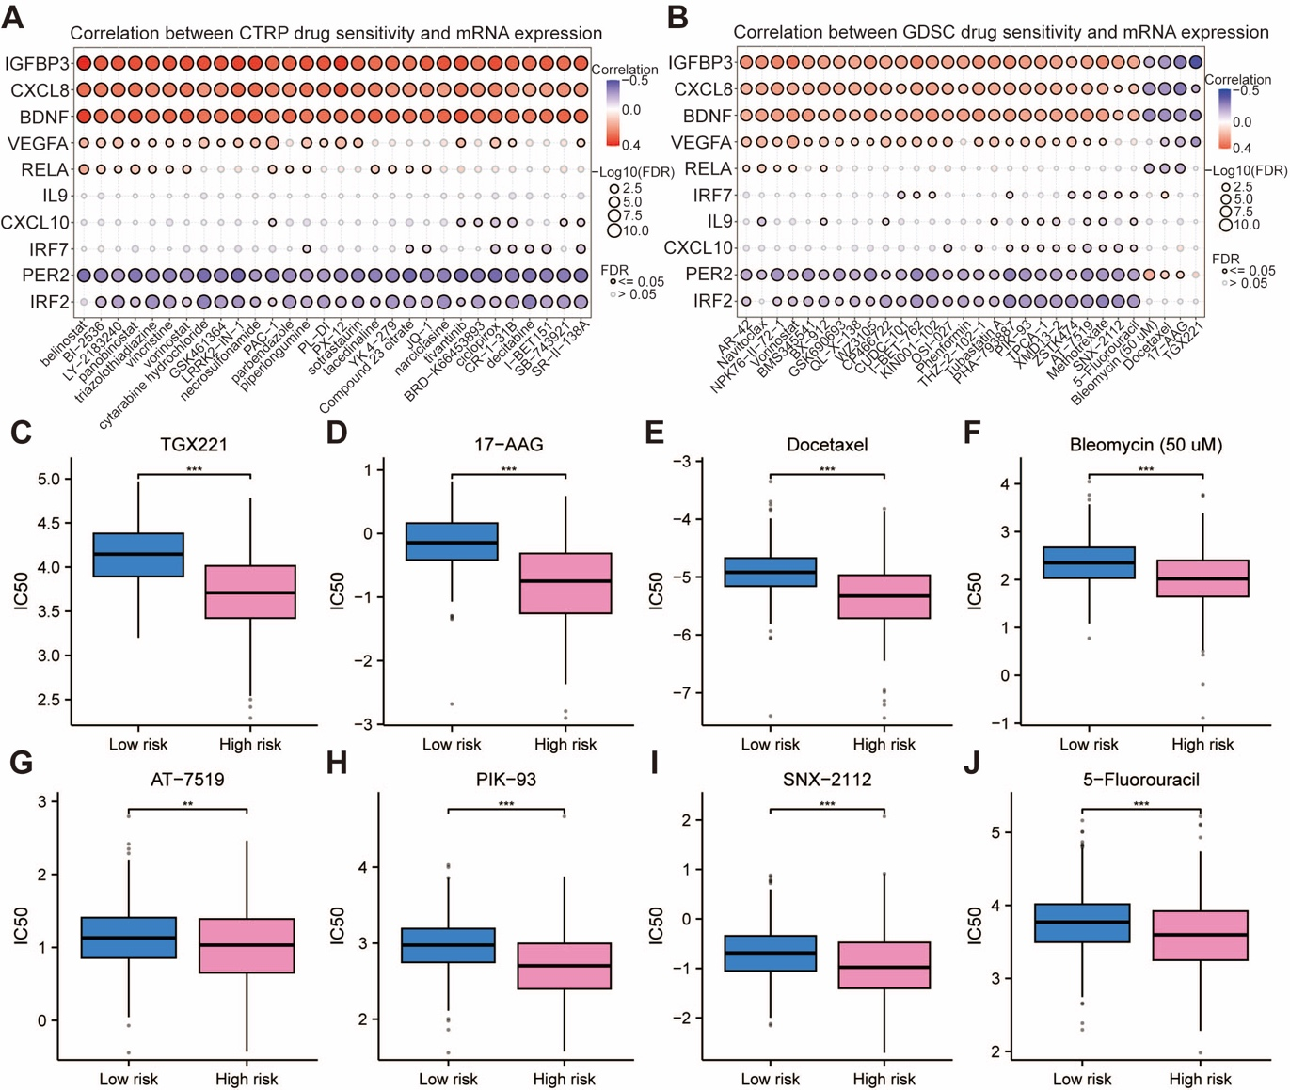
Supplementary Figure 13. Drug sensitivity analysis. Antitumor medication predictions based on the expression of CAGs in glioma from the (A) CTRP and (B) GDSC datasets. Positive correlation indicates a higher gene expression may lead to drug resistance. Negative correlation indicates a higher gene expression may make drug sensitive. (C-J) IC50 value distribution between low- and high-risk groups. ** p < 0.01, *** p < 0.001.
Supplementary Figure 14. Spearman correlation analysis of 10 CAGs and IC50 of drugs.

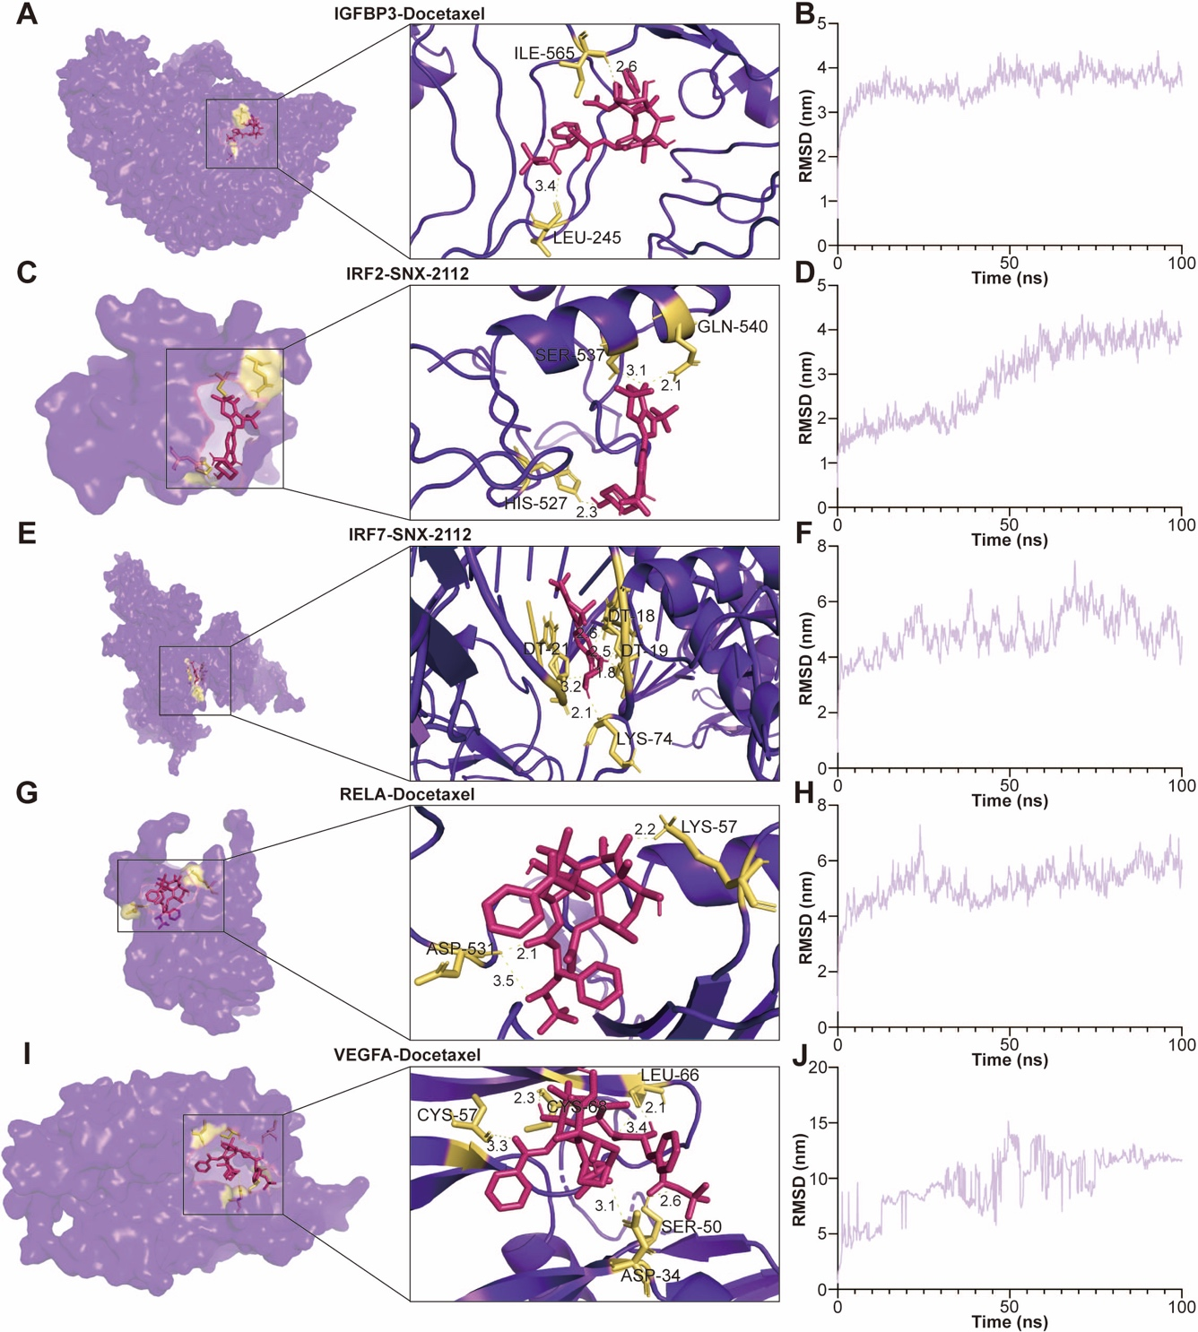
Supplementary Figure 15. Molecular docking and molecular dynamics simulation analysis. The yellow dashed line and accompanying numbers signify hydrogen bonding and the length of the hydrogen bond, whereas red denotes small molecule drugs. (A-B) The optimal docking conformation between IGFBP3 and Docetaxel, along with the root mean square deviation (RMSD) trajectory over a 100 ns timescale. (C-D) The optimal docking conformation between IRF2 and SNX-2112, along with the RMSD trajectory over a 100 ns timescale. (E-F) The optimal docking conformation between IRF7 and SNX-2112, along with the RMSD trajectory over a 100 ns timescale. (G-H) The optimal docking conformation between RELA and Docetaxel, along with the RMSD trajectory over a 100 ns timescale. (I-J) The optimal docking conformation between VEGFA and Docetaxel, along with the RMSD trajectory over a 100 ns timescale.

