Table 1

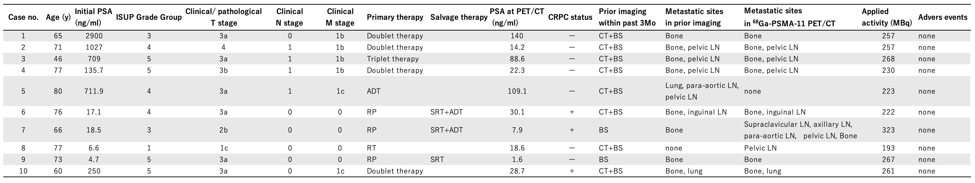
RP = radical prostatectomy; RT = radiation therapy; SRT = salvage radiation therapy; BS = bone scintigraphy; ADT = androgen deprivation therapy

