Supplementary Information

Electric field control of spin-orbit torque switching in a spin-orbit ferromagnet single layer
Miao Jiang^{1*}, Hirokatsu Asahara¹, Shinobu Ohya^{1,2,3*} and Masaaki Tanaka^{1,2*}
¹Department of Electrical Engineering and Information Systems, The University of Tokyo, 7-3-1 Hongo, Bunkyo-ku, Tokyo 113-8656, Japan
²Center for Spintronics Research Network (CSRN), Graduate School of Engineering, The University of Tokyo, 7-3-1 Hongo, Bunkyo-ku, Tokyo 113-8656, Japan
³Institute of Engineering Innovation, Graduate School of Engineering, The University of Tokyo, 7-3-1 Hongo, Bunkyo-ku, Tokyo 113-8656, Japan
*E-mail: jiangmiao@g.ecc.u-tokyo.ac.jp; ohya@cryst.t.u-tokyo.ac.jp; masaaki@ee.t.u-tokyo.ac.jp

Supplementary Note 1. Device preparation
The crossbar with a size of 0.5 μm (width) $×$ 2 μm (length) was patterned by electron beam (EB) lithography in this work and the device fabrication process is described as follows:
a) Deposition of the Au/Cr electrodes (Supplementary Fig. 1a,b). Firstly, the as-grown sample consisting of (Ga_{0.94},Mn_{0.06})As (7 nm) / In_{0.3}Ga_{0.7}As (500 nm) / GaAs was cleaned with isopropanol (IPA) using an ultrasonic vibrator. The cleaned sample is shown in Supplementary Fig. 1a. After that, the electrodes were patterned by EB lithography. Before the exposure, the sample was coated by a 400-nm-thick positive resist ZEP-520A with a spin-coating rotational speed of 4000 rpm for 60 seconds and then pre-baked at 180 °C for 5 minutes. During the exposure, the dose amount was set to be 105 µC cm^{–2}. After the exposure, a development process was conducted using ZED-N50 for 60 seconds to obtain the pattern for the deposition of the metal electrodes. Here, the Au (100 nm)/ Cr (5 nm) was deposited as the electrodes by EB evaporation, as shown in Supplementary Fig. 1b.
b) Etching to form the crossbar structure (Supplementary Fig. 1c). The crossbar structure was patterned by EB lithography by using a positive resist ZEP-520A-7. The thickness of the resist ZEP-520A-7 is less than 200 nm, thinner than that of the resist ZEP-520A used in step a). The rotational speed during spin-coating was 4000 rpm and the rotational time was 60 seconds. During the exposure process, the dose amount was set to be 60 µC cm^{–2}. Then the exposed sample was developed with the same process as shown in step a) and etched by Ar milling for obtaining a structure, as shown in Supplementary Fig. 1c.
c) Deposition of AlO_{x} (Supplementary Fig. 1d). As shown in Supplementary Fig. 1d, a 40-nm-thick AlO_{x} layer was deposited by atomic layer deposition (ALD) as a gate dielectric layer for the application of the electric field. The deposition temperature was set to be 150 °C.
d) Deposition of the gate electrode (Supplementary Fig. 1e). The gate electrode was patterned by using the EB lithography with the same parameters as described in step a). During the exposure process, to prevent the charging-up effect and resist evaporation due to the heat, the electron beams were scanned 2 times in a Field Path mode. Then the Au (100 nm)/ Cr (5 nm) metal layers was deposited as the gate electrode by EB evaporation, as shown in Supplementary Fig. 1e.

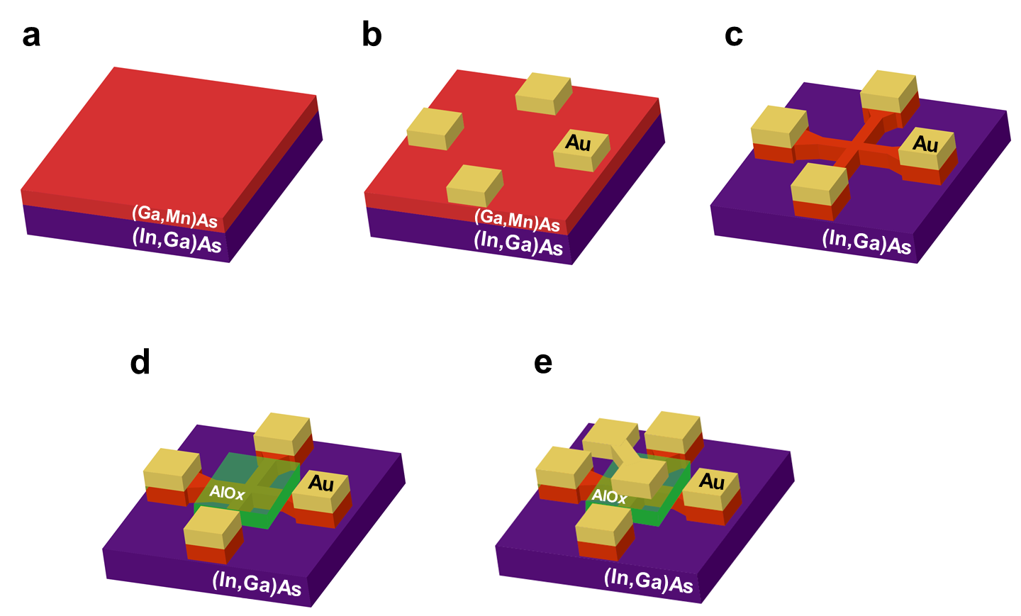
Supplementary Figure 1 | Schematic illustrations of the fabrication process of the crossbar device. (a) As-grown 7-nm-thick (Ga_{0.94},Mn_{0.06})As thin film. (b) Deposition of the Au (100 nm)/ Cr (5 nm) layers as the metal electrodes. (c) Etching to form the crossbar with a width of 0.5 μm and a length of 2 μm. (d) Deposition of AlO_{x} as a gate insulator by ALD. (e) Deposition of the Au (100 nm)/ Cr (5 nm) layers as the gate electrode.
Supplementary Note 2. Curie temperature of the (Ga,Mn)As thin film and the device
To estimate the Curie temperature T_{C}, the temperature T dependence of the saturated magnetisation M in the 7-nm-thick (Ga_{0.94},Mn_{0.06})As thin film is obtained as shown in Supplementary Fig. 2a. From the results, the M becomes to be around 0 when the T increases to 75 K, which indicates that the T_{C} of the 7-nm-thick (Ga,Mn)As thin film is 75 K. Supplementary Figure 2b shows the T dependence of the longitudinal resistance R in the (Ga,Mn)As crossbar with a width of 0.5 μm and a length of 2 μm. When the T decreases from the room temperature to 112 K, the R increases, which results from the decrease in the hole concentration with the decrease of the T. When T < 112 K, as T decreases, the R decreases, which is because the (Ga,Mn)As shows the ferromagnetic property. The spin-flip scattering and the single magnon scattering arising from the ferromagnetically correlated localized Mn spins make the R decrease with decreasing T. From this result, the T_{C} of the crossbar can be confirmed to be around 112 K, which is higher than that (75 K) measured in the (Ga,Mn)As thin film. This is probably caused by the annealing process resulting from the increase of the sample temeprature during the device fabrication process.
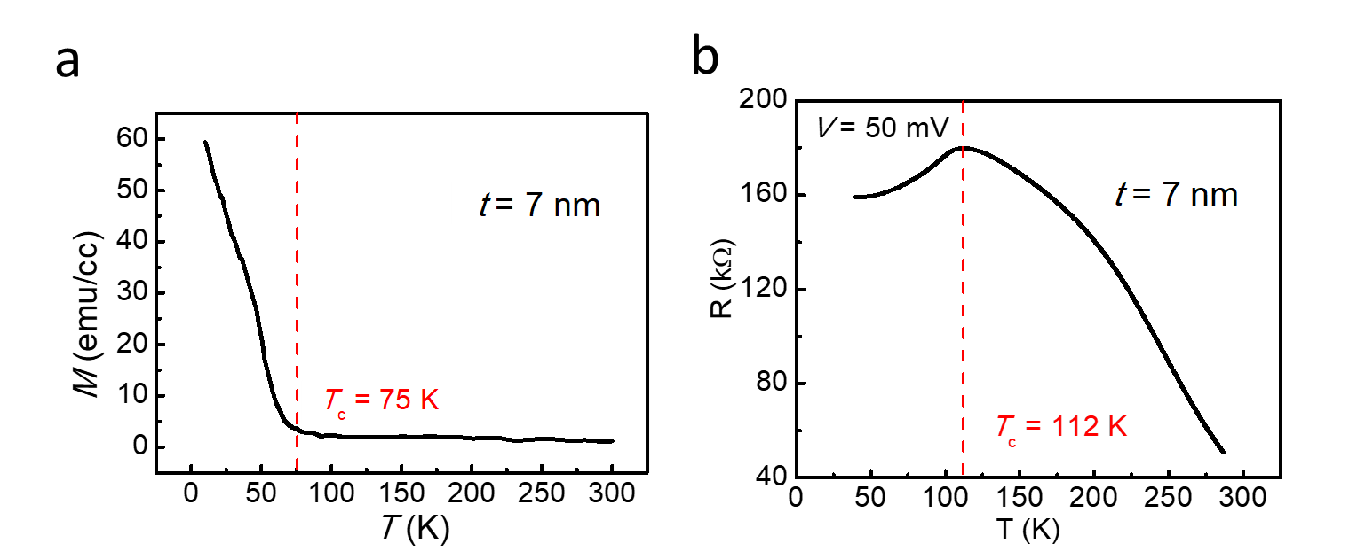
Supplementary Figure 2 | Curie temperature of the (Ga,Mn)As thin film and device. T dependence of the a, saturated magnetisation M in the 7-nm-thick (Ga_{0.94},Mn_{0.06})As thin film and b, longitudinal resistance R in the (Ga,Mn)As crossbar device.

Supplementary Note 3. Electric field control of SOT switching in a (Ga,Mn)As thin film
Supplementary Figure 3 shows the manipulation of the SOT switching (J // $\left[\overline{\text{1}}\text{10}\right]$) at different gate voltages V_{g} of ±5 V, ±10 V, ±15 V and ±20 V at 40 K, from which it can be concluded that the positive V_{g} makes the J_{c} decrease and the negative V_{g} makes J_{c} increase. This indicates that the switching behavior is solidly manipulated via pure electronic fields reversibly.

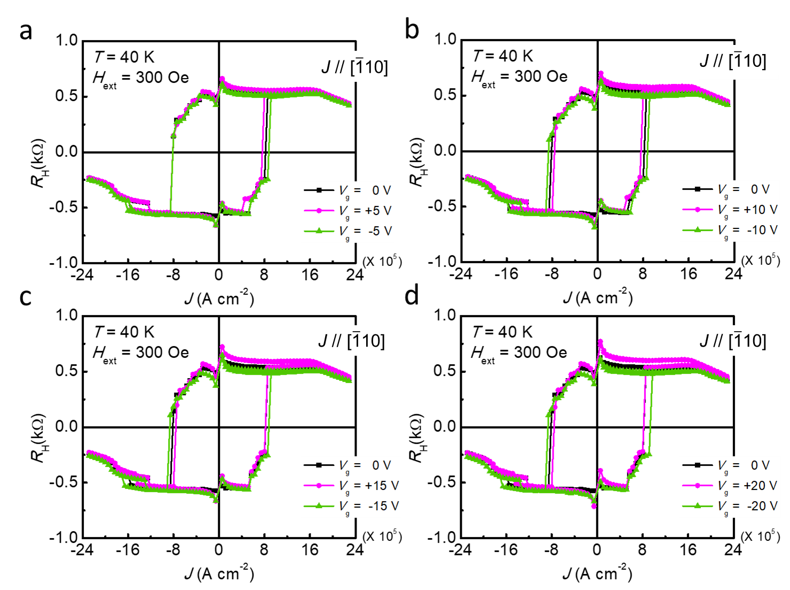
Supplementary Figure 3 | Field-assisted SOT switching with applying the V_{g} of 0, ±5 V, ±10 V, ±15 V and ±20 V in a 7-nm-thick (Ga_{0.94},Mn_{0.06})As thin film at 40 K. Here, J // $\left[\overline{\text{1}}\text{10}\right]$ and H_{ext} = 300 Oe.

