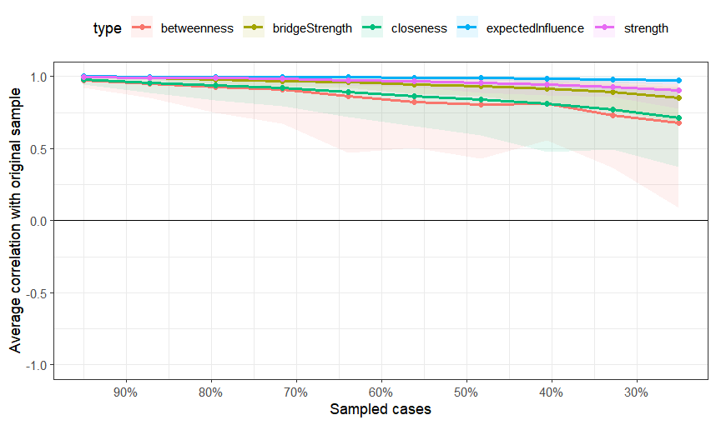
Supplementary Figure 1. Correlation between Node Centrality Indices and the Original Sample at Different Subsampling Proportions

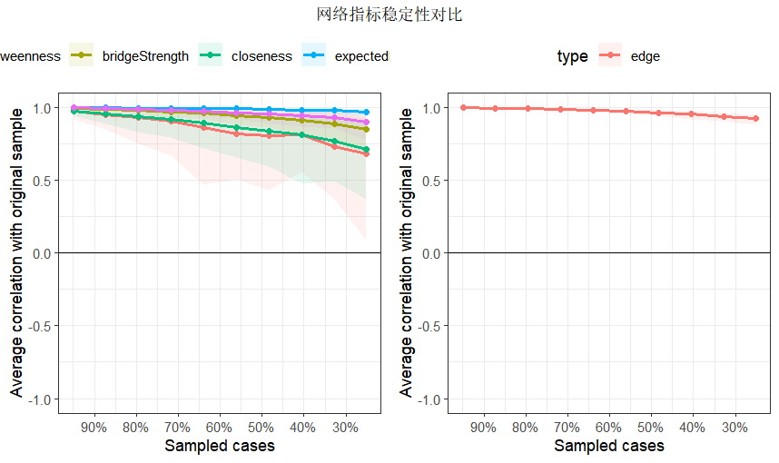
Supplementary Figure 2. Comparison of Network Metric Stability: Correlation Analysis Between Metrics and the Original Sample at Different Subsampling Proportions

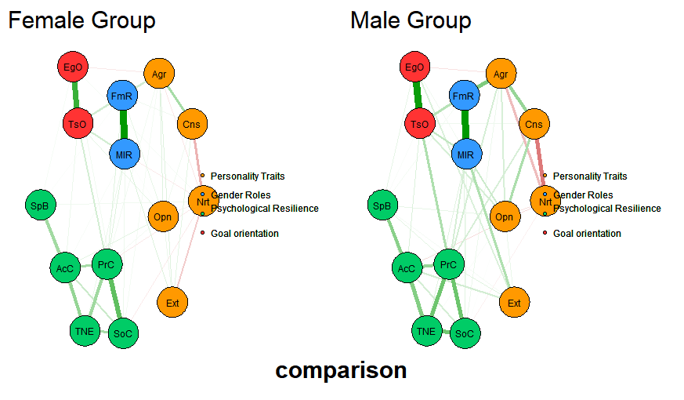
Supplementary Figure 3. Comparison of Network Structures by Gender
Supplementary Table 1 .Results of Bootstrap Mediation Effect Analysis
Effect | Paths | Effect size | Boot SE | Boot CI Lower | Boot CI Upper | Effect size/%
Total effect | — | 0.392 | 0.040 | 0.314 | 0.470 | —
Total indirect effect | — | 0.091 | 0.023 | 0.044 | 0.137 | 68.36%
Direct effect | AGR→PR | 0.124 | 0.036 | 0.053 | 0.194 | 31.63%
Indirect effect 1 | AGR→MIR→PR | 0.167 | 0.027 | 0.117 | 0.221 | 42.60%
Indirect effect 2 | AGR→TSO→PR | 0.044 | 0.014 | 0.020 | 0.073 | 11.22%
Indirect effect 3 | AGR→MIR→TSO→PR | 0.057 | 0.012 | 0.035 | 0.083 | 14.54%

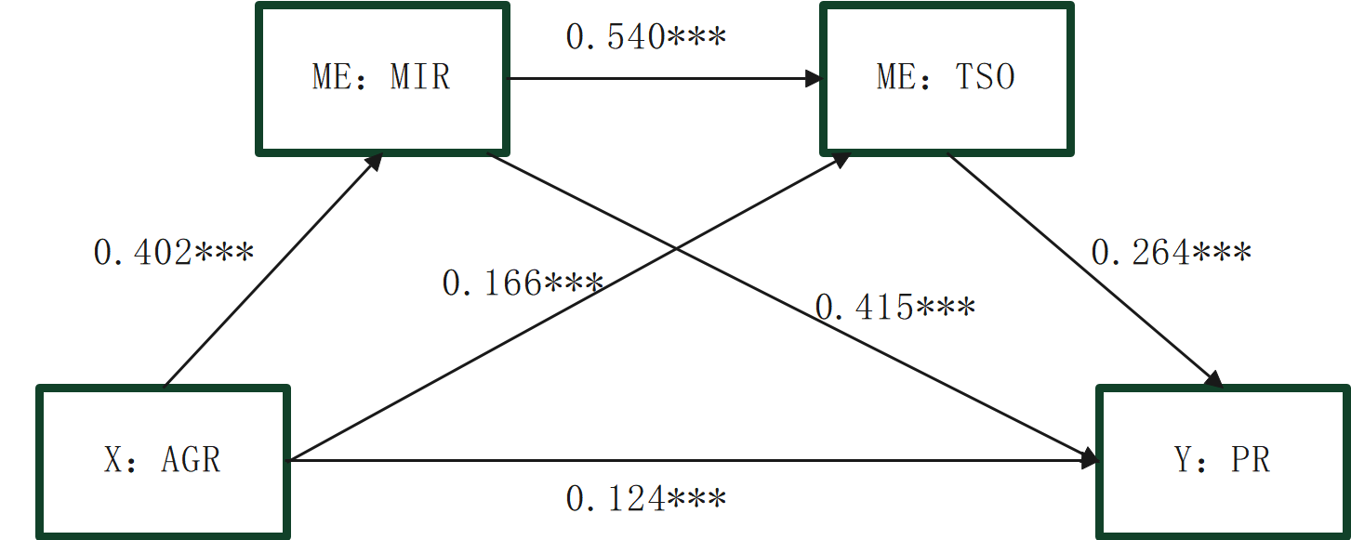

Supplementary Figure 4. Schematic Diagram of the Path Structure for the Effect of Agreeableness on Psychological Resilience

