Supporting data
Nitrophenyl-Group-Containing Heterocycles. Part I. Synthesis, characterization, anticancer activity and antioxidant properties of some New 5,6,7,8-tetrahydroisoquinolines Bearing 3(4)-nitrophenyl group
Eman M. Sayed,¹ Reda Hassanien,¹ Nasser Farhan,¹ Hanan F. Aly,² Khaled Mahmoud³ and Etify A. Bakhite^{4*}
¹Chemistry Department, Faculty of Science, New Valley University, 72511 El-Kharja, Egypt. ²Department of Therapeutic Chemistry, National Research Centre, El-Behooth St., 12622 Dokki, Cairo, Egypt. ³Pharmacognosy Department, National Research Centre, El-Behooth St., 12622 Dokki, Cairo, Egypt,⁴Chemistry Department, Faculty of Science, Assiut University, 71516 Assiut, Egypt.

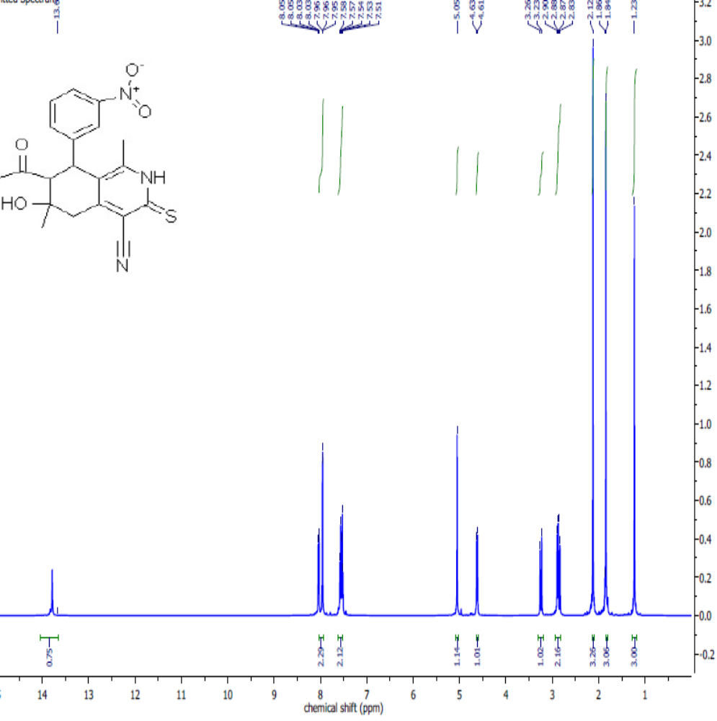
Figure S1: ¹H NMR Spectrum of 7-Acetyl-4-cyano-1,6-dimethyl-6-hydroxy-8-(3- nitrophenyl)-5,6,7,8-tetra-hydroisoquinoline-3(2H)-thione (2a) in DMSO-d₆.

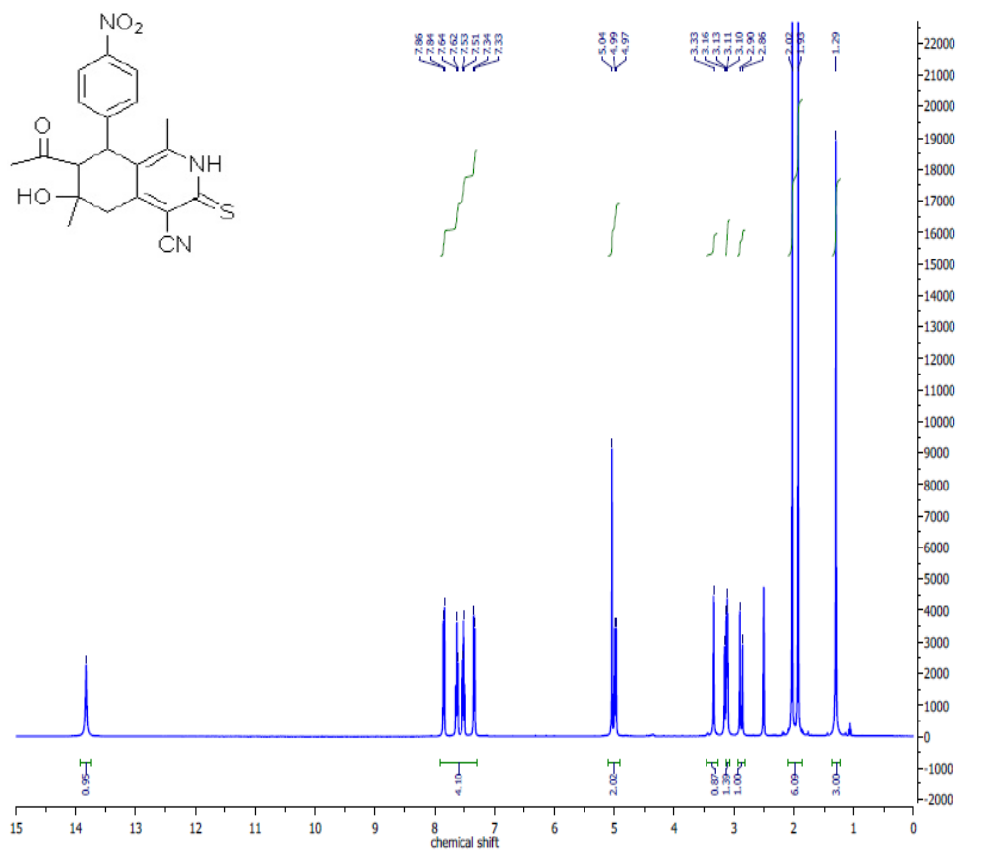
Figure S2: ¹H NMR Spectrum of 7-Acetyl-4-cyano-1,6-dimethyl-6-hydroxy-8-(4-nitrophenyl)-5,6,7,8-tetrahydroisoquinoline-3(2H)-thione (2b) in DMSO-d₆.

.
.
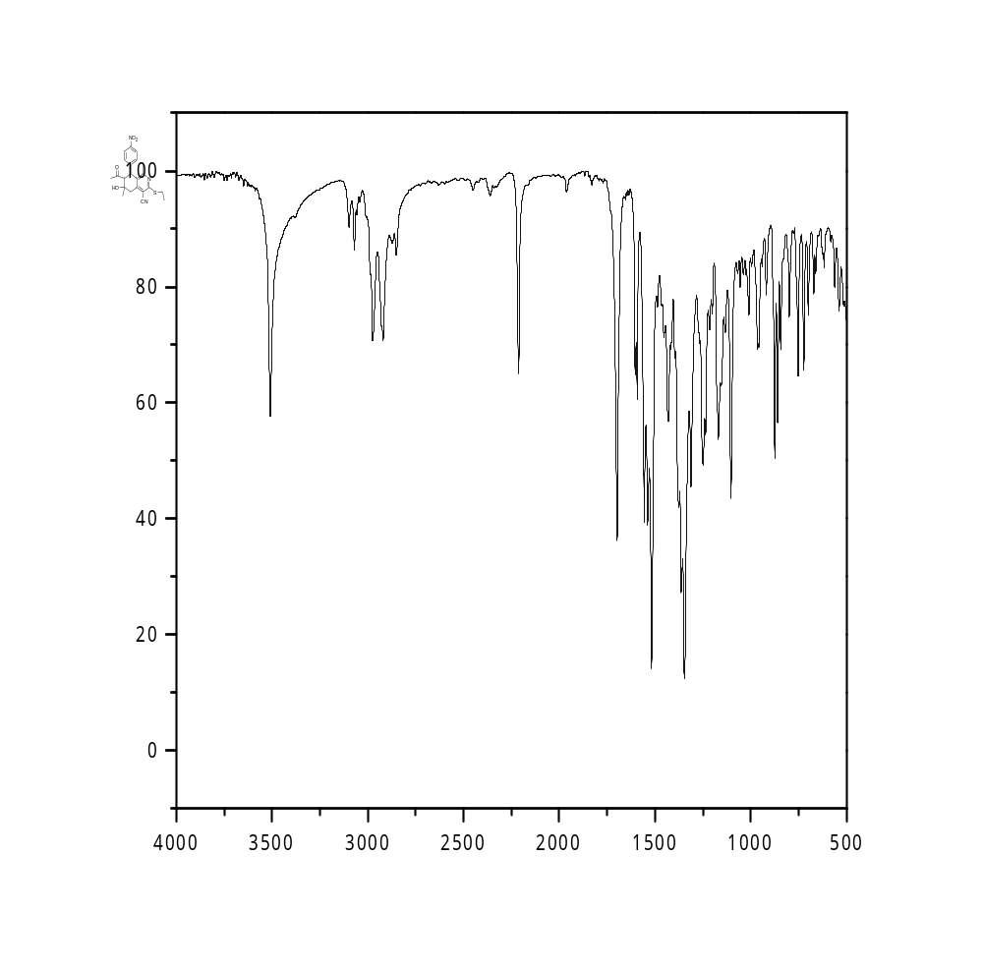
Figure S3: IR Spectrum of 7-Acetyl-4-cyano-1,6-dimethyl-3-ethylthio-6-hydroxy-8-(4-nitrophenyl)-5,6,7,8-tetrahydroisoquinoline (3)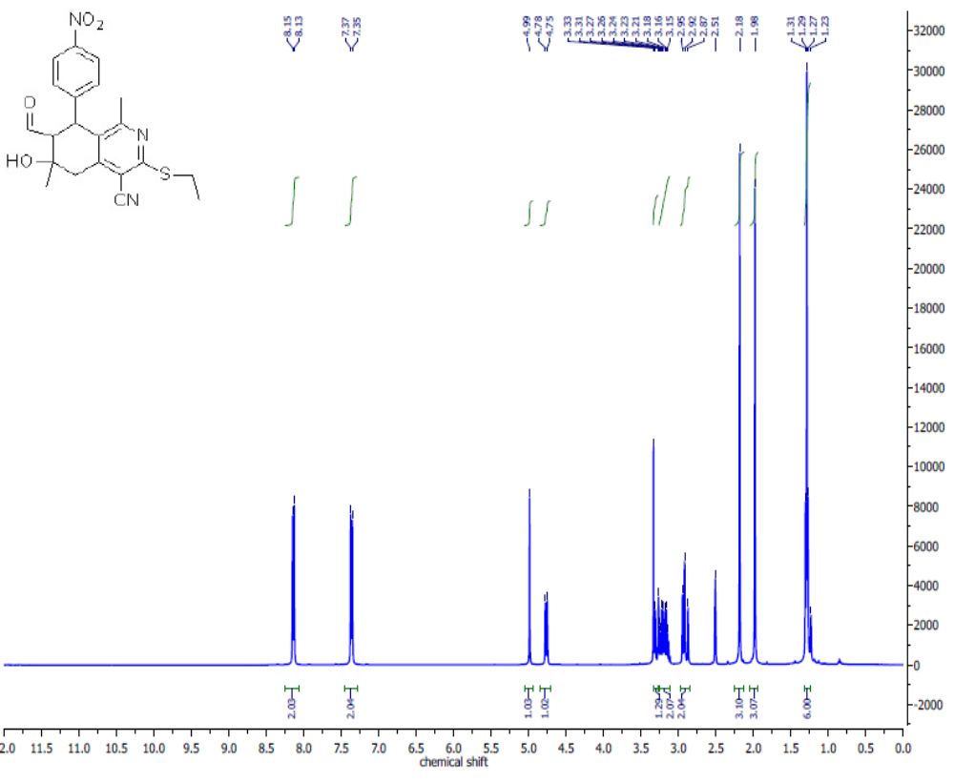Figure S4: ¹H NMR Spectrum of 7-Acetyl-4-cyano-1,6-dimethyl-3-ethylthio-6-hydroxy-8-(4-nitrophenyl)-5,6,7,8-tetrahydroisoquinoline (3) in CDCl₃.
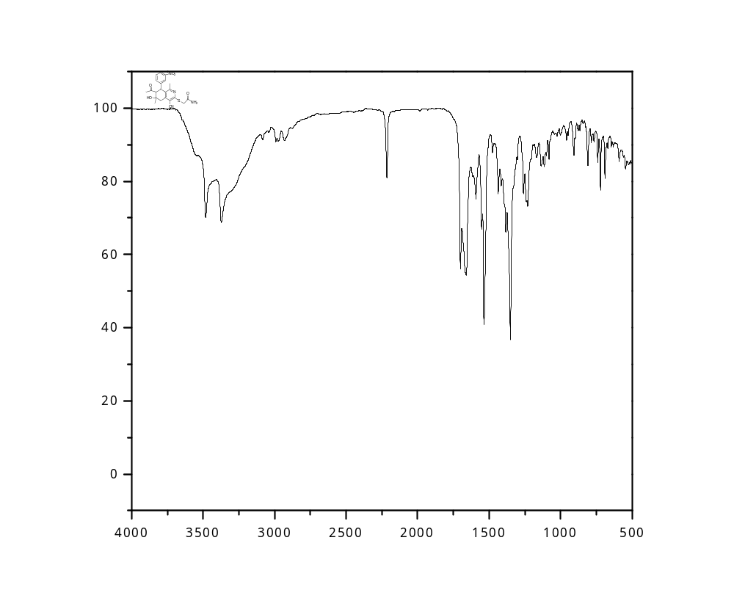
Figure S5: IR Spectrum of 2-[(7-Acetyl-4-cyano-1,6-dimethyl-6-hydroxy-8-(3-nitrophenyl)-5,6,7,8-tetrahydroisoquinolin-3-yl)thio]acetamide (5a) 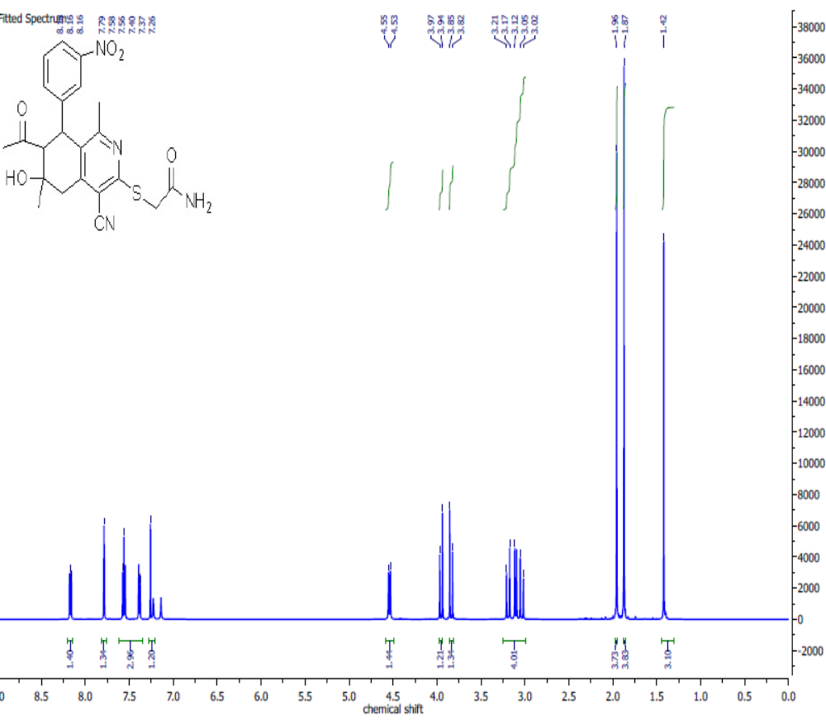Figure S6: ¹H NMR Spectrum of 2-[(7-Acetyl-4-cyano-1,6-dimethyl-6-hydroxy-8-(3-nitrophenyl)-5,6,7,8-tetrahydroisoquinolin-3-yl)thio]acetamide (5a) in CDCl₃.

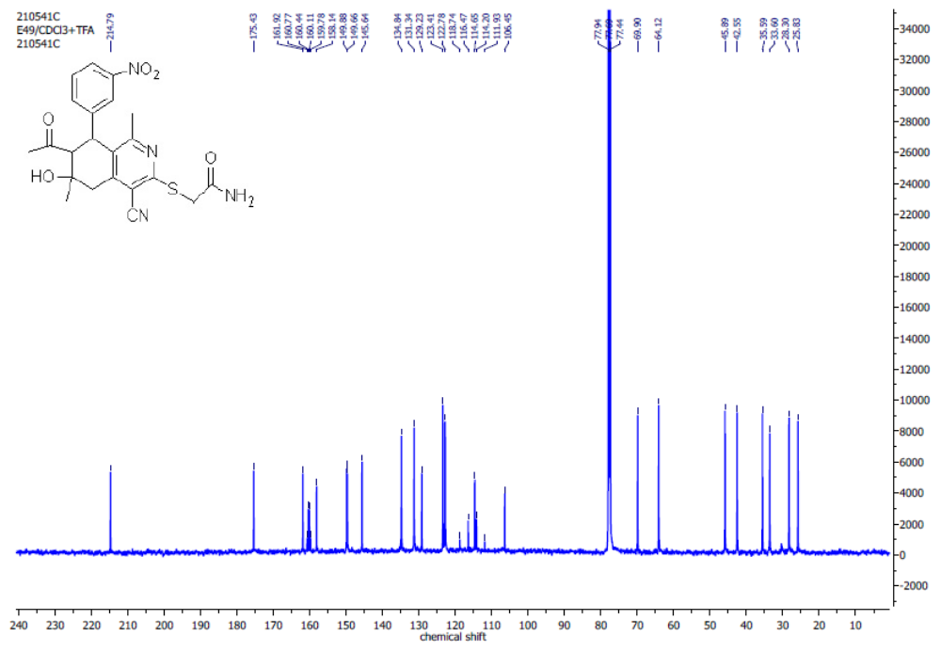Figure S7: ¹³C NMR Spectrum of 2-[(7-Acetyl-4-cyano-1,6-dimethyl-6-hydroxy-8-(3-nitrophenyl)-5,6,7,8-tetrahydroisoquinolin-3-yl)thio]acetamide (5a ) in CDCl₃.

.

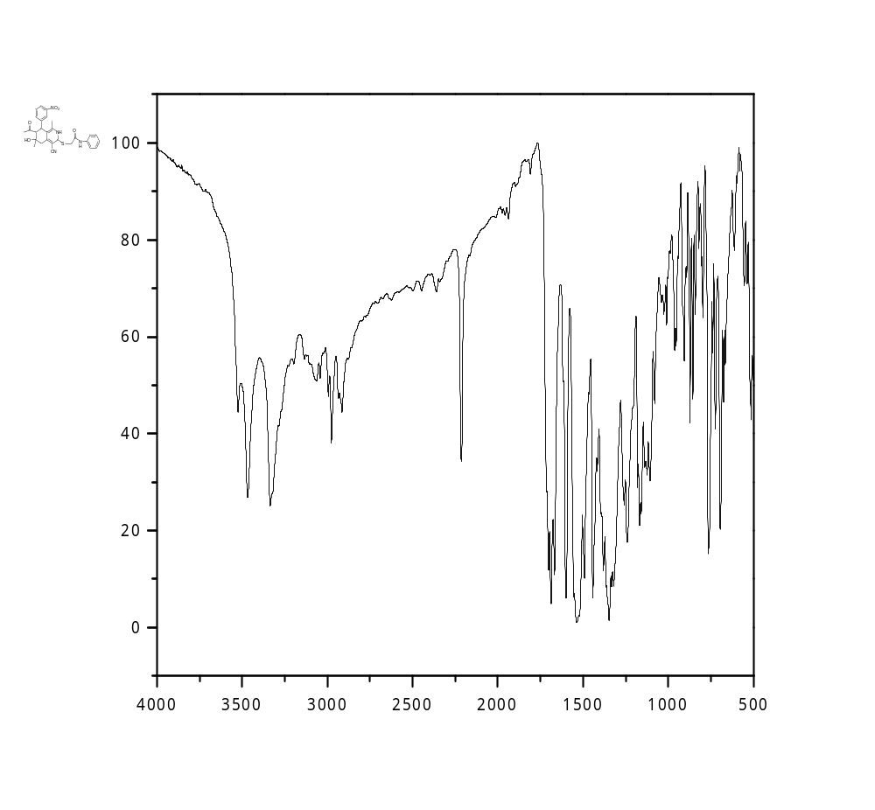
Figure S8: IR Spectrum of 2-[(7-Acetyl-4-cyano-1,6-dimethyl-6-hydroxy-8-(3-nitrophenyl)-5,6,7,8-tetrahydroisoquinolin-3-yl)thio]-N-phenylacetamide (5b) in DMSO-d₆.

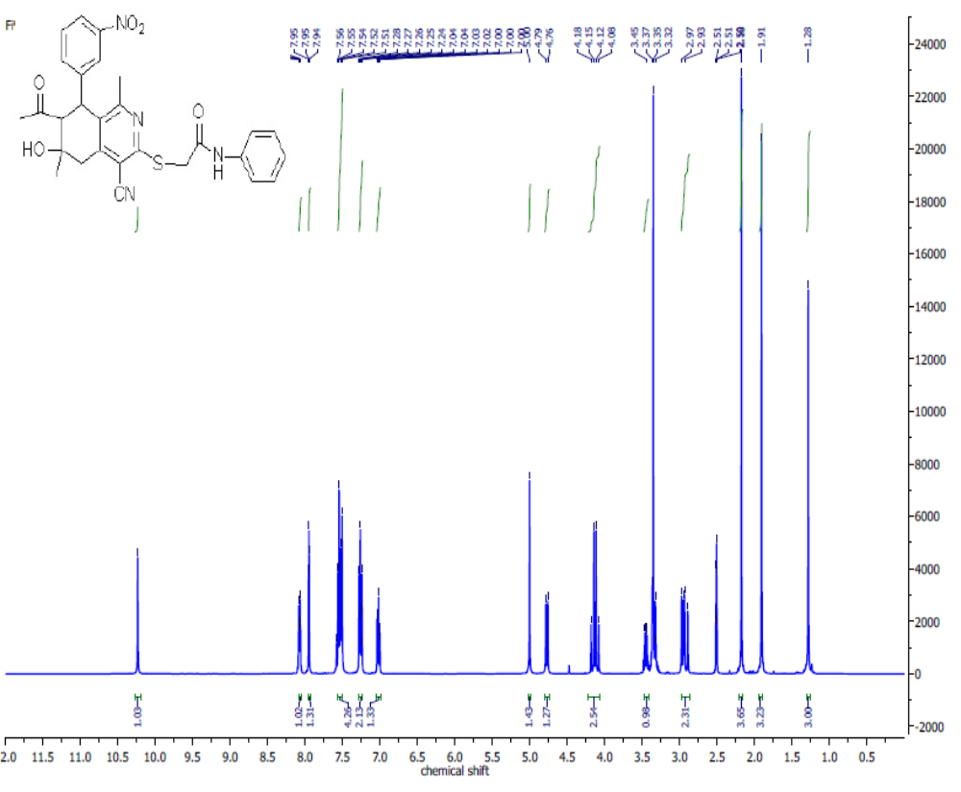
Figure S9: ¹H NMR Spectrum of 2-[(7-Acetyl-4-cyano-1,6-dimethyl-6-hydroxy-8-(3-nitrophenyl)-5,6,7,8-tetrahydroisoquinolin-3-yl)thio]-N-phenylacetamide (5b) in DMSO-d₆.

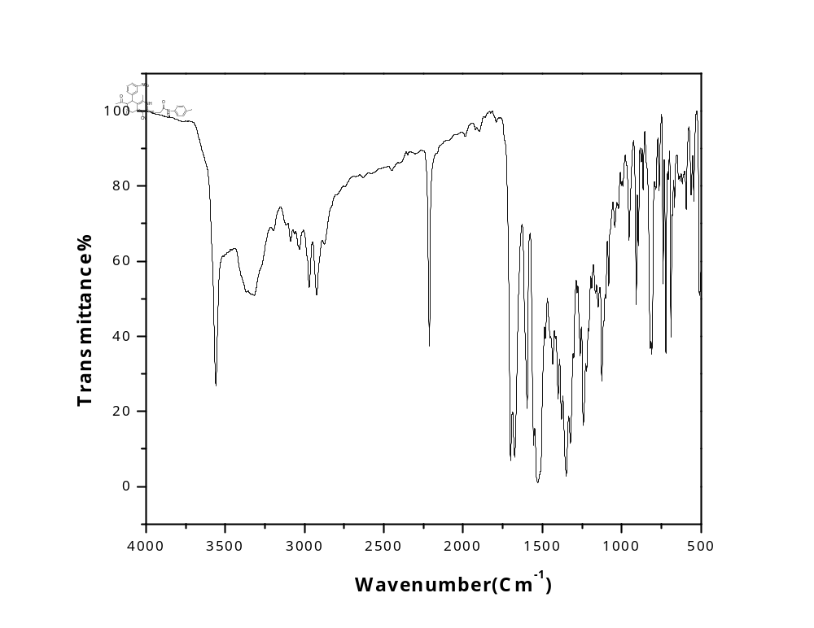Figure S10: IR Spectrum of 2-[(7-Acetyl-4-cyano-1,6-dimethyl-6-hydroxy-8-(3-nitrophenyl)-5,6,7,8-tetrahydroisoquinolin-3-yl)thio]-N-(4-tolyl)acetamide (5c).
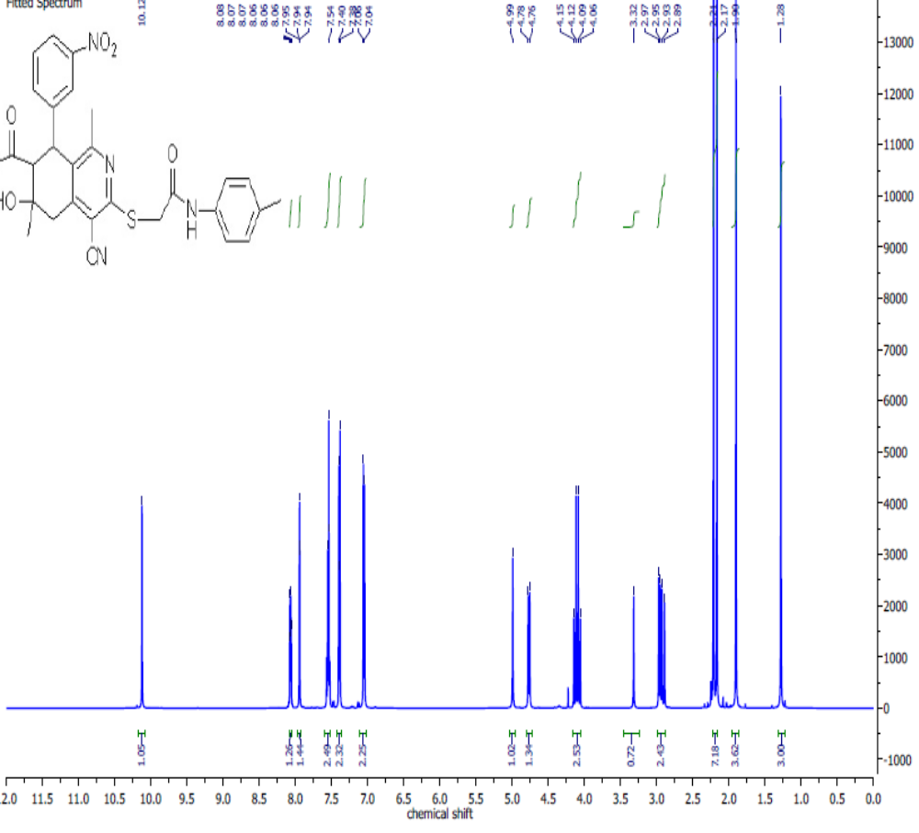Figure S11: ¹H NMR Spectrum of 2-[(7-Acetyl-4-cyano-1,6-dimethyl-6-hydroxy-8-(3-nitrophenyl)-5,6,7,8-tetrahydroisoquinolin-3-yl)thio]-N-(4-tolyl)acetamide (5c) in DMSO-d₆.
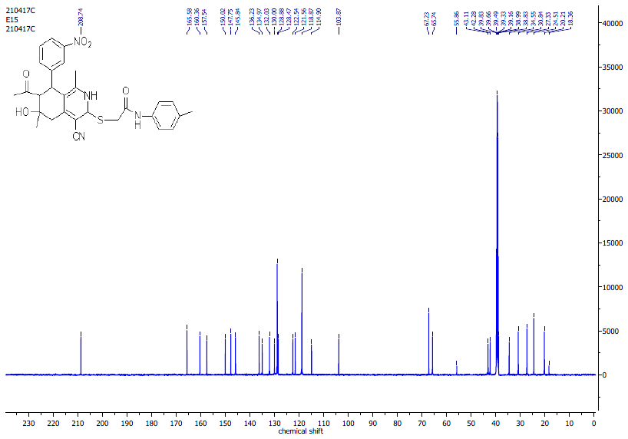
Figure S12: ¹³C NMR Spectrum of 2-[(7-Acetyl-4-cyano-1,6-dimethyl-6-hydroxy-8-(3-nitrophenyl)-5,6,7,8-tetrahydroisoquinolin-3-yl)thio]-N-(4-tolyl)acetamide (5c) in DMSO-d₆.

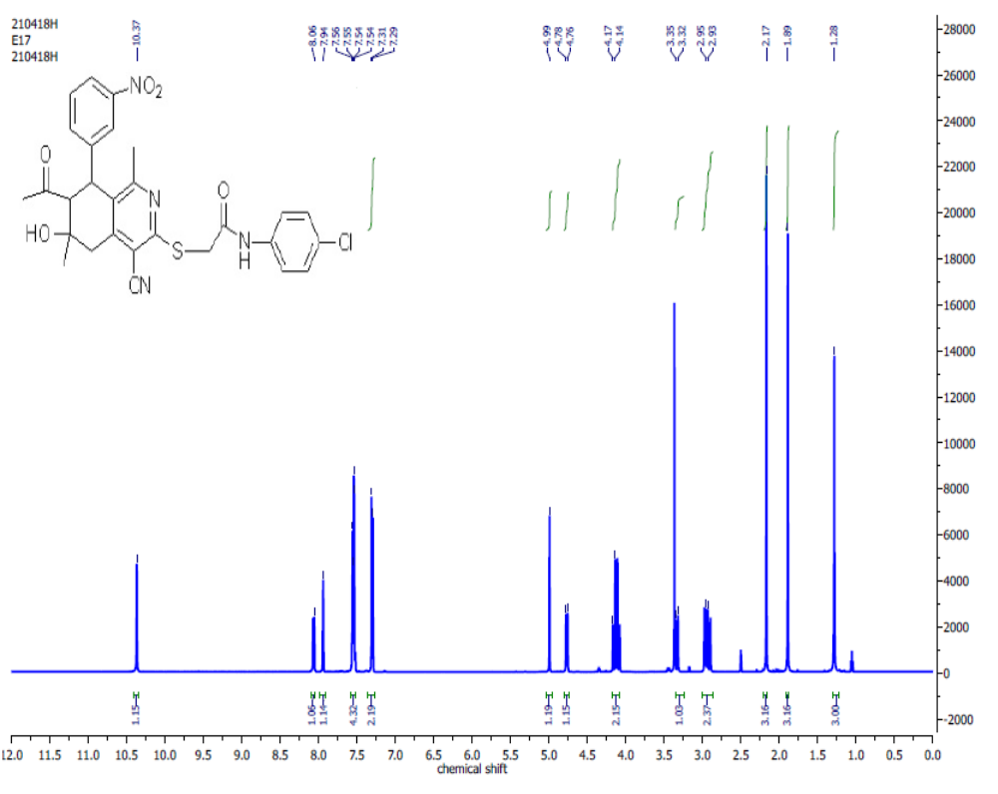
Figure S13: ¹H NMR Spectrum of 2-[(7-Acetyl-4-cyano-1,6-dimethyl-6-hydroxy-8-(3-nitrophenyl)-5,6,7,8-tetrahydroisoquinolin-3-yl)thio]-N-(4-chlorophenyl)acetamide (5d) in DMSO-d₆.

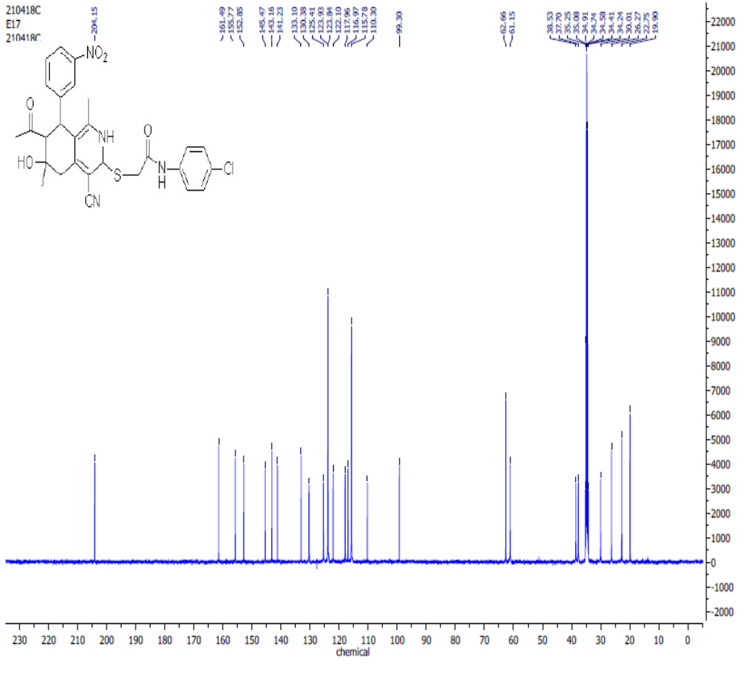Figure S14: ¹³C NMR Spectrum of of 2-[(7-Acetyl-4-cyano-1,6-dimethyl-6-hydroxy-8-(3-nitrophenyl)-5,6,7,8-tetrahydroisoquinolin-3-yl)thio]-N-(4-chlorophenyl)acetamide (5d) in DMSO-d₆.

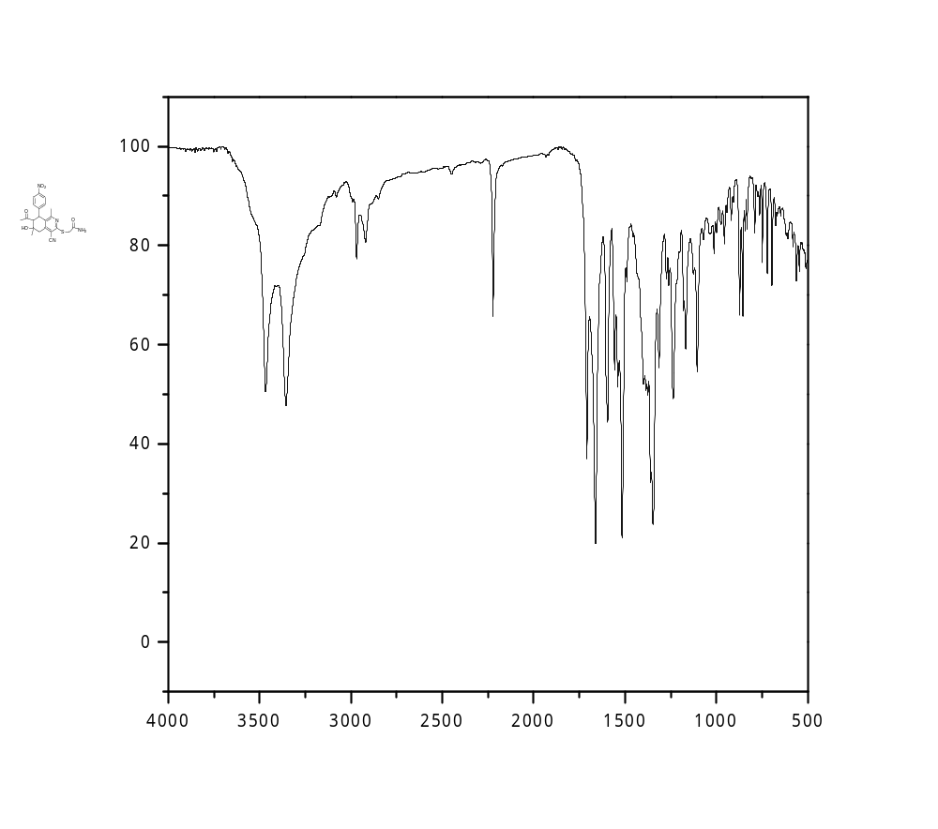
Figure S15: IR Spectrum of 2-[(7-Acetyl-4-cyano-1,6-dimethyl-6-hydroxy-8-(4-nitrophenyl)-5,6,7,8-tetrahydroisoquinolin-3-yl)thio]acetamide (5e)

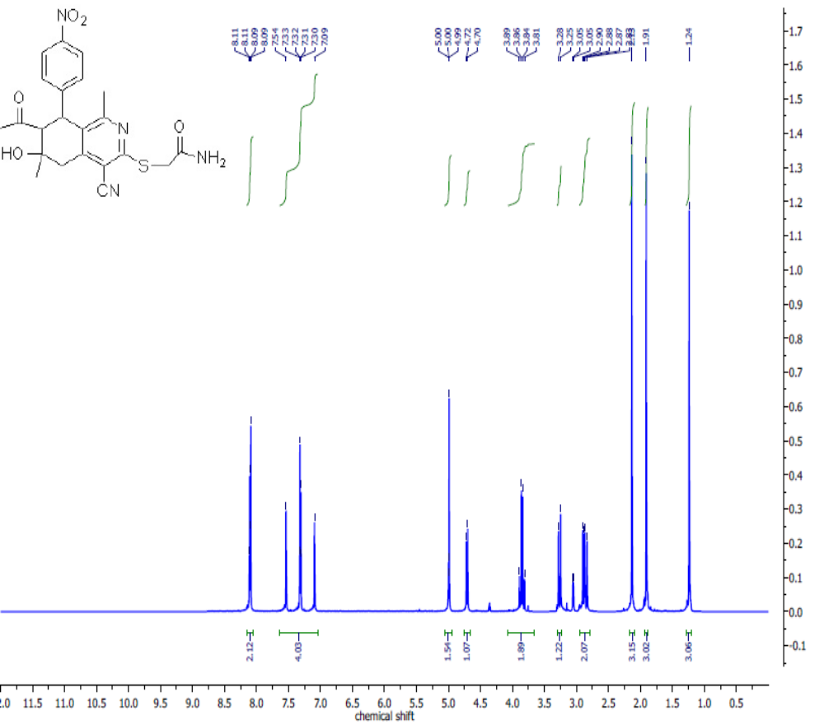Figure S16: ¹H NMR Spectrum of 2-[(7-Acetyl-4-cyano-1,6-dimethyl-6-hydroxy-8-(4-nitrophenyl)-5,6,7,8-tetrahydroisoquinolin-3-yl)thio]acetamide (5e) in DMSO-d₆.

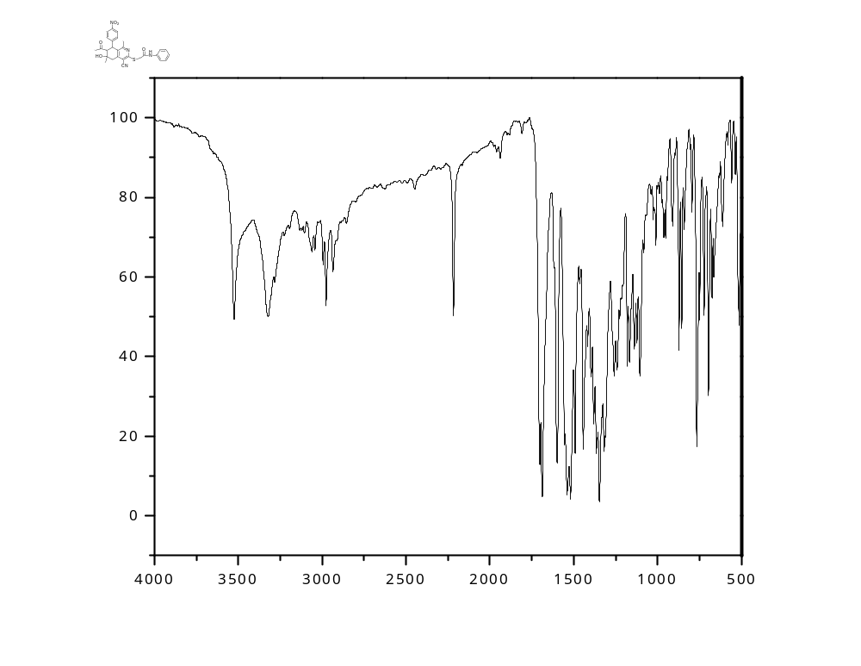
Figure S17: IR Spectrum of 2-[(7-Acetyl-4-cyano-1,6-dimethyl-6-hydroxy-8-(4-nitrophenyl)-5,6,7,8-tetrahydroisoquinolin-3-yl)thio]-N-phenylacetamide (5f).

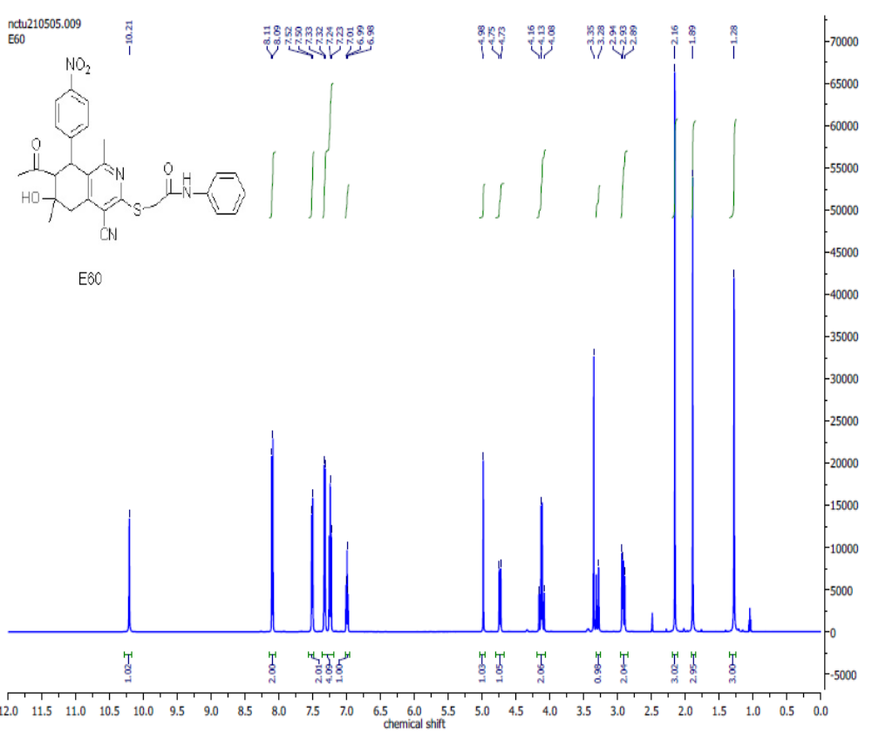Figure S18: ¹H NMR Spectrum of 2-[(7-Acetyl-4-cyano-1,6-dimethyl-6-hydroxy-8-(4-nitrophenyl)-5,6,7,8-tetrahydroisoquinolin-3-yl)thio]-N-phenylacetamide (5f) in DMSO-d₆.

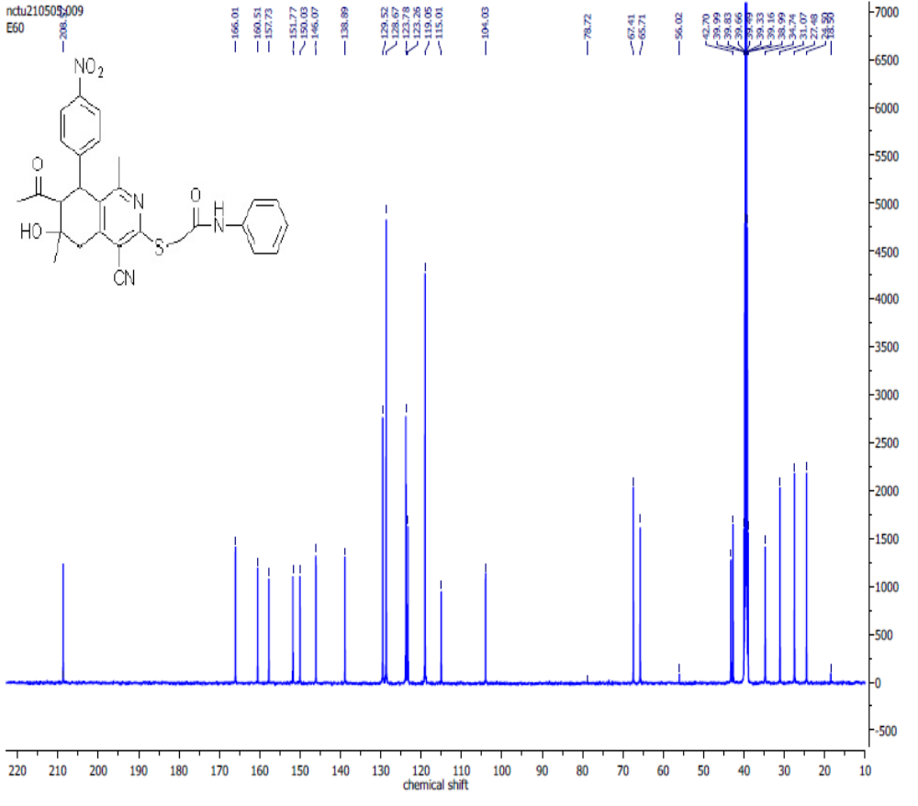Figure S19: ¹³C NMR Spectrum of 2-((7-Acetyl-4-cyano-6-hydroxy-1,6-dimethyl-8-(4-nitrophenyl)-5,6,7,8-tetrahydroisoquinolin-3-yl)thio)-N-phenylacetamide (5f) in DMSO-d₆.

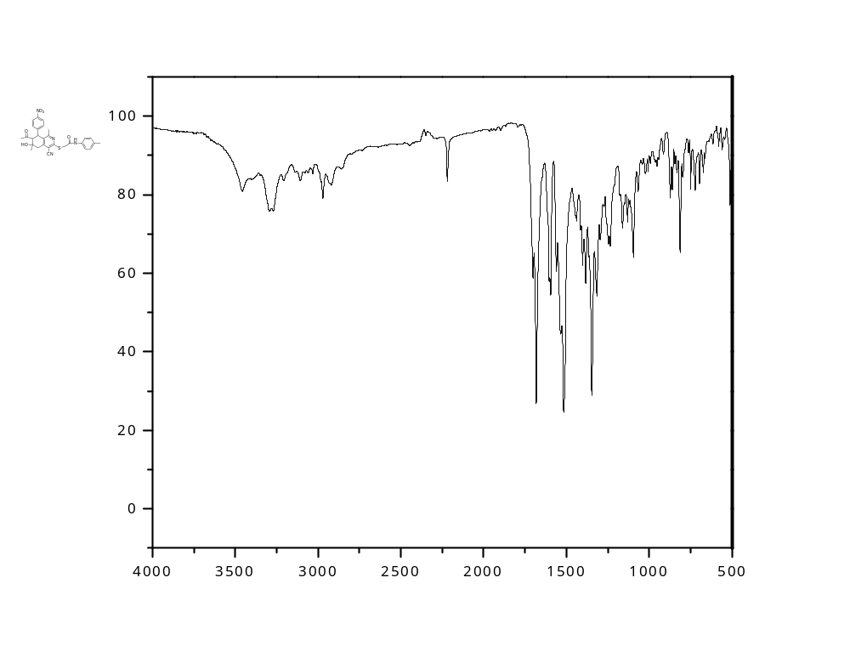
Figure S20: IR Spectrum of 2-[(7-Acetyl-4-cyano-1,6-dimethyl-6-hydroxy-8-(4-nitrophenyl)-5,6,7,8-tetrahydroisoquinolin-3-yl)thio]-N-(4-tolyl)acetamide (5g).
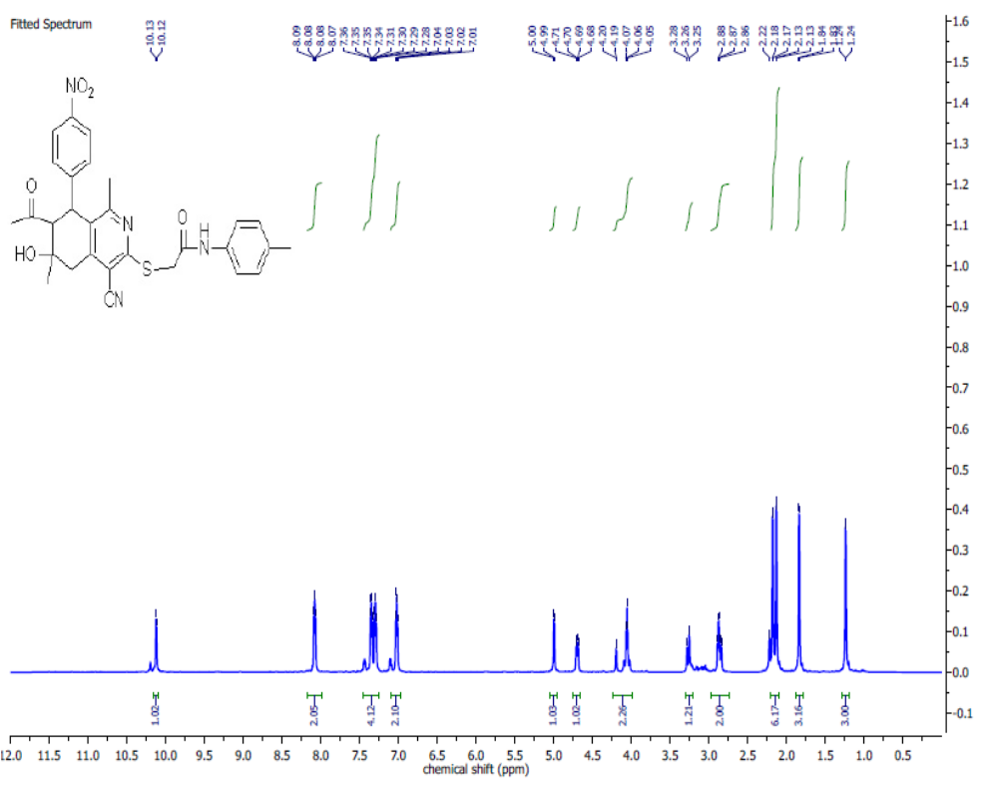

Figure S21: ¹H NMR Spectrum of 2-[(7-Acetyl-4-cyano-1,6-dimethyl-6-hydroxy-8-(4-nitrophenyl)-5,6,7,8-tetrahydroisoquinolin-3-yl)thio]-N-(4-tolyl)acetamide (5g) in DMSO-d₆.

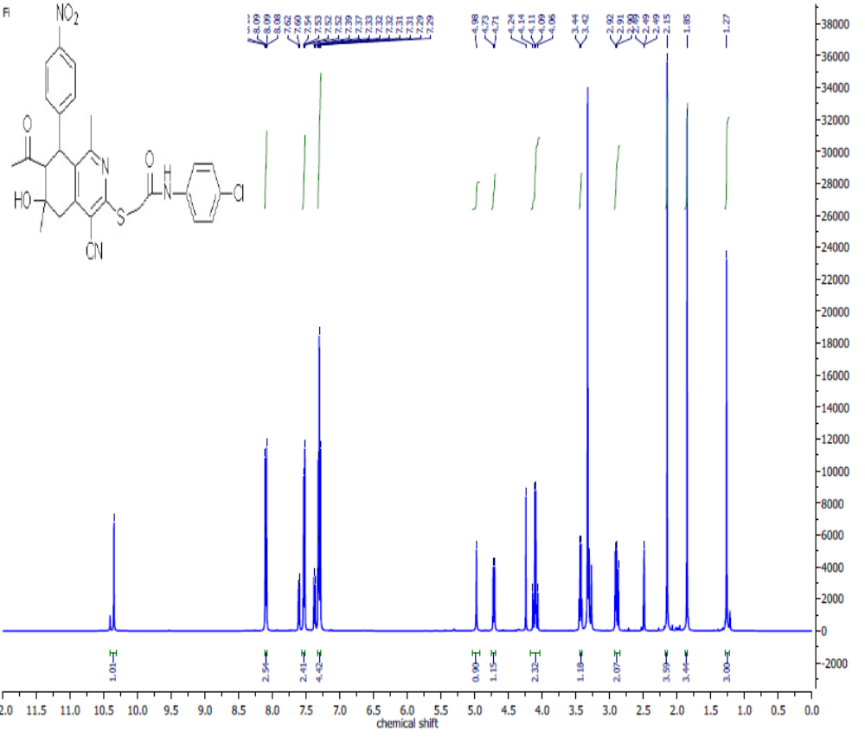Figure S22: ¹H NMR Spectrum of 2-[(7-Acetyl-4-cyano-1,6-dimethyl-6-hydroxy-8-(4-nitrophenyl)-5,6,7,8-tetrahydroisoquinolin-3-yl)thio]-N-(4-chlorophenyl)acetamide (5h) in DMSO-d₆.

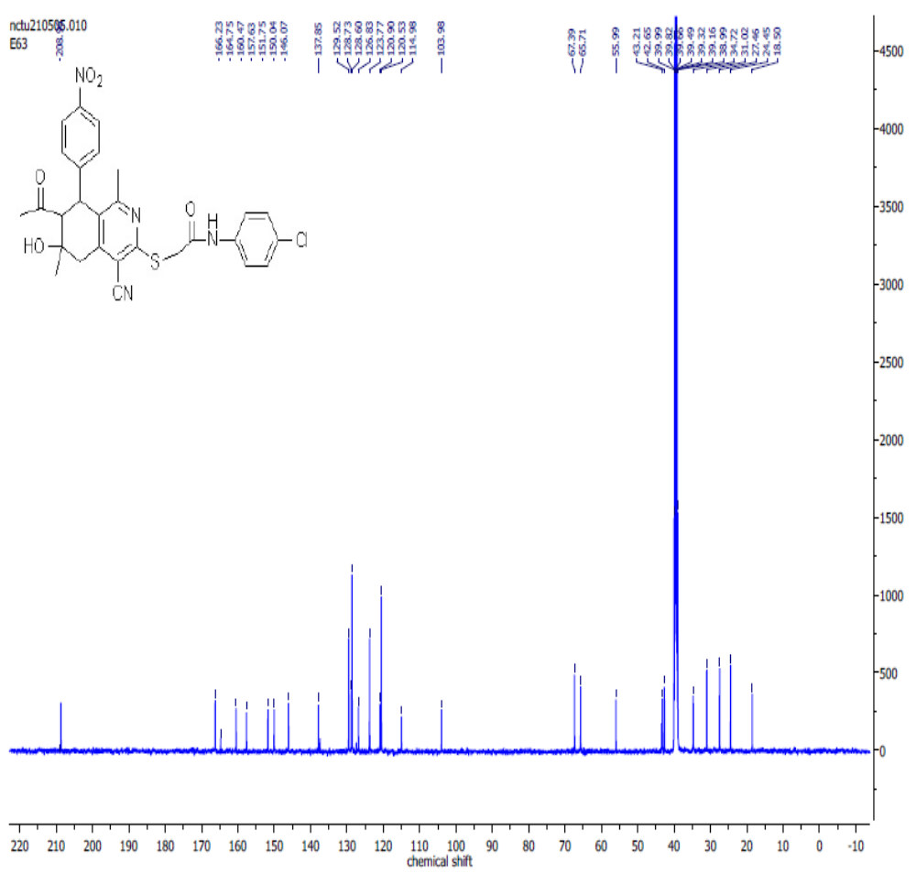
Figure S23: ¹³C NMR Spectrum of 22-[(7-Acetyl-4-cyano-1,6-dimethyl-6-hydroxy-8-(4-nitrophenyl)-5,6,7,8-tetrahydroisoquinolin-3-yl)thio]-N-(4-chlorophenyl)acetamide (5h) in DMSO-d₆.

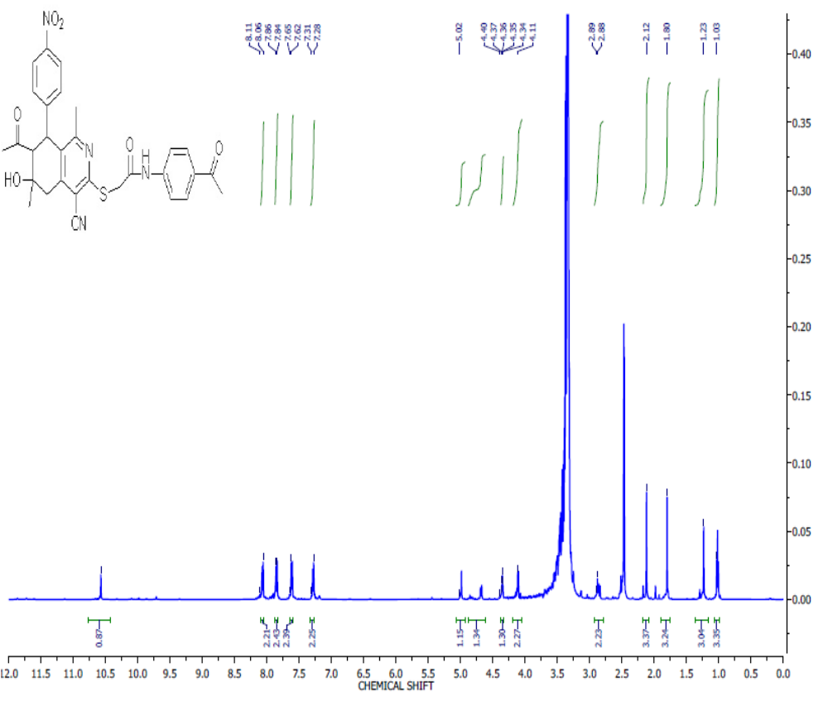
Figure S24: ¹H NMR Spectrum of 2-[(7-Acetyl-4-cyano-1,6-dimethyl-6-hydroxy-8-(4-nitrophenyl)-5,6,7,8-tetrahydroisoquinolin-3-yl)thio]-N-(4-acetylphenyl)acetamide (5i) in DMSO-d₆.

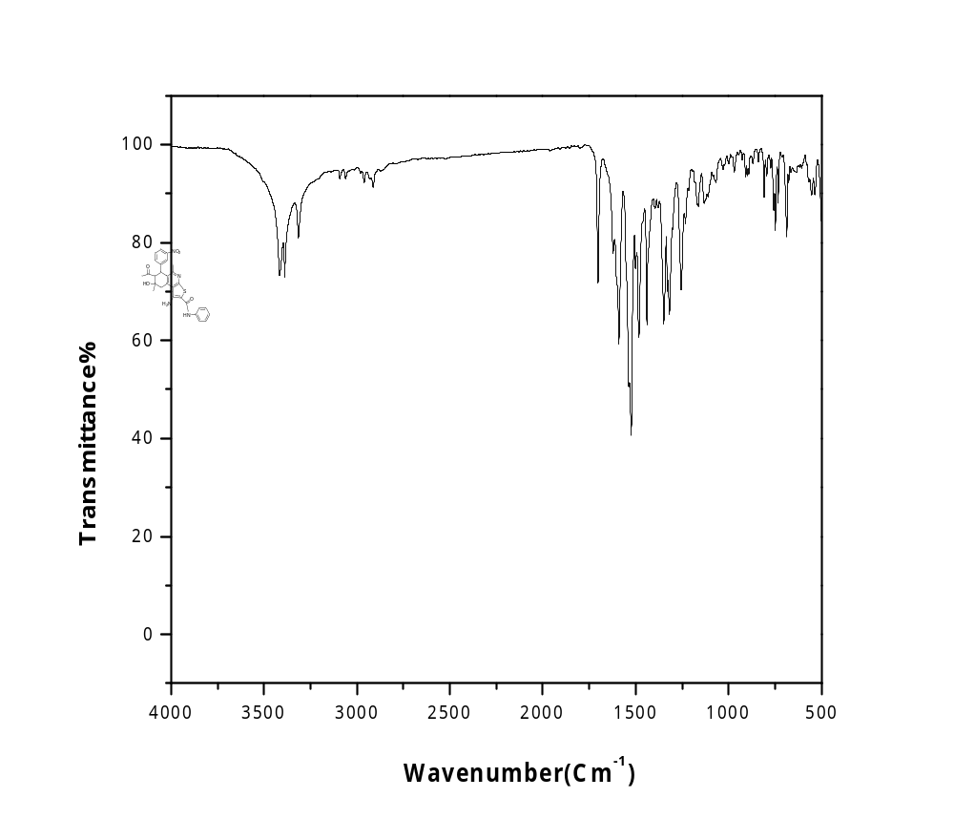
Figure S25: IR Spectrum of 7-Acetyl-1-amino-5,8-dimethyl-8-hydroxy-6-(3-nitrophenyl)-N-phenyl-6,7,8,9-tetrahydrothieno[2,3-c]isoquinoline-2-carboxamide (6b).

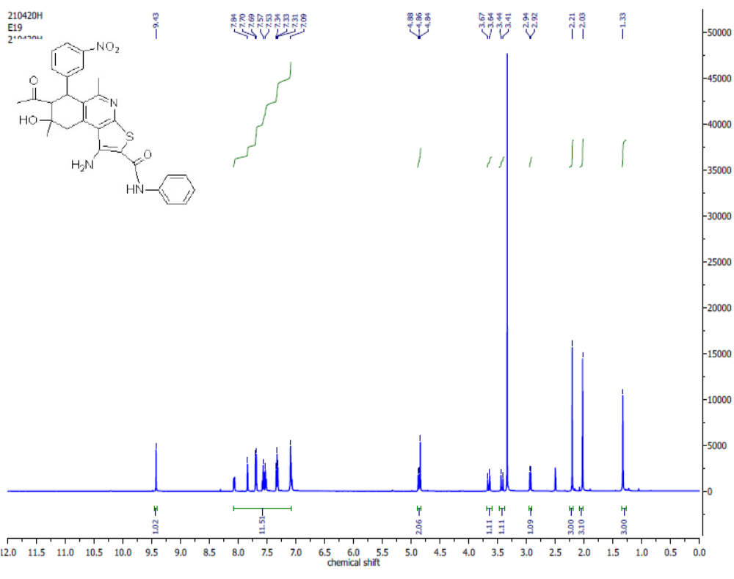Figure S26: ¹H NMR Spectrum of 7-Acetyl-1-amino-5,8-dimethyl-8-hydroxy-6-(3-nitrophenyl)-N-phenyl-6,7,8,9-tetrahydrothieno[2,3-c]isoquinoline-2-carboxamide (6b) in DMSO-d₆.
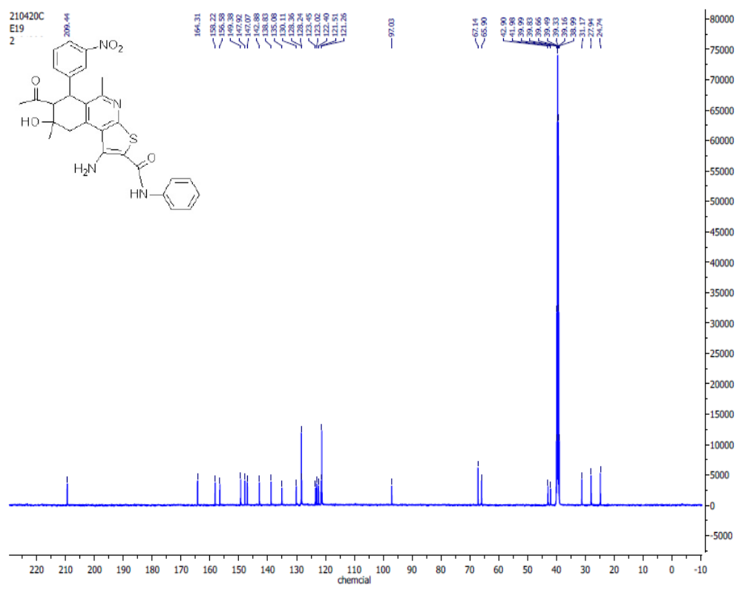Figure S27: ¹³C NMR Spectrum of 7-Acetyl-1-amino-5,8-dimethyl-8-hydroxy-6-(3-nitrophenyl)-N-phenyl-6,7,8,9-tetrahydrothieno[2,3-c]isoquinoline-2-carboxamide (6b) in DMSO-d₆.

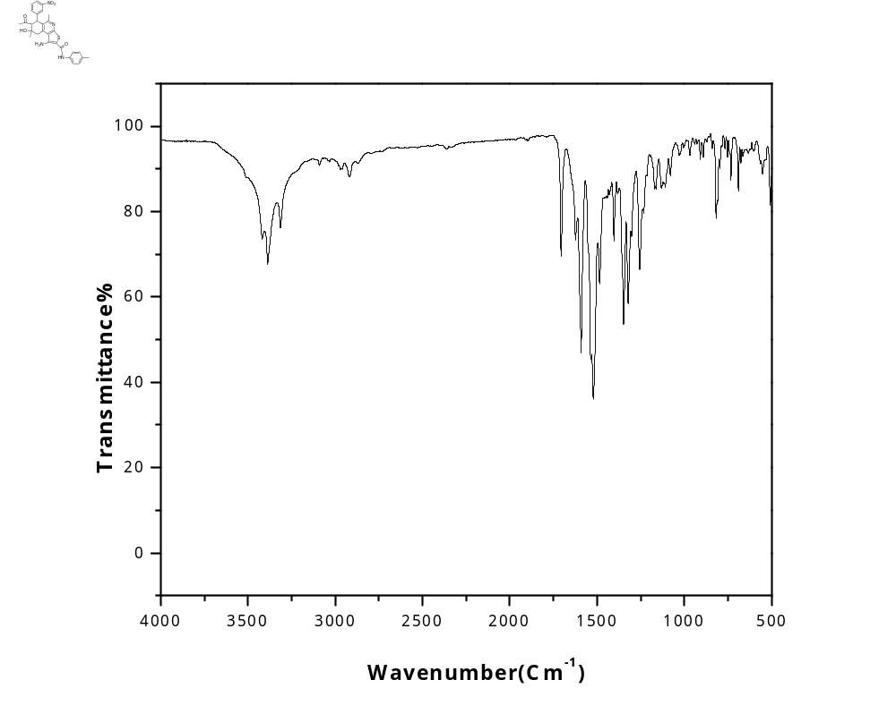
Figure S28: IR Spectrum of 7-Acetyl-1-amino-5,8-dimethyl-8-hydroxy-6-(3-nitro-phenyl)-N-(4-tolyl)-6,7,8,9-tetrahydrothieno[2,3-c]isoquinoline-2-carboxamide (6c).
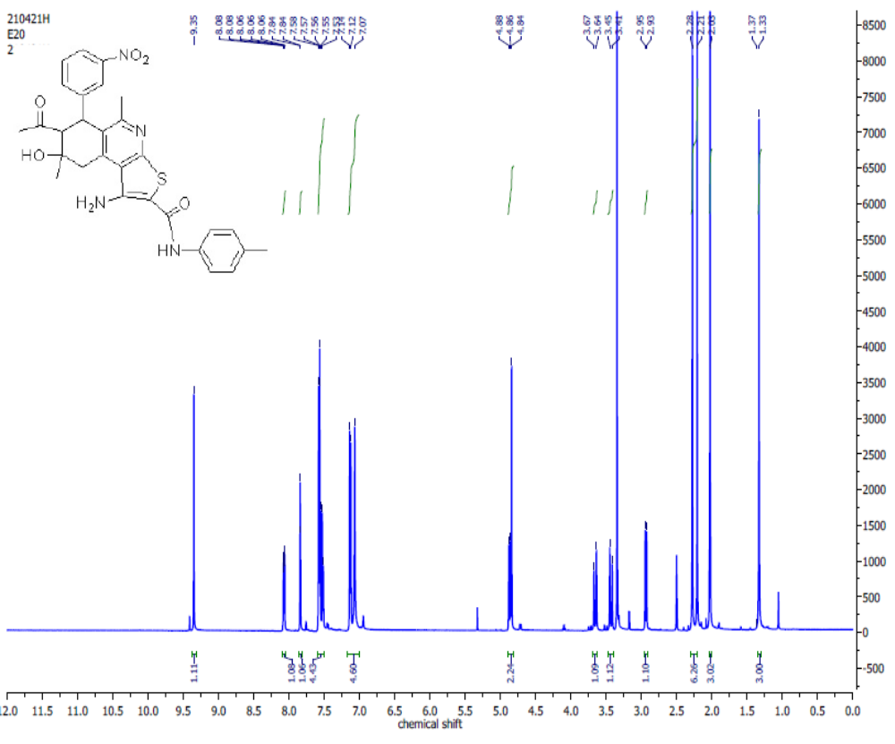Figure S29: ¹H NMR Spectrum of 7-Acetyl-1-amino-5,8-dimethyl-8-hydroxy-6-(3-nitrophenyl)-N-(4-tolyl)-6,7,8,9-tetrahydrothieno[2,3-c]isoquinoline-2-carboxamide (6c) in DMSO-d₆.

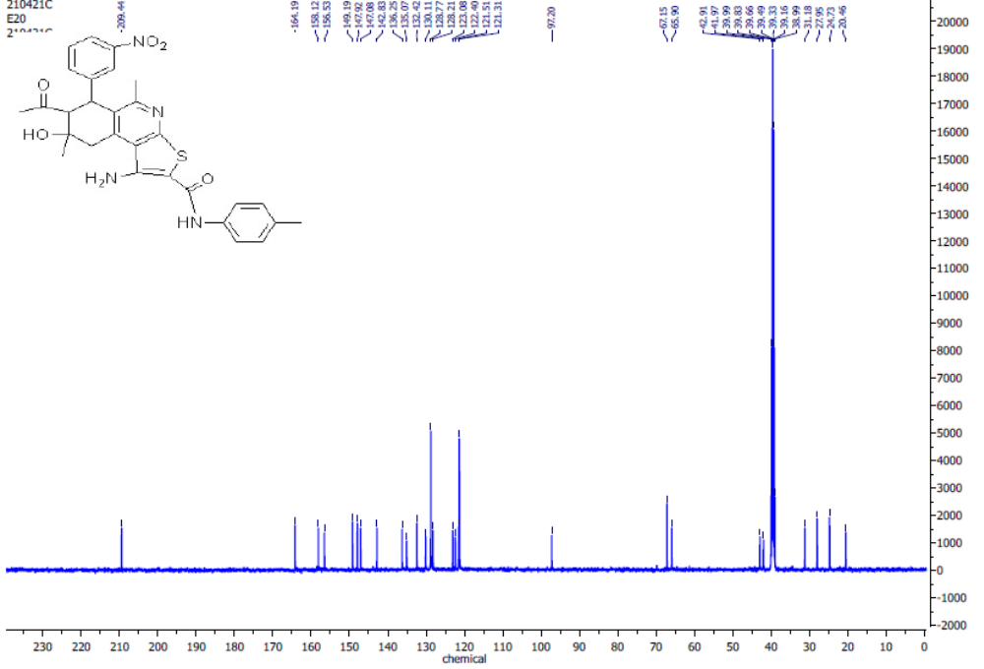Figure S30: ¹³C NMR Spectrum of 7-Acetyl-1-amino-5,8-dimethyl-8-hydroxy-6-(3-nitrophenyl)-N-(4-tolyl)-6,7,8,9-tetrahydrothieno[2,3-c]isoquinoline-2-carboxamide (6c) in DMSO-d₆.

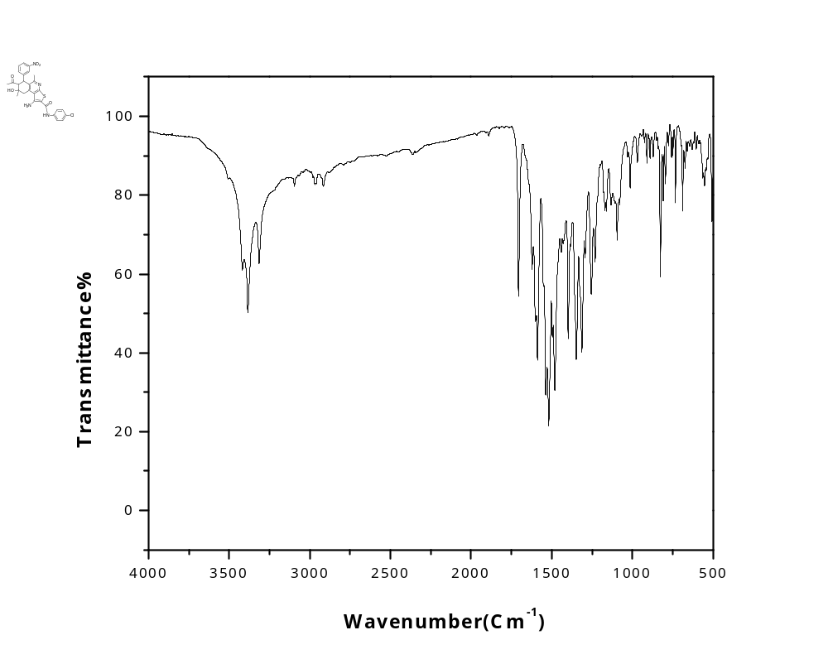
Figure S31: IR Spectrum of 7-Acetyl-1-amino-N-(4-chlorophenyl)-5,8-dimethyl-8-hydroxy-6-(3-nitrophenyl)-6,7,8,9-tetrahydrothieno[2,3-c]isoquinoline-2-carboxamide (6d).
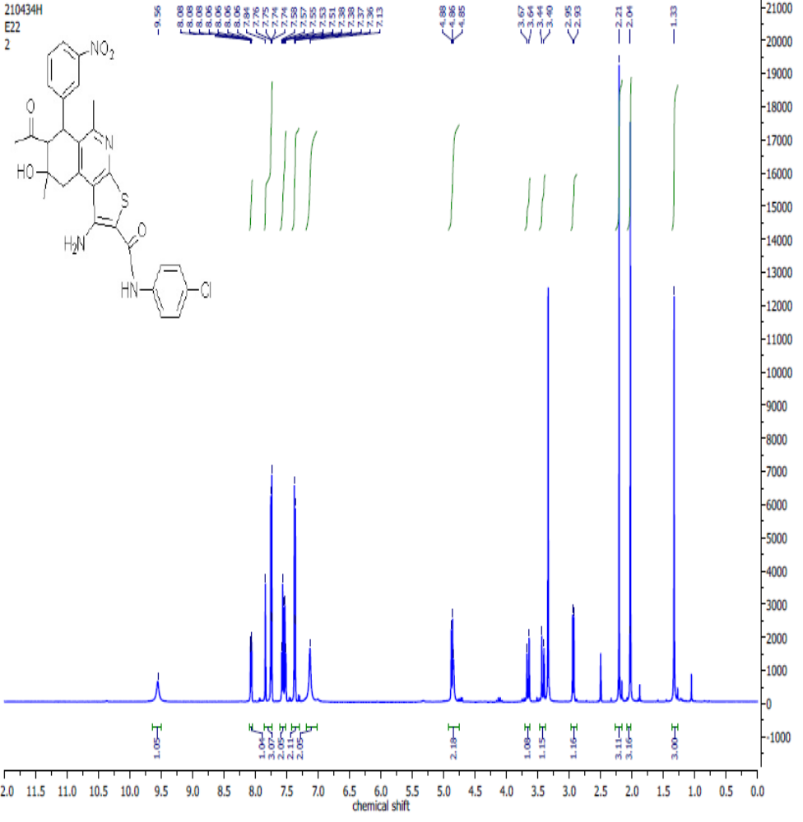 Figure S32:¹H NMR Spectrum of 7-Acetyl-1-amino-N-(4-chlorophenyl)-5,8-dimethyl-8-hydroxy-6-(3-nitrophenyl)-6,7,8,9-tetrahydrothieno[2,3-c]isoquinoline-2-carboxamide (6d) in DMSO-d₆.
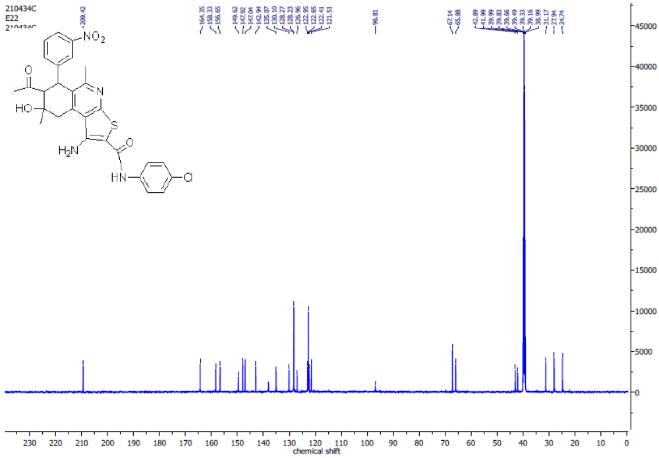
Figure S33: ¹³ C NMR Spectrum of 7-Acetyl-1-amino-N-(4-chlorophenyl)-5,8-dimethyl-8-hydroxy-6-(3-nitrophenyl)-6,7,8,9-tetrahydrothieno[2,3-c]isoquinoline-2-carboxamide (6d) in DMSO-d₆.

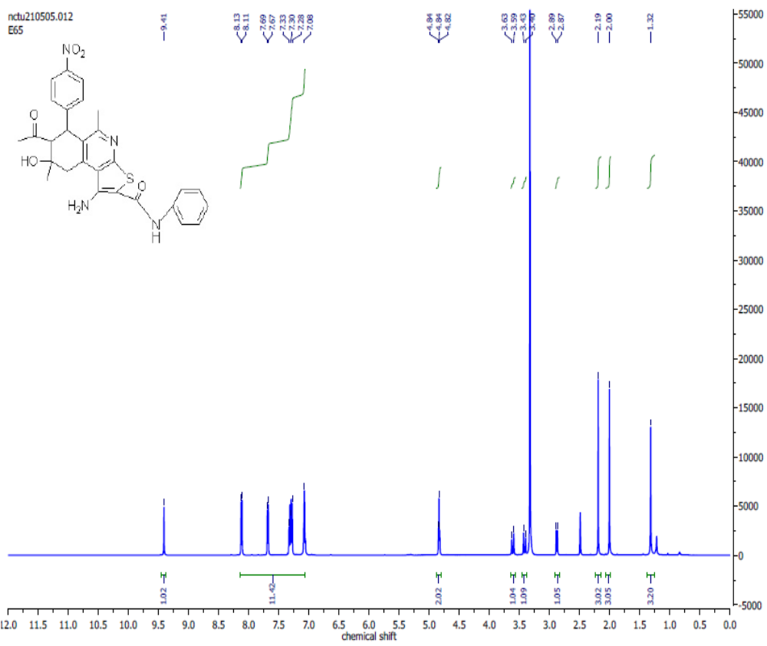Figure S34: ¹H NMR Spectrum of 7-Acetyl-1-amino-5,8-dimethyl-8-hydroxy-6-(4-nitrophenyl)-N-phenyl-6,7,8,9-tetrahydrothieno[2,3-c]isoquinoline-2-carboxamide (6f) in DMSO-d₆.

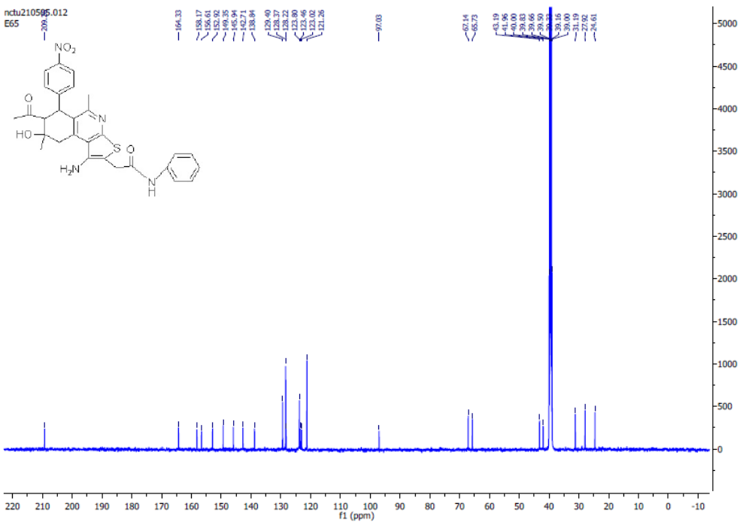
Figure S35: ¹³C NMR Spectrum of 7-Acetyl-1-amino-5,8-dimethyl-8-hydroxy-6-(4-nitrophenyl)-N-phenyl-6,7,8,9-tetrahydrothieno[2,3-c]isoquinoline-2-carboxamide (6f) in DMSO-d_{6.}

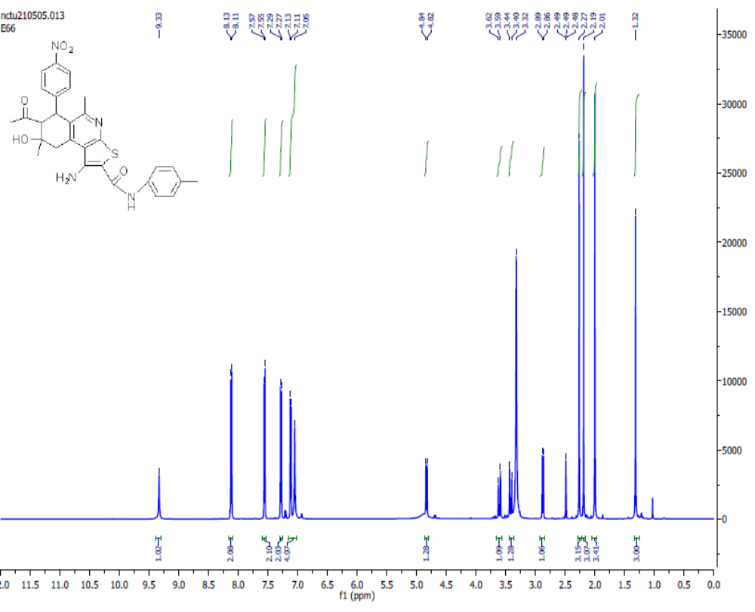Figure S36: ¹HNMR Spectrum of 7-Acetyl-1-amino-8-hydroxy-5,8-dimethyl-6-(4-nitrophenyl)-N-(4-tolyl)-6,7,8,9-tetrahydrothieno[2,3-c]isoquinoline-2-carboxamide(6g) in DMSO-d₆.

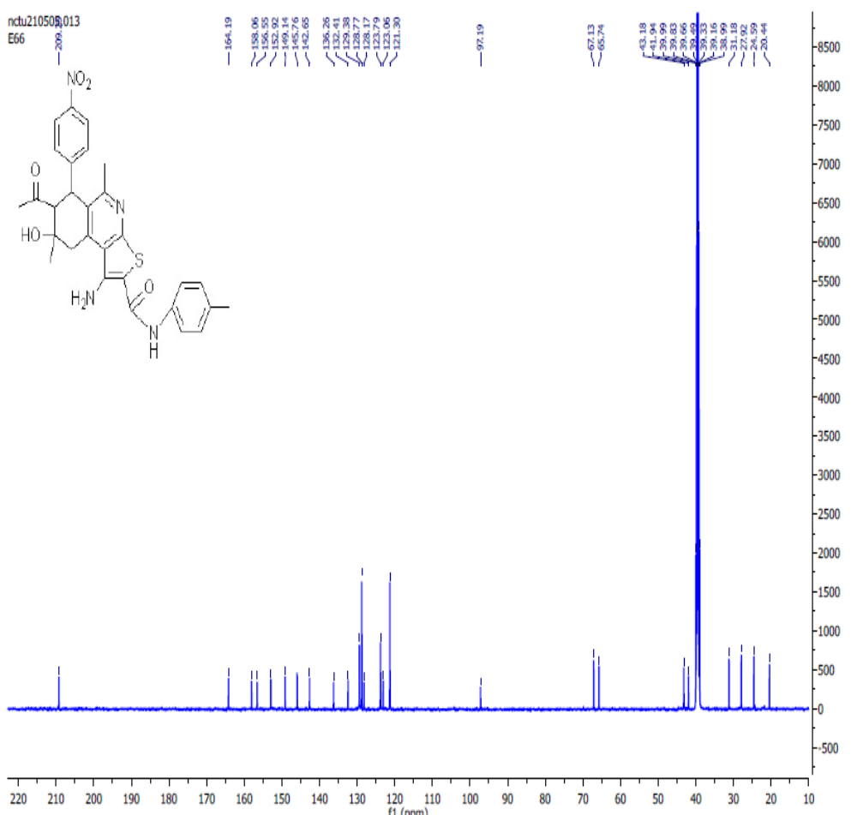Figure S37: ¹³ C NMR Spectrum of 7-Acetyl-1-amino-8-hydroxy-5,8-dimethyl-6-(4-nitrophenyl)-
N-(4-tolyl)-6,7,8,9-tetrahydrothieno[2,3-c]isoquinoline-2-carboxamide (6g) in DMSO-d₆.

Table S1: Probit Analysis and raw data for cytotoxicity of compound 3 against PACA2 (Pancreatic cancer cell line)
Parameter Estimates
 | Parameter | Estimate | Std. Error | Z | Sig. | 95% Confidence Interval
 |  |  |  |  |  | Lower Bound | Upper Bound
PROBITª | conc | 3.588 | .304 | 11.808 | .000 | 2.993 | 4.184
PROBITª | Intercept | -6.202- | .514 | -12.056- | .000 | -6.716- | -5.688-
a. PROBIT model: PROBIT(p) = Intercept + BX (Covariates X are transformed using the base 10.000 logarithm.)

Chi-Square Tests
 |  | Chi-Square | dfª | Sig.
PROBIT | Pearson Goodness-of-Fit Test | 3.513 | 6 | .742^{b}
a. Statistics based on individual cases differ from statistics based on aggregated cases.
b. Since the significance level is greater than .150, no heterogeneity factor is used in the calculation of confidence limits.

Cell Counts and Residuals
 | Number | conc | Number of Subjects | Observed Responses | Expected Responses | Residual | Probability
PROBIT | 1 | 2.000 | 100 | 87 | 83.502 | 3.498 | .835
PROBIT | 2 | 1.699 | 100 | 39 | 45.782 | -6.782- | .458
PROBIT | 3 | 1.398 | 100 | 13 | 11.780 | 1.220 | .118
PROBIT | 4 | 1.097 | 100 | 2 | 1.172 | .828 | .012
PROBIT | 5 | .787 | 100 | 0 | .037 | -.037- | .000
PROBIT | 6 | .494 | 100 | 0 | .000 | .000 | .000
PROBIT | 7 | .193 | 100 | 0 | .000 | .000 | .000
PROBIT | 8 | -.108- | 100 | 0 | .000 | .000 | .000

Confidence Limits
 | Probability | 95% Confidence Limits for conc |  |  | 95% Confidence Limits for log(conc)ª
 | Probability | Estimate | Lower Bound | Upper Bound | Estimate | Lower Bound | Upper Bound
PROBIT | 0.01 | 12.027 | 8.973 | 14.922 | 1.080 | .953 | 1.174
PROBIT | 0.02 | 14.326 | 11.035 | 17.387 | 1.156 | 1.043 | 1.240
PROBIT | 0.03 | 16.007 | 12.578 | 19.166 | 1.204 | 1.100 | 1.283
PROBIT | 0.04 | 17.401 | 13.875 | 20.629 | 1.241 | 1.142 | 1.314
PROBIT | 0.05 | 18.624 | 15.025 | 21.905 | 1.270 | 1.177 | 1.341
PROBIT | 0.06 | 19.732 | 16.077 | 23.057 | 1.295 | 1.206 | 1.363
PROBIT | 0.07 | 20.758 | 17.057 | 24.121 | 1.317 | 1.232 | 1.382
PROBIT | 0.08 | 21.722 | 17.982 | 25.118 | 1.337 | 1.255 | 1.400
PROBIT | 0.09 | 22.637 | 18.865 | 26.063 | 1.355 | 1.276 | 1.416
PROBIT | 0.1 | 23.514 | 19.714 | 26.968 | 1.371 | 1.295 | 1.431
PROBIT | 0.15 | 27.520 | 23.622 | 31.102 | 1.440 | 1.373 | 1.493
PROBIT | 0.2 | 31.184 | 27.218 | 34.908 | 1.494 | 1.435 | 1.543
PROBIT | 0.25 | 34.715 | 30.676 | 38.618 | 1.541 | 1.487 | 1.587
PROBIT | 0.3 | 38.225 | 34.086 | 42.367 | 1.582 | 1.533 | 1.627
PROBIT | 0.35 | 41.793 | 37.510 | 46.257 | 1.621 | 1.574 | 1.665
PROBIT | 0.4 | 45.487 | 40.996 | 50.377 | 1.658 | 1.613 | 1.702
PROBIT | 0.45 | 49.371 | 44.591 | 54.817 | 1.693 | 1.649 | 1.739
PROBIT | 0.5 | 53.517 | 48.349 | 59.677 | 1.728 | 1.684 | 1.776
PROBIT | 0.55 | 58.012 | 52.333 | 65.080 | 1.764 | 1.719 | 1.813
PROBIT | 0.6 | 62.965 | 56.628 | 71.184 | 1.799 | 1.753 | 1.852
PROBIT | 0.65 | 68.530 | 61.348 | 78.208 | 1.836 | 1.788 | 1.893
PROBIT | 0.7 | 74.928 | 66.661 | 86.477 | 1.875 | 1.824 | 1.937
PROBIT | 0.75 | 82.503 | 72.820 | 96.505 | 1.916 | 1.862 | 1.985
PROBIT | 0.8 | 91.844 | 80.255 | 109.177 | 1.963 | 1.904 | 2.038
PROBIT | 0.85 | 104.075 | 89.774 | 126.216 | 2.017 | 1.953 | 2.101
PROBIT | 0.9 | 121.803 | 103.231 | 151.690 | 2.086 | 2.014 | 2.181
PROBIT | 0.91 | 126.520 | 106.754 | 158.605 | 2.102 | 2.028 | 2.200
PROBIT | 0.92 | 131.851 | 110.710 | 166.486 | 2.120 | 2.044 | 2.221
PROBIT | 0.93 | 137.973 | 115.222 | 175.617 | 2.140 | 2.062 | 2.245
PROBIT | 0.94 | 145.146 | 120.469 | 186.423 | 2.162 | 2.081 | 2.270
PROBIT | 0.95 | 153.784 | 126.733 | 199.580 | 2.187 | 2.103 | 2.300
PROBIT | 0.96 | 164.591 | 134.496 | 216.252 | 2.216 | 2.129 | 2.335
PROBIT | 0.97 | 178.923 | 144.672 | 238.705 | 2.253 | 2.160 | 2.378
PROBIT | 0.98 | 199.926 | 159.369 | 272.257 | 2.301 | 2.202 | 2.435
PROBIT | 0.99 | 238.145 | 185.549 | 335.100 | 2.377 | 2.268 | 2.525
a. Logarithm base = 10.
PROBIT dead OF total WITH conc
/LOG 10
/MODEL PROBIT
/PRINT FREQ CI
/CRITERIA P(0.15) ITERATE(20) STEPLIMIT(.1).

Table S2: Probit Analysis and raw data for cytotoxicity of compound 5c against PACA2 (Pancreatic cancer cell line)
Parameter Estimates
 | Parameter | Estimate | Std. Error | Z | Sig. | 95% Confidence Interval
 |  |  |  |  |  | Lower Bound | Upper Bound
PROBITª | conc | 2.034 | .169 | 12.057 | .000 | 1.704 | 2.365
PROBITª | Intercept | -3.619- | .269 | -13.470- | .000 | -3.887- | -3.350-
a. PROBIT model: PROBIT(p) = Intercept + BX (Covariates X are transformed using the base 10.000 logarithm.)

Chi-Square Tests
 |  | Chi-Square | dfª | Sig.
PROBIT | Pearson Goodness-of-Fit Test | 17.454 | 6 | .008^{b}
a. Statistics based on individual cases differ from statistics based on aggregated cases.
b. Since the significance level is less than .150, a heterogeneity factor is used in the calculation of confidence limits.

Cell Counts and Residuals
 | Number |  |  | conc |  | Number of Subjects | Observed Responses |  |  | Expected Responses | Residual |  |  | Probability
PROBIT |  | 1 | 2.000 |  | 100 |  |  | 73 | 67.364 |  |  | 5.636 | .674
 |  | 2 | 1.699 |  | 100 |  |  | 38 | 43.549 |  |  | -5.549- | .435
 |  | 3 | 1.398 |  | 100 |  |  | 20 | 21.922 |  |  | -1.922- | .219
 |  | 4 | 1.097 |  | 100 |  |  | 9 | 8.268 |  |  | .732 | .083
 |  | 5 | .787 |  | 100 |  |  | 2 | 2.182 |  |  | -.182- | .022
 |  | 6 | .494 |  | 100 |  |  | 0 | .448 |  |  | -.448- | .004
 |  | 7 | .193 |  | 100 |  |  | 1 | .063 |  |  | .937 | .001
 |  | 8 | -.108- |  | 100 |  |  | 0 | .006 |  |  | -.006- | .000

Confidence Limits
 | Probability | 95% Confidence Limits for conc |  |  | 95% Confidence Limits for log(conc)^{b}
 | Probability | Estimate | Lower Bound | Upper Bound | Estimate | Lower Bound | Upper Bound
PROBIT | 0.01 | 4.318 | 1.338 | 7.899 | .635 | .126 | .898
PROBIT | 0.02 | 5.879 | 2.122 | 10.039 | .769 | .327 | 1.002
PROBIT | 0.03 | 7.150 | 2.838 | 11.710 | .854 | .453 | 1.069
PROBIT | 0.04 | 8.284 | 3.528 | 13.165 | .918 | .548 | 1.119
PROBIT | 0.05 | 9.339 | 4.207 | 14.494 | .970 | .624 | 1.161
PROBIT | 0.06 | 10.341 | 4.882 | 15.744 | 1.015 | .689 | 1.197
PROBIT | 0.07 | 11.308 | 5.559 | 16.942 | 1.053 | .745 | 1.229
PROBIT | 0.08 | 12.250 | 6.240 | 18.103 | 1.088 | .795 | 1.258
PROBIT | 0.09 | 13.175 | 6.927 | 19.242 | 1.120 | .841 | 1.284
PROBIT | 0.1 | 14.089 | 7.621 | 20.365 | 1.149 | .882 | 1.309
PROBIT | 0.15 | 18.593 | 11.225 | 25.971 | 1.269 | 1.050 | 1.414
PROBIT | 0.2 | 23.180 | 15.074 | 31.919 | 1.365 | 1.178 | 1.504
PROBIT | 0.25 | 28.007 | 19.163 | 38.591 | 1.447 | 1.282 | 1.586
PROBIT | 0.3 | 33.193 | 23.476 | 46.341 | 1.521 | 1.371 | 1.666
PROBIT | 0.35 | 38.851 | 28.009 | 55.543 | 1.589 | 1.447 | 1.745
PROBIT | 0.4 | 45.110 | 32.783 | 66.630 | 1.654 | 1.516 | 1.824
PROBIT | 0.45 | 52.124 | 37.854 | 80.135 | 1.717 | 1.578 | 1.904
PROBIT | 0.5 | 60.091 | 43.310 | 96.761 | 1.779 | 1.637 | 1.986
PROBIT | 0.55 | 69.275 | 49.277 | 117.488 | 1.841 | 1.693 | 2.070
PROBIT | 0.6 | 80.046 | 55.929 | 143.750 | 1.903 | 1.748 | 2.158
PROBIT | 0.65 | 92.942 | 63.514 | 177.739 | 1.968 | 1.803 | 2.250
PROBIT | 0.7 | 108.787 | 72.392 | 222.996 | 2.037 | 1.860 | 2.348
PROBIT | 0.75 | 128.929 | 83.139 | 285.639 | 2.110 | 1.920 | 2.456
PROBIT | 0.8 | 155.777 | 96.745 | 377.280 | 2.193 | 1.986 | 2.577
PROBIT | 0.85 | 194.206 | 115.147 | 523.152 | 2.288 | 2.061 | 2.719
PROBIT | 0.9 | 256.301 | 142.950 | 791.530 | 2.409 | 2.155 | 2.898
PROBIT | 0.91 | 274.064 | 150.562 | 875.106 | 2.438 | 2.178 | 2.942
PROBIT | 0.92 | 294.758 | 159.271 | 976.061 | 2.469 | 2.202 | 2.989
PROBIT | 0.93 | 319.322 | 169.403 | 1100.721 | 2.504 | 2.229 | 3.042
PROBIT | 0.94 | 349.182 | 181.454 | 1259.064 | 2.543 | 2.259 | 3.100
PROBIT | 0.95 | 386.661 | 196.211 | 1467.922 | 2.587 | 2.293 | 3.167
PROBIT | 0.96 | 435.865 | 215.038 | 1758.387 | 2.639 | 2.333 | 3.245
PROBIT | 0.97 | 505.017 | 240.606 | 2196.047 | 2.703 | 2.381 | 3.342
PROBIT | 0.98 | 614.216 | 279.238 | 2952.212 | 2.788 | 2.446 | 3.470
PROBIT | 0.99 | 836.212 | 352.811 | 4710.266 | 2.922 | 2.548 | 3.673
a. Logarithm base = 10.
PROBIT dead OF total WITH conc
/LOG 10
/MODEL PROBIT
/PRINT FREQ CI
/CRITERIA P(0.15) ITERATE(20) STEPLIMIT(.1).

Table S3: Probit Analysis and raw data for cytotoxicity of compound 5h against PACA2 (Pancreatic cancer cell line).
Parameter Estimates
 | Parameter | Estimate | Std. Error | Z | Sig. | 95% Confidence Interval
 |  |  |  |  |  | Lower Bound | Upper Bound
PROBITª | conc | 3.195 | .222 | 14.394 | .000 | 2.760 | 3.630
PROBITª | Intercept | -4.517- | .317 | -14.250- | .000 | -4.834- | -4.200-
a. PROBIT model: PROBIT(p) = Intercept + BX (Covariates X are transformed using the base 10.000 logarithm.)

Chi-Square Tests
 |  | Chi-Square | dfª | Sig.
PROBIT | Pearson Goodness-of-Fit Test | 10.858 | 6 | .093^{b}
a. Statistics based on individual cases differ from statistics based on aggregated cases.
b. Since the significance level is less than .150, a heterogeneity factor is used in the calculation of confidence limits.

Cell Counts and Residuals
 | Number | conc | Number of Subjects | Observed Responses | Expected Responses | Residual | Probability
PROBIT | 1 | 2.000 | 100 | 100 | 96.951 | 3.049 | .970
PROBIT | 2 | 1.699 | 100 | 82 | 81.905 | .095 | .819
PROBIT | 3 | 1.398 | 100 | 38 | 48.000 | -10.000- | .480
PROBIT | 4 | 1.097 | 100 | 17 | 15.576 | 1.424 | .156
PROBIT | 5 | .787 | 100 | 5 | 2.264 | 2.736 | .023
PROBIT | 6 | .494 | 100 | 0 | .165 | -.165- | .002
PROBIT | 7 | .193 | 100 | 0 | .005 | -.005- | .000
PROBIT | 8 | -.108- | 100 | 0 | .000 | .000 | .000

Confidence Limits
 | Probability | 95% Confidence Limits for conc |  |  | 95% Confidence Limits for log(conc)^{b}
 | Probability | Estimate | Lower Bound | Upper Bound | Estimate | Lower Bound | Upper Bound
PROBIT | 0.01 | 4.848 | 2.884 | 6.816 | .686 | .460 | .834
PROBIT | 0.02 | 5.901 | 3.703 | 8.036 | .771 | .569 | .905
PROBIT | 0.03 | 6.684 | 4.337 | 8.926 | .825 | .637 | .951
PROBIT | 0.04 | 7.341 | 4.882 | 9.665 | .866 | .689 | .985
PROBIT | 0.05 | 7.923 | 5.373 | 10.313 | .899 | .730 | 1.013
PROBIT | 0.06 | 8.454 | 5.829 | 10.902 | .927 | .766 | 1.038
PROBIT | 0.07 | 8.949 | 6.260 | 11.449 | .952 | .797 | 1.059
PROBIT | 0.08 | 9.417 | 6.671 | 11.963 | .974 | .824 | 1.078
PROBIT | 0.09 | 9.864 | 7.067 | 12.453 | .994 | .849 | 1.095
PROBIT | 0.1 | 10.294 | 7.451 | 12.924 | 1.013 | .872 | 1.111
PROBIT | 0.15 | 12.282 | 9.258 | 15.100 | 1.089 | .967 | 1.179
PROBIT | 0.2 | 14.133 | 10.971 | 17.136 | 1.150 | 1.040 | 1.234
PROBIT | 0.25 | 15.942 | 12.658 | 19.149 | 1.203 | 1.102 | 1.282
PROBIT | 0.3 | 17.763 | 14.356 | 21.214 | 1.250 | 1.157 | 1.327
PROBIT | 0.35 | 19.636 | 16.090 | 23.386 | 1.293 | 1.207 | 1.369
PROBIT | 0.4 | 21.595 | 17.881 | 25.720 | 1.334 | 1.252 | 1.410
PROBIT | 0.45 | 23.676 | 19.751 | 28.275 | 1.374 | 1.296 | 1.451
PROBIT | 0.5 | 25.920 | 21.724 | 31.121 | 1.414 | 1.337 | 1.493
PROBIT | 0.55 | 28.377 | 23.831 | 34.343 | 1.453 | 1.377 | 1.536
PROBIT | 0.6 | 31.111 | 26.115 | 38.057 | 1.493 | 1.417 | 1.580
PROBIT | 0.65 | 34.215 | 28.634 | 42.423 | 1.534 | 1.457 | 1.628
PROBIT | 0.7 | 37.822 | 31.476 | 47.682 | 1.578 | 1.498 | 1.678
PROBIT | 0.75 | 42.142 | 34.779 | 54.217 | 1.625 | 1.541 | 1.734
PROBIT | 0.8 | 47.536 | 38.776 | 62.701 | 1.677 | 1.589 | 1.797
PROBIT | 0.85 | 54.700 | 43.911 | 74.462 | 1.738 | 1.643 | 1.872
PROBIT | 0.9 | 65.268 | 51.204 | 92.702 | 1.815 | 1.709 | 1.967
PROBIT | 0.91 | 68.113 | 53.121 | 97.775 | 1.833 | 1.725 | 1.990
PROBIT | 0.92 | 71.344 | 55.277 | 103.616 | 1.853 | 1.743 | 2.015
PROBIT | 0.93 | 75.074 | 57.740 | 110.459 | 1.875 | 1.761 | 2.043
PROBIT | 0.94 | 79.470 | 60.611 | 118.656 | 1.900 | 1.783 | 2.074
PROBIT | 0.95 | 84.800 | 64.047 | 128.776 | 1.928 | 1.806 | 2.110
PROBIT | 0.96 | 91.520 | 68.318 | 141.807 | 1.962 | 1.835 | 2.152
PROBIT | 0.97 | 100.516 | 73.938 | 159.695 | 2.002 | 1.869 | 2.203
PROBIT | 0.98 | 113.858 | 82.095 | 187.098 | 2.056 | 1.914 | 2.272
PROBIT | 0.99 | 138.571 | 96.738 | 240.340 | 2.142 | 1.986 | 2.381
a. Logarithm base = 10.
PROBIT dead OF total WITH conc
/LOG 10
/MODEL PROBIT
/PRINT FREQ CI
/CRITERIA P(0.15) ITERATE(20) STEPLIMIT(.1).

Table S4: Probit Analysis and raw data for cytotoxicity of compound 5i against PACA2 (Pancreatic cancer cell line).
Parameter Estimates
 | Parameter | Estimate | Std. Error | Z | Sig. | 95% Confidence Interval
 |  |  |  |  |  | Lower Bound | Upper Bound
PROBITª | conc | 2.381 | .224 | 10.649 | .000 | 1.942 | 2.819
PROBITª | Intercept | -4.441- | .376 | -11.817- | .000 | -4.817- | -4.065-
a. PROBIT model: PROBIT(p) = Intercept + BX (Covariates X are transformed using the base 10.000 logarithm.)

Chi-Square Tests
 |  | Chi-Square | dfª | Sig.
PROBIT | Pearson Goodness-of-Fit Test | 1.342 | 6 | .969^{b}
a. Statistics based on individual cases differ from statistics based on aggregated cases.
b. Since the significance level is greater than .150, no heterogeneity factor is used in the calculation of confidence limits.

Cell Counts and Residuals
 | Number | conc | Number of Subjects | Observed Responses | Expected Responses | Residual | Probability
PROBIT | 1 | 2.000 | 100 | 65 | 62.559 | 2.441 | .626
PROBIT | 2 | 1.699 | 100 | 32 | 34.590 | -2.590- | .346
PROBIT | 3 | 1.398 | 100 | 12 | 13.285 | -1.285- | .133
PROBIT | 4 | 1.097 | 100 | 4 | 3.365 | .635 | .034
PROBIT | 5 | .787 | 100 | 1 | .513 | .487 | .005
PROBIT | 6 | .494 | 100 | 0 | .055 | -.055- | .001
PROBIT | 7 | .193 | 100 | 0 | .003 | -.003- | .000
PROBIT | 8 | -.108- | 100 | 0 | .000 | .000 | .000

Confidence Limits
 | Probability | 95% Confidence Limits for conc |  |  | 95% Confidence Limits for log(conc)ª
 | Probability | Estimate | Lower Bound | Upper Bound | Estimate | Lower Bound | Upper Bound
PROBIT | 0.01 | 7.731 | 5.060 | 10.449 | .888 | .704 | 1.019
PROBIT | 0.02 | 10.064 | 6.958 | 13.116 | 1.003 | .842 | 1.118
PROBIT | 0.03 | 11.897 | 8.509 | 15.163 | 1.075 | .930 | 1.181
PROBIT | 0.04 | 13.492 | 9.895 | 16.921 | 1.130 | .995 | 1.228
PROBIT | 0.05 | 14.946 | 11.181 | 18.508 | 1.175 | 1.048 | 1.267
PROBIT | 0.06 | 16.307 | 12.403 | 19.983 | 1.212 | 1.094 | 1.301
PROBIT | 0.07 | 17.602 | 13.579 | 21.380 | 1.246 | 1.133 | 1.330
PROBIT | 0.08 | 18.848 | 14.722 | 22.720 | 1.275 | 1.168 | 1.356
PROBIT | 0.09 | 20.058 | 15.839 | 24.019 | 1.302 | 1.200 | 1.381
PROBIT | 0.1 | 21.240 | 16.938 | 25.288 | 1.327 | 1.229 | 1.403
PROBIT | 0.15 | 26.923 | 22.280 | 31.406 | 1.430 | 1.348 | 1.497
PROBIT | 0.2 | 32.505 | 27.546 | 37.523 | 1.512 | 1.440 | 1.574
PROBIT | 0.25 | 38.209 | 32.861 | 43.955 | 1.582 | 1.517 | 1.643
PROBIT | 0.3 | 44.178 | 38.301 | 50.934 | 1.645 | 1.583 | 1.707
PROBIT | 0.35 | 50.540 | 43.933 | 58.664 | 1.704 | 1.643 | 1.768
PROBIT | 0.4 | 57.421 | 49.838 | 67.354 | 1.759 | 1.698 | 1.828
PROBIT | 0.45 | 64.970 | 56.118 | 77.243 | 1.813 | 1.749 | 1.888
PROBIT | 0.5 | 73.366 | 62.900 | 88.630 | 1.865 | 1.799 | 1.948
PROBIT | 0.55 | 82.849 | 70.350 | 101.917 | 1.918 | 1.847 | 2.008
PROBIT | 0.6 | 93.740 | 78.686 | 117.666 | 1.972 | 1.896 | 2.071
PROBIT | 0.65 | 106.503 | 88.212 | 136.705 | 2.027 | 1.946 | 2.136
PROBIT | 0.7 | 121.839 | 99.380 | 160.311 | 2.086 | 1.997 | 2.205
PROBIT | 0.75 | 140.875 | 112.898 | 190.587 | 2.149 | 2.053 | 2.280
PROBIT | 0.8 | 165.593 | 129.995 | 231.310 | 2.219 | 2.114 | 2.364
PROBIT | 0.85 | 199.930 | 153.062 | 290.178 | 2.301 | 2.185 | 2.463
PROBIT | 0.9 | 253.423 | 187.776 | 386.411 | 2.404 | 2.274 | 2.587
PROBIT | 0.91 | 268.359 | 197.250 | 414.147 | 2.429 | 2.295 | 2.617
PROBIT | 0.92 | 285.584 | 208.075 | 446.564 | 2.456 | 2.318 | 2.650
PROBIT | 0.93 | 305.803 | 220.650 | 485.173 | 2.485 | 2.344 | 2.686
PROBIT | 0.94 | 330.081 | 235.580 | 532.288 | 2.519 | 2.372 | 2.726
PROBIT | 0.95 | 360.131 | 253.826 | 591.678 | 2.556 | 2.405 | 2.772
PROBIT | 0.96 | 398.950 | 277.048 | 670.036 | 2.601 | 2.443 | 2.826
PROBIT | 0.97 | 452.453 | 308.492 | 780.824 | 2.656 | 2.489 | 2.893
PROBIT | 0.98 | 534.845 | 355.820 | 957.130 | 2.728 | 2.551 | 2.981
PROBIT | 0.99 | 696.210 | 445.433 | 1319.696 | 2.843 | 2.649 | 3.120
a. Logarithm base = 10.
PROBIT dead OF total WITH conc
/LOG 10
/MODEL PROBIT
/PRINT FREQ CI
/CRITERIA P(0.15) ITERATE(20) STEPLIMIT(.1).
Table S5: Probit Analysis and raw data for cytotoxicity of compound 6b against A549 (Lung carcinoma cell line)
Parameter Estimates
 | Parameter | Estimate | Std. Error | Z | Sig. | 95% Confidence Interval
 |  |  |  |  |  | Lower Bound | Upper Bound
PROBITª | conc | 2.419 | .169 | 14.331 | .000 | 2.088 | 2.750
PROBITª | Intercept | -3.731- | .254 | -14.685- | .000 | -3.986- | -3.477-
a. PROBIT model: PROBIT(p) = Intercept + BX (Covariates X are transformed using the base 10.000 logarithm.)

Chi-Square Tests
 |  | Chi-Square | dfª | Sig.
PROBIT | Pearson Goodness-of-Fit Test | 8.623 | 6 | .196^{b}
a. Statistics based on individual cases differ from statistics based on aggregated cases.
b. Since the significance level is greater than .150, no heterogeneity factor is used in the calculation of confidence limits.

Cell Counts and Residuals
 | Number | conc | Number of Subjects | Observed Responses | Expected Responses | Residual | Probability
PROBIT | 1 | 2.000 | 100 | 89 | 86.568 | 2.432 | .866
PROBIT | 2 | 1.699 | 100 | 68 | 64.730 | 3.270 | .647
PROBIT | 3 | 1.398 | 100 | 27 | 36.314 | -9.314- | .363
PROBIT | 4 | 1.097 | 100 | 14 | 14.047 | -.047- | .140
PROBIT | 5 | .787 | 100 | 4 | 3.381 | .619 | .034
PROBIT | 6 | .494 | 100 | 2 | .560 | 1.440 | .006
PROBIT | 7 | .193 | 100 | 0 | .055 | -.055- | .001
PROBIT | 8 | -.108- | 100 | 0 | .003 | -.003- | .000

Confidence Limits
 | Probability | 95% Confidence Limits for conc |  |  | 95% Confidence Limits for log(conc)ª
 | Probability | Estimate | Lower Bound | Upper Bound | Estimate | Lower Bound | Upper Bound
PROBIT | 0.01 | 3.810 | 2.698 | 4.983 | .581 | .431 | .698
PROBIT | 0.02 | 4.939 | 3.631 | 6.284 | .694 | .560 | .798
PROBIT | 0.03 | 5.823 | 4.382 | 7.283 | .765 | .642 | .862
PROBIT | 0.04 | 6.590 | 5.046 | 8.141 | .819 | .703 | .911
PROBIT | 0.05 | 7.289 | 5.658 | 8.915 | .863 | .753 | .950
PROBIT | 0.06 | 7.941 | 6.236 | 9.634 | .900 | .795 | .984
PROBIT | 0.07 | 8.561 | 6.790 | 10.314 | .933 | .832 | 1.013
PROBIT | 0.08 | 9.158 | 7.326 | 10.965 | .962 | .865 | 1.040
PROBIT | 0.09 | 9.736 | 7.849 | 11.594 | .988 | .895 | 1.064
PROBIT | 0.1 | 10.300 | 8.363 | 12.206 | 1.013 | .922 | 1.087
PROBIT | 0.15 | 13.007 | 10.853 | 15.133 | 1.114 | 1.036 | 1.180
PROBIT | 0.2 | 15.658 | 13.317 | 17.998 | 1.195 | 1.124 | 1.255
PROBIT | 0.25 | 18.358 | 15.833 | 20.936 | 1.264 | 1.200 | 1.321
PROBIT | 0.3 | 21.178 | 18.451 | 24.038 | 1.326 | 1.266 | 1.381
PROBIT | 0.35 | 24.175 | 21.210 | 27.388 | 1.383 | 1.327 | 1.438
PROBIT | 0.4 | 27.412 | 24.152 | 31.071 | 1.438 | 1.383 | 1.492
PROBIT | 0.45 | 30.955 | 27.323 | 35.187 | 1.491 | 1.437 | 1.546
PROBIT | 0.5 | 34.888 | 30.782 | 39.855 | 1.543 | 1.488 | 1.600
PROBIT | 0.55 | 39.321 | 34.609 | 45.236 | 1.595 | 1.539 | 1.655
PROBIT | 0.6 | 44.403 | 38.912 | 51.544 | 1.647 | 1.590 | 1.712
PROBIT | 0.65 | 50.347 | 43.848 | 59.091 | 1.702 | 1.642 | 1.772
PROBIT | 0.7 | 57.475 | 49.649 | 68.351 | 1.759 | 1.696 | 1.835
PROBIT | 0.75 | 66.302 | 56.690 | 80.097 | 1.822 | 1.754 | 1.904
PROBIT | 0.8 | 77.736 | 65.617 | 95.704 | 1.891 | 1.817 | 1.981
PROBIT | 0.85 | 93.575 | 77.700 | 117.945 | 1.971 | 1.890 | 2.072
PROBIT | 0.9 | 118.168 | 95.955 | 153.663 | 2.072 | 1.982 | 2.187
PROBIT | 0.91 | 125.019 | 100.951 | 163.837 | 2.097 | 2.004 | 2.214
PROBIT | 0.92 | 132.912 | 106.666 | 175.667 | 2.124 | 2.028 | 2.245
PROBIT | 0.93 | 142.168 | 113.314 | 189.680 | 2.153 | 2.054 | 2.278
PROBIT | 0.94 | 153.270 | 121.218 | 206.676 | 2.185 | 2.084 | 2.315
PROBIT | 0.95 | 166.993 | 130.893 | 227.951 | 2.223 | 2.117 | 2.358
PROBIT | 0.96 | 184.693 | 143.232 | 255.796 | 2.266 | 2.156 | 2.408
PROBIT | 0.97 | 209.045 | 159.978 | 294.783 | 2.320 | 2.204 | 2.470
PROBIT | 0.98 | 246.459 | 185.262 | 356.050 | 2.392 | 2.268 | 2.552
PROBIT | 0.99 | 319.480 | 233.357 | 479.700 | 2.504 | 2.368 | 2.681

a. Logarithm base = 10.
PROBIT dead OF total WITH conc
/LOG 10
/MODEL PROBIT
/PRINT FREQ CI
/CRITERIA P(0.15) ITERATE(20) STEPLIMIT(.1).
Table S6: Probit Analysis and raw data for cytotoxicity of compound 6d against A549 (Lung carcinoma cell line).

Parameter Estimates
 | Parameter | Estimate | Std. Error | Z | Sig. | 95% Confidence Interval
 |  |  |  |  |  | Lower Bound | Upper Bound
PROBITª | conc | 2.130 | .174 | 12.211 | .000 | 1.788 | 2.472
PROBITª | Intercept | -3.751- | .278 | -13.487- | .000 | -4.029- | -3.473-
a. PROBIT model: PROBIT(p) = Intercept + BX (Covariates X are transformed using the base 10.000 logarithm.)

Chi-Square Tests
 |  | Chi-Square | dfª | Sig.
PROBIT | Pearson Goodness-of-Fit Test | 9.161 | 6 | .165^{b}
a. Statistics based on individual cases differ from statistics based on aggregated cases.
b. Since the significance level is greater than .150, no heterogeneity factor is used in the calculation of confidence limits.

Cell Counts and Residuals
 | Number | conc | Number of Subjects | Observed Responses | Expected Responses | Residual | Probability
PROBIT | 1 | 2.000 | 100 | 77 | 69.481 | 7.519 | .695
PROBIT | 2 | 1.699 | 100 | 38 | 44.762 | -6.762- | .448
PROBIT | 3 | 1.398 | 100 | 18 | 21.979 | -3.979- | .220
PROBIT | 4 | 1.097 | 100 | 7 | 7.866 | -.866- | .079
PROBIT | 5 | .787 | 100 | 4 | 1.904 | 2.096 | .019
PROBIT | 6 | .494 | 100 | 1 | .349 | .651 | .003
PROBIT | 7 | .193 | 100 | 0 | .042 | -.042- | .000
PROBIT | 8 | -.108- | 100 | 0 | .003 | -.003- | .000

Confidence Limits
 | Probability | 95% Confidence Limits for conc |  |  | 95% Confidence Limits for log(conc)ª
 | Probability | Estimate | Lower Bound | Upper Bound | Estimate | Lower Bound | Upper Bound
PROBIT | 0.01 | 4.663 | 3.073 | 6.358 | .669 | .488 | .803
PROBIT | 0.02 | 6.261 | 4.345 | 8.234 | .797 | .638 | .916
PROBIT | 0.03 | 7.548 | 5.409 | 9.710 | .878 | .733 | .987
PROBIT | 0.04 | 8.688 | 6.374 | 10.997 | .939 | .804 | 1.041
PROBIT | 0.05 | 9.741 | 7.282 | 12.175 | .989 | .862 | 1.085
PROBIT | 0.06 | 10.737 | 8.153 | 13.281 | 1.031 | .911 | 1.123
PROBIT | 0.07 | 11.694 | 8.999 | 14.337 | 1.068 | .954 | 1.156
PROBIT | 0.08 | 12.623 | 9.828 | 15.358 | 1.101 | .992 | 1.186
PROBIT | 0.09 | 13.532 | 10.645 | 16.354 | 1.131 | 1.027 | 1.214
PROBIT | 0.1 | 14.426 | 11.455 | 17.332 | 1.159 | 1.059 | 1.239
PROBIT | 0.15 | 18.803 | 15.466 | 22.116 | 1.274 | 1.189 | 1.345
PROBIT | 0.2 | 23.210 | 19.536 | 26.977 | 1.366 | 1.291 | 1.431
PROBIT | 0.25 | 27.806 | 23.757 | 32.145 | 1.444 | 1.376 | 1.507
PROBIT | 0.3 | 32.704 | 28.189 | 37.799 | 1.515 | 1.450 | 1.577
PROBIT | 0.35 | 38.010 | 32.889 | 44.111 | 1.580 | 1.517 | 1.645
PROBIT | 0.4 | 43.838 | 37.927 | 51.267 | 1.642 | 1.579 | 1.710
PROBIT | 0.45 | 50.326 | 43.393 | 59.489 | 1.702 | 1.637 | 1.774
PROBIT | 0.5 | 57.649 | 49.404 | 69.055 | 1.761 | 1.694 | 1.839
PROBIT | 0.55 | 66.036 | 56.120 | 80.344 | 1.820 | 1.749 | 1.905
PROBIT | 0.6 | 75.810 | 63.758 | 93.884 | 1.880 | 1.805 | 1.973
PROBIT | 0.65 | 87.435 | 72.630 | 110.459 | 1.942 | 1.861 | 2.043
PROBIT | 0.7 | 101.620 | 83.204 | 131.284 | 2.007 | 1.920 | 2.118
PROBIT | 0.75 | 119.520 | 96.228 | 158.381 | 2.077 | 1.983 | 2.200
PROBIT | 0.8 | 143.187 | 113.013 | 195.412 | 2.156 | 2.053 | 2.291
PROBIT | 0.85 | 176.750 | 136.151 | 249.927 | 2.247 | 2.134 | 2.398
PROBIT | 0.9 | 230.375 | 171.886 | 341.058 | 2.362 | 2.235 | 2.533
PROBIT | 0.91 | 245.601 | 181.809 | 367.715 | 2.390 | 2.260 | 2.566
PROBIT | 0.92 | 263.284 | 193.228 | 399.065 | 2.420 | 2.286 | 2.601
PROBIT | 0.93 | 284.200 | 206.599 | 436.660 | 2.454 | 2.315 | 2.640
PROBIT | 0.94 | 309.531 | 222.611 | 482.885 | 2.491 | 2.348 | 2.684
PROBIT | 0.95 | 341.188 | 242.373 | 541.655 | 2.533 | 2.384 | 2.734
PROBIT | 0.96 | 382.541 | 267.813 | 619.971 | 2.583 | 2.428 | 2.792
PROBIT | 0.97 | 440.311 | 302.736 | 732.037 | 2.644 | 2.481 | 2.865
PROBIT | 0.98 | 530.830 | 356.235 | 913.162 | 2.725 | 2.552 | 2.961
PROBIT | 0.99 | 712.741 | 460.214 | 1294.332 | 2.853 | 2.663 | 3.112
a. Logarithm base = 10.
PROBIT dead OF total WITH conc
/LOG 10
/MODEL PROBIT
/PRINT FREQ CI
/CRITERIA P(0.15) ITERATE(20) STEPLIMIT(.1).

Table S7: Probit Analysis and raw data for cytotoxicity of compound 6g against A549 (Lung carcinoma cell line).

Parameter Estimates
 | Parameter | Estimate | Std. Error | Z | Sig. | 95% Confidence Interval
 |  |  |  |  |  | Lower Bound | Upper Bound
PROBITª | conc | 2.312 | .179 | 12.925 | .000 | 1.961 | 2.662
PROBITª | Intercept | -3.851- | .282 | -13.649- | .000 | -4.133- | -3.568-
a. PROBIT model: PROBIT(p) = Intercept + BX (Covariates X are transformed using the base 10.000 logarithm.)

Chi-Square Tests
 |  | Chi-Square | dfª | Sig.
PROBIT | Pearson Goodness-of-Fit Test | 1.164 | 6 | .979^{b}
a. Statistics based on individual cases differ from statistics based on aggregated cases.
b. Since the significance level is greater than .150, no heterogeneity factor is used in the calculation of confidence limits.

Cell Counts and Residuals
 | Number | conc | Number of Subjects | Observed Responses | Expected Responses | Residual | Probability
PROBIT | 1 | 2.000 | 100 | 77 | 78.013 | -1.013- | .780
PROBIT | 2 | 1.699 | 100 | 54 | 53.059 | .941 | .531
PROBIT | 3 | 1.398 | 100 | 28 | 26.793 | 1.207 | .268
PROBIT | 4 | 1.097 | 100 | 8 | 9.426 | -1.426- | .094
PROBIT | 5 | .787 | 100 | 3 | 2.112 | .888 | .021
PROBIT | 6 | .494 | 100 | 0 | .338 | -.338- | .003
PROBIT | 7 | .193 | 100 | 0 | .033 | -.033- | .000
PROBIT | 8 | -.108- | 100 | 0 | .002 | -.002- | .000

Confidence Limits
 | Probability | 95% Confidence Limits for conc |  |  | 95% Confidence Limits for log(conc)ª
 | Probability | Estimate | Lower Bound | Upper Bound | Estimate | Lower Bound | Upper Bound
PROBIT | 0.01 | 4.564 | 3.102 | 6.111 | .659 | .492 | .786
PROBIT | 0.02 | 5.988 | 4.255 | 7.765 | .777 | .629 | .890
PROBIT | 0.03 | 7.114 | 5.198 | 9.046 | .852 | .716 | .956
PROBIT | 0.04 | 8.099 | 6.040 | 10.150 | .908 | .781 | 1.006
PROBIT | 0.05 | 8.999 | 6.822 | 11.151 | .954 | .834 | 1.047
PROBIT | 0.06 | 9.844 | 7.565 | 12.083 | .993 | .879 | 1.082
PROBIT | 0.07 | 10.650 | 8.281 | 12.967 | 1.027 | .918 | 1.113
PROBIT | 0.08 | 11.427 | 8.978 | 13.816 | 1.058 | .953 | 1.140
PROBIT | 0.09 | 12.183 | 9.661 | 14.638 | 1.086 | .985 | 1.165
PROBIT | 0.1 | 12.923 | 10.333 | 15.442 | 1.111 | 1.014 | 1.189
PROBIT | 0.15 | 16.497 | 13.623 | 19.307 | 1.217 | 1.134 | 1.286
PROBIT | 0.2 | 20.030 | 16.913 | 23.137 | 1.302 | 1.228 | 1.364
PROBIT | 0.25 | 23.658 | 20.295 | 27.112 | 1.374 | 1.307 | 1.433
PROBIT | 0.3 | 27.473 | 23.825 | 31.363 | 1.439 | 1.377 | 1.496
PROBIT | 0.35 | 31.555 | 27.552 | 36.014 | 1.499 | 1.440 | 1.556
PROBIT | 0.4 | 35.989 | 31.527 | 41.192 | 1.556 | 1.499 | 1.615
PROBIT | 0.45 | 40.870 | 35.812 | 47.048 | 1.611 | 1.554 | 1.673
PROBIT | 0.5 | 46.319 | 40.490 | 53.765 | 1.666 | 1.607 | 1.731
PROBIT | 0.55 | 52.496 | 45.671 | 61.587 | 1.720 | 1.660 | 1.789
PROBIT | 0.6 | 59.616 | 51.510 | 70.846 | 1.775 | 1.712 | 1.850
PROBIT | 0.65 | 67.991 | 58.225 | 82.030 | 1.832 | 1.765 | 1.914
PROBIT | 0.7 | 78.095 | 66.146 | 95.883 | 1.893 | 1.821 | 1.982
PROBIT | 0.75 | 90.688 | 75.797 | 113.634 | 1.958 | 1.880 | 2.056
PROBIT | 0.8 | 107.115 | 88.091 | 137.479 | 2.030 | 1.945 | 2.138
PROBIT | 0.85 | 130.055 | 104.818 | 171.891 | 2.114 | 2.020 | 2.235
PROBIT | 0.9 | 166.023 | 130.253 | 228.019 | 2.220 | 2.115 | 2.358
PROBIT | 0.91 | 176.108 | 137.244 | 244.171 | 2.246 | 2.137 | 2.388
PROBIT | 0.92 | 187.760 | 145.254 | 263.037 | 2.274 | 2.162 | 2.420
PROBIT | 0.93 | 201.464 | 154.590 | 285.489 | 2.304 | 2.189 | 2.456
PROBIT | 0.94 | 217.954 | 165.714 | 312.864 | 2.338 | 2.219 | 2.495
PROBIT | 0.95 | 238.415 | 179.363 | 347.340 | 2.377 | 2.254 | 2.541
PROBIT | 0.96 | 264.922 | 196.819 | 392.776 | 2.423 | 2.294 | 2.594
PROBIT | 0.97 | 301.580 | 220.588 | 456.929 | 2.479 | 2.344 | 2.660
PROBIT | 0.98 | 358.281 | 256.628 | 558.844 | 2.554 | 2.409 | 2.747
PROBIT | 0.99 | 470.058 | 325.617 | 767.882 | 2.672 | 2.513 | 2.885
a. Logarithm base = 10.
PROBIT dead OF total WITH conc
/LOG 10
/MODEL PROBIT
/PRINT FREQ CI
/CRITERIA P(0.15) ITERATE(20) STEPLIMIT(.1).

