Supporting data
Nitrophenyl-Group-Containing Heterocycles. Part I. Synthesis, characterization, anticancer activity and antioxidant properties of some New 5,6,7,8-tetrahydroisoquinolines Bearing 3(4)-nitrophenyl group
Eman M. Sayed,ª Reda Hassanien,ª Nasser Farhan,ª Hanan F. Aly,^{b} Khaled Mahmoud^{c} and Etify A. Bakhite^{d*}
ªChemistry Department, Faculty of Science, New Valley University, 72511 El-Kharja, Egypt. ^{b}Department of Therapeutic Chemistry, National Research Centre, El-Behooth St., 12622 Dokki, Cairo, Egypt. ^{c}Pharmacognosy Department, National Research Centre, El-Behooth St., 12622 Dokki, Cairo, Egypt,^{d}Chemistry Department, Faculty of Science, Assiut University, 71516 Assiut, Egypt.

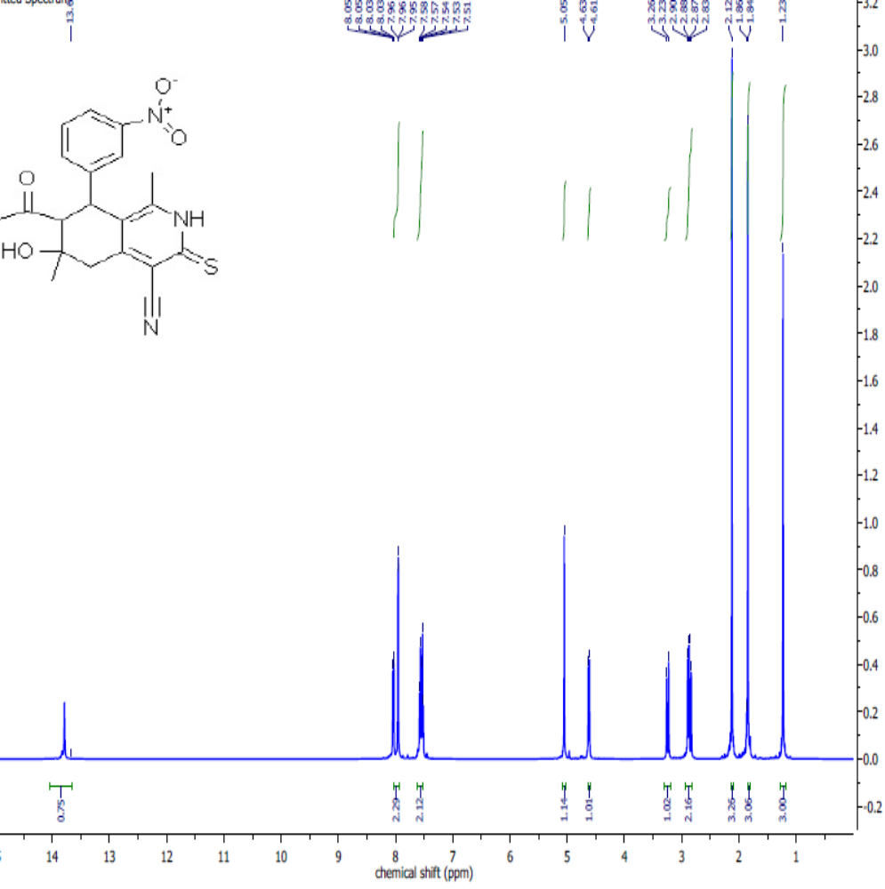
Figure S1: ¹H NMR spectrum of 7-Acetyl-4-cyano-1,6-dimethyl-6-hydroxy-8-(3- nitrophenyl)-5,6,7,8-tetra-hydroisoquinoline-3(2H)-thione (2a).

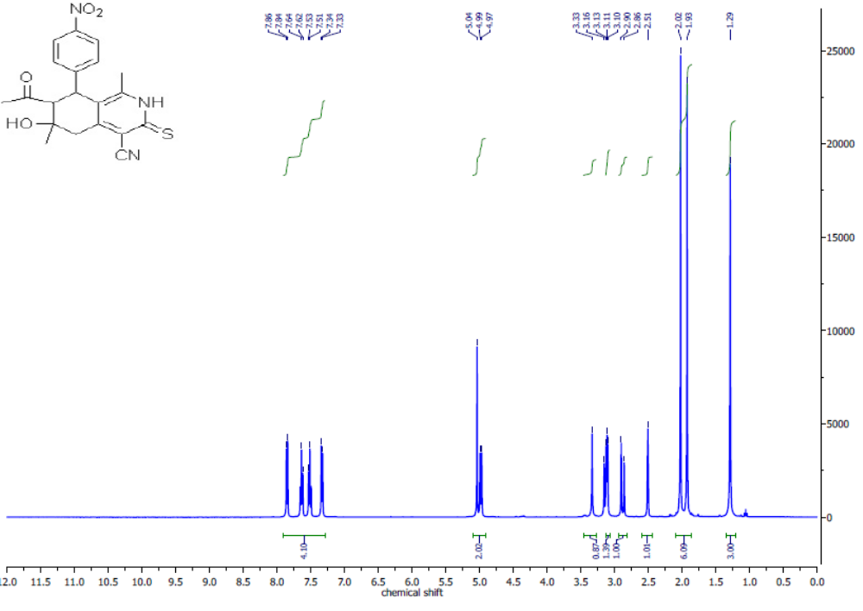
Figure S2: ¹H NMR spectrum of 7-Acetyl-4-cyano-1,6-dimethyl-6-hydroxy-8-(4-nitrophenyl)-5,6,7,8-tetrahydroisoquinoline-3(2H)-thione (2b).

.
.
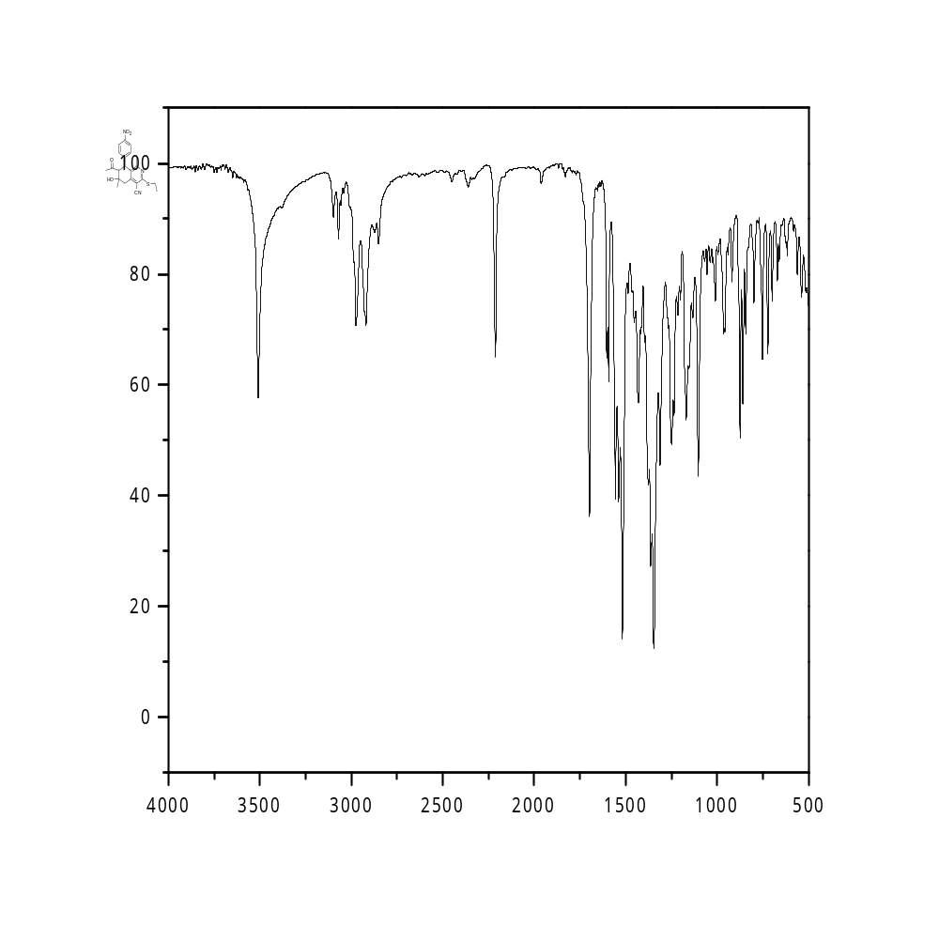
Figure S3: IR spectrum of 7-Acetyl-4-cyano-1,6-dimethyl-3-ethylthio-6-hydroxy-8-(4-nitrophenyl)-5,6,7,8-tetrahydroisoquinoline (3)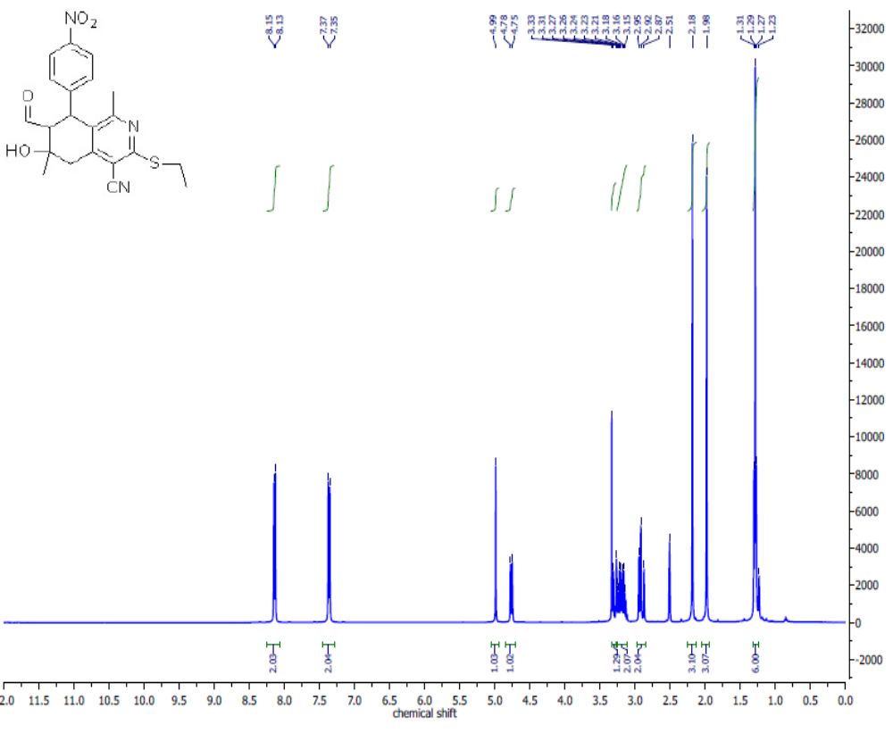Figure S4: ¹H NMR spectrum of 7-Acetyl-4-cyano-1,6-dimethyl-3-ethylthio-6-hydroxy-8-(4-nitrophenyl)-5,6,7,8-tetrahydroisoquinoline (3)
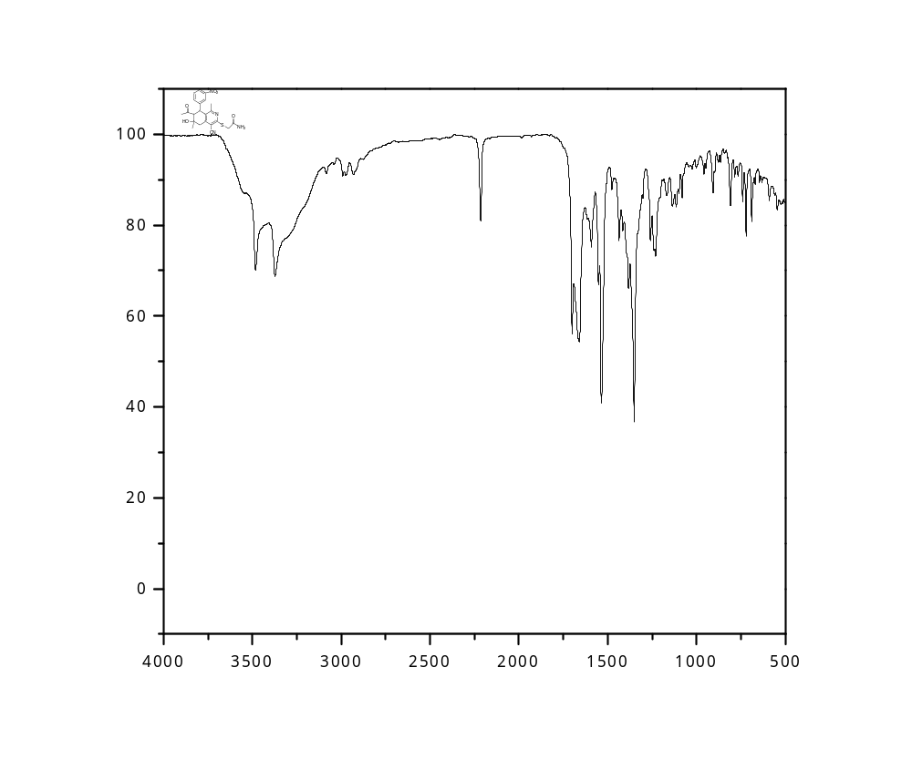
Figure S5: IR spectrum of 2-[(7-Acetyl-4-cyano-1,6-dimethyl-6-hydroxy-8-(3-nitrophenyl)-5,6,7,8-tetrahydroisoquinolin-3-yl)thio]acetamide (4a) 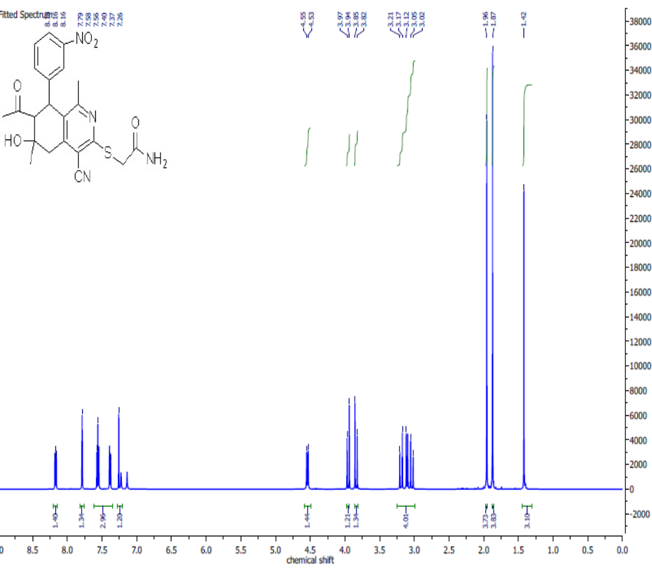Figure S6: ¹H NMR spectrum of 2-[(7-Acetyl-4-cyano-1,6-dimethyl-6-hydroxy-8-(3-nitrophenyl)-5,6,7,8-tetrahydroisoquinolin-3-yl)thio]acetamide (4a) in CDCl₃.

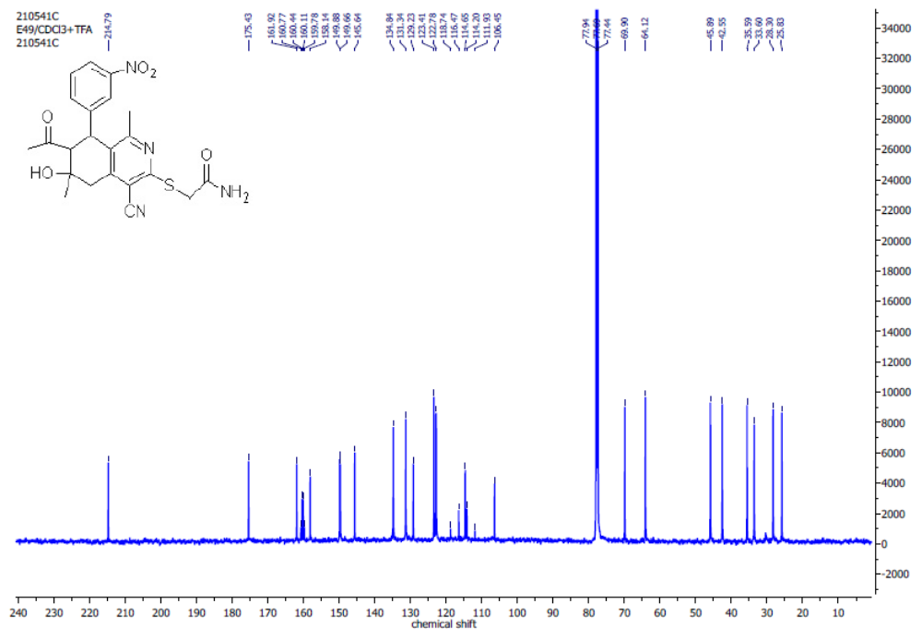Figure S7: ¹³C NMR spectrum of 2-[(7-Acetyl-4-cyano-1,6-dimethyl-6-hydroxy-8-(3-nitrophenyl)-5,6,7,8-tetrahydroisoquinolin-3-yl)thio]acetamide (4a ).

.
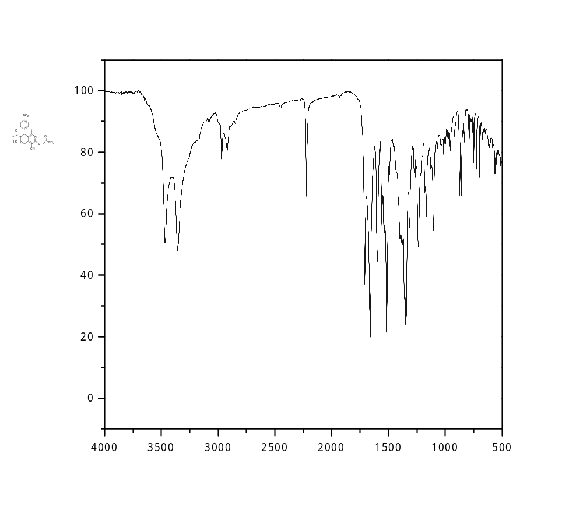
Figure S8: IR spectrum of 2-[(7-Acetyl-4-cyano-1,6-dimethyl-6-hydroxy-8-(4-nitrophenyl)-5,6,7,8-tetrahydroisoquinolin-3-yl)thio]acetamide (4b) 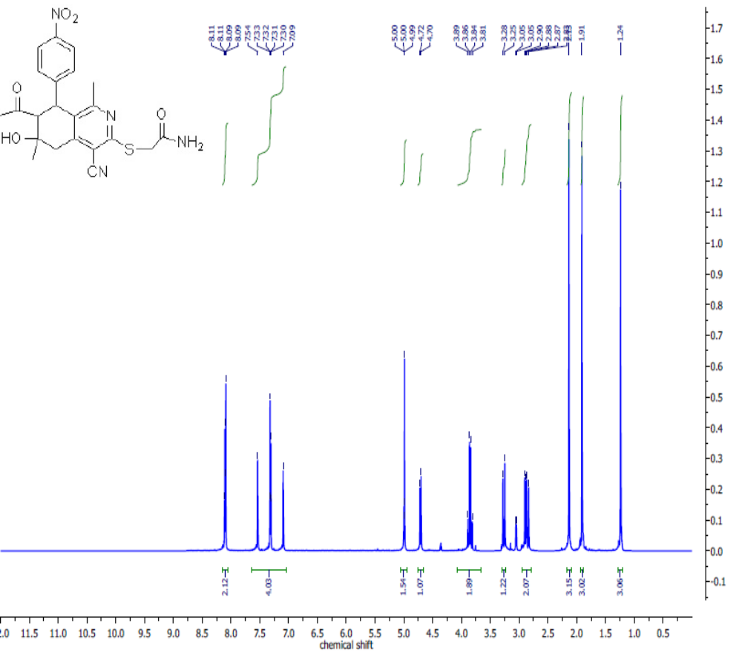Figure S9: ¹H NMR spectrum of 2-[(7-Acetyl-4-cyano-1,6-dimethyl-6-hydroxy-8-(4-nitrophenyl)-5,6,7,8-tetrahydroisoquinolin-3-yl)thio]acetamide (4b).

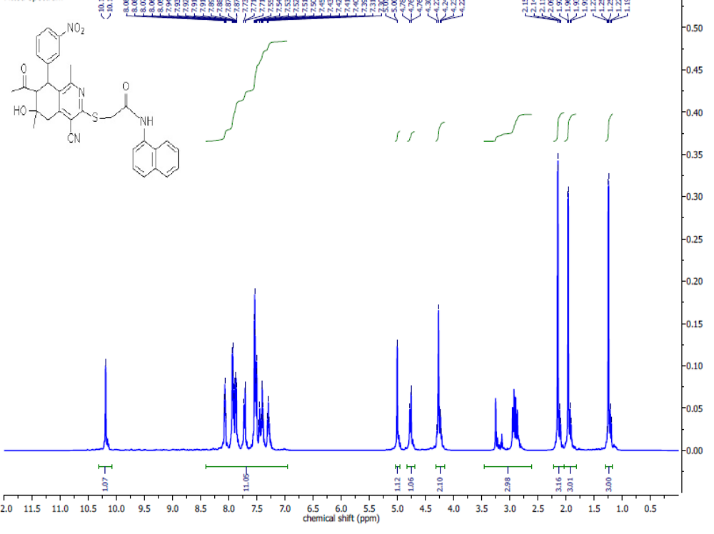Figure S10: ¹H NMR spectrum of 2-[(7-Acetyl-4-cyano-1,6-dimethyl-6-hydroxy-8-(3-nitrophenyl)-5,6,7,8-tetrahydroisoquinolin-3-yl)thio]-N-(naphthalen-1-yl)acetamide (6).

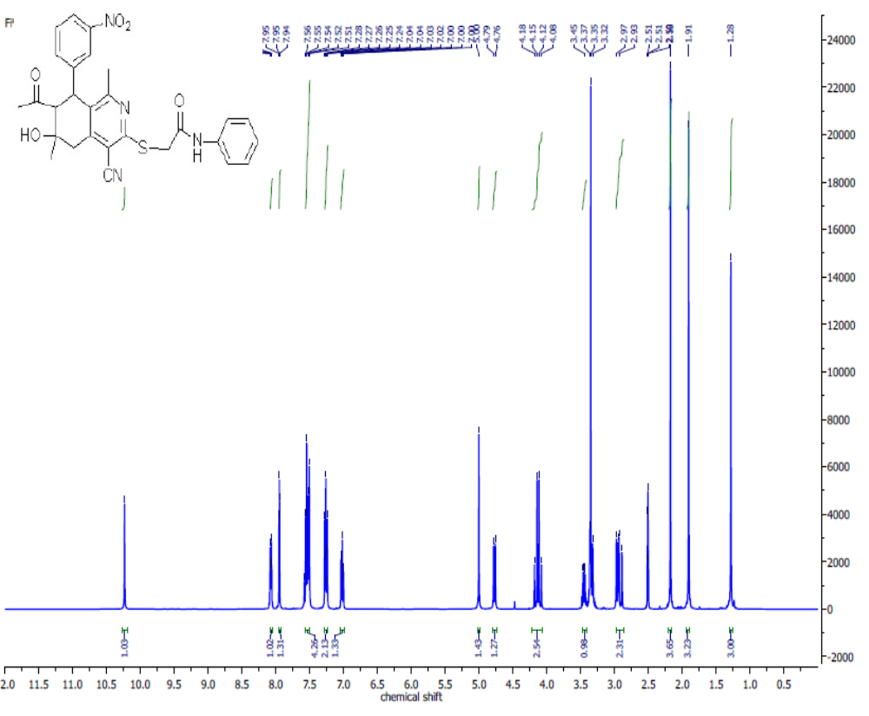
Figure S11: ¹H NMR spectrum of 2-[(7-Acetyl-4-cyano-1,6-dimethyl-6-hydroxy-8-(3-nitrophenyl)-5,6,7,8-tetrahydroisoquinolin-3-yl)thio]-N-phenylacetamide (8a).

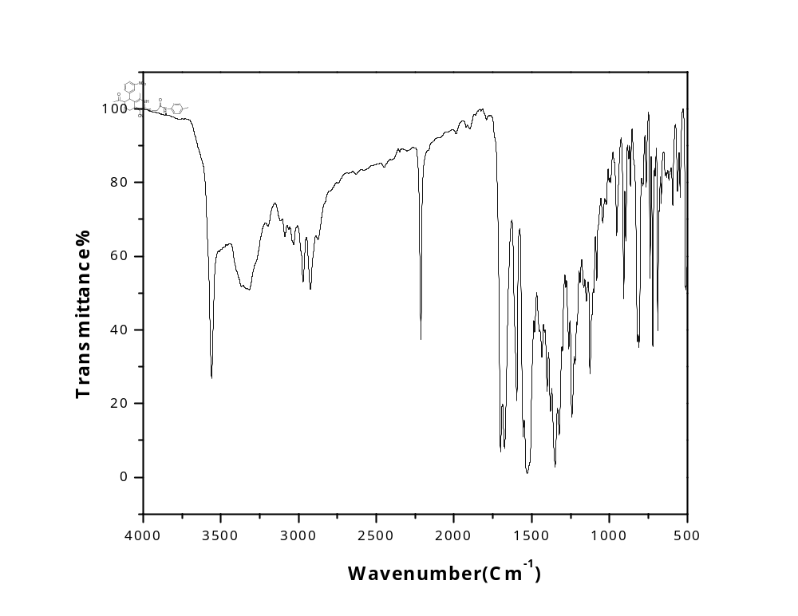Figure S12: IR spectrum of 2-[(7-Acetyl-4-cyano-1,6-dimethyl-6-hydroxy-8-(3-nitrophenyl)-5,6,7,8-tetrahydroisoquinolin-3-yl)thio]-N-(4-tolyl)acetamide (8b).
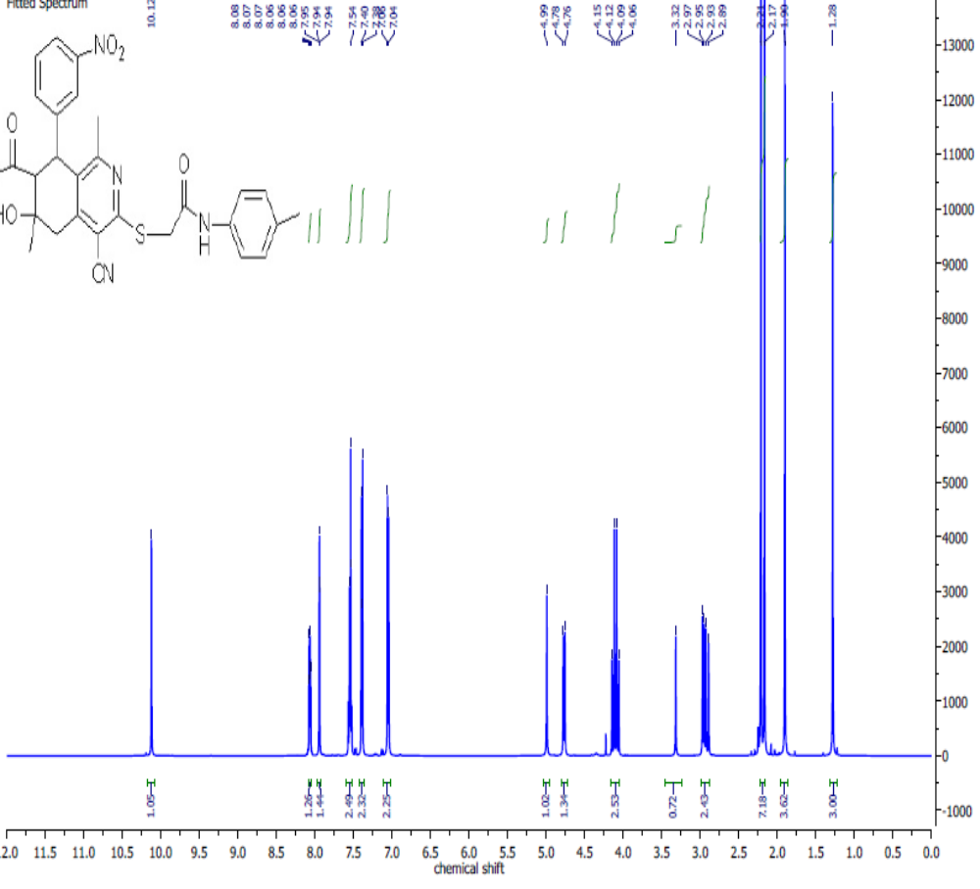Figure S13: ¹H NMR spectrum of 2-[(7-Acetyl-4-cyano-1,6-dimethyl-6-hydroxy-8-(3-nitrophenyl)-5,6,7,8-tetrahydroisoquinolin-3-yl)thio]-N-(4-tolyl)acetamide (8b).
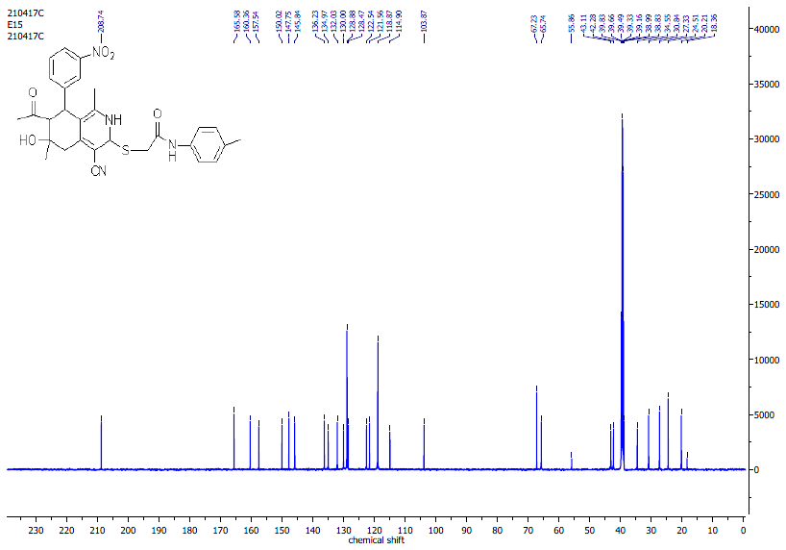
Figure S14: ¹³C NMR spectrum of 2-[(7-Acetyl-4-cyano-1,6-dimethyl-6-hydroxy-8-(3-nitrophenyl)-5,6,7,8-tetrahydroisoquinolin-3-yl)thio]-N-(4-tolyl)acetamide (8b).

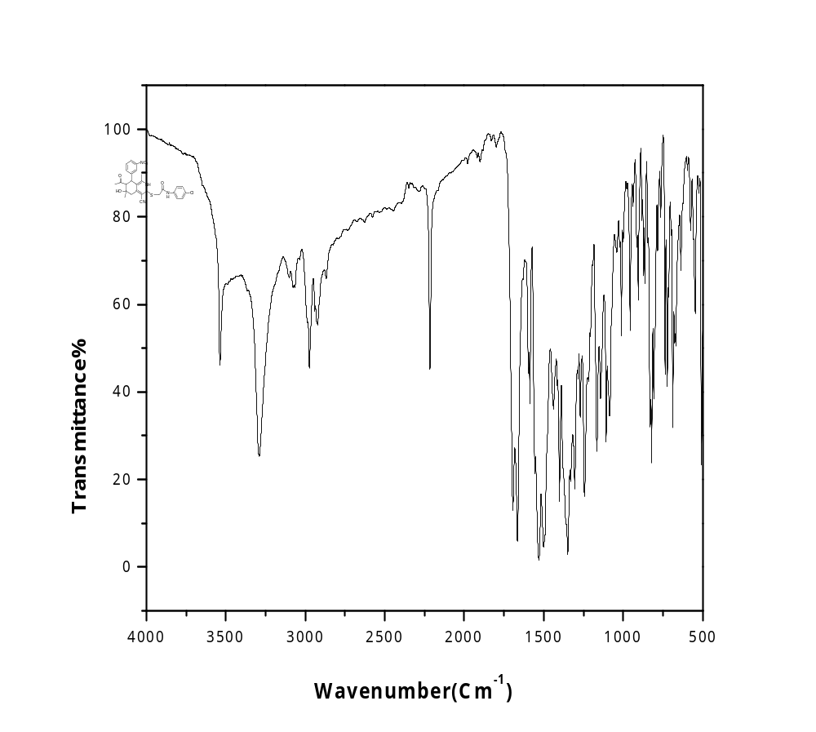Figure S15: IR spectrum of 2-[(7-Acetyl-4-cyano-1,6-dimethyl-6-hydroxy-8-(3-nitrophenyl)-5,6,7,8-tetrahydroisoquinolin-3-yl)thio]-N-(4-chlorophenyl)acetamide (8c) 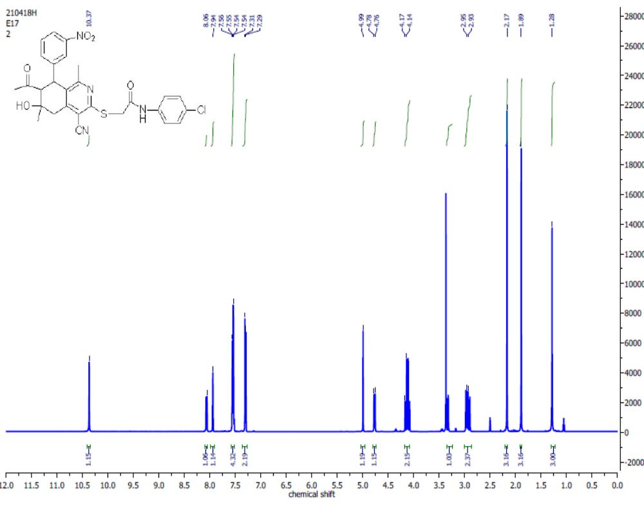Figure S16: ¹H NMR spectrum of 2-[(7-Acetyl-4-cyano-1,6-dimethyl-6-hydroxy-8-(3-nitrophenyl)-5,6,7,8-tetrahydroisoquinolin-3-yl)thio]-N-(4-chlorophenyl)acetamide (8c).

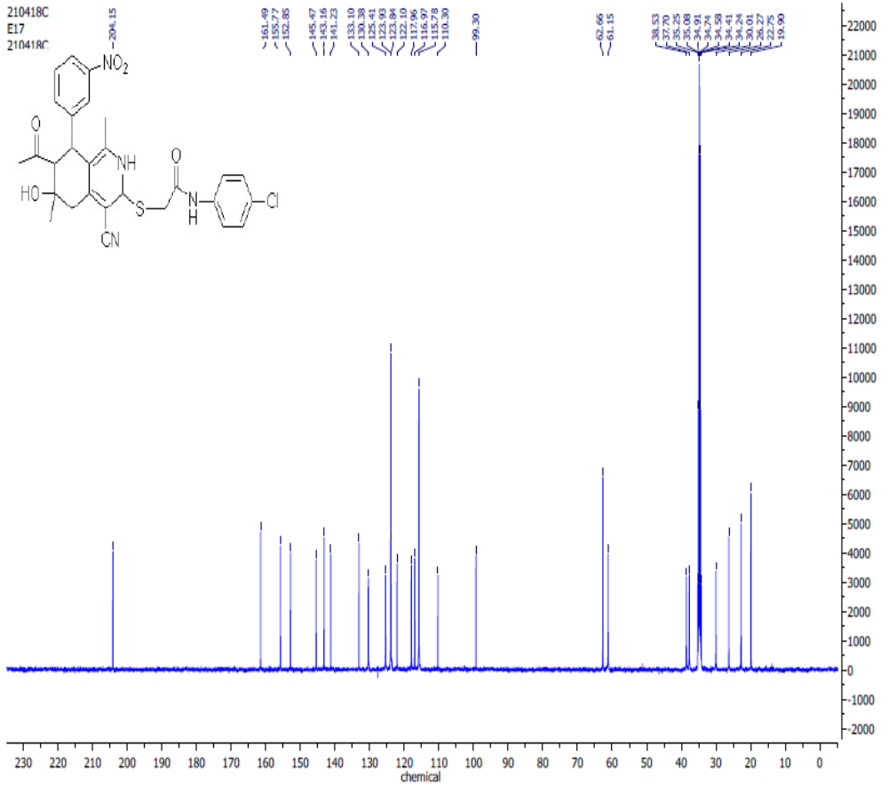Figure S17: ¹³ C NMR spectrum of of 2-[(7-Acetyl-4-cyano-1,6-dimethyl-6-hydroxy-8-(3-nitrophenyl)-5,6,7,8-tetrahydroisoquinolin-3-yl)thio]-N-(4-chlorophenyl)acetamide (8c).

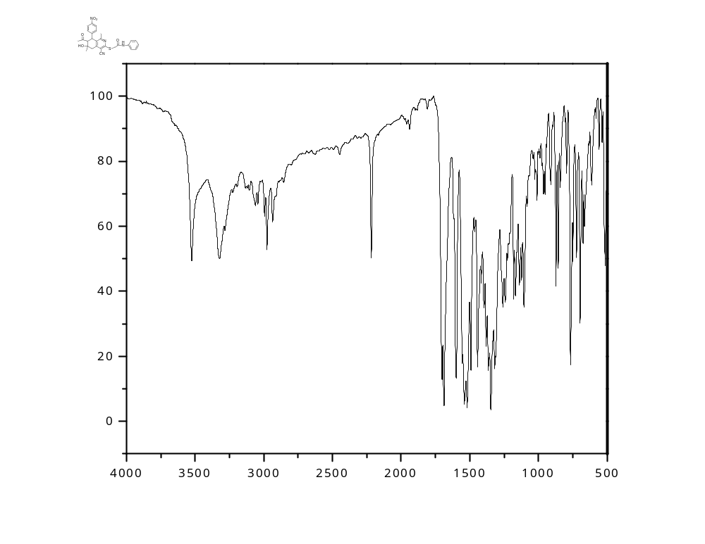
Figure S18: IR spectrum of 2-[(7-Acetyl-4-cyano-1,6-dimethyl-6-hydroxy-8-(4-nitrophenyl)-5,6,7,8-tetrahydroisoquinolin-3-yl)thio]-N-phenylacetamide (8d).

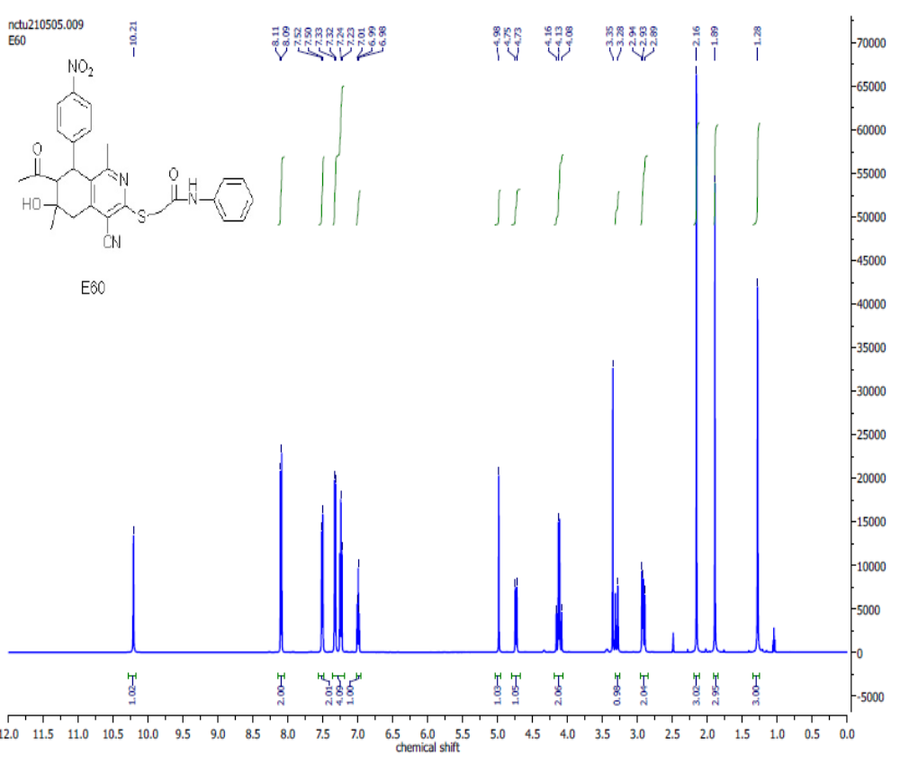Figure S19: ¹H NMR spectrum of 2-[(7-Acetyl-4-cyano-1,6-dimethyl-6-hydroxy-8-(4-nitrophenyl)-5,6,7,8-tetrahydroisoquinolin-3-yl)thio]-N-phenylacetamide (8d).

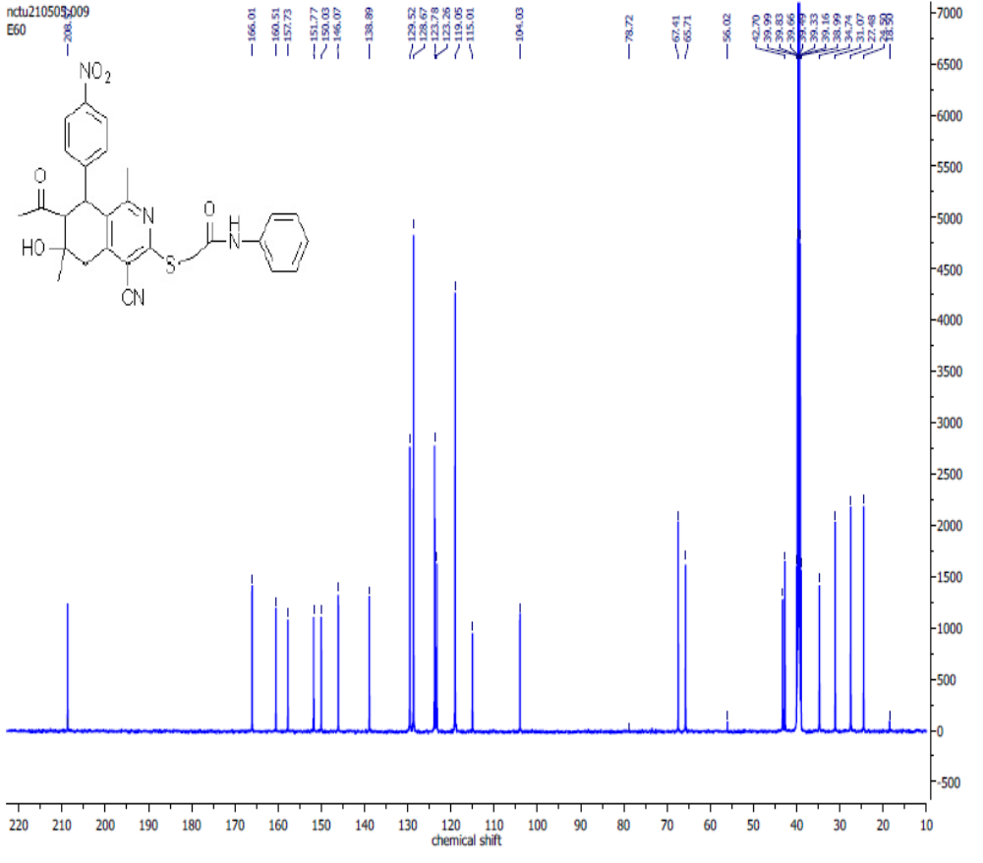Figure S20: ¹³C NMR spectrum of 2-((7-acetyl-4-cyano-6-hydroxy-1,6-dimethyl-8-(4-nitrophenyl)-5,6,7,8-tetrahydroisoquinolin-3-yl)thio)-N-phenylacetamide (8d).

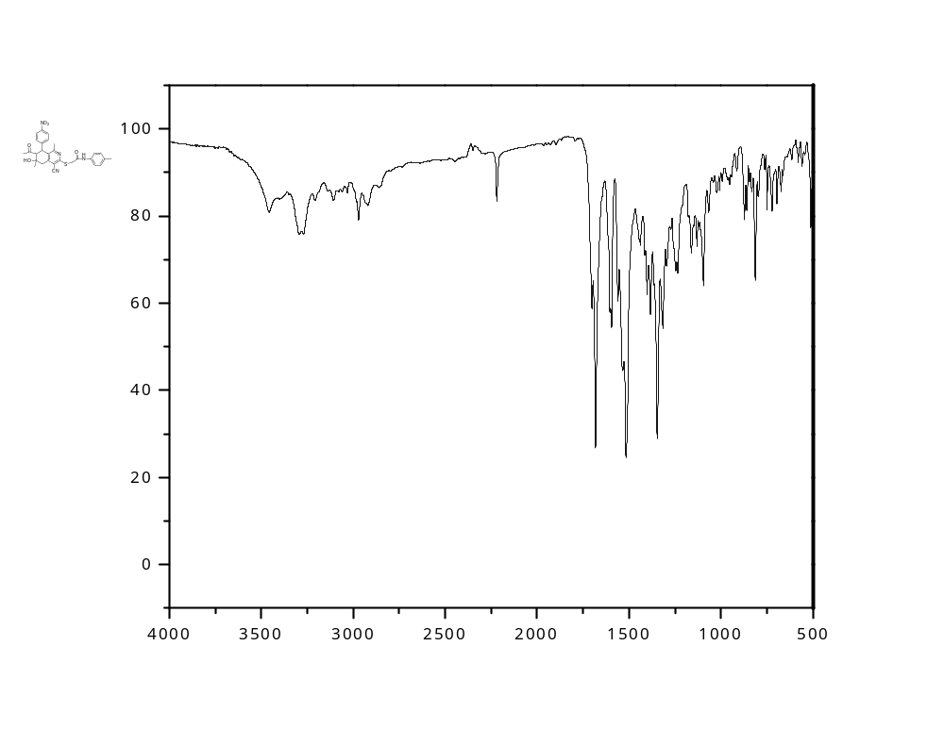
Figure S21: IR spectrum of 2-[(7-Acetyl-4-cyano-1,6-dimethyl-6-hydroxy-8-(4-nitrophenyl)-5,6,7,8-tetrahydroisoquinolin-3-yl)thio]-N-(4-tolyl)acetamide (8e).
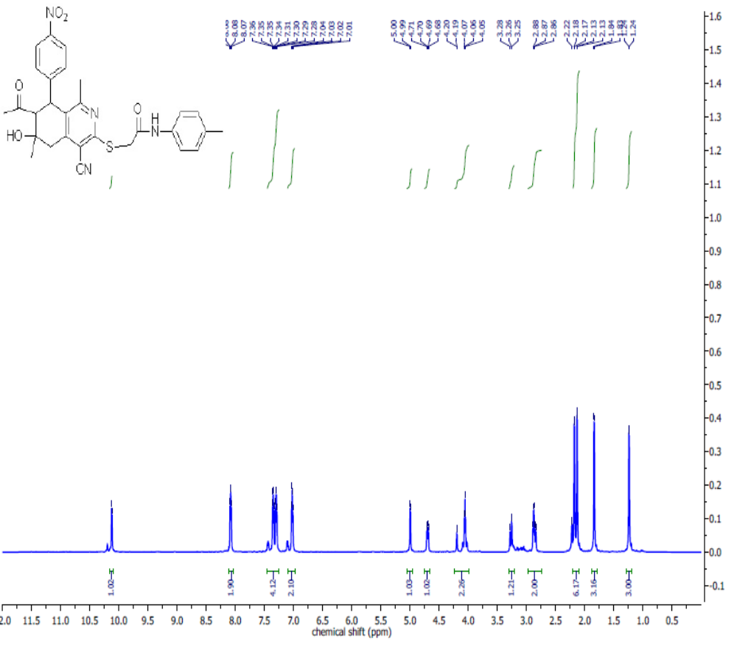Figure S22: ¹H NMR spectrum of 2-[(7-Acetyl-4-cyano-1,6-dimethyl-6-hydroxy-8-(4-nitrophenyl)-5,6,7,8-tetrahydroisoquinolin-3-yl)thio]-N-(4-tolyl)acetamide (8e).

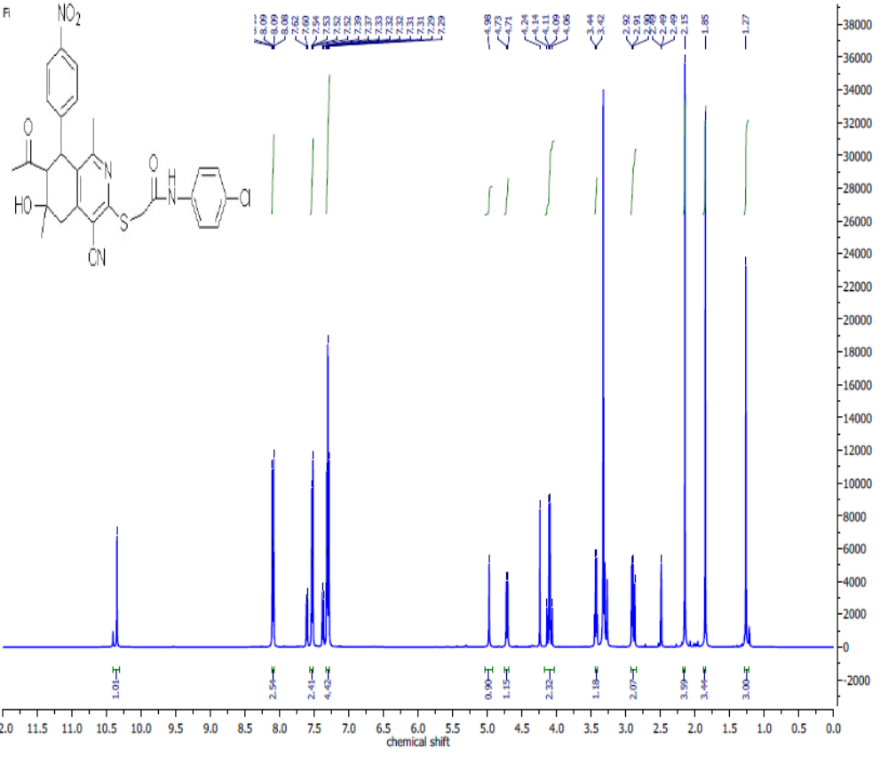Figure S23: ¹H NMR spectrum of 2-[(7-Acetyl-4-cyano-1,6-dimethyl-6-hydroxy-8-(4-nitrophenyl)-5,6,7,8-tetrahydroisoquinolin-3-yl)thio]-N-(4-chlorophenyl)acetamide (8f).

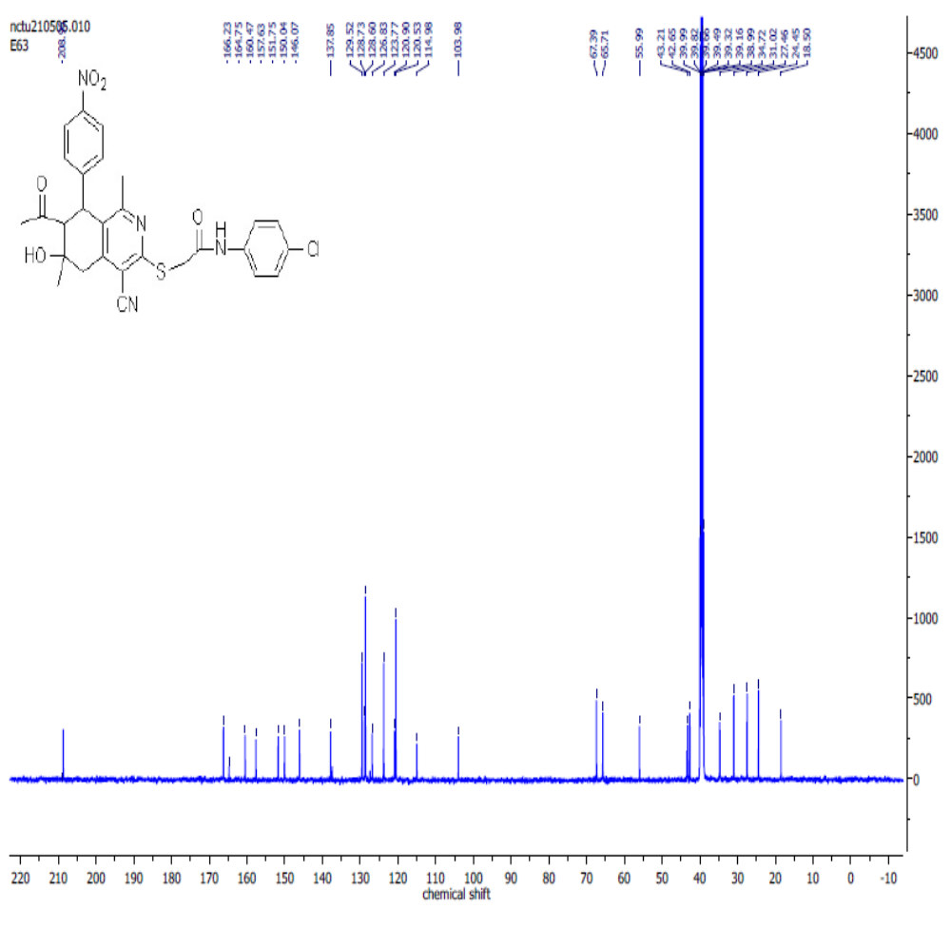
Figure S24: ¹³C NMR spectrum of 22-[(7-Acetyl-4-cyano-1,6-dimethyl-6-hydroxy-8-(4-nitrophenyl)-5,6,7,8-tetrahydroisoquinolin-3-yl)thio]-N-(4-chlorophenyl)acetamide (8f).

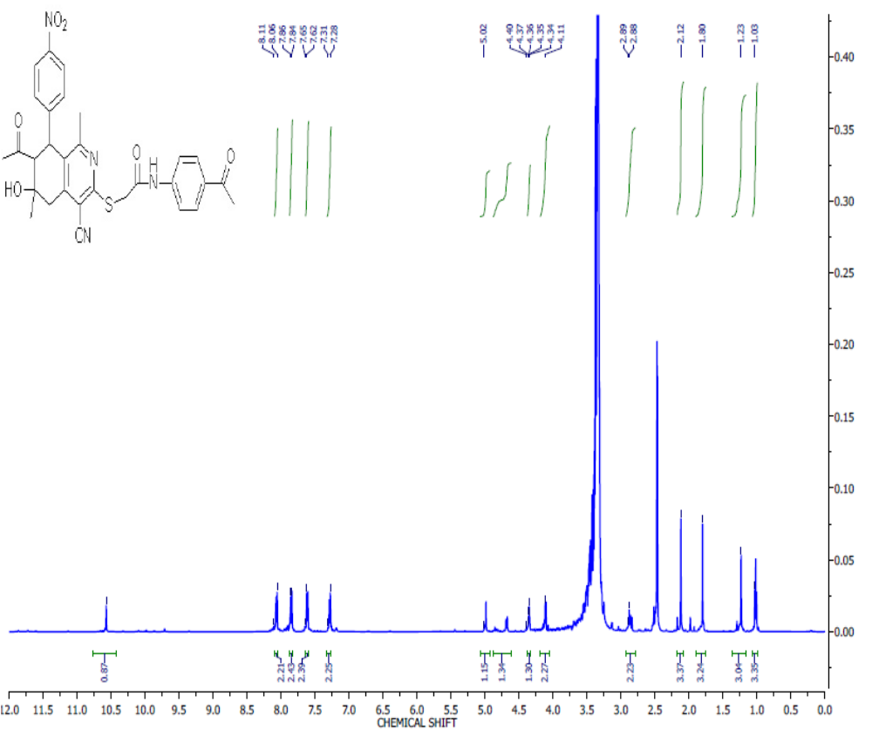
Figure S25: ¹H NMR spectrum of 2-[(7-Acetyl-4-cyano-1,6-dimethyl-6-hydroxy-8-(4-nitrophenyl)-5,6,7,8-tetrahydroisoquinolin-3-yl)thio]-N-(4-acetylphenyl)acetamide (8g).

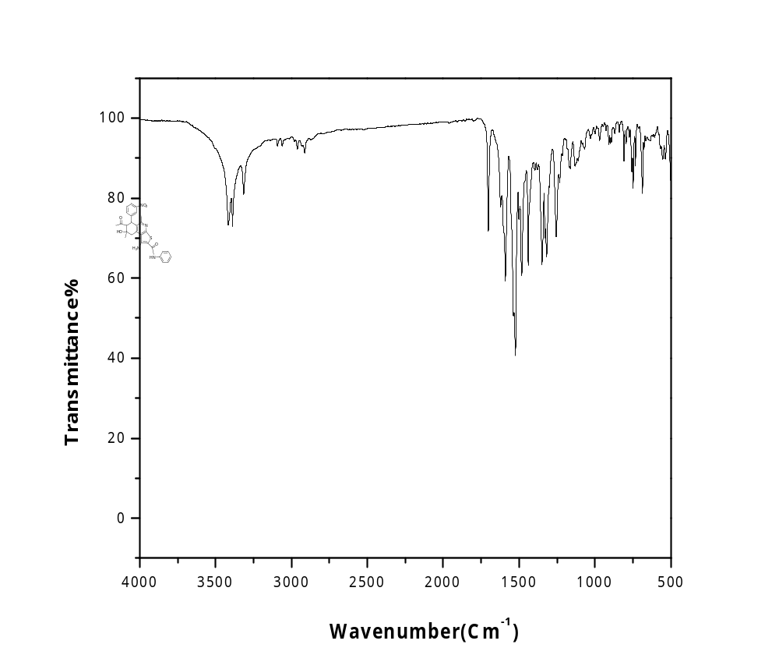
Figure S26: IR spectrum of 7-Acetyl-1-amino-5,8-dimethyl-8-hydroxy-6-(3-nitrophenyl)-N-phenyl-6,7,8,9-tetrahydrothieno[2,3-c]isoquinoline-2-carboxamide (9a).

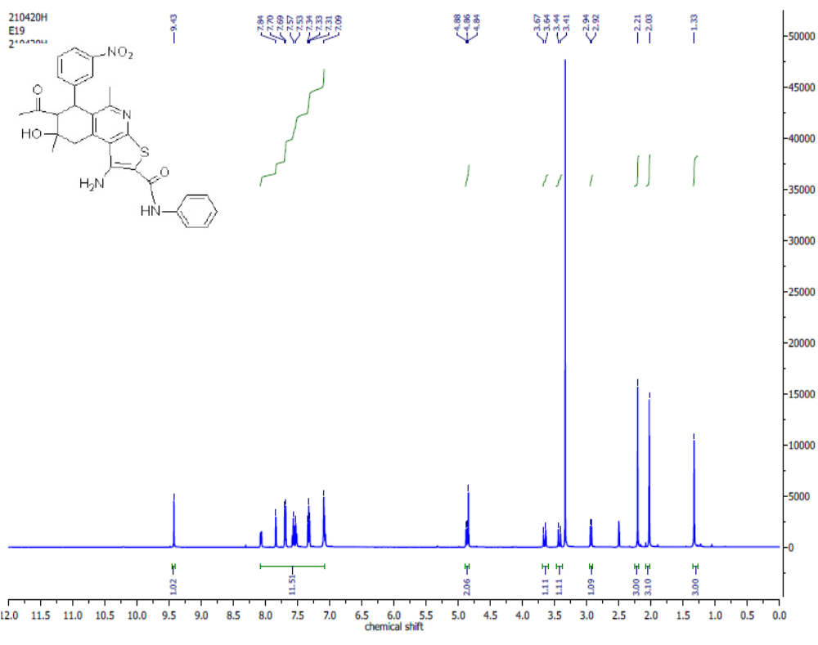Figure 27: ¹H NMR spectrum of 7-Acetyl-1-amino-5,8-dimethyl-8-hydroxy-6-(3-nitrophenyl)-N-phenyl-6,7,8,9-tetrahydrothieno[2,3-c]isoquinoline-2-carboxamide (9a).
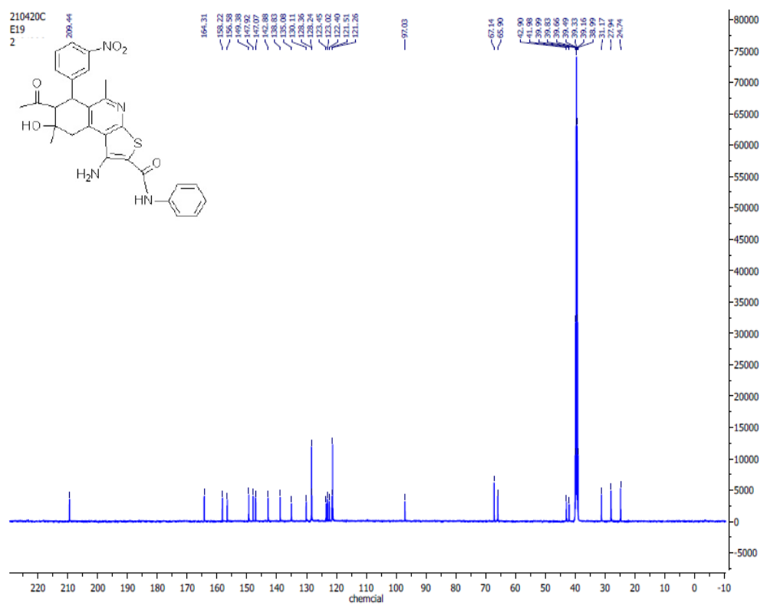Figure S28: ¹³C NMR spectrum of 7-Acetyl-1-amino-5,8-dimethyl-8-hydroxy-6-(3-nitrophenyl)-N-phenyl-6,7,8,9-tetrahydrothieno[2,3-c]isoquinoline-2-carboxamide (9a).

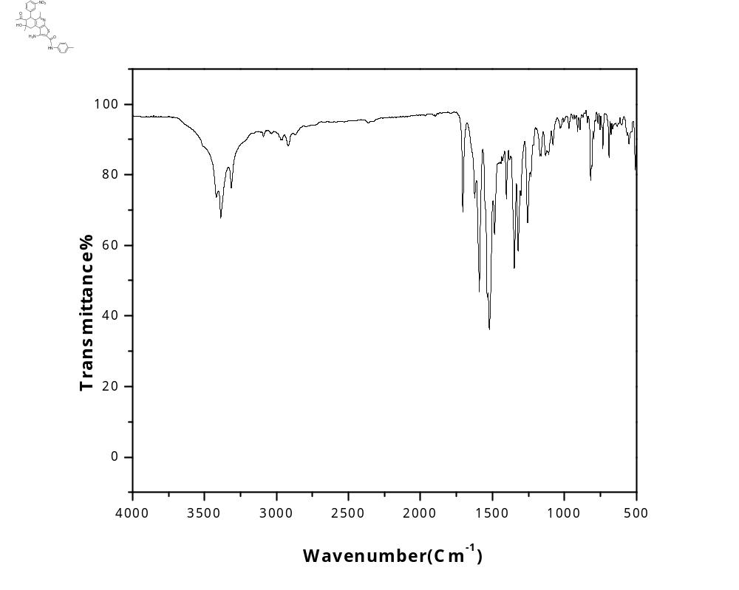
Figure S29: IR spectrum of 7-Acetyl-1-amino-5,8-dimethyl-8-hydroxy-6-(3-nitrophenyl)-N-(4-tolyl)-6,7,8,9-tetrahydrothieno[2,3-c]isoquinoline-2-carboxamide (9b).
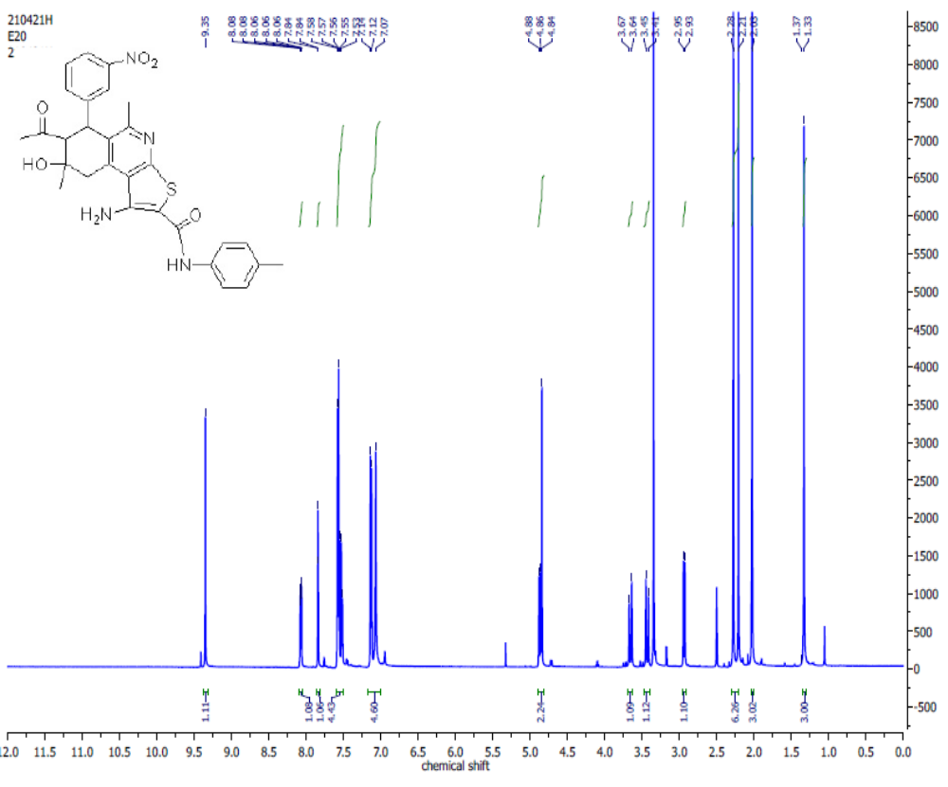Figure S30: ¹H NMR spectrum of 7-Acetyl-1-amino-5,8-dimethyl-8-hydroxy-6-(3-nitrophenyl)-N-(4-tolyl)-6,7,8,9-tetrahydrothieno[2,3-c]isoquinoline-2-carboxamide (9b).

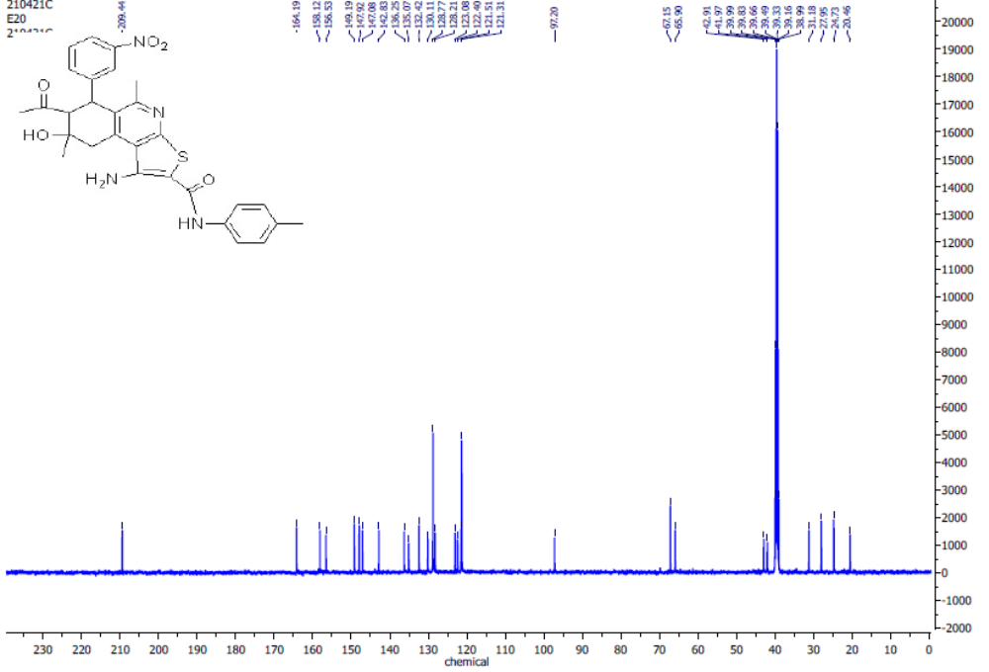Figure S31: ¹³C NMR spectrum of 7-Acetyl-1-amino-5,8-dimethyl-8-hydroxy-6-(3-nitrophenyl)-N-(4-tolyl)-6,7,8,9-tetrahydrothieno[2,3-c]isoquinoline-2-carboxamide (9b).

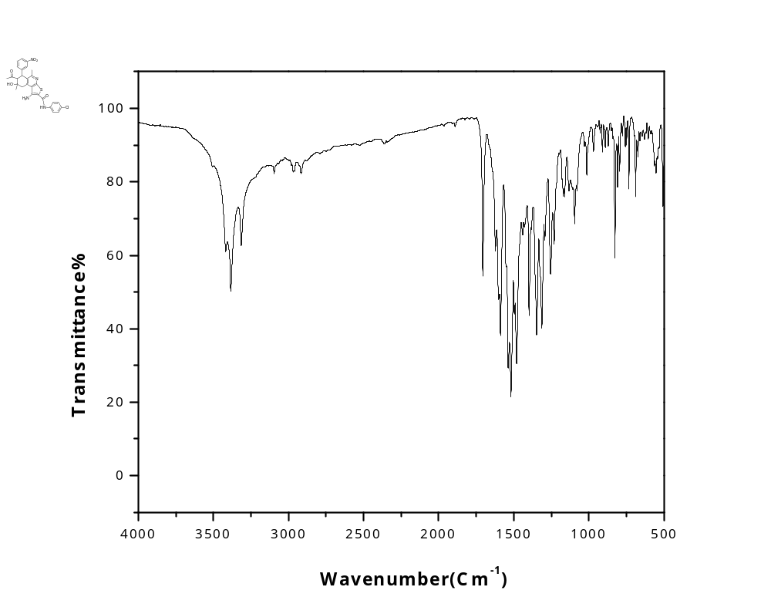
Figure S32: IR spectrum of 7-Acetyl-1-amino-N-(4-chlorophenyl)-5,8-dimethyl-8-hydroxy-6-(3-nitrophenyl)-6,7,8,9-tetrahydrothieno[2,3-c]isoquinoline-2-carboxamide (9c).
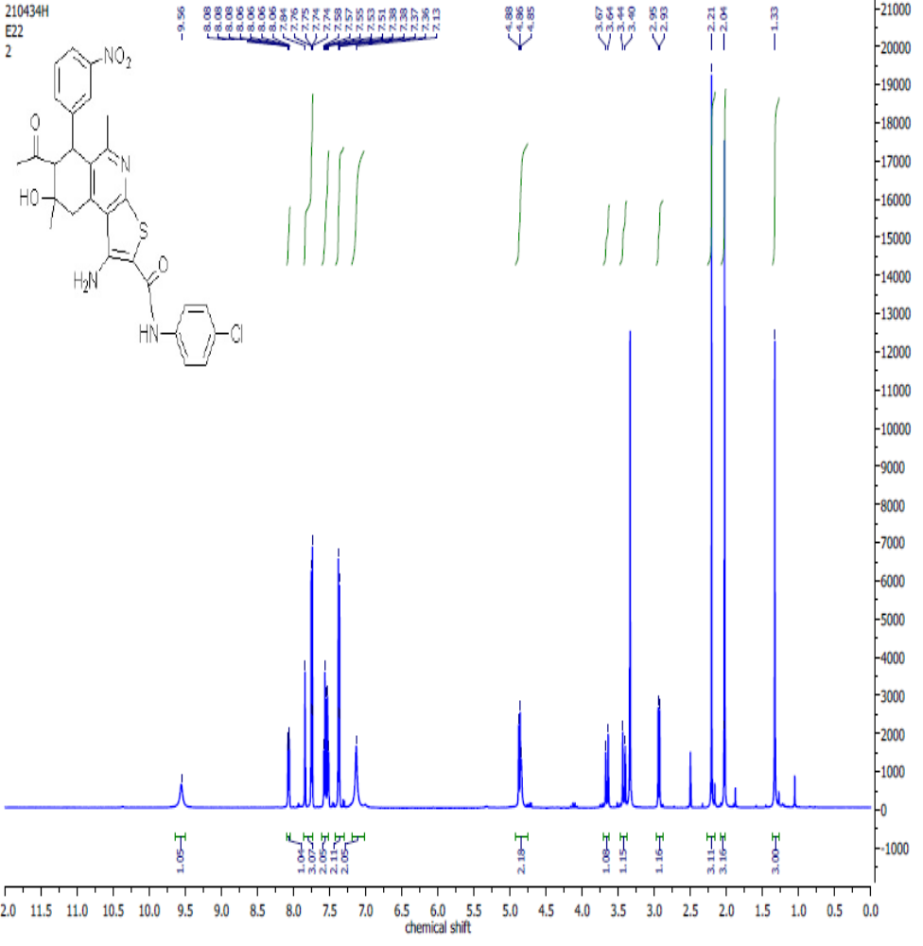 Figure S33:¹H NMR spectrum of 7-Acetyl-1-amino-N-(4-chlorophenyl)-5,8-dimethyl-8-hydroxy-6-(3-nitrophenyl)-6,7,8,9-tetrahydrothieno[2,3-c]isoquinoline-2-carboxamide (9c).
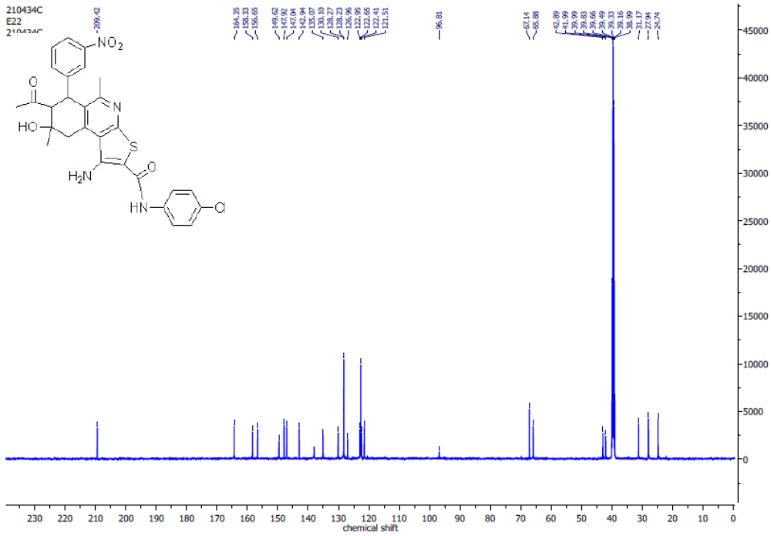
Figure S34: ¹³ C NMR spectrum of 7-Acetyl-1-amino-N-(4-chlorophenyl)-5,8-dimethyl-8-hydroxy-6-(3-nitrophenyl)-6,7,8,9-tetrahydrothieno[2,3-c]isoquinoline-2-carboxamide (9c).

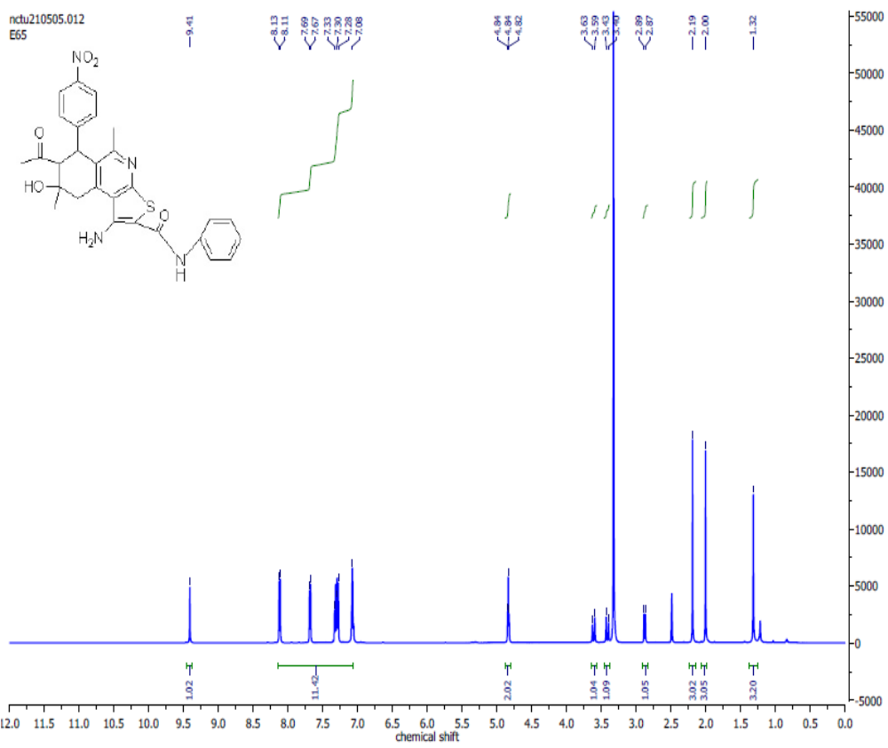Figure S35: ¹H NMR spectrum of 7-Acetyl-1-amino-5,8-dimethyl-8-hydroxy-6-(4-nitrophenyl)-N-phenyl-6,7,8,9-tetrahydrothieno[2,3-c]isoquinoline-2-carboxamide (9d).

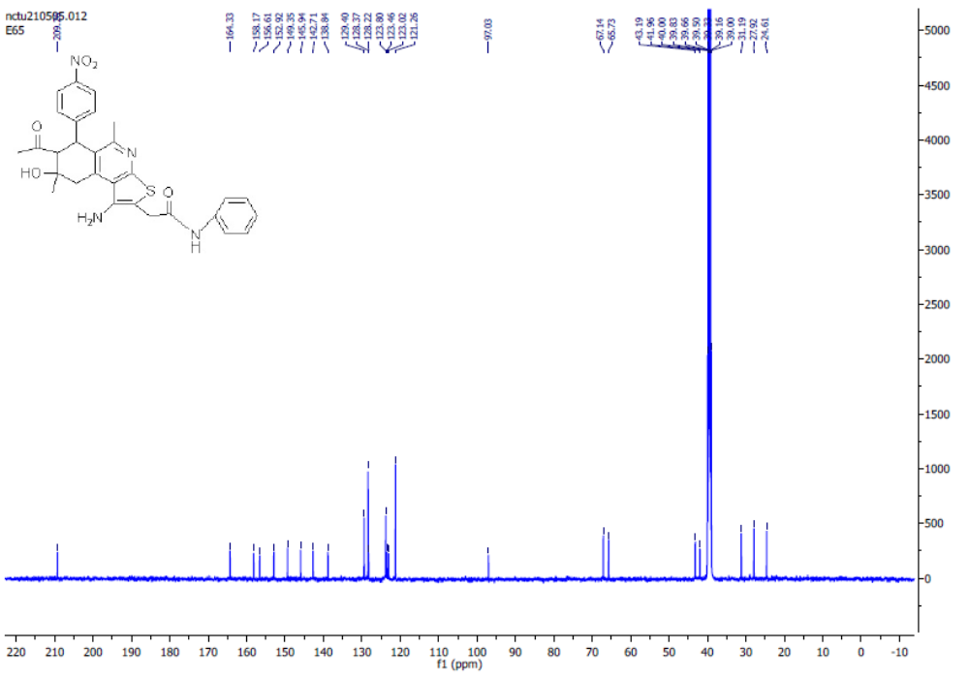
Figure S36: ¹³C NMR spectrum of 7-Acetyl-1-amino-5,8-dimethyl-8-hydroxy-6-(4-nitrophenyl)-N-phenyl-6,7,8,9-tetrahydrothieno[2,3-c]isoquinoline-2-carboxamide (9d).

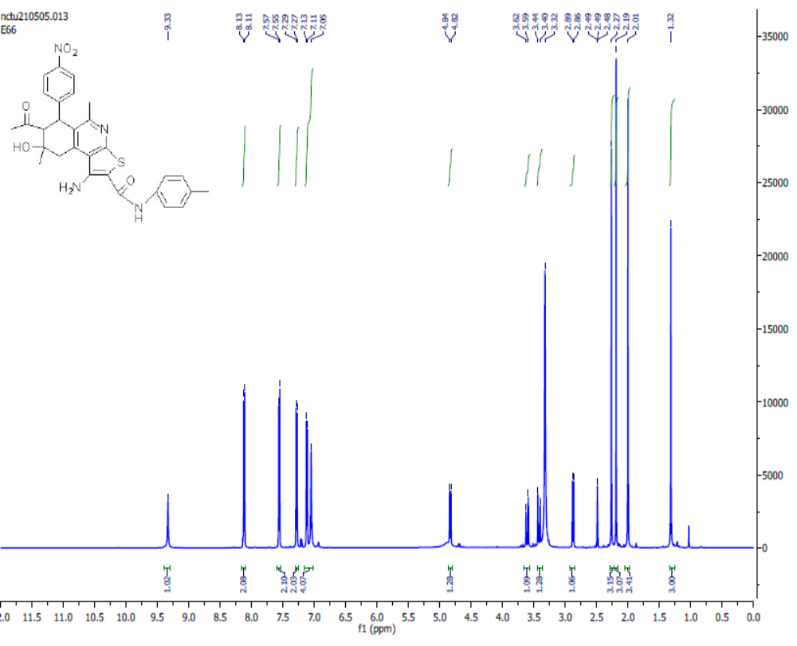Figure S37: ¹HNMR spectrum of 7-acetyl-1-amino-8-hydroxy-5,8-dimethyl-6-(4-nitrophenyl)-N-(p-tolyl)-6,7,8,9-tetrahydrothieno[2,3-c]isoquinoline-2-carboxamide(9e).

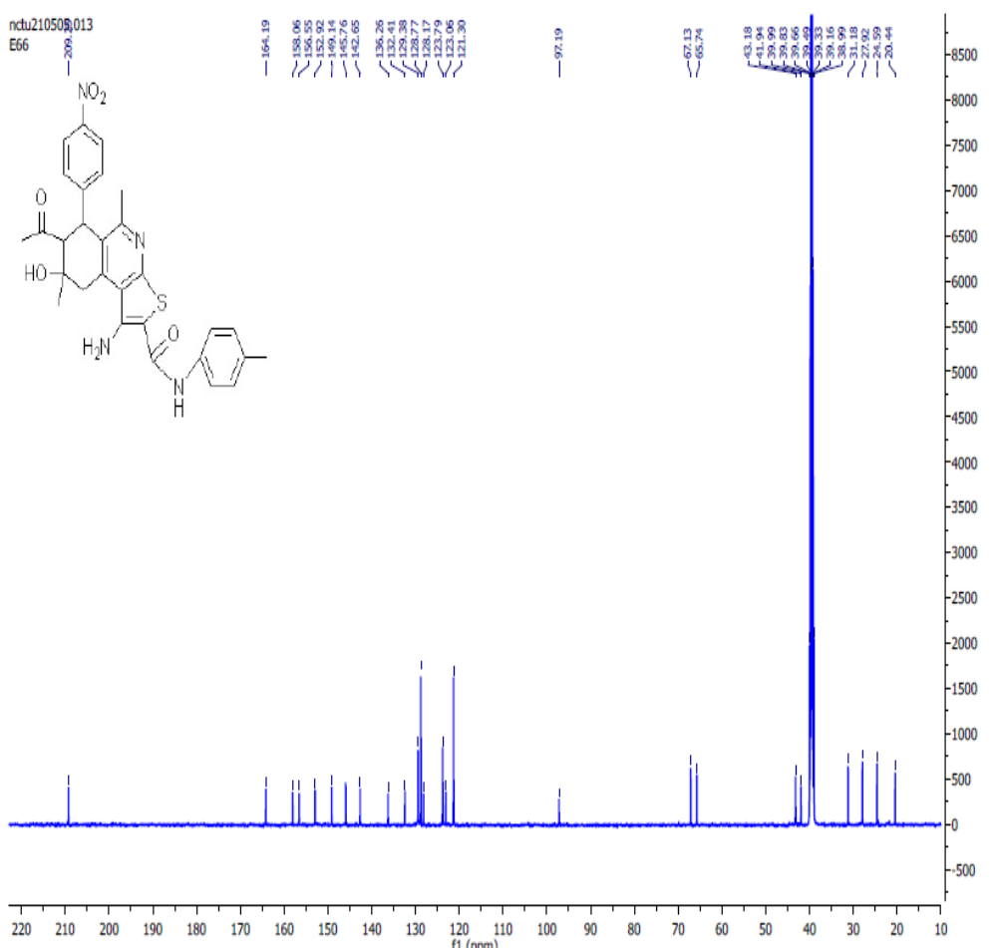Figure S38: ¹³ C NMR spectrum of 7-acetyl-1-amino-8-hydroxy-5,8-dimethyl-6-(4-nitrophenyl)-
N-(p-tolyl)-6,7,8,9-tetrahydrothieno[2,3-c]isoquinoline-2-carboxamide (9e).

