Sex-Specific Effects of GLP-1R Variants on BMI and Obesity Treatment Response

Luisa Sophie Rajcsanyi^{1,2,3}, Jasmin Schmidt^{1,4}, Aaron Novikoff^{5,6}, Ezgi Karaoglu^{5,6}, Callum Coupland^{5,6}, Tobias Hagemann⁷, Anne Hoffmann⁷, Peter Kovacs^{6,8}, Hans Hauner^{9,10}, Melina Claussnitzer^{11,12,13}, Christiane Krüger^{4,14}, Sebastian Martin Majorczyk^{4,15}, Nele Bohne^{1,4}, Anna-Lena Volckmar^{4,16}, Yiran Zheng^{1,4,17}, Johannes Hebebrand⁴, Triinu Peters^{1,2,3}, Matthias Blüher^{6,7,8}, Timo Dirk Müller^{5,6,18} and Anke Hinney^{1,2,3}

¹ Section of Molecular Genetics in Mental Disorders, LVR University Hospital Essen, University of Duisburg-Essen, Essen, Germany
² Institute for Sex- and Gender-Sensitive Medicine, University Hospital Essen, Essen, Germany
³ Center for Translational Neuro- and Behavioural Sciences, University Hospital Essen, Essen, Germany
⁴ Department of Child and Adolescent Psychiatry, Psychosomatics and Psychotherapy, University Hospital Essen, University of Duisburg-Essen, Essen, Germany
⁵ Institute for Diabetes and Obesity, Helmholtz Diabetes Center at Helmholtz Zentrum Munich, Neuherberg, Germany
⁶ German Center for Diabetes Research (DZD), Neuherberg, Germany
⁷ Helmholtz Institute for Metabolic, Obesity and Vascular Research (HI-MAG) of the Helmholtz Zentrum München at the University of Leipzig and University Hospital, Leipzig, Germany
⁸ Medical Department III – Endocrinology, Nephrology, Rheumatology, University of Leipzig Medical Center, University of Leipzig, Leipzig, Germany
⁹ Else Kröner-Fresenius-Center for Nutritional Medicine, School of Life Sciences, Technical University of Munich, Freising-Weihenstephan, Germany
¹⁰ Institute for Nutritional Medicine, School of Medicine and Health, Technical University of Munich, Munich, Germany
¹¹ Broad Institute of MIT and Harvard, Medical and Population Genetics Program & Broad Diabetes Initiative, Cambridge, MA, USA
¹² Novo Nordisk Foundation Center for Genomic Mechanisms of Disease, Broad Institute of MIT and Harvard, Cambridge, MA, USA
¹³ Diabetes Unit and Center for Genomic Medicine, Massachusetts General Hospital, Boston, MA, USA
¹⁴ Department of Neurology, Neurogeriatrics and Early Neurological Rehabilitation, EVK Wesel, Wesel, Germany
¹⁵ Department of Medical Oncology, West German Cancer Centre (WTZ), University Hospital Essen, Essen, Germany
¹⁶ Institute of Pathology, University Hospital Heidelberg, Heidelberg, Germany
¹⁷ Helmholtz Pioneer Campus, Helmholtz Zentrum Munich, Munich, Germany
¹⁸ Walther-Straub-Institute for Pharmacology and Toxicology, Ludwig-Maximillians-University Munich (LMU), Munich, Germany

Corresponding author:
Luisa Sophie Rajcsanyi, luisa.rajcsanyi@uk-essen.de

Supplementary Table 1: Variants in GLP-1R with a sex-specific effect on the BMI. The GWAS-based sex-specific analysis was based on publicly available data of a GWAS for BMI variance (Pulit et al., 2019).
Genetic variant | Position (GRCh37) | Tested Allele | Other Allele | Women + men |  |  | Women only |  |  | Men only |  |  | |z-score| | P for |z-score|
 |  |  |  | Freq.  Tested  Allele | BETA | P | Freq.  Tested  Allele | BETA | P | Freq.  Tested  Allele | BETA | P | |z-score| | P for |z-score|
rs1042044 | chr6:39041502 | A | C | 0.42 | -0.008 | 2.84E-06 | 0.42 | -0.003 | 0.137 | 0.421 | -0.013 | 2.12E-08 | 3.079 | 0.0021
rs2268644 | chr6:39044558 | C | G | 0.57 | 0.008 | 1.94E-06 | 0.57 | 0.004 | 0.121 | 0.572 | 0.014 | 2.27E-08 | 3.091 | 0.0020
rs877446 | chr6:39031039 | A | G | 0.43 | -0.009 | 2.89E-07 | 0.43 | -0.004 | 0.065 | 0.434 | -0.015 | 3.55E-09 | 3.120 | 0.0018
rs910163 | chr6:39033420 | A | G | 0.45 | -0.007 | 1.74E-05 | 0.45 | -0.003 | 0.226 | 0.446 | -0.014 | 4.37E-08 | 3.209 | 0.0013
rs910162 | chr6:39033427 | A | T | 0.45 | -0.007 | 1.89E-05 | 0.45 | -0.003 | 0.230 | 0.446 | -0.014 | 4.76E-08 | 3.209 | 0.0013
rs2300616 | chr6:39039458 | C | G | 0.56 | 0.007 | 1.71E-05 | 0.57 | 0.003 | 0.213 | 0.566 | 0.014 | 4.20E-08 | 3.209 | 0.0013
rs910170 | chr6:39032415 | A | G | 0.45 | -0.008 | 3.57E-06 | 0.45 | -0.003 | 0.171 | 0.447 | -0.015 | 5.10E-09 | 3.385 | 0.0007
rs2254336 | chr6:39032835 | A | T | 0.48 | -0.008 | 2.78E-06 | 0.48 | -0.004 | 0.132 | 0.476 | -0.015 | 3.33E-09 | 3.385 | 0.0007
rs910165 | chr6:39033180 | A | G | 0.51 | 0.007 | 3.10E-05 | 0.51 | 0.002 | 0.420 | 0.510 | 0.014 | 8.14E-09 | 3.709 | 0.0002

Supplementary Table 2: r² values for the GLP-1R variants with sex-specific BMI effects in the CEU population. The data was returned by LDMatrix applying the CEU population from the 1000 Genomes Project with the GRCh38 genome build.
Variant ID | rs877446 | rs910170 | rs2254336 | rs910165 | rs910163 | rs910162 | rs2300616 | rs1042044 | rs2268644
rs877446 | 1.0 | 0.941 | 0.868 | 0.83 | 0.882 | 0.882 | 0.863 | 0.882 | 0.882
rs910170 | 0.941 | 1.0 | 0.922 | 0.884 | 0.941 | 0.941 | 0.922 | 0.903 | 0.903
rs2254336 | 0.868 | 0.922 | 1.0 | 0.808 | 0.868 | 0.868 | 0.85 | 0.833 | 0.833
rs910165 | 0.83 | 0.884 | 0.808 | 1.0 | 0.868 | 0.868 | 0.85 | 0.833 | 0.833
rs910163 | 0.882 | 0.941 | 0.868 | 0.868 | 1.0 | 1.0 | 0.98 | 0.96 | 0.96
rs910162 | 0.882 | 0.941 | 0.868 | 0.868 | 1.0 | 1.0 | 0.98 | 0.96 | 0.96
rs2300616 | 0.863 | 0.922 | 0.85 | 0.85 | 0.98 | 0.98 | 1.0 | 0.98 | 0.98
rs1042044 | 0.882 | 0.903 | 0.833 | 0.833 | 0.96 | 0.96 | 0.98 | 1.0 | 1.0
rs2268644 | 0.882 | 0.903 | 0.833 | 0.833 | 0.96 | 0.96 | 0.98 | 1.0 | 1.0

Supplementary Table 3: r² values of the GLP-1R variants with sex-specific BMI effects in the GBR population. The data was returned by LDMatrix applying the GBR population from the 1000 Genomes Project with the GRCh38 genome build.
Variant ID | rs877446 | rs910170 | rs2254336 | rs910165 | rs910163 | rs910162 | rs2300616 | rs1042044 | rs2268644
rs877446 | 1.0 | 0.978 | 0.856 | 0.854 | 0.934 | 0.934 | 0.956 | 0.978 | 0.956
rs910170 | 0.978 | 1.0 | 0.876 | 0.873 | 0.956 | 0.956 | 0.978 | 0.956 | 0.935
rs2254336 | 0.856 | 0.876 | 1.0 | 0.792 | 0.876 | 0.876 | 0.856 | 0.838 | 0.819
rs910165 | 0.854 | 0.873 | 0.792 | 1.0 | 0.915 | 0.915 | 0.895 | 0.875 | 0.856
rs910163 | 0.934 | 0.956 | 0.876 | 0.915 | 1.0 | 1.0 | 0.978 | 0.956 | 0.935
rs910162 | 0.934 | 0.956 | 0.876 | 0.915 | 1.0 | 1.0 | 0.978 | 0.956 | 0.935
rs2300616 | 0.956 | 0.978 | 0.856 | 0.895 | 0.978 | 0.978 | 1.0 | 0.978 | 0.956
rs1042044 | 0.978 | 0.956 | 0.838 | 0.875 | 0.956 | 0.956 | 0.978 | 1.0 | 0.978
rs2268644 | 0.956 | 0.935 | 0.819 | 0.856 | 0.935 | 0.935 | 0.956 | 0.978 | 1.0

Supplementary Table 4: Results of TWL% GWAS for three GLP-1R variants.
Variant | Reference allele | Alternative allele | Cohort | N | AF | Call rate | N hom ref | N het | N hom alt | Effect size* | p-value
rs1042044 | A | C | Total | 807 | 0.55 | 1 | 161 | 404 | 242 | 0.07 | 0.16
rs1042044 | A | C | Females | 543 | 0.55 | 1 | 99 | 284 | 160 | 0.09 | 0.13
rs1042044 | A | C | Males | NA | NA | NA | NA | NA | NA | NA | NA
rs910170 | A | G | Total | 807 | 0.53 | 1 | 184 | 386 | 237 | 0.08 | 0.10
rs910170 | A | G | Females | 543 | 0.53 | 1 | 112 | 280 | 151 | 0.09 | 0.17
rs910170 | A | G | Males | NA | NA | NA | NA | NA | NA | NA | NA
rs10305420 | C | T | Total | 807 | 0.35 | 1 | 332 | 374 | 101 | 0.008 | 0.88
rs10305420 | C | T | Females | 543 | 0.34 | 1 | 223 | 258 | 62 | 0.005 | 0.94
rs10305420 | C | T | Males | NA | NA | NA | NA | NA | NA | NA | NA
GWAS was calculated for total weight loss percentage (TWL%) for a total cohort (females + males) and sex-stratified groups of 807 patients of the Leipzig Obesity BioBank. Covariates included in the model were sex, age, type of bariatric surgery and technical batch. *The stated effect size refers to the alternative allele. AF = allele frequency. Alt = alternative allele. N = number of samples. NA = not available. Ref = reference allele.

Supplementary Table 5: Allele frequencies and genotype distributions of rs1042044 in men who underwent bariatric surgery.
TWL% cutoff | N  (res: non-res) | MAF | Responder* |  |  | Non-responder* |  |  | P-value
TWL% cutoff | N  (res: non-res) | MAF | AA | CA/AC | CC | AA | CA/AC | CC | P-value
> 10% | 257:7 | A: 0.46 | 61  (0.24) | 115  (0.45) | 81  (0.32) | 1  (0.14) | 5  (0.71) | 1  (0.14) | 0.54
> 15% | 242:22 | A: 0.46 | 58  (0.24) | 107  (0.44) | 77  (0.32) | 4  (0.19) | 13  (0.59) | 5  (0.23) | 0.41
> 20% | 215:49 | A: 0.47 | 52  (0.24) | 99  (0.46) | 64  (0.30) | 10  (0.20) | 21  (0.43) | 18  (0.38) | 0.62
> 40% | 14:250 | A: 0.43 | 4  (0.20) | 4  (0.45) | 6  (0.35) | 58  (0.26) | 116  (0.46) | 76  (0.29) | 0.42
Top 100 TWL% | 100:164 | A: 0.43 | 20  (0.29) | 45  (0.29) | 35  (0.43) | 52  (0.23) | 75  (0.46) | 47  (0.30) | 0.15
Here, only men are included. *The total number of samples with a respective genotype is presented. The corresponding allele frequency is shown in parenthesis. P-values correspond to the Chi-square or Fisher-Freeman-Halton test. N = number of samples. MAF = minor allele frequency. TWL% = total weight loss percentage. Res = responder. Non-res = non-responder.

Supplementary Table 6: Allele frequencies and genotype distributions of rs1042044 in women who underwent bariatric surgery.
TWL% cutoff | N  (res:non-res) | MAF | Responder* |  |  | Non-responder* |  |  | P-value
TWL% cutoff | N  (res:non-res) | MAF | AA | CA/AC | CC | AA | CA/AC | CC | P-value
> 10% | 531:12 | A: 0.44 | 92  (0.17) | 280  (0.53) | 159  (0.30) | 7  (0.58) | 4  (0.33) | 1  (0.08) | 0.004
> 15% | 516:27 | A: 0.44 | 90  (0.17) | 270  (0.52) | 156  (0.30) | 9  (0.33) | 14  (0.51) | 4  (0.14) | 0.06
> 20% | 470:73 | A: 0.44 | 81  (0.17) | 248  (0.53) | 141  (0.30) | 18  (0.25) | 36  (0.49) | 19  (0.26) | 0.30
> 40% | 42:501 | A: 0.38 | 6  (0.14) | 20  (0.53) | 16  (0.33) | 93  (0.19) | 264  (0.52) | 144  (0.29) | 0.42
Top 100 TWL% | 100:443 | A: 0.41 | 14  (0.14) | 53  (0.48) | 33  (0.48) | 85  (0.19) | 231  (0.53) | 127  (0.29) | 0.42
Here, only women are included. *The total number of samples with a respective genotype is presented. The corresponding allele frequency is shown in parenthesis. N = number of samples. MAF = minor allele frequency. TWL% = total weight loss percentage. Res = responder. Non-res = non-responder.

Supplementary Table 7: Maximal (E_{max}) effects of GLP-1(7-36)amide and semaglutide on GLP-1-R internalization as measured by a BRET assay.
Agonist | E_{max} | pEC50 | EC50
Agonist | mean ± SEM | pEC50 | EC50
Agonist | mean ± SEM | mean ± SEM | EC50
Native GLP-1-R w/ GLP-1 (7-36) amide | 5.086 ± 0.4011 | -6.531 ± 0.1523 | 2.943*e⁻⁷
Native GLP-1-R w/ semaglutide | 4.746 ± 0.3174 | -6.490 ± 0.1268 | 3.237*e⁻⁷
Mutant GLP-1-R w/ GLP-1 (7-36) amide | 5.024 ± 0.3778 | -6.501 ± 0.1433 | 3.153*e⁻⁷
Mutant GLP-1-R w/ semaglutide | 4.572 ± 0.2959 | -6.451 ± 0.1206 | 3.538*e⁻⁷
Data were generated in cells transiently transfected to express either native or mutant (p.Leu260Phe) GLP-1-R. The presented values were generated from dose-response values fitted to sigmoidal curves applying a three-parameter non-linear logistic regression in GraphPad’s Prism. Data is expressed as mean ± SEM from at least three independent experiments with at least two replicates.

Supplementary Table 8: Genetic variants within GIP, GIP-R, GCG, GCG-R and GLP-1R identified in women.
Gene | Variant | Chromosomal position (GRCh38) | Consequence | Allele 1 | Allele 2 | Women with obesity (n = 48) |  |  |  | Healthy, lean women  (n = 38)
 |  |  |  |  |  | 11 | 12 | 22 | MAF | 11 | 12 | 22 | MAF
GIPs | rs2291725 | chr17: 48961770 | Ser103Gly | A | G | AA: 9 | AG:23 | GG:16 | 42.7% | AA:14 | AG:17 | GG: 7 | 40.79%
GIP-R | rs191937467 | chr19: 45674137 | Ala150Thr | G | A | 48 | 0 | 0 | 0% | 38 | 0 | 0 | 0%
GIP-R | rs139215588 | chr19: 45674762 | Arg190Gln | G | A | 48 | 0 | 0 | 0% | 37 | 1 | 0 | 1.32%
GIP-R | rs1800436 | chr19: 45674813 | Ala207Val | C | T | 48 | 0 | 0 | 0% | 37 | 1 | 0 | 1.32%
GIP-R | rs1800437 | chr19: 45678134 | Glu354Gln | G | C | GG:39 | GC:9 | CC:0 | 9.38% | GG:17 | GC:18 | CC:3 | 31.58%
GIP-R | rs137944672 | chr19: 45678220 | Ser321= | C | T | 48 | 0 | 0 | 0% | 38 | 0 | 0 | 0%
GIP-R | rs776722055 | chr19: 45681819 | Arg429Trp | C | T | 48 | 0 | 0 | 0% | 38 | 0 | 0 | 0%
GCG | rs5645 | chr2: 162149164 | Tyr5= | C | T | 44 | 4 | 0 | 4.17% | 36 | 2 | 0 | 2.63%
GCG-R | rs1801483 | chr17:81809839 | Gly40Ser | G | A | 47 | 1 | 0 | 1.04% | 35 | 3 | 0 | 3.95%
GCG-R | rs189736697 | chr17:81810888 | Thr76Met | C | T | 48 | 0 | 0 | 0% | 37 | 1 | 0 | 1.32%
GCG-R | rs5386 | chr17:81811293 | Ala155= | C | G | 39 | 7 | 2 | 11.46% | 26 | 11 | 1 | 17.11%
GCG-R | rs781413720 | chr17:81811699 | Val236Met | G | A | 47 | 1 | 0 | 1.04% | 38 | 0 | 0 | 0%
GCG-R | rs368152053 | chr17:81811803 | Ile270= | C | T | 48 | 0 | 0 | 0% | 37 | 1 | 0 | 1.32%
GCG-R | rs5384 | chr17:81812864 | Phe365= | C | T | 30 | 16 | 2 | 20.83% | 27 | 10 | 1 | 15.79%
GCG-R | rs545914836 | chr17:81813568 | Ser438Leu | C | T | 47 | 1 | 0 | 1.04% | 38 | 0 | 0 | 0%
GCG-R | rs183571856 | chr17:81813573 | Gly440Ser | G | A | 47 | 1 | 0 | 1.04% | 38 | 0 | 0 | 0%
GCG-R | rs138492107 | chr17:81813627 | Asp458His | G | C | 48 | 0 | 0 | 0% | 38 | 0 | 0 | 0%
GLP-1R | rs10305420* | chr6: 39048860 | Pro7Leu | C | T | CC:25 | CT:16 | TT:7 | 31.25% | CC:15 | CT:15 | TT:8 | 40.79%
GLP-1R | rs3765468 | chr6: 39065817 | Lys130= | G | A | 47 | 1 | 0 | 1.04% | 29 | 8 | 1 | 13.16%
GLP-1R | rs6918287 | chr6: 39065826 | Glu133= | A | G | 47 | 1 | 0 | 1.04% | 35 | 3 | 0 | 3.95%
GLP-1R | rs61754624 | chr6: 39066295 | Leu167= | C | T | 48 | 0 | 0 | 0% | 37 | 1 | 0 | 1.32%
GLP-1R | rs6923761 | chr6: 39066296 | Gly168Ser | G | A | GG:23 | GA:21 | AA:4 | 40.63% | GG:16 | GA:17 | AA:5 | 35.53%
GLP-1R | rs2235868 | chr6: 39072878 | Arg176= | A | C | AA: 13 | AC:26 | CC:9 | 45.83% | AA: 8 | AC:21 | CC:9 | 48.68%
GLP-1R | rs1042044* | chr6: 39073726 | Leu260Phe | A | C | AA: 10 | AC: 28 | CC:10 | 50% | AA: 7 | AC:22 | CC:9 | 47.37%
GLP-1R | rs10305492 | chr6: 39079018 | Ala316Thr | G | A | 47 | 1 | 0 | 1.04% | 38 | 0 | 0 | 0%
GLP-1R | rs1126476 | chr6: 39080715 | Ile400= | A | C | AA: 14 | AC: 28 | CC: 6 | 41.67% | AA: 9 | AC:20 | CC:9 | 50%
Women with obesity (n = 48) have been selected based on their genotype of rs2302382, an intronic variant in GIP-R (Vogel et al., 2009). All non-synonymous variants detected in women are marked in yellow. Of note, variants detected only in men are represented in italics. *These variants were additionally genotyped in 777 children and adolescents with severe obesity and both biological parents (see Table 5).

Supplementary Table 9: Variants within GIP, GIP-R, GCG, GCG-R and GLP-1R identified in men.
Gene | Variant | Chromosomal position (GRCh38) | Consequence | Allele 1 | Allele 2 | Men with obesity (n = 46) |  |  |  | Healthy, lean men  (n = 58)
 |  |  |  |  |  | 11 | 12 | 22 | MAF | 11 | 12 | 22 | MAF
GIP | rs2291725 | chr17: 48961770 | Ser103Gly | A | G | AA: 15 | AG:22 | GG:9 | 43.48% | AA: 15 | AG:23 | GG:20 | 45.69%
GIP-R | rs191937467 | chr19: 45674137 | Ala150Thr | G | A | 45 | 1 | 0 | 1.09% | 58 | 0 | 0 | 0%
GIP-R | rs139215588 | chr19: 45674762 | Arg190Gln | G | A | 46 | 0 | 0 | 0% | 58 | 0 | 0 | 0%
GIP-R | rs1800436 | chr19: 45674813 | Ala207Val | C | T | 46 | 0 | 0 | 0% | 58 | 0 | 0 | 0%
GIP-R | rs1800437 | chr19: 45678134 | Glu354Gln | G | C | GG:36 | GC:10 | CC:0 | 10.87% | GG:33 | GC:17 | CC:8 | 28.45%
GIP-R | rs137944672 | chr19: 45678220 | Ser321= | C | T | 45 | 1 | 0 | 1.09% | 58 | 0 | 0 | 0%
GIP-R | rs776722055 | chr19: 45681819 | Arg429Trp | C | T | 46 | 0 | 0 | 0% | 57 | 1 | 0 | 0.86%
GCG | rs5645 | chr2: 162149164 | Tyr5= | C | T | 45 | 1 | 0 | 1.09% | 55 | 3 | 0 | 2.57%
GCG-R | rs1801483 | chr17:81809839 | Gly40Ser | G | A | 44 | 2 | 0 | 2.17% | 56 | 2 | 0 | 1.72%
GCG-R | rs189736697 | chr17:81810888 | Thr76Met | C | T | 43 | 3 | 0 | 3.26% | 58 | 0 | 0 | 0%
GCG-R | rs5386 | chr17:81811293 | Ala155= | C | G | 38 | 8 | 0 | 8.70% | 50 | 6 | 2 | 8.62%
GCG-R | rs781413720 | chr17:81811699 | Val236Met | G | A | 46 | 0 | 0 | 0% | 58 | 0 | 0 | 0%
GCG-R | rs368152053 | chr17:81811803 | Ile270= | C | T | 45 | 1 | 0 | 1.09% | 58 | 0 | 0 | 0%
GCG-R | rs5384 | chr17:81812864 | Phe365= | C | T | 33 | 10 | 3 | 17.39% | 35 | 22 | 1 | 20.69%
GCG-R | rs545914836 | chr17:81813568 | Ser438Leu | C | T | 46 | 0 | 0 | 0% | 58 | 0 | 0 | 0%
GCG-R | rs183571856 | chr17:81813573 | Gly440Ser | G | A | 46 | 0 | 0 | 0% | 58 | 0 | 0 | 0%
GCG-R | rs138492107 | chr17:81813627 | Asp458His | G | C | 46 | 0 | 0 | 0% | 57 | 1 | 0 | 0.86%
GLP-1R | rs10305420* | chr6: 39048860 | Pro7Leu | C | T | CC:24 | CT:17 | TT:5 | 29.35% | CC:25 | CT: 21 | TT: 12 | 38.79%
GLP-1R | rs3765468 | chr6: 39065817 | Lys130= | G | A | 39 | 6 | 1 | 8.70% | 46 | 12 | 0 | 10.34%
GLP-1R | rs6918287 | chr6: 39065826 | Glu133= | A | G | 45 | 1 | 0 | 1.09% | 58 | 0 | 0 | 0%
GLP-1R | rs61754624 | chr6: 39066295 | Leu167= | C | T | 46 | 0 | 0 | 0% | 58 | 0 | 0 | 0%
GLP-1R | rs6923761 | chr6: 39066296 | Gly168Ser | G | A | GG:27 | GA:14 | AA:5 | 26.09% | GG:28 | GA:19 | AA:11 | 35.34%
GLP-1R | rs2235868 | chr6: 39072878 | Arg176= | A | C | AA: 13 | AC:24 | CC:9 | 45.65% | AA: 12 | AC:28 | CC:18 | 20.69%
GLP-1R | rs1042044* | chr6: 39073726 | Leu260Phe | A | C | AA: 9 | AC:25 | CC:12 | 46.74% | AA: 10 | AC:30 | CC:18 | 43.10%
GLP-1R | rs10305492 | chr6: 39079018 | Ala316Thr | G | A | 45 | 1 | 0 | 1.09% | 57 | 1 | 0 | 0.86%
GLP-1R | rs1126476 | chr6: 39080715 | Ile400= | A | C | AA: 16 | AC:22 | CC:8 | 41.30% | AA: 13 | AC:26 | CC:19 | 44.83%
Men with obesity (n = 46) have been selected based on their genotype of rs2302382, an intronic variant in GIP-R (Vogel et al., 2009). All non-synonymous variants detected in men are marked in yellow. Of note, variants detected only in women are represented in italics. *These SNPs were additionally genotyped in 777 children and adolescents with severe obesity and both biological parents (see Table 5).

Supplementary Table 10: Results of the in silico analyses.
Gene | Variant | Con-sequence | Mutation-Taster2021 |  |  | Variant Effect Predictor |  |  | PolyPhen2
Gene | Variant | Con-sequence | Prediction | phyloP | PhastCons | SIFT | SpliceAI | AlphaMissense | PolyPhen2
GIP | rs2291725 | Ser103Gly | Benign | -0.895 | 0 | tolerated | No changes | Likely benign | Benign
GIP-R | rs191937467 | Ala150Thr | Benign | 2.374 | 0.998 | tolerated | Decreased probability by 0.06 for donor loss 40 bases downstream | Likely benign | Benign
GIP-R | rs139215588 | Arg190Gln | Benign | 1.453 | 0.236 | tolerated | No changes | Likely benign | Probably damaging
GIP-R | rs1800436 | Ala207Val | Benign | -0.412 | 0 | tolerated | Decreased probability by 0.03 for a splice donor 13 bases downstream | Likely benign | Benign
GIP-R | rs1800437 | Glu354Gln | Benign | 2.231 | 1 | probably damaging | Increased probability by 0.01 for a splice donor 2 bases downstream | Ambiguous | Probably damaging
 |  |  |  |  |  |  | Increased probability by 0.43 for a splice acceptor 25 bases downstream | Ambiguous | Probably damaging
GIP-R | rs137944672 | Ser321= | Benign | 0.123 | 0.997 | / | No changes | / | /
GIP-R | rs776722055 | Arg429Trp | Benign | -0.052 | 0.001 | deleterious | No changes | Likely benign | Probably damaging
GCG | rs5645 | Tyr5= | Deleterious | 1.708 | 1 | / | Decreased probability by 0.04 for splice donor 13 bases downstream | / | /
GCG-R | rs1801483 | Gly40Ser | Benign | 0.13 | 0.057 | tolerated | Increased probability by 0.02 for splice acceptor 36 bases upstream | Likely benign | Benign
GCG-R | rs189736697 | Thr76Met | Benign | 1.795 | 0.948 | deleterious | No changes | Likely benign | Probably damaging
GCG-R | rs5386 | Ala155= | Benign | -0.03 | 0.99 | / | No changes | / | /
GCG-R | rs781413720 | Val236Met | Benign | 1.283 | 0.875 | tolerated | Decreased probability by 0.01 for splice acceptor 48 bases upstream | Likely benign | Benign
GCG-R | rs368152053 | Ile270= | Benign | 0.352 | 0.999 | / | No changes | / | /
GCG-R | rs5384 | Phe365= | Benign | -0.105 | 0.975 | / | No changes | / | /
GCG-R | rs545914836 | Ser438Leu | Benign | 0.066 | 0 | tolerated | No changes | Likely benign | Benign
GCG-R | rs183571856 | Gly440Ser | Benign | -2.817 | 0 | tolerated | Increased probability by 0.02 for splice acceptor 2 bases upstream | Likely benign | Benign
GCG-R | rs138492107 | Asp458His | Benign | 0.47 | 0.011 | deleterious | No changes | Likely benign | Probably damaging
GLP-1R | rs10305420 | Pro7Leu | Benign | 0.258 | 0.06 | tolerated low confidence | No changes | Likely benign | Benign
GLP-1R | rs3765468 | Lys130= | Benign | 0.258 | 0.874 | / | No changes | / | /
GLP-1R | rs6918287 | Glu133= | Benign | -0.033 | 0.552 | / | Decreased probability by 0.09 for splice donor 3 bases downstream | / | /
GLP-1R | rs61754624 | Leu167= | Benign | -1.968 | 0 | / | No changes | / | /
GLP-1R | rs6923761 | Gly168Ser | Benign | -0.366 | 0.003 | tolerated | No changes | Likely benign | Benign
GLP-1R | rs2235868 | Arg176= | Benign | 1.397 | 1 | / | No changes | / | /
GLP-1R | rs1042044 | Leu260Phe | Benign | 0.512 | 0.998 | tolerated | Increased probability by 0.02 for splice acceptor 27 bases downstream | Likely benign | Benign
GLP-1R | rs10305492 | Ala316Thr | Benign | 5.226 | 1 | deleterious | No changes | Likely benign | Benign
GLP-1R | rs1126476 | Ile400= | Benign | 0.829 | 0.993 | / | Increased probability by 0.07 for splice donor 24 bases downstream | / | /
In silico analyses were performed for allele 2 (see Table 3, see Supplementary Tables 8 and 9).

Supplementary Table 11: r² values of the GLP-1R variants detected within the mutation screen and GWAS-based sex-specific analyses in the CEU population. The data was returned by LDMatrix applying the CEU population from the 1000 Genomes Project with the GRCh38 genome build. Variants with a sex-specific effect on the BMI are marked in yellow.
Variant ID | rs10305420 | rs877446 | rs910170 | rs2254336 | rs910165 | rs910163 | rs910162 | rs3765468 | rs6918287 | rs61754624 | rs6923761 | rs2300616 | rs2235868 | rs1042044 | rs2268644 | rs10305492 | rs1126476
rs10305420 | 1 | 0.026 | 0.028 | 0.039 | 0.025 | 0.026 | 0.026 | 0.034 | 0.003 | NA | 0.097 | 0.024 | 0.024 | 0.022 | 0.022 | 0.032 | 0.029
rs877446 | 0.026 | 1 | 0.941 | 0.868 | 0.83 | 0.882 | 0.882 | 0.085 | 0.006 | NA | 0.409 | 0.863 | 0.809 | 0.882 | 0.882 | 0.018 | 0.775
rs910170 | 0.028 | 0.941 | 1 | 0.922 | 0.884 | 0.941 | 0.941 | 0.09 | 0.006 | NA | 0.437 | 0.922 | 0.826 | 0.903 | 0.903 | 0.019 | 0.791
rs2254336 | 0.039 | 0.868 | 0.922 | 1 | 0.808 | 0.868 | 0.868 | 0.098 | 0.005 | NA | 0.366 | 0.85 | 0.755 | 0.833 | 0.833 | 0.02 | 0.72
rs910165 | 0.025 | 0.83 | 0.884 | 0.808 | 1 | 0.868 | 0.868 | 0.098 | 0.005 | NA | 0.505 | 0.85 | 0.941 | 0.833 | 0.833 | 0.02 | 0.902
rs910163 | 0.026 | 0.882 | 0.941 | 0.868 | 0.868 | 1 | 1 | 0.085 | 0.006 | NA | 0.465 | 0.98 | 0.846 | 0.96 | 0.96 | 0.018 | 0.811
rs910162 | 0.026 | 0.882 | 0.941 | 0.868 | 0.868 | 1 | 1 | 0.085 | 0.006 | NA | 0.465 | 0.98 | 0.846 | 0.96 | 0.96 | 0.018 | 0.811
rs3765468 | 0.034 | 0.085 | 0.09 | 0.098 | 0.098 | 0.085 | 0.085 | 1 | 0.001 | NA | 0.055 | 0.083 | 0.092 | 0.082 | 0.082 | 0.002 | 0.096
rs6918287 | 0.003 | 0.006 | 0.006 | 0.005 | 0.005 | 0.006 | 0.006 | 0.001 | 1 | NA | 0.003 | 0.006 | 0.006 | 0.006 | 0.006 | 0 | 0.005
rs61754624 | NA | NA | NA | NA | NA | NA | NA | NA | NA | NA | NA | NA | NA | NA | NA | NA | NA
rs6923761 | 0.097 | 0.409 | 0.437 | 0.366 | 0.505 | 0.465 | 0.465 | 0.055 | 0.003 | NA | 1 | 0.456 | 0.504 | 0.447 | 0.447 | 0.038 | 0.525
rs2300616 | 0.024 | 0.863 | 0.922 | 0.85 | 0.85 | 0.98 | 0.98 | 0.083 | 0.006 | NA | 0.456 | 1 | 0.865 | 0.98 | 0.98 | 0.017 | 0.83
rs2235868 | 0.024 | 0.809 | 0.826 | 0.755 | 0.941 | 0.846 | 0.846 | 0.092 | 0.006 | NA | 0.504 | 0.865 | 1 | 0.885 | 0.885 | 0.019 | 0.96
rs1042044 | 0.022 | 0.882 | 0.903 | 0.833 | 0.833 | 0.96 | 0.96 | 0.082 | 0.006 | NA | 0.447 | 0.98 | 0.885 | 1 | 1 | 0.017 | 0.85
rs2268644 | 0.022 | 0.882 | 0.903 | 0.833 | 0.833 | 0.96 | 0.96 | 0.082 | 0.006 | NA | 0.447 | 0.98 | 0.885 | 1 | 1 | 0.017 | 0.85
rs10305492 | 0.032 | 0.018 | 0.019 | 0.02 | 0.02 | 0.018 | 0.018 | 0.002 | 0 | NA | 0.038 | 0.017 | 0.019 | 0.017 | 0.017 | 1 | 0.02
rs1126476 | 0.029 | 0.775 | 0.791 | 0.72 | 0.902 | 0.811 | 0.811 | 0.096 | 0.005 | NA | 0.525 | 0.83 | 0.96 | 0.85 | 0.85 | 0.02 | 1

Supplementary Table 12: r² values of the GLP-1R variants detected within the mutation screen and GWAS-based sex-specific analyses in the GBR population. The data was returned by LDMatrix applying the GBR population from the 1000 Genomes Project with the GRCh38 genome build. Variants with a sex-specific effect on the BMI are marked in yellow.
Variant ID | rs10305420 | rs877446 | rs910170 | rs2254336 | rs910165 | rs910163 | rs910162 | rs3765468 | rs6918287 | rs61754624 | rs6923761 | rs2300616 | rs2235868 | rs1042044 | rs2268644 | rs10305492 | rs1126476
rs10305420 | 1 | 0.001 | 0 | 0.001 | 0.003 | 0.002 | 0.002 | 0.038 | 0.007 | NA | 0.007 | 0.001 | 0.003 | 0.001 | 0.002 | 0.019 | 0
rs877446 | 0.001 | 1 | 0.978 | 0.856 | 0.854 | 0.934 | 0.934 | 0.05 | 0.014 | NA | 0.493 | 0.956 | 0.913 | 0.978 | 0.956 | 0.009 | 0.792
rs910170 | 0 | 0.978 | 1 | 0.876 | 0.873 | 0.956 | 0.956 | 0.052 | 0.014 | NA | 0.505 | 0.978 | 0.892 | 0.956 | 0.935 | 0.009 | 0.772
rs2254336 | 0.001 | 0.856 | 0.876 | 1 | 0.792 | 0.876 | 0.876 | 0.059 | 0.012 | NA | 0.421 | 0.856 | 0.774 | 0.838 | 0.819 | 0.01 | 0.661
rs910165 | 0.003 | 0.854 | 0.873 | 0.792 | 1 | 0.915 | 0.915 | 0.056 | 0.013 | NA | 0.553 | 0.895 | 0.936 | 0.875 | 0.856 | 0.01 | 0.811
rs910163 | 0.002 | 0.934 | 0.956 | 0.876 | 0.915 | 1 | 1 | 0.052 | 0.014 | NA | 0.537 | 0.978 | 0.892 | 0.956 | 0.935 | 0.009 | 0.772
rs910162 | 0.002 | 0.934 | 0.956 | 0.876 | 0.915 | 1 | 1 | 0.052 | 0.014 | NA | 0.537 | 0.978 | 0.892 | 0.956 | 0.935 | 0.009 | 0.772
rs3765468 | 0.038 | 0.05 | 0.052 | 0.059 | 0.056 | 0.052 | 0.052 | 1 | 0.001 | NA | 0.043 | 0.05 | 0.053 | 0.049 | 0.048 | 0.001 | 0.055
rs6918287 | 0.007 | 0.014 | 0.014 | 0.012 | 0.013 | 0.014 | 0.014 | 0.001 | 1 | NA | 0.007 | 0.014 | 0.014 | 0.014 | 0.015 | 0 | 0.013
rs61754624 | NA | NA | NA | NA | NA | NA | NA | NA | NA | NA | NA | NA | NA | NA | NA | NA | NA
rs6923761 | 0.007 | 0.493 | 0.505 | 0.421 | 0.553 | 0.537 | 0.537 | 0.043 | 0.007 | NA | 1 | 0.525 | 0.549 | 0.514 | 0.502 | 0.017 | 0.574
rs2300616 | 0.001 | 0.956 | 0.978 | 0.856 | 0.895 | 0.978 | 0.978 | 0.05 | 0.014 | NA | 0.525 | 1 | 0.913 | 0.978 | 0.956 | 0.009 | 0.792
rs2235868 | 0.003 | 0.913 | 0.892 | 0.774 | 0.936 | 0.892 | 0.892 | 0.053 | 0.014 | NA | 0.549 | 0.913 | 1 | 0.935 | 0.915 | 0.009 | 0.872
rs1042044 | 0.001 | 0.978 | 0.956 | 0.838 | 0.875 | 0.956 | 0.956 | 0.049 | 0.014 | NA | 0.514 | 0.978 | 0.935 | 1 | 0.978 | 0.009 | 0.813
rs2268644 | 0.002 | 0.956 | 0.935 | 0.819 | 0.856 | 0.935 | 0.935 | 0.048 | 0.015 | NA | 0.502 | 0.956 | 0.915 | 0.978 | 1 | 0.008 | 0.834
rs10305492 | 0.019 | 0.009 | 0.009 | 0.01 | 0.01 | 0.009 | 0.009 | 0.001 | 0 | NA | 0.017 | 0.009 | 0.009 | 0.009 | 0.008 | 1 | 0.01
rs1126476 | 0 | 0.792 | 0.772 | 0.661 | 0.811 | 0.772 | 0.772 | 0.055 | 0.013 | NA | 0.574 | 0.792 | 0.872 | 0.813 | 0.834 | 0.01 | 1

Supplementary Table 13: Primer sequences.
Gene | Exon | Label | Sequence | Amplicon size
GIP | Exon 1 | F | GCAGTGAGCCAAGATTGTGC | 522 bp
GIP | Exon 1 | R | TCCCGCCAGAGATCTAACCA | 522 bp
GIP | Exon 2 | F | GCTGAGGATAAAGCCTGGGG | 513 bp
GIP | Exon 2 | R | GGGCGAAAGAGTGAGACTCC | 513 bp
GIP | Exons 3+4 | F | CCCTCTGCTTTTGGGGTTCA | 1,111 bp
GIP | Exons 3+4 | R | GCATGTGGAGGGGCAAAGAT | 1,111 bp
GIP | Exon 5 | F | AAATTAGCTGGGCGTGGAGG | 597 bp
GIP | Exon 5 | R | CGAATCCTCCAGACTCAGCC | 597 bp
GIP-R | Exon 2 | F | CACCACCGGAGTTCCACC | 512 bp
GIP-R | Exon 2 | R | AGAGAGGGAGTTTCACCATGT | 512 bp
GIP-R | Exons 3+4 | F | CAAGCTACCCAAGACTCCCG | 981 bp
GIP-R | Exons 3+4 | R | AGCTGTGGGACTCGGATGTAG | 981 bp
GIP-R | Exon 5 | F | TCATCACCACTTCGGCTCTC | 506 bp
GIP-R | Exon 5 | R | CGGGGTTTTGACATGTTGGC | 506 bp
GIP-R | Exons 6+7 | F | GAGCCAAGCCTTGTTCCC | 939 bp  Seq: 287 bp
GIP-R | Exons 6+7 | R | CCCCACCCCAAGACACATTT | 939 bp  Seq: 287 bp
GIP-R | Exons 6+7 | R  (for seq. of exon 6) | GAGCTCCTTTAACCACCCCC | 939 bp  Seq: 287 bp
GIP-R | Exons 8+9 | F | GGGGACACAGAGTGGAA | 644 bp
GIP-R | Exons 8+9 | R | CTGCCCACATGTCCATCAC | 644 bp
GIP-R | Exons 10-12 | F | GGGCGGGACCTTAGAGAATG | 755 bp
GIP-R | Exons 10-12 | R | CCCATCTTCCCACCCCATTC | 755 bp
GIP-R | Exons 13+14 | F | GGCGGTTACAGTCCTGCC | 698 bp
GIP-R | Exons 13+14 | R | CTCCAGCTCTCCCCAAAGTG | 698 bp
GCG | Exon 1 | F | GGGGGTGGCATGATGGATAA | 549 bp
GCG | Exon 1 | R | TCACAGGCTTTATTCCAACCA | 549 bp
GCG | Exon 2 | F | TTCCTTCCACTGCTAGCCAC | 798 bp
GCG | Exon 2 | R | GGTTAAGACATTCGGGGGCA | 798 bp
GCG | Exon 3 | F | GAACCCAAAGTTGCCACTGC | 502 bp
GCG | Exon 3 | R | TACTCTCAGAGGTGGCCTGG | 502 bp
GCG | Exons 4+5 | F | GTCACTGGTCCACATGGGTT | 660 bp
GCG | Exons 4+5 | R | GCTGCATTTCACCTTTGTGC | 660 bp
GCG-R | Exon 1 | F | GCTCAGAGGGGCAGCTTC | 370 bp
GCG-R | Exon 1 | R | GACAGGCAGATGGGCAGG | 370 bp
GCG-R | Exon 2 | F | CTATCCATCTACCTGCCTGCC | 507 bp
GCG-R | Exon 2 | R | GAAAACTCCACGGGGCTGTA | 507 bp
GCG-R | Exons 3 – 5 | F | GCTCAGGCTTCCAGAGAGAG | 713 bp
GCG-R | Exons 3 – 5 | R | GATTCGCGTGGATGGCATTG | 713 bp
GCG-R | Exons 6 - 8 | F | GGCCACTGTAACTCGCAGAA | 970 bp
GCG-R | Exons 6 - 8 | R | CAGGCCACTCACATACTGGG | 970 bp
GCG-R | Exons 9 – 11 | F | GGGAGGGGGTCATTTGTGAC | 1,025 bp
GCG-R | Exons 9 – 11 | R | CCACTCCCACCTACCTCCTT | 1,025 bp
GCG-R | Exons 12-13 | F | TTCCTCAGCTCCTTCCAGGT | 915 bp
GCG-R | Exons 12-13 | R | CAATCTCGCAGACAGCCACA | 915 bp
GLP-1-R | Exon 1 | F | GGGGTTGCTGTAGCTTTCCT | 574 bp
GLP-1-R | Exon 1 | R | CGGTCTCGGAGTTTCGTTCA | 574 bp

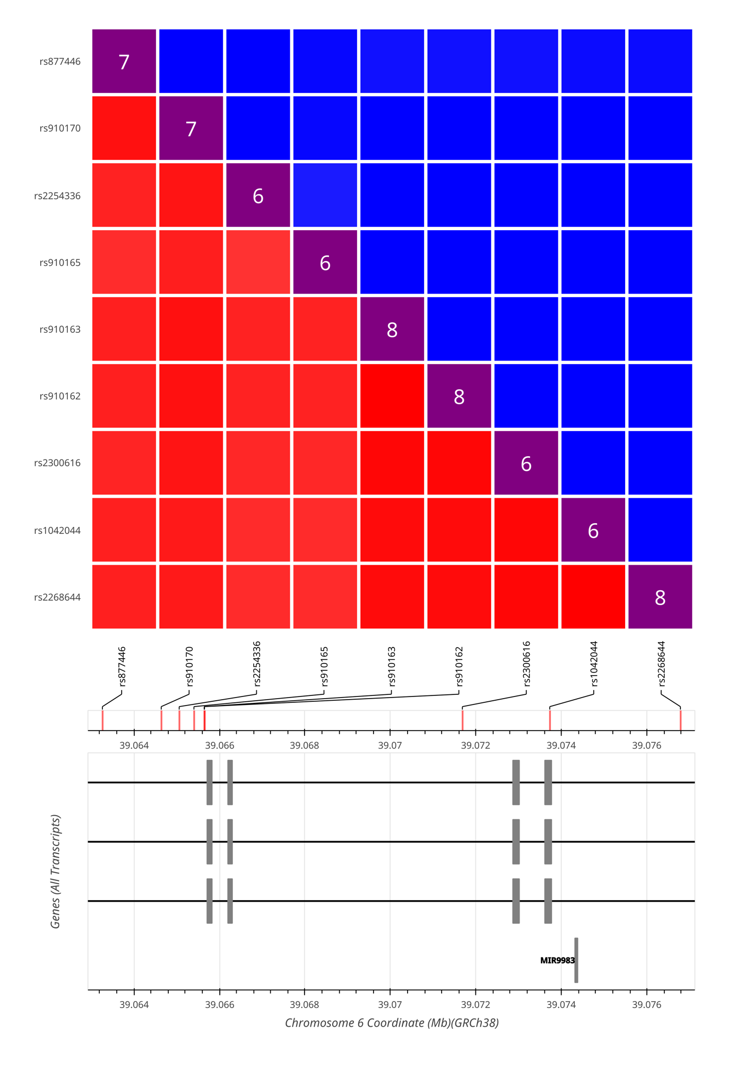
Supplementary Figure 1: Graphical Output of the linkage disequilibrium of the GLP-1R SNPs with sex-specific BMI effects in the CEU population. The graphical output was generated by LDMatrix.
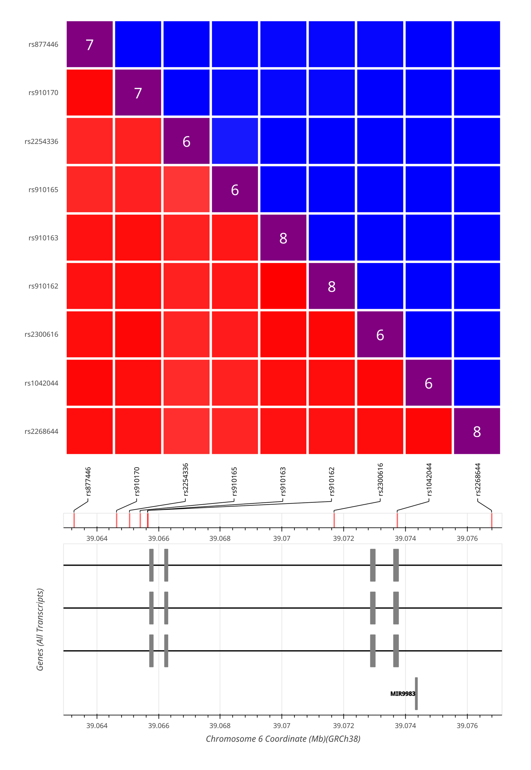
Supplementary Figure 2: Graphical Output of the linkage disequilibrium of the GLP-1R SNPs with sex-specific BMI effects in the GBR population. The graphical output was generated by LDMatrix.
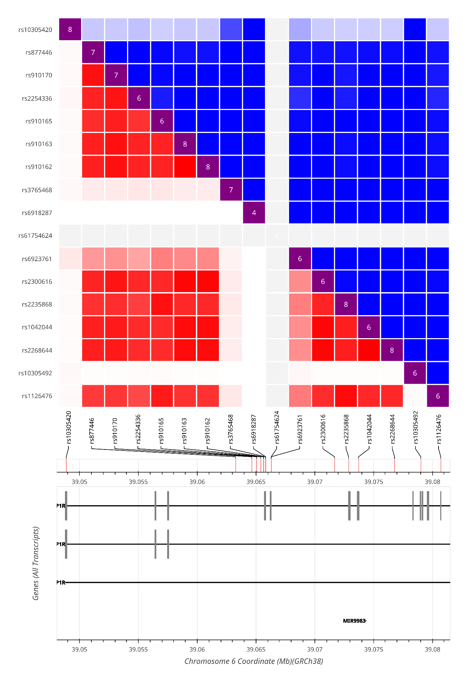
Supplementary Figure 3: Graphical Output of the linkage disequilibrium of the GLP-1R SNPs detected within the mutation screen and GWAS-based sex-specific analyses in the CEU population. The graphical output was generated by LDMatrix.
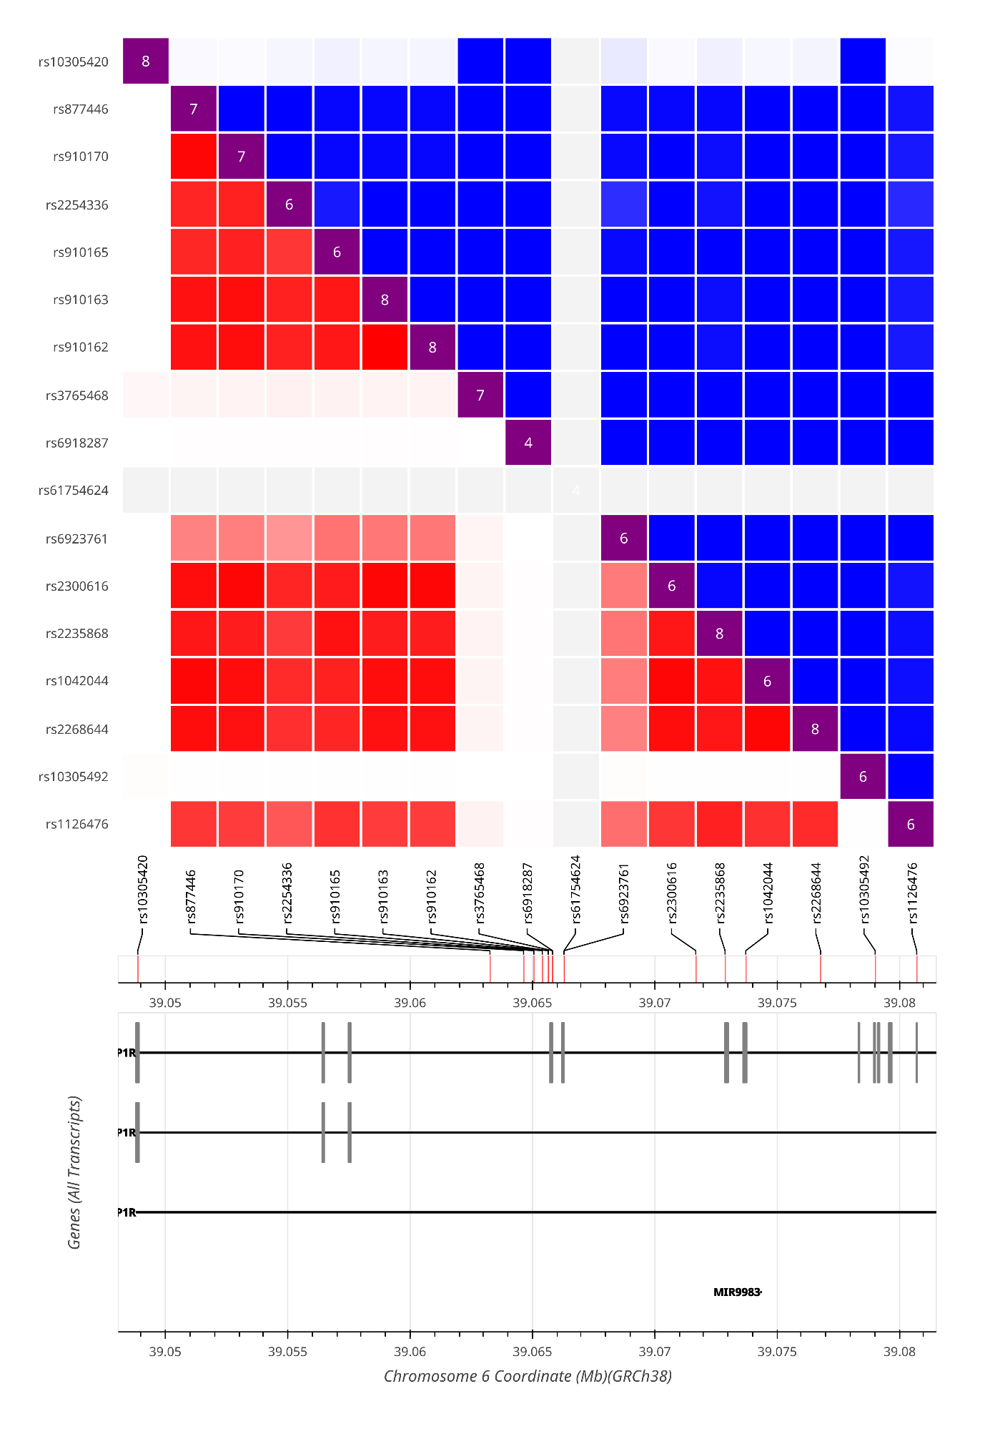
Supplementary Figure 4: Graphical Output of the linkage disequilibrium of the GLP-1R SNPs detected within the mutation screen and GWAS-based sex-specific analyses in the GBR population. The graphical output was generated by LDMatrix.

