Supplemental Material
Supplemental Table 1. Gene set enrichment analysis (GSEA) of human adaptive and pre-adaptive NK cells
Pathway | P value | FDR | log2err | ES | NES | Size | Leading-edge genes
Cytotoxicity | 9.2 × 10⁻⁶ | 1.4 × 10⁻⁴ | 0.59 | 0.94 | 2.05 | 9 | GZMA, KLRD1, GNLY, FASLG, NKG7, GZMH
Activating receptors | 1.9 × 10⁻⁴ | 9.7 × 10⁻⁴ | 0.52 | 0.94 | 1.85 | 6 | KLRC2, KLRK1, SLAMF7, NCR1, NCR3
Chemokine trafficking | 1.6 × 10⁻⁴ | 9.7 × 10⁻⁴ | 0.52 | 0.93 | 1.89 | 7 | CCL4, CCL5, CXCR3, CCL3, CXCR4
Collagen/TGFβ fibrosis | 1.3 × 10⁻³ | 4.8 × 10⁻³ | 0.46 | 0.91 | 1.79 | 6 | ITGA1, ITGB1, SMAD7, CD44
Hallmark allograft rejection | 1.9 × 10⁻³ | 5.6 × 10⁻³ | 0.46 | 0.46 | 1.63 | 96 | CCL4, CCL5, CD8A, GZMA, CD3D, KLRD1, CD2, IFNG, CXCR3, NCR1, IL2RB, CD3G, CD247, CD96, FASLG, LCK, CD8B, ETS1, GBP2, CD3E, STAT4
Hallmark TNFα signaling via NF-κB | 6.0 × 10⁻³ | 0.015 | 0.41 | 0.48 | 1.62 | 71 | CCL4, CCL5, PHLDA1, DUSP2, CFLAR, DUSP4, GADD45B, TANK, MCL1, PNRC1, CD44, SLC2A3, TIPARP, CD69, NFE2L2, KLF6, ATF3, TNIP1
Tissue residency | 7.9 × 10⁻³ | 0.017 | 0.38 | 0.84 | 1.70 | 7 | ZNF683, CXCR6, ITGA1, RGS1, CD69
Hallmark oxidative phosphorylation | 0.032 | 0.060 | 0.32 | −0.42 | −1.36 | 141 | ATP6V0B, MGST3, NDUFB1, COX5B, ATP6V0C, GPX4, ATP6V1F, ATP5MC3, NDUFA4, ATP6AP1, TIMM10, UQCRC1, ACO2, NDUFA7, NDUFA5, ATP5PO, ALAS1, ATP6V1D, SLC25A6, ATP5MG, MDH1, ATP5PD, POR, ATP6V1G1, NDUFB2, HADHA, MRPL11, NDUFS3, TIMM13, ATP1B1, PRDX3, COX7A2L, ATP5F1A, NDUFB6, NDUFB4, ISCU, SDHD, NDUFB5, ATP5ME, NDUFA8, ATP5PF, ATP6V0E1, NDUFS2, CYB5R3, PDHA1, MRPS12, NDUFB7, UQCR11, IDH3G, TIMM8B, ECH1, NDUFC2, COX6B1, ACADVL, DECR1
Hallmark IFNα response | 0.088 | 0.13 | 0.18 | −0.47 | −1.34 | 55 | IFI30, CD74, LGALS3BP, IFI27, BST2, IFIT3, SELL, STAT2, PLSCR1, PARP14
NKG2D signaling | 0.084 | 0.13 | 0.23 | 0.71 | 1.41 | 6 | KLRK1, HCST, PIK3CD
Hallmark inflammatory response | 0.29 | 0.40 | 0.09 | −0.39 | −1.12 | 56 | TIMP1, CYBB, MARCO, PLAUR, CD14, BST2, MSR1, AHR, SELL, CD82, C5AR1, ATP2B1, GPR183, P2RX4, IL7R
Hallmark IFNγ response | 0.33 | 0.42 | 0.08 | −0.34 | −1.07 | 103 | IFI30, CD74, HLA-DMA, SERPING1, HLA-DRB1, LGALS3BP, HLA-DQA1, IFI27, FCGR1A, BST2, IFIT3
Inhibitory/exhaustion | 0.46 | 0.53 | 0.09 | 0.55 | 1.03 | 5 | CD96, KLRC1, KIR2DL3, KIR3DL1
Adaptor loss | 0.60 | 0.61 | 0.07 | −0.53 | −0.93 | 5 | FCER1G
Hallmark IL-2/STAT5 signaling | 0.61 | 0.61 | 0.05 | −0.31 | −0.91 | 71 | TNFRSF4, SYNGR2, IFNGR1, CAPG, AHR, CTSZ, ANXA4, SELL, GPX4, GPR65, PHTF2, PLSCR1, DHRS3, P2RX4, PLIN2, GLIPR2, RNH1, TNFRSF18

fluorophore | target | clone | catalog # | supplier | location
BUV395 | CD27 | LG.3A20 | 740247 | BD Biosciences | San Jose, CA, USA
Viability UV | Live/Dead |  | L23105A | Invitrogen | Carlsbad, CA, USA
BUV563 | CD49b | HMa2 | 741280 | BD Biosciences | San Jose, CA, USA
BUV496 | CD4 | H129.19 | 741078 | BD Biosciences | San Jose, CA, USA
BUV805 | NKG2ACE | 20d5 | 741990 | BD Biosciences | San Jose, CA, USA
BUV615 | CD45RA | 14.8 | 751645 | BD Biosciences | San Jose, CA, USA
BUV737 | CD49a | Ha31/8 | 741776 | BD Biosciences | San Jose, CA, USA
BV650 | NKp46 | 29A1.4 | 137612 | BioLegend | San Diego, CA, USA
BV570 | Ly6C | HK1.4 | 128030 | BioLegend | San Diego, CA, USA
RB780 | PD-1 | J43 | 755328 | BD Biosciences | San Jose, CA, USA
SB436 | NK1.1 | PK136 | 62-5941-82 | ThermoFisher | Waltham, MA, USA
Pacific Blue | CD69 | H1.2F3 | 104524 | BioLegend | San Diego, CA, USA
BV510 | CD11b | M1/70 | 101263 | BioLegend | San Diego, CA, USA
Pacific Orange | CD8a |  | 2311814 | ThermoFisher | Waltham, MA, USA
BV711 | DNAM1 | TX42.1 | 133609 | BioLegend | San Diego, CA, USA
BV605 | CD90.2 | 30-H12 | 740334 | BD Biosciences | San Jose, CA, USA
BV785 | KLRG1 | 2F1/KLRG1 | 138429 | BioLegend | San Diego, CA, USA
FITC | LY49C/I | 5E6 | 553276 | BD Biosciences | San Jose, CA, USA
Spark Blue 550 | CD3 | 17A2 | 100259 | BioLegend | San Diego, CA, USA
AlexaFluor594 | CD107a | 1D4B | 121622 | Biolegend | San Diego, CA, USA
PE/Cy7 | γδ/ TCR | GL3 | 118124 | Biolegend | San Diego, CA, USA
PE-eFlour 610 | NKG2D | CX5 | 130207 | BioLegend | San Diego, CA, USA
BUV661 | CCR5 | 53-7.3(RUO) | 741459 | BD Biosciences | San Jose, CA, USA
spark YG570 | F4/80 | BM8 | 565411 | BD Biosciences | San Jose, CA, USA
BB700 | CD122 | 5H4 | 742153 | BD Biosciences | San Jose, CA, USA
AlexaFluor647 | CXCR6 | SA051D1 | 151114 | BioLegend | San Diego, CA, USA
APC | Ly49H+ | 3D10 | 144712 | BioLegend | San Diego, CA, USA
AlexaFluor700 | CD45 | 30-F11 | 560510 | BD Biosciences | San Jose, CA, USA
Spark NIRtm 685 | CD19 | 6D5 | 115568 | BioLegend | San Diego, CA, USA
APC/eF780 | CD62L | MEL-14 | 2282693 | ThermoFisher | Waltham, MA, USA
Abbreviations: Alexa Fluor, Alexa Fluor; APC, allophycocyanin; BB, Brilliant Blue; BV, Brilliant Violet; BUV, Brilliant Ultraviolet; FITC, fluorescein isothiocyanate; Pacific Blue, Pacific Blue; Pacific Orange, Pacific Orange; PE, phycoerythrin; RB, R-phycoerythrin tandem dye; SB, Super Bright; Spark Blue, Spark Blue; Spark NIR, Spark near-infrared; Spark YG, Spark yellow-green; Viability UV, ultraviolet viability dye.

Supplemental Table 2. Spectral flow cytometry panel antibodies

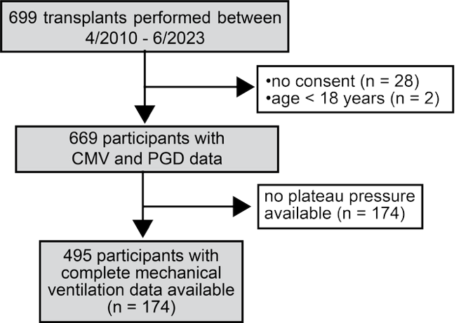
Supplemental Figure 1. CONSORT diagram for human CMV cohort

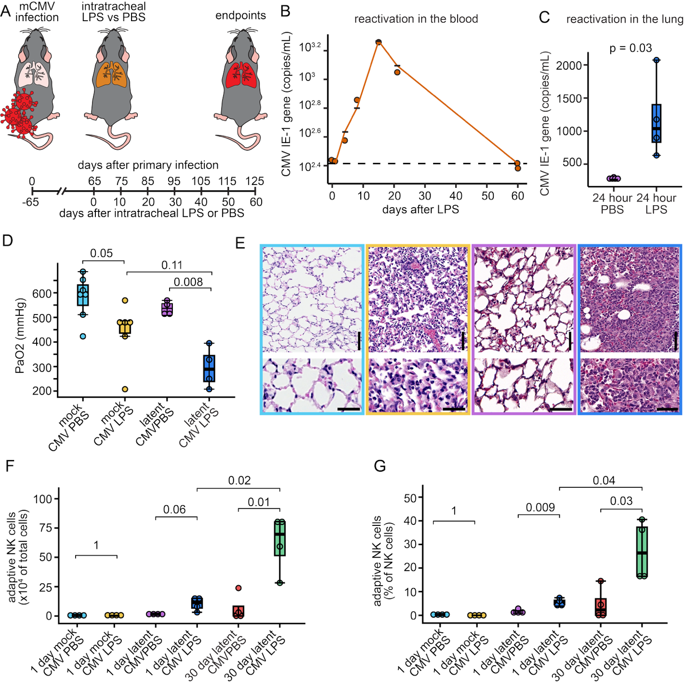
Supplemental Figure 2. CMV reactivation after lipopolysaccharide induced acute lung injury. (A) Schematic of the LPS model of mCMV reactivation. Latently mCMV-infected mice received intratracheal LPS or saline control. (B) Longitudinal blood CMV IE-1 gene copies (copies/mL) following intratracheal LPS, showing individual trajectories and median. (C) Lung tissue CMV IE-1 gene copies in latently infected mice receiving intratracheal LPS versus intratracheal saline. Serial mCMV copies were monitored in blood for n = 2 mice. Differences in lung tissue mCMV copies were assessed in n=4 per group. Differences in panel C were assessed with Mann-Whitney U testing.
(D) Arterial partial pressure of oxygen (PaO2) measured 24 hours after intratracheal LPS or saline in mock infected and latently mCMV infected mice. (E) H&E staining of representative lungs from each condition, scale bars represent 100 µm. (F) Absolute counts of adaptive NK cells and (G) adaptive NK cells as a percent of total NK cells, 1 day and 30 days after intratracheal LPS or saline in mock infected and latently infected mice. Serial mCMV copies were monitored in blood for n = 2 mice. Differences in lung tissue mCMV copies, injury and immune cells were assessed in at least n = 4 per group. Box and whisker plots are bound by 25th and 75th percentile with boxes bisected by the median. Differences in panel C were assessed with Mann-Whitney U testing. Comparisons in panels D, F, and G were made with Wilcoxon tests with Benjamini-Hochberg adjustment.

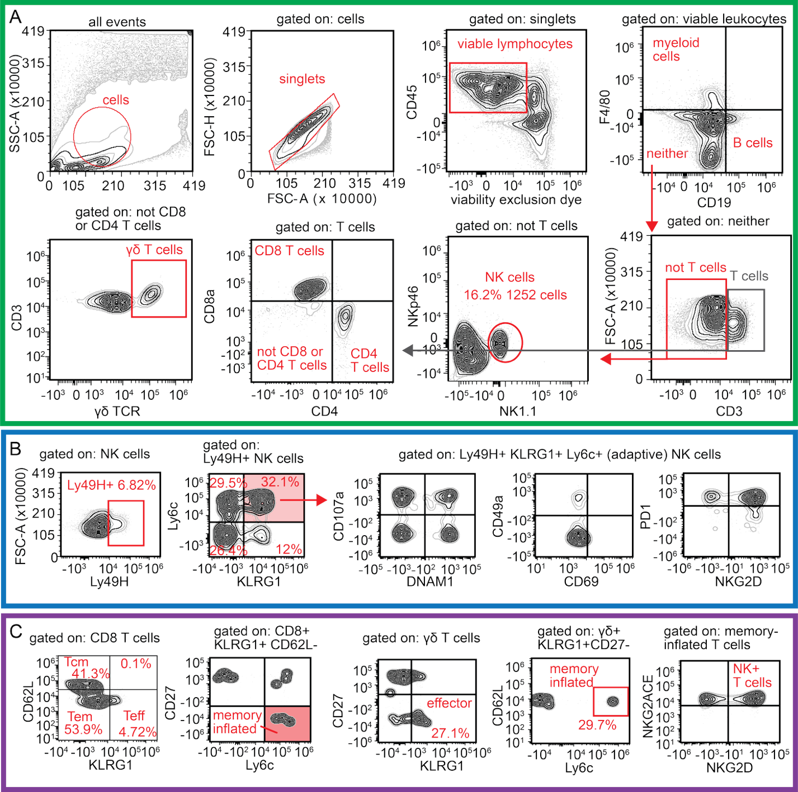
Supplemental Figure 3. Spectral flow cytometry gating strategy for NK and T cells. (A) General gating to identify myeloid cells, B cells, T cells, NK cells, CD8 T cells, CD4 T cells and GD T cells. (B) NK cell strategy to define adaptive NK cells as Ly49H+ KLRG1+Ly6c+ and common maturation, tissue residency, and activation markers. (C) Gating strategy for identifying memory inflated CD8 T cells, γδ T cells, and NKG2D+ T cells in both lineages.

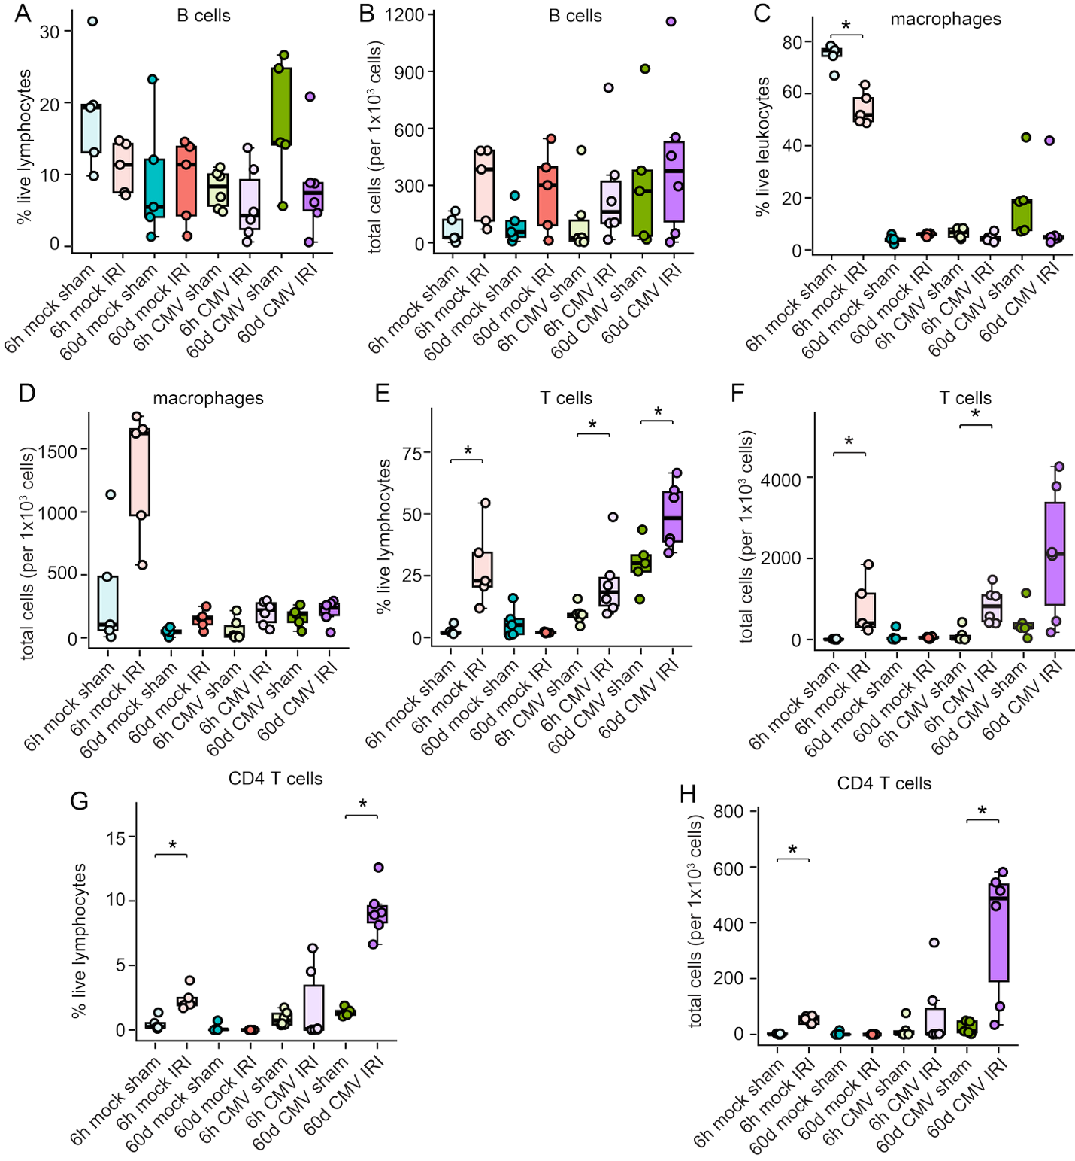
Supplemental Figure 4. Immune cell frequencies and counts following sham or IRI in mock or latently mCMV infected mice. In the latent mouse CMV versus mock infection model, we performed IRI or procedures and collected lungs at 6 hours and 60 days for quantification of: (A) percentage of B cells relative to live lymphocyte, (B) total B cells, (C) percentage of macrophages relative to live leukocytes, (D) total macrophages, (E) percentage of T cells relative to live lymphocytes, (F) total T cells, (G) the percentage of CD4 T cells relative to live lymphocytes, and (H) total CD4 T cells. Each dot represents an individual sample, box plots show median with interquartile range, and whiskers indicate minimum–maximum values. Statistical significance was determined with Mann Whitney U-testing adjusted with the Benjamini-Hochberg approach, with findings indicated by brackets with asterisks (*p < 0.05, **p < 0.01).

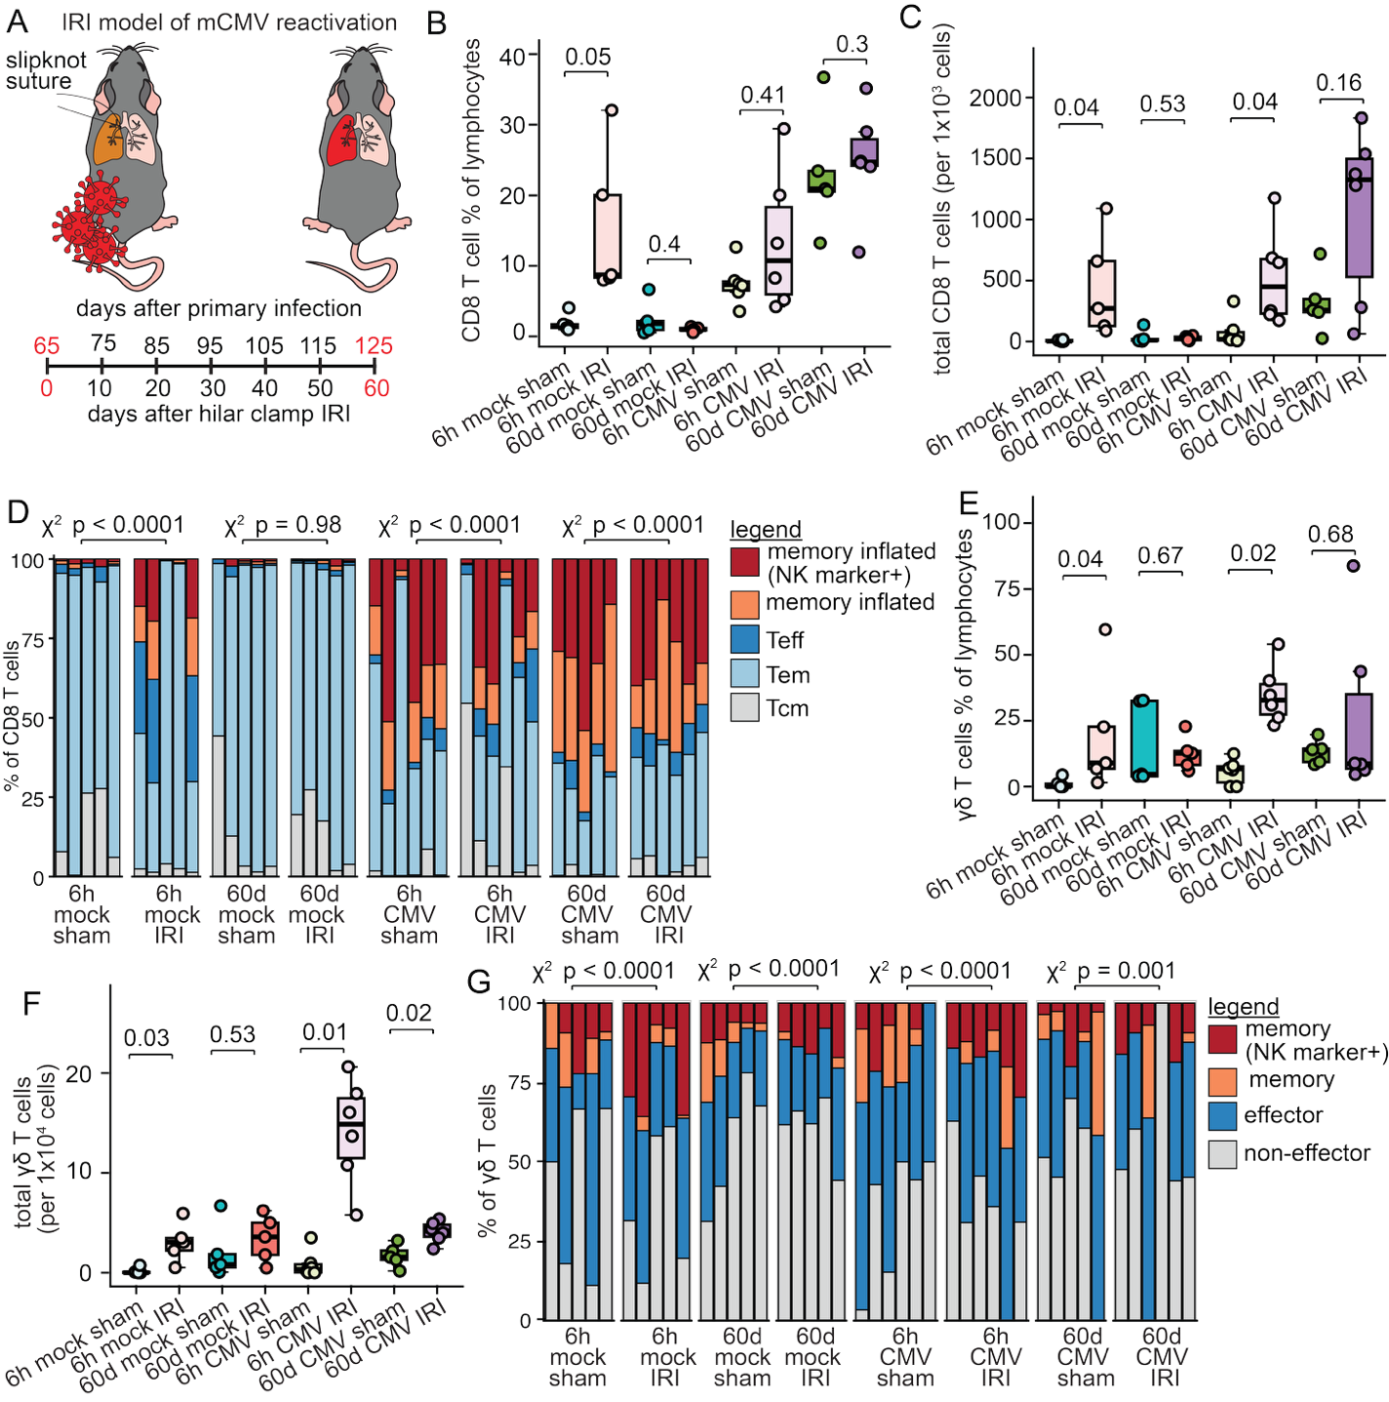
Supplemental Figure 5. CD8 and γδ T cells are increased after IRI and CMV reactivation but memory inflation is CMV and not injury dependent. (A) Schematic of the mouse IRI model of mCMV reactivation. Latently infected or mock-infected C57BL/6 mice underwent lung IRI or sham surgery and endpoints were collected 6 hours or 60 days after procedures. Across mCMV and IRI groups, lung T cells were quantified. CD8 T cells are shown as (B) a percentage of total viable lymphocytes, (C) in absolute counts relative to total cells, and as (D) individual animal stacked bar plots depicting the relative frequencies of memory subsets. γδ T cells were also quantified as (E) a percentage of total viable lymphocytes, (F) in absolute counts relative to total cells, and as (G) individual animal stacked bar plots depicting the relative frequencies of memory subsets. Data are shown as median with IQR with n=5–6 mice per condition. Comparisons between IRI and sham across mCMV groupings were performed using the Wilcoxon rank-sum test adjusted for false discovery with the Benjamini-Hochberg approach. Comparisons of distributions across memory populations were made with χ² tests with Monte Carlo simulation.

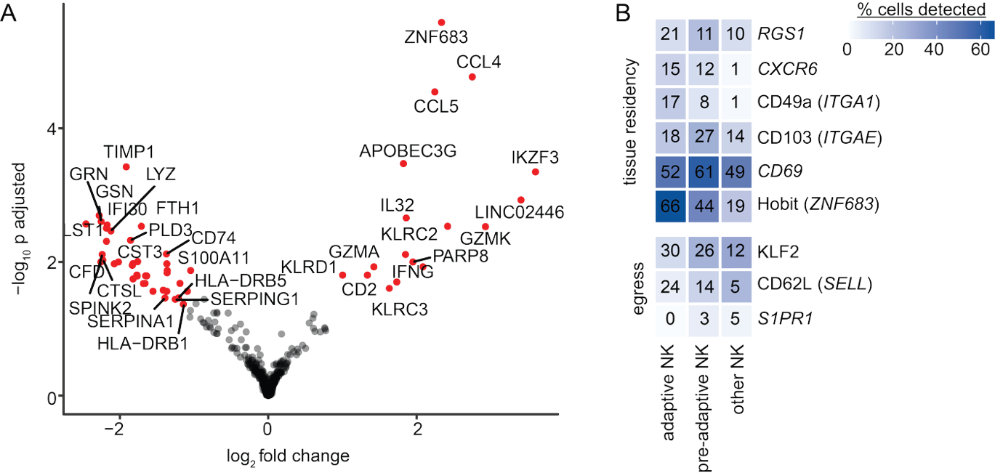
Supplemental Figure 6. Differential gene expression of adaptive NK cells compared to other NK cells in human BAL. (A) Volcano plot of differential gene expression between adaptive and other NK cells. Red points pass FDR-adjusted threshold of significance. (B) Fraction of cells expressing tissue-residency (RGS1, CXCR6, CD49a/ITGA1, CD103/ITGAE, CD69, Hobit/ZNF683) and egress (KLF2, CD62L/SELL, S1PR1) genes across adaptive, pre-adaptive, and other NK subsets, colored by percent detected

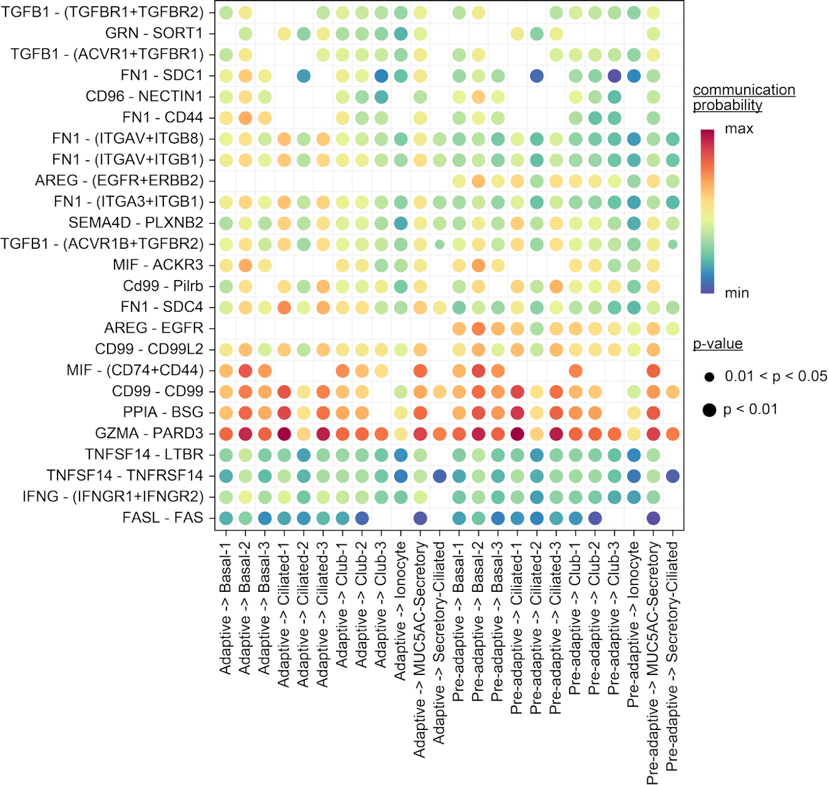
Supplemental Figure 7. Outgoing NK cell communication pathways with airway epithelial cells. CellChat-inferred ligand–receptor signaling from NK cells (sender) to airway epithelial cell populations (receivers), derived from scRNA-seq. Each dot represents a ligand–receptor pair; dot color indicates the communication probability and dot size indicates significance (permutation-test p-value).

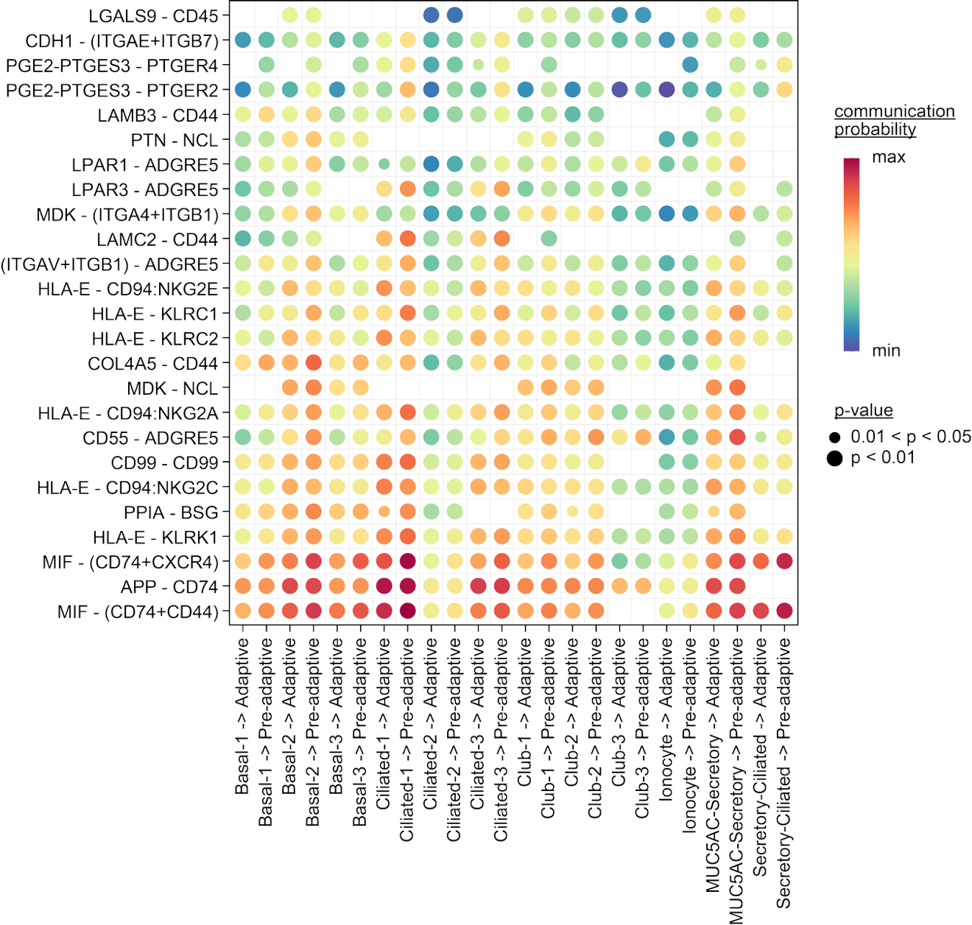
Supplemental Figure 8. Incoming NK cell communication pathways with airway epithelial cells. CellChat-inferred ligand–receptor signaling from airway epithelial cells (sender) to NK cell populations (receivers), derived from scRNA-seq. Each dot represents a ligand–receptor pair; dot color indicates the communication probability and dot size indicates significance (permutation-test p-value).
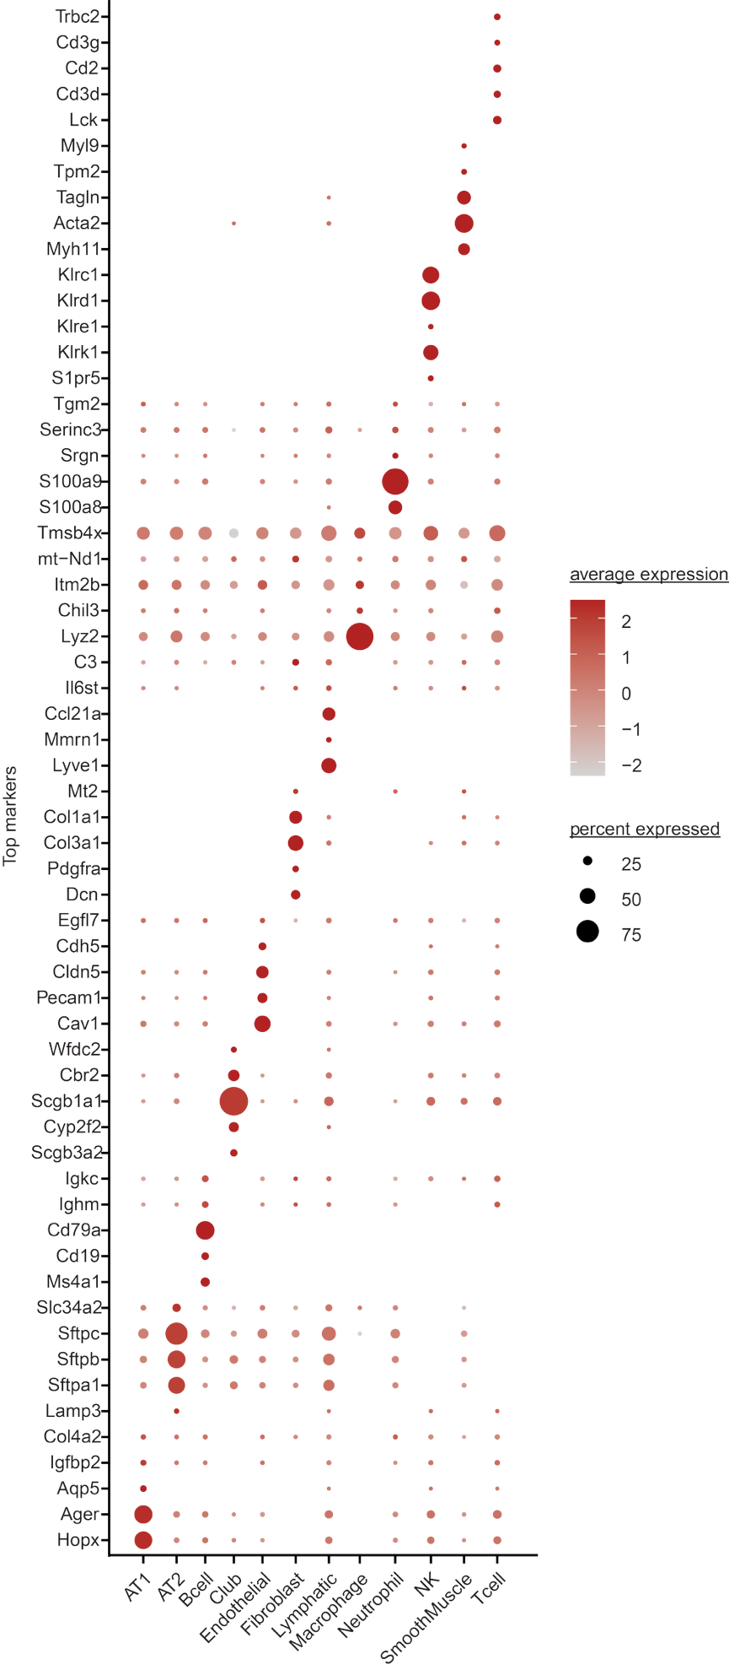
Supplemental Figure 9. Dot plot of the top marker genes used to annotate the 12 spatial cell-type populations in the mouse lung data. Dot size indicating the percentage of bins expressing each gene and color indicating scaled average expression.

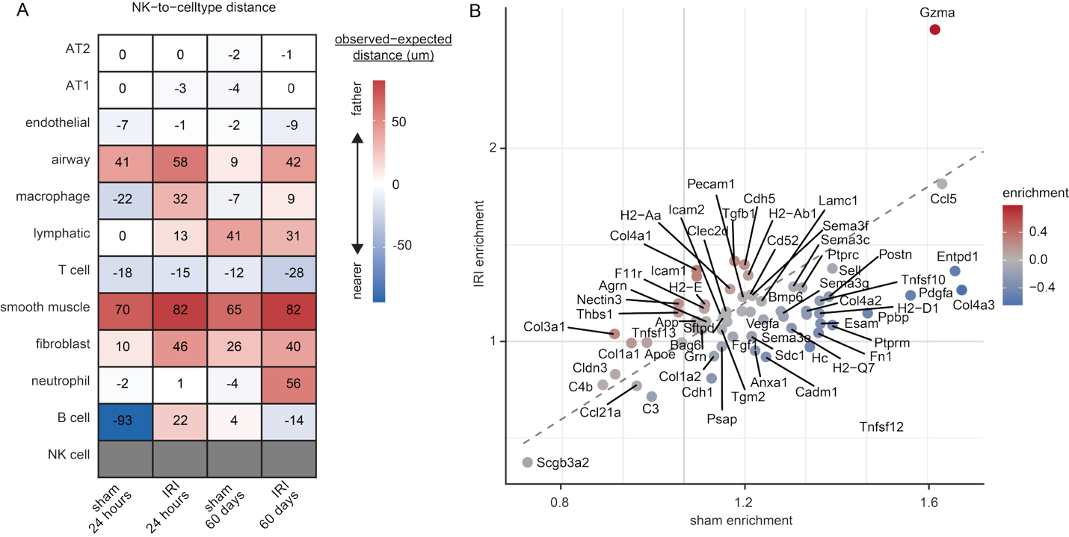
Supplemental Figure 10. NK cell proximity analyses to other cells and ligands. (A) Heatmap of NK cell–to–cell type spatial proximity, shown as observed–expected distance (µm) for each cell type (rows) across conditions (columns). Red indicates cell types positioned farther from NK cells than expected and blue indicates those positioned nearer. (B) Per-gene enrichment in NK cell proximity in IRI versus sham.
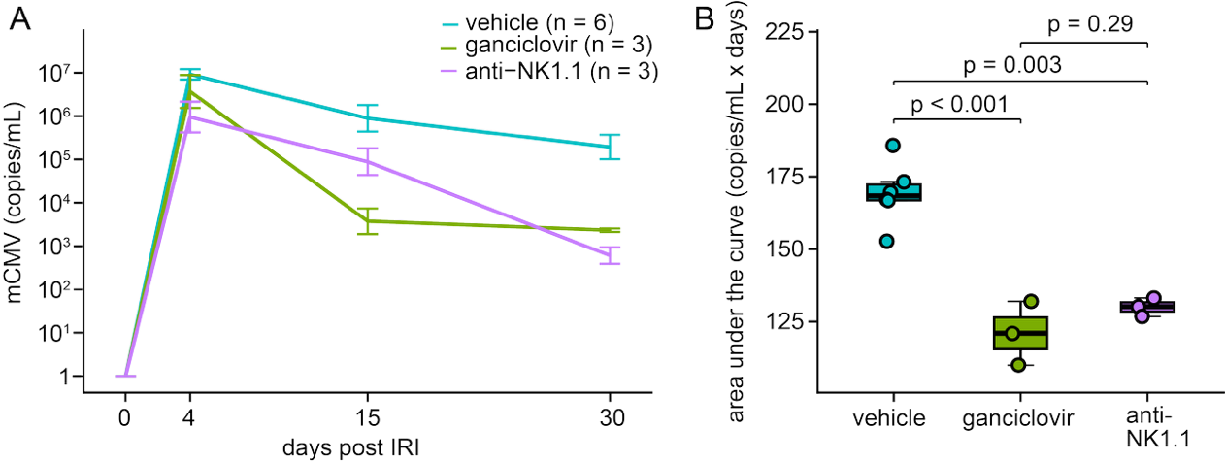
Supplemental Figure 11. Longitudinal blood CMV IE-1 copies by treatment group. (A) Blood mCMV viral load (IE-1 copies/mL, log scale) over 30 days post IRI in mice treated with vehicle (n = 6), ganciclovir (n = 3), or NK cell depleting anti-NK1.1 antibody (n = 3). Lines show group means with error bars indicating SEM. (B) Per-animal area under the viral load curve (AUC, log₁₀ copies/mL × days) for each group. Pairwise comparisons were made with Dunn’s post hoc testing following a Kruskal-Wallis test.

