Supplementary information – Supplementary Figures 1-7 from Lou et al.

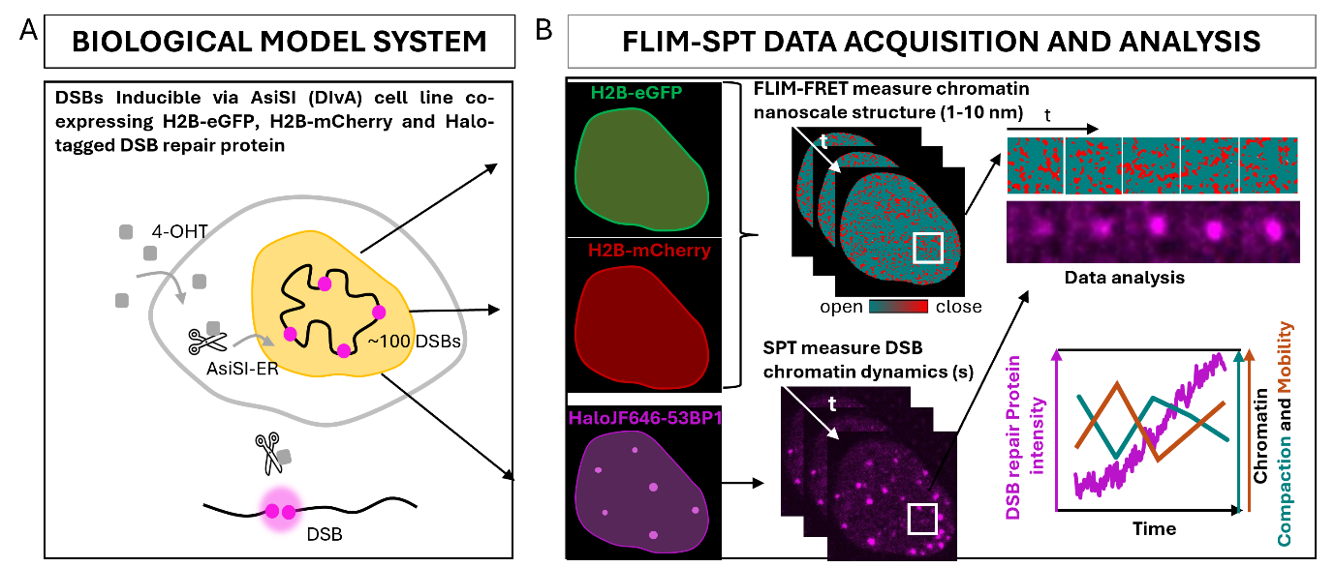
Supplementary Figure 1. Correlative fluorescence lifetime imaging microscopy–histone Förster resonance energy transfer (FLIM–FRET) and single-particle tracking (SPT) workflow. A. Schematic of the DIvA mammalian cell system, which enables the inducible generation of DNA double-strand breaks (DSBs) and the expression of histone FRET sensors together with Halo-tagged DSB repair proteins. B. Histone FLIM–FRET and SPT image acquisition and analysis pipeline used to quantify chromatin compaction and DSB mobility while tracking the recruitment of Halo-tagged DNA repair proteins to individual DSB sites.

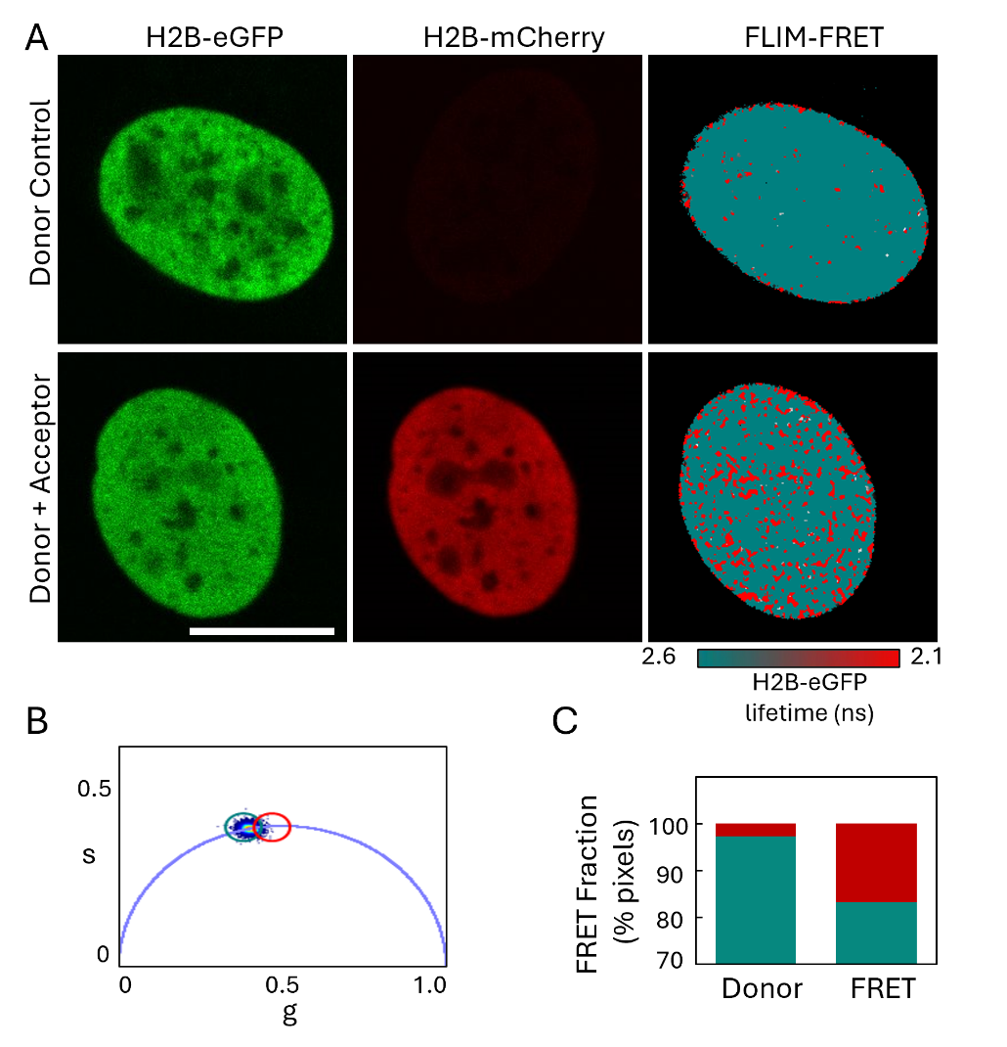
Supplementary Figure 2. Histone FLIM–FRET measurement of chromatin compaction in living cells. A–B. Representative fluorescence intensity images of DIvA cell nuclei expressing either the donor-only construct, H2B–eGFP (top), or the FRET pair, H2B–eGFP and H2B–mCherry (bottom), together with the corresponding donor fluorescence lifetime maps (A). The lifetime maps are pseudocoloured according to the phasor plot palette shown in B. Pixels with an unquenched H2B–eGFP lifetime of 2.6 ns are shown in teal, whereas pixels with a shortened lifetime of 2.1 ns are shown in red. The shortened donor lifetime results from histone FRET and indicates more compact chromatin structure. C. Quantification of the compact chromatin fraction, defined by the proportion of pixels with a quenched donor fluorescence lifetime, in DIvA cells expressing either H2B–eGFP alone or the H2B–eGFP/H2B–mCherry FRET pair.

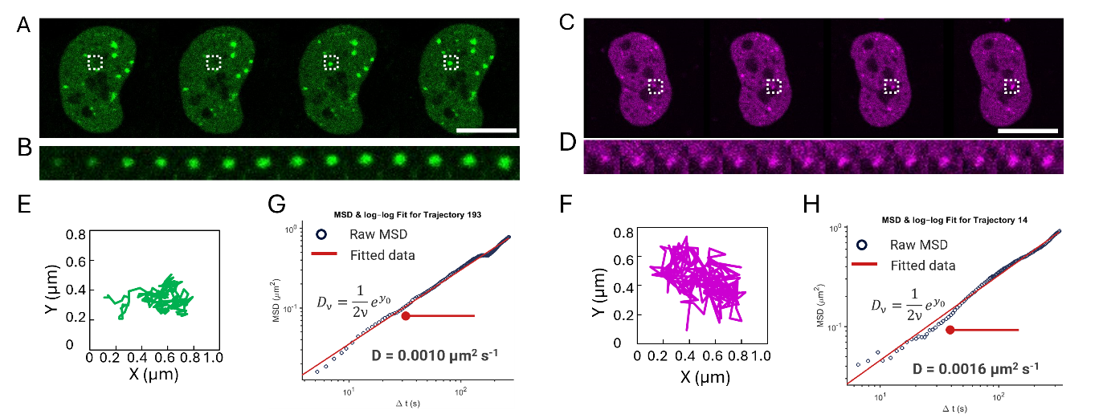
Supplementary Figure 3. Single-particle tracking analysis and calculation of diffusion coefficients. A–D. Representative image sequences of DIvA cell nuclei expressing Halo–JF646–53BP1 (A) or Halo–JF646–PALB2 (C) following induction of DNA double-strand breaks (DSBs) with 4-hydroxytamoxifen (4-OHT). Enlarged views of the regions outlined by the white dashed boxes in A and C show individual newly formed DSB foci positive for 53BP1 (B) or PALB2 (D), respectively. E–F. Two-dimensional trajectories showing the x- and y-coordinates of the 53BP1-positive (E) and PALB2-positive (F) DSB foci presented in B and D, respectively, tracked over 120 frames for a total of 10 minutes. G–H. Log–log plots of mean squared displacement against time delay (Δt) for the 53BP1-positive (G) and PALB2-positive (H) DSB trajectories. Linear fitting at order ν = 2 was used to determine the y-axis intercept (y0), and calculate the diffusion coefficient as Dv = $\frac{1}{2v}e^{y0}$. When ν = 2, D2 corresponds to the conventional diffusion coefficient for strongly self-similar, purely diffusive motion.

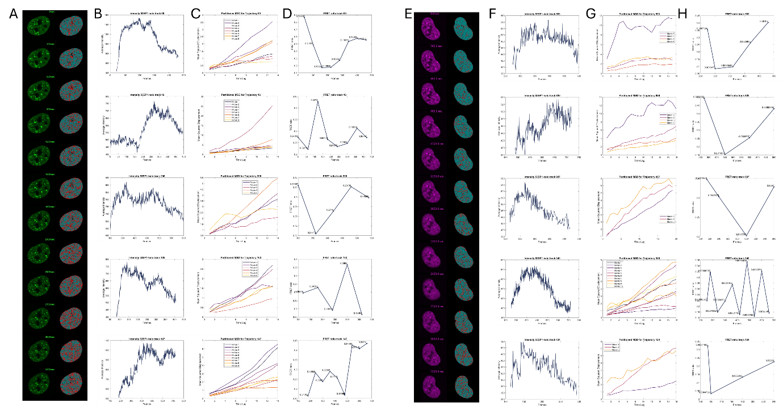
Supplementary Figure 4. Correlative histone FLIM–FRET and single-particle tracking measurements of chromatin compaction and mobility at individual DNA double-strand breaks. A and E. Representative images of DIvA cell nuclei expressing Halo–JF646–53BP1 (A) or Halo–JF646–PALB2 (E). The left panels show the first frame of 12 sequential time-lapse movies acquired from the same nucleus, with 60 frames per movie and a 5-second interval between frames. The right panels show the corresponding histone FLIM–FRET maps acquired immediately before each time-lapse movie. The maps are pseudocoloured to indicate chromatin compaction, with teal representing open chromatin and red representing compact chromatin. B and F. Representative fluorescence intensity profiles of 53BP1-positive (B) or PALB2-positive (F) DSB foci identified by single-particle tracking. Intensity is plotted against frame number across the 12 concatenated time-lapse movies. C and G. Mean squared displacement plotted against time delay for the representative 53BP1 (C) and PALB2 (G) trajectories shown in B and F, respectively. Diffusion coefficients were calculated separately for each 60-frame movie. Therefore, a single DSB trajectory could generate multiple diffusion-coefficient measurements, depending on how many movies the trajectory spanned. D and H. Relationship between local chromatin compaction and the diffusion coefficient of 53BP1-positive (D) or PALB2-positive (H) DSB foci. For each movie, the local compact chromatin fraction was calculated as the proportion of red pixels within a 6-pixel-diameter region centred on the x–y position of the DSB focus in the first frame. This value was then compared with the diffusion coefficient calculated from the corresponding time-lapse movie.

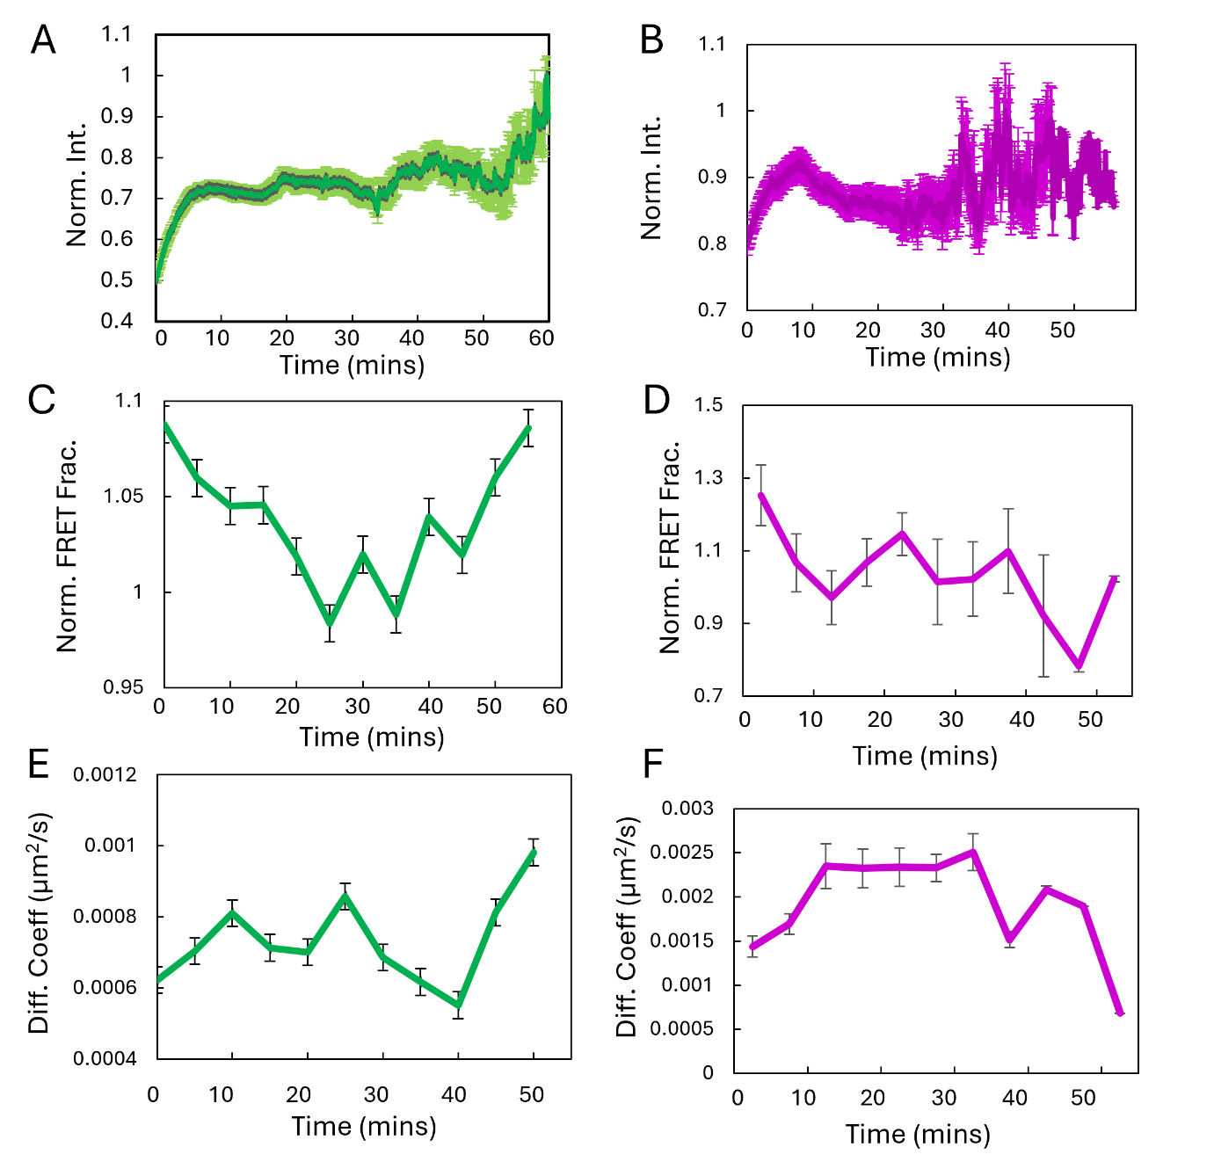
Supplementary Figure 5. Quantification of chromatin compaction and mobility at individual DNA double-strand breaks across multiple cells. A–B. Mean fluorescence intensity of nascent DSB foci marked by Halo–JF646–53BP1 (A) or Halo–JF646–PALB2 (B) over time. Individual trajectories were aligned to the first frame in which each focus was detected and tracked. The raw intensity of each trajectory was normalised to its maximum value. Dark green and magenta lines show the mean normalised intensity for 53BP1 and PALB2, respectively, and error bars indicate the standard error of the mean (SEM). C–D. Mean normalised histone FRET fraction over time at 53BP1-positive (C) or PALB2-positive (D) DSB foci. For each trajectory, the local histone FRET fraction was normalised to the maximum value measured for that focus before averaging across all trajectories. Error bars indicate the SEM. E–F. Mean diffusion coefficient over time for 53BP1-positive (E) or PALB2-positive (F) DSB foci. Error bars indicate the SEM. A total of 189 53BP1 trajectories from 13 cells and 107 PALB2 trajectories from 11 cells were analysed across at least four independent biological replicates.

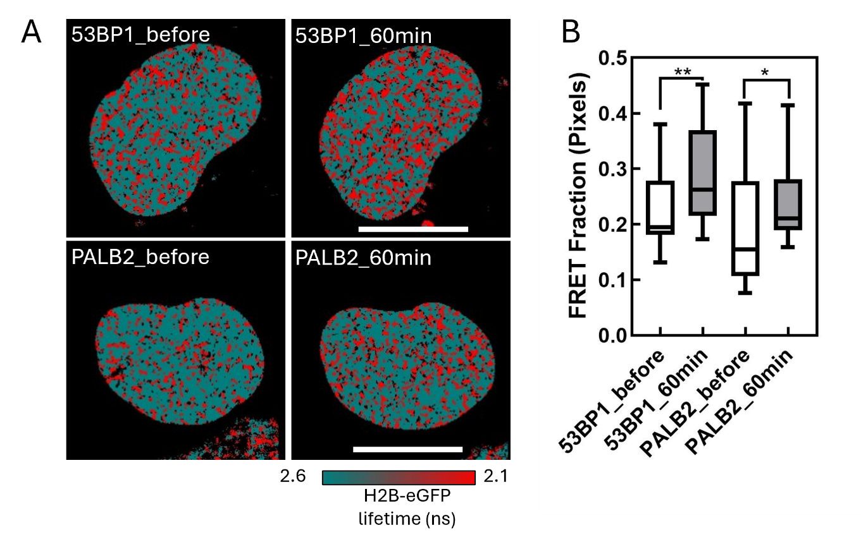

Supplementary Figure 6. Histone FLIM–FRET measurement of global chromatin compaction before and after DNA DSB induction. A. Representative H2B–eGFP fluorescence lifetime maps, pseudocoloured to indicate chromatin compaction, in cells expressing 53BP1–Halo–JF646 (top row) or PALB2–Halo–JF646 before and after DNA DSB induction. Pixels with an unquenched H2B–eGFP fluorescence lifetime of 2.6 ns are shown in teal, whereas pixels with a shortened lifetime of 2.1 ns are shown in red. The shortened donor fluorescence lifetime results from histone FRET and indicates a more compact chromatin structure. Scale bars: 10 μm. B. Quantification of the compact chromatin fraction, defined as the proportion of pixels exhibiting a quenched donor fluorescence lifetime, across multiple cells.

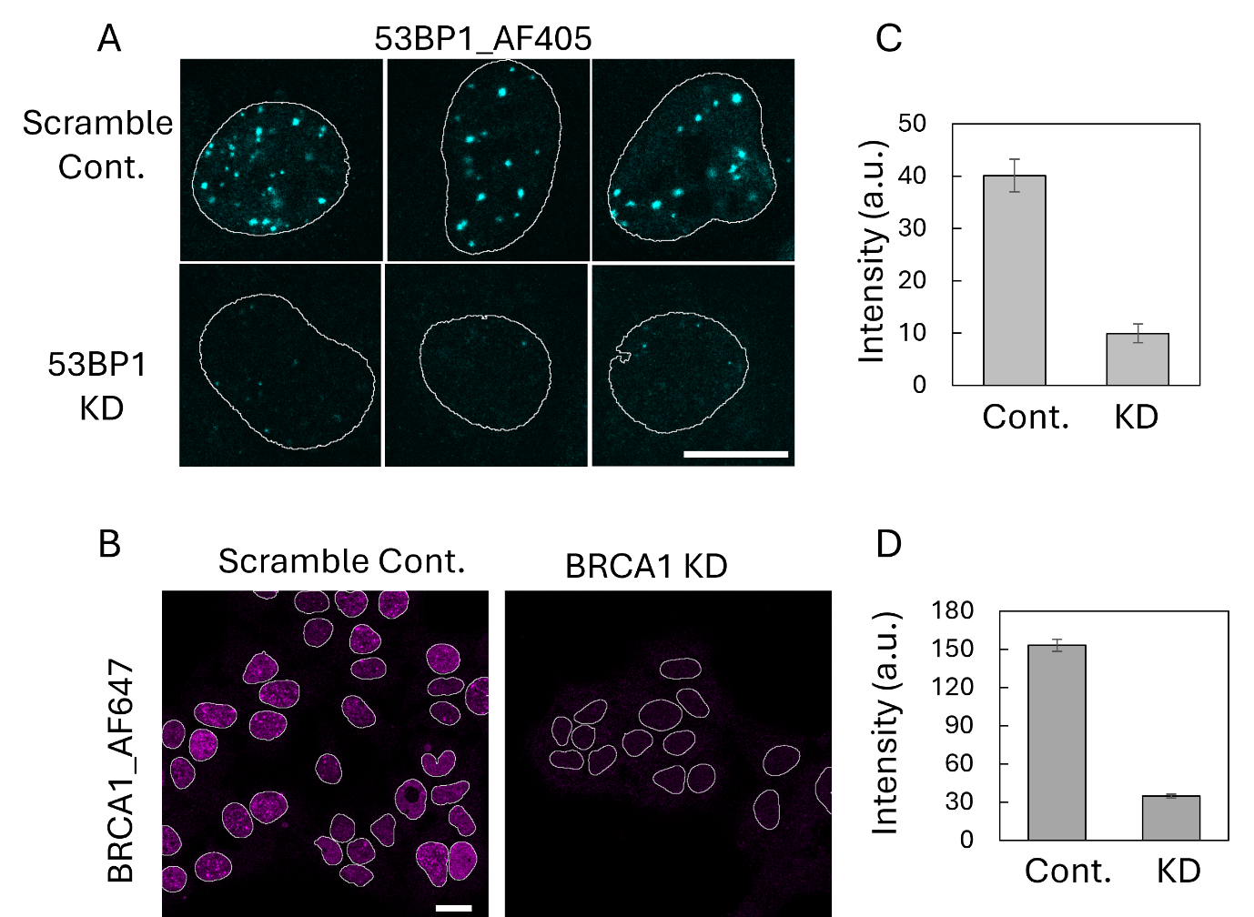
Supplementary Figure 7. Verification of 53BP1 and BRCA1 knockdown. A–B. Representative immunofluorescence images of 53BP1 (A) and BRCA1 (B) in DIvA cells treated with scrambled siRNA or siRNA targeting 53BP1 or BRCA1, respectively. Scale bars: 10 μm in A and 20 μm in B. C–D. Quantification of 53BP1 (C) and BRCA1 (D) expression in control and knockdown cells. More than 30 cells were analysed for 53BP1 and more than 100 cells for BRCA1. Error bars indicate the standard error of the mean (SEM).

