Supplementary Materials for
Dynamic Hydration Gating Enables Terahertz Frequency-Selective Na⁺ Transport under Nanoconfinement
Chen Chenª, Huaxi Guo^{b}, Ting Wang^{c}*, Ruihan Hou^{d}*, You Liu^{e} and Li Zhang^{b}*
ª School of Physical Science and Technology, Nantong University, Nantong 226019, China.
^{b} School of Chemistry and Chemical Engineering, Key Laboratory of Surface & Interface Science of Polymer Materials of Zhejiang Province, Zhejiang Sci-Tech University, Hangzhou, 310018, China.
^{c} School of Pharmaceutical and Chemical Engineering, Taizhou University, Taizhou 318000, China.
^{d} Department of Polymer Science and Engineering, Key Laboratory of High Performance Polymer Material and Technology of Ministry of Education, School of Chemistry, Nanjing University, Nanjing 210023, China.
^{e} College of New Energy, Anhui Science and Technology University, Chuzhou, 239050, China.
*E-mail: tingwang14@tzc.edu.cn, houruihan0001@163.com, lizhang@zstu.edu.cn

This file includes:
Figures S1 to S8

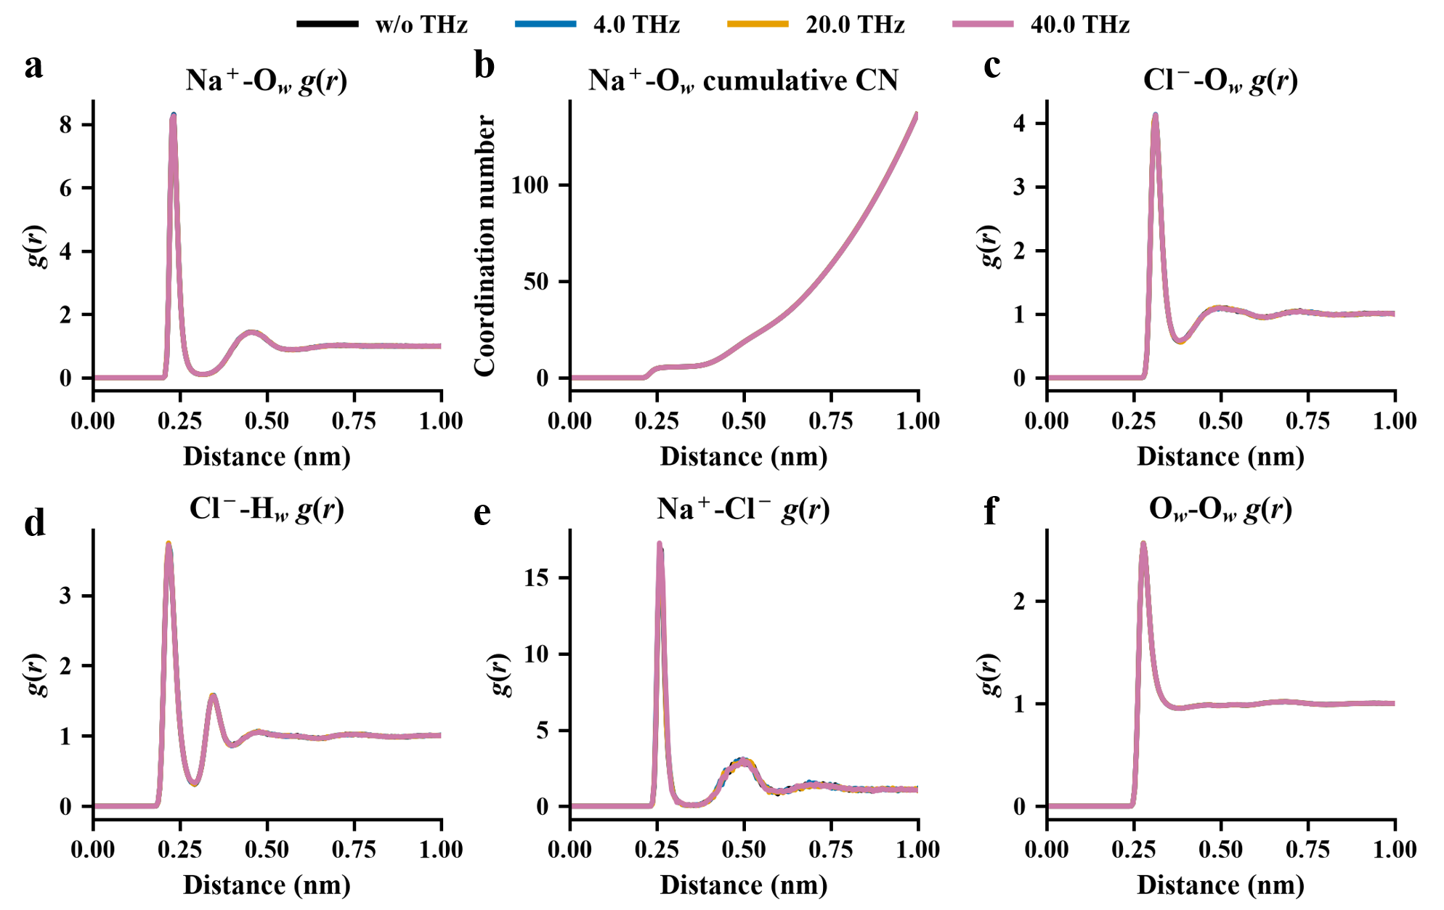
Figure S1. Radial distribution functions and coordination characteristics in bulk NaCl solution under terahertz excitation. (a) Na⁺–Ow ​radial distribution function g(r). (b) Cumulative Na⁺–Ow coordination number. (c) Cl⁻–Ow g(r). (d) Cl⁻–Hw g(r). (e) Na⁺–Cl⁻ g(r). (f) Ow–Ow​ g(r). Results are shown for w/o THz, 4.0, 20.0, and 40.0 THz conditions in 0.15 M NaCl solution. The terahertz field amplitude was 0.5 V/nm.

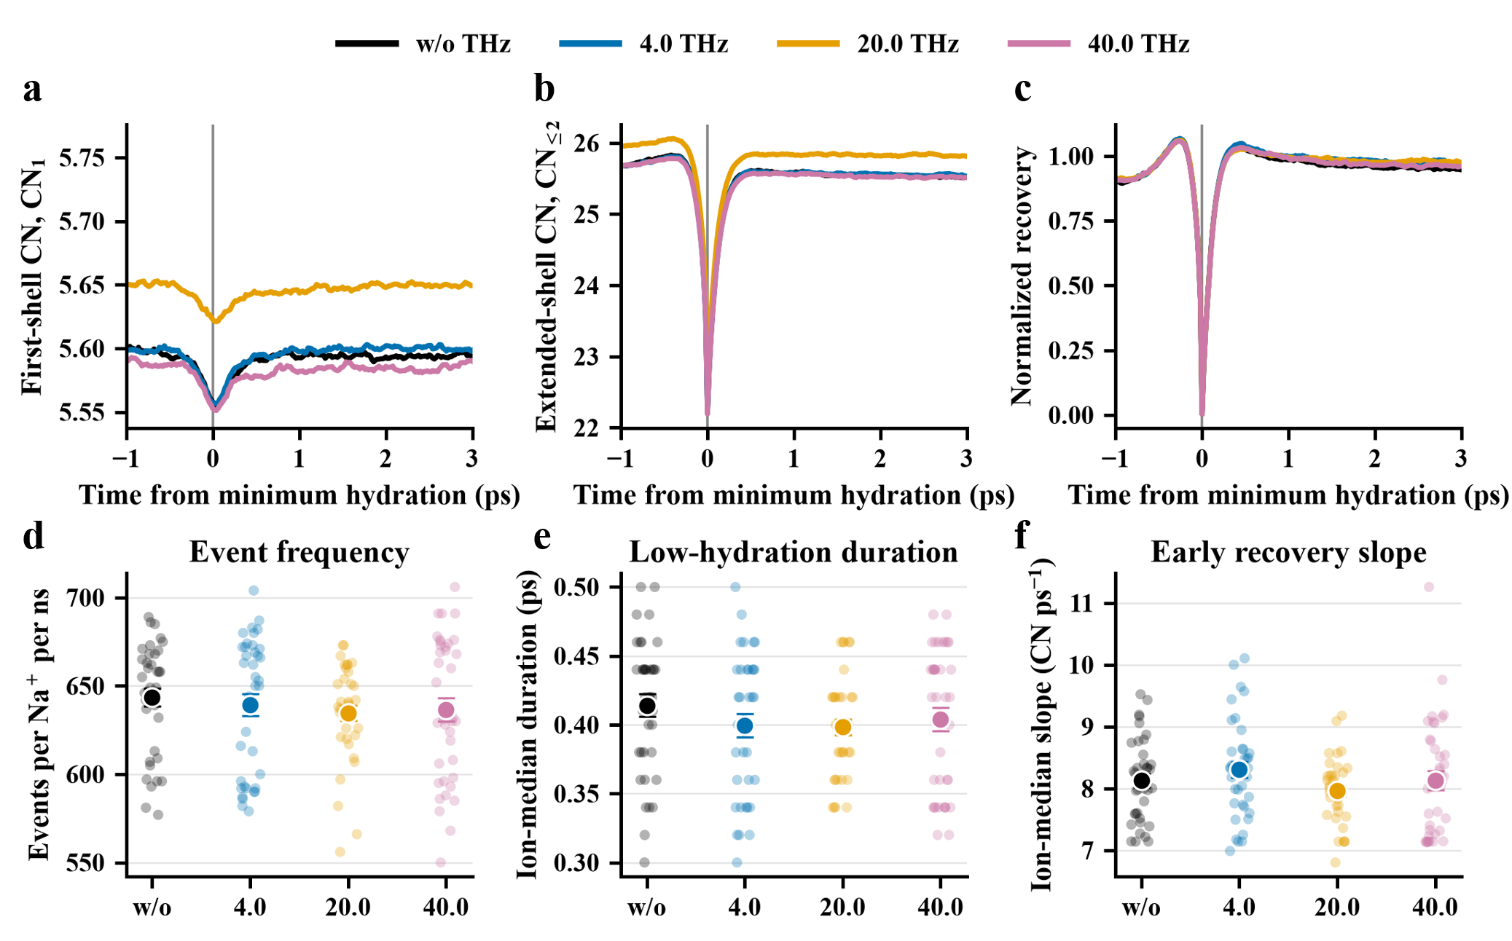
Figure S2. Event-resolved Na⁺ hydration dynamics in bulk NaCl solution under terahertz excitation. (a,b) First-shell coordination number CN₁ and extended-shell coordination number CN_{ext} (CN<=2), aligned at the minimum-hydration time (t=0). (c) Normalized hydration recovery following the coordination minimum. (d–f) Ion-resolved event frequency, low-hydration duration, and early recovery slope, respectively. Small circles represent individual Na⁺ ions, and large circles with error bars indicate the ion-level median and associated uncertainty. Results are shown for w/o, 4.0, 20.0, and 40.0 THz conditions.

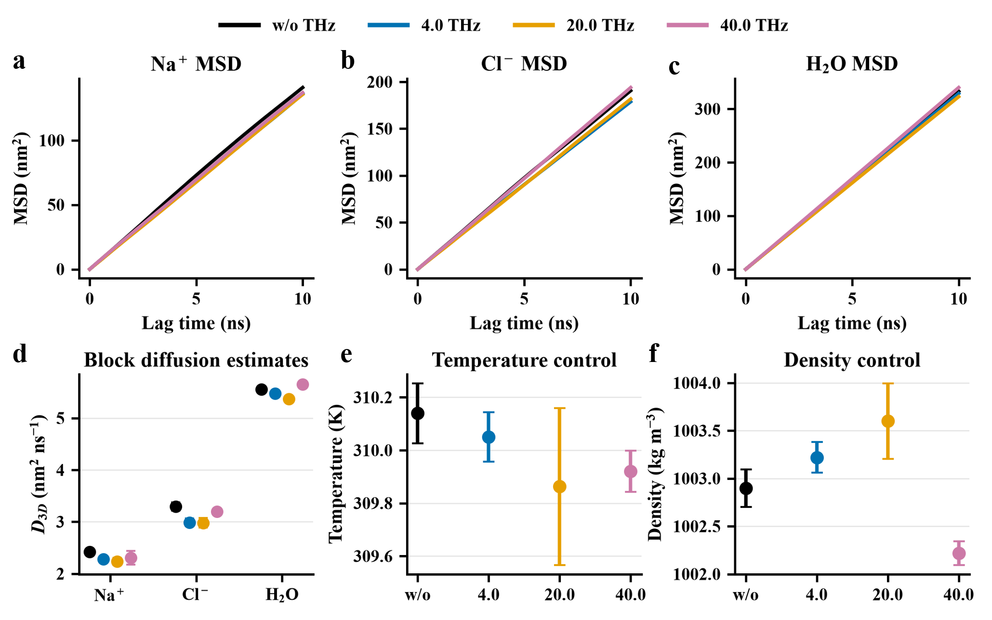
Figure S3. Bulk diffusion and thermodynamic stability under terahertz excitation. (a–c) Mean-square displacement (MSD) of Na⁺, Cl⁻, and H₂O, respectively. (d) Three-dimensional diffusion coefficients estimated by block analysis. (e,f) Average system temperature and density, respectively. Results are shown for w/o THz, 4.0, 20.0, and 40.0 THz conditions in 0.15 M NaCl solution; error bars indicate variability among trajectory blocks.
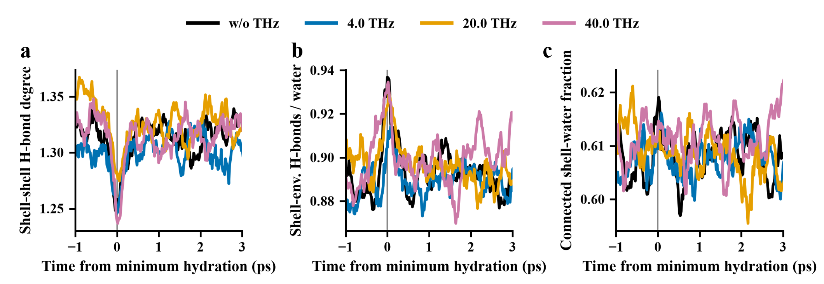
Figure S4. Hydrogen-bond network dynamics during transient Na⁺ dehydration in bulk solution. (a) Mean shell-shell hydrogen-bond degree. (b) Number of shell-environment hydrogen bonds normalized by the number of hydration-shell water molecules. (c) Fraction of hydration-shell water molecules connected to the surrounding water network. All trajectories were aligned at the minimum-hydration time (t=0) and are shown for w/o THz, 4.0, 20.0, and 40.0 THz conditions.

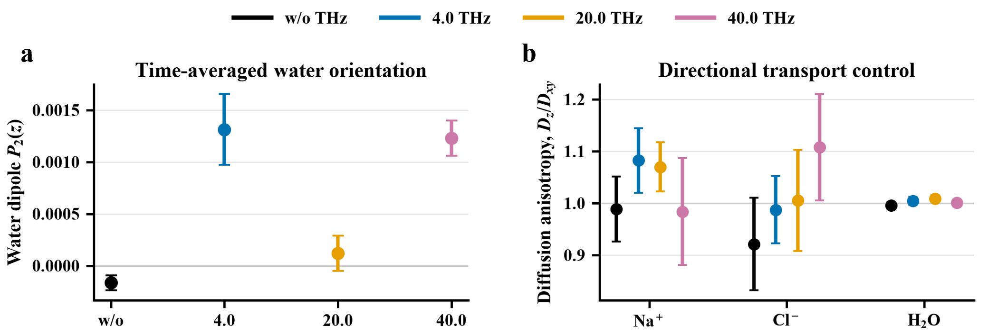
Figure S5. Water orientation and directional diffusion in bulk NaCl solution under terahertz excitation. (a) Time-averaged second-order orientational parameter P₂​(z) of water dipoles relative to the z direction. (b) Diffusion anisotropy D_{z}/D_{xy} for Na⁺, Cl⁻, and H₂O. Results are shown for w/o THz, 4.0, 20.0, and 40.0 THz conditions; error bars indicate variability among trajectory blocks.

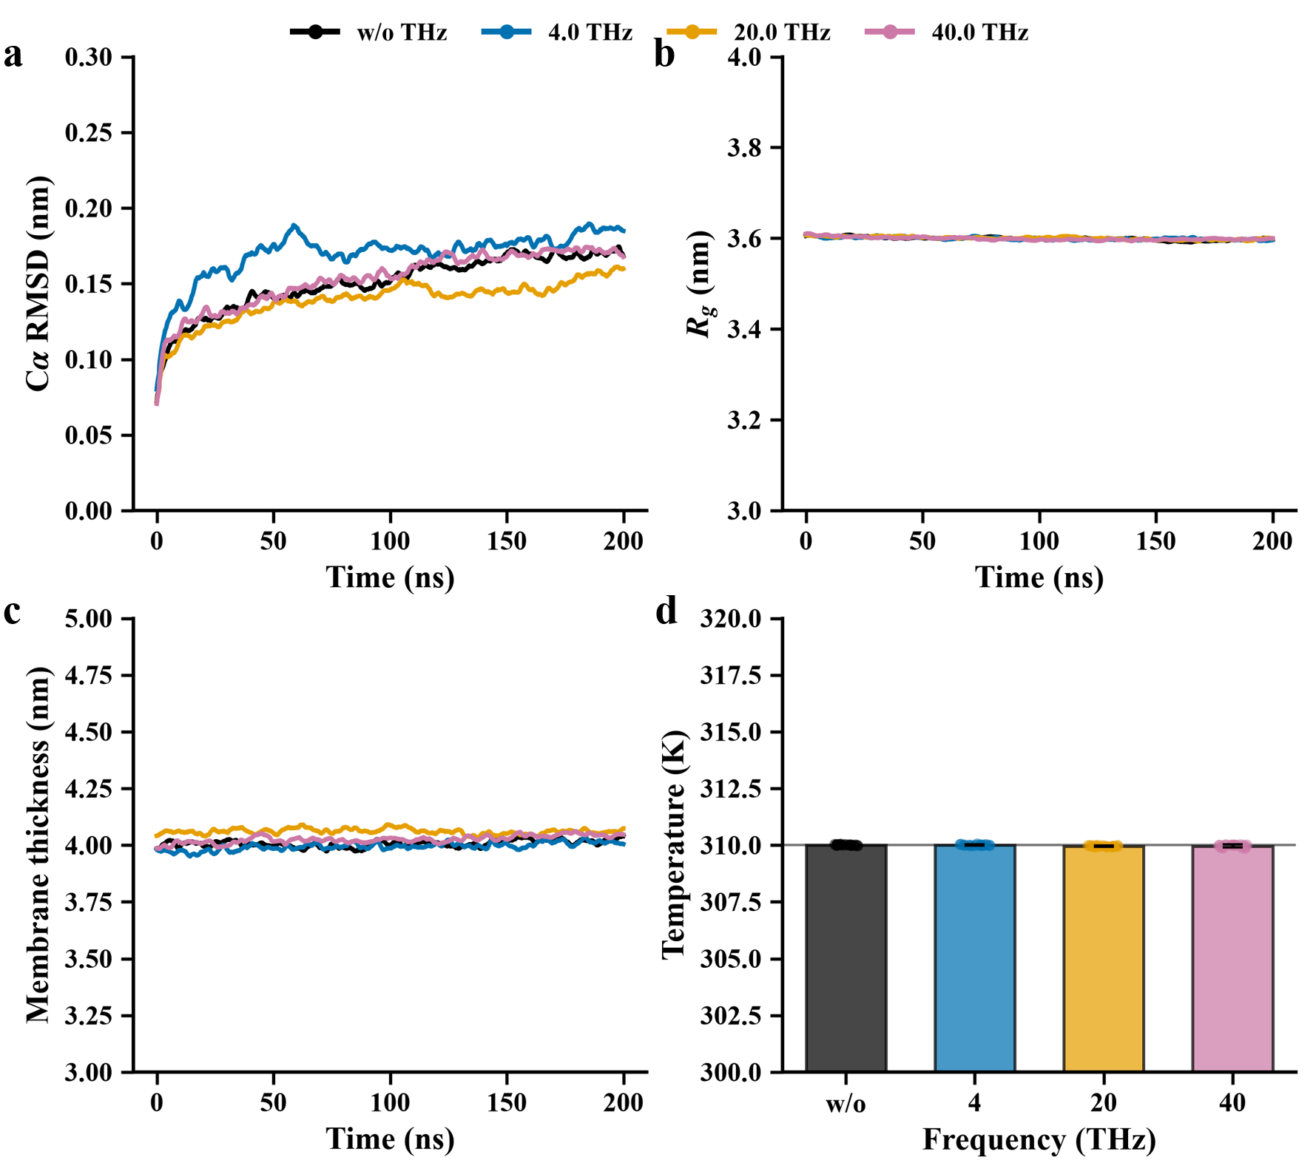 Figure S6. Structural and thermal stability of the membrane protein system under terahertz excitation. (a) Cα root-mean-square deviation (RMSD) of the membrane protein. (b) Protein radius of gyration Rg. (c) Membrane thickness. (d) Average system temperature. Results are shown for w/o THz, 4.0, 20.0, and 40.0 THz conditions over the 200 ns simulations.

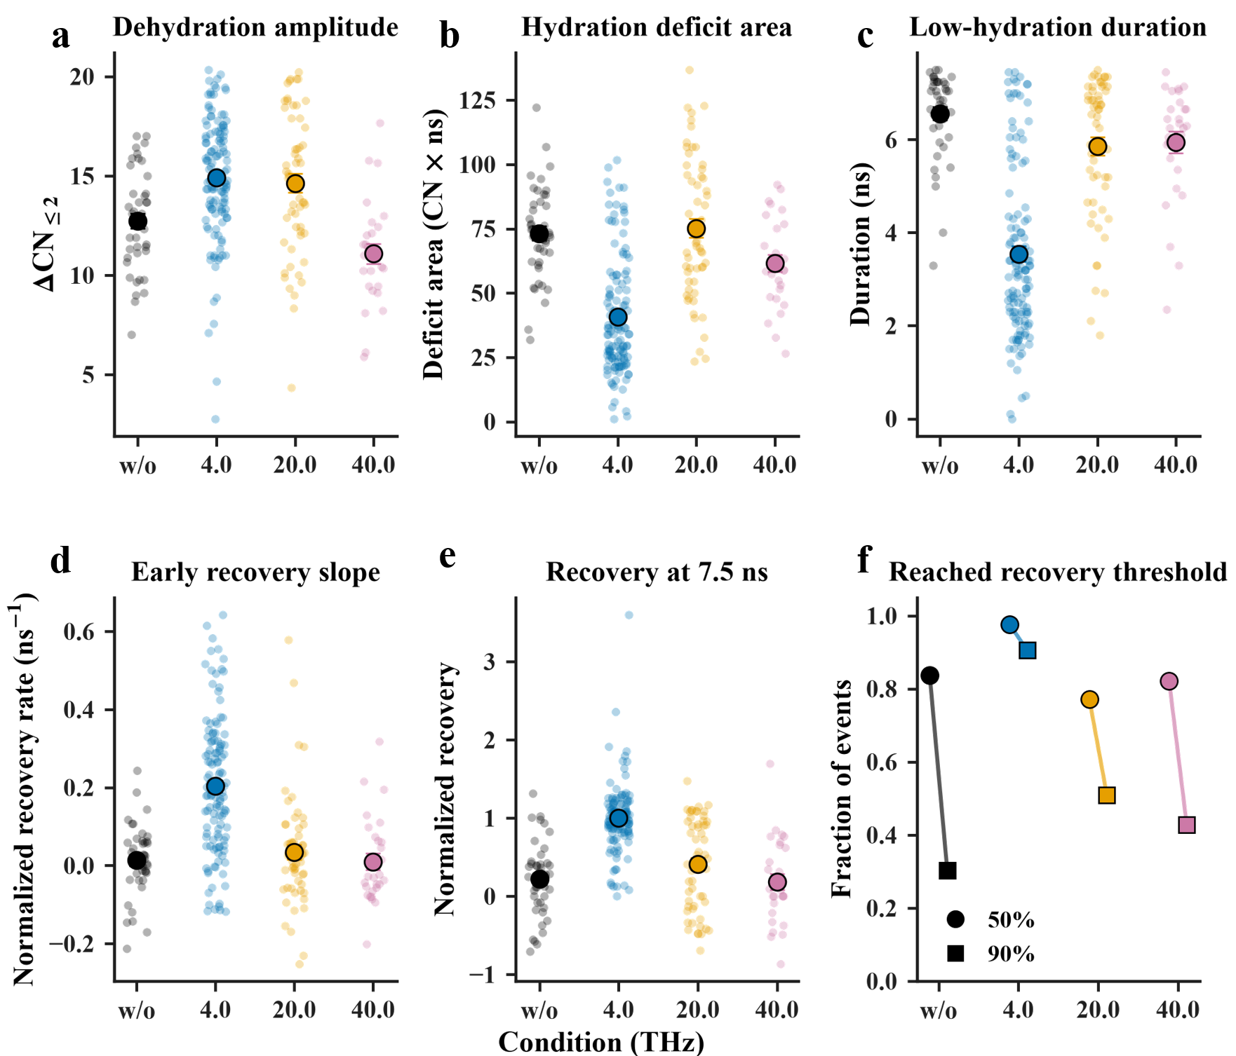
Figure S7. Event-resolved Na⁺ hydration perturbation and recovery during transmembrane permeation. (a) Dehydration amplitude. (b) Integrated hydration deficit area. (c) Duration of the low-hydration state. (d) Early hydration-recovery slope. (e) Normalized hydration recovery at 7.5 ns after pore entry. (f) Fractions of permeation events reaching 50% and 90% of the pre-entry hydration level. Small circles represent individual events, whereas large symbols with error bars summarize the corresponding event distributions under w/o THz, 4.0, 20.0, and 40.0 THz conditions.

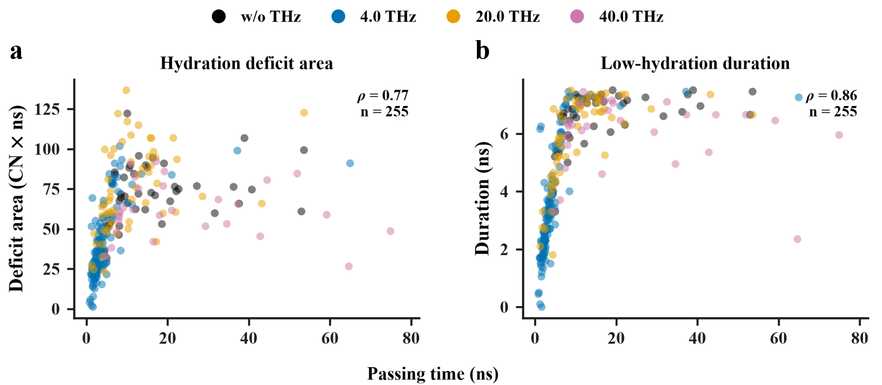
Figure S8. Correlations between Na⁺ hydration-recovery metrics and passage time. (a) Hydration deficit area and (b) low-hydration duration. Each point represents an individual permeation event under w/o THz, 4.0, 20.0, or 40.0 THz conditions. Pooled Spearman correlation coefficients (ρ) are indicated in each panel.

