SUPPLEMENTAL MATERIAL
Table of
Content
Table S1. The questionnaire utilized in the current study.
Table S2. The Climate Change Anxiety Scale utilized in the current study.
Table S3. Healthcare workers’ perceptions of climate change and their health consequences.
Table S4. Healthcare workers’ perceptions of extreme weather events and their health consequences.
Table S5. Climate anxiety among participants in different subgroups.
Figure S1. Distribution of Climate Change Anxiety Scale scores among healthcare workers.

Table S1. The questionnaire utilized in the current study.
Item | Question
Part Ⅰ
Q1 | Do you think climate change is a public health issue?
Q2 | Do you think climate change has a significant impact on public health?
Q3 | Do you think it is necessary for universities to include courses on climate change and health?
Q4 | Do you believe that the Centers for Disease Control and Prevention play an important role in addressing the health impacts of climate change?
Q5 | Do you believe that clinical workers play an important role in addressing the health impacts of climate change?
Q6 | In which of the following scenarios do you think hospitals need to strengthen public education or interventions regarding climate change and health?
Q7 | Has your workplace developed any emergency response plans or contingency plans addressing health risks related to climate change? (e.g., health alerts for heat waves, medical response plans for weather disasters, etc.)?
Part Ⅱ
Q8 | Over the past three years, have you followed any news reports or research on the health impacts of extreme weather events (heat waves, cold waves, floods, and blizzards)?
Q9 | Do you think health alerts for extreme weather events (heat waves, cold waves, floods, and blizzards) are important?
Q10 | In your opinion, how much emphasis does your current workplace place on health protection in response to extreme weather events (heat waves, cold waves, floods, and blizzards)?
Q11 | Which of the following extreme weather events do you think has the greatest impact on public health?
Q12 | What effects do you think extreme weather events (heat waves, cold waves, floods, and blizzards) have on health?
Q13 | Would you be interested in participating in professional training or continuing education on extreme weather events related health (heat waves, cold waves, floods, and blizzards)?
Q14 | What are the main factors influencing your participation in training related to extreme weather events (heat waves, cold waves, floods, and blizzards)?

Table S2. The Climate Change Anxiety Scale utilized in the current study.
Item | Question
A | Thinking about climate change makes it difficult for me to concentrate.
B | Thinking about climate change makes it difficult for me to sleep.
C | I have nightmares about climate change.
D | I find myself crying because of climate change.
E | I think, “why can’t I handle climate change better?”
F | I go away by myself and think about why I feel this way about climate change.
G | I write down my thoughts about climate change and analyze them.
H | I think, “why do I react to climate change this way?”
I | My concerns about climate change make it hard for me to have fun with my family or friends.
J | I have problems balancing my concerns about sustainability with the needs of my family.
K | My concerns about climate change interfere with my ability to get work or school assignments done.
L | My concerns about climate change undermine my ability to work to my potential.
M | My friends say I think about climate change too much.

Table S3. Healthcare workers’ perceptions of climate change and its health consequences.
Variable | Subgroup | Q1 |  |  | Q2 |  |  |  |  | Q3 |  |  |  | Q4 |  |  | Q5 |  |  | Q7
Variable | Subgroup | Yes | No | P | Strongly agree | Agree | Disagree | I don’t know | P | Yes | No | I don’t  know | P | Yes | No | P | Yes | No | P | Yes | No | I don’t  know | P
Gender | Males | 565  (95.12%) | 29  (4.88%) | 0.8294 | 399  (67.06%) | 163  (27.39%) | 30  (5.04%) | 3  (0.50%) | 0.6779 | 506  (85.04%) | 25  (4.20%) | 64  (10.76%) | 0.2269 | 218  (78.14%) | 61  (21.86%) | 0.7248 | 264  (83.54%) | 52  (16.46%) | 0.6791 | 337  (56.64%) | 82  (13.78%) | 176  (29.58%) | ＜0.001
Gender | Females | 1035  (95.48%) | 49  (4.52%) | 0.8294 | 737  (67.93%) | 292  (26.91%) | 50  (4.61%) | 6  (0.55%) | 0.6779 | 948  (87.37%) | 30  (2.76%) | 107  (9.86%) | 0.2269 | 201  (79.76%) | 51  (20.24%) | 0.7248 | 706  (84.75%) | 127  (15.25%) | 0.6791 | 692  (63.78%) | 82  (7.56%) | 311  (28.66%) | ＜0.001
Age | 20-29 years | 296  (96.73%) | 10  (3.27%) | 0.1836 | 190  (62.30%) | 105  (34.43%) | 9  (2.95%) | 1  (0.33%) | 0.0534 | 256  (83.93%) | 20  (5.65%) | 29  (9.51%) | 0.009 | 91  (75.83%) | 29  (24.17%) | 0.4256 | 153  (82.70%) | 32  (17.30%) | 0.0481 | 184  (60.33%) | 18  (5.90%) | 103  (33.77%) | 0.0071
Age | 30-39 years | 639  (93.83%) | 42  (6.17%) | 0.1836 | 467  (68.68%) | 166  (24.41%) | 43  (6.32%) | 4  (0.59%) | 0.0534 | 574  (84.41%) | 25  (3.68%) | 81  (11.91%) | 0.009 | 151  (77.84%) | 43  (22.16%) | 0.4256 | 398  (81.89%) | 88  (18.11%) | 0.0481 | 407  (59.85%) | 69  (10.15%) | 204  (30.00%) | 0.0071
Age | 40-49 years | 428  (95.96%) | 18  (4.04%) | 0.1836 | 310 (69.66%) | 117  (26.29%) | 17  (3.82%) | 1  (0.22%) | 0.0534 | 398  (89.44%) | 7  (1.57%) | 40  (8.99%) | 0.009 | 94  (78.99%) | 25  (21.01%) | 0.4256 | 290  (88.96%) | 36  (11.04%) | 0.0481 | 283  (63.60%) | 57  (12.81%) | 105  (23.60%) | 0.0071
Age | ≥50 years | 239  (95.22%) | 12  (4.78%) | 0.1836 | 169  (67.60%) | 67  (26.80%) | 11  (4.40%) | 3  (1.20%) | 0.0534 | 226  (90.40%) | 3  (1.20%) | 21  (8.40%) | 0.009 | 83  (84.69%) | 15  (15.31%) | 0.4256 | 129  (84.87%) | 23  (15.13%) | 0.0481 | 155  (62.00%) | 20  (8.00%) | 75  (30.00%) | 0.0071
Occupation | Doctor | 545  (97.67%) | 13  (2.33%) | 0.0014 | 398  (71.33%) | 141  (25.27%) | 14  (2.51%) | 5  (0.90%) | 0.0753 | 480  (86.02%) | 17  (3.05%) | 61  (10.93%) | 0.5994 | - | - |  | - | - |  | 334  (59.86%) | 53  (9.50%) | 171  (30.65%) | ＜0.001
Occupation | Nurse | 462  (94.09%) | 29  (5.91%) | 0.0014 | 317  (64.56%) | 142  (28.92%) | 29  (5.91%) | 3  (0.61%) | 0.0753 | 435  (88.59%) | 16  (3.26%) | 40  (8.15%) | 0.5994 | - | - |  | - | - |  | 339  (69.04%) | 30  (6.11%) | 122  (24.85%) | ＜0.001
Occupation | Public health physicians | 201  (97.10%) | 6  (2.90%) | 0.0014 | 135  (65.22%) | 66  (31.88%) | 6  (2.90%) | 0 | 0.0753 | 180  (86.96%) | 5  (2.42%) | 22  (10.63%) | 0.5994 | - | - |  | - | - |  | 115  (55.56%) | 36  (17.39%) | 56  (27.05%) | ＜0.001
Occupation | Others | 394  (92.92%) | 30  (7.08%) | 0.0014 | 286  (67.45%) | 106  (25.00%) | 31  (7.31%) | 1  (0.24%) | 0.0753 | 359  (84.67%) | 17  (4.01%) | 48  (11.32%) | 0.5994 | - | - |  | - |  |  | 241  (56.84%) | 45  (10.61%) | 138  (32.55%) | ＜0.001
Workplace | Hospitals | 1101  (97.43%) | 29  (2057%) | ＜0.001 | 772  (67.19%) | 319  (27.76%) | 51  (4.44%) | 7  (0.61%) | 0.3308 | 991  (86.25%) | 38  (3.31%) | 120  (10.44%) | 0.8602 | - | - |  | - | - |  | 730  (63.53%) | 85  (7.40%) | 334  (29.07%) | ＜0.001
Workplace | Centers for Disease  Control and Prevention | 501  (91.09%) | 49  (8.91%) | ＜0.001 | 364  (65.12%) | 164  (29.34%) | 29  (5.19%) | 2  (0.36%) | 0.3308 | 463  (87.19%) | 17  (3.20%) | 51  (9.60%) | 0.8602 | - | - |  | - | - |  | 299  (56.31%) | 79  (14.88%) | 153  (28.81%) | ＜0.001

Table S4. Healthcare workers’ perceptions of extreme weather events and its health consequences.
Variable | Subgroup | Q8 |  |  |  | Q9 |  |  | Q10 |  |  |  |  | Q13
Variable | Subgroup | Often | Sometimes | Never | P | Yes | No | P | Great emphasis | Moderate emphasis | Little emphasis | I don’t know | P | Yes | No | I don’t know | P
Gender | Males | 320  (53.78%) | 254  (42.69%) | 21  (3.53%) | 0.0002 | 587  (98.66%) | 8  (1.34%) | 0.2355 | 312  (52.44%) | 232  (38.99%) | 16  (2.69%) | 35  (5.88%) | 0.0513 | 507  (85.21%) | 25  (4.20%) | 63  (10.59%) | 0.0565
Gender | Females | 480  (44.24%) | 555  (51.15%) | 50  (4.61%) | 0.0002 | 1078 (99.35%) | 7  (0.65%) | 0.2355 | 626  (57.70%) | 373  (34.38%) | 21  (1.94%) | 65  (5.99%) | 0.0513 | 962  (88.66%) | 26  (2.40%) | 97  (8.94%) | 0.0565
Age | 20-29 years | 130  (42.62%) | 163  (53.44%) | 12  (3.93%) | 0.0001 | 300  (98.36%) | 5  (1.64%) | 0.4802 | 183  (60.00%) | 105  (34.43%) | 5  (1.64%) | 12  (3.93%) | 0.2961 | 254  (83.28%) | 15  (4.92%) | 36  (11.80%) | 0.0082
Age | 30-39 years | 289  (42.50%) | 359  (52.79%) | 32  (4.71%) | 0.0001 | 674  (99.12%) | 6  (0.88%) | 0.4802 | 375  (55.15%) | 240  (35.29%) | 13  (1.91%) | 52  (7.65%) | 0.2961 | 589  (86.62%) | 25  (3.68%) | 66  (9.71%) | 0.0082
Age | 40-49 years | 229  (51.46%) | 198  (44.49%) | 18  (4.04%) | 0.0001 | 442  (99.33%) | 3  (0.67%) | 0.4802 | 241  (54.16%) | 168  (37.75%) | 15  (3.37%) | 21  (4.72%) | 0.2961 | 394  (88.54%) | 11  (2.47%) | 40  (8.99%) | 0.0082
Age | ≥50 years | 152  (60.80%) | 89  (35.60%) | 9  (3.60%) | 0.0001 | 249  (99.60%) | 1  (0.40%) | 0.4802 | 139  (55.60%) | 92  (36.80%) | 4  (1.60%) | 15  (6.00%) | 0.2961 | 232  (92.80%) | 0 | 18  (7.20%) | 0.0082
Occupation | Doctor | 292  (52.33%) | 244  (43.73%) | 22  (3.94%) | 0.0258 | 556  (99.64%) | 2  (0.36%) | 0.1859 | 293  (52.51%) | 222  (39.78%) | 12  (2.15%) | 31  (5.56%) | 0.0076 | 483  (86.56%) | 13  (2.33%) | 62  (11.11%) | 0.0163
Occupation | Nurse | 213  (43.38%) | 254  (51.73%) | 24  (4.89%) | 0.0258 | 487  (99.19%) | 4  (0.81%) | 0.1859 | 301  (61.30%) | 157  (31.98%) | 8  (1.63%) | 25  (5.09%) | 0.0076 | 442  (90.02%) | 10  (2.04%) | 39  (7.94%) | 0.0163
Occupation | Public health physicians | 103  (49.76%) | 95  (45.89%) | 9  (4.35%) | 0.0258 | 205  (99.03%) | 2  (0.97%) | 0.1859 | 100  (48.30%) | 88  (42.51%) | 10  (4.83%) | 9  (4.35%) | 0.0076 | 180  (86.96%) | 13  (6.28%) | 14  (6.76%) | 0.0163
Occupation | Others | 192  (45.28%) | 216  (50.94%) | 16  (3.77%) | 0.0258 | 417  (98.35%) | 7  (1.65%) | 0.1859 | 244  (57.55%) | 138  (32.55%) | 7  (1.65%) | 35  (8.25%) | 0.0076 | 364  (85.85%) | 15  (3.54%) | 45  (10.61%) | 0.0163
Workplace | Hospitals | 552  (48.04%) | 551  (47.95%) | 46  (4.00%) | 0.5377 | 1143 (99.48%) | 6  (0.52%) | 0.0360 | 634  (55.18%) | 417  (36.29%) | 23  (2.00%) | 75  (6.53%) | 0.3492 | 1008  (87.73%) | 25  (2.18%) | 116  (10.10%) | 0.0063
Workplace | Centers for Disease  Control and Prevention | 248  (46.70%) | 258  (48.59%) | 25  (4.71%) | 0.5377 | 522  (98.31%) | 9  (1.69%) | 0.0360 | 304  (57.25%) | 188  (35.40%) | 14  (2.64%) | 25  (4.71%) | 0.3492 | 461  (86.82%) | 26  (4.90%) | 44  (8.29%) | 0.0063

Table S5. Climate anxiety among participants in different subgroups.
Variable | Subgroup | Median (25th,75th) | P
Gender | Males | 14 (7-24) | 0.683
Gender | Females | 14 (7-22) | 0.683
Age | 20-29 years | 13 (5-22) | 0.1552
Age | 30-39 years | 14 (8-23) | 0.1552
Age | 40-49 years | 14 (8-22) | 0.1552
Age | ≥50 years | 13 (8-20) | 0.1552
Occupation | Doctor | 14 (6-23) | 0.0001
Occupation | Nurse | 16 (11-26) | 0.0001
Occupation | Public health physicians | 10 (5-16) | 0.0001
Occupation | Others | 13 (6-19) | 0.0001
Workplace | Hospitals | 15 (8-25) | 0.0001
Workplace | Centers for Disease Control and Prevention | 12 (5-17) | 0.0001

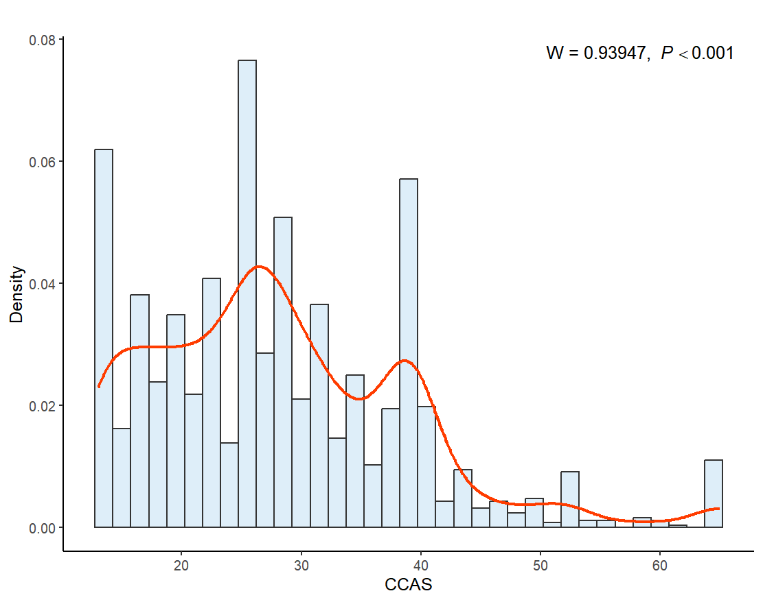Figure S1. Distribution of Climate Change Anxiety Scale scores among public health and clinical workers.

