Supplementary Material
Associations of four insulin resistance-related indices with vagal heart rate variability and confirmed cardiovascular autonomic neuropathy in type 2 diabetes: a cross-sectional study
Tianqi Wang, Boyu Chen, Siwen Zhao, Qijun Fang, Jiulong Wu, Shanmei Shen, Chenxi Li, Weimin Wang, Yan Bi
Supplementary Tables
Table S1. Stepwise multivariable associations of four insulin resistance-related indices with vagally mediated heart rate variability.
Index | Outcome | Model | n | Beta per 1 SD (95% CI) | P value | % difference
TyG | log-RMSSD | Model 1 | 1360 | -0.114 (-0.148, -0.080) | <0.001 | -10.8
TyG | log-RMSSD | Model 2 | 1153 | -0.103 (-0.142, -0.064) | <0.001 | -9.8
TyG | log-RMSSD | Model 3 | 1145 | -0.106 (-0.147, -0.064) | <0.001 | -10.0
TyG | log-HF | Model 1 | 1356 | -0.245 (-0.317, -0.173) | <0.001 | -21.7
TyG | log-HF | Model 2 | 1151 | -0.220 (-0.303, -0.137) | <0.001 | -19.8
TyG | log-HF | Model 3 | 1143 | -0.229 (-0.316, -0.141) | <0.001 | -20.4
TG/HDL-C | log-RMSSD | Model 1 | 1365 | -0.064 (-0.097, -0.031) | <0.001 | -6.2
TG/HDL-C | log-RMSSD | Model 2 | 1156 | -0.059 (-0.095, -0.023) | 0.001 | -5.7
TG/HDL-C | log-RMSSD | Model 3 | 1146 | -0.078 (-0.116, -0.040) | <0.001 | -7.5
TG/HDL-C | log-HF | Model 1 | 1361 | -0.128 (-0.198, -0.058) | <0.001 | -12.0
TG/HDL-C | log-HF | Model 2 | 1154 | -0.114 (-0.191, -0.038) | 0.003 | -10.8
TG/HDL-C | log-HF | Model 3 | 1144 | -0.158 (-0.239, -0.077) | <0.001 | -14.6
TyG-WC | log-RMSSD | Model 1 | 1338 | -0.089 (-0.124, -0.055) | <0.001 | -8.6
TyG-WC | log-RMSSD | Model 2 | 1138 | -0.084 (-0.123, -0.046) | <0.001 | -8.1
TyG-WC | log-RMSSD | Model 3 | 1130 | -0.083 (-0.123, -0.044) | <0.001 | -8.0
TyG-WC | log-HF | Model 1 | 1334 | -0.209 (-0.282, -0.136) | <0.001 | -18.9
TyG-WC | log-HF | Model 2 | 1136 | -0.200 (-0.281, -0.119) | <0.001 | -18.1
TyG-WC | log-HF | Model 3 | 1128 | -0.201 (-0.284, -0.118) | <0.001 | -18.2
CTI | log-RMSSD | Model 1 | 1346 | -0.122 (-0.157, -0.088) | <0.001 | -11.5
CTI | log-RMSSD | Model 2 | 1142 | -0.115 (-0.154, -0.075) | <0.001 | -10.8
CTI | log-RMSSD | Model 3 | 1141 | -0.116 (-0.157, -0.075) | <0.001 | -10.9
CTI | log-HF | Model 1 | 1342 | -0.267 (-0.339, -0.194) | <0.001 | -23.4
CTI | log-HF | Model 2 | 1140 | -0.245 (-0.328, -0.161) | <0.001 | -21.7
CTI | log-HF | Model 3 | 1139 | -0.247 (-0.333, -0.160) | <0.001 | -21.9
Model 1 adjusted for age and sex; Model 2 additionally adjusted for BMI and HbA1c; Model 3 additionally adjusted for eGFR and LDL-C. BMI was omitted from TyG-WC Models 2–3 because waist circumference is incorporated in the index. Model 4 results are reported in Table 2. Beta coefficients are per 1-SD increment; percentage differences were calculated as [exp(beta)-1] x 100.
Table S2. Stepwise multivariable associations of four insulin resistance-related indices with confirmed cardiovascular autonomic neuropathy.
Index | Model | n | Cases | OR per 1 SD (95% CI) | P value
TyG | Model 1 | 1348 | 219 | 1.293 (1.111, 1.506) | <0.001
TyG | Model 2 | 1137 | 182 | 1.182 (0.987, 1.414) | 0.069
TG/HDL-C | Model 1 | 1352 | 218 | 1.062 (0.942, 1.198) | 0.323
TG/HDL-C | Model 2 | 1140 | 182 | 1.041 (0.902, 1.203) | 0.581
TyG-WC | Model 1 | 1325 | 211 | 1.277 (1.098, 1.486) | 0.002
TyG-WC | Model 2 | 1122 | 178 | 1.258 (1.063, 1.489) | 0.008
CTI | Model 1 | 1334 | 214 | 1.388 (1.186, 1.625) | <0.001
CTI | Model 2 | 1127 | 179 | 1.297 (1.077, 1.561) | 0.006
Model 1 adjusted for age and sex; Model 2 additionally adjusted for BMI and HbA1c. BMI was omitted from the TyG-WC model. Model 3 results are reported in Table 3. Odds ratios are reported per 1-SD increment.
Table S3. Pairwise comparisons of the areas under the receiver operating characteristic curves for confirmed CAN.
Comparison | Delta AUC | SE | z | P value
TyG vs TG/HDL-C | 0.017 | 0.014 | 1.171 | 0.242
TyG vs CTI | -0.011 | 0.009 | -1.180 | 0.238
TyG vs TyG-WC | 0.023 | 0.017 | 1.332 | 0.183
TG/HDL-C vs CTI | -0.028 | 0.016 | -1.706 | 0.088
TG/HDL-C vs TyG-WC | 0.006 | 0.018 | 0.343 | 0.732
CTI vs TyG-WC | 0.034 | 0.017 | 1.944 | 0.052
Paired DeLong tests were performed in the common complete-case sample (n=1,312; 207 confirmed-CAN cases). Single-index AUC estimates are reported in Table 4.
Table S4. Overall and non-linearity tests from restricted cubic spline analyses.
Index | Outcome | n | Cases | Reference | P overall | P nonlinear
TyG | log-RMSSD | 1145 |  | 9.059 | 0.007 | 0.040
TyG | log-HF | 1143 |  | 9.059 | 0.024 | 0.290
TyG | Confirmed CAN | 1129 | 180 | 9.066 | 0.285 | 0.793
TG/HDL-C | log-RMSSD | 1146 |  | 1.279 | 0.005 | 0.026
TG/HDL-C | log-HF | 1144 |  | 1.279 | 0.008 | 0.031
TG/HDL-C | Confirmed CAN | 1130 | 180 | 1.297 | 0.204 | 0.373
TyG-WC | log-RMSSD | 1130 |  | 832.305 | 0.587 | 0.826
TyG-WC | log-HF | 1128 |  | 832.305 | 0.220 | 0.977
TyG-WC | Confirmed CAN | 1114 | 176 | 835.859 | 0.071 | 0.692
CTI | log-RMSSD | 1141 |  | 9.684 | 0.014 | 0.073
CTI | log-HF | 1139 |  | 9.684 | 0.020 | 0.157
CTI | Confirmed CAN | 1126 | 179 | 9.692 | 0.068 | 0.794
Restricted cubic spline models used the outcome-specific fully adjusted covariate sets (Model 4 for HRV and Model 3 for confirmed CAN); BMI was omitted from TyG-WC models. The reference value was the median of each index.
Table S5. Component analyses of triglycerides, fasting plasma glucose, and C-reactive protein.
Component | Outcome | n | Cases | Effect per 1 SD (95% CI) | P value
ln(TG) | log-RMSSD | 1146 | — | -0.045 (-0.077, -0.014) | 0.005
ln(FPG) | log-RMSSD | 1145 | — | 0.004 (-0.031, 0.040) | 0.812
ln(CRP) | log-RMSSD | 1142 | — | -0.006 (-0.035, 0.023) | 0.680
ln(TG) | log-HF | 1144 | — | -0.101 (-0.169, -0.033) | 0.004
ln(FPG) | log-HF | 1143 | — | -0.004 (-0.081, 0.073) | 0.923
ln(CRP) | log-HF | 1140 | — | -0.020 (-0.084, 0.043) | 0.534
ln(TG) | Confirmed CAN | 1130 | 180 | 1.157 (0.971, 1.378) | 0.102
ln(FPG) | Confirmed CAN | 1129 | 180 | 1.083 (0.880, 1.332) | 0.451
ln(CRP) | Confirmed CAN | 1127 | 179 | 1.280 (1.069, 1.533) | 0.007
Components were natural-log transformed and standardized. Estimates are from the outcome-specific fully adjusted models (Model 4 for HRV and Model 3 for confirmed CAN). Beta, linear-regression coefficient; OR, odds ratio.
Table S6. Sensitivity analyses using expanded clinical and medication-adjusted models.
Index | Outcome | Expanded clinical n | Effect per 1 SD (95% CI) | P | Expanded clinical + medication n | Effect per 1 SD (95% CI) | P
TyG | log-RMSSD | 1143 | -0.045 (-0.079, -0.011) | .009 | 1143 | -0.044 (-0.080, -0.009) | .013
TyG | log-HF | 1141 | -0.100 (-0.173, -0.027) | .008 | 1141 | -0.096 (-0.172, -0.020) | .014
TG/HDL-C | log-RMSSD | 1144 | -0.039 (-0.069, -0.008) | .014 | 1144 | -0.038 (-0.069, -0.007) | .018
TG/HDL-C | log-HF | 1142 | -0.076 (-0.142, -0.009) | .025 | 1142 | -0.073 (-0.141, -0.005) | .035
CTI | log-RMSSD | 1139 | -0.044 (-0.077, -0.010) | .011 | 1139 | -0.044 (-0.079, -0.009) | .015
CTI | log-HF | 1137 | -0.096 (-0.169, -0.022) | .011 | 1137 | -0.092 (-0.168, -0.016) | .018
TyG-WC | log-RMSSD | 1128 | -0.027 (-0.061, 0.006) | .113 | 1128 | -0.030 (-0.067, 0.006) | .107
TyG-WC | log-HF | 1126 | -0.081 (-0.153, -0.008) | .029 | 1126 | -0.085 (-0.163, -0.006) | .035
TyG | Confirmed CAN | 1129/180 | 1.145 (0.940, 1.394) | .179 | 1129/180 | 1.118 (0.910, 1.373) | .289
TG/HDL-C | Confirmed CAN | 1130/180 | 1.148 (0.958, 1.375) | .135 | 1130/180 | 1.127 (0.937, 1.355) | .206
CTI | Confirmed CAN | 1126/179 | 1.259 (1.030, 1.539) | .025 | 1126/179 | 1.241 (1.005, 1.533) | .045
TyG-WC | Confirmed CAN | 1114/176 | 1.177 (0.979, 1.414) | .083 | 1114/176 | 1.174 (0.957, 1.441) | .124
Values are β coefficients for HRV outcomes and odds ratios for confirmed CAN, each per 1-SD increment. For confirmed CAN, n/cases is reported. The expanded clinical model additionally adjusted for diabetes duration, supine systolic blood pressure, current or former smoking, and beta-blocker use. The expanded clinical plus medication model further adjusted for ACE inhibitor/ARB, statin, SGLT2 inhibitor, GLP-1 receptor agonist, insulin, and calcium channel blocker use. Resting mean heart rate was included only in HRV models; BMI was omitted from TyG-WC models.
Supplementary Figures
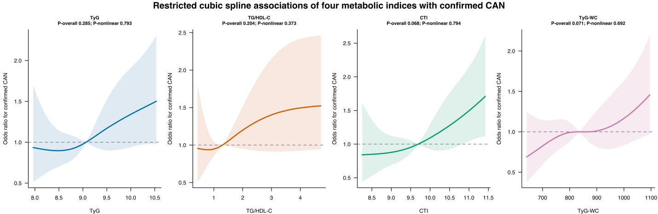
Figure S1. Restricted cubic spline associations of four metabolic indices with confirmed CAN.
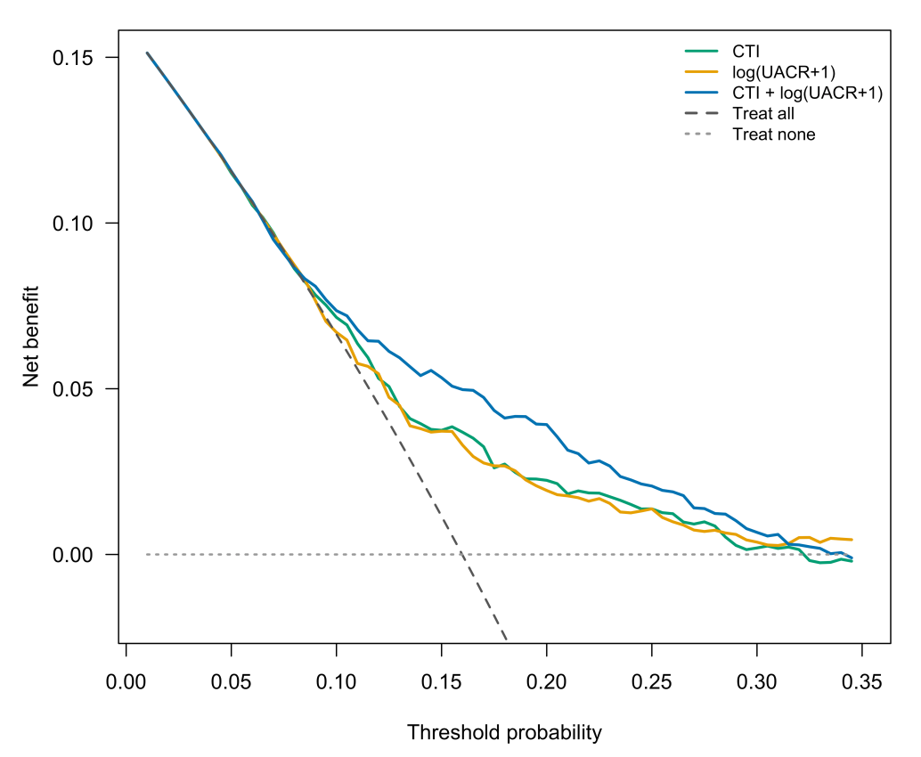
Figure S2. Decision-curve analysis of the exploratory CTI and ln(UACR+1) model. The analysis included 1,308 participants with complete CTI, UACR, and confirmed-CAN data (209 cases).

