Supplementary materials

Supplementary section 1. Additional Dim light melatonin onset (DLMO) considerations to establish baseline values and saliva melatonin concentration threshold.
• Selection of the three initial low melatonin level datapoints for calculating baseline average and standard deviation (SD) calculation is ideal.
• If baseline is unstable or clear artifacts are present, selection of the 3 lowest data points prior to visual DLMO is acceptable.
• Transient increases (1 or 2 datapoints) with return to low level data points are typically not considered DLMO. A sustained increase of melatonin levels above baseline threshold is required to establish DLMO.
• Initial high melatonin level data points can be ignored if a subsequent low melatonin level baseline is present.
• In some cases, 1 or 2 low level data points may be used as baseline instead of 3 if visual DLMO is apparent later.

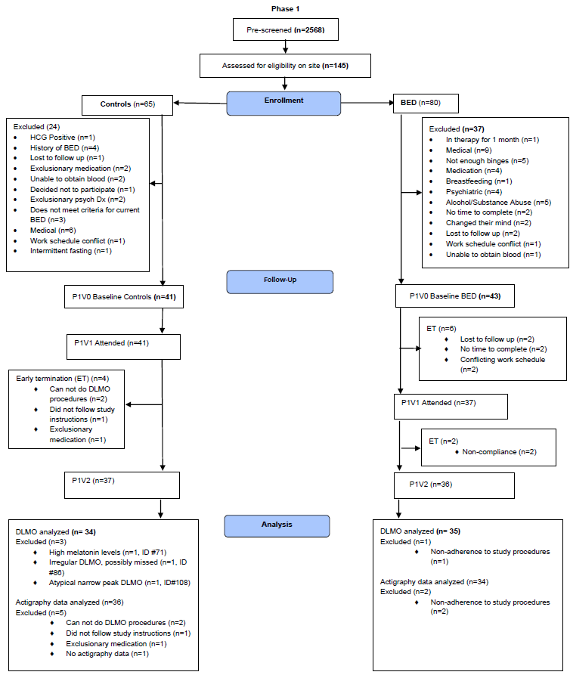
Supplementary figure 1. CONSORT flow diagram for phase 1

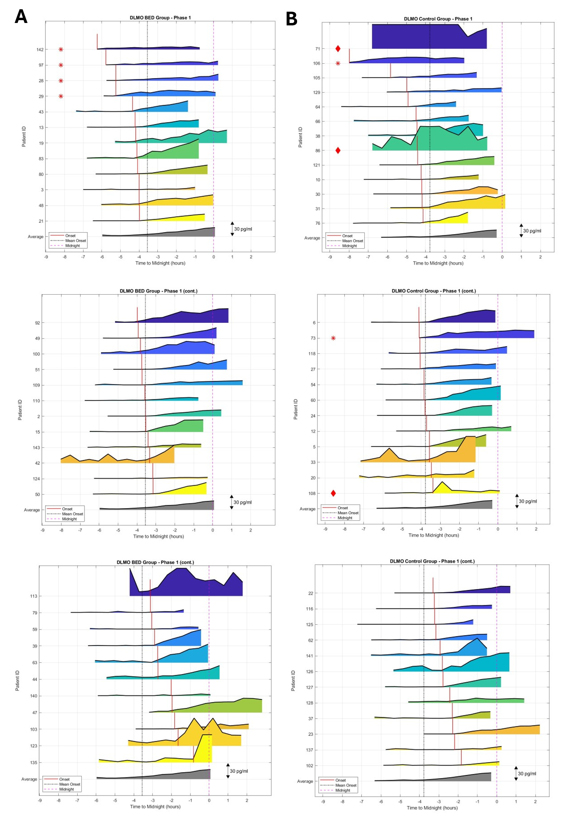

Supplementary figure 2. Dim light melatonin onset plots for the binge eating disorder (BED, n=36) in (A) and control (n=35) groups in (B). Red asterisks indicate cases excluded in sensitivity analysis, while red diamond shapes indicate cases exluded due to unreliable or not evident DLMOs. Y-axis reflects melatonin concentration (pg/ml) in saliva with each row scaled at a height of 30 pg/ml. Maximum melatonin concentration levels reported by the radioimmunoassay were 50 pg/ml.
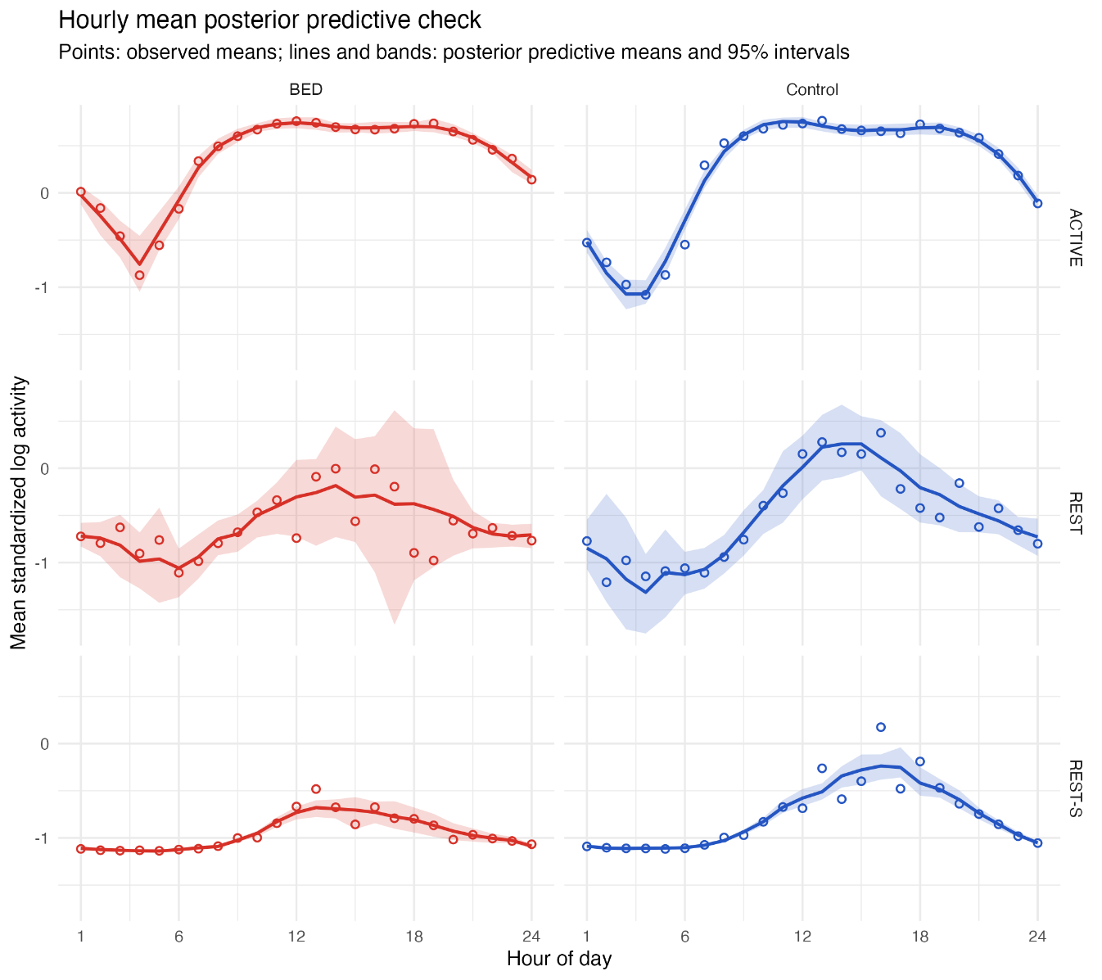
Supplementary figure 3. Posterior predictive checks of hourly locomotor activity. Observed hourly mean standardized log activity (open circles) is compared with the posterior-predicted mean (solid lines) and 95% posterior predictive intervals (shaded regions). Results are stratified by group—BED (red) and control (blue)—and activity interval status (ACTIVE, REST, and REST-Sleep [REST-S]).

Supplementary table 1. Correlation between phase 1 DLMO and BED severity measures.
Phase 1 Correlations in the BED group |  |  |  |  |  | Sensitivity analysis
 | r | p-value | n |  |  | r | p-value | n
DLMO BL (3 BL + 2 SD) vs. BE days | 0.28 | 0.11 | 35 |  |  | 0.25 | 0.17 | 31
DLMO BL (3 BL + 2 SD) vs. BE episodes | 0.22 | 0.22 | 35 |  |  | 0.27 | 0.15 | 31
DLMO BL (3 BL + 2 SD) vs. YBOCS-BE total | 0.50 | <0.01 | 35 |  |  | 0.46 | 0.01 | 31
DLMO BL (3 BL + 2 SD) vs. YBOCS-BE obsessional | 0.37 | 0.03 | 35 |  |  | 0.31 | 0.09 | 31
DLMO BL (3 BL + 2 SD) vs. YBOCS-BE compulsion | 0.51 | <0.01 | 35 |  |  | 0.51 | <0.01 | 31

Supplementary figure 4. CONSORT flow diagram for phase 2
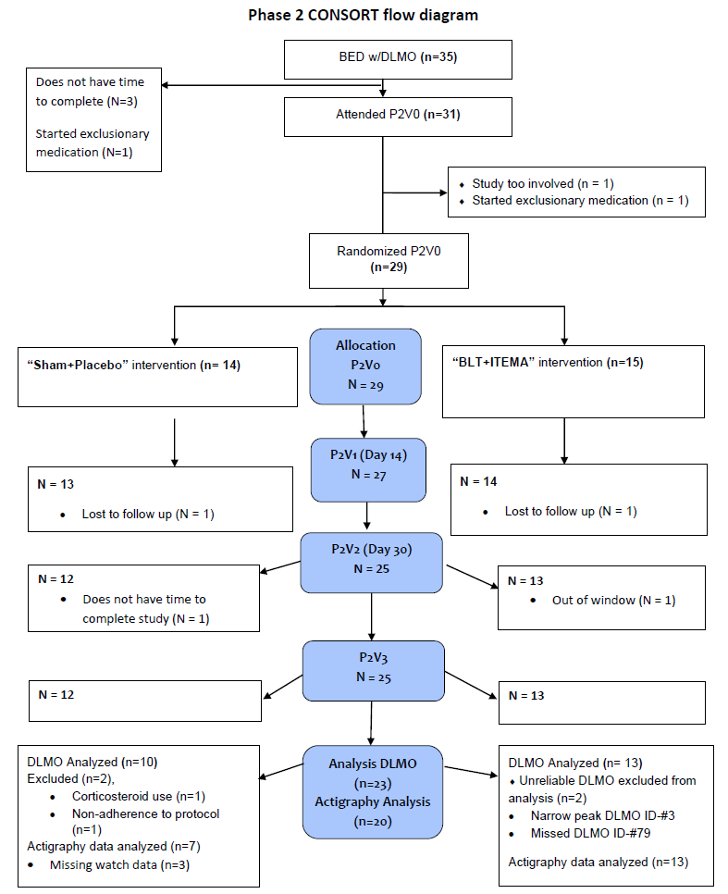

Supplementary table 2. Baseline characteristics for Phase 2 intervention groups.
 | BED BLT+ITEMA |  | BED Sham+Placebo
 | Mean (SD) | n | Mean (SD) | n | p-value
Age | 39.4 (7.4) | 14 | 39.9 (10.3) | 12 | 0.89
DLMO BL + 2 SD, hours | 20.41 (1.21) | 11 | 20.69 (0.73) | 10 | 0.53
SOT, hours | 23.96 (1.03) | 13 | 23.83 (1.06) | 10 | 0.78
Phase angle, hours | 3.75 (1.07) | 11 | 3.14 (0.80) | 10 | 0.16
BE days (last 14 days) | 5.5 (3.2) | 14 | 6.8 (2.0) | 11 | 0.28
BE episodes (last 14 days) | 6.0 (6.2) | 14 | 7.7 (3.3) | 11 | 0.38
PSQI global score | 6.6 (3.4) | 14 | 5.6 (2.9) | 12 | 0.40
MEQ total score | 52.6 (9.2) | 14 | 57.4 (7.2) | 12 | 0.16
REAP-S | 25.6 (4.3) | 14 | 25.1 (5.4) | 12 | 0.80
NEQ | 16.0 (5.1) | 14 | 17.3 (6.1) | 12 | 0.55
EDE dietary restraint | 1.5 (2.1) | 14 | 2.6 (2.0) | 12 | 0.17
EDE shape/wt overvaluation | 4.5 (1.9) | 14 | 4.6 (1.8) | 12 | 0.87
EDE body dissatisfaction | 10.5 (2.4) | 14 | 11.0 (1.6) | 12 | 0.54
YBOCS-BE total | 19.0 (3.9) | 14 | 22.1 (4.6) | 12 | 0.08
YBOCS-BE obsessional | 9.1 (2.2) | 14 | 10.9 (2.5) | 12 | 0.07
YBOCS-BE compulsion | 9.9 (2.3) | 14 | 11.2 (2.9) | 12 | 0.22
FGF-21 | 211 (185) | 13 | 273 (208) | 9 | 0.47
Leptin | 89.4 (39.3) | 13 | 107.1 (88.9) | 10 | 0.57
Insulin | 18.4 (9.3) | 13 | 12.2 (4.0) | 10 | 0.04
LCn-3 fatty acids | 4.1 (1.0) | 12 | 4.1 (0.5) | 10 | 0.99
Systolic blood pressure in mmHg | 122.1 (8.3) | 14 | 122.0 (9.2) | 11 | 0.98
Diastolic blood pressure in mmHg | 79.8 (5.5) | 14 | 79.5 (5.7) | 11 | 0.92
Heart rate in BPM | 72.3 (7.9) | 14 | 74.4 (7.4) | 11 | 0.51
Body Mass Index (BMI) | 42.0 (6.3) | 14 | 42.0 (8.9) | 11 | 0.99
Fat mass, percentage | 46.0 (3.4) | 14 | 43.7 (3.6) | 11 | 0.12
Body water, percentage | 38.6 (2.4) | 14 | 40.2 (2.6) | 11 | 0.12
Muscle mass, percentage | 51.1 (3.2) | 14 | 53.9 (4.0) | 11 | 0.07
Basal metabolic rate, kcal | 1990 (245) | 14 | 1988 (297) | 11 | 0.98
Abbreviations: Dim light melatonin onset (DLMO); Sleep onset time (SOT); Binge eating (BE); Pittsburgh Sleep Quality Inventory (PSQI); Morningness-Eveningness Questionnaire (MEQ); Rapid Eating Assessment for Participants-Short Version (REAP-S); Night Eating Questionnaire (NEQ); Eating Disorder Examination Questionnaire (EDE-Q); Yale-Brown Obsessive Compulsive Scale- adapted for Binge Eating (Y-BOCS-BE); Fibroblast Growth Factor-21 (FGF-21); Long Chain-3 fatty acids (LcN-3); beats per minute (BPM)
^controls for age

Supplementary figure 5. Phase 1 (P1) and Phase 2 (P2) dim light melatonin onset (DLMO) profiles after excluding participant ID#142 for a sensitivity analysis.
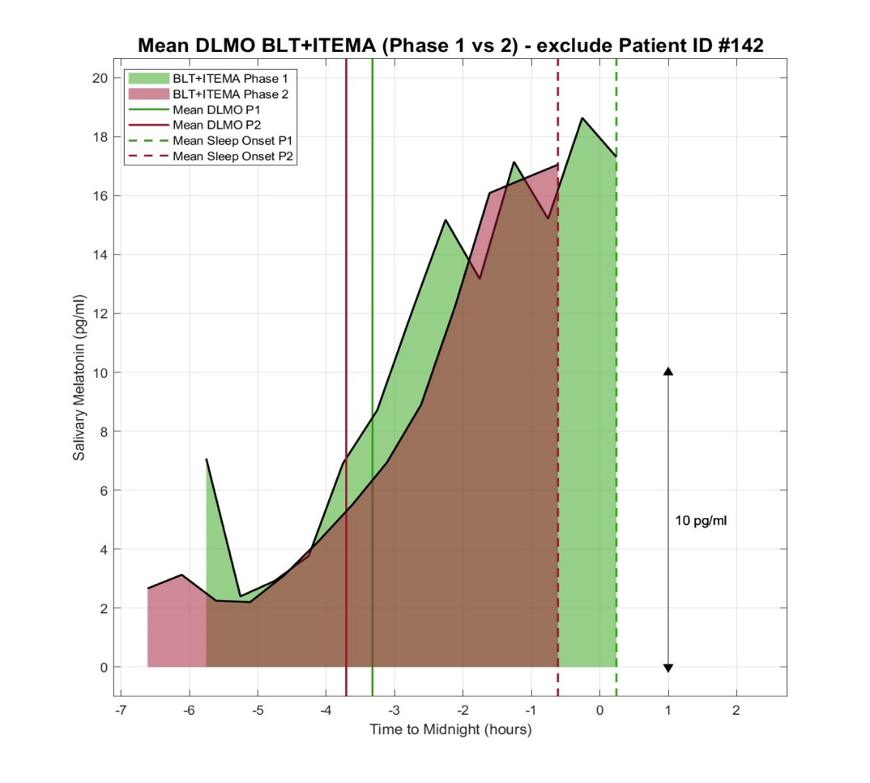

Supplementary Table 3. Phase 2 DLMO (change/ baseline) correlations with BED features.

Phase 2 Correlations in the BLT/Melatonin group |  |  |  |  |  | Sensitivity analysis
 | r | p-value | n |  |  | r | p-value | n
DLMO chg. (3 BL + 2 SD) vs. BE days chg. | 0.21 | 0.56 | 11 |  |  | 0.06 | 0.88 | 10
DLMO chg. (3 BL + 2 SD) vs. BE episodes chg. | 0.20 | 0.58 | 11 |  |  | 0.11 | 0.79 | 10
DLMO chg. (3 BL + 2 SD) vs. YBOCS-BE total chg. | 0.08 | 0.83 | 11 |  |  | -0.07 | 0.12 | 10
DLMO chg. (3 BL + 2 SD) vs. YBOCS-BE obsessional chg. | 0.03 | 0.93 | 11 |  |  | -0.27 | 0.49 | 10
DLMO chg. (3 BL + 2 SD) vs. YBOCS-BE compulsion chg. | 0.09 | 0.80 | 11 |  |  | 0.09 | 0.82 | 10
DLMO chg. (3 BL + 2 SD) vs. Melatonin admin distance (DLMO-Mel admin time) | -0.15 | 0.67 | 11 |  |  | -0.56 | 0.12 | 10
DLMO BL (3 BL + 2 SD) vs. DLMO chg. (3 BL + 2 SD) | -0.69 | 0.03 | 11 |  |  | -0.29 | 0.46 | 10
DLMO BL (3 BL + 2 SD) vs. BE days chg. | -0.41 | 0.16 | 14 |  |  | -0.37 | 0.24 | 13
DLMO BL (3 BL + 2 SD) vs. BE episodes chg. | -0.60 | 0.03 | 14 |  |  | -0.71 | 0.01 | 13
DLMO BL (3 BL + 2 SD) vs. YBOCS-BE total chg. | -0.08 | 0.81 | 14 |  |  | -0.01 | 0.97 | 13
DLMO BL (3 BL + 2 SD) vs. YBOCS-BE obsessional chg. | -0.22 | 0.47 | 14 |  |  | -0.22 | 0.48 | 13
DLMO BL (3 BL + 2 SD) vs. YBOCS-BE compulsion chg. | 0.04 | 0.89 | 14 |  |  | 0.14 | 0.67 | 13
Phase 2 Correlations in the Sham+Placebo group
DLMO chg. (3 BL + 2 SD) vs. BE days chg. | 0.51 | 0.16 | 10 |  |  | no change
DLMO chg. (3 BL + 2 SD) vs. BE episodes chg. | 0.60 | 0.09 | 10 |  |  | no change
DLMO chg. (3 BL + 2 SD) vs. YBOCS-BE total chg. | 0.64 | 0.06 | 10 |  |  | no change
DLMO chg. (3 BL + 2 SD) vs. YBOCS-BE obsessional chg. | 0.37 | 0.33 | 10 |  |  | no change
DLMO chg. (3 BL + 2 SD) vs. YBOCS-BE compulsion chg. | 0.69 | 0.04 | 10 |  |  | no change
DLMO chg. (3 BL + 2 SD) vs. Melatonin admin distance (DLMO-Mel admin time) | 0.32 | 0.40 | 10 |  |  | no change
DLMO BL (3 BL + 2 SD) vs. DLMO chg. (3 BL + 2 SD) | 0.13 | 0.73 | 10 |  |  | no change
DLMO BL (3 BL + 2 SD) vs. BE days chg. | -0.26 | 0.46 | 11 |  |  | -0.03 | 0.94 | 10
DLMO BL (3 BL + 2 SD) vs. BE episodes chg. | -0.37 | 0.29 | 11 |  |  | -0.25 | 0.51 | 10
DLMO BL (3 BL + 2 SD) vs. YBOCS-BE total chg. | 0.07 | 0.84 | 12 |  |  | -0.07 | 0.85 | 11
DLMO BL (3 BL + 2 SD) vs. YBOCS-BE obsessional chg. | 0.25 | 0.46 | 12 |  |  | 0.15 | 0.68 | 11
DLMO BL (3 BL + 2 SD) vs. YBOCS-BE compulsion chg. | -0.05 | 0.87 | 12 |  |  | -0.19 | 0.60 | 11
Phase 2 Correlations in both tx groups
DLMO chg. (3 BL + 2 SD) vs. BE days chg. | 0.32 | 0.17 | 21 |  |  | 0.26 | 0.28 | 20
DLMO chg. (3 BL + 2 SD) vs. BE episodes chg. | 0.31 | 0.19 | 21 |  |  | 0.26 | 0.29 | 20
DLMO chg. (3 BL + 2 SD) vs. YBOCS-BE total chg. | 0.31 | 0.19 | 21 |  |  | 0.40 | 0.09 | 20
DLMO chg. (3 BL + 2 SD) vs. YBOCS-BE obsessional chg. | 0.12 | 0.61 | 21 |  |  | 0.14 | 0.58 | 20
DLMO chg. (3 BL + 2 SD) vs. YBOCS-BE compulsion chg. | 0.36 | 0.11 | 21 |  |  | 0.49 | 0.03 | 20
DLMO chg. (3 BL + 2 SD) vs. Melatonin admin distance (DLMO-Mel admin time) | 0.06 | 0.81 | 21 |  |  | -0.01 | 0.95 | 20
DLMO BL (3 BL + 2 SD) vs. DLMO chg. (3 BL + 2 SD) | -0.46 | 0.04 | 21 |  |  | -0.05 | 0.83 | 20
DLMO BL (3 BL + 2 SD) vs. BE days chg. | -0.35 | 0.09 | 25 |  |  | -0.26 | 0.25 | 23
DLMO BL (3 BL + 2 SD) vs. BE episodes chg. | -0.52 | 0.01 | 25 |  |  | -0.58 | <0.01 | 23
DLMO BL (3 BL + 2 SD) vs. YBOCS-BE total chg. | 0.02 | 0.92 | 26 |  |  | -0.03 | 0.90 | 24
DLMO BL (3 BL + 2 SD) vs. YBOCS-BE obsessional chg. | 0.06 | 0.76 | 26 |  |  | -0.04 | 0.86 | 24
DLMO BL (3 BL + 2 SD) vs. YBOCS-BE compulsion chg. | -0.01 | 0.96 | 26 |  |  | -0.01 | 0.95 | 24

Supplementary table 4. Complete DID rhythm-characteristic summaries.
parameter | mean | lower90 | upper90 | lower95 | upper95 | prob_gt0 | prob_lt0
DID_Amplitude | 0.024 | -0.012 | 0.061 | -0.019 | 0.067 | 0.868 | 0.132
DID_MESOR | 0.008 | -0.014 | 0.030 | -0.018 | 0.034 | 0.737 | 0.263
DID_Peak | 0.076 | 0.007 | 0.144 | -0.008 | 0.155 | 0.964 | 0.036
DID_Peak_time | -2.249 | -7.050 | 1.503 | -7.859 | 1.849 | 0.286 | 0.699
DID_Trough | 0.027 | 0.003 | 0.054 | -0.002 | 0.059 | 0.968 | 0.032
DID_Trough_time | 0.744 | -4.161 | 6.276 | -4.623 | 7.010 | 0.701 | 0.274

Supplementary table 5. Complete within-treatment P2 − P1 rhythm-characteristic changes.
Treatment | parameter | mean | lower90 | upper90 | lower95 | upper95 | prob_gt0 | prob_lt0
SHM_PLA | d_Amplitude | -0.048 | -0.078 | -0.017 | -0.084 | -0.011 | 0.006 | 0.994
SHM_PLA | d_MESOR | -0.003 | -0.021 | 0.015 | -0.025 | 0.018 | 0.375 | 0.625
SHM_PLA | d_Peak | -0.081 | -0.140 | -0.021 | -0.151 | -0.009 | 0.012 | 0.988
SHM_PLA | d_Peak_time | 1.424 | -0.231 | 4.045 | -0.462 | 4.508 | 0.868 | 0.099
SHM_PLA | d_Trough | 0.014 | -0.008 | 0.035 | -0.013 | 0.038 | 0.869 | 0.131
SHM_PLA | d_Trough_time | -0.668 | -5.854 | 0.578 | -6.317 | 0.925 | 0.330 | 0.561
BLT_MEL | d_Amplitude | -0.023 | -0.043 | -0.004 | -0.047 | -0.000 | 0.023 | 0.977
BLT_MEL | d_MESOR | 0.005 | -0.008 | 0.018 | -0.010 | 0.020 | 0.735 | 0.265
BLT_MEL | d_Peak | -0.005 | -0.042 | 0.031 | -0.049 | 0.037 | 0.424 | 0.576
BLT_MEL | d_Peak_time | -0.825 | -4.508 | 1.849 | -4.623 | 2.196 | 0.562 | 0.431
BLT_MEL | d_Trough | 0.042 | 0.028 | 0.056 | 0.025 | 0.059 | 1.000 | 0.000
BLT_MEL | d_Trough_time | 0.075 | -4.161 | 4.508 | -4.392 | 4.854 | 0.637 | 0.213

Supplementary table 6. Complete phase-by-treatment rhythm-characteristic summaries.
Phase | Treatment | parameter | mean | lower90 | upper90 | lower95 | upper95 | prob_gt0 | prob_lt0
P1 | SHM_PLA | Amplitude | 0.198 | 0.157 | 0.242 | 0.149 | 0.249 | 1.000 | 0.000
P1 | SHM_PLA | MESOR | 0.019 | -0.044 | 0.082 | -0.061 | 0.095 | 0.693 | 0.307
P1 | SHM_PLA | Peak | 0.252 | 0.162 | 0.342 | 0.141 | 0.360 | 1.000 | 0.000
P1 | SHM_PLA | Peak_time | 12.893 | 12.211 | 13.598 | 12.095 | 13.829 | 1.000 | 0.000
P1 | SHM_PLA | Trough | -0.144 | -0.219 | -0.070 | -0.234 | -0.057 | 0.001 | 0.999
P1 | SHM_PLA | Trough_time | 6.629 | 4.930 | 19.608 | 4.583 | 23.307 | 1.000 | 0.000
P1 | BLT_MEL | Amplitude | 0.195 | 0.166 | 0.225 | 0.161 | 0.231 | 1.000 | 0.000
P1 | BLT_MEL | MESOR | -0.011 | -0.059 | 0.038 | -0.070 | 0.047 | 0.358 | 0.642
P1 | BLT_MEL | Peak | 0.180 | 0.119 | 0.240 | 0.106 | 0.253 | 1.000 | 0.000
P1 | BLT_MEL | Peak_time | 14.609 | 11.980 | 17.990 | 11.864 | 18.221 | 1.000 | 0.000
P1 | BLT_MEL | Trough | -0.210 | -0.264 | -0.155 | -0.277 | -0.145 | 0.000 | 1.000
P1 | BLT_MEL | Trough_time | 6.252 | 1.000 | 24.000 | 1.000 | 24.000 | 1.000 | 0.000
P2 | SHM_PLA | Amplitude | 0.150 | 0.114 | 0.189 | 0.108 | 0.198 | 1.000 | 0.000
P2 | SHM_PLA | MESOR | 0.016 | -0.045 | 0.077 | -0.060 | 0.090 | 0.665 | 0.335
P2 | SHM_PLA | Peak | 0.171 | 0.094 | 0.248 | 0.077 | 0.264 | 0.999 | 0.001
P2 | SHM_PLA | Peak_time | 14.317 | 12.558 | 17.065 | 12.442 | 17.296 | 1.000 | 0.000
P2 | SHM_PLA | Trough | -0.129 | -0.201 | -0.058 | -0.215 | -0.045 | 0.002 | 0.998
P2 | SHM_PLA | Trough_time | 8.634 | 5.161 | 24.000 | 4.814 | 24.000 | 1.000 | 0.000
P2 | BLT_MEL | Amplitude | 0.172 | 0.145 | 0.201 | 0.139 | 0.207 | 1.000 | 0.000
P2 | BLT_MEL | MESOR | -0.006 | -0.054 | 0.043 | -0.063 | 0.052 | 0.423 | 0.577
P2 | BLT_MEL | Peak | 0.175 | 0.116 | 0.236 | 0.103 | 0.248 | 1.000 | 0.000
P2 | BLT_MEL | Peak_time | 13.784 | 13.020 | 15.222 | 12.905 | 16.372 | 1.000 | 0.000
P2 | BLT_MEL | Trough | -0.168 | -0.222 | -0.113 | -0.234 | -0.104 | 0.000 | 1.000
P2 | BLT_MEL | Trough_time | 5.344 | 1.000 | 24.000 | 1.000 | 24.000 | 1.000 | 0.000

Supplementary table 7. Adverse events documented during phase 2.
 | BLT+ITEMA | Sham+Placebo
 | (n=14) | (n=12) | p-value
Headache | 4 (29%) | 1 (8%) | 0.33
Vivid Dreams | 3 (21%) | 0 (0%) | 0.22
Nausea | 2 (14%) | 2 (17%) | 0.99
Respiratory Infection | 2 (14%) | 0 (0%) | 0.48
Tooth Ache | 2 (14%) | 0 (0%) | 0.48
Fatigue | 1 (7%) | 1 (8%) | 0.99
Allergic Rhinitis | 1 (7%) | 0 (0%) | 0.99
Nasal Discharge | 1 (7%) | 0 (0%) | 0.99
Streptococcal Pharyngitis Infection | 1 (7%) | 0 (0%) | 0.99
Urinary Tract Infection | 1 (7%) | 0 (0%) | 0.99
Abdominal Pain | 0 (0%) | 1 (8%) | 0.46
Diverticulitis | 0 (0%) | 1 (8%) | 0.46
Dizziness | 0 (0%) | 1 (8%) | 0.46
Irritability | 0 (0%) | 1 (8%) | 0.46
Low mood | 0 (0%) | 1 (8%) | 0.46
Menstrual Pain | 0 (0%) | 1 (8%) | 0.46
Norovirus | 0 (0%) | 1 (8%) | 0.46
Sleepiness | 0 (0%) | 1 (8%) | 0.46

