Cost-Effectiveness of Erdafinib vs. Chemotherapy for Advanced or Metastatic Urothelial Carcinoma from the Payer Perspectives in the US and China
Bin Zhang^{‡,1}, Yijia Zhao^{‡,1}, Zhiqi Zhang¹, Qianxin Liu¹, Xiaocong Pang*^{,1}, Ying Zhou*^{,1, 2}
Author affiliations:
1Department of Pharmacy, Peking University First Hospital, No. 8 Xishiku Street, Xicheng District, Beijing 100034, China
2Drug Clinical Trial Institution, Peking University First Hospital, No. 8 Xishiku Street, Xicheng District, Beijing 100034, China
‡Authors contributed equally
*Author for correspondence:
Xiaocong Pang, No. 8 Xishiku Street, Xicheng District, Beijing 100034, China. pangxiaocong1227@163.com.
Zhou Ying, No. 8 Xishiku Street, Xicheng District, Beijing 100034, China. bdyyzy@pku.edu.cn.

Supplementary Appendix
CHEERS Checklists
Section/topic | Item No | Guidance for reporting | Reported on Page No
Title
Title | 1 | Identify the study as an economic evaluation and specify the interventions being compared. | 1
Abstract
Abstract | 2 | Provide a structured summary that highlights context, key methods, results, and alternative analyses. | 1
Introduction
Background and objectives | 3 | Give the context for the study, the study question, and its practical relevance for decision making in policy or practice. | 2
Methods
Health economic analysis plan | 4 | Indicate whether a health economic analysis plan was developed and where available. | 3
Study population | 5 | Describe characteristics of the study population (such as age range, demographics, socioeconomic, or clinical characteristics). | 3
Setting and location | 6 | Provide relevant contextual information that may influence findings. | 3
Comparators | 7 | Describe the interventions or strategies being compared and why chosen. | 3-4 and Table S1
Perspective | 8 | State the perspective(s) adopted by the study and why chosen. | 2
Time horizon | 9 | State the time horizon for the study and why appropriate. | 4
Discount rate | 10 | Report the discount rate(s) and reason chosen. | 4
Selection of outcomes | 11 | Describe what outcomes were used as the measure(s) of benefit(s) and harm(s). | 4
Measurement of outcomes | 12 | Describe how outcomes used to capture benefit(s) and harm(s) were measured. | 4
Valuation of outcomes | 13 | Describe the population and methods used to measure and value outcomes. | 4-5
Measurement and valuation of resources and costs | 14 | Describe how costs were valued. | 5
Currency, price date, and conversion | 15 | Report the dates of the estimated resource quantities and unit costs, plus the currency and year of conversion. | 4
Rationale and description of model | 16 | If modelling is used, describe in detail and why used. Report if the model is publicly available and where it can be accessed. | 4
Analytics and assumptions | 17 | Describe any methods for analysing or statistically transforming data, any extrapolation methods, and approaches for validating any model used. | 4
Characterizing heterogeneity | 18 | Describe any methods used for estimating how the results of the study vary for subgroups. | Not applicable
Characterizing distributional effects | 19 | Describe how impacts are distributed across different individuals or adjustments made to reflect priority populations. | Not applicable
Characterizing uncertainty | 20 | Describe methods to characterise any sources of uncertainty in the analysis. | 6
Approach to engagement with patients and others affected by the study | 21 | Describe any approaches to engage patients or service recipients, the general public, communities, or stakeholders (such as clinicians or payers) in the design of the study. | Not applicable
Results
Study parameters | 22 | Report all analytic inputs (such as values, ranges, references) including uncertainty or distributional assumptions. | Table 1 and Table S3
Summary of main results | 23 | Report the mean values for the main categories of costs and outcomes of interest and summarise them in the most appropriate overall measure. | 8 and Table 2
Effect of uncertainty | 24 | Describe how uncertainty about analytic judgments, inputs, or projections affect findings. Report the effect of choice of discount rate and time horizon, if applicable. | 8-11
Effect of engagement with patients and others affected by the study | 25 | Report on any difference patient/service recipient, general public, community, or stakeholder involvement made to the approach or findings of the study. | Not applicable
Discussion
Study findings, limitations, generalizability, and current knowledge | 26 | Report key findings, limitations, ethical or equity considerations not captured, and how these could affect patients, policy, or practice. | 11-13
Other relevant information
Source of funding | 27 | Describe how the study was funded and any role of the funder in the identification, design, conduct, and reporting of the analysis. | 14
Conflicts of interest | 28 | Report authors conflicts of interest according to journal or International Committee of Medical Journal Editors requirements. | 14

Table
Table S1 Treatment regimen and dosage administration
Grouping | Treatment regimen and dosage administration
Initial treatment
Erdafitinib | Erdafitinib 8 mg per day with a pharmacodynamically guided increase in the dose to 9 mg on day 14 q3w, po^{[1]}
Chemotherapy | Docetaxel, 75 mg/m², 60 min-infusion, q3w^{[1]}
Subsequent Treatment
Chemotherapy | Gemcitabine, 1000mg/m², 30 min-infusion, d1, d8 + Paclitaxel, 175mg/m², 60 min-infusion, d1, q3w, with a maximum of six cycles^{[2]}
ADC | Enfortumab vedotin, 1.25mg/kg, 30 min-infusion, d1, d8, d15, q4w^{[3]}
ADC: Antibody-drug conjugates; po: Per os; q3w: 3 weeks using a; q4w: 4 weeks using a.

Table S2 AIC and BIC values for the fitted distribution of survival curves
(a) Erdafitinib Group
Parametric models | OS |  | PFS
Parametric models | AIC | BIC | AIC | BIC
Exponential | 626.3076 | 629.2203 | 615.2879 | 618.2005
Gompertz | 626.6679 | 632.4932 | 617.0616 | 622.8869
Gamma | 616.3532 | 622.1785 | 599.6772 | 605.5025
Gengamma | 617.0559 | 625.7939 | 591.3123 | 600.0503
Weibull | 618.7392 | 624.5646 | 606.3004 | 612.1257
Log-logistic | 611.5369 | 617.3622 | 586.8486 | 592.6740
Log-normal | 619.0352 | 624.8605 | 589.3124 | 595.1378
AIC: Akaike’ s information criterion; BIC: Bayesian information criterion; OS: Overall survival; PFS: Progression-free survival.
(b) Chemotherapy Group
Parametric models | OS |  | PFS
Parametric models | AIC | BIC | AIC | BIC
Exponential | 571.8044 | 574.6719 | 488.1245 | 490.9921
Gompertz | 573.1674 | 578.9025 | 488.9271 | 494.6622
Gamma | 573.7140 | 579.4490 | 485.9415 | 491.6766
Gengamma | 572.8043 | 581.4069 | 469.1884 | 477.7911
Weibull | 573.8039 | 579.5390 | 488.7396 | 494.4747
Log-logistic | 571.9934 | 577.7285 | 472.2233 | 477.9583
Log-normal | 571.7099 | 577.4450 | 469.1194 | 474.8545
AIC: Akaike’ s information criterion; BIC: Bayesian information criterion; OS: Overall survival; PFS: Progression-free survival.

Table S3 Remaining parameters of partitioned survival model
Variable | Baseline value | Range |  | Distribution | Reference
Variable | Baseline value | Minimum | Maximum | Distribution | Reference
Risk of ≥ Grade 3 AEs
Erdafitinib Group
Hyperphosphatemia | 0.052 | 0.041 | 0.062 | Beta | ^{[1]}
Stomatitis | 0.081 | 0.065 | 0.098 | Beta | ^{[1]}
Palmar-Plantar Erythrodysesthesia Syndrome | 0.096 | 0.077 | 0.116 | Beta | ^{[1]}
Onycholysis | 0.059 | 0.047 | 0.071 | Beta | ^{[1]}
Chemotherapy Group
Anemia | 0.063 | 0.050 | 0.075 | Beta | ^{[1]}
Neutropenia | 0.134 | 0.107 | 0.161 | Beta | ^{[1]}
Subsequent-line Therapy Proportion
Erdafitinib Group
BSC | 0.676 | 0.541 | 0.812 | Beta | ^{[1]}
Chemotherapy | 0.162 | - | - | - | Assumption
ADC | 0.162 | - | - | - | Assumption
Chemotherapy Group
BSC | 0.631 | 0.505 | 0.757 | Beta | ^{[1]}
Chemotherapy | 0.185 | - | - | - | Assumption
ADC | 0.185 | - | - | - | Assumption
Height in the U.S., m | 1.714 | 1.371 | 2.057 | Gamma | ^{[4]}
Height in China., m | 1.662 | 1.330 | 1.994 | Gamma | ^{[5]}
Weight in the U.S., kg | 80.000 | 64.000 | 96.000 | Gamma | ^{[4]}
Weight in China., kg | 65.000 | 52.000 | 78.000 | Gamma | ^{[5]}
BSA in the U.S., m2 | 1.917 | 1.533 | 2.300 | Gamma | ^{[4]}
BSA in China, m2 | 1.693 | 1.354 | 2.031 | Gamma | ^{[5]}
ADC: Antibody-drug conjugates; AE: Adverse event; BSA: Body surface area; BSC: Best supportive care.

Table S4 Cost-effectiveness analysis results in scenario analysis
Strategies | Cost | Incr Cost | LYs | Incr LYs | ICER/LY | QALYs | Incr QALYs | ICER/QALY | NHB/QALY | NMB/QALY
US Payers
Chemotherapy | 156136.55 |  | 1.42 |  |  | 1.08
Erdafitinib | 471219.85 | 315083.30 | 1.68 | 0.27 | 1182176.57 | 1.31 | 0.22 | 1418329.62 | -1.88 | -281760.66
Chinese Payers
Chemotherapy | 27583.11 |  | 1.42 |  |  | 1.04
Erdafitinib | 68791.21 | 41208.10 | 1.68 | 0.27 | 154610.72 | 1.26 | 0.22 | 187151.85 | -0.80 | -32327.14
ICER: Incremental cost-effectiveness ratio; Incr: Incremental; LY: Life-year; NHB: Net health benefit; NMB: Net monetary benefit; QALY: Quality-adjusted life-year.

Figure
Fig. S1 Schematic diagram of three state partitioned survival model.
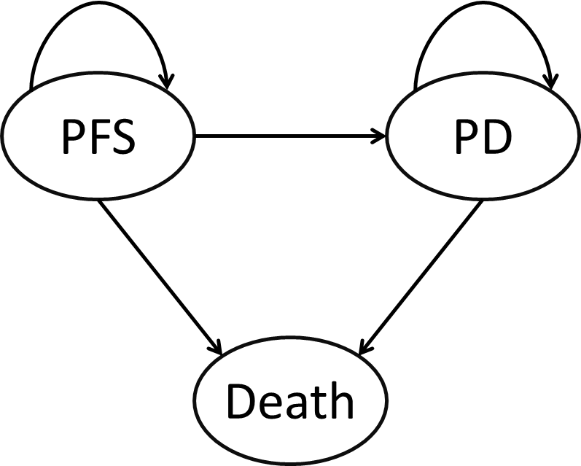
PD: Progressed disease; PFS: Progression-free survival.

Fig. S2 Comparison of original and reconstructed survival curves
(a) OS
(b) PFS

Fig. S3 Probabilistic scatter plot of the ICER
(a) U.S.
(b) China

Reference
[1] Loriot Y, Matsubara N, Park S H, et al. Erdafitinib or Chemotherapy in Advanced or Metastatic Urothelial Carcinoma[J]. The New England Journal of Medicine, 2023, 389(21): 1961-1971.
[2] Albers P, Park S I, Niegisch G, et al. Randomized phase III trial of 2nd line gemcitabine and paclitaxel chemotherapy in patients with advanced bladder cancer: short-term versus prolonged treatment [German Association of Urological Oncology (AUO) trial AB 20/99][J]. Annals of Oncology: Official Journal of the European Society for Medical Oncology, 2011, 22(2): 288-294.
[3] Powles T, Rosenberg J E, Sonpavde G P, et al. Enfortumab Vedotin in Previously Treated Advanced Urothelial Carcinoma[J]. The New England Journal of Medicine, 2021, 384(12): 1125-1135.
[4] National Center for Health Statistics. Body Measurements[EB/OL]. (2023-10-01)[2025-03-05]. https://www.cdc.gov/nchs/fastats/body-measurements.htm.
[5] Status of nutrition and chronic diseases in China(2020)[J]. Acta Nutrimenta Sinica, 2020, 42(6): 521.

