Climate Dynamics
Supporting Information for

Subseasonal Predictability of Diverse Persistent Wet-Cold Compound Extreme Events over China Based on Calibrating Dynamical and AI models
Jiaxu Wang^{a,b}, Jie Wu^{c}*, Hong-Li Renª, Li Guo^{c}, Lijuan Chen^{c}, Chenguang Zhou^{c}
ª Chinese Academy of Meteorological Sciences, Beijing 100081, China
^{b} College of Earth and Planetary Sciences, University of Chinese Academy of Sciences, Beijing 100049, China
^{c} State Key Laboratory of Climate System Prediction and Risk Management/China Meteorological Administration Key Laboratory for Climate Prediction Studies, National Climate Centre, China Meteorological Administration, Beijing 100081, China
*Corresponding author: Jie Wu; Email: wujie@cma.gov.cn
ORCID: Jiaxu Wang, https://orcid.org/0009-0003-4233-2740
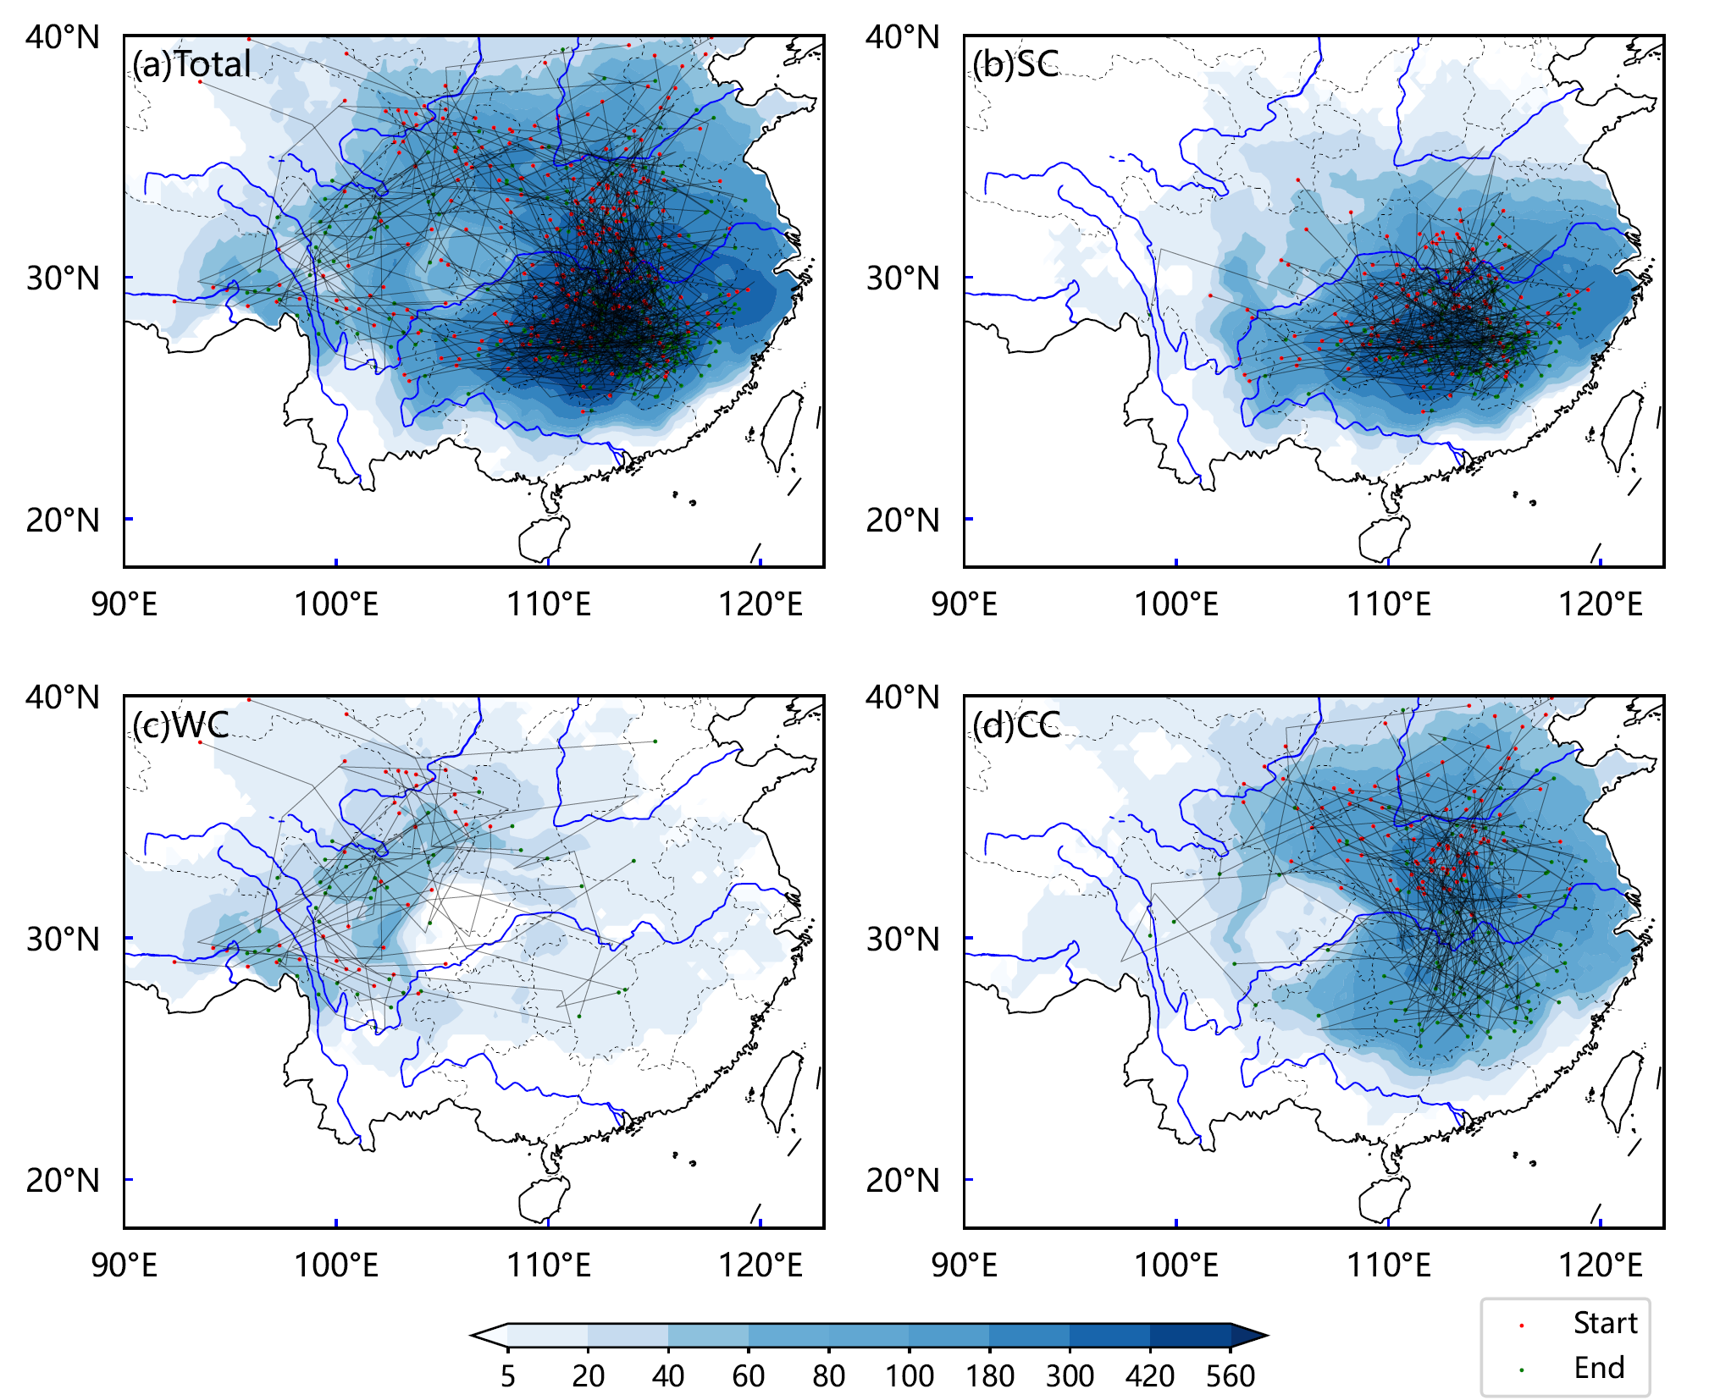
Fig. S1 Propagation paths of Persistent wet–cold compound extreme events (PWCEs) (lines) and the frequency of PWCEs at each grid point during PWCE periods (shading). Shading indicates the total number of days with cold–wet weather at each location across all PWCEs. Panel (a) shows all PWCEs, while panels (b), (c), and (d) correspond to the South China (SC), Western China (WC), and Central China (CC) types, respectively.
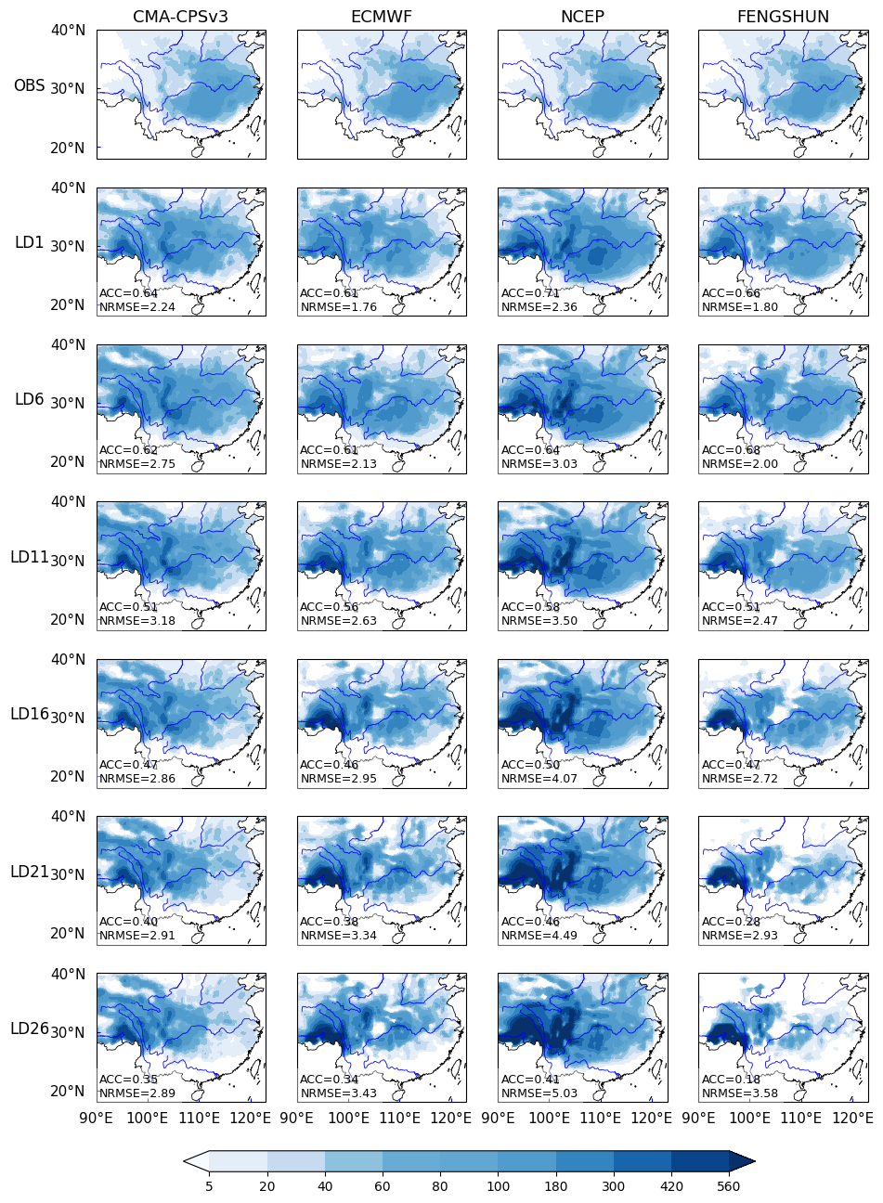
Fig. S2 Spatial distribution of the frequency of single-day, grid-point events occurring during PWCE periods, as identified from four S2S models (CMA-CPSv3, ECMWF, NCEP, and FENGSHUN) before cumulative distribution function (CDF)-based calibration. The first row shows the observations (OBS), and the remaining rows present the corresponding model results at different lead times (LD1, LD6, LD11, LD16, LD21, and LD26). Shading denotes the event occurrence frequency, with colors from light to dark indicating increasing frequency. The anomaly correlation coefficient (ACC) and the normalized root mean square error (NRMSE) for each panel are shown in the lower-left corner.
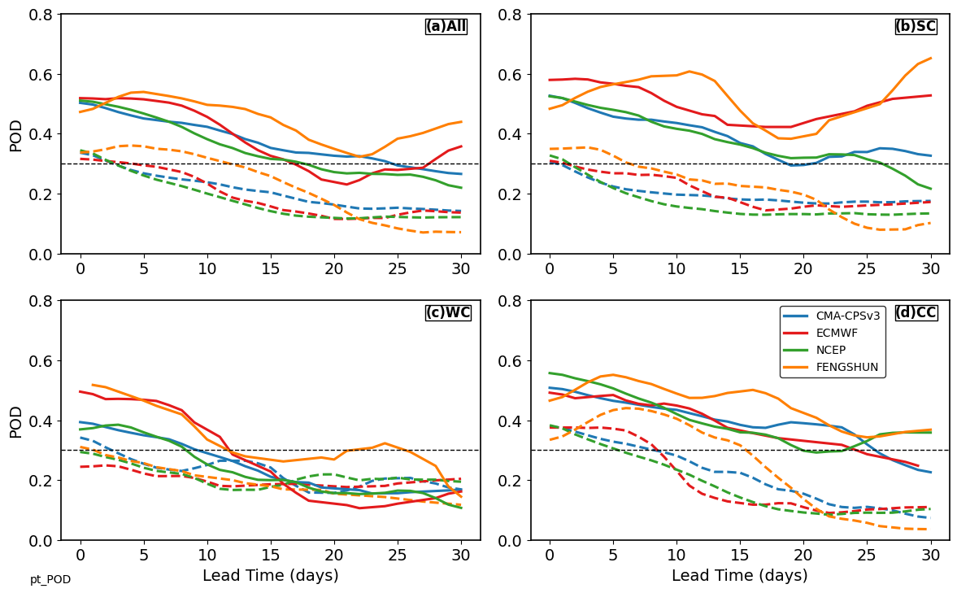
Fig. S3 Lead-time dependence of the probability of detection (POD) for PWCEs from four S2S models before and after CDF calibration, shown for all events and the three PWCE types. Solid and dashed lines indicate corrected and uncorrected results, respectively.
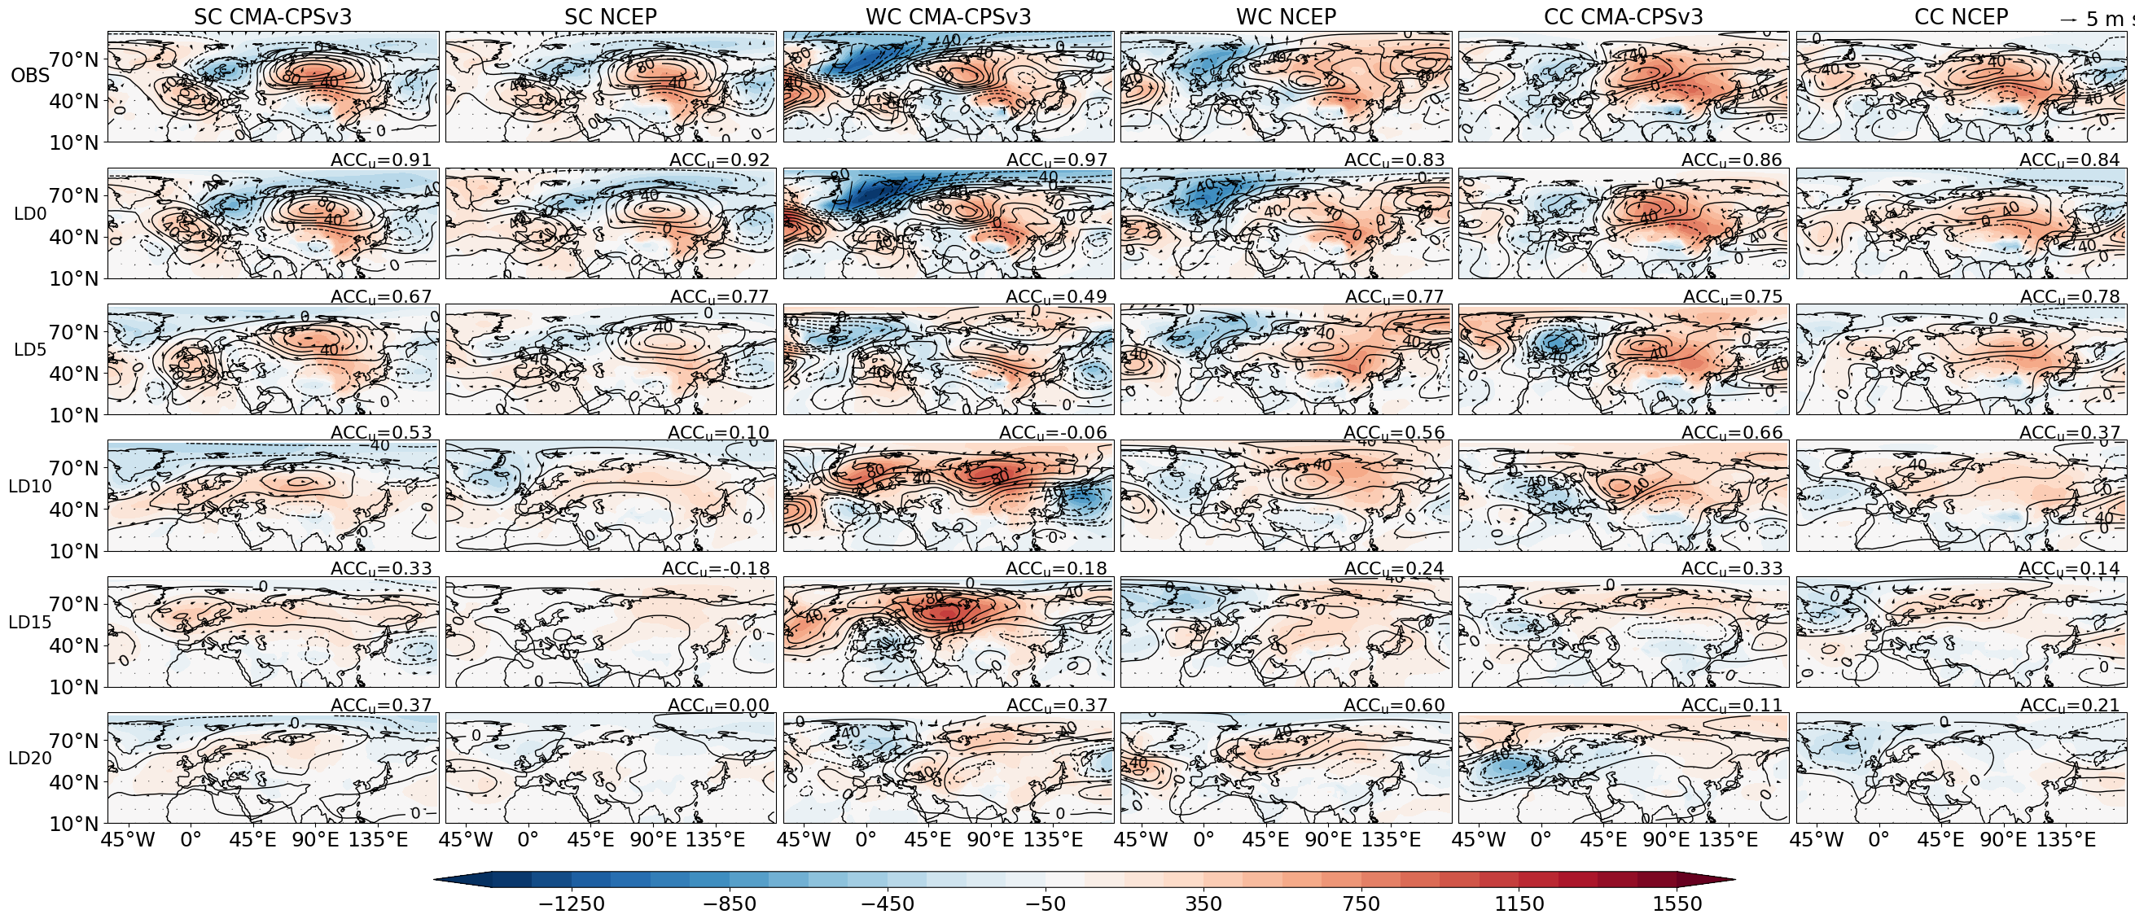
Fig. S4 Composite high-latitude circulation anomalies on PWCE types from the CMA-CPSv3 and NCEP models at different forecast lead times. Contours show 500-hPa GPH (Z500), and shading indicates sea level pressure (MSL) anomalies. Stippling denotes regions where MSL anomalies pass the significance test. The non-centered ACC (ACCu) of each model result relative to the corresponding observations in the first row is shown in the upper-right corner of each panel.
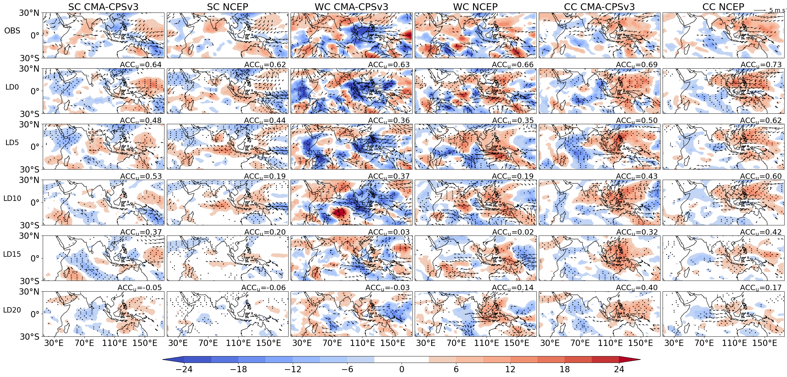
Fig. S5 Composite low-latitude circulation anomalies on the first day of the three PWCE types from the CMA-CPSv3 and NCEP models at different forecast lead times. Shading indicates outgoing longwave radiation (OLR) anomalies, and stippling denotes regions where OLR anomalies pass the significance test. Vectors show low-level winds, with only wind speeds exceeding 1 m s⁻¹ displayed. ACCu relative to observations is shown in the upper-right corner.
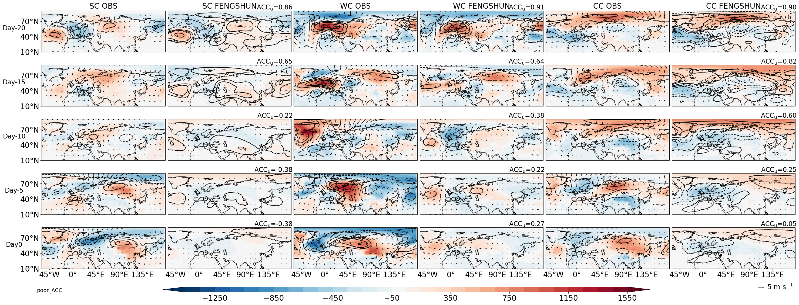
Fig. S6 Lead–lag composites of mid- to high-latitude circulation anomalies for low-skill PWCEs from the FENGSHUN model. For each event type, the left and right panels show the observed and corresponding FENGSHUN forecast composites for the same events, respectively. Shading, vectors, and contours indicate sea level pressure anomalies, 850-hPa wind anomalies, and 500-hPa geopotential height anomalies. The upper-right value in each forecast panel indicates the Z500 ACCu.

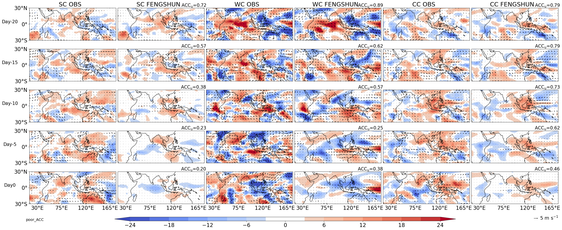
Fig. S7 Lead–lag composites of low-latitude circulation anomalies for low-skill PWCEs from the FENGSHUN model. For each event type, the left and right panels show the observed and corresponding FENGSHUN forecast composites for the same set of low-skill events, respectively. Shading denotes outgoing longwave radiation anomalies, and vectors denote 850-hPa wind anomalies. The upper-right value in each forecast panel indicates the OLR ACCu.

