Supporting information
Self-Sensitized Upconversion Luminescence of Cs₂NaErF₆ Nanocrystals Toward Highly Responsive Photodetection under 1532 nm Illumination

Fei Wen^{[1, 2, 3]}, Datao Tu* ^{[1, 2, 3]}, Liwei Tang^{[1, 3]}, Meng Cui^{[1, 3]}, Shiqi Yu^{[1, 2, 3]}, Meiqi Zhang^{[1, 2]}, Wei Lian^{[1, 2]}, Xiaoying Shang^{[1, 2]}, and Xueyuan Chen* ^{[1, 2, 3]}

¹ State Key Laboratory of Structural Chemistry, and Fujian Key Laboratory of Nanomaterials, Fujian Institute of Research on the Structure of Matter, Chinese Academy of Sciences, Fuzhou, Fujian 350002, China.
² Fujian Science & Technology Innovation Laboratory for Optoelectronic Information of China, Fuzhou, Fujian 350108, China.
³ University of Chinese Academy of Sciences, Beijing, 100049, China.

* Corresponding authors: dttu@fjirsm.ac.cn; xchen@fjirsm.ac.cn

Table S1. UCL decays at 654 nm for Cs₂NaY_{x}Er_{1-x}F₆ NCs and α-NaErF₄ NCs with various doping concentrations of Er³⁺. The UCL lifetime of Cs₂NaErF₆ NCs was determined to be 54.59 μs, while the luminescence of α-NaErF₄ NCs was completely quenched.
 | 25 mol% | 50 mol% | 75 mol% | 1.00 mol%
Cs₂NaY_{x}Er_{1-x}F₆ | 532.37 μs | 134.18 μs | 104.50 μs | 54.59 μs
α-NaErF₄ | 3.27 μs | 1.94 μs | 1.33 μs | -

Table S2. Comparison of Cs₂NaErF₆ cell structure parameters and α-NaErF₄ cell structure parameters. The minimum cation distance of Cs₂NaErF₆ is significantly larger than that of α-NaErF₄.

 | Cs₂NaErF₆ | α-NaErF₄
Crystal system | Cubic | Cubic
Space group | Fm-3m | Fm-3m
Cell parameters | a = b= c= 9.061Å | a = b= c= 5.465 Å
c/a | 1 | 1
Z | 4 | 2
Minimum cation distance (Er³⁺-Er³⁺) | 6.407 Å | 3.864 Å
Cell volume | 743.92 [Å³] | 163.22 [Å³]

Cs₂NaErF₆:xTm³⁺ | Feeding ratio (mol%) |  |  |  | ICP-AES result (mol%)
Cs₂NaErF₆:xTm³⁺ | Cs⁺ | Na⁺ | Er³⁺ | Tm³⁺ | Cs⁺ | Na⁺ | Er³⁺ | Tm³⁺
x = 0 | 1.00 | 1.00 | 1.00 | - | 0.97 | 0.98 | 0.98 | -
x = 0.01 | 1.00 | 1.00 | 0.99 | 0.01 | 0.98 | 0.97 | 0.97 | -
x = 0.02 | 1.00 | 1.00 | 0.98 | 0.02 | 0.97 | 0.98 | 0.96 | 0.018
x = 0.03 | 1.00 | 1.00 | 0.97 | 0.03 | 0.98 | 0.96 | 0.97 | 0.027
Table S3. Elemental concentrations obtained from ICP-AES data for Cs₂NaErF₆:xTm³⁺ samples with different Tm³⁺ feed ratios. The feeding ratios of all elements were almost consistent with the ICP-AES results, indicating that Tm³⁺ occupies the surface Er³⁺ lattice site.

Cs₂NaErF₆:Tm³⁺@xCaF₂ | Feeding ratio |  |  | ICP-AES result
Cs₂NaErF₆:Tm³⁺@xCaF₂ | [Na⁺]/[RE³⁺] | Cs⁺ mol% | Ca²⁺ mol% | [Na⁺]/[RE³⁺] | Cs⁺ mol% | Ca²⁺ mol%
x = 0 | 1.00 | 1.00 | - | 0.97 | 0.98 | -
x = 0.5 | 1.00 | 1.00 | 0.05 | 0.96 | 0.91 | 0.04
x = 0.10 | 1.00 | 1.00 | 0.10 | 0.97 | 0.86 | 0.07
x = 0.20 | 1.00 | 1.00 | 0.20 | 0.95 | 0.76 | 0.16
x = 0.40 | 1.00 | 1.00 | 0.40 | 0.98 | 0.76 | 0.37
x = 0.60 | 1.00 | 1.00 | 0.60 | 0.96 | 0.75 | 0.58
Table S4. Elemental concentrations obtained from ICP-AES data for Cs₂NaErF₆:0.03Tm³⁺@CaF₂ samples with different Ca(TFA)₂ feed ratios. The feeding ratios of [Na⁺]/[RE³⁺] were almost consistent with the ICP-AES results, indicating that Ca²⁺ may occupy the surface Cs⁺ lattice site.

Table S5. Summary of the NIR performance of typical photodetectors in previous reports.
Structure | Response  wavelength (nm) | Responsivity  (A/W) | Detectivity*  (Jones) | EQE | Refs.
UCNPs/Graphene | 808 | 4.0 | - | - | ¹
NaYF₄:Er/Si-PD | 1500 | - | 6.15×10¹² | - | ²
Cs₂NaEr_{0.15}Yb_{0.85}Cl₆/Si PDs | 1550 | ~0.037 | ~1.0×10¹⁰ |  | ³
UCNPs/MAPbI₃ | 980 | 0.102 | 1.8×10⁹ | - | ⁴
UCNPs/Graphene/GaAs | 980 | 0.597 | 1.1×10¹¹ | - | ⁵
Cu₂SnS₃ quantum dots | 1500 | 0.93×10⁻⁴ | 2.80×10⁹ | 0.075 | ⁶
Er-Y-Silicate/Perovskite | 1500 | 1.20×10⁻⁴ | - | - | ⁷
D-Au@Ag NRs/UCNPs/MAPbI₃ | 1550 | 0.32 | 1.6×10¹⁰ | - | ⁸
NaYF₄:Er@NaYF₄/Si PD | 1550 | 0.22 | - | 17.6 | ⁹
MLA/Au NRs/UCNCs/MAPbI₃ | 808 | 30.73 | 5.36×10¹¹ | 47.26 | ¹⁰
MLA/Au NRs/UCNCs/MAPbI₃ | 980 | 23.15 | 3.45×10¹¹ | 29.35
MLA/Au NRs/UCNCs/MAPbI₃ | 1540 | 12.20 | 1.91×10¹¹ | 9.84
UCNPs/PDPP4T | 808 | 0.56 | - | 86 | ¹¹
UCNPs/PDPP4T | 975 | 1.42 | - | 180
UCNPs/PDPP4T | 1532 | 0.02 | - | 2
La₂O₂S:Er@La₂O₂S/MAPbI₃ | 1550 | 0.023 | 2.57×10⁸ | - | ¹²
QC-LC/FTO/SnO₂/CsPbI₃:Er-PbS QDs heterojunction/MoO₃/Au | 1550 | - | 5.23×10¹¹ | - | ¹³
MAPbI₃:Yb, Er/SC | 900-1600 | 0.1-0.6 | 0.6-0.11×10¹¹ | - | ¹⁴
Cs₂NaEr_{0.2}Yb_{0.8}Cl₆/MAPbI₃ | 1550 | 0.11 | 0.11×10¹⁰ | 8.8 | ¹⁵
NaYS₂:Er@MAPbI₃ | 808 | 0.26 | 4.6×10¹⁰ | 39 | ¹⁶
NaYS₂:Er@MAPbI₃ | 980 | 0.44 | 5.6×10¹⁰ | 55
NaYS₂:Er@MAPbI₃ | 1550 | 0.73 | 8.4×10¹⁰ | 59
Cs₂NaErF₆:Tm@CaF₂/MAPbI₃ | 808 | 0.32 | 3.48×10¹⁰ | 0.49 | This work
Cs₂NaErF₆:Tm@CaF₂/MAPbI₃ | 980 | 0.40 | 5.62×10¹⁰ | 0.50
Cs₂NaErF₆:Tm@CaF₂/MAPbI₃ | 1532 | 4.97 | 4.47×10¹¹ | 4.07

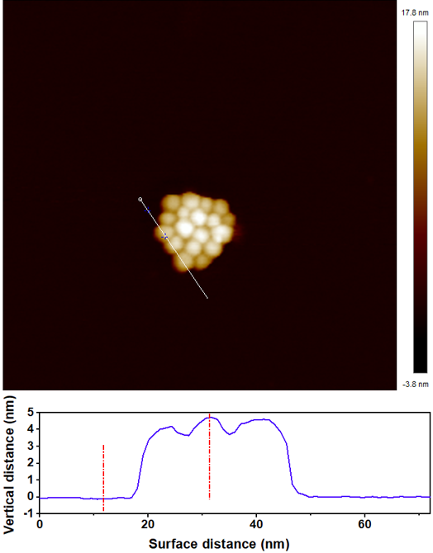
Figure S1. Atomic force microscopy image of Cs₂NaErF₆ NCs, showing a thickness of ~4.8 nm.

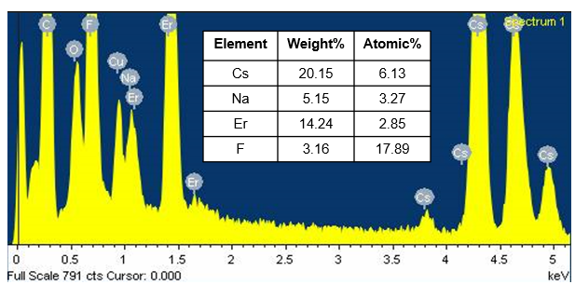

Figure S2. EDX spectrum of Cs₂NaErF₆ NCs, revealing a molar ratio of approximately 1:3 for Cs⁺/F⁻ in the as-prepared NCs.

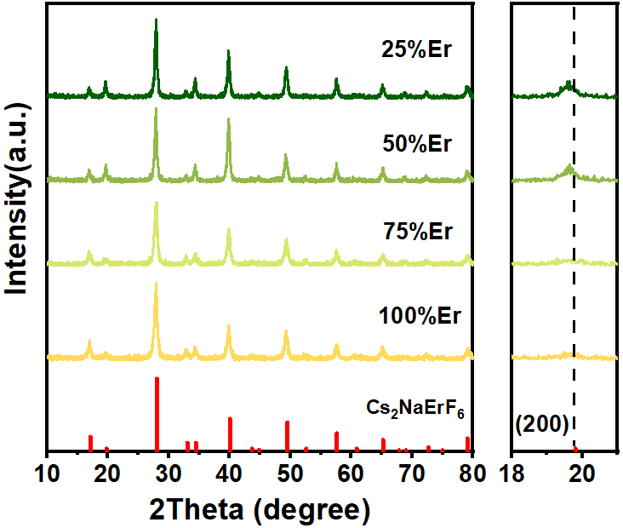

Figure S3. XRD patterns of Cs₂NaY_{1-x}Er_{x}F₆ NCs with different Er³⁺ concentrations, exhibiting intense diffraction peaks without any observable impurities. The diffraction peak (200) crystal plane of Cs₂NaY_{1-x}Er_{x}F₆ NCs gradually decreased with increasing Y³⁺ content, which was attributed to lattice expansion caused by the larger radius of the doped Y³⁺ than that of Er³⁺.

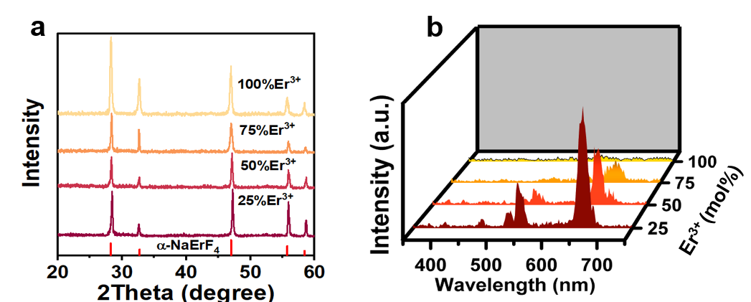

Figure S4. (a) XRD patterns of α-NaY_{1-x}Er_{x}F₄ NCs with different Er³⁺ concentrations, exhibiting intense diffraction peaks without any observable impurities. (b) UCL spectrum of α-NaY_{1-x}Er_{x}F₄ NCs under 1532 nm excitation. With the increase of Er³⁺ concentration, the UCL intensity decreased sharply under 1532 nm excitation, which was caused by severe concentration quenching.

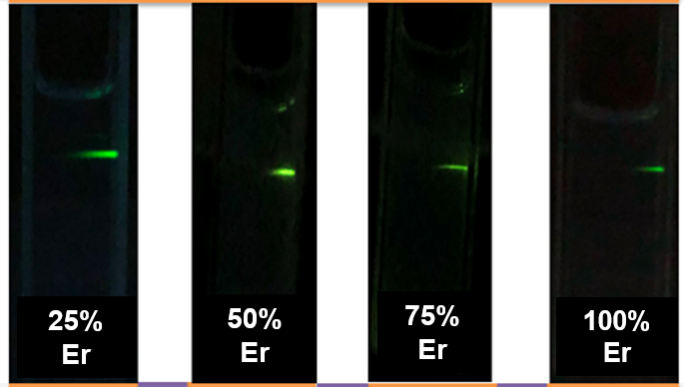

Figure S5. Photographs demonstrating the UCL of Cs₂NaY_{1-x}Er_{x}F₆ NCs upon excitation at 1532 nm (100 W/cm²). With 100% Er³⁺ doping concentration, green UCL was still visible to the naked eye.

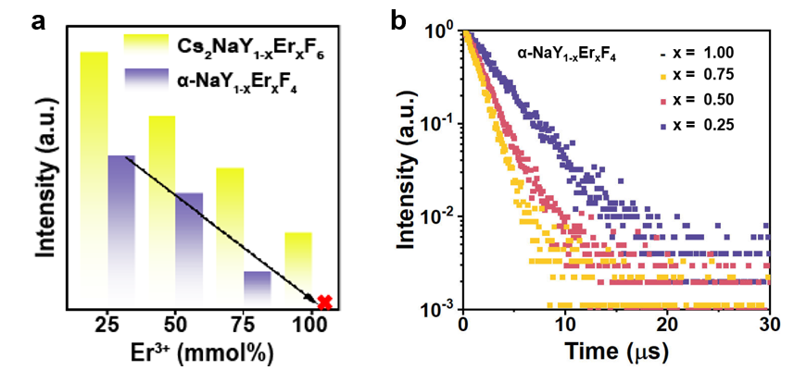

Figure S6. (a) Comparison of the integrated UCL intensity between Cs₂NaY_{1-x}Er_{x}F₆ NCs and α-NaY_{1-x}Er_{x}F₄ NCs. (b) UCL decays of α-NaY_{1-x}Er_{x}F₄ NCs at different Er³⁺ concentrations under 1532 nm excitation (λ_{em} = 654 nm). The lifetime was shortened with increasing Er³⁺ concentration. For α-NaErF₄ NCs, the UCL decays can not be detected due to concentration quenching.

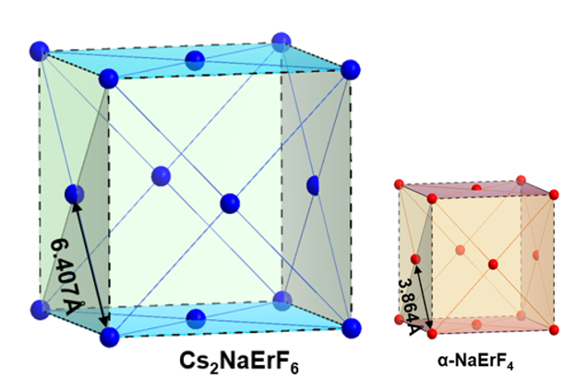

Figure S7. Schematic illustration of the structure of Cs₂NaErF₆ and α-NaErF₄. The shortest distance between two adjacent Er³⁺ in the Cs₂NaErF₆ crystal (r = 6.407 Å) is much larger than that of the α-NaErF₄ crystal (r = 3.864 Å), which may effectively inhibit the detrimental CR and concentration quenching between Er³⁺.

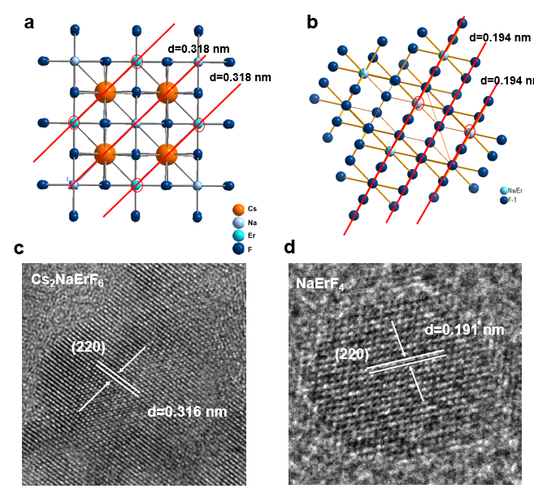
Figure S8. (a) Schematic diagram of the crystal structure of Cs₂NaErF₆ NCs. (b) Schematic diagram of the crystal structure of α-NaErF₄ NCs. (c) High-resolution TEM of Cs₂NaErF₆ NCs. (d) High-resolution TEM of α-NaErF₄ NCs.

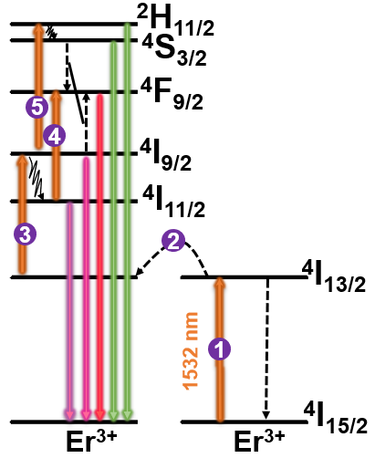

Figure S9. Schematic of the self-sensitized UCL mechanism of Cs₂NaErF₆ NCs. Upon excitation at 1532 nm, the electrons of Er³⁺ can be first pumped to the ⁴I_{13/2} level via ground-state absorption or energy transfer from adjacent Er³⁺ ions. Subsequently, the electrons in the ⁴I_{13/2} level were pumped to the ⁴I_{9/2} level via excited-state absorption. Part of the electrons in the ⁴I_{9/2} level underwent radiative relaxation to the ⁴I_{11/2} level. Concurrently, the electrons in the ⁴I_{9/2} and ⁴I_{11/2} levels absorbed a third photon and populated the ²H_{11/2}/⁴S_{3/2} and ⁴F_{9/2} levels, respectively, resulting in red and green UCL.
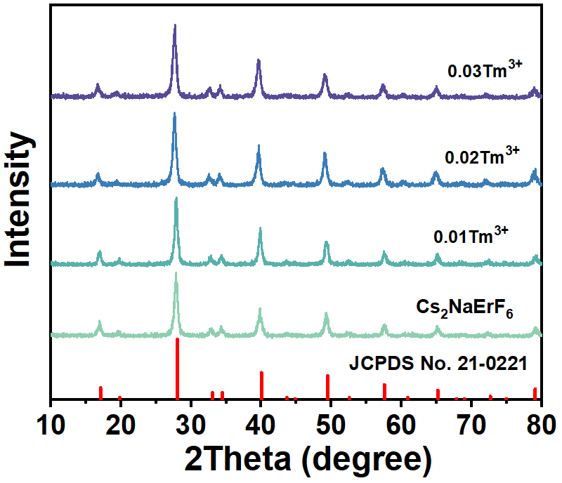

Figure S10. XRD patterns of Cs₂NaErF₆:xTm³⁺ NCs with different Tm³⁺ doping concentrations, exhibiting intense diffraction peaks without any observable impurities.

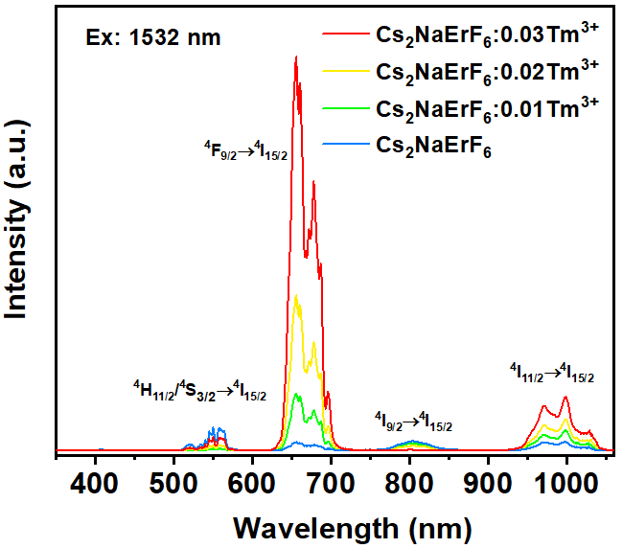
Figure S11. UCL spectra of Cs₂NaErF₆:xTm³⁺ (λ_{ex} = 1532 nm) NCs. As the Tm³⁺ concentration increased, the emissions from the ⁴H_{11/2}/⁴S_{3/2} → ⁴I_{15/2} transition, the ⁴F_{9/2} → ⁴I_{15/2} transition, and the ⁴I_{11/2} → ⁴I_{15/2} transition continuously increased, while the emission from the ⁴I_{9/2} → ⁴I_{15/2} transition gradually decreased. Note that the emission at ~800 nm (from the ⁴I_{9/2} energy level) was stronger than that at ~545 nm (⁴S_{3/2}) and ~660 nm (⁴F_{9/2}) in the pristine Cs₂NaErF₆ NCs. However, after Tm³⁺ doping, it was discovered that the emission at ~800 nm gradually decreased with increasing Tm³⁺ doping concentration. The reason lies in the energy transfer from ⁴I_{9/2} level of Er³⁺ to ³H₄ level of Tm³⁺, resulting in a decrease in emission intensity at 800 nm. This assignment is further supported by the lifetime data, where the 800 nm UCL lifetime decreased from 156 to 47 μs with increasing Tm³⁺ concentration.

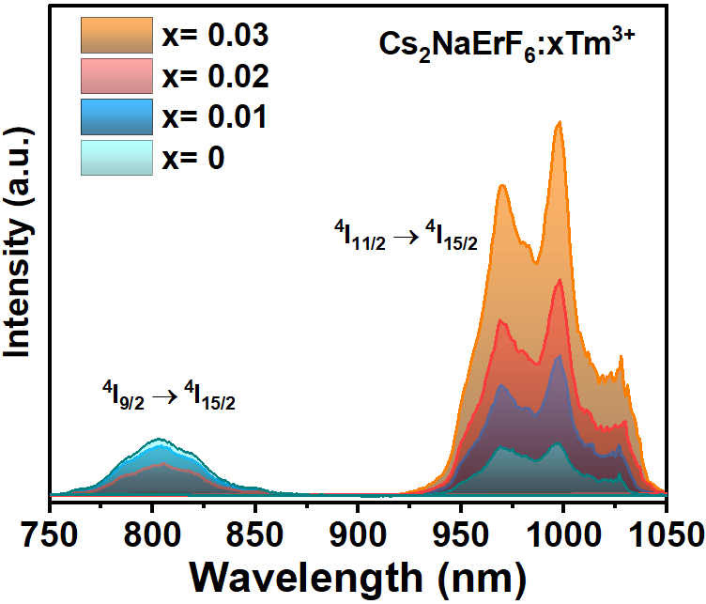

Figure S12. UCL spectra of Cs₂NaErF₆:xTm³⁺ (λ_{ex} = 1532 nm) NCs. The intensity from ⁴I_{9/2} → ⁴I_{15/2} decreased, while the intensity from ⁴I_{11/2} → ⁴I_{15/2} increased, indicating that Tm³⁺ doping altered the electronic populations of the ⁴I_{9/2} and ⁴I_{15/2} energy levels of Er³⁺.

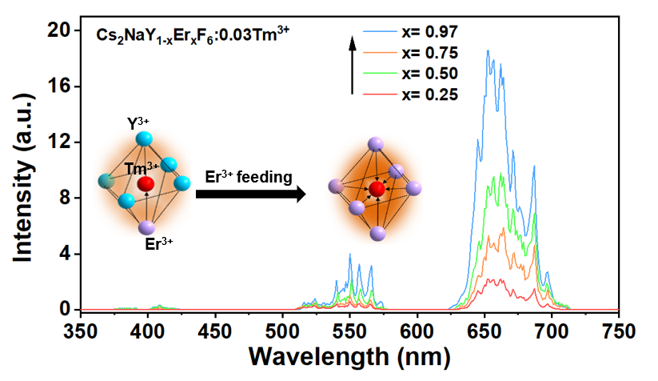

Figure S13. UCL spectra of the Cs₂NaY_{1-X}Er_{X}F₆:0.03Tm³⁺ NCs (λ_{ex} = 1532 nm). With the increased of Er³⁺ content, the UCL was enhanced, indicating that the energy transfer efficiency between Er³⁺ and Tm³⁺ was improved with increasing Er³⁺ content.

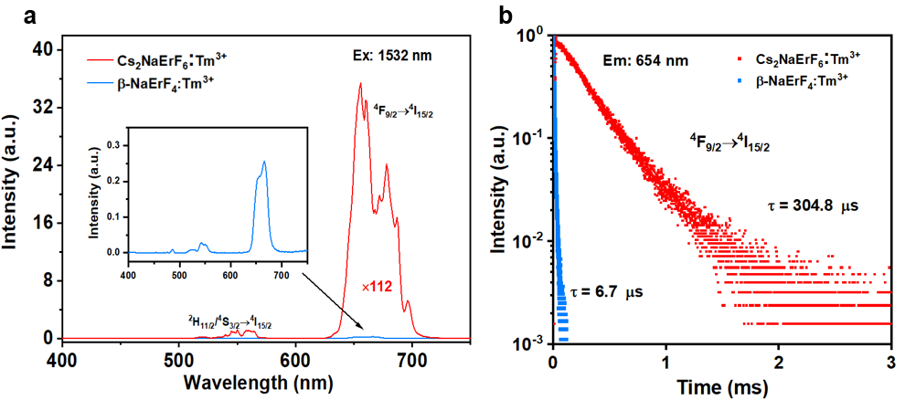
Figure S14. (a) UCL spectra of Cs₂NaErF₆:Tm³⁺ NCs and β-NaErF₄:Tm³⁺ NCs upon excitation at 1532 nm. (b) UCL decays of Cs₂NaErF₆:Tm³⁺ NCs and β-NaErF₄:Tm³⁺ NCs upon excitation at 1532 nm.
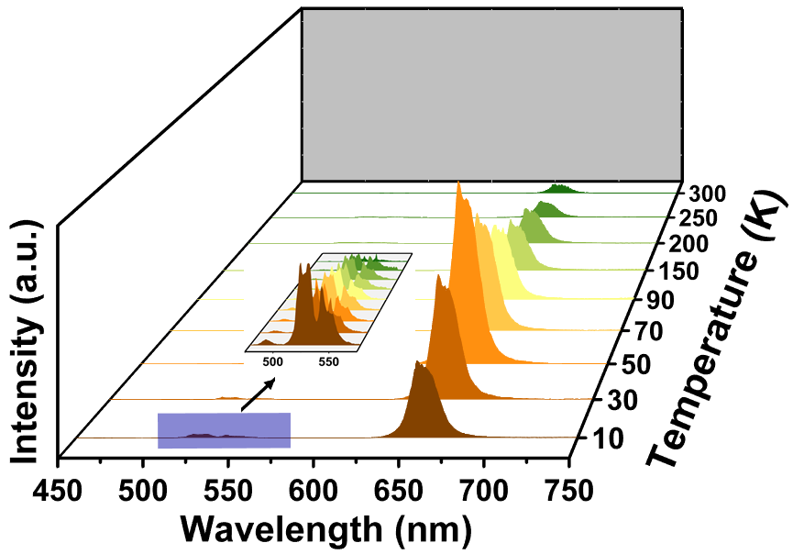

Figure S15. Temperature-dependent UCL spectra of Cs₂NaErF₆:0.03Tm³⁺ NCs (λ_{ex} = 1532 nm). The red UCL of Er³⁺ increased gradually with increasing temperature from 10 to 50 K and then decreased at higher temperatures.

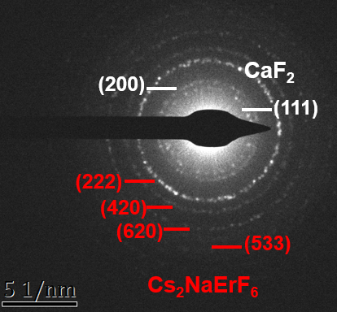

Figure S16. SAED of Cs₂NaErF₆:0.03Tm³⁺@CaF₂ NCs. Characteristic rings from Cs₂NaErF₆:0.03Tm³⁺ and CaF₂ can be identified in the SAED pattern.

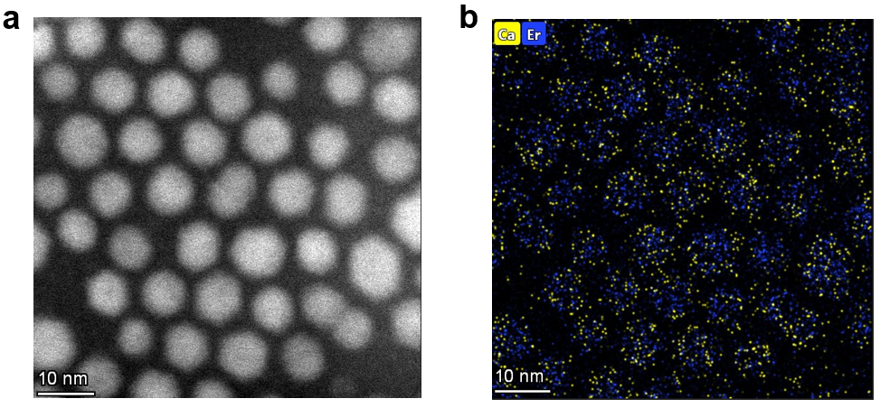
Figure S17. Elemental mapping of Cs₂NaErF₆@CaF₂ NCs. Er³⁺ was uniformly distributed within the lattice, and Ca²⁺ was uniformly distributed around the Er³⁺ ions.

Figure S18. XRD patterns of Cs₂NaErF₆:0.03Tm³⁺@CaF₂ NCs with different Ca(TFA)₂ feeding. The Cs₂NaErF₆:0.03Tm³⁺ coexists with CaF₂ when Ca(TFA)₂ feeding was lower than 0.2 mmol, suggesting the formation of a CaF₂ shell. When Ca(TFA)₂ feeding exceeded 0.2 mmol, the CaF₂ impurity phase was generated, resulting in the widening of the diffraction peaks.

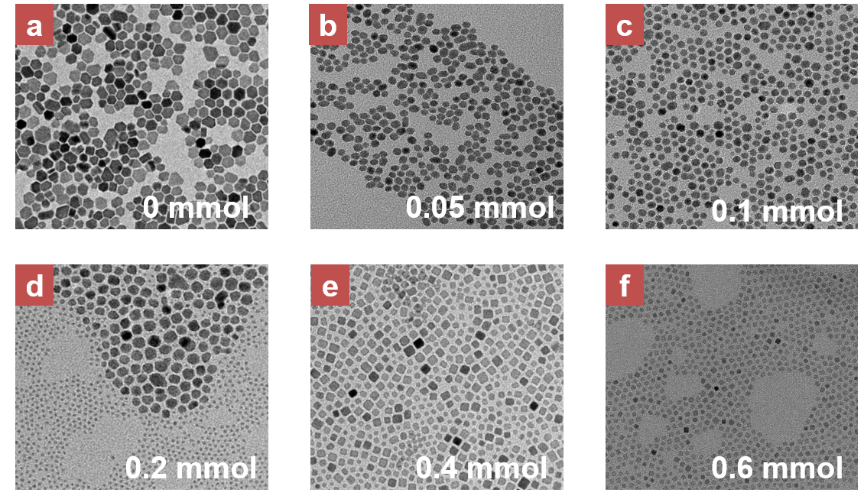

Figure S19. TEM images of Cs₂NaErF₆:0.03Tm³⁺@CaF₂ NCs with different Ca(TFA)₂ feeding: (a) 0 mmol, (b) 0.05 mmol, (c) 0.10 mmol, (d) 0.20 mmol, (e) 0.40 mmol, and (f) 0.60 mmol. With increased Ca(TFA)₂ feeding, CaF₂ impurity phases were produced besides Cs₂NaErF₆:0.03Tm³⁺@CaF₂ NCs.

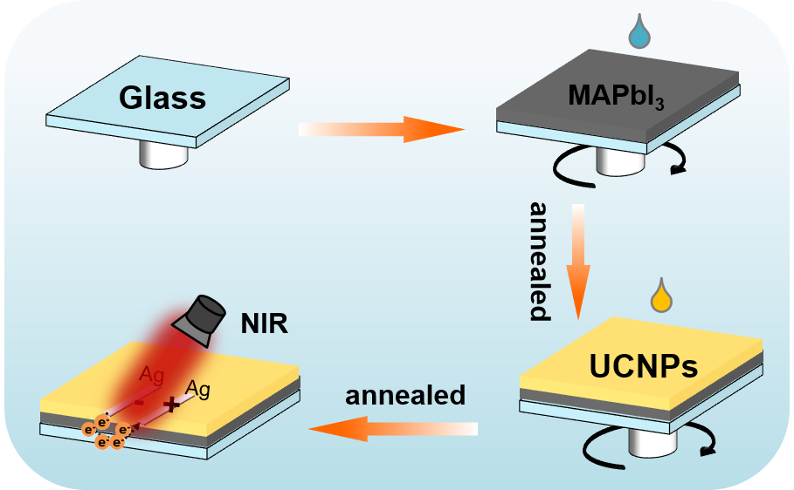

Figure S20. Schematic of photodetector fabrication, wherein spin-coating of MAPbI₃ and Cs₂NaErF₆:0.03Tm³⁺@CaF₂ NCs was carried out in sequence on a glass substrate.

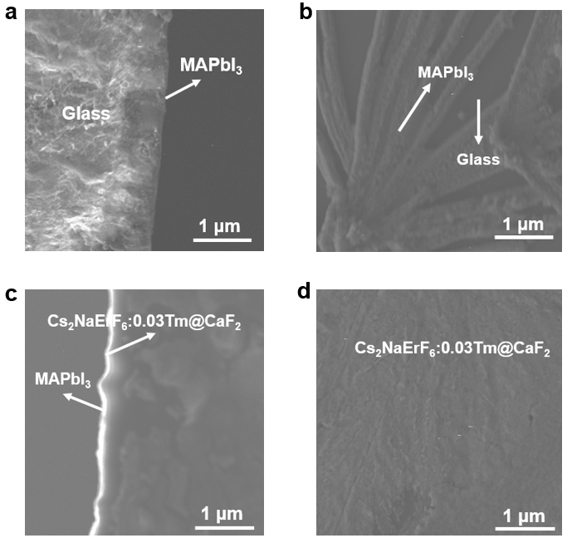

Figure S21. Sectional view SEM images of (a) MAPbI₃/glass and (c) Cs₂NaErF₆:0.03Tm³⁺@CaF₂/MAPbI₃/glass. The top-view SEM images of (b) MAPbI₃/glass and (d) Cs₂NaErF₆:0.03Tm³⁺@CaF₂/MAPbI₃/glass. The MAPbI₃ and Cs₂NaErF₆:0.03Tm³⁺@CaF₂ NCs were evenly covered on the glass substrate.

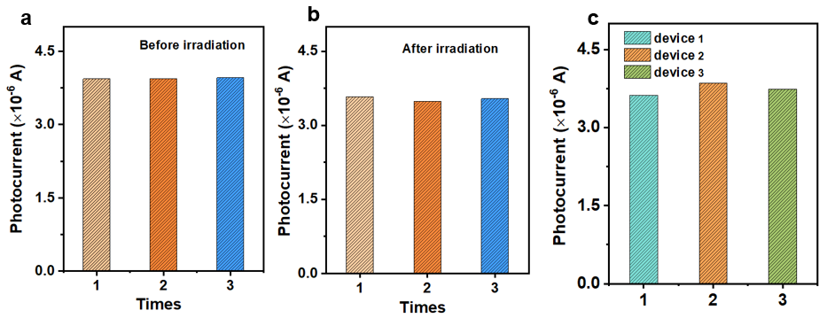
Figure S22. (a-b) Photocurrent intensity of Cs₂NaErF₆:0.03Tm³⁺@CaF₂/MAPbI₃ PD before and after 1, 2, 3, and 4 h of continuous irradiation at 1532 nm. (c) Photocurrent intensity of Cs₂NaErF₆:0.03Tm³⁺@CaF₂/MAPbI₃ PD after one month in a desiccator.

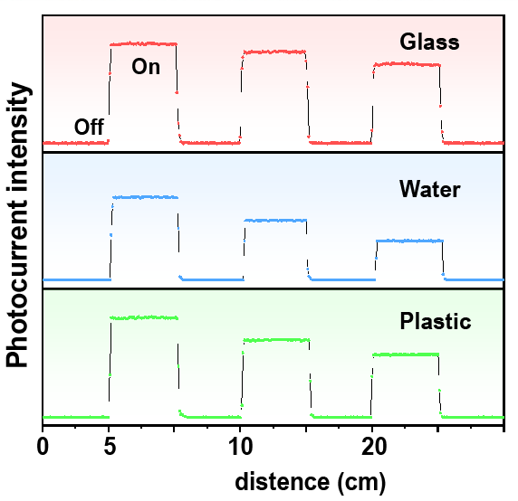

Figure S23. Optical signal intensity received by NIR PDs at different distances after 1532-nm laser penetration through different media. After propagating through 20 cm of glass, water, and plastic, 1532-nm optical signals can be received by PDs with no discernible distortion, achieving relative signal intensities of 85%, 73%, and 56%, respectively.

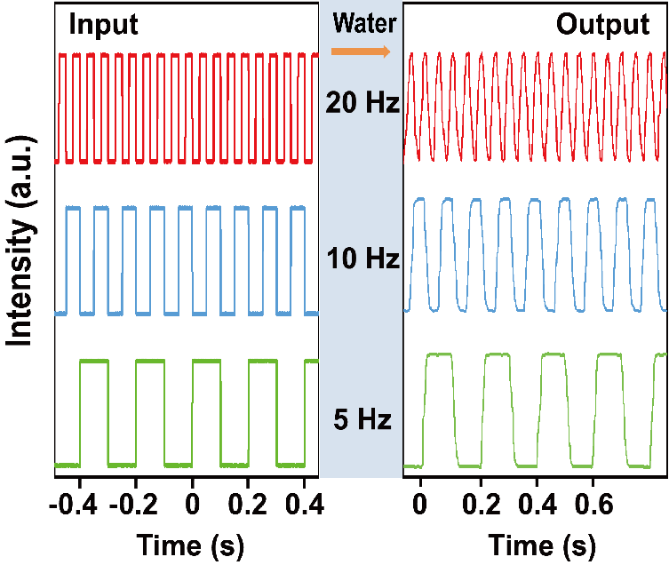

Figure S24. Input and output signals of 1532 nm light at different frequencies in water medium. Pulse signal transmission was achieved by tuning the emission frequency of the 1532-nm laser. Using a pulse modulator, the 1532 nm light source was modulated into pulsed light signals at 5, 10, and 20 Hz, respectively. It proved that the received signals in the water medium remained stable under different modulation frequencies and faithfully matched the input signal, underscoring the outstanding dynamic response characteristics of the PDs.

References
1 Kataria, M. et al. Transparent, wearable, broadband, and highly sensitive upconversion nanoparticles and graphene-based hybrid photodetectors. ACS Photonics 5, 2336-2347, doi:10.1021/acsphotonics.8b00141 (2018).
2 Xiang, H. et al. Upconversion nanoparticles extending the spectral sensitivity of silicon photodetectors to λ=1.5 μm. Nanotechnol. 31, 495201, doi:10.1088/1361-6528/abb2c4 (2020).
3 Wang, M. et al. Erbium-doped double perovskite nanocrystals enable broadband-narrowband dual-mode photodetection. J. Alloys Compd. 1050, 185675, doi:10.1016/j.jallcom.2025.185675 (2026).
4 Wang, T. et al. A crystal-growth boundary-fusion strategy to prepare high-quality MAPbI₃ films for excellent Vis-NIR photodetectors. Nano Energy 64, 103914, doi:10.1016/j.nanoen.2019.103914 (2019).
5 Wu, J. et al. Enhanced performance of a graphene/GaAs self-driven near-infrared photodetector with upconversion nanoparticles. Nanoscale 10, 8023-8030, doi:10.1039/c8nr00594j (2018).
6 Dias, S., Kumawat, K., Biswas, S. & Krupanidhi, S. B. Solvothermal synthesis of Cu₂SnS₃ quantum dots and their application in near-infrared photodetectors. Inorg. Chem. 56, 2198-2203, doi:10.1021/acs.inorgchem.6b02832 (2017).
7 Zhang, X. et al. Perovskite-erbium silicate nanosheet hybrid waveguide photodetectors at the near-infrared telecommunication band. Adv. Mater. 29, 1604431, doi:10.1002/adma.201604431 (2017).
8 Ji, Y. et al. Aligned plasmonic antenna and upconversion nanoparticles toward polarization-sensitive narrowband photodetection and imaging at 1550 nm. ACS Appl. Mater. Interfaces 14, 50045-50054, doi:10.1021/acsami.2c14127 (2022).
9 Chen, W. et al. Enabling highly efficient infrared silicon photodetectors via disordered metasurfaces with upconversion nanoparticles. Sci. Adv. 11, eadx7783, doi:10.1126/sciadv.adx7783 (2025).
10 Ji, Y. et al. Huge upconversion luminescence enhancement by a cascade optical field modulation strategy facilitating selective multispectral narrow-band near-infrared photodetection. Light:Sci. Appl. 9, 184, doi:10.1038/s41377-020-00418-0 (2020).
11 Zhao, X., Song, L., Zhao, R. & Tan, M. C. High-performance and flexible shortwave infrared photodetectors using composites of rare earth-doped nanoparticles. ACS Appl. Mater. Interfaces 11, 2344-2351, doi:10.1021/acsami.8b16978 (2019).
12 Dong, X. et al. NIR II-responsive core-shell La₂O₂S:Er³⁺@La₂O₂S nanoparticles towards 1.5 μm photodetection. J. Mater. Chem. C 12, 11386-11393, doi:10.1039/d4tc01409j (2024).
13 Ding, N. et al. Highly DUV to NIR-II responsive broadband quantum dots heterojunction photodetectors by integrating quantum cutting luminescent concentrators. Light:Sci. Appl. 13, 289, doi:10.1038/s41377-024-01604-0 (2024).
14 Zi, L. et al. Lanthanide-doped MAPbI₃ single crystals: Fabrication, optical and electrical properties, and multi-mode photodetection. Chem. Mater. 34, 7412-7423, doi:10.1021/acs.chemmater.2c01549 (2022).
15 Liu, B. et al. Simultaneous Improvement and Tailoring Upconversion and Downshift Luminescence of Cs₂NaErCl₆ via Yb³⁺ Alloying for Versatile Photoelectric Applications. ACS Appl. Mater. Interfaces 17, 18688-18700, doi:10.1021/acsami.5c01548 (2025).
16 Yin, X. et al. Towards highly efficient NIR II response up-conversion phosphor enabled by long lifetimes of Er³⁺. Nat. Commun. 13, 6549, doi:10.1038/s41467-022-34350-1 (2022).

