Supporting Information
Pioneer plant species shape rhizosphere dissolved organic matter chemodiversity and selective organo-mineral association in bauxite residue
Chenglong Lu ª, Songlin Wu ^{a, *}, Fang You ª, Dingyi Yu ^{b}, Long Ma ª, Jitraporn Vongsvivut ^{c}, Annaleise Klein ^{c}, Lars Thomsen ^{c}, David Parry ^{d}, Longbin Huang ^{a, *}

ª Centre for Mined Land Rehabilitation, Sustainable Minerals Institute, The University of Queensland, Brisbane 4072, Australia
^{b} St Vincent's Institute of Medical Research, Melbourne, Victoria 3065, Australia
^{c} Australian Synchrotron, ANSTO, Melbourne, Victoria 3168, Australia
^{d} Rio Tinto, Brisbane, Queensland 4000, Australia

* Corresponding Author: Longbin Huang, Songlin Wu
Postal address: Sustainable Minerals Institute, The University of Queensland, Brisbane 4072, Australia
Tel: +61 7 3346 3130, E-mail: l.huang@uq.edu.au; slwu@rcees.ac.cn

This Supporting Information includes:
17 pages, 1 table, and 6 figures, together with supplementary experimental methods and descriptions of the results.

Text S1 DOM extraction
Bauxite residue (BR) samples collected from the different pioneer plant treatments were used for DOM extraction, with three biological replicates analyzed for each treatment. Briefly, 3 g of each BR sample was placed in a polypropylene centrifuge tube and mixed with 15 mL of Milli-Q water at a solid-to-liquid ratio of 1:5 (w/v). The mixtures were shaken overnight at 170 rpm and subsequently centrifuged at 4000 rpm for 30 min. The resulting supernatants were filtered through 0.45 μm cellulose acetate membrane filters to remove suspended particles.
A 5 mL aliquot of each filtered supernatant was acidified to pH 2 by the dropwise addition of HCl to improve the retention of acidic organic compounds by the PPL sorbent. Solid-phase extraction (SPE) was then performed to isolate and desalt the extracted DOM using the following procedure:
a. The PPL cartridge was rinsed with 6 mL of MS-grade methanol at a flow rate of 2 mL/min.
b. The PPL cartridge was conditioned by elution with 6 mL of pH 2 HCl.
c. A 5 mL aliquot of the DOM supernatant from the above reaction was passed through the PPL cartridge at a flow rate of 1 mL/min.
d. The PPL cartridge was rinsed with 15 mL of Milli-Q water to remove salts.
e. The PPL cartridge was dried under a stream of nitrogen gas for approximately 1 hour.
f. DOM was eluted from the PPL cartridge using 5 mL of MS-grade methanol, collected into acid-washed glass vials, and stored at -20°C.
The SPE recovery of DOM was determined by comparing the blank-corrected TOC contents of the DOM extracts before and after SPE. The SPE recovery exceeded 85% for all samples.
Text S2 Methods for ESI Orbitrap data collection
Data was collected in negative ion mode across the mass range m/z 150-1000. The Orbitrap resolution was set at 500,000. Samples were delivered by syringe pump and infused at a rate of 3.5 µL/min. Instrument parameters included the following settings: Negative ion spray voltage was set to 2500 V. The Sheath Gas was set to 5 (arb), auxiliary gas (Aux Gas) to 4 (arb), and sweep gas to 2 (arb). The ion transfer tube temperature was maintained at 300°C, and the vaporizer temperature was set to 20°C. The RF lens was set to 60%. The AGC target was set 100%. Max injection time was 100 ms. Deuterated stearic acid (CAS Number: 17660-51-4, Sigma-Aldrich, C₁₈D₃₅HO₂, 20 µM, [M-H]⁻ m/z 318.48394; [M+Cl]⁻ (C₁₈D₃₅HO₂Cl) m/z 354.460618) was added as internal standard to the solutions and used for internal Reference Mass during acquisition. Blank analyses of the solvent and SPE extractions were performed to check for possible contaminants and background signals. Mass spectra were analysed and mass features extracted using Thermo Fisher Freestyle software (Version 1.8). The background signal found in blank samples were subtracted from the sample spectra.

Text S3 DOM classification and parameters calculation.
Seven groups of organic matter were classified according to H/C and O/C ratios in van Krevelen diagram, i.e., carbohydrates (H/C = 1.5-2.1; O/C > 0.67), proteins (H/C = 1.5-2.1; O/C = 0.3-0.67), lipids (H/C = 1.5-2.0; O/C = 0.1-0.3); unsaturated hydrocarbons (H/C = 0.7-1.5; O/C < 0.1); tannins (H/C = 0.5-1.5; O/C > 0.67); lignins (H/C = 0.7-1.5; O/C = 0.1-0.67); condensed aromatics (H/C = 0.2-0.7; O/C < 0.67). Double bond equivalence (DBE) was used for measure of the number of double bonds and rings in a molecule. Aromaticity index (AI) was calculated from the formulas to estimate fraction of aromatic and condensed aromatic groups. NOSC, namely nominal oxidation state of carbon, representing the average oxidation state of all carbons per formula independent of the chemical structure was calculated. The parameter is directly related to the H/C and O/C and can provide an estimate of the polarity, mobility and bioavailability/biogeochemical reactivity of the substances. Carboxyl-rich alicyclic molecules (CRAMs) are the majority of recalcitrant DOM, with DBE/C 0.30-0.68; DBE/O 0.77-1.75; DBE/H 0.20-0.95, which may be microbial-derived recalcitrant compounds. The magnitude weighted parameters including DBE_{w}, M/Z_{w}, H/C_{w}, O/C_{w}, AI_{w}, NOSCw were calculated according to Sleighter and Hatcher.

Text S4. C 1s NEXAFS Analysis
Synchrotron-based near edge X-ray absorption fine structure (NEXAFS) spectroscopy was employed to investigate the chemical bonding environments of carbon in bauxite residue (BR) samples following long-term plant colonization. The measurements were conducted at the Soft X-ray Spectroscopy beamline (14ID) of the Australian Synchrotron.
For C 1s analysis, BR samples were freeze-dried, finely ground (<7 μm), mounted onto copper tape, and fixed to a stainless ruler. The synchrotron beam was operated in continuous top-up mode with a beam spot size of 1 mm². Spectra were collected in partial electron yield (PEY) mode at a 55° angle to the incident beam over an energy range of 270–330 eV, with a step size of 0.1 eV and a collection time of 0.8 s per step. Data acquisition was carried out using the Channeltron Front detector (CHF, 200 eV) and a Hemispherical Analyser (HA, 100 eV), with the Flood Gun on to minimize surface charging. Each sample was measured three times at different positions.
Spectra were processed using the QANT software package (Igor Pro 8), following the double normalization method: first normalized to the incident photon flux (I⁰), and then by a photodiode reference spectrum collected under ultrahigh vacuum (UHV). Energy calibration was performed using a highly oriented pyrolytic graphite (HOPG) standard, with its main exciton peak at 291.65 eV. Background subtraction was applied using a linear fit to pre-edge (272–278 eV) and post-edge (323–329 eV) regions.
Peak fitting of the C 1s NEXAFS spectra was performed using Gaussian functions with a fixed edge jump at 290 eV, a normalized edge height of 1.3 (a.u.), and a consistent peak width of 1.2 eV. A total of ten Gaussian components were applied to represent distinct carbon bonding environments. Functional group assignments were based on their resonance energies as follows: 284.3 and 285.0 eV (aromatic carbon, 1s → π*), 286.5 eV (phenolic carbon), 287.3 eV (aliphatic carbon), 288.4 eV (carboxylic carbon), and 289.3 eV (O-alkyl carbon). Two extended transitions at 289.1 and 289.7 eV were also included as contributions from highly conjugated aromatic structures (1s → 2π*). Additionally, peaks at 291.0 and 292.0 eV represent σ* transitions associated with saturated covalent C–C bonding in ordered or graphitic structures. The relative abundance of each functional group was calculated as the percentage of its corresponding peak area divided by the total integrated area of all fitted peaks.

Text S5 Synchrotron-based transmission FTIR mapping
Synchrotron-based transmission Fourier transform infrared (FTIR) microspectroscopy was conducted at the Infrared Microspectroscopy (IRM) beamline of the Australian Synchrotron to characterize the composition and microscale spatial distribution of organic functional groups in bauxite residue (BR) after colonization by different pioneer plant species.
BR samples collected from the rhizobox BR chambers were fractionated using a modified wet-sieving procedure. Macroaggregates ranging from 250 to 2000 μm were first isolated, gently disrupted, and wet-sieved through a 53 μm mesh to separate coarse particulate organic matter (POM) from the operationally defined mineral-associated organic matter (MAOM) fraction. The MAOM fraction was collected for FTIR analysis. The isolated MAOM samples were embedded in Milli-Q water, rapidly frozen using dry ice, and cryosectioned into 2.5 μm-thick sections at −26 °C using a CryoStar NX70 cryomicrotome (Thermo Fisher, USA).
Synchrotron-based FTIR measurements were performed in transmission mode using a Bruker VERTEX 80v FTIR spectrometer coupled with a Hyperion 3000 infrared microscope equipped with a mercury cadmium telluride (MCT) single-element detector. The microscope was fitted with 36× condenser and objective optics with a numerical aperture of 0.5. Spectral maps covering areas of approximately 200 × 250 μm were acquired using a nominal sampling interval of 2.5 μm. Each spectrum was collected by co-adding 64 scans over the range of 3900–800 cm⁻¹ at a spectral resolution of 4 cm⁻¹.
Spectral data were processed using OPUS 8.5 software (Bruker Optik GmbH, Germany). Atmospheric compensation was applied to minimize residual spectral contributions from atmospheric water vapour and carbon dioxide. All FTIR spectra and chemical maps were subsequently visualized and exported using Quasar software (Version 1.9.2).
For functional-group mapping, selected absorbance bands were integrated using local baselines defined on both sides of the corresponding absorption peaks. Representative band assignments and their associated organic functional groups and mineral-related vibrations are provided in Figure S3. Pixel-wise integrated absorbance values were exported from the functional-group maps, and Pearson correlation coefficients were calculated to evaluate spatial co-associations among the selected organic functional groups and mineral-related bands. The resulting correlation matrices were visualized as heatmaps using the Seaborn package in Python.

Table S1. Nutrition solutions applied to the plants. Note: elements Na, Si, and Fe were not applied, as bauxite residue could be sole sources for these elements.
Chemical compound Name | K₂HPO₄ | KNO₃ | CuSO₄ | H₃BO₃ | MnCl₂ | ZnSO₄ | K₂MoO₄
Concentration (mmol L⁻¹) | 5 | 20 | 0.002 | 0.1 | 0.02 | 0.01 | 0.0005

All treatments were watered daily to maintain a water content of 15% w/w. A nutrient solution without the use of elements Na, Si, and Fe is applied to plants every 2 weeks to support plant growth, because bauxite residue may be the only source of these elements.

Figure S1. Schematic and photographic representation of the side-inserted BR chamber system used to assess root–bauxite residue (BR) interactions. The system consists of a primary growth chamber filled with neutralized river sand, into which a cylindrical BR compartment was laterally embedded. Plants were initially grown in the sand matrix and allowed to gradually extend their roots into the BR chamber through a 2 mm nylon mesh interface. The photographs on the right show extensive root colonization of the BR compartment by Chloris gayana (Rhodes grass) after 347 days of cultivation, forming a defined root–mineral interaction zone.

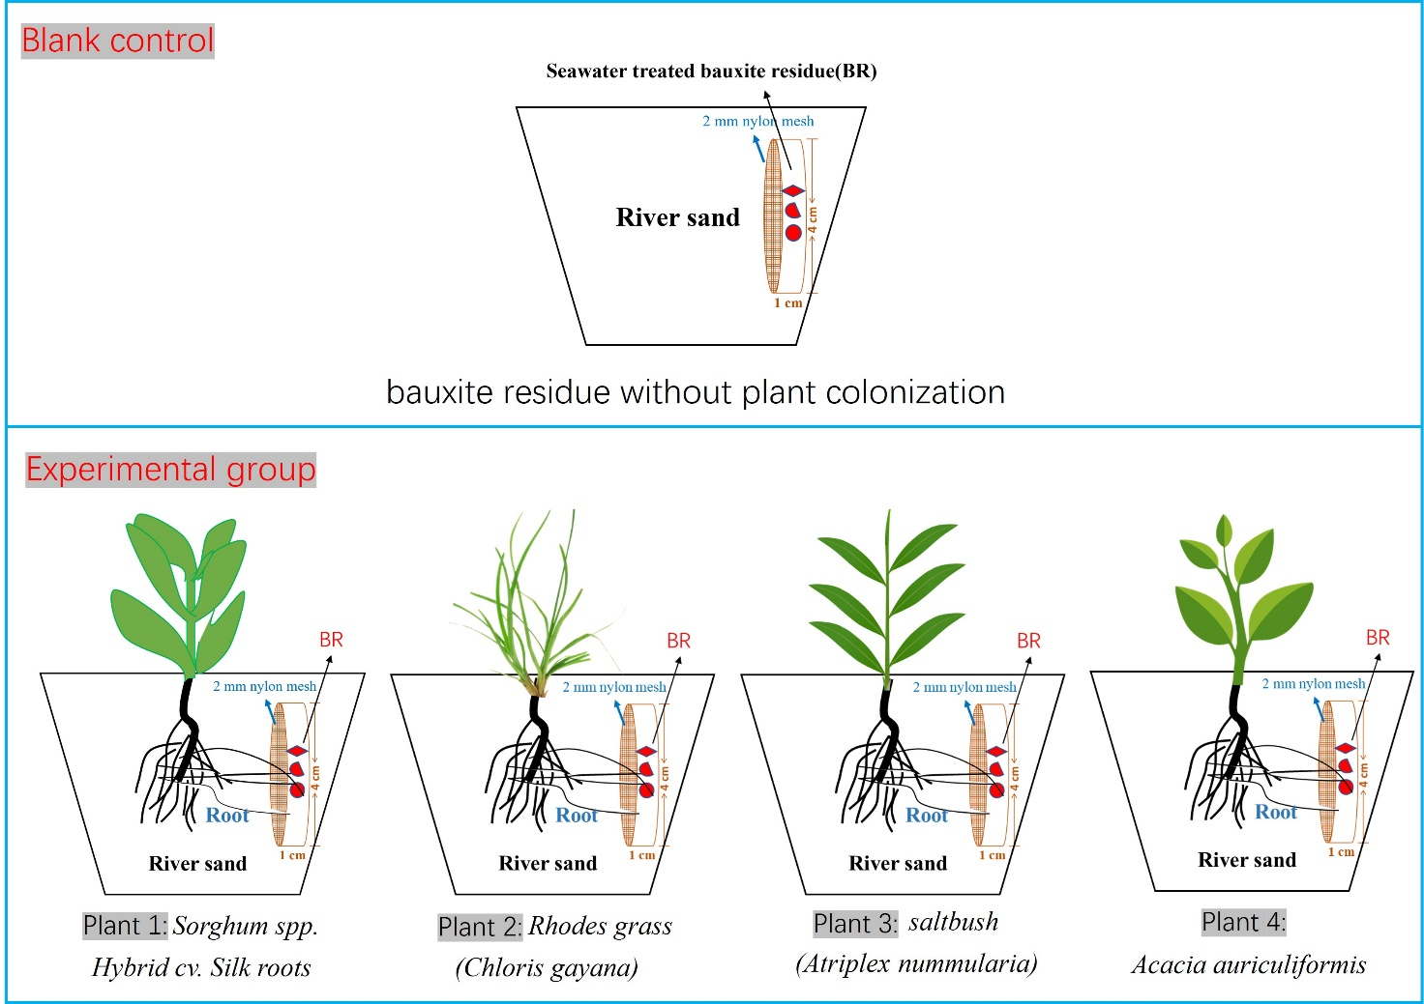
Figure S2. Schematic diagram of the side-inserted rhizobox experimental design. The primary growth substrate was washed river sand, into which a cylindrical chamber containing seawater-neutralized bauxite residue (BR) was laterally embedded. A 2 mm nylon mesh separated the BR chamber from the surrounding sand, allowing root penetration while preventing bulk material mixing. The experimental group consisted of four haloalkalitolerant pioneer plant species: (1) Sorghum spp. Hybrid cv. Silk (SHS), (2) Chloris gayana (Cg), (3) Atriplex nummularia (An), and (4) Acacia auriculiformis (Aa). The control group (“Blank control”) included BR without plant colonization. Each treatment included four plants per pot and four biological replicates.

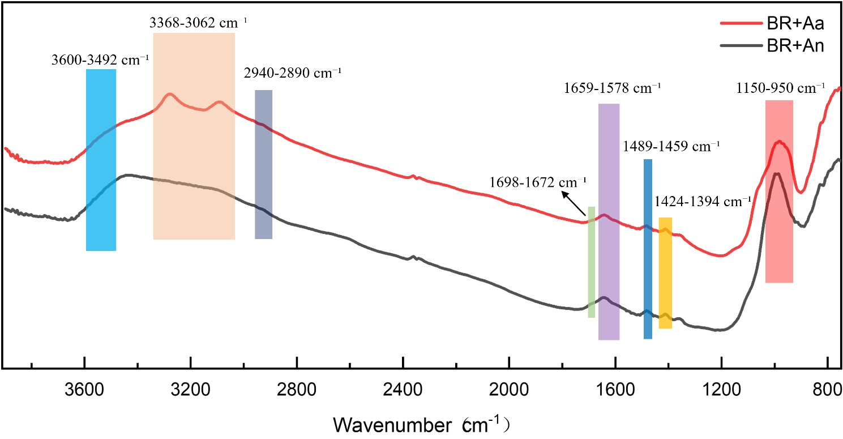
Figure S3. Representative synchrotron-based FTIR spectra showing DOM–mineral associations in bauxite residue after pioneer plant colonization (Atriplex nummularia, An; Acacia auriculiformis, Aa). The major organic functional groups and mineral phases were identified based on characteristic absorbance peaks in the FTIR spectrum, as follows (Barth, 2000; Boily and Felmy, 2008; Coates, 2000; Faix, 1991; Madejova and Komadel, 2001; Smith, 2018): The broad peak in the range of 3600-3492 cm⁻¹ (3585, 3566, 3527, and 3521 cm⁻¹) corresponds to O-H stretching vibrations of hydroxy oxides (including amorphous Al/Fe/Si-OH, Fe-OH and structural hydroxyls in clay minerals). The strong peak in the range of 3368-3062 cm⁻¹ (3287 cm⁻¹) is assigned to N-H stretching vibrations of amino acids or protein degradation products. The absorption peak in the range of 2940-2890 cm⁻¹ (2920 cm⁻¹) represents the C-H stretching vibrations of lipid-related aliphatic hydrocarbons. The peak within 1698-1672 cm⁻¹ corresponds to the C=O stretching of organic carboxylic acids, while the peaks in 1659-1578 cm⁻¹ (1641 and 1596 cm⁻¹) are attributed to aromatic C=C stretching in lignin. The peaks in the range of 1489-1459 cm⁻¹ (1474 cm⁻¹) are due to C-H bending vibrations in lipids, particularly from methyl (-CH₃) and methylene (-CH₂) groups. The region of 1424-1394 cm⁻¹ (1409 cm⁻¹) corresponds to long-chain aliphatic compounds. Finally, the strong absorption in the 1150-950 cm⁻¹ range is attributed to Si-O stretching vibrations in silicate minerals such as quartz, kaolinite, and montmorillonite.
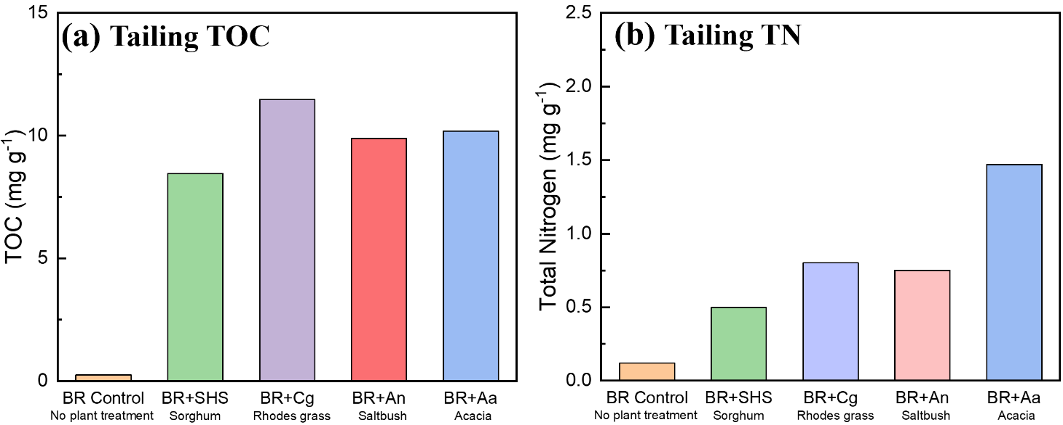
Figure S4. Total organic carbon (TOC) (Lu et al., 2025) and total nitrogen (TN) concentrations in bauxite residue (BR) after colonization by different pioneer plant species. Increased TOC and TN levels reflect enhanced inputs and accumulation of carbon and nitrogen in BR induced by rhizosphere activity.

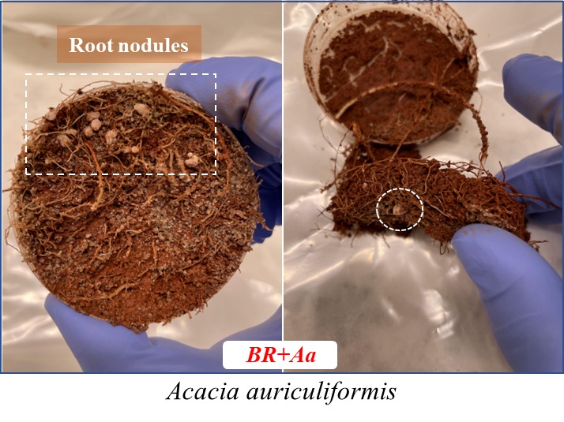
Figure S5. Representative rhizosphere discs showing the interaction between plant roots and seawater-neutralized bauxite residue (BR). Root nodules formed on Acacia auriculiformis (Aa) roots are highlighted by dashed circles. Modified from Lu et al. (2025).

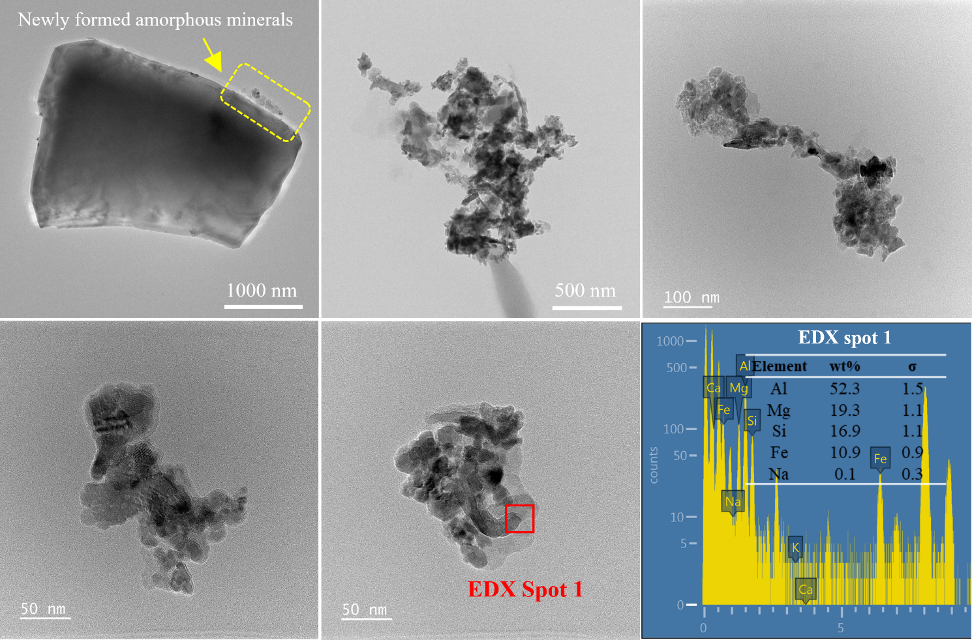
Figure S6. Transmission electron microscopy coupled with energy dispersive X-ray spectroscopy (EDX) of rhizosphere bauxite residue samples colonized by salt bush (An) roots.

References:
Barth, A., 2000. The infrared absorption of amino acid side chains. Progress in biophysics and molecular biology 74(3-5), 141–173.
Boily, J.-F., Felmy, A.R., 2008. On the protonation of oxo-and hydroxo-groups of the goethite (α-FeOOH) surface: A FTIR spectroscopic investigation of surface O–H stretching vibrations. Geochimica et Cosmochimica Acta 72(14), 3338–3357.
Coates, J., 2000. Interpretation of infrared spectra, a practical approach. Encyclopedia of analytical chemistry 12, 10815–10837.
Faix, O., 1991. Classification of lignins from different botanical origins by FT-IR spectroscopy.
Lu, C., Wu, S., Ma, L., You, F., Saha, N., Bu, H., Fernando, J., Parry, D., Thomsen, L., Chan, T.-S., 2025. Haloalkalitolerant plants drive alkaline mineral weathering and dealkalization of seawater-treated bauxite residue. Plant and Soil 514(2), 1993–2011.
Madejova, J., Komadel, P., 2001. Baseline studies of the clay minerals society source clays: infrared methods. Clays and clay minerals 49(5), 410–432.
Smith, B.C., 2018. Infrared spectral interpretation: a systematic approach. CRC press.

