Figure S1: Total number of unique parent firms over time for each state
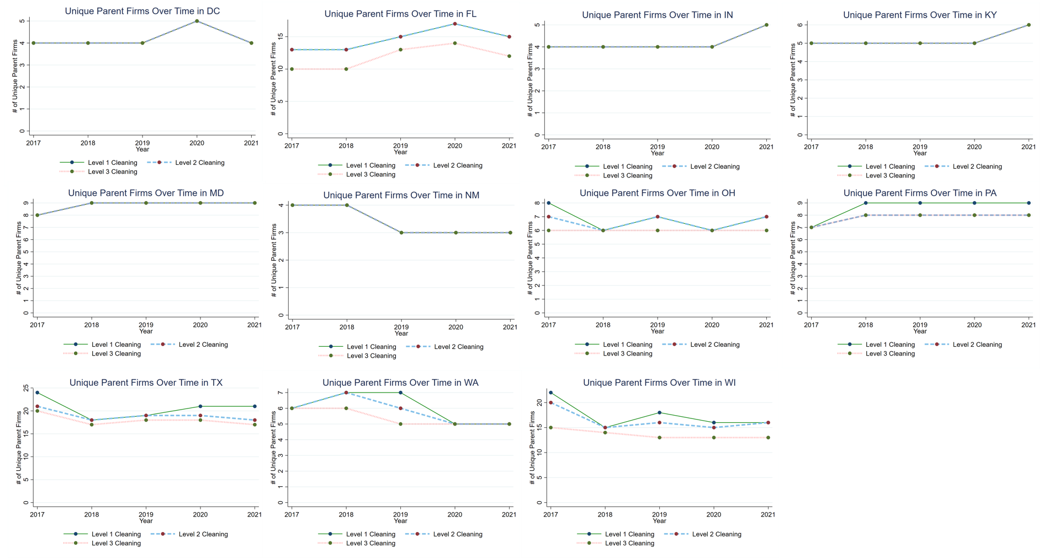
SOURCE Author’s analysis of data from Medicaid Managed Care Enrollment Report (MMCER), 2017-2021.

Figure S2: Total number of unique plans over time for each state
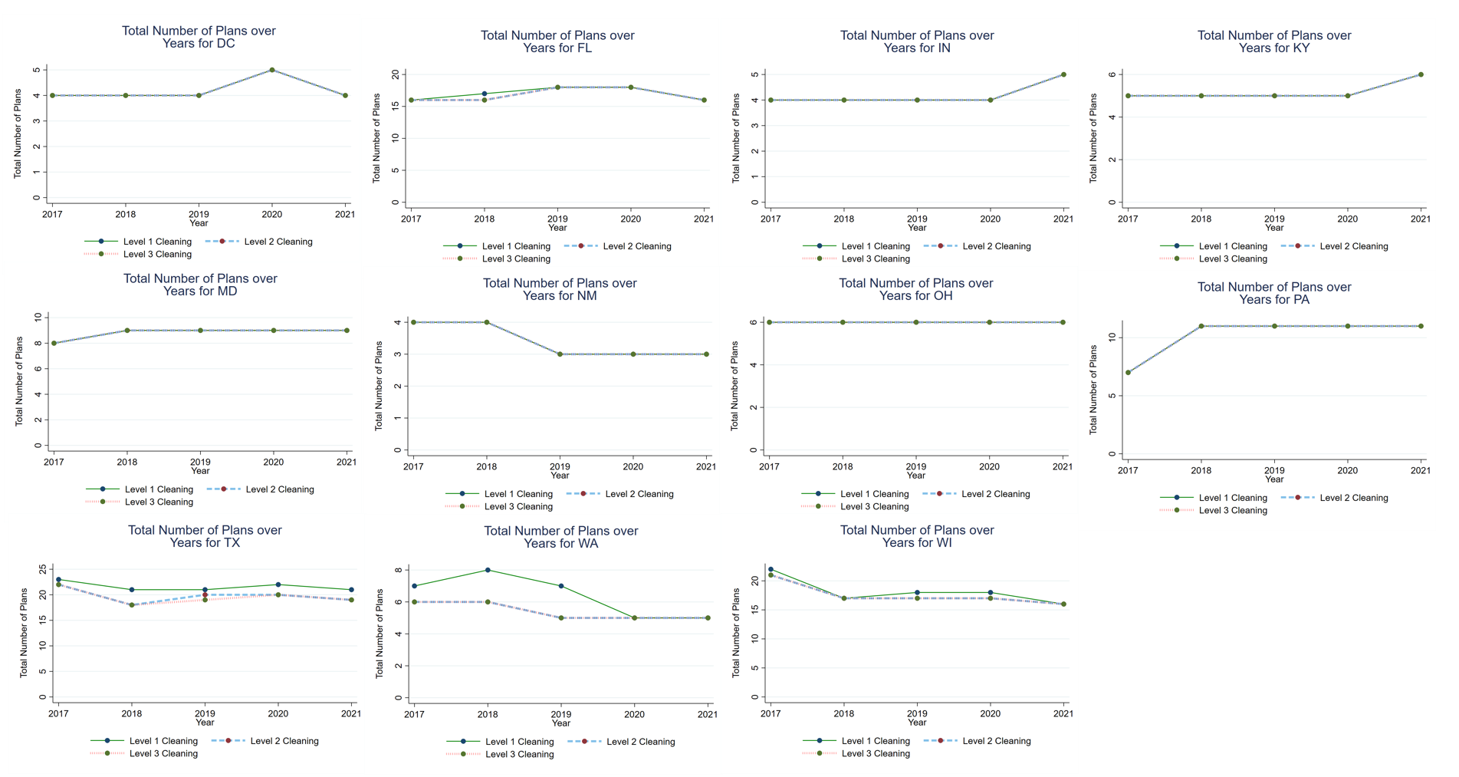
SOURCE Author’s analysis of data from Medicaid Managed Care Enrollment Report (MMCER), 2017-2021.

Figure S3: Average number of plans per parent firm over time for each state (plan-parent firm ratio)
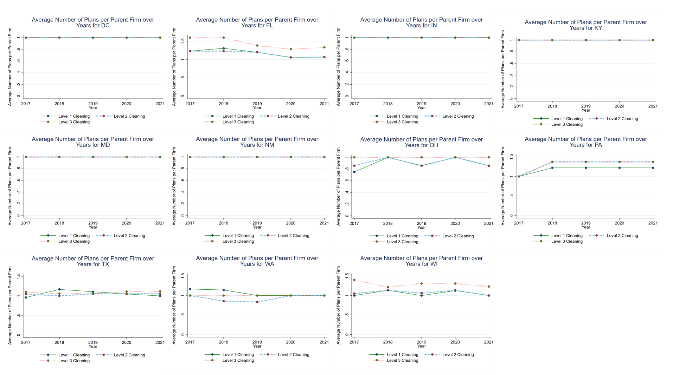
SOURCE Author’s analysis of data from Medicaid Managed Care Enrollment Report (MMCER), 2017-2021.

Figure S4: Share of plans provided by the Big Five over time for each state
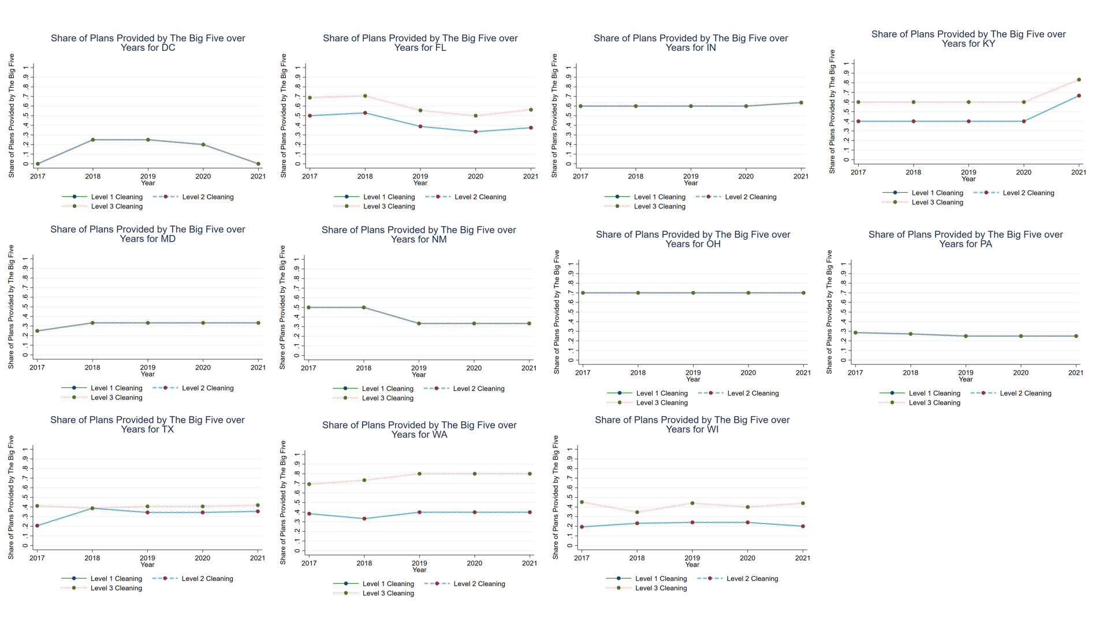
SOURCE Author’s analysis of data from Medicaid Managed Care Enrollment Report (MMCER), 2017-2021.

