Supplemental Figures

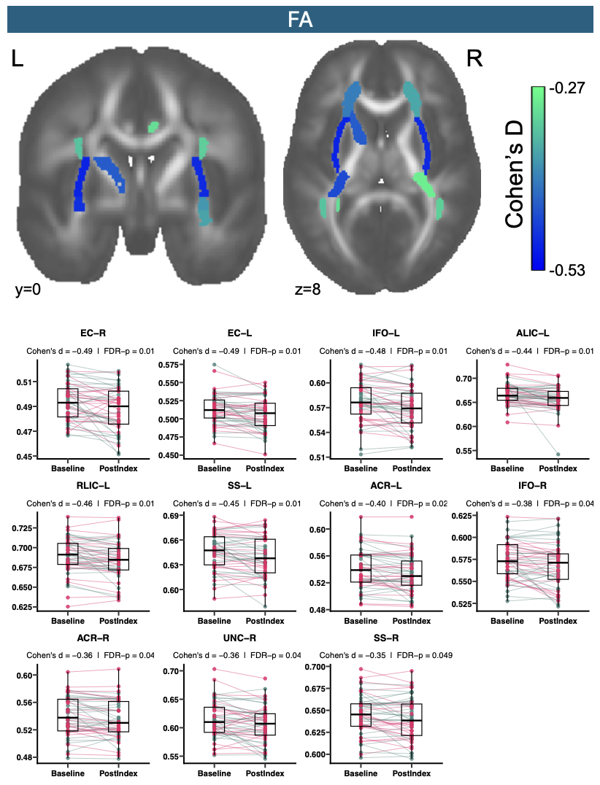
Supplemental Figure 1. (Top) Effect-size maps showing the standardized effect of time (change in baseline-SD units) for all FA regions with uncorrected p < 0.05. (Bottom) Spaghetti plots of residualized FA ROI values (adjusted for age, sex, and study) at Baseline and Post-Index for the regions surviving FDR correction.
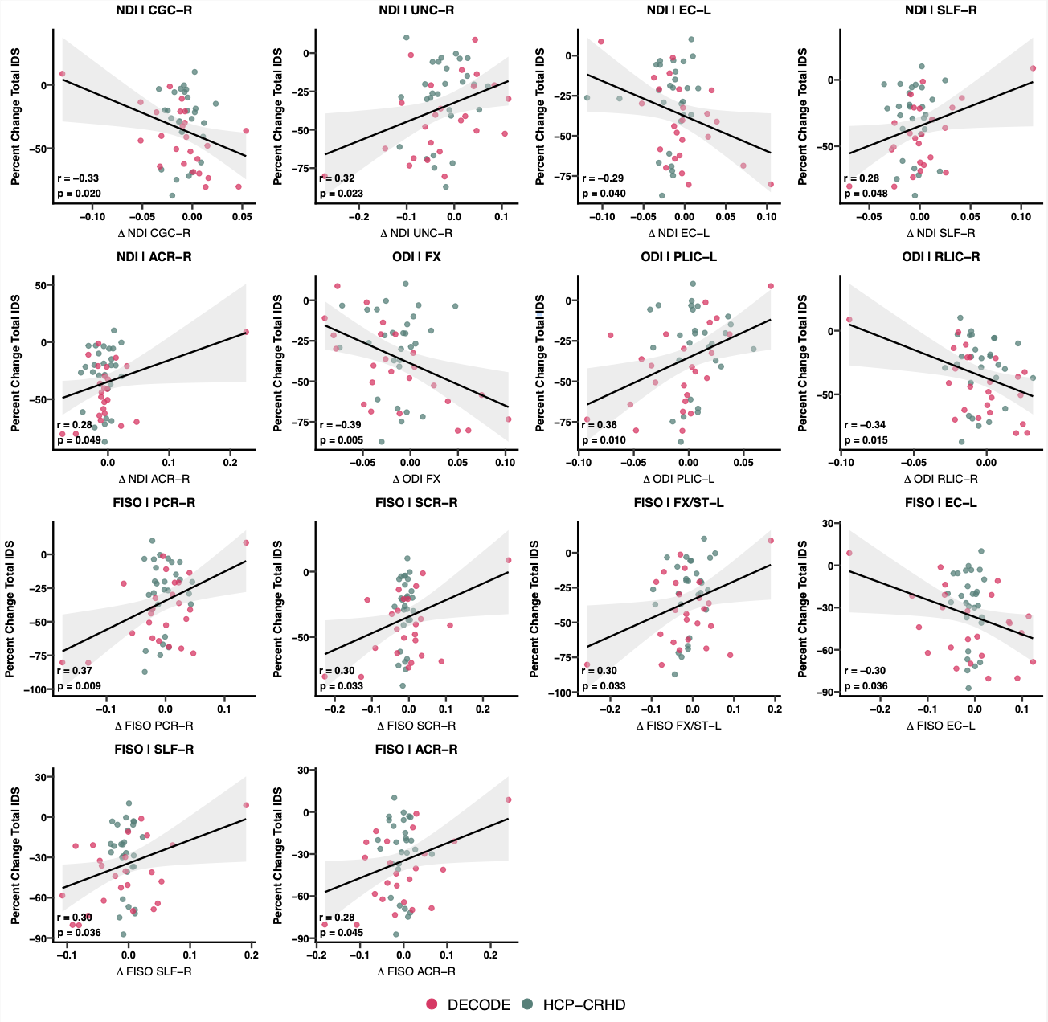
Supplemental Figure 2. Scatter plots of percent change in Total IDS against ROI white-matter change for the 14 ROIs reaching p < 0.05 in the per-region regression % Δ Total IDS ~ Δ ROI + age + sex. Both axes are residualized for age and sex.

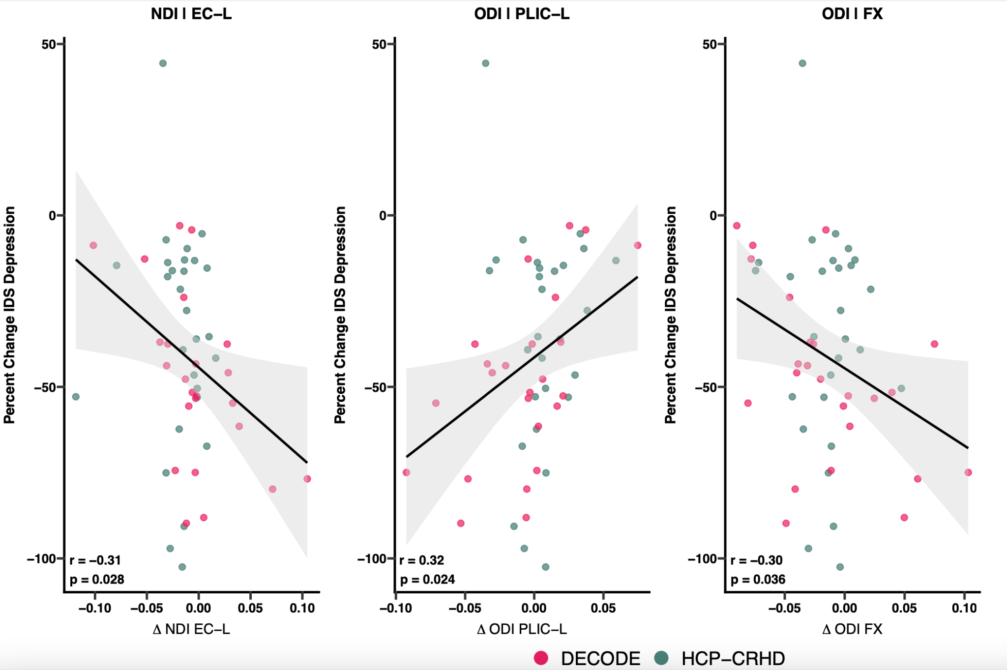
Supplemental Figure 3. Scatter plots of percent change in IDS core depression symptoms against ROI white-matter change for the 3 ROIs reaching p < 0.05 in the per-region regression % Δ Total IDS ~ Δ ROI + age + sex. Both axes are residualized for age and sex.

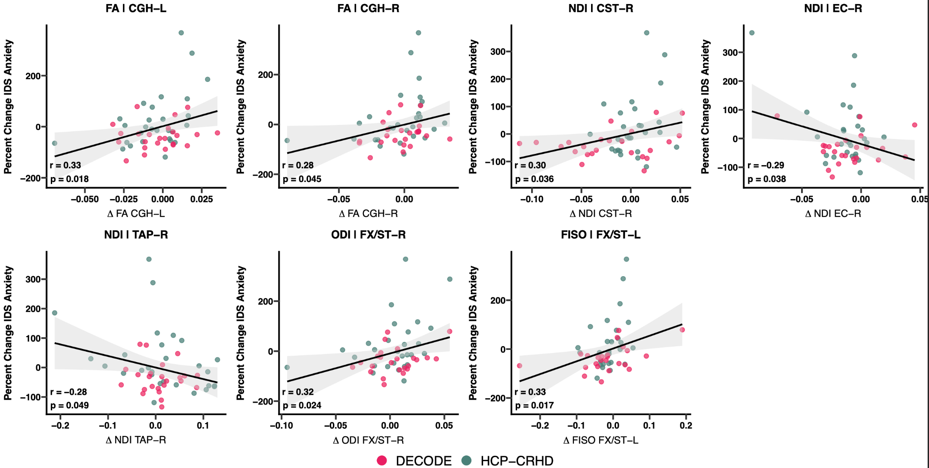
Supplemental Figure 4. Scatter plots of percent change in IDS core anxiety symptoms against ROI white-matter change for the 7 ROIs reaching p < 0.05 in the per-region regression % Δ Total IDS ~ Δ ROI + age + sex. Both axes are residualized for age and sex.
Supplemental Tables

Supplemental Table 1. Neuroimaging acquisition details by cohort.
Sequence | HCP-CRHD | DECODE
Scanner | Siemens Prisma 3T | Siemens Prisma 3T
Head coil | 32-channel | 32-channel
T1w | MPRAGE | MPRAGE
Resolution | 0.8 mm isotropic | 0.8 mm isotropic
TR (ms) | 2500 | 2400
TE (ms) | 1.81, 3.60, 5.39, 7.18 (multi-echo) | 2.22
TI (ms) | 1000 | 1000
Flip angle | 8° | 8°
T2w | SPACE | SPACE
Resolution | 0.8 mm isotropic | 0.8 mm isotropic
TR (ms) | 3200 | 3200
TE (ms) | 564 | 564
Diffusion | HCP Lifespan | Modified ABCD
Resolution | 1.5 mm isotropic | 2.0 mm isotropic
Sequence | Multiband spin-echo EPI | Multiband spin-echo EPI
Multiband factor | 4 | 3
TR (ms) | 3230 | 4100
TE (ms) | 89 | 88
b-values (s/mm²) | 1500, 3000 | 500, 1000, 2000, 3000
Diffusion directions | 185 | 96
b = 0 images | 24 | 7
Phase encoding | AP/PA | AP/PA
Supplemental Table 2. List of major white matter tracts from JHU atlas included in analyses.
BCC | Body of corpus callosum
SCC | Splenium of corpus callosum
FX | Fornix (column and body of fornix)
CST-R | Corticospinal tract right
CST-L | Corticospinal tract left
ALIC-L | Anterior limb of internal capsule left
PLIC-R | Posterior limb of internal capsule right
PLIC-L | Posterior limb of internal capsule left
RLIC-R | Retrolenticular part of internal capsule right
RLIC-L | Retrolenticular part of internal capsule left
ACR-R | Anterior corona radiata right
ACR-L | Anterior corona radiata left
SCR-R | Superior corona radiata right
SCR-L | Superior corona radiata left
PCR-R | Posterior corona radiata right
PCR-L | Posterior corona radiata left
PTR-R | Posterior thalamic radiation right
PTR-L | Posterior thalamic radiation left
SS-R | Sagittal stratum right
SS-L | Sagittal stratum left
EC-R | External capsule right
EC-L | External capsule left
CGC-R | Cingulum (cingulate gyrus) right
CGC-L | Cingulum (cingulate gyrus) left
CGH-R | Cingulum (hippocampus) right
CGH-L | Cingulum (hippocampus) left
FX/ST-R | Fornix (cres) / Stria terminalis right
FX/ST-L | Fornix (cres) / Stria terminalis left
SLF-R | Superior longitudinal fasciculus right
SLF-L | Superior longitudinal fasciculus left
SFO-R | Superior fronto-occipital fasciculus right
SFO-L | Superior fronto-occipital fasciculus left
IFO-R | Inferior fronto-occipital fasciculus right
IFO-L | Inferior fronto-occipital fasciculus left
UNC-R | Uncinate fasciculus right
UNC-L | Uncinate fasciculus left
TAP-R | Tapetum right
TAP-L | Tapetum left
Supplemental Table 3. Race, medications, and comorbidities
 | DECODE | HCP-CHRD | Merged
Race
Asian | 12.5% | 10.7% | 11.5%
Black or African American | 4.2% | 7.1% | 5.8%
White | 58.3% | 71.4% | 65.4%
More than one race | 16.7% | 7.1% | 11.5%
Unknown / prefer not to answer | 8.3% | 0.0% | 3.8%
Ethnicity
Not Hispanic or Latino | 70.8% | 92.9% | 82.7%
Hispanic or Latino | 25.0% | 3.6% | 13.5%
Unknown / prefer not to answer | 4.2% | 3.6% | 3.8%
Primary diagnosis
Major depressive disorder, single episode | 4.2% | 14.3% | 9.6%
Major depressive disorder, recurrent | 75.0% | 60.7% | 67.3%
Bipolar disorder (I or II), depressed | 16.7% | 25.0 | 21.2%
With psychotic features | 12.5% | 10.7% | 11.5%
Not specified in record | 4.2% | 0.0% | 1.9%
Medication
Any psychotropic medication | 75.0% | 100.0% | 88.5%
SSRI | 16.7% | 21.4% | 19.2%
SNRI | 41.7% | 28.6% | 34.6%
Other antidepressant | 29.2% | 39.3% | 34.6%

Supplemental Table 4. Descriptive statistics for the effect of time in the full sample, in the DECODE only sample, and in the HCP-CRHD only sample. Raw p-values, FDR-corrected p-values, and Cohen’s D are listed. Regions with raw p-value <0.05 are italicized, regions with FDR-corrected p-values <0.05 are bolded.

 | Full sample |  |  | DECODE |  |  | HCP-CRHD
ROI | Raw p | FDR p | Cohen’s D | Raw p | FDR p | Cohen’s D | Raw p | FDR p | Cohen’s D
FA
BCC | 0.213 | 0.337 | -0.17 | 0.225 | 0.357 | -0.25 | 0.420 | 0.499 | -0.15
SCC | 0.301 | 0.458 | -0.14 | 0.835 | 0.860 | -0.04 | 0.256 | 0.406 | -0.22
FX | 0.970 | 0.970 | -0.01 | 0.217 | 0.357 | 0.26 | 0.278 | 0.406 | -0.21
CST-R | 0.894 | 0.943 | -0.02 | 0.188 | 0.357 | 0.28 | 0.367 | 0.485 | -0.17
CST-L | 0.659 | 0.758 | -0.06 | 0.129 | 0.308 | 0.32 | 0.088 | 0.270 | -0.33
ALIC-L | 0.003 | 0.017 | -0.44 | 0.002 | 0.029 | -0.73 | 0.036 | 0.143 | -0.42
PLIC-R | 0.630 | 0.748 | 0.07 | 0.528 | 0.645 | 0.13 | 0.868 | 0.897 | 0.03
PLIC-L | 0.539 | 0.683 | -0.09 | 0.225 | 0.357 | 0.25 | 0.260 | 0.406 | -0.22
RLIC-R | 0.043 | 0.101 | -0.29 | 0.217 | 0.357 | -0.26 | 0.112 | 0.279 | -0.31
RLIC-L | 0.002 | 0.017 | -0.46 | 0.049 | 0.223 | -0.42 | 0.013 | 0.088 | -0.50
ACR-R | 0.012 | 0.046 | -0.36 | 0.008 | 0.085 | -0.59 | 0.125 | 0.279 | -0.30
ACR-L | 0.005 | 0.029 | -0.40 | 0.042 | 0.223 | -0.44 | 0.038 | 0.143 | -0.41
SCR-R | 0.539 | 0.683 | 0.09 | 0.862 | 0.862 | 0.04 | 0.538 | 0.620 | 0.12
SCR-L | 0.333 | 0.468 | 0.14 | 0.164 | 0.346 | 0.29 | 0.897 | 0.897 | 0.02
PCR-R | 0.394 | 0.535 | 0.12 | 0.091 | 0.250 | 0.36 | 0.893 | 0.897 | -0.03
PCR-L | 0.851 | 0.924 | -0.03 | 0.053 | 0.223 | 0.42 | 0.112 | 0.279 | -0.31
PTR-R | 0.120 | 0.217 | -0.22 | 0.087 | 0.250 | -0.36 | 0.419 | 0.499 | -0.16
PTR-L | 0.055 | 0.122 | -0.27 | 0.033 | 0.210 | -0.46 | 0.302 | 0.425 | -0.20
SS-R | 0.014 | 0.049 | -0.35 | 0.010 | 0.085 | -0.57 | 0.242 | 0.406 | -0.23
SS-L | 0.002 | 0.017 | -0.45 | 0.147 | 0.329 | -0.31 | 0.007 | 0.069 | -0.55
EC-R | < .001 | 0.013 | -0.49 | 0.092 | 0.250 | -0.36 | 0.005 | 0.057 | -0.59
EC-L | < .001 | 0.013 | -0.49 | 0.127 | 0.308 | -0.32 | 0.003 | 0.057 | -0.62
CGC-R | 0.033 | 0.083 | -0.30 | 0.067 | 0.250 | -0.39 | 0.158 | 0.306 | -0.27
CGC-L | 0.186 | 0.307 | -0.19 | 0.838 | 0.860 | -0.04 | 0.180 | 0.326 | -0.26
CGH-R | 0.329 | 0.468 | -0.14 | 0.694 | 0.776 | -0.08 | 0.376 | 0.485 | -0.17
CGH-L | 0.179 | 0.307 | -0.19 | 0.727 | 0.789 | -0.07 | 0.161 | 0.306 | -0.27
FX/ST-R | 0.731 | 0.817 | -0.05 | 0.286 | 0.402 | -0.22 | 0.783 | 0.875 | 0.05
FX/ST-L | 0.067 | 0.142 | -0.26 | 0.462 | 0.585 | -0.15 | 0.092 | 0.270 | -0.33
SLF-R | 0.025 | 0.074 | -0.32 | 0.085 | 0.250 | -0.37 | 0.121 | 0.279 | -0.30
SLF-L | 0.020 | 0.064 | -0.33 | 0.219 | 0.357 | -0.26 | 0.052 | 0.181 | -0.38
SFO-R | 0.930 | 0.955 | -0.01 | 0.263 | 0.400 | 0.23 | 0.383 | 0.485 | -0.17
SFO-L | 0.566 | 0.694 | 0.08 | 0.283 | 0.402 | 0.22 | 0.830 | 0.897 | -0.04
IFO-R | 0.009 | 0.042 | -0.38 | 0.001 | 0.029 | -0.76 | 0.276 | 0.406 | -0.21
IFO-L | 0.001 | 0.013 | -0.48 | 0.011 | 0.085 | -0.56 | 0.018 | 0.088 | -0.48
UNC-R | 0.012 | 0.046 | -0.36 | 0.296 | 0.402 | -0.22 | 0.018 | 0.088 | -0.48
UNC-L | 0.107 | 0.214 | -0.23 | 0.442 | 0.579 | 0.16 | 0.004 | 0.057 | -0.60
TAP-R | 0.112 | 0.214 | -0.22 | 0.543 | 0.645 | -0.13 | 0.144 | 0.304 | -0.28
TAP-L | 0.032 | 0.083 | -0.31 | 0.648 | 0.746 | -0.09 | 0.018 | 0.088 | -0.47
NDI
BCC | 0.073 | 0.197 | -0.25 | 0.063 | 0.393 | -0.40 | 0.675 | 0.777 | -0.08
SCC | 0.194 | 0.369 | -0.18 | 0.096 | 0.454 | -0.35 | 0.227 | 0.318 | 0.23
FX | 0.788 | 0.788 | 0.04 | 0.420 | 0.687 | 0.17 | 0.464 | 0.568 | -0.14
CST-R | 0.129 | 0.272 | -0.21 | 0.038 | 0.357 | -0.45 | 0.436 | 0.553 | 0.15
CST-L | 0.166 | 0.333 | -0.19 | 0.145 | 0.490 | -0.31 | 0.913 | 0.913 | 0.02
ALIC-L | 0.443 | 0.561 | -0.11 | 0.980 | 0.980 | 0.01 | 0.045 | 0.115 | -0.40
PLIC-R | 0.531 | 0.629 | -0.09 | 0.888 | 0.946 | -0.03 | 0.234 | 0.318 | -0.23
PLIC-L | 0.659 | 0.695 | -0.06 | 0.914 | 0.946 | 0.02 | 0.036 | 0.098 | -0.42
RLIC-R | 0.347 | 0.507 | -0.13 | 0.921 | 0.946 | -0.02 | 0.082 | 0.149 | -0.34
RLIC-L | 0.059 | 0.191 | -0.27 | 0.435 | 0.687 | -0.16 | 0.005 | 0.034 | -0.57
ACR-R | 0.546 | 0.629 | -0.08 | 0.895 | 0.946 | 0.03 | 0.054 | 0.117 | -0.38
ACR-L | 0.012 | 0.075 | -0.36 | 0.338 | 0.642 | -0.20 | 0.007 | 0.037 | -0.55
SCR-R | 0.021 | 0.102 | -0.33 | 0.056 | 0.393 | -0.41 | 0.216 | 0.316 | -0.24
SCR-L | 0.086 | 0.218 | -0.24 | 0.232 | 0.490 | -0.25 | 0.052 | 0.117 | -0.38
PCR-R | 0.104 | 0.233 | -0.23 | 0.010 | 0.357 | -0.57 | 0.801 | 0.867 | 0.05
PCR-L | 0.062 | 0.191 | -0.26 | 0.184 | 0.490 | -0.28 | 0.132 | 0.228 | -0.29
PTR-R | 0.494 | 0.605 | -0.10 | 0.435 | 0.687 | -0.16 | 0.821 | 0.867 | -0.04
PTR-L | 0.741 | 0.762 | -0.05 | 0.452 | 0.687 | -0.16 | 0.545 | 0.648 | 0.12
SS-R | 0.611 | 0.663 | -0.07 | 0.786 | 0.946 | 0.06 | 0.184 | 0.279 | -0.26
SS-L | 0.037 | 0.139 | -0.30 | 0.404 | 0.687 | -0.17 | 0.026 | 0.083 | -0.44
EC-R | < .001 | 0.019 | -0.49 | 0.029 | 0.357 | -0.48 | 0.016 | 0.056 | -0.48
EC-L | 0.029 | 0.122 | -0.31 | 0.725 | 0.939 | -0.07 | 0.003 | 0.029 | -0.62
CGC-R | 0.012 | 0.075 | -0.36 | 0.109 | 0.459 | -0.34 | 0.012 | 0.045 | -0.51
CGC-L | 0.330 | 0.501 | -0.14 | 0.645 | 0.880 | -0.10 | 0.167 | 0.276 | -0.27
CGH-R | 0.270 | 0.428 | -0.15 | 0.877 | 0.946 | -0.03 | 0.036 | 0.098 | -0.42
CGH-L | 0.220 | 0.395 | -0.17 | 0.649 | 0.880 | -0.09 | 0.179 | 0.279 | -0.26
FX/ST-R | 0.009 | 0.075 | -0.38 | 0.199 | 0.490 | -0.27 | < .001 | 0.029 | -0.70
FX/ST-L | 0.008 | 0.075 | -0.38 | 0.072 | 0.393 | -0.38 | 0.055 | 0.117 | -0.38
SLF-R | 0.583 | 0.652 | -0.08 | 0.741 | 0.939 | 0.07 | 0.059 | 0.118 | -0.37
SLF-L | < .001 | 0.019 | -0.51 | 0.035 | 0.357 | -0.46 | 0.003 | 0.029 | -0.63
SFO-R | 0.237 | 0.395 | -0.17 | 0.227 | 0.490 | -0.25 | 0.788 | 0.867 | -0.05
SFO-L | 0.102 | 0.233 | -0.23 | 0.307 | 0.614 | -0.21 | 0.009 | 0.044 | -0.53
IFO-R | 0.065 | 0.191 | -0.26 | 0.224 | 0.490 | -0.25 | 0.077 | 0.147 | -0.35
IFO-L | 0.404 | 0.530 | -0.12 | 0.894 | 0.946 | 0.03 | 0.004 | 0.029 | -0.60
UNC-R | 0.019 | 0.101 | -0.34 | 0.226 | 0.490 | -0.25 | 0.011 | 0.045 | -0.52
UNC-L | 0.391 | 0.530 | -0.12 | 0.123 | 0.467 | 0.33 | 0.002 | 0.029 | -0.64
TAP-R | 0.239 | 0.395 | 0.17 | 0.484 | 0.708 | 0.15 | 0.339 | 0.444 | 0.18
TAP-L | 0.388 | 0.530 | -0.12 | 0.230 | 0.490 | -0.25 | 0.880 | 0.903 | -0.03
ODI
BCC | 0.126 | 0.705 | -0.22 | 0.798 | 0.999 | 0.05 | < .001 | 0.004 | -0.86
SCC | 0.975 | 0.975 | 0.00 | 0.789 | 0.999 | -0.06 | 0.763 | 0.906 | 0.06
FX | 0.015 | 0.352 | -0.35 | 0.219 | 0.931 | -0.26 | 0.008 | 0.070 | -0.54
CST-R | 0.063 | 0.477 | 0.26 | 0.177 | 0.931 | 0.28 | 0.161 | 0.343 | 0.27
CST-L | 0.575 | 0.886 | -0.08 | 0.296 | 0.931 | -0.22 | 0.361 | 0.508 | 0.18
ALIC-L | 0.975 | 0.975 | 0.00 | 0.846 | 0.999 | 0.04 | 0.878 | 0.970 | -0.03
PLIC-R | 0.894 | 0.975 | 0.02 | 0.345 | 0.931 | -0.20 | 0.158 | 0.343 | 0.27
PLIC-L | 0.970 | 0.975 | -0.01 | 0.424 | 0.934 | -0.17 | 0.224 | 0.403 | 0.24
RLIC-R | 0.130 | 0.705 | -0.21 | 0.344 | 0.931 | -0.20 | 0.177 | 0.343 | -0.26
RLIC-L | 0.464 | 0.856 | -0.10 | 0.923 | 0.999 | -0.02 | 0.181 | 0.343 | -0.26
ACR-R | 0.435 | 0.856 | -0.11 | 0.645 | 0.999 | 0.10 | 0.070 | 0.240 | -0.36
ACR-L | 0.062 | 0.477 | -0.26 | 0.212 | 0.931 | -0.26 | 0.176 | 0.343 | -0.26
SCR-R | 0.473 | 0.856 | -0.10 | 0.482 | 0.934 | 0.15 | < .001 | 0.019 | -0.70
SCR-L | 0.168 | 0.797 | -0.19 | 0.546 | 0.943 | -0.13 | 0.065 | 0.240 | -0.36
PCR-R | 0.519 | 0.886 | 0.09 | 0.127 | 0.931 | 0.32 | 0.076 | 0.240 | -0.35
PCR-L | 0.316 | 0.856 | -0.14 | 0.999 | 0.999 | 0.00 | 0.060 | 0.240 | -0.37
PTR-R | 0.329 | 0.856 | 0.14 | 0.237 | 0.931 | 0.25 | 0.928 | 0.970 | -0.02
PTR-L | 0.858 | 0.975 | 0.02 | 0.776 | 0.999 | 0.06 | 0.945 | 0.970 | -0.01
SS-R | 0.660 | 0.886 | -0.06 | 0.996 | 0.999 | 0.00 | 0.311 | 0.499 | -0.20
SS-L | 0.952 | 0.975 | -0.01 | 0.925 | 0.999 | -0.02 | 0.977 | 0.977 | 0.01
EC-R | 0.690 | 0.886 | -0.06 | 0.514 | 0.934 | 0.14 | 0.170 | 0.343 | -0.27
EC-L | 0.391 | 0.856 | -0.12 | 0.589 | 0.973 | -0.11 | 0.353 | 0.508 | -0.18
CGC-R | 0.631 | 0.886 | 0.07 | 0.392 | 0.931 | 0.18 | 0.416 | 0.565 | -0.16
CGC-L | 0.293 | 0.856 | -0.15 | 0.897 | 0.999 | 0.03 | 0.009 | 0.070 | -0.53
CGH-R | 0.453 | 0.856 | 0.10 | 0.141 | 0.931 | 0.31 | 0.132 | 0.343 | -0.29
CGH-L | 0.700 | 0.886 | -0.05 | 0.333 | 0.931 | 0.20 | 0.021 | 0.115 | -0.46
FX/ST-R | 0.252 | 0.856 | 0.16 | 0.320 | 0.931 | 0.21 | 0.491 | 0.643 | 0.13
FX/ST-L | 0.676 | 0.886 | 0.06 | 0.981 | 0.999 | 0.00 | 0.572 | 0.724 | 0.11
SLF-R | 0.658 | 0.886 | 0.06 | 0.702 | 0.999 | 0.08 | 0.835 | 0.961 | 0.04
SLF-L | 0.223 | 0.856 | -0.17 | 0.194 | 0.931 | -0.27 | 0.930 | 0.970 | -0.02
SFO-R | 0.372 | 0.856 | -0.12 | 0.516 | 0.934 | 0.13 | 0.018 | 0.115 | -0.48
SFO-L | 0.432 | 0.856 | 0.11 | 0.096 | 0.931 | 0.35 | 0.315 | 0.499 | -0.19
IFO-R | 0.028 | 0.352 | -0.31 | 0.502 | 0.934 | -0.14 | 0.031 | 0.146 | -0.43
IFO-L | 0.868 | 0.975 | 0.02 | 0.308 | 0.931 | 0.21 | 0.347 | 0.508 | -0.18
UNC-R | 0.023 | 0.352 | -0.33 | 0.715 | 0.999 | 0.08 | 0.003 | 0.041 | -0.61
UNC-L | 0.677 | 0.886 | -0.06 | 0.810 | 0.999 | 0.05 | 0.178 | 0.343 | -0.26
TAP-R | 0.879 | 0.975 | 0.02 | 0.380 | 0.931 | 0.18 | 0.737 | 0.903 | -0.06
TAP-L | 0.408 | 0.856 | -0.12 | 0.885 | 0.999 | -0.03 | 0.233 | 0.403 | -0.23
FISO
BCC | 0.283 | 0.427 | -0.15 | 0.599 | 0.756 | -0.11 | 0.180 | 0.325 | -0.26
SCC | 0.315 | 0.427 | -0.14 | 0.132 | 0.456 | -0.32 | 0.419 | 0.513 | 0.16
FX | 0.220 | 0.423 | -0.17 | 0.588 | 0.756 | -0.11 | < .001 | 0.004 | -0.77
CST-R | 0.092 | 0.318 | -0.24 | 0.023 | 0.236 | -0.50 | 0.703 | 0.722 | 0.07
CST-L | 0.286 | 0.427 | -0.15 | 0.154 | 0.487 | -0.30 | 0.450 | 0.526 | 0.14
ALIC-L | 0.344 | 0.435 | -0.13 | 0.965 | 0.965 | 0.01 | 0.023 | 0.087 | -0.46
PLIC-R | 0.305 | 0.427 | -0.14 | 0.410 | 0.738 | -0.17 | 0.282 | 0.429 | -0.21
PLIC-L | 0.540 | 0.555 | -0.09 | 0.332 | 0.738 | -0.20 | 0.160 | 0.311 | 0.27
RLIC-R | < .001 | 0.034 | -0.49 | 0.002 | 0.064 | -0.73 | 0.200 | 0.346 | -0.25
RLIC-L | 0.382 | 0.453 | -0.12 | 0.566 | 0.756 | -0.12 | 0.315 | 0.443 | -0.19
ACR-R | 0.507 | 0.546 | -0.09 | 0.710 | 0.818 | -0.08 | 0.345 | 0.452 | -0.18
ACR-L | 0.201 | 0.423 | -0.18 | 0.449 | 0.738 | -0.16 | 0.164 | 0.311 | -0.27
SCR-R | 0.393 | 0.453 | -0.12 | 0.787 | 0.850 | -0.06 | < .001 | 0.005 | -0.73
SCR-L | 0.075 | 0.285 | -0.25 | 0.118 | 0.449 | -0.33 | 0.159 | 0.311 | -0.27
PCR-R | 0.453 | 0.507 | -0.10 | 0.553 | 0.756 | -0.12 | 0.621 | 0.655 | -0.09
PCR-L | 0.309 | 0.427 | -0.14 | 0.267 | 0.706 | -0.23 | 0.985 | 0.985 | 0.00
PTR-R | 0.007 | 0.063 | -0.39 | 0.055 | 0.315 | -0.41 | 0.055 | 0.164 | -0.38
PTR-L | 0.310 | 0.427 | -0.14 | 0.401 | 0.738 | -0.17 | 0.583 | 0.633 | -0.11
SS-R | 0.065 | 0.273 | -0.26 | 0.466 | 0.738 | -0.15 | 0.005 | 0.023 | -0.58
SS-L | 0.108 | 0.341 | -0.23 | 0.400 | 0.738 | -0.17 | 0.060 | 0.164 | -0.37
EC-R | 0.002 | 0.040 | -0.45 | 0.058 | 0.315 | -0.41 | < .001 | < .001 | -0.94
EC-L | 0.190 | 0.423 | -0.18 | 0.532 | 0.756 | -0.13 | 0.001 | 0.006 | -0.69
CGC-R | 0.305 | 0.427 | -0.14 | 0.805 | 0.850 | -0.05 | 0.008 | 0.032 | -0.55
CGC-L | 0.244 | 0.427 | -0.16 | 0.369 | 0.738 | -0.19 | 0.471 | 0.526 | -0.14
CGH-R | 0.223 | 0.423 | -0.17 | 0.692 | 0.818 | -0.08 | < .001 | < .001 | -0.92
CGH-L | 0.121 | 0.354 | -0.22 | 0.543 | 0.756 | -0.13 | < .001 | 0.006 | -0.71
FX/ST-R | 0.028 | 0.133 | -0.31 | 0.074 | 0.351 | -0.38 | 0.031 | 0.107 | -0.43
FX/ST-L | 0.135 | 0.365 | -0.21 | 0.279 | 0.706 | -0.23 | 0.250 | 0.396 | -0.22
SLF-R | 0.364 | 0.447 | -0.13 | 0.617 | 0.756 | -0.10 | 0.057 | 0.164 | -0.38
SLF-L | 0.158 | 0.401 | -0.20 | 0.195 | 0.570 | -0.27 | 0.299 | 0.437 | -0.20
SFO-R | 0.019 | 0.104 | -0.34 | 0.743 | 0.831 | -0.07 | < .001 | 0.005 | -0.73
SFO-L | 0.328 | 0.430 | -0.14 | 0.432 | 0.738 | -0.16 | 0.368 | 0.466 | -0.17
IFO-R | 0.011 | 0.072 | -0.36 | 0.025 | 0.236 | -0.49 | 0.132 | 0.307 | -0.29
IFO-L | 0.517 | 0.546 | -0.09 | 0.839 | 0.862 | -0.04 | 0.079 | 0.199 | -0.35
UNC-R | 0.008 | 0.063 | -0.38 | 0.031 | 0.236 | -0.47 | 0.137 | 0.307 | -0.29
UNC-L | 0.978 | 0.978 | 0.00 | 0.407 | 0.738 | 0.16 | 0.340 | 0.452 | -0.18
TAP-R | 0.003 | 0.040 | -0.43 | 0.007 | 0.129 | -0.61 | 0.214 | 0.353 | -0.24
TAP-L | 0.216 | 0.423 | -0.17 | 0.101 | 0.426 | -0.35 | 0.461 | 0.526 | 0.14

Supplemental Table 5. IDS and IL6
 | IDS total |  | IDS Depression |  | IDS Anxiety |  | IL-6
Region | p | r | p | r | p | r | p | r
FA
BCC | 0.992 | 0.00 | 0.515 | -0.09 | 0.055 | 0.27 | 0.070 | -0.38
SCC | 0.913 | -0.02 | 0.732 | -0.05 | 0.189 | 0.19 | 0.229 | -0.26
FX | 0.754 | 0.05 | 0.821 | -0.03 | 0.696 | 0.06 | 0.479 | -0.15
CST-R | 0.538 | -0.09 | 0.696 | -0.06 | 0.754 | -0.05 | 0.091 | -0.35
CST-L | 0.865 | -0.02 | 0.528 | -0.09 | 0.754 | 0.05 | 0.788 | -0.06
ALIC-L | 0.441 | 0.11 | 0.693 | 0.06 | 0.660 | 0.06 | 0.107 | -0.34
PLIC-R | 0.801 | 0.04 | 0.639 | -0.07 | 0.436 | 0.11 | 0.787 | -0.06
PLIC-L | 0.408 | 0.12 | 0.620 | 0.07 | 0.229 | 0.17 | 0.441 | -0.16
RLIC-R | 0.739 | -0.05 | 0.985 | 0.00 | 0.177 | 0.19 | 0.168 | -0.29
RLIC-L | 0.636 | 0.07 | 0.565 | 0.08 | 0.417 | 0.12 | 0.066 | -0.38
ACR-R | 0.401 | 0.12 | 0.597 | 0.08 | 0.062 | 0.27 | 0.089 | -0.35
ACR-L | 0.425 | 0.12 | 0.914 | -0.02 | 0.063 | 0.27 | 0.071 | -0.38
SCR-R | 0.863 | 0.02 | 0.677 | -0.06 | 0.218 | 0.18 | 0.285 | -0.23
SCR-L | 0.756 | -0.05 | 0.232 | -0.17 | 0.783 | 0.04 | 0.142 | -0.31
PCR-R | 0.770 | -0.04 | 0.964 | -0.01 | 0.433 | 0.11 | 0.804 | 0.05
PCR-L | 0.145 | -0.21 | 0.121 | -0.22 | 0.502 | -0.10 | 0.432 | -0.17
PTR-R | 0.191 | -0.19 | 0.706 | -0.05 | 0.401 | 0.12 | 0.716 | -0.08
PTR-L | 0.198 | -0.19 | 0.404 | -0.12 | 0.763 | 0.04 | 0.452 | -0.16
SS-R | 0.617 | 0.07 | 0.540 | 0.09 | 0.119 | 0.22 | 0.190 | -0.28
SS-L | 0.846 | 0.03 | 0.728 | 0.05 | 0.349 | 0.14 | 0.234 | -0.25
EC-R | 0.258 | -0.16 | 0.199 | -0.18 | 0.613 | 0.07 | 0.315 | -0.21
EC-L | 0.796 | -0.04 | 0.591 | -0.08 | 0.579 | 0.08 | 0.175 | -0.29
CGC-R | 0.472 | 0.10 | 0.916 | -0.02 | 0.093 | 0.24 | 0.057 | -0.39
CGC-L | 0.831 | 0.03 | 0.517 | -0.09 | 0.387 | 0.13 | 0.344 | -0.20
CGH-R | 0.056 | 0.27 | 0.067 | 0.26 | 0.045 | 0.28 | 0.236 | -0.25
CGH-L | 0.626 | 0.07 | 0.784 | 0.04 | 0.018 | 0.33 | 0.096 | -0.35
FX/ST-R | 0.201 | 0.18 | 0.392 | 0.12 | 0.106 | 0.23 | 0.164 | -0.29
FX/ST-L | 0.192 | 0.19 | 0.314 | 0.15 | 0.178 | 0.19 | 0.015 | -0.49
SLF-R | 0.767 | 0.04 | 0.810 | 0.03 | 0.148 | 0.21 | 0.409 | -0.18
SLF-L | 0.397 | -0.12 | 0.174 | -0.20 | 0.727 | 0.05 | 0.473 | -0.15
SFO-R | 0.698 | 0.06 | 0.872 | 0.02 | 0.311 | 0.15 | 0.224 | -0.26
SFO-L | 0.586 | -0.08 | 0.214 | -0.18 | 0.365 | 0.13 | 0.029 | -0.45
IFO-R | 0.927 | 0.01 | 0.977 | 0.00 | 0.094 | 0.24 | 0.042 | -0.42
IFO-L | 0.772 | 0.04 | 0.759 | -0.04 | 0.131 | 0.22 | 0.072 | -0.37
UNC-R | 0.600 | -0.08 | 0.838 | -0.03 | 0.575 | 0.08 | 0.131 | -0.32
UNC-L | 0.564 | -0.08 | 0.372 | -0.13 | 0.963 | 0.01 | 0.667 | -0.09
TAP-R | 0.483 | -0.10 | 0.985 | 0.00 | 0.432 | 0.11 | 0.553 | -0.13
TAP-L | 0.770 | -0.04 | 0.533 | 0.09 | 0.919 | -0.01 | 0.904 | 0.03
NDI
BCC | 0.809 | -0.04 | 0.680 | 0.06 | 0.656 | 0.06 | 0.369 | -0.19
SCC | 0.142 | -0.21 | 0.894 | -0.02 | 0.884 | 0.02 | 0.623 | -0.11
FX | 0.657 | 0.06 | 0.624 | -0.07 | 0.441 | 0.11 | 0.974 | -0.01
CST-R | 0.736 | -0.05 | 0.967 | -0.01 | 0.036 | 0.30 | 0.467 | -0.16
CST-L | 0.664 | -0.06 | 0.542 | -0.09 | 0.472 | 0.10 | 0.302 | -0.22
ALIC-L | 0.096 | -0.24 | 0.094 | -0.24 | 0.580 | -0.08 | 0.358 | -0.20
PLIC-R | 0.944 | -0.01 | 0.650 | -0.07 | 0.629 | 0.07 | 0.667 | 0.09
PLIC-L | 0.190 | -0.19 | 0.114 | -0.23 | 0.226 | -0.17 | 0.764 | -0.06
RLIC-R | 0.753 | -0.05 | 0.983 | 0.00 | 0.998 | 0.00 | 0.807 | -0.05
RLIC-L | 0.134 | 0.21 | 0.692 | 0.06 | 0.971 | -0.01 | 0.216 | -0.26
ACR-R | 0.049 | 0.28 | 0.200 | 0.18 | 0.629 | 0.07 | 0.585 | 0.12
ACR-L | 0.785 | 0.04 | 0.483 | -0.10 | 0.818 | 0.03 | 0.476 | -0.15
SCR-R | 0.864 | 0.02 | 0.730 | -0.05 | 0.534 | -0.09 | 0.173 | 0.29
SCR-L | 0.957 | 0.01 | 0.656 | -0.06 | 0.781 | -0.04 | 0.965 | -0.01
PCR-R | 0.849 | -0.03 | 0.788 | 0.04 | 0.582 | 0.08 | 0.150 | -0.30
PCR-L | 0.131 | -0.22 | 0.114 | -0.23 | 0.408 | -0.12 | 0.061 | 0.39
PTR-R | 0.840 | 0.03 | 0.772 | 0.04 | 0.204 | 0.18 | 0.404 | 0.18
PTR-L | 0.537 | 0.09 | 0.760 | 0.04 | 0.484 | -0.10 | 0.458 | -0.16
SS-R | 0.157 | 0.20 | 0.517 | 0.09 | 0.936 | 0.01 | 0.311 | 0.22
SS-L | 0.066 | 0.26 | 0.186 | 0.19 | 0.330 | 0.14 | 0.497 | -0.15
EC-R | 0.284 | -0.15 | 0.090 | -0.24 | 0.038 | -0.29 | 0.568 | 0.12
EC-L | 0.040 | -0.29 | 0.028 | -0.31 | 0.136 | -0.21 | 0.610 | 0.11
CGC-R | 0.020 | -0.33 | 0.256 | -0.16 | 0.659 | -0.06 | 0.530 | 0.13
CGC-L | 0.943 | -0.01 | 0.647 | 0.07 | 0.725 | -0.05 | 0.447 | 0.16
CGH-R | 0.773 | 0.04 | 0.995 | 0.00 | 0.919 | -0.01 | 0.682 | 0.09
CGH-L | 0.236 | -0.17 | 0.633 | -0.07 | 0.812 | -0.03 | 0.475 | -0.15
FX/ST-R | 0.371 | 0.13 | 0.248 | 0.17 | 0.580 | 0.08 | 0.306 | -0.22
FX/ST-L | 0.233 | 0.17 | 0.449 | 0.11 | 0.253 | 0.16 | 0.792 | -0.06
SLF-R | 0.048 | 0.28 | 0.329 | 0.14 | 0.895 | 0.02 | 0.637 | 0.10
SLF-L | 0.818 | 0.03 | 0.945 | 0.01 | 0.973 | 0.00 | 0.675 | 0.09
SFO-R | 0.449 | 0.11 | 0.361 | 0.13 | 0.081 | 0.25 | 0.330 | 0.21
SFO-L | 0.955 | -0.01 | 0.536 | 0.09 | 0.670 | 0.06 | 0.624 | -0.11
IFO-R | 0.444 | -0.11 | 0.462 | -0.11 | 0.921 | -0.01 | 0.774 | 0.06
IFO-L | 0.954 | 0.01 | 0.762 | -0.04 | 0.970 | -0.01 | 0.497 | -0.15
UNC-R | 0.023 | 0.32 | 0.062 | 0.27 | 0.869 | -0.02 | 0.423 | 0.17
UNC-L | 0.870 | -0.02 | 0.373 | -0.13 | 0.577 | -0.08 | 0.312 | 0.22
TAP-R | 0.288 | -0.15 | 0.373 | -0.13 | 0.049 | -0.28 | 0.470 | -0.15
TAP-L | 0.415 | -0.12 | 0.627 | 0.07 | 0.524 | -0.09 | 0.866 | -0.04
ODI
BCC | 0.082 | 0.25 | 0.308 | 0.15 | 0.747 | 0.05 | 0.921 | -0.02
SCC | 0.173 | 0.20 | 0.255 | 0.16 | 0.210 | 0.18 | 0.462 | -0.16
FX | 0.005 | -0.39 | 0.036 | -0.30 | 0.960 | 0.01 | 0.381 | -0.19
CST-R | 0.265 | 0.16 | 0.645 | 0.07 | 0.437 | 0.11 | 0.385 | 0.19
CST-L | 0.212 | -0.18 | 0.723 | -0.05 | 0.565 | -0.08 | 0.266 | -0.24
ALIC-L | 0.805 | -0.04 | 0.534 | 0.09 | 0.261 | 0.16 | 0.299 | -0.22
PLIC-R | 0.417 | -0.12 | 0.429 | -0.11 | 0.127 | 0.22 | 0.262 | -0.24
PLIC-L | 0.010 | 0.36 | 0.024 | 0.32 | 0.084 | 0.25 | 0.985 | 0.00
RLIC-R | 0.015 | -0.34 | 0.165 | -0.20 | 0.884 | -0.02 | 0.970 | -0.01
RLIC-L | 0.643 | 0.07 | 0.454 | 0.11 | 0.282 | 0.16 | 0.294 | -0.22
ACR-R | 0.793 | 0.04 | 0.479 | -0.10 | 0.611 | -0.07 | 0.497 | 0.15
ACR-L | 0.535 | 0.09 | 0.592 | 0.08 | 0.436 | -0.11 | 0.427 | 0.17
SCR-R | 0.594 | 0.08 | 0.882 | 0.02 | 0.600 | -0.08 | 0.657 | 0.10
SCR-L | 0.878 | 0.02 | 0.744 | -0.05 | 0.814 | 0.03 | 0.646 | 0.10
PCR-R | 0.650 | 0.07 | 0.760 | 0.04 | 0.902 | 0.02 | 0.328 | 0.21
PCR-L | 0.775 | 0.04 | 0.632 | -0.07 | 0.917 | -0.02 | 0.768 | 0.06
PTR-R | 0.052 | -0.28 | 0.098 | -0.24 | 0.549 | -0.09 | 0.432 | 0.17
PTR-L | 0.530 | -0.09 | 0.751 | -0.05 | 0.706 | -0.05 | 0.366 | 0.19
SS-R | 0.777 | -0.04 | 0.770 | -0.04 | 0.763 | -0.04 | 0.400 | -0.18
SS-L | 0.807 | 0.04 | 0.155 | 0.20 | 0.176 | 0.19 | 0.434 | -0.17
EC-R | 0.596 | 0.08 | 0.923 | -0.01 | 0.524 | 0.09 | 0.596 | -0.11
EC-L | 0.394 | -0.12 | 0.937 | 0.01 | 0.701 | -0.06 | 0.278 | 0.23
CGC-R | 0.215 | 0.18 | 0.516 | 0.09 | 0.544 | 0.09 | 0.282 | 0.23
CGC-L | 0.850 | 0.03 | 0.869 | 0.02 | 0.868 | 0.02 | 0.896 | 0.03
CGH-R | 0.128 | 0.22 | 0.298 | 0.15 | 0.441 | 0.11 | 0.388 | 0.18
CGH-L | 0.400 | -0.12 | 0.428 | -0.11 | 0.261 | -0.16 | 0.805 | -0.05
FX/ST-R | 0.143 | 0.21 | 0.580 | 0.08 | 0.024 | 0.32 | 0.152 | -0.30
FX/ST-L | 0.297 | 0.15 | 0.514 | 0.09 | 0.092 | 0.24 | 0.078 | -0.37
SLF-R | 0.139 | -0.21 | 0.301 | -0.15 | 0.407 | -0.12 | 0.765 | -0.06
SLF-L | 0.445 | 0.11 | 0.214 | 0.18 | 0.260 | 0.16 | 0.506 | 0.14
SFO-R | 0.967 | 0.01 | 0.571 | -0.08 | 0.992 | 0.00 | 0.026 | -0.45
SFO-L | 0.338 | 0.14 | 0.805 | -0.04 | 0.822 | -0.03 | 0.173 | 0.29
IFO-R | 0.541 | 0.09 | 0.761 | 0.04 | 0.124 | 0.22 | 0.434 | -0.17
IFO-L | 0.838 | -0.03 | 0.877 | -0.02 | 0.516 | 0.09 | 0.480 | -0.15
UNC-R | 0.439 | -0.11 | 0.147 | -0.21 | 0.832 | 0.03 | 0.230 | -0.25
UNC-L | 0.573 | -0.08 | 0.415 | -0.12 | 0.711 | -0.05 | 0.859 | -0.04
TAP-R | 0.516 | -0.09 | 0.416 | -0.12 | 0.854 | -0.03 | 0.422 | -0.17
TAP-L | 0.229 | 0.17 | 0.259 | 0.16 | 0.168 | 0.20 | 0.841 | -0.04
FISO
BCC | 0.724 | 0.05 | 0.808 | -0.04 | 0.718 | 0.05 | 0.881 | -0.03
SCC | 0.679 | -0.06 | 0.791 | -0.04 | 0.933 | 0.01 | 0.541 | -0.13
FX | 0.433 | -0.11 | 0.479 | -0.10 | 0.909 | 0.02 | 0.326 | 0.21
CST-R | 0.394 | 0.12 | 0.297 | 0.15 | 0.265 | 0.16 | 0.351 | -0.20
CST-L | 0.266 | -0.16 | 0.508 | -0.10 | 0.857 | -0.03 | 0.527 | -0.14
ALIC-L | 0.597 | -0.08 | 0.466 | -0.11 | 0.964 | 0.01 | 0.613 | -0.11
PLIC-R | 0.177 | -0.19 | 0.686 | -0.06 | 0.832 | -0.03 | 0.896 | -0.03
PLIC-L | 0.563 | -0.08 | 0.445 | -0.11 | 0.616 | -0.07 | 0.822 | 0.05
RLIC-R | 0.255 | -0.16 | 0.596 | -0.08 | 0.225 | 0.17 | 0.862 | -0.04
RLIC-L | 0.129 | 0.22 | 0.238 | 0.17 | 0.242 | 0.17 | 0.632 | -0.10
ACR-R | 0.045 | 0.28 | 0.050 | 0.28 | 0.382 | 0.13 | 0.493 | 0.15
ACR-L | 0.410 | 0.12 | 0.425 | 0.12 | 0.822 | -0.03 | 0.319 | 0.21
SCR-R | 0.033 | 0.30 | 0.209 | 0.18 | 0.519 | 0.09 | 0.108 | 0.34
SCR-L | 0.983 | 0.00 | 0.841 | 0.03 | 0.982 | 0.00 | 0.433 | 0.17
PCR-R | 0.009 | 0.37 | 0.065 | 0.26 | 0.530 | 0.09 | 0.675 | 0.09
PCR-L | 0.866 | 0.02 | 0.988 | 0.00 | 0.712 | -0.05 | 0.621 | 0.11
PTR-R | 0.772 | 0.04 | 0.841 | -0.03 | 0.703 | -0.06 | 0.442 | 0.16
PTR-L | 0.296 | 0.15 | 0.653 | 0.07 | 0.303 | -0.15 | 0.880 | 0.03
SS-R | 0.098 | 0.24 | 0.368 | 0.13 | 0.396 | 0.12 | 0.653 | 0.10
SS-L | 0.122 | -0.22 | 0.265 | -0.16 | 0.589 | -0.08 | 0.496 | 0.15
EC-R | 0.985 | 0.00 | 0.819 | 0.03 | 0.702 | 0.06 | 0.217 | 0.26
EC-L | 0.036 | -0.30 | 0.130 | -0.22 | 0.653 | -0.07 | 0.860 | -0.04
CGC-R | 0.054 | 0.27 | 0.080 | 0.25 | 0.228 | 0.17 | 0.630 | 0.10
CGC-L | 0.990 | 0.00 | 0.595 | -0.08 | 0.347 | 0.14 | 0.449 | 0.16
CGH-R | 0.089 | 0.24 | 0.131 | 0.22 | 0.472 | 0.10 | 0.853 | -0.04
CGH-L | 0.641 | -0.07 | 0.684 | 0.06 | 0.960 | -0.01 | 0.176 | -0.29
FX/ST-R | 0.251 | 0.17 | 0.523 | 0.09 | 0.649 | 0.07 | 0.802 | 0.05
FX/ST-L | 0.033 | 0.30 | 0.092 | 0.24 | 0.017 | 0.33 | 0.898 | 0.03
SLF-R | 0.036 | 0.30 | 0.254 | 0.16 | 0.283 | 0.15 | 0.560 | 0.13
SLF-L | 0.157 | -0.20 | 0.475 | -0.10 | 0.765 | -0.04 | 0.714 | 0.08
SFO-R | 0.377 | 0.13 | 0.765 | 0.04 | 0.410 | -0.12 | 0.832 | 0.05
SFO-L | 0.902 | 0.02 | 0.572 | 0.08 | 0.973 | 0.00 | 0.950 | 0.01
IFO-R | 0.147 | -0.21 | 0.488 | -0.10 | 0.859 | -0.03 | 0.375 | 0.19
IFO-L | 0.489 | 0.10 | 0.477 | 0.10 | 0.973 | 0.00 | 0.347 | -0.20
UNC-R | 0.339 | -0.14 | 0.245 | -0.17 | 0.414 | -0.12 | 0.064 | 0.38
UNC-L | 0.911 | -0.02 | 0.805 | -0.04 | 0.482 | 0.10 | 0.288 | -0.23
TAP-R | 0.904 | 0.02 | 0.882 | 0.02 | 0.823 | 0.03 | 0.516 | -0.14
TAP-L | 0.680 | -0.06 | 0.769 | -0.04 | 0.727 | -0.05 | 0.192 | 0.28

