European climate extremes intensify unevenly across warming levels with weak contemporaneous AMOC associations

Emmanuel O. Eresanya*^{1,3}, Kazeem Abiodun Ishola^{1,2}, Mojolaoluwa Toluwalase Daramola¹, Brian Odhiambo Ayugi^{3,4}, Hyacinth C. Nnamchi⁵, Samantha Hallam¹

1. Irish Climate Analysis Research Units (ICARUS), Department of Geography, Maynooth University, Co. Kildare, Ireland
2. Research & Application Division, Met Éireann, Glasnevin, Dublin, Ireland
3. Organization of African Academic Doctors (OAAD), Langata, Nairobi P.O. Box 14833-00100, Kenya
4. Wyss Academy for Nature, University of Bern, Hub East Africa, 3011 Bern, Switzerland
5. GEOMAR Helmholtz Centre for Ocean Research Kiel, Germany

* Corresponding author: emmanuel.eresanya@mu.ie

S.1 Evaluation of CMIP6 model performance
The performance of the bias-corrected and statistically downscaled CMIP6 simulations was evaluated against E-OBS ² over the 1995–2014 reference period. Evaluation was based on Taylor-diagram statistics (Supplementary Fig. 2) and spatial comparisons of six ETCCDI climate-extreme indices (Supplementary Figs. 3–5). The Taylor diagrams summarize spatial correlation, normalized spatial standard deviation and normalized centred root-mean-square difference (RMSD), following Taylor ³. Related diagnostic frameworks have been widely applied to evaluate simulated climate extremes ^{4_6}.
The multi-model ensemble mean reproduces the principal spatial characteristics of European temperature and precipitation extremes, although its skill differs among indices (Supplementary Fig. 2). TXn, WSDI and CSDI exhibit moderate-to-high spatial correlations with E-OBS, of approximately 0.65, whereas TXx shows weaker spatial agreement. Normalized RMSD values for the temperature indices remain below unity, indicating that the ensemble captures much of their observed large-scale spatial variability despite regional biases.
Rx1day and Rx5day also exhibit spatial correlations of approximately 0.65, but their normalized RMSD values are generally larger than those of the temperature indices. The ensemble reproduces the broad geographical distribution of heavy-precipitation extremes, including enhanced values across parts of western and central Europe (Supplementary Fig. 5). However, it underestimates precipitation extremes along portions of the western European coastline and overestimates them across parts of northern, eastern and southeastern Europe. These residual biases are consistent with the difficulty of representing localized convection, orographic precipitation and other mesoscale processes in climate models ^{4_6}.
The spatial climatologies confirm that the ensemble captures the observed north–south gradients in TXx and TXn and the broad distributions of warm- and cold-spell duration (Supplementary Figs. 3 and 4). Nevertheless, statistically significant regional biases remain, particularly for TXx across western and southern Europe, CSDI across northern and eastern Europe, and precipitation extremes over mountainous and coastal regions.
Taken together, the Taylor-diagram statistics and spatial diagnostics demonstrate that the bias-corrected CMIP6 ensemble captures the dominant geographical structures of European climate extremes while retaining index- and region-dependent biases. This level of performance supports its use for assessing large-scale responses across global warming levels, although localized projections—particularly for precipitation extremes—should be interpreted with appropriate caution.

.
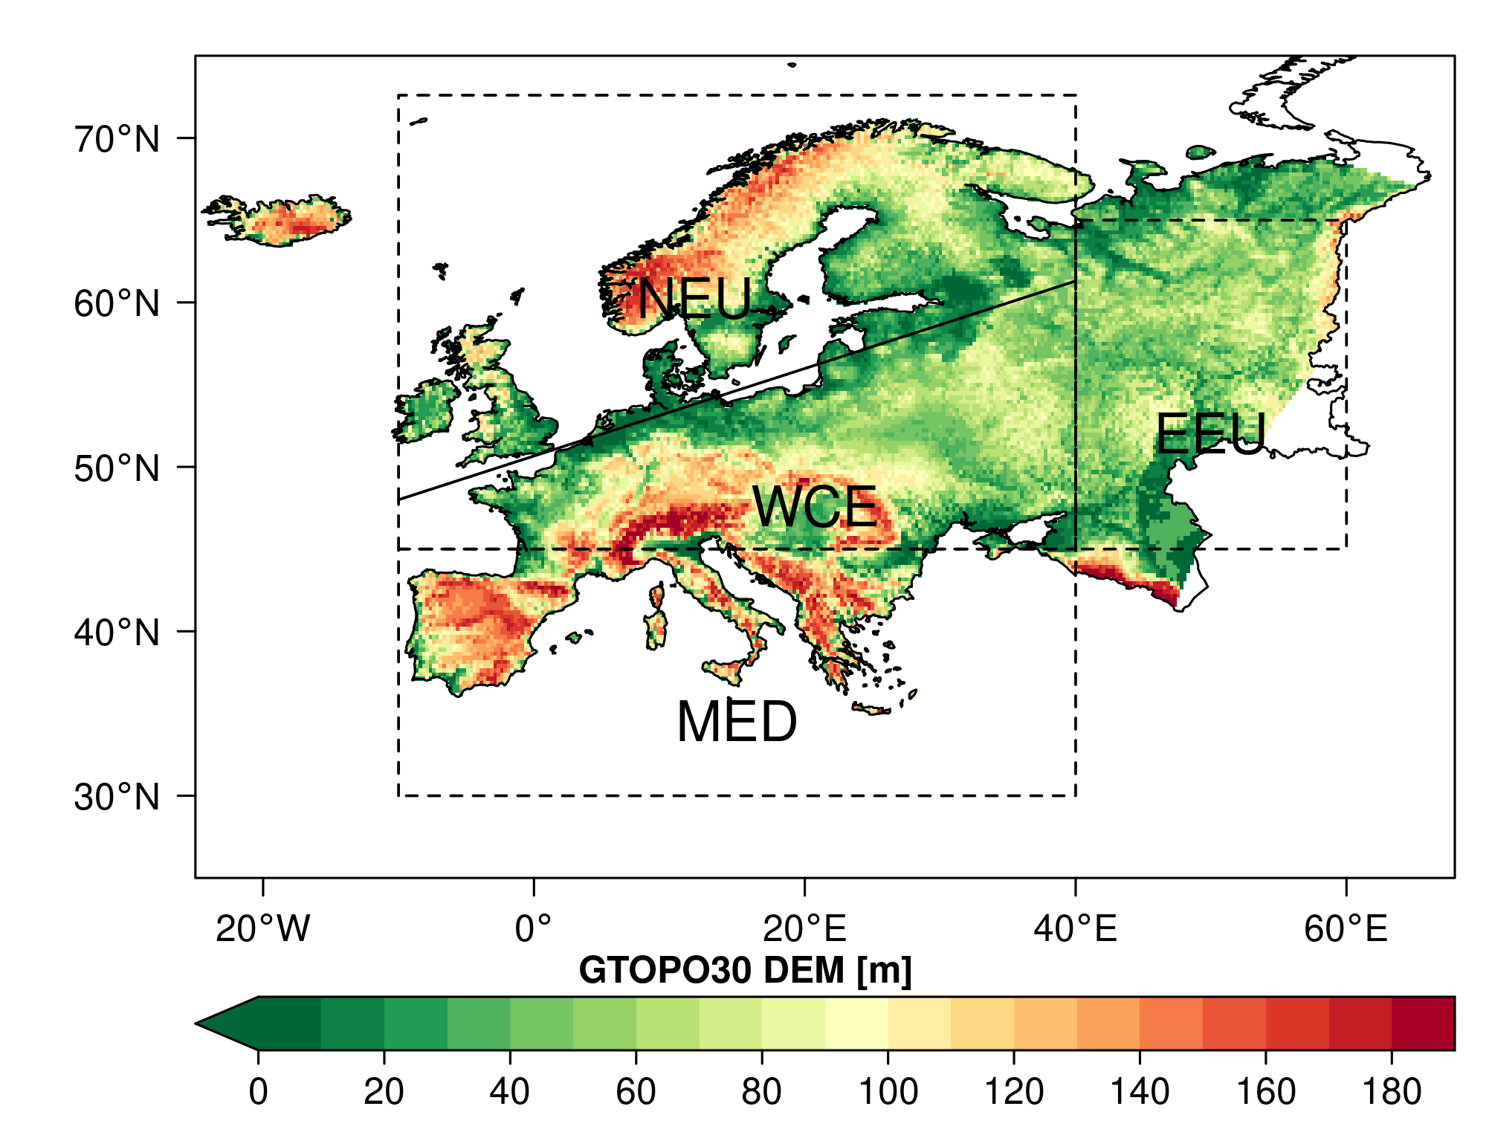
Supplementary Fig. 1 | European study domain and climate-reference regions. European domain used in this study, subdivided into the four updated IPCC climate-reference regions: Northern Europe (NEU), Western and Central Europe (WCE), Eastern Europe (EEU) and the Mediterranean (MED)¹. Background shading shows terrain elevation derived from the GTOPO30 global digital elevation model.

(a)Temperature
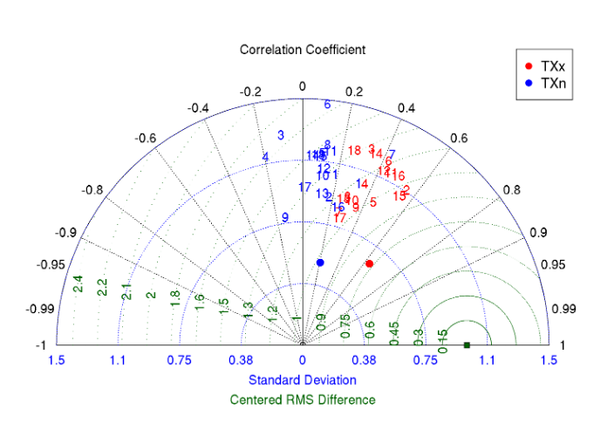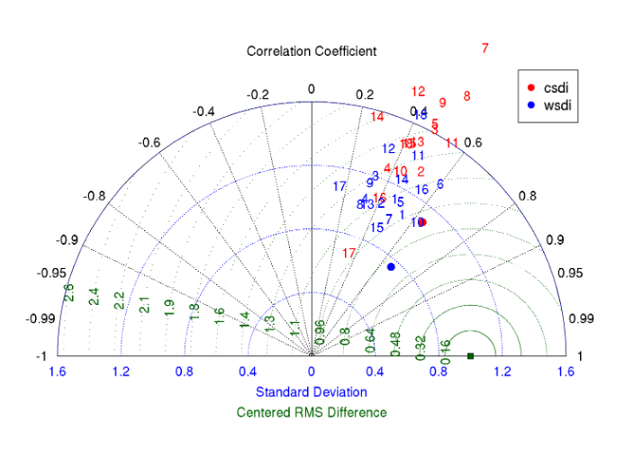

(b) Precipitation
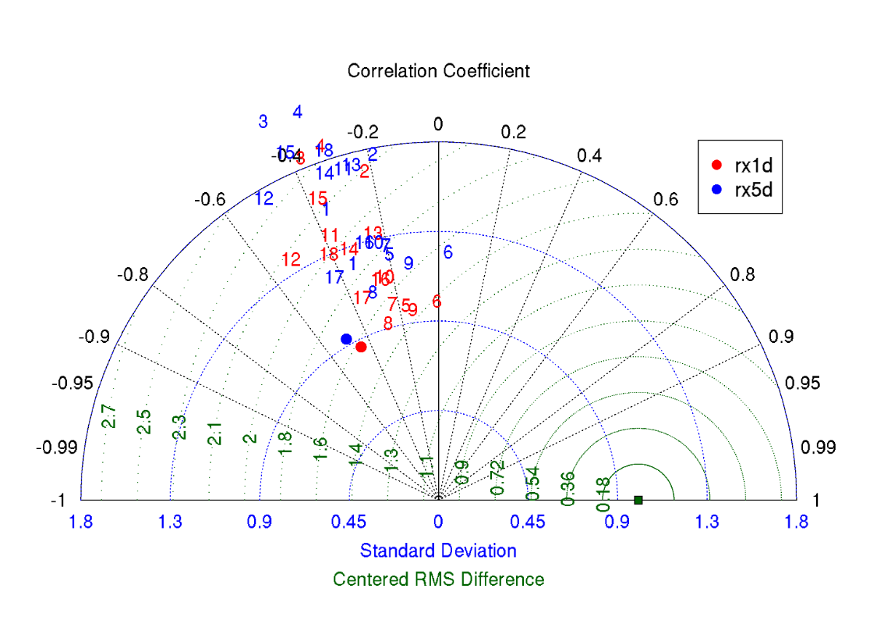
Supplementary Fig. 2 | Spatial performance of CMIP6 simulations of European climate extremes during 1995–2014.Taylor diagrams comparing the spatial climatologies of individual CMIP6 models and their multi-model ensemble mean with E-OBS for a, temperature-extreme indices and b, precipitation-extreme indices. Symbols represent individual models, and filled circles denote the multi-model ensemble mean. Angular position indicates the spatial correlation coefficient, radial distance indicates the spatial standard deviation normalized by the corresponding E-OBS value, and distance from the E-OBS reference point represents the normalized centred root-mean-square difference.

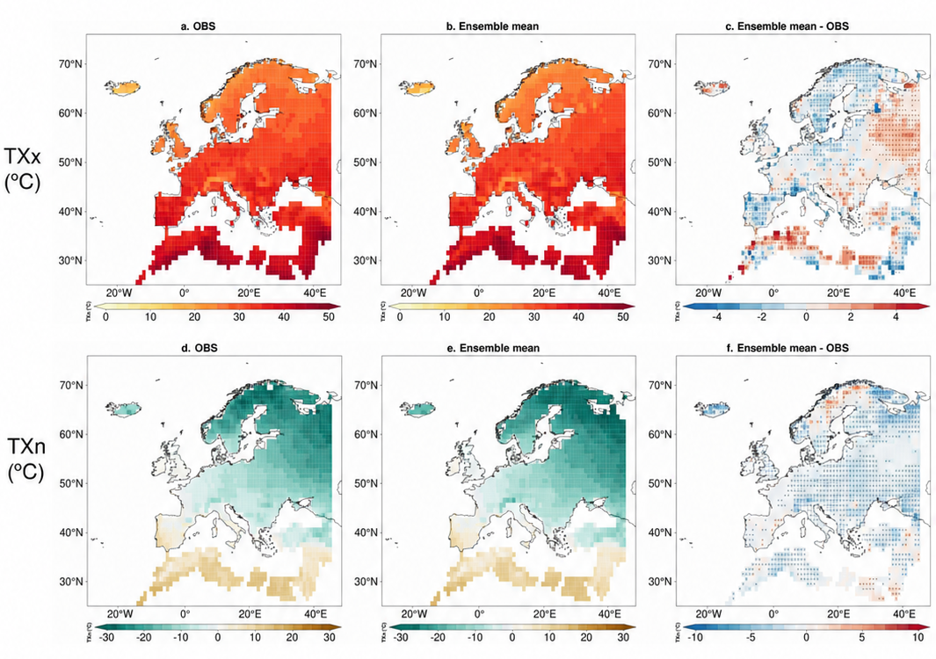
Supplementary Fig. 3 | Evaluation of simulated European temperature extremes during 1995–2014. Spatial climatologies of annual maximum daily maximum temperature (TXx) from a, E-OBS and b, the CMIP6 multi-model ensemble mean, together with c, the corresponding model bias. d–f, As in a–c, but for annual minimum daily maximum temperature (TXn). Bias is calculated as the ensemble mean minus E-OBS; positive values indicate a warm bias and negative values indicate a cold bias. All values are expressed in degrees Celsius. Stippling denotes grid cells where the ensemble-mean bias is statistically significant at the 95% confidence level.

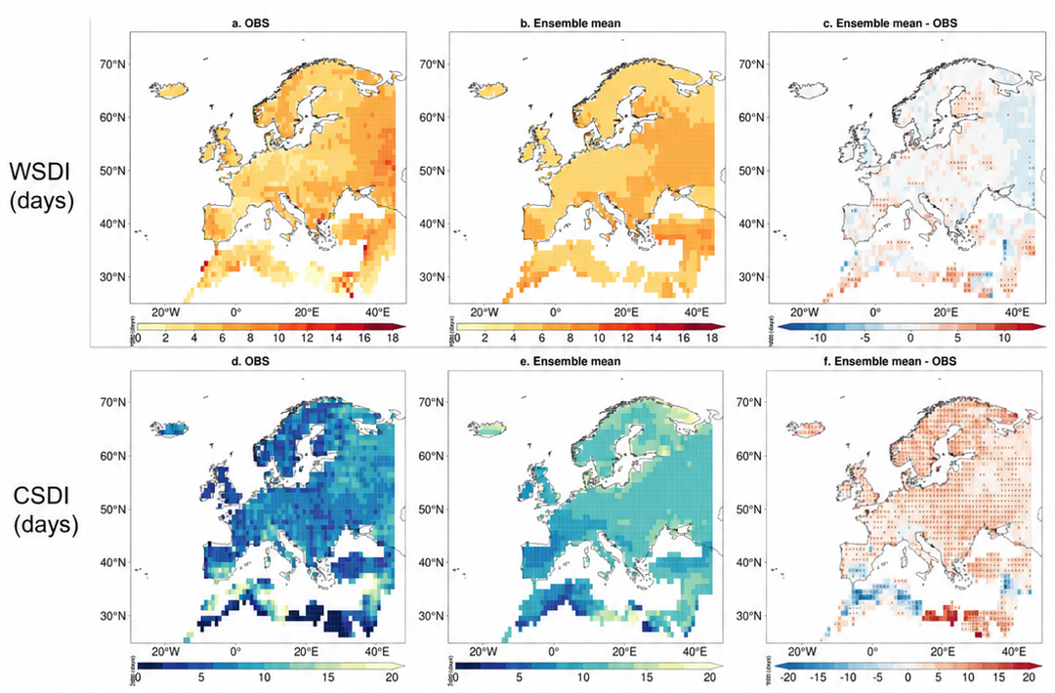

Supplementary Fig. 4 | Evaluation of simulated European warm- and cold-spell duration during 1995–2014. Spatial climatologies of the Warm Spell Duration Index (WSDI) from a, E-OBS and b, the CMIP6 multi-model ensemble mean, together with c, the corresponding model bias. d–f, As in a–c, but for the Cold Spell Duration Index (CSDI). Bias is calculated as the ensemble mean minus E-OBS; positive values indicate overestimation and negative values indicate underestimation of spell duration. All values are expressed in days. Stippling denotes grid cells where the ensemble-mean bias is statistically significant at the 95% confidence level.

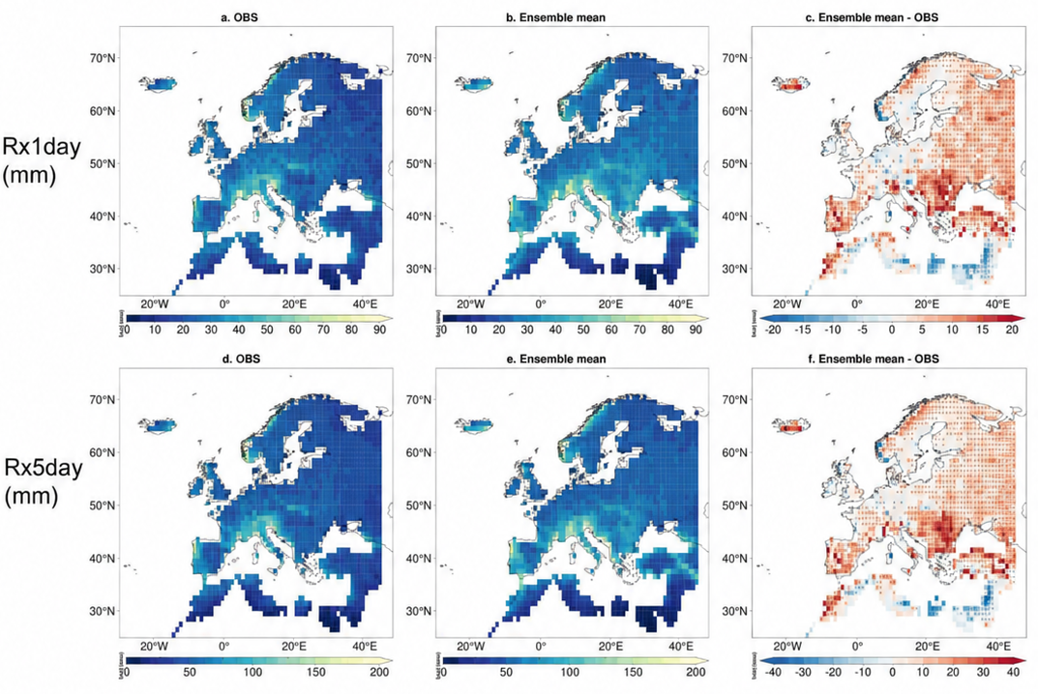
Supplementary Fig. 5 | Evaluation of simulated European precipitation extremes during 1995–2014. Spatial climatologies of annual maximum 1-day precipitation (Rx1day) from a, E-OBS and b, the CMIP6 multi-model ensemble mean, together with c, the corresponding model bias. d–f, As in a–c, but for annual maximum consecutive 5-day precipitation (Rx5day). Bias is calculated as the ensemble mean minus E-OBS; positive values indicate overestimation and negative values indicate underestimation. All values are expressed in millimetres. Stippling denotes grid cells where the ensemble-mean bias is statistically significant at the 95% confidence level.

Supplementary Table 1 | CMIP6 models and scenario availability used to calculate European climate-extreme indices
CMIP6 model | Ensemble member | SSP2–4.5 | SSP5–8.5 | Modelling centre | Country | Native atmospheric resolution  (latitude × longitude)
BCC-CSM2-MR | r1i1p1f1 | ✓ | ✓ | Beijing Climate Center, China Meteorological Administration | China | 1.125° × 1.125°
CanESM5 | r1i1p1f1 | ✓ | ✓ | Canadian Centre for Climate Modelling and Analysis | Canada | 2.8° × 2.8°
CMCC-CM2-SR5 | r1i1p1f1 | ✓ | ✓ | Fondazione Centro Euro-Mediterraneo sui Cambiamenti Climatici | Italy | 0.9375° × 1.25°
CMCC-ESM2 | r1i1p1f1 | ✓ | ✓ | Fondazione Centro Euro-Mediterraneo sui Cambiamenti Climatici | Italy | 0.9375° × 1.25°
EC-Earth3-CC | r1i1p1f1 | ✓ | ✓ | EC-Earth Consortium | Europe | ~0.7° × 0.7°
EC-Earth3 | r1i1p1f1 | ✓ | ✓ | EC-Earth Consortium | Europe | ~0.7° × 0.7°
EC-Earth3-Veg | r1i1p1f1 | ✓ | ✓ | EC-Earth Consortium | Europe | ~0.7° × 0.7°
EC-Earth3-Veg-LR | r1i1p1f1 | ✓ | ✓ | EC-Earth Consortium | Europe | ~1.125° × 1.125°
GFDL-CM4 | r1i1p1f1 | ✓ | ✓ | NOAA Geophysical Fluid Dynamics Laboratory | USA | 1.0° × 1.25°
GFDL-ESM4 | r1i1p1f1 | ✓ | ✓ | NOAA Geophysical Fluid Dynamics Laboratory | USA | 1.0° × 1.25°
HadGEM3-GC31-LL | r1i1p1f3 | ✓ | ✓ | Met Office Hadley Centre | UK | 1.25° × 1.875°
MIROC-ES2L | r1i1p1f2 | ✓ | ✓ | JAMSTEC, AORI, NIES and RIKEN Center for Computational Science | Japan | ~1.4° × 1.4°
MIROC6 | r1i1p1f1 | ✓ | ✓ | JAMSTEC, AORI, NIES and RIKEN Center for Computational Science | Japan | ~1.4° × 1.4°
MPI-ESM1-2-LR | r1i1p1f1 | ✓ | ✓ | Max Planck Institute for Meteorology | Germany | 1.875° × 1.875°
NESM3 | r1i1p1f1 | ✓ | ✓ | Nanjing University of Information Science and Technology | China | 1.875° × 1.875°
NorESM2-LM | r1i1p1f1 | ✓ | ✓ | Norwegian Climate Centre | Norway | 1.875° × 2.5°
NorESM2-MM | r1i1p1f1 | ✓ | ✓ | Norwegian Climate Centre | Norway | 0.9375° × 1.25°
UKESM1-0-LL | r1i1p1f2 | ✓ | ✓ | Met Office Hadley Centre | UK | 1.25° × 1.875°
Note. Check marks indicate model–scenario combinations available in the downloaded GDPCIR dataset. All 18 models were available under SSP2–4.5 and SSP5–8.5; the principal GWL analyses used SSP5–8.5 because too few models reached GWL3.0 under SSP2–4.5 by 2100. Ensemble members follow the CMIP6 variant-label convention: r, realization; i, initialization method; p, physics version; and f, forcing variant. Resolutions are approximate native atmospheric-grid spacings of the parent CMIP6 models, expressed as latitude × longitude. The GDPCIR variables used in this study were bias-corrected and statistically downscaled to a common 0.25° grid. AORI, Atmosphere and Ocean Research Institute; BCC, Beijing Climate Center; CMCC, Euro-Mediterranean Center on Climate Change; GFDL, Geophysical Fluid Dynamics Laboratory; GDPCIR, Global Downscaled Projections for Climate Impacts Research; GWL, global warming level; JAMSTEC, Japan Agency for Marine-Earth Science and Technology; MPI-M, Max Planck Institute for Meteorology; NIES, National Institute for Environmental Studies; NOAA, National Oceanic and Atmospheric Administration; SSP, Shared Socioeconomic Pathway.

Supplementary Table 2 | ETCCDI climate-extreme indices analysed in this study
Index | Climate variable | Definition | Unit | Physical interpretation
TXx | Temperature | Annual maximum of daily maximum temperature | °C | Intensity of the hottest daytime temperature
TXn | Temperature | Annual minimum of daily maximum temperature | °C | Intensity of the coldest daytime temperature
WSDI | Temperature | Annual count of days in periods of ≥6 consecutive days when daily maximum temperature exceeds the calendar-day 90th percentile | days | Duration of warm spells
CSDI | Temperature | Annual count of days in periods of ≥6 consecutive days when daily minimum temperature falls below the calendar-day 10th percentile | days | Duration of cold spells
Rx1day | Precipitation | Annual maximum 1-day precipitation amount | mm | Intensity of extreme daily precipitation
Rx5day | Precipitation | Annual maximum consecutive 5-day precipitation amount | mm | Magnitude of prolonged heavy precipitation
Note. WSDI and CSDI thresholds were calculated for each calendar day using the 1979–2014 reference period and applied consistently to historical and future simulations. CSDI, Cold Spell Duration Index; ETCCDI, Expert Team on Climate Change Detection and Indices; Rx1day, annual maximum 1-day precipitation; Rx5day, annual maximum consecutive 5-day precipitation; TXn, annual minimum of daily maximum temperature; TXx, annual maximum of daily maximum temperature; WSDI, Warm Spell Duration Index.

S.2 Determination of Global Warming Levels
Global warming levels (GWLs) provide a policy-relevant framework for comparing regional climate responses at equivalent increases in global mean temperature rather than at fixed future periods. This approach reduces the influence of differences among models in climate sensitivity and the timing of threshold attainment and facilitates comparison with internationally relevant warming targets ^{7, 8}. We evaluated climate extremes at GWL1.5, GWL2.0 and GWL3.0 relative to the 1850–1900 pre-industrial mean.
For each model, historical CMIP6 simulations were concatenated with the corresponding SSP2–4.5 and SSP5–8.5 simulations to obtain continuous records spanning 1850–2100. Annual global mean near-surface air temperature was calculated using grid-cell-area weighting. Temperature anomalies were then calculated relative to 1850-1900, and a centred 30-year running mean was applied to suppress interannual and decadal variability. The crossing year for each GWL was defined as the first central year for which the smoothed global mean temperature anomaly equalled or exceeded the prescribed threshold. The CMIP6 and Shared Socioeconomic Pathway experiments follow the designs described in refs. 9 and 10, and the GWL framework is consistent with that used in the IPCC Sixth Assessment Report ⁷.
For each model and GWL, we extracted a model-specific 20-year window comprising the ten years preceding the crossing year and the crossing year plus the following nine years. Thus, a model reaching a threshold in 2037 was evaluated over 2027–2046. Climate-extreme and AMOC diagnostics were first calculated separately for each model within its corresponding window and were subsequently combined across models. This approach compares models at equivalent levels of global warming while retaining differences in the timing of threshold attainment.
Threshold-crossing years were calculated under both SSP2–4.5 and SSP5–8.5 (Supplementary Table 3). However, the principal climate-extreme analyses used SSP5–8.5 because all 18 selected models reached GWL1.5, GWL2.0 and GWL3.0 under this pathway. Several models did not reach GWL3.0 under SSP2–4.5 by 2100. Using SSP5–8.5 therefore preserved a common 18-model ensemble across the three warming levels and avoided changes in ensemble composition.
Analyses involving the AMOC were restricted to the 11 models for which matched AMOC output and climate-extreme indices were available. These models retained the same model-specific threshold-crossing years and 20-year windows used in the climate-extreme analysis; GWLs were not redefined from a separate ensemble-mean trajectory. Multi-model mean crossing years are reported in Supplementary Table 3 as descriptive summaries of the individual-model crossing years and were not used to impose common calendar windows across models.
This model-specific GWL framework enables internally consistent comparison of European climate extremes and AMOC states across warming thresholds while separating the magnitude of global warming from differences in the calendar timing of threshold attainment.

Supplementary Table 3 | Model-specific global-warming-level threshold-crossing years under SSP2–4.5 and SSP5–8.5
CMIP6 model | SSP2–4.5 |  |  | SSP5–8.5 |  |  | Included in matched  AMOC analyses
CMIP6 model | GWL1.5 | GWL2.0 | GWL3.0 | GWL1.5 | GWL2.0 | GWL3.0 | Included in matched  AMOC analyses
BCC-CSM2-MR | 2047 | 2069 | — | 2036 | 2046 | 2065 | ✓
CanESM5 | 2027 | 2037 | 2059 | 2026 | 2032 | 2045 | ✓
CMCC-CM2-SR5 | 2043 | 2053 | 2078 | 2037 | 2044 | 2059 | —
CMCC-ESM2 | 2042 | 2050 | 2074 | 2041 | 2047 | 2060 | —
EC-Earth3-CC | 2055 | 2069 | — | 2047 | 2054 | 2067 | —
EC-Earth3 | 2037 | 2051 | — | 2032 | 2040 | 2058 | ✓
EC-Earth3-Veg | 2047 | 2061 | — | 2037 | 2047 | 2062 | ✓
EC-Earth3-Veg-LR | 2053 | 2069 | — | 2044 | 2052 | 2065 | —
GFDL-CM4 | 2043 | 2059 | — | 2037 | 2046 | 2062 | ✓
GFDL-ESM4 | 2042 | 2085 | — | 2047 | 2058 | 2076 | —
HadGEM3-GC31-LL | 2027 | 2037 | 2059 | 2025 | 2033 | 2047 | ✓
MIROC-ES2L | 2050 | 2070 | — | 2040 | 2050 | 2069 | —
MIROC6 | 2054 | 2078 | — | 2045 | 2055 | 2073 | ✓
MPI-ESM1-2-LR | 2061 | — | — | 2049 | 2060 | 2078 | —
NESM3 | 2037 | 2051 | — | 2028 | 2038 | 2055 | ✓
NorESM2-LM | 2074 | — | — | 2052 | 2062 | 2079 | ✓
NorESM2-MM | 2065 | — | — | 2048 | 2060 | 2078 | ✓
UKESM1-0-LL | 2028 | 2036 | 2055 | 2026 | 2033 | 2045 | ✓
Multi-model mean | 2043 | 2058 | — | 2037 | 2046 | 2062 | 11 models
Note. Values indicate the first year in which each model reached the prescribed global warming level relative to the 1850–1900 mean. An em dash indicates that the threshold was not reached by 2100. The principal climate-extreme analyses used SSP5–8.5 because all 18 selected models reached GWL1.5, GWL2.0 and GWL3.0 under this pathway, preserving a common model ensemble across warming levels. Check marks identify the 11 models included in the matched AMOC and climate-extreme analyses. Multi-model means summarize the model-specific crossing years and were not used to impose common calendar windows. All climate-extreme and AMOC diagnostics were calculated using model-specific 20-year windows comprising the ten years preceding the crossing year, the crossing year itself and the following nine years. AMOC, Atlantic Meridional Overturning Circulation; GWL, global warming level; SSP, Shared Socioeconomic Pathway.

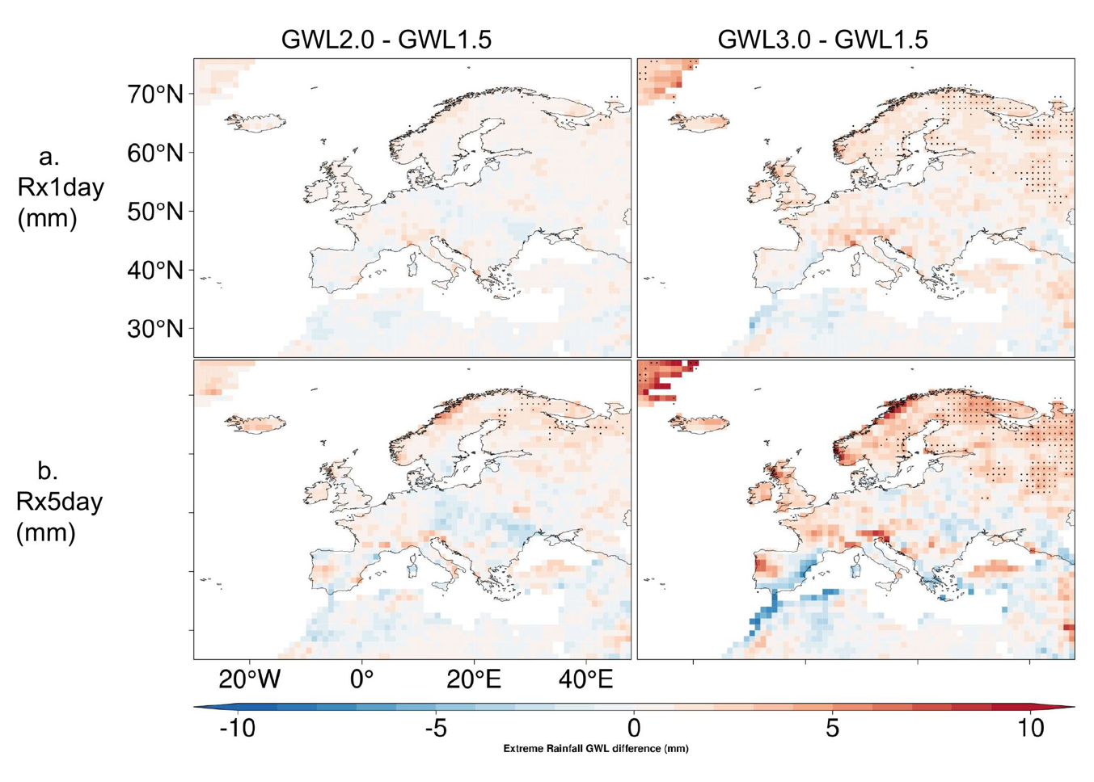
Supplementary Fig. 6 | Additional intensification of European precipitation extremes beyond GWL1.5. Multi-model ensemble-mean differences in projected changes between GWL2.0 and GWL1.5 (left column) and between GWL3.0 and GWL1.5 (right column) for a, annual maximum 1-day precipitation (Rx1day) and b, annual maximum consecutive 5-day precipitation (Rx5day). Positive values indicate further intensification at the higher warming level, whereas negative values indicate a weaker response relative to GWL1.5. All values are expressed in millimetres. Stippling denotes grid cells where the difference between warming levels is statistically significant at the 95% confidence level.
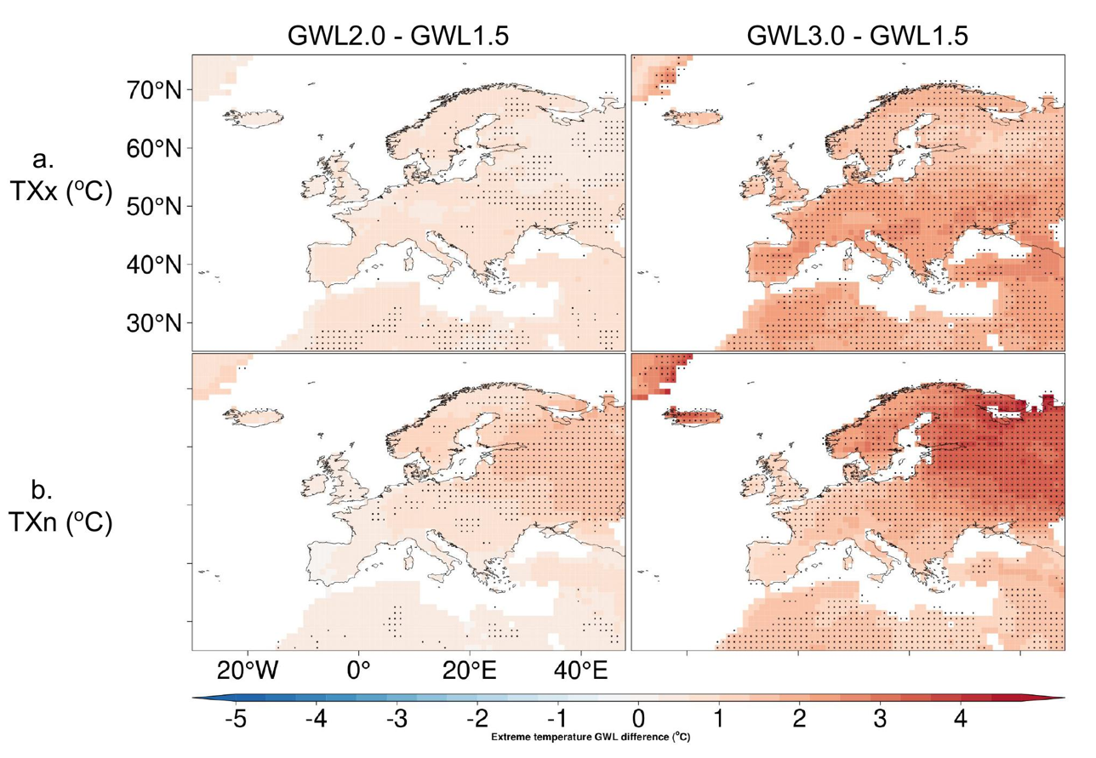

Supplementary Fig. 7 | Additional warming of European temperature extremes beyond GWL1.5. Multi-model ensemble-mean differences in projected changes between GWL2.0 and GWL1.5 (left column) and between GWL3.0 and GWL1.5 (right column) for a, annual maximum daily maximum temperature (TXx) and b, annual minimum daily maximum temperature (TXn). Positive values indicate additional warming at the higher global warming level, whereas negative values indicate a weaker response relative to GWL1.5. All values are expressed in degrees Celsius. Stippling denotes grid cells where the difference between warming levels is statistically significant at the 95% confidence level.
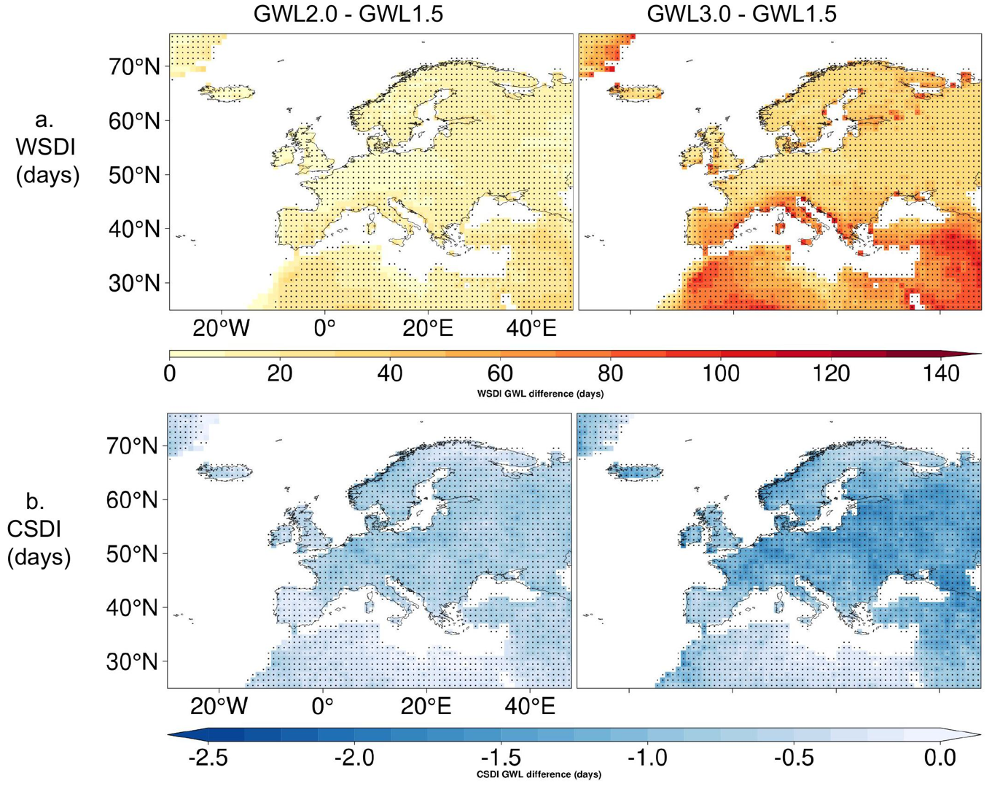

Supplementary Fig. 8 | Additional changes in European warm- and cold-spell duration beyond GWL1.5. Multi-model ensemble-mean differences in projected changes between GWL2.0 and GWL1.5 (left column) and between GWL3.0 and GWL1.5 (right column) for a, the Warm Spell Duration Index (WSDI) and b, the Cold Spell Duration Index (CSDI). Positive WSDI values indicate additional warm-spell days at the higher global warming level, whereas negative CSDI values indicate further reductions in cold-spell days relative to GWL1.5. All values are expressed in days. Stippling denotes grid cells where the difference between warming levels is statistically significant at the 95% confidence level.

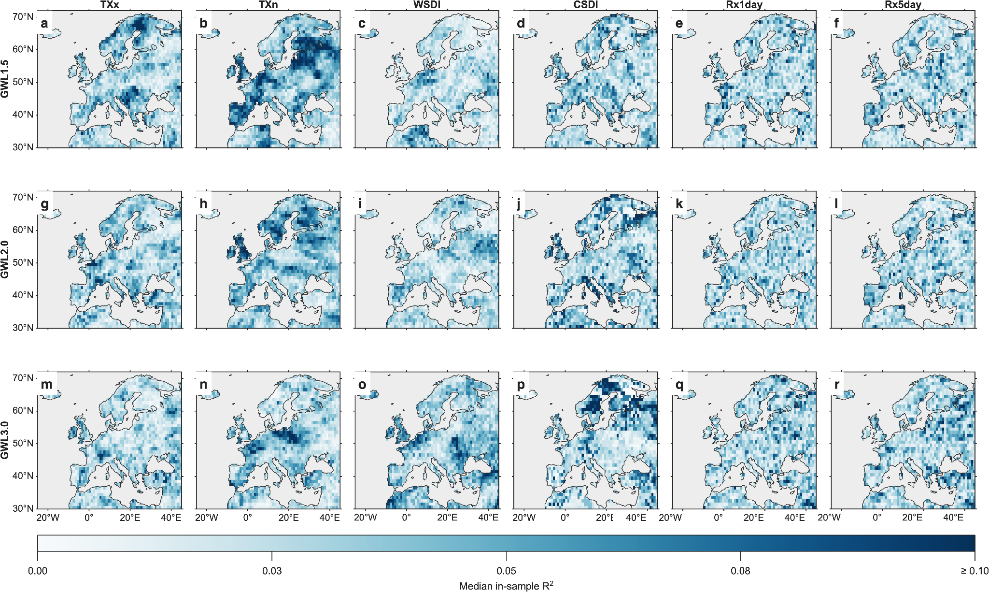
Supplementary Fig. 9 | Spatial distribution of in-sample associations between detrended AMOC variability and European climate extremes. Maps show the median in-sample (R^2) across 11 matched CMIP6 models for contemporaneous grid-cell associations between detrended annual AMOC anomalies and TXx, TXn, WSDI, CSDI, Rx1day and Rx5day within model-specific 20-year windows corresponding to GWL1.5, GWL2.0 and GWL3.0. Stippling denotes grid cells where the across-model Fisher-(z)-transformed mean correlation differs from zero after Benjamini–Hochberg false-discovery-rate correction at (q=0.05). The colour scale is truncated at the pooled 98th percentile. The (R^2) values describe in-sample statistical fit and should not be interpreted as independent predictive skill, causal AMOC influence or a formal estimate of internally generated variability.

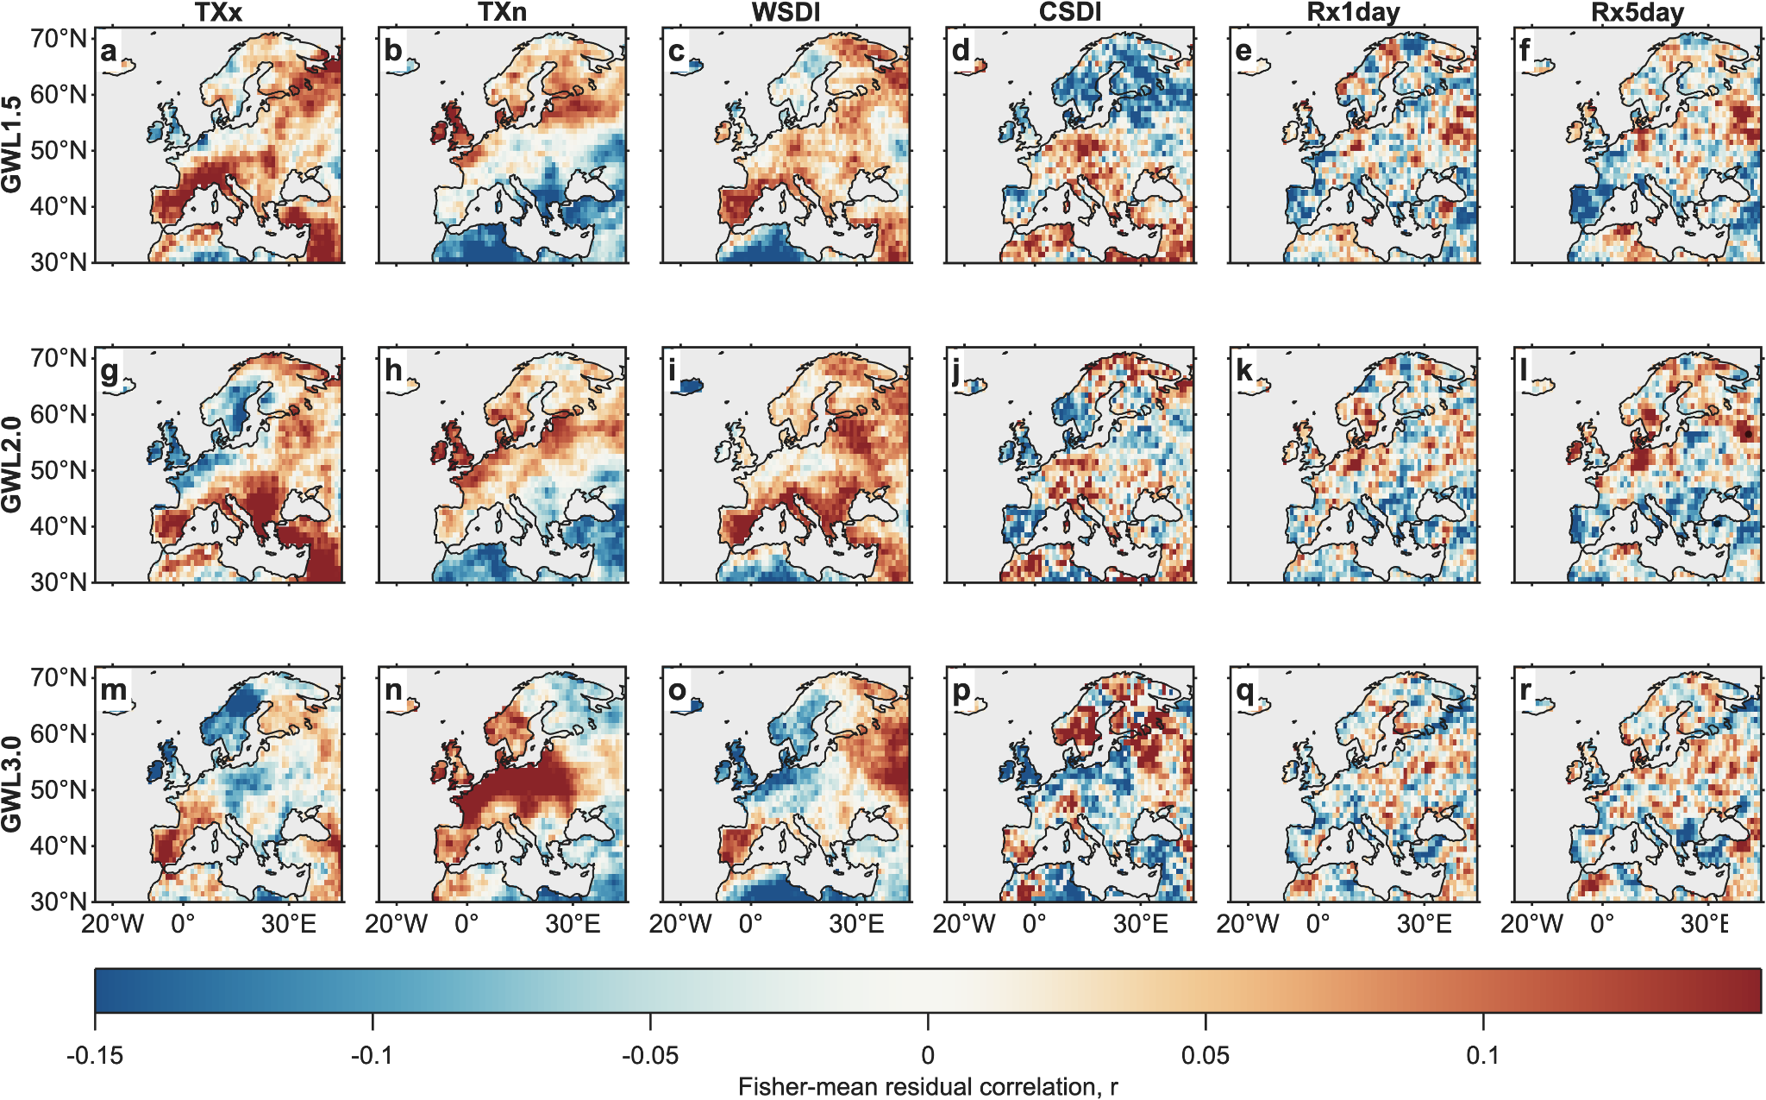
Supplementary Fig. 10 | Spatial correlations between detrended AMOC variability and European climate extremes. Maps show the across-model Fisher-(z) mean correlation between detrended annual AMOC anomalies and each climate-extreme index across 11 matched CMIP6 models within model-specific 20-year GWL windows. Stippling denotes grid cells surviving Benjamini–Hochberg false-discovery-rate correction at (q=0.05). Positive correlations indicate that higher climate-extreme-index values are associated with stronger AMOC anomalies, whereas negative correlations indicate that higher index values are associated with weaker AMOC anomalies. The correlations represent contemporaneous statistical associations and do not establish causality.

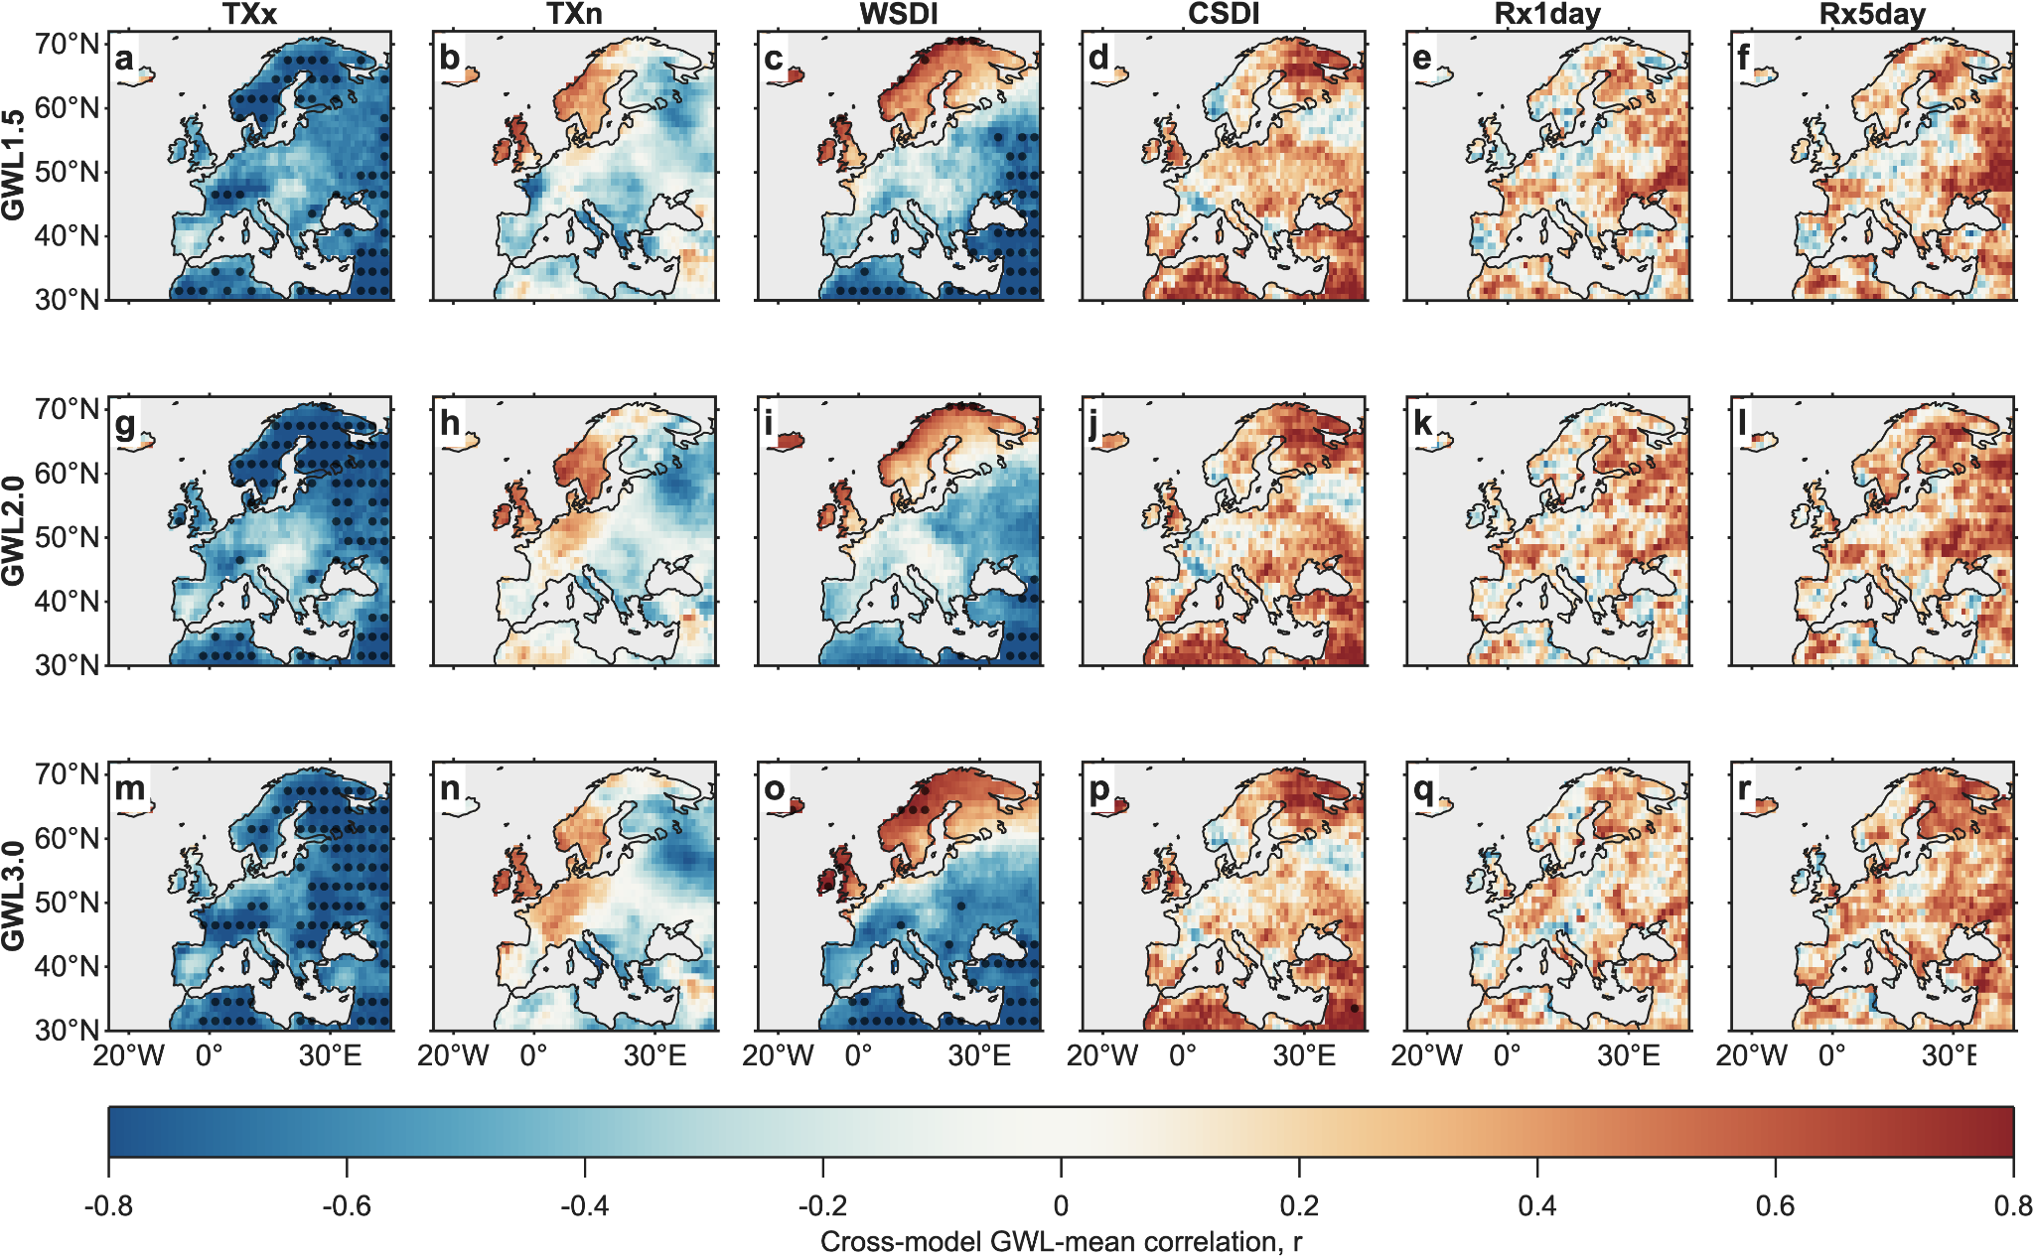
Supplementary Fig. 11 | Exploratory inter-model covariation between GWL-mean AMOC anomalies and projected European climate-extreme changes. Maps show Pearson correlation coefficients calculated across 11 matched CMIP6 models between model-mean AMOC anomalies and projected changes in TXx, TXn, WSDI, CSDI, Rx1day and Rx5day within model-specific 20-year windows at GWL1.5, GWL2.0 and GWL3.0. Stippling denotes grid cells surviving Benjamini–Hochberg false-discovery-rate correction at (q=0.05). The diagnostic does not control for inter-model differences in climate sensitivity, ocean heat uptake, sea-ice response, circulation adjustment or shared model genealogy. The correlations are therefore descriptive and should not be interpreted as evidence of an AMOC-mediated response or physical coupling.

Supplementary Table 4 | Detailed contemporaneous associations between detrended AMOC variability and European climate extremes
GWL | Extreme  index | Models  (n) | Fisher  mean r | Mean R²  (%) | Adjusted R²  (%) | AC-adjusted R²  (%) | Effective  sample size | Sign agreement  (%) | FDR area  (%) | Bootstrap 95% CI  lower (%) | Bootstrap 95% CI  upper (%)
GWL1.5 | TXx | 11 | 0.045 | 5.76 | 0.53 | 0.37 | 19.51 | 63.1 | 0 | 5.08 | 6.47
GWL1.5 | TXn | 11 | −0.029 | 7.29 | 2.14 | 2.03 | 19.65 | 61.9 | 0 | 5.68 | 8.85
GWL1.5 | WSDI | 11 | 0.022 | 4.89 | −0.39 | −0.53 | 19.56 | 64.1 | 0 | 4.03 | 5.97
GWL1.5 | CSDI | 11 | 0.003 | 5.41 | 0.16 | 0.03 | 19.6 | 65.4 | 0 | 4.56 | 6.32
GWL1.5 | Rx1day | 11 | −0.019 | 5.39 | 0.13 | −0.01 | 19.57 | 63.5 | 0 | 5.18 | 5.62
GWL1.5 | Rx5day | 11 | −0.016 | 5.43 | 0.17 | 0.03 | 19.57 | 63 | 0 | 5.17 | 5.71
GWL2.0 | TXx | 11 | 0.044 | 5.69 | 0.46 | 0.31 | 19.55 | 64.8 | 0 | 4.86 | 6.62
GWL2.0 | TXn | 11 | −0.007 | 6.02 | 0.8 | 0.7 | 19.71 | 61 | 0 | 5.06 | 7.07
GWL2.0 | WSDI | 11 | 0.046 | 5.05 | −0.23 | −0.35 | 19.63 | 63.9 | 0 | 4.18 | 5.96
GWL2.0 | CSDI | 11 | 0.001 | 6.16 | 0.95 | 0.86 | 19.73 | 63.8 | 0 | 5.01 | 7.47
GWL2.0 | Rx1day | 11 | −0.016 | 5.35 | 0.09 | −0.02 | 19.65 | 62.6 | 0 | 5.14 | 5.55
GWL2.0 | Rx5day | 11 | −0.014 | 5.37 | 0.11 | 0 | 19.66 | 63.4 | 0.15 | 5.03 | 5.68
GWL3.0 | TXx | 11 | −0.003 | 5.28 | 0.02 | −0.09 | 19.68 | 62.7 | 0 | 4.57 | 6.06
GWL3.0 | TXn | 11 | 0.03 | 5.74 | 0.5 | 0.33 | 19.5 | 64 | 0 | 4.59 | 6.96
GWL3.0 | WSDI | 11 | −0.014 | 7.01 | 1.84 | 1.65 | 19.43 | 62.2 | 0 | 5.31 | 9.04
GWL3.0 | CSDI | 11 | −0.018 | 5.2 | −0.07 | −0.16 | 19.74 | 70.8 | 0 | 4.19 | 6.42
GWL3.0 | Rx1day | 11 | −0.013 | 5.74 | 0.51 | 0.38 | 19.62 | 62.1 | 0 | 5.44 | 6.05
GWL3.0 | Rx5day | 11 | −0.004 | 5.88 | 0.65 | 0.53 | 19.64 | 62.2 | 0 | 5.61 | 6.12
Note. Values are area-weighted summaries across 11 matched CMIP6 models. Annual AMOC anomalies and climate-extreme indices were independently linearly detrended within each model-specific 20-year GWL window. Fisher mean (r) is the back-transformed across-model mean of the Fisher-(z)-transformed grid-cell correlations. Mean (R^2) is the in-sample variance accounted for by the fitted ordinary least-squares association; adjusted (R^2) accounts for finite sample size, and AC-adjusted (R^2) additionally uses the lag-1-autocorrelation-adjusted effective sample size. Negative adjusted values indicate no improvement over an intercept-only model after adjustment. Sign agreement is the mean percentage of models sharing the modal regression-coefficient sign. FDR area is the percentage of the analysed European land domain surviving Benjamini–Hochberg false-discovery-rate correction at (q=0.05). Bootstrap intervals are 95% confidence intervals for mean in-sample (R^2). These statistics describe contemporaneous associations after removal of fitted within-window linear trends; they do not formally separate forced and internal variability or establish causality or independent predictive skill. AC, autocorrelation; AMOC, Atlantic Meridional Overturning Circulation; CI, confidence interval; FDR, false discovery rate; GWL, global warming level.

Supplementary Table 5 | Exploratory inter-model associations between GWL-mean AMOC anomalies and projected European climate-extreme changes
GWL | Extreme index | Mean β per Sv | Mean r | Mean R² (%) | FDR area (%)
GWL1.5 | TXx | −0.192 | −0.604 | 40.07 | 33.97
GWL1.5 | TXn | −0.056 | −0.153 | 10.63 | 0.00
GWL1.5 | WSDI | −1.611 | −0.339 | 32.01 | 29.13
GWL1.5 | CSDI | 0.168 | 0.302 | 17.46 | 0.00
GWL1.5 | Rx1day | 0.203 | 0.168 | 11.49 | 0.00
GWL1.5 | Rx5day | 0.520 | 0.230 | 14.43 | 0.00
GWL2.0 | TXx | −0.192 | −0.575 | 37.53 | 41.21
GWL2.0 | TXn | −0.035 | −0.085 | 9.22 | 0.00
GWL2.0 | WSDI | −1.652 | −0.300 | 25.00 | 10.84
GWL2.0 | CSDI | 0.160 | 0.322 | 19.53 | 0.00
GWL2.0 | Rx1day | 0.165 | 0.159 | 10.73 | 0.00
GWL2.0 | Rx5day | 0.507 | 0.252 | 14.52 | 0.00
GWL3.0 | TXx | −0.218 | −0.644 | 44.97 | 58.18
GWL3.0 | TXn | −0.052 | −0.122 | 11.78 | 0.00
GWL3.0 | WSDI | −2.366 | −0.359 | 37.21 | 28.63
GWL3.0 | CSDI | 0.148 | 0.311 | 18.41 | 0.09
GWL3.0 | Rx1day | 0.172 | 0.171 | 9.98 | 0.00
GWL3.0 | Rx5day | 0.584 | 0.302 | 16.23 | 0.00
Note. Values describe exploratory inter-model associations between model-mean AMOC anomalies and projected climate-extreme changes within model-specific 20-year GWL windows across 11 matched CMIP6 models. The regression coefficient (\beta) is the ordinary least-squares slope associated with a 1 Sv difference in AMOC strength and has index-specific units: °C Sv(^{-1}) for TXx and TXn, days Sv(^{-1}) for WSDI and CSDI, and mm Sv(^{-1}) for Rx1day and Rx5day. Mean (r) and (R^2) are area-weighted summaries of the grid-cell inter-model relationships. FDR area is the percentage of the analysed European land domain surviving Benjamini–Hochberg false-discovery-rate correction at (q=0.05). The analysis does not control for differences among models in climate sensitivity, ocean heat uptake, sea-ice response, circulation adjustment or shared model genealogy. These descriptive associations are not interpreted as evidence of an AMOC-mediated response, physical coupling or causal influence. AMOC, Atlantic Meridional Overturning Circulation; FDR, false discovery rate; GWL, global warming level; Sv, sverdrup.

References
- Iturbide, M. et al. An update of IPCC climate reference regions for subcontinental analysis of climate model data: Definition and aggregated datasets. Earth Syst. Sci. Data 12, 2959–2970 (2020)
- Cornes, R. C., van der Schrier, G., van den Besselaar, E. J. M. & Jones, P. D. An ensemble version of the E-OBS temperature and precipitation data sets. J. Geophys. Res. Atmos. 123, 9391–9409 (2018). https://doi.org/10.1029/2017JD028200
- Taylor, K. E. Summarizing multiple aspects of model performance in a single diagram. J. Geophys. Res. Atmos. 106, 7183–7192 (2001). https://doi.org/10.1029/2000JD900719
- Kim, Y. E., Min, S.-K., Zhang, X., Sillmann, J. & Sandstad, M. Evaluation of the CMIP6 multi-model ensemble for climate extreme indices. Weather Clim. Extrem. 29, 100269 (2020). https://doi.org/10.1016/j.wace.2020.100269
- Chen, H., Sun, J., Lin, W. & Xu, H. Comparison of CMIP6 and CMIP5 models in simulating climate extremes. Sci. Bull. 65, 1415–1418 (2020). https://doi.org/10.1016/j.scib.2020.05.015
- Li, C., Zwiers, F., Zhang, X., Li, G., Sun, Y. & Wehner, M. Changes in annual extremes of daily temperature and precipitation in CMIP6 models. J. Clim. 34, 3441–3460 (2021). https://doi.org/10.1175/JCLI-D-19-1013.1
- Intergovernmental Panel on Climate Change (IPCC). Climate Change 2021: The Physical Science Basis. Cambridge University Press, Cambridge, UK (2021).
- Ayugi, B. O., Chung, E. S., Zhu, H., Ogega, O. M., Babousmail, H. & Ongoma, V. Projected changes in extreme climate events over Africa under 1.5 °C, 2.0 °C and 3.0 °C global warming levels based on CMIP6 projections. Atmos. Res. 281, 106872 (2023). https://doi.org/10.1016/j.atmosres.2023.106872
- Eyring, V. et al. Overview of the Coupled Model Intercomparison Project Phase 6 (CMIP6) experimental design and organization. Geosci. Model Dev. 9, 1937–1958 (2016). https://doi.org/10.5194/gmd-9-1937-2016
- O'Neill, B. C. et al. The Scenario Model Intercomparison Project (ScenarioMIP) for CMIP6. Geosci. Model Dev. 9, 3461–3482 (2016). https://doi.org/10.5194/gmd-9-3461-2016

