Supplementary Table S1. Robustness of remifentanil-DGE association (the seven-covariate core model is primary; extended models are exploratory)
DGE-severe (ISGPS grade C) as outcome. OR per one-level increase in dose group. CI = 95% confidence interval.
Model | OR | 95% CI | P value | EPV
Crude | 2.13 | 1.33–3.40 | 0.0016 | 20.5
Minimal (age/sex/surg_dur) | 2.12 | 1.32–3.43 | 0.0021 | 8.2
Reduced (age/sex/bmi/asa/surg_dur) | 2.40 | 1.44–4.00 | 0.0008 | 5.9
Full standard logistic | 2.39 | 1.41–4.07 | 0.0013 | 2.6
Full Firth penalized | 2.22 | 1.35–3.67 | 0.0018 | 2.6
High vs Low standard logistic | 8.12 | 2.52–26.17 | 0.0005 | 2.6
High vs Low Firth penalized | 6.00 | 2.10–17.21 | 0.0008 | 2.6
High vs Low PS-adjusted | 4.34 | 1.62–11.61 | 0.0034 | 13.7

Supplementary Table S2. Temporal validation by surgical date
Split at median surgical date (2024-02-07). Firth penalized logistic regression adjusted for 14 covariates.
Period | N | Events | Adjusted OR | 95% CI | P value
2024-02-07 and before | 148 | 22 | 2.38 | 1.20–4.71 | 0.0131
After 2024-02-07 | 148 | 19 | 1.43 | 0.63–3.26 | 0.3921

Supplementary Table S3. Sensitivity analysis: additional adjustment for sufentanil
Overall sufentanil use: 62.5% (80.2% low, 56.9% medium, 31.1% high remifentanil groups). All models adjusted for 14 baseline covariates.
Model | OR | 95% CI | P value
Without sufentanil (primary) | 2.391 | 1.405–4.069 | 0.0013
+ Sufentanil use (binary) | 2.591 | 1.461–4.595 | 0.0011
+ Sufentanil dose (continuous, µg) | 2.703 | 1.537–4.755 | 0.0006
Sufentanil direct association (per µg) | 1.017 | 0.994–1.040 | 0.1548

Supplementary Figure S1
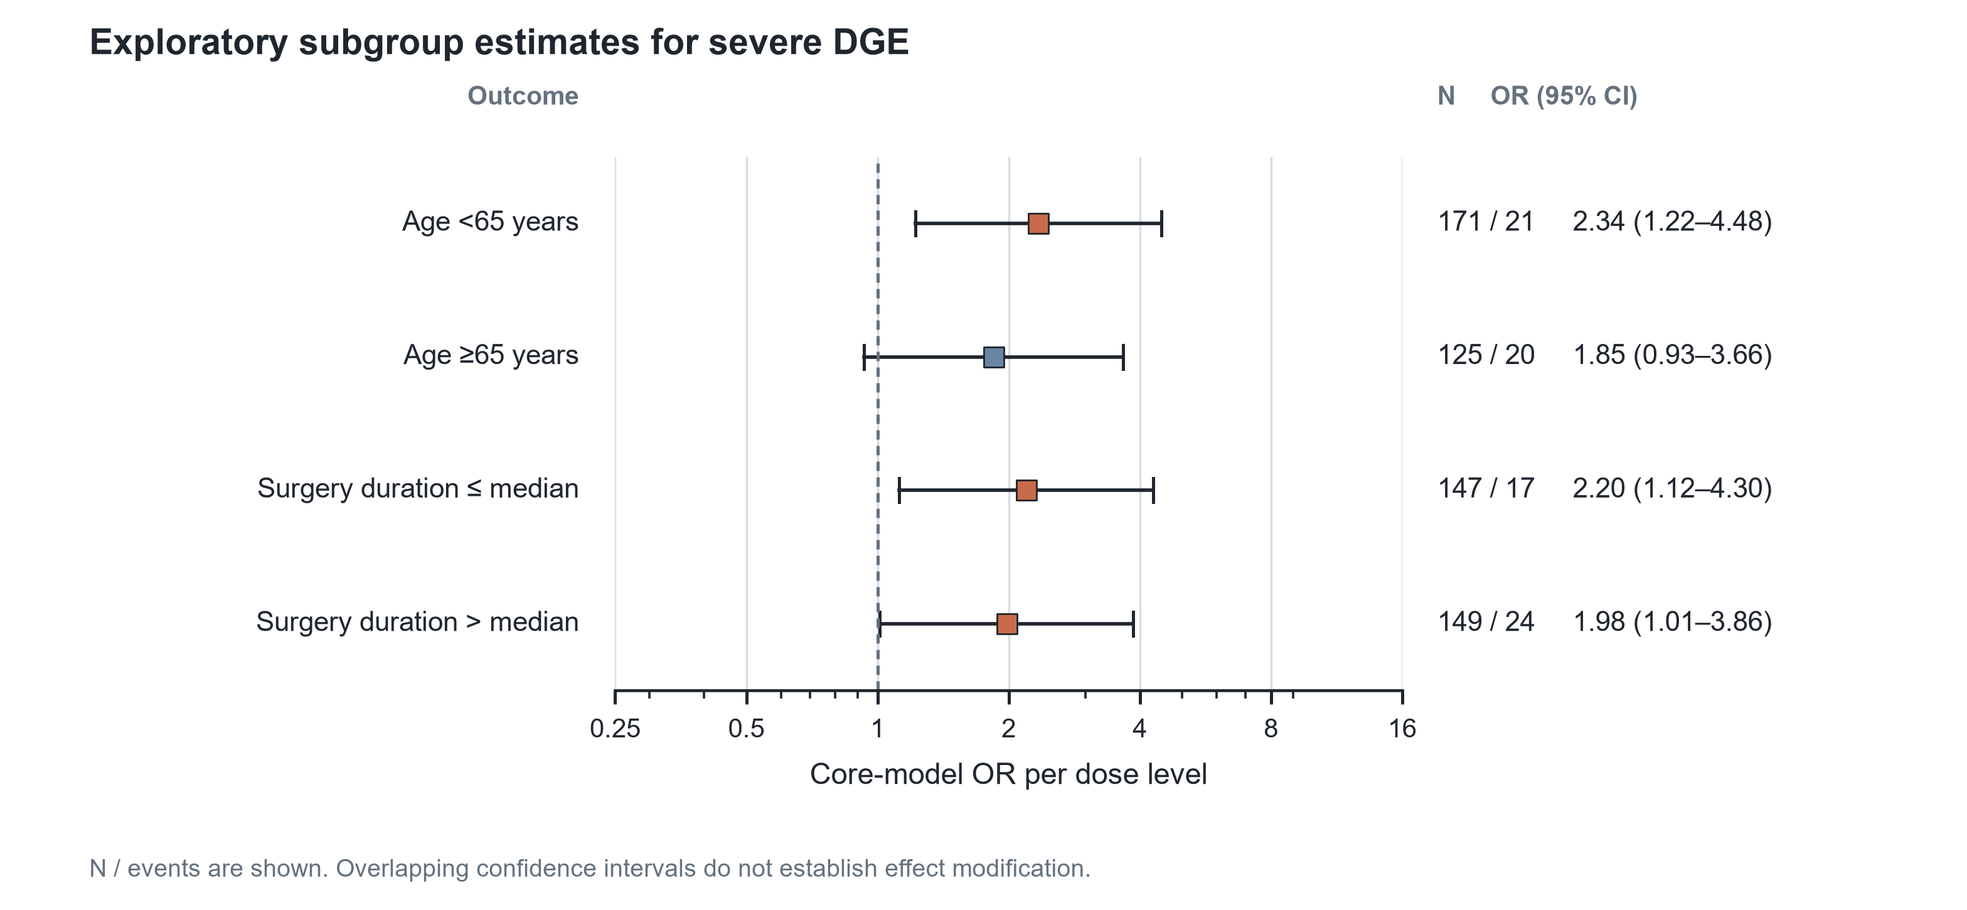
Supplementary Figure S1. Exploratory subgroup estimates for severe delayed gastric emptying. Squares show core-model odds ratios per one-level increase in cumulative remifentanil dose group; horizontal lines show 95% confidence intervals. N/events are shown. Overlapping confidence intervals do not establish effect modification.

Supplementary Figure S2
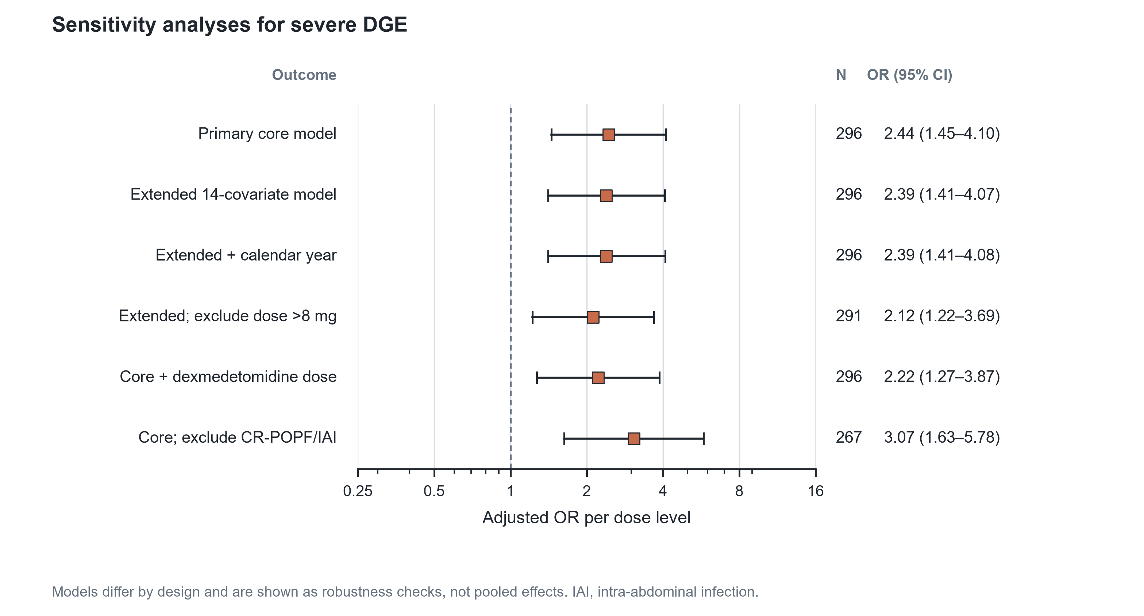
Supplementary Figure S2. Sensitivity analyses for severe delayed gastric emptying. Estimates are adjusted odds ratios per one-level increase in cumulative remifentanil dose group. Models differ by design and are shown as robustness checks, not pooled effects. CR-POPF, clinically relevant postoperative pancreatic fistula; IAI, intra-abdominal infection.

Supplementary Figure S3
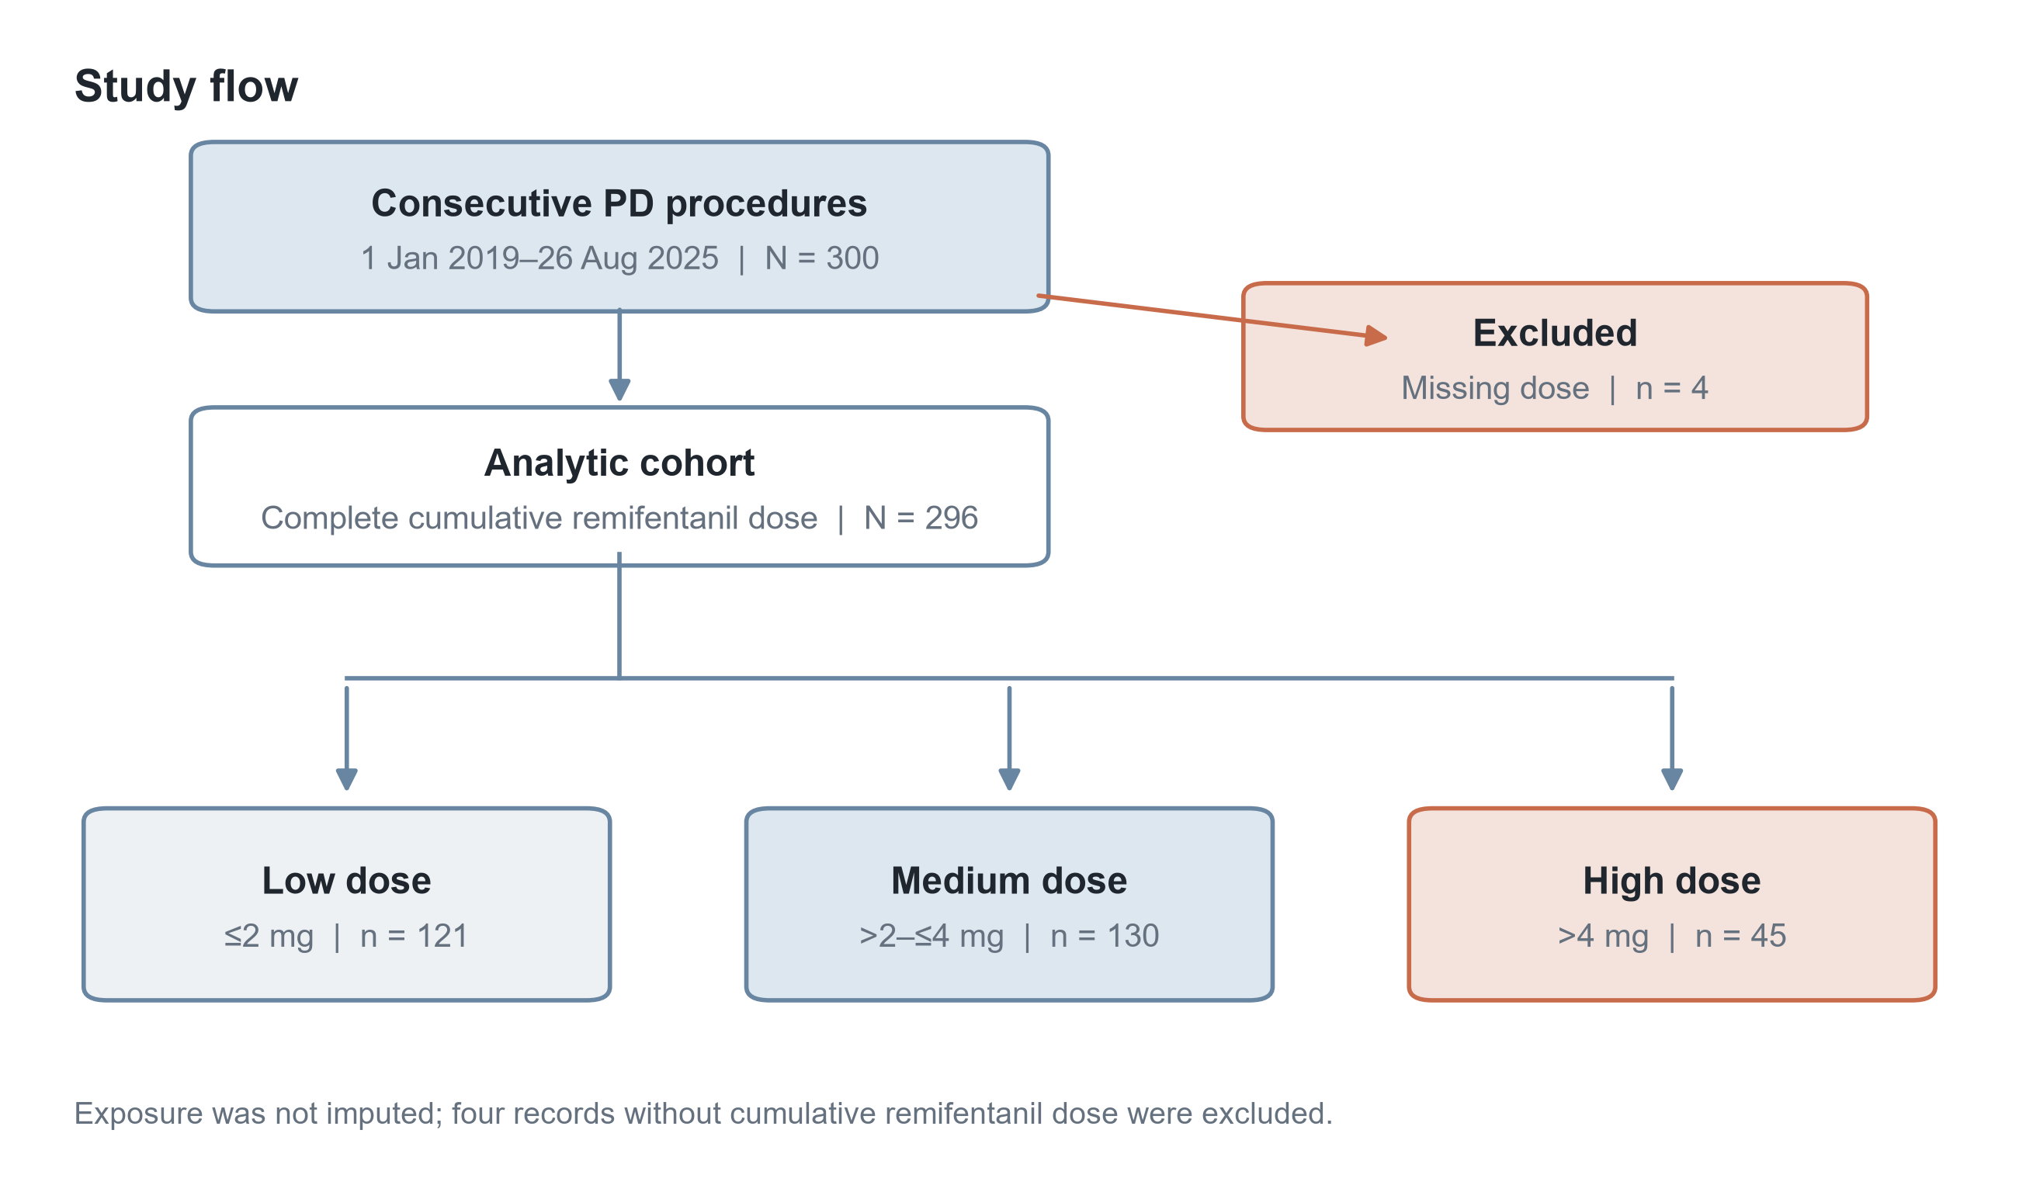
Supplementary Figure S3. Study flow. Of 300 consecutive pancreaticoduodenectomy procedures, four records without cumulative remifentanil dose were excluded, leaving 296 patients for analysis.

Supplementary Figure S4
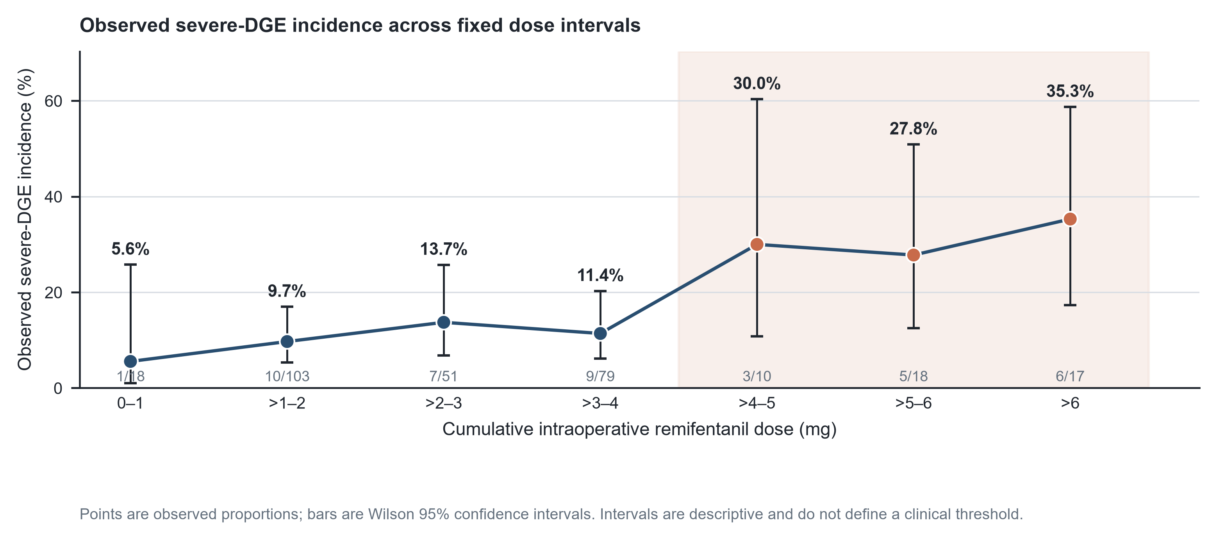
Supplementary Figure S4. Observed severe-DGE incidence across fixed cumulative remifentanil dose intervals. Points are observed proportions and bars are Wilson 95% confidence intervals. Intervals are descriptive and do not define a clinical dosing threshold.

