Establishment of long-term callus cultures of Deguelia duckeana (Fabaceae) with sustained production of lupane-type triterpenes
Cristine Luciana de Souza Rescarolli* (ORCID https://orcid.org/0000-0003-1920-2502), Priscila de Menezes Pinheiro* (ORCID https://orcid.org/0000-0001-5356-0499), Cecilia Veronica Nunez (ORCID https://orcid.org/0000-0003-3400-9508)

Supplemental Material

Supplementary Fig. S1 Comparative ¹H NMR spectra (300 MHz, CDCl₃ with TMS) of crude extracts obtained from pooled subcultures 11-15 (upper spectrum) and subculture 83 (lower spectrum), showing the high similarity of the metabolic profiles after long-term in vitro cultivation
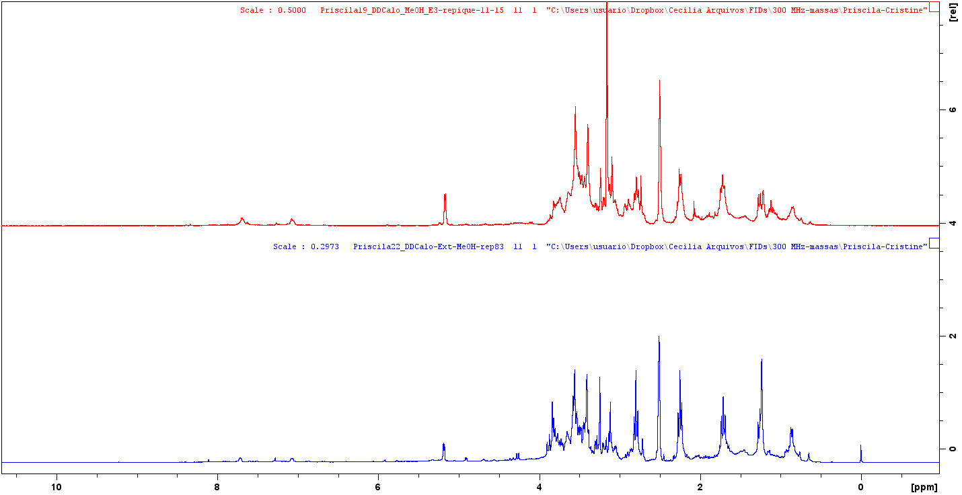

Supplementary Fig. S2 Expanded region (δ_{H} 0.0 to 4.0 ppm) of the comparative ¹H NMR spectra shown in Supplementary Fig. S1, highlighting the conserved aliphatic region characteristic of triterpenes. The upper spectrum corresponds to pooled subcultures 11–15 and the lower spectrum to subculture 83
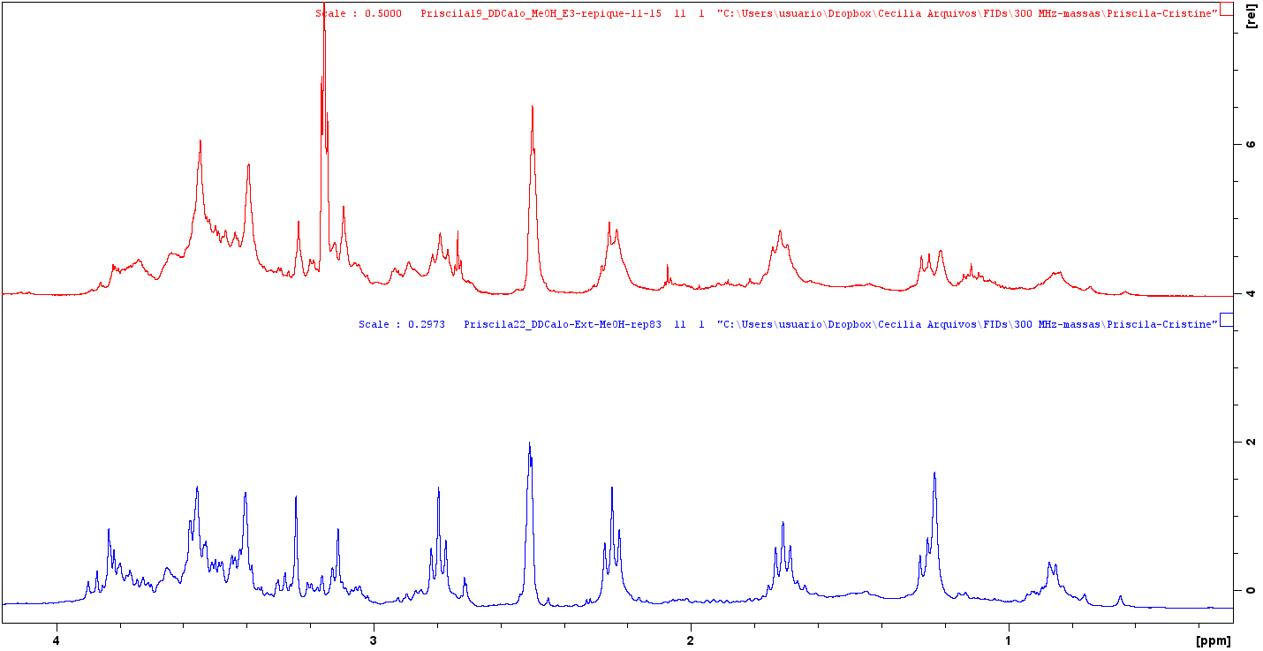
Supplementary Fig. S3 Expanded region (δ_{H} 4.0 to 9.0 ppm) of the comparative ¹H NMR spectra shown in Supplementary Fig. S1, showing the preservation of the olefinc and oxygenated proton signals throughout long-term cultivation. The upper spectrum corresponds to pooled subcultures 11–15 and the lower spectrum to subculture 83
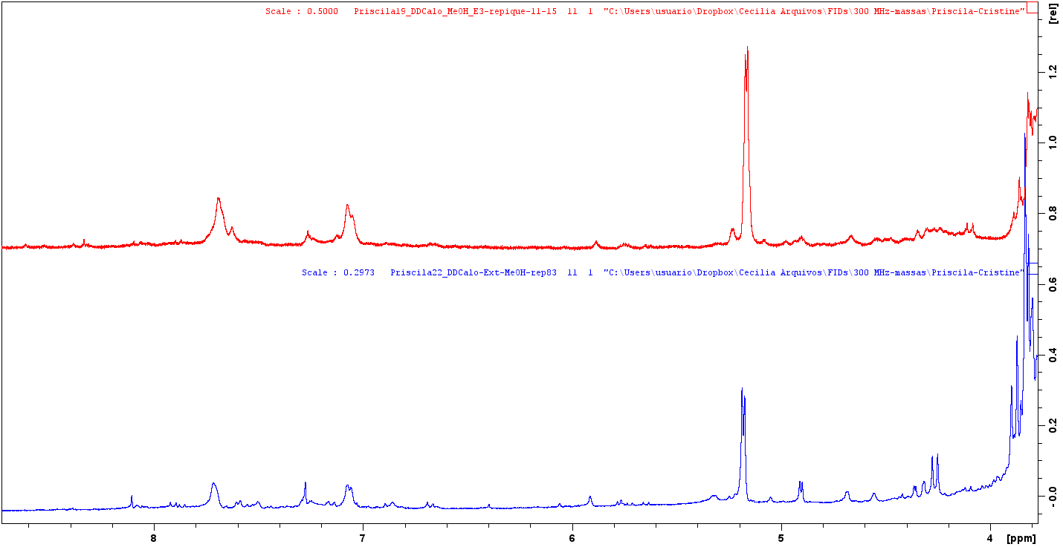
Supplementary Text S4 Spectroscopic identification of betulinaldehyde (compound I), lupeol (compound II), and betulinic acid (compound III) isolated form Deguelia duckeana callus cultures
Fractionation of hexane/EtOAc extract afforded two lupane-type triterpenes, identified as betulinaldehyde (compound I) and lupeol (compound II). The EtOAC phase of the methanolic extract of D. duckeana calluses also contained betulinaldehyde and lupeol, in addition to betulinic acid (compound III).
Fraction DdC0F35 exhibited signals between δ_{H} 0.75 and 1.14 in the ¹H NMR spectrum, corresponding to triterpene methyl groups. Two singlets at δ_{H} 4.61 and 4.74 were also observed, corresponding to the two hydrogens of the terminal double bond (H-29) (Supplementary fig. S5, S6). The HSQC spectrum confirmed the correlation of the methylene carbon at δc 110.18 (C-29) with the terminal double-bond hydrogens(S7). In the ¹³C NMR spectrum, in addition to the signal at δc 110.18 assigned to C-29, a quaternary carbon signal at δc 149.70 (C-20) was observed, both characteristic of the olefinic group (S8). A singlet at δ_{H} 9.68 in the ¹H NMR spectrum correlating with the carbon signal at δ_{C} 206.77 in the HSQC spectrum, indicating the presence of an aldehyde bound to C-28 (S9). These data allowed the identification of betulinaldehyde as compound I.
Fractions DdC2F11-12 and DdC2F16-17 were pooled (44.8 mg) and analyzed by ¹H and ¹³C NMR (S10). The spectra showed the typical triterpene signals, including two terminal double-bond hydrogens at δ_{H} 4.57 and 4.69, wich correlated with carbon signal δ_{C} 109.32 in the HSQC spectrum. Signals between δ_{H} 0.70 and 1.25, typical of triterpene methyl groups, were also observed (S11). Comparison of the obtained data with those reported in the literature (Mahato and Kundu 1994) allowed the identification of lupeol as compound II (Supplementary table S15).
The ¹H NMR spectrum of the EtOAc phase of methanolic extract showed signals corresponding to terminal olefinic hydrogens at δ_{H} 4.68 and 4.65 (S12), characteristic of lupane-type triterpenes. Signals between 0.65 and 1.70 corresponding tomethyls were also observed. The HSQC (S13) and HMBC (S14) spectra showed signals corresponding to 30 carbons, characteristic of triterpenes and correlating with hydrogens. A carbon signal at δ_{C} 177.70 was attributed to thecarbonyl group at C-28, characteristic of the acid group, in addition signals at δ_{C} 109.00 and 150.80 corresponding to C-29 and C-20, respectively, and a carbon signal at δ_{C} 77.20 corresponding C-3. Comparison of the obtained data with those described in the literature (Wenkert et al. 1978) allowed the identification of betulinic acid as compound III (Supplementary table S15).

Supplementary Fig. S5 ¹H NMR spectrum (300 MHz, CDCl₃ with TMS) of betulinaldehyde (compound I)
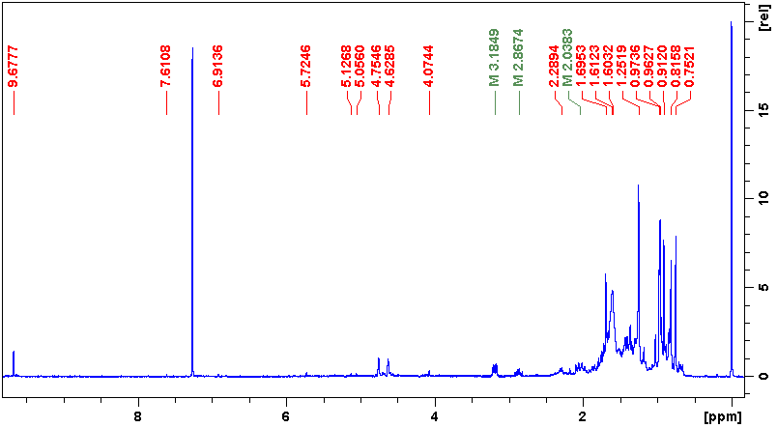

Supplementary Fig. S6 Expanded region (δ_{H} 0.0 to 5.0 ppm) of the ¹H NMR spectrum of betulinaldehyde (compound I), highlighting the hydrogens of the double terminal bond characteristic of the lupane skeleton
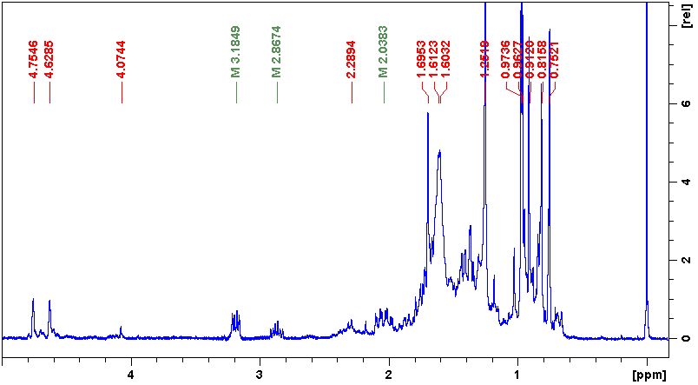

Supplementary Fig. S7 Expanded HSQC spectrum of betulinaldehyde (compound I). (A) Correlation between the exomethylene proton H-29 (δ_{H} 4.61 and 4.74) and carbon C-29 (δ_{C} 110.18). (B) Correlation between the aldehyde proton (δ_{H} 9.68) and carbonyl carbon C-28 (δ_{C} 206.77), confirming the presence of the aldehyde group
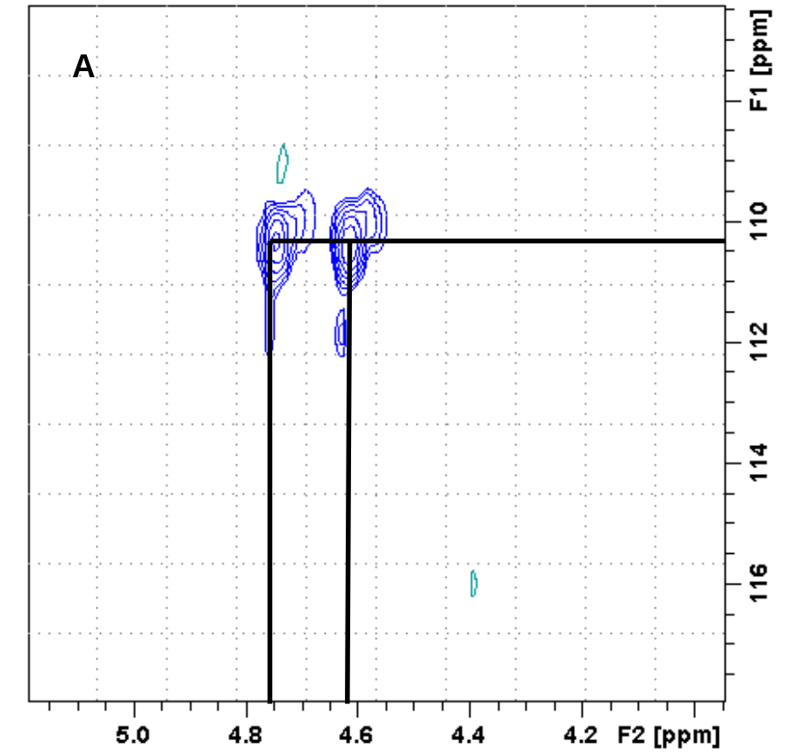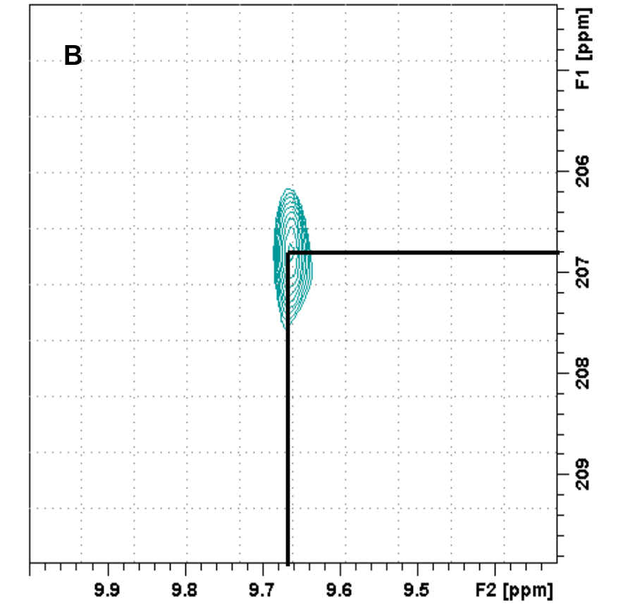

Supplementary Fig. S8 ¹³C NMR spectrum (75 MHz, CDCl₃ with TMS) of betulinaldehyde (compound I)
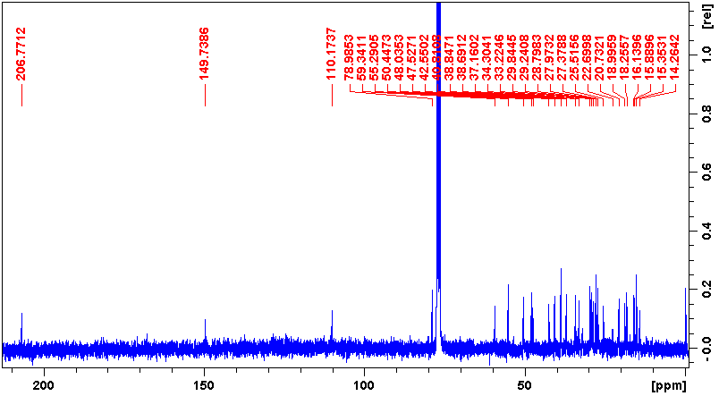
Supplementary Fig. S9 Expanded region (δ_{C} 109 to 207) of the ¹³C NMR spectrum of betulinaldehyde (compound I), showing the characteristic olefinic carbons (C-20 and C-29) and the aldehyde carbonyl carbon (C-28)
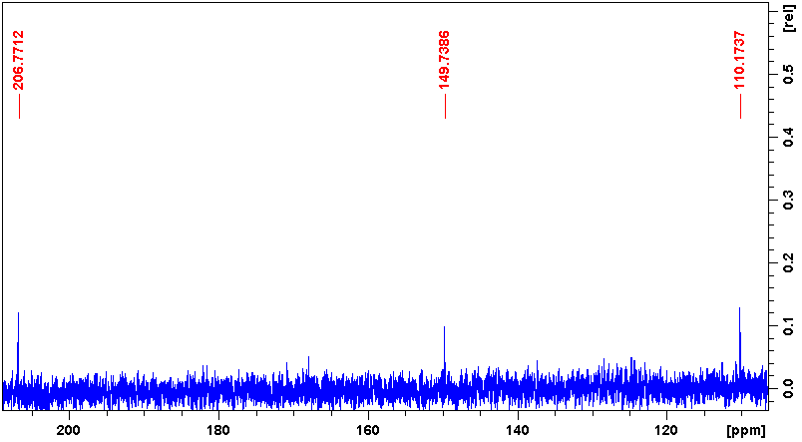
Supplementary Fig. S10 ¹³C NMR spectrum (75 MHz, CDCl₃) of lupeol (compound II) isolated from fractions DdC2F11-12
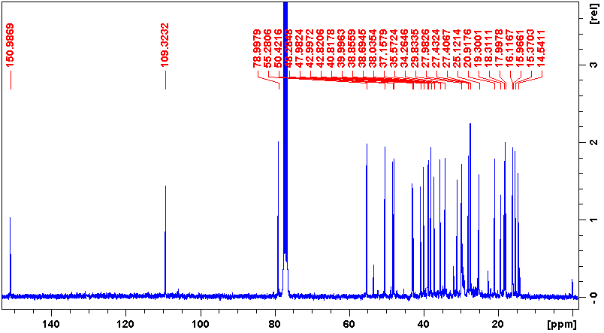

Supplementary Fig. S11 ¹H NMR spectrum (300 MHz, CDCl₃) of lupeol (compound II) from fraction DDC2F11-12
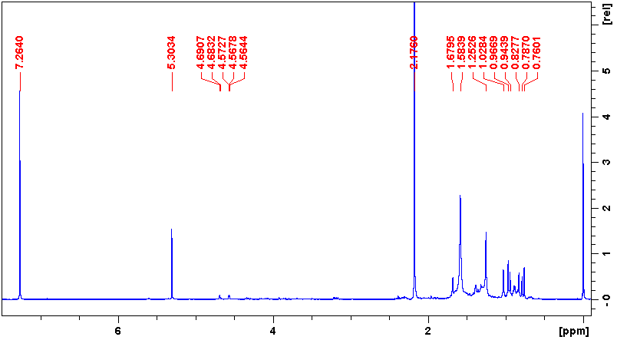

Supplementary Fig. S12 ¹H NMR spectrum (300 MHz, DMSO-d₆ with TMS) of betulinic acid (compound III)
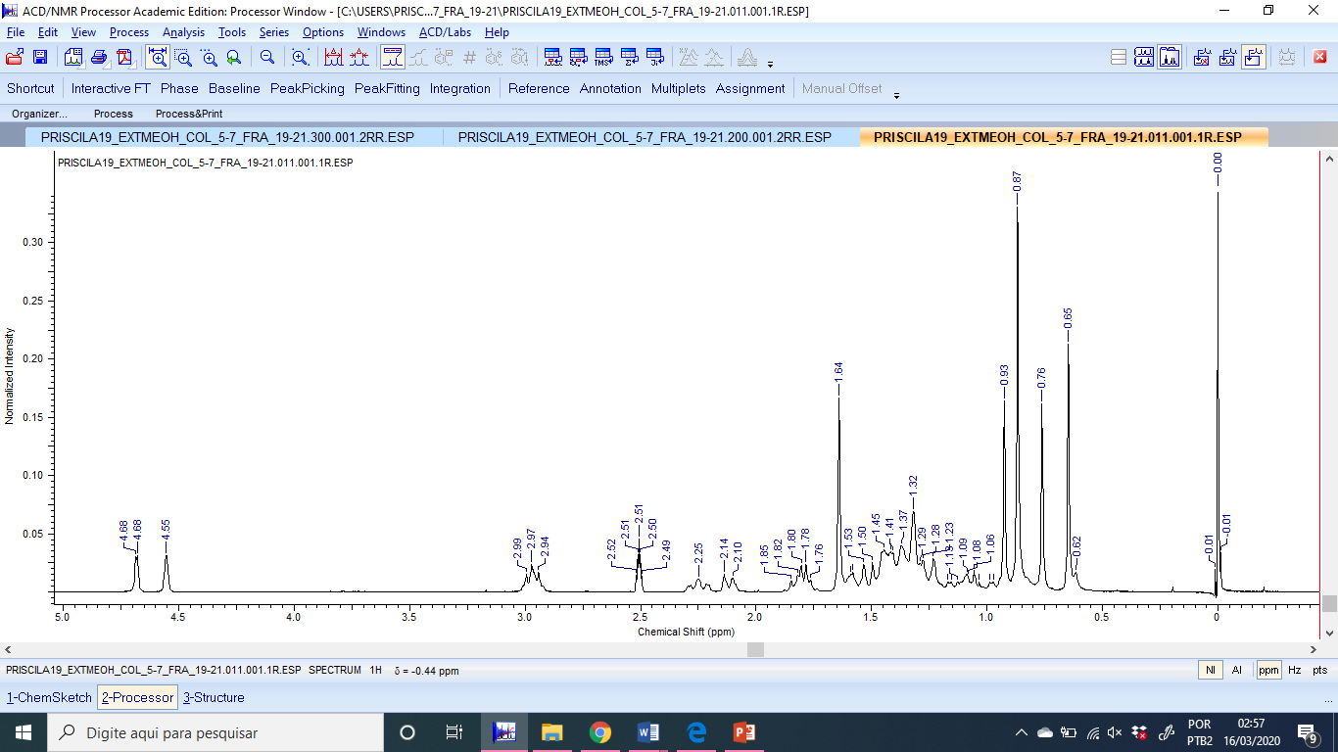

Supplementary Fig. S13 HSQC spectrum of betulinic acid (compound III), showing the correlations between proton and directly bonded carbon resonances used for structural assignment
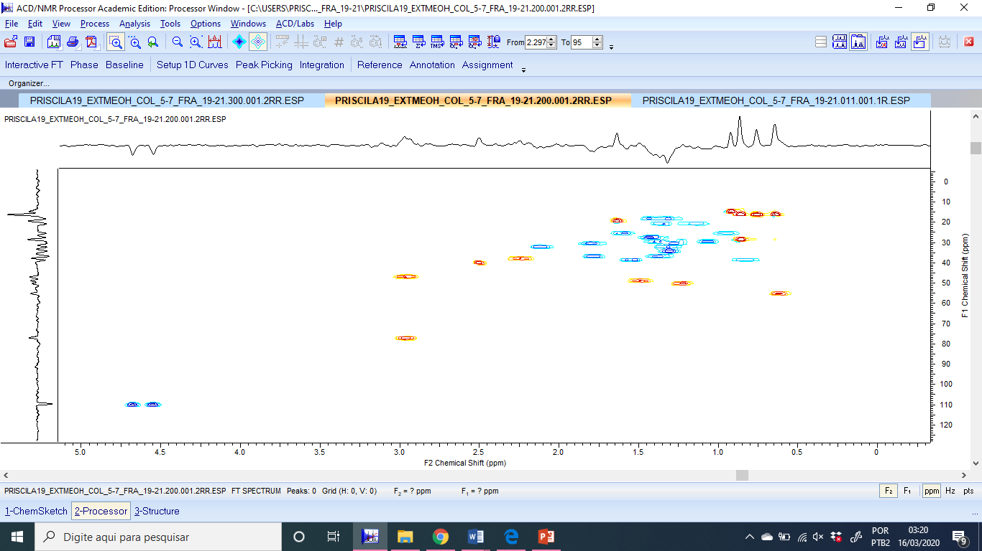
Supplementary Fig. S14 HMBC spectrum of betulinic acid (compound III), showing the key long-range ¹H– ¹³C correlations supporting the structural assignment
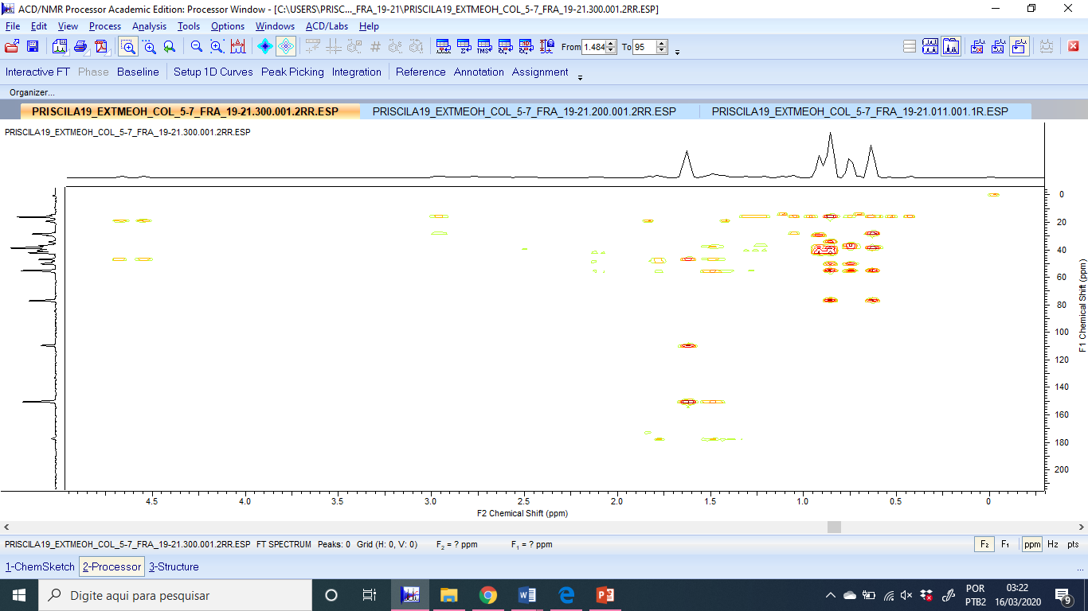

Supplementary Table S15 ¹³C-NMR chemical shift assignments for betulinaldehyde (compound I), lupeol (compound II) and betulinic acid (compound III) isolated from Deguelia duckeana callus cultures, compared with literature data.
Position | Betulinaldehyde¹ |  |  | Lupeol² |  |  | Betulinic acid³
Position | Observ. | Mult. | Literat. | Observ. | Mult. | Literat. | Observ. | Mult. | Literat.
1 | 38.85 | CH₂ | 39.1 | 38.69 | CH₂ | 38.7 | 38.70 | CH₂ | 38.2
2 | 27.38 | CH₂ | 27.6 | 27.40 | CH₂ | 27.4 | 27.65 | CH₂ | 27.1
3 | 78.99 | CH | 79.0 | 78.99 | CH | 78.9 | 77.20 | CH | 76.7
4 | 38.72 | C | 38.9 | 38.85 | C | 38.8 | 38.70 | C | 38.5
5 | 55.29 | CH | 55.5 | 55.28 | CH | 55.3 | 55.30 | CH | 54.8
6 | 18.26 | CH₂ | 18.5 | 18.31 | CH₂ | 18.3 | 18.42 | CH₂ | 17.9
7 | 34.31 | CH₂ | 34.5 | 34.26 | CH₂ | 34.2 | 34.33 | CH₂ | 33.9
8 | 40.81 | C | 41.0 | 40.82 | C | 40.8 | 38.70 | C | 38.5
9 | 50.46 | CH | 50.6 | 50.42 | CH | 50.4 | 50.38 | CH | 49.9
10 | 37.16 | C | 37.4 | 37.15 | C | 37.1 | 39.90 | C | 36.7
11 | 20.74 | CH₂ | 21.0 | 20.92 | CH₂ | 20.9 | 20.87 | CH₂ | 20.4
12 | 25.52 | CH₂ | 25.7 | 25.12 | CH₂ | 25.1 | 25.54 | CH₂ | 25
13 | 38.69 | CH | 38.8 | 38.03 | CH | 38 | 37.95 | CH | 37.5
14 | 42.55 | C | 42.7 | 42.82 | C | 42.8 | 42.20 | C | 41.9
15 | 28.80 | CH₂ | 29.0 | 27.43 | CH₂ | 27.4 | 30.62 | CH₂ | 29.2
16 | 33.23 | CH₂ | 30.1 | 35.57 | CH₂ | 35.5 | 32.37 | CH₂ | 31.7
17 | 59.35 | C | 59.4 | 42.99 | C | 43 | 55.30 | C | 55.4
18 | 48.04 | CH | 48.3 | 48.28 | CH | 48 | 47.13 | CH | 48.5
19 | 47.53 | CH | 47.6 | 47.98 | CH | 47.9 | 50.37 | CH | 49.9
20 | 149.70 | C | 149.6 | 150.99 | C | 150.9 | 150.80 | C | 150.3
21 | 29.24 | CH₂ | 29.4 | 29.83 | CH₂ | 29.8 | 30.57 | CH₂ | 30.9
22 | 29.85 | CH₂ | 33.4 | 39.99 | CH₂ | 40 | 36.90 | CH₂ | 36.3
23 | 27.98 | CH₃ | 28.1 | 27.98 | CH₃ | 28 | 28.56 | CH₃ | 28.1
24 | 15.36 | CH₃ | 15.5 | 15.37 | CH₃ | 15.4 | 16.24 | CH₃ | 15.73
25 | 16.15 | CH₃ | 16.1 | 16.12 | CH₃ | 16.1 | 16.27 | CH₃ | 15.9
26 | 15.89 | CH₃ | 16.3 | 15.97 | CH₃ | 15.9 | 16.44 | CH₃ | 15.8
27 | 14.27 | CH₃ | 14.5 | 14.54 | CH₃ | 14.5 | 14.80 | CH₃ | 14.3
28 | 206.77 | C | 206.8 | 17.99 | CH₃ | 18 | 177.70 | C | 177.2
29 | 110.18 | CH₂ | 110.1 | 109.32 | CH₂ | 109.3 | 109.00 | CH₂ | 109.0
30 | 19.00 | CH₃ | 19.0 | 19.30 | CH₃ | 19.3 | 19.40 | CH₃ | 18.9
Legend: ¹Betulinaldehyde, in CDCl₃ (75 MHz) with literature comparison (Mahato and Kundu 1994; Barthel et al 2008); ²Lupeol, in CDCl₃ (75 MHz) with literature comparison (Mahato and Kundu 1994); ³Betulinic acid, in DMSO-d₆ (75 MHz) with literature comparison (Wenkert et al. 1978).

Supplementary Text S16 Additional chromatographic procedures for methanolic extracts from Deguelia duckeana callus cultures

The methanolic extract from subculture 17 (2.29 g) was fractionated by open column chromatography on silica gel using successive solvent systems of increasing polarity, including dichloromethane (DCM), ethyl acetate (EtOAc), acetone, acetone/methanol (1:1, v/v), and methanol (MeOH). The EtOAc fraction (277 mg) was further purified by silica gel chromatography using DCM gradient (100:0 to 0:100, v/v), yielding 68 subfractions.
The same chromatographic strategy was applied to pooled methanolic extracts from subcultures 21, 25, and 28 (8.82 g). The resulting EtOAC fraction (927 mg) was further fractionated on silica gel using a DCM/MeOH gradient, affording 188 subfractions. The corresponding acetone fraction was subsequently subjected to recrystallization (DCM/MeOH), Sephadex LH-20 column chromatography, and preparative thin-layer chromatography (TLC).
To investigate the occurrence of additional secondary metabolites during prolonged cultivation, pooled methanolic extract from representative long-term subcultures (33, 38, 50, 53, 57, 70, 73, 76, 78, 80, and 83), totaling 22 g of extract, were fractionated by an H₂O/MeOH gradient, followed by elution with 100% EtOA.
All fractions were monitored by TLC under UV light (254 and 365 nm) and visualized with anisaldehyde reagent, iodine vapor and FeCl₃. Selected fractions were further analyzed by ¹H-NMR spectroscopy. Although these additional chromatographic procedures generated numerous fractions and subfractions, betulinaldehyde, lupeol, and betulinic acid werethe only compounds that could be unequivocally identified. Other metabolites were detected in several fractions but could not be structurally characterized because they were present only in trace amounts and/or as complex mixtures, preventing further structural characterization.

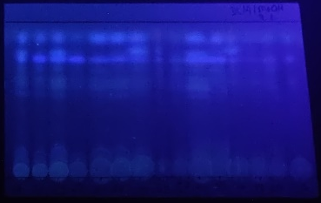
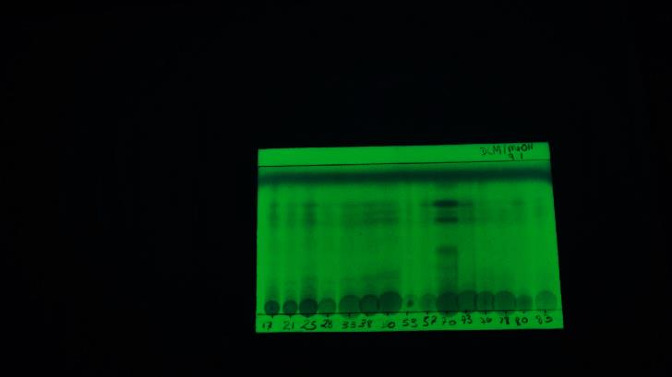
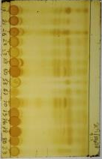
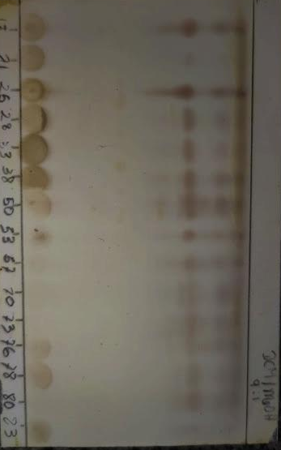
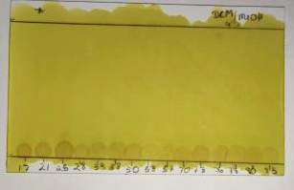
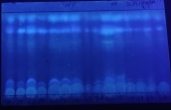
Supplementary Fig. S17 Thin-layer chromatography (TLC) profiles of methanolic extracts obtainded from representative subcultures (17, 21, 25, 28, 33, 38, 50, 53, 57, 70, 73, 76, 78, 80, and 83) of Deguelia duckeana callus cultures, developed with dichloromethane/methanol (9:1, v/v), demonstrating the consistency of the chromatographic profiles throught long-term cultivation
UV light 365 nm
C
UV light 254 nm
Iodine
B
A
F
17 21 25 28 33 38 5053 57 70 7376 78 80 83
17 21 25 28 33 38 50 53 57 70 73 76 78 80 83
17 21 25 28 33 38 50 53 57 70 7376 78 80 83
D
E

17 21 25 28 33 38 50 53 57 70 7376 78 80 83
17 21 25 28 33 38 50 53 57 70 73 76 78 80 83
17 21 25 28 33 38 50 53 57 70 7376 78 80 83
Ce(SO₄)₂
FeCl₃
NP-PEG + UV light 365 nm

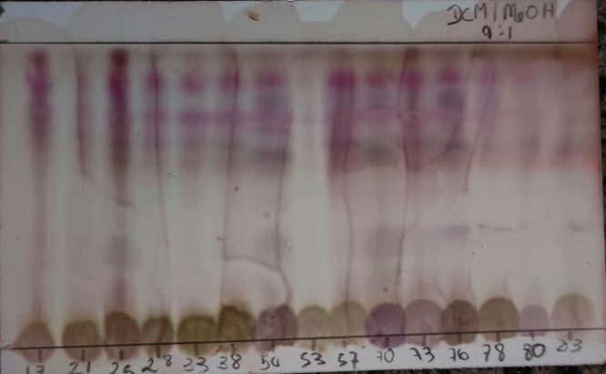
Anisaldehyde
G

17 21 25 28 33 38 50 53 57 70 73 76 78 80 83
References
Barthel A, Stark S, Csuk R. (2008) Oxidative transformations of betulinol. Tetrahedron 64: 9225–9229. https://doi.org/10.1016/j.tet.2008.07.042
Mahato SB, Kundu AP (1994) ¹³C NMR Spectra of pentacyclic triterpenoids – A compilation and some salient features. Phytochem 37(6):1517–1575. https://doi.org/10.1016/S0031-9422(00)89569-2
Wenkert E, Baddeley V, Burfett IR, Moreno LN (1978) ¹³C Nuclear magnetic-resonance spectroscopy of naturally-occurring substances. Triterpenes related to lupane and hopane. Org Magn Reson 11:337–343.

