Quantitative adaptor heterogeneity sets single-cell thresholds for innate immune activation and attenuation
Arpan Dey^{1,2}§*, Yuhao Cui^{1,2}§, Bharti Nawalpuri³, Georg Meisl^{1,2}, Gavin W. Sewell⁴, Abhishek Patil⁵, Nurun N Fancy^{6,7}, Clare Bryant^{3,8}*, David Klenerman^{1,2,9}*
¹Yusuf Hamied Department of Chemistry, University of Cambridge, Cambridge, UK
²UK Dementia Research Institute, University of Cambridge, UK
³Department of Medicine, University of Cambridge, UK
⁴Cambridge Institute of therapeutic Immunology and Infectious Disease, Department of Medicine, University of Cambridge, Cambridge, UK
⁵Monash Biomedicine Discovery Institute, Faculty of Medicine, Nursing, and Health Sciences, Monash University, Melbourne, Australia
⁶UK Dementia Research Institute Centre, Imperial College London, London, UK
⁷ Department of Brain Sciences, Imperial College London, Hammersmith Hospital, London, UK
⁸ Department of Veterinary Medicine, University of Cambridge, UK
⁹Lead contact
§ These authors contributed equally to this work
*Correspondence: ad2327@cam.ac.uk (A.D), ceb27@cam.ac.uk (C.B), dk10012@cam.ac.uk (D.K)

This file contains supplementary figures (figure SI 1-8) and figure legends.

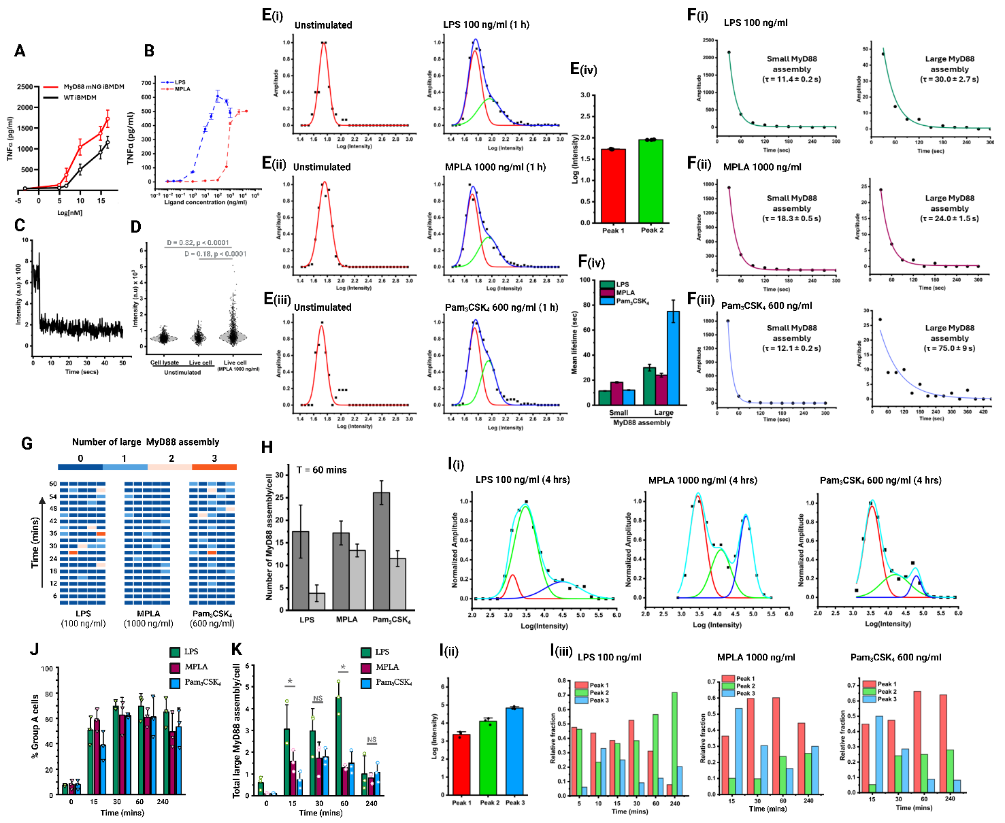
Figure SI 1

Figure SI 1. Characterization of ligand-dependent endogenous MyD88 assembly kinetics.
A) Dose-dependent LPS-induced TNFα release from MyD88-mNG iBMDMs and WT iBMDMs, at 4 h showing comparable cytokine production between endogenously tagged and WT cells. Data represent mean ± SD from 3 biological replicates.
B) Dose-dependent TNFα release from MyD88-mNG iBMDMs after stimulation with increasing concentrations of LPS or MPLA at 4 h. Data represent mean ± SD across 4 independent measurements from 2 biological replicates.
C) Representative fluorescence bleaching trajetory from lysed MyD88-mNG iBMDMs. A single photobleaching step indicates detection of monomeric MyD88-mNG.
D) Distribution of MyD88-mNG puncta intensities measured from cell lysate, unstimulated live cells, and MPLA-stimulated live cells. Monomeric MyD88-mNG intensity was estimated from the lysate condition and used as the reference for assembly-size normalization. Pairwise differences between distributions were assessed using the Kolmogorov–Smirnov test.
E) Quantification of MyD88 assembly intensity distributions from TIRF imaging. (i–iii) Representative log-transformed intensity distributions of MyD88-mNG puncta in unstimulated cells and in cells stimulated for 1 h with LPS, MPLA, or Pam3CSK4. Distributions were fitted with a sum of two Gaussian components to estimate peak positions, (iv) Fitted log-intensity values of the two major peaks detected after stimulation. Data represent mean ± SD from intensity peak fits of MyD88 assemblies formed at 15, 30, and 60 min.
F) Lifetime analysis of membrane-proximal MyD88 assemblies detected by TIRF imaging. (i–iii) Representative decay curves showing the lifetime distributions of small and large MyD88 assemblies after stimulation with the highest doses of LPS, MPLA, or Pam3CSK4. Small assemblies were defined as assemblies below the hexameric threshold, whereas large assemblies were defined as hexameric or larger MyD88 assemblies. Decay curves were fitted with a single-exponential function, (iv) Mean lifetimes of small and large MyD88 assemblies across the three ligand conditions. Error bars indicate fitting error.
G) Single-cell heatmaps showing the number of large MyD88 assemblies (hexameric and higher) detected over time after stimulation with LPS, MPLA, or Pam3CSK4. Each row represents an individual cell, and colour indicates the number of large assemblies detected at each time point.
H) Total number of MyD88 assemblies per cell at 60 min after stimulation, stratified into Group A and Group B cells. Group A cells, shown in dark Gray, were defined by the presence of at least one hexameric or larger MyD88 assembly, whereas Group B cells, shown in light Gray, lacked such assemblies.
I) Intensity distributions of MyD88 assemblies throughout the cell volume. (i) Representative log-transformed intensity distributions of MyD88 assemblies, and peak fits for LPS, MPLA, and Pam3CSK4 stimulation at 4 h. Distributions were fitted with a sum of three Gaussian components to resolve distinct assembly-intensity populations, (ii) Fitted log-intensity values of the three major peaks detected in volumetric measurements across 15, 30, 60, and 240 min, (iii) Relative fraction of each fitted peak over time after stimulation with LPS, MPLA, or Pam3CSK4. Based on monomer intensity calibration, Peak 2 and Peak 3 were assigned to hexamer-like and higher-order MyD88 assemblies, respectively.
J) Percentage of Group A cells over time after stimulation with the highest doses of LPS, MPLA, or Pam3CSK4, based on volumetric MyD88 assembly analysis.
K) Number of large MyD88 assemblies per cell over time after stimulation with the highest doses of LPS, MPLA, or Pam3CSK4. Significance was assessed using two-sided unpaired Student’s t test, *p < 0.05, NS, not significant.
Sample sizes and replicate information for MyD88 assembly analyses are as described for Figure 1, unless otherwise indicated.

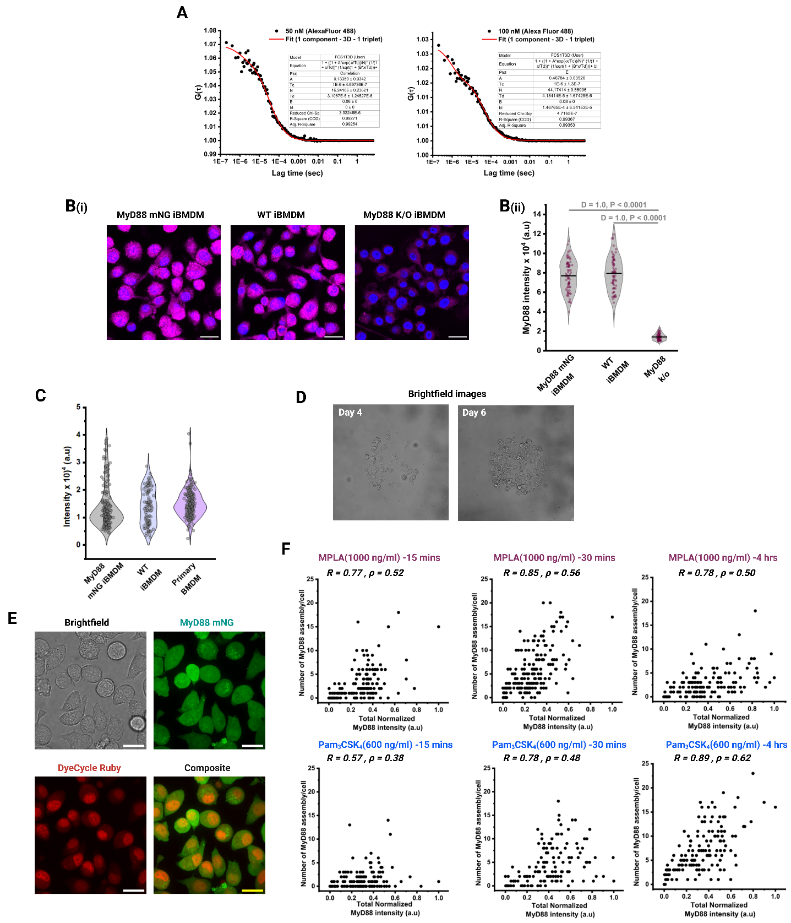
Figure SI 2

Figure SI 2. Calibration and validation of MyD88 heterogeneity measurements.
A) Representative fluorescence correlation spectroscopy (FCS) calibration measurements using Alexa Fluor 488 succinimidyl ester solutions of 50 nM, and 100 nM respectively. Autocorrelation curves were fitted using a 3D diffusion model to determine the effective confocal volume as described in Methods. The fitted particle number (N) scaled linearly with dye concentration, validating the calibration.
B) Validation of MyD88 immunofluorescence specificity. (i) Representative immunofluorescence images of MyD88-mNG iBMDMs, WT iBMDMs, and MyD88 knockout (MKO) iBMDMs stained with anti-MyD88 antibody. MyD88 signal is shown in magenta and nuclei are shown in blue. Scale bar 20 μm, (ii) Quantification of MyD88 immunofluorescence intensity in MyD88-mNG iBMDMs, WT iBMDMs, and MKO iBMDMs. MKO data represent mean ± SD from 4 independent measurements across 2 biological replicates. Pairwise differences between distributions were assessed using the Kolmogorov–Smirnov test.
C) Total MyD88 immunofluorescence intensity distributions in MyD88-mNG iBMDMs, WT iBMDMs, and primary BMDMs, showing comparable cell-to-cell heterogeneity.
D) Representative brightfield images of MyD88-mNG iBMDMs growing within micropatterned wells at day 4 and day 6 after seeding. Patterning restricted cells within individual wells.
E) Representative images of MyD88-mNG iBMDMs stained with DyeCycle Ruby to assess DNA content and cell-cycle state. Brightfield, MyD88-mNG, DyeCycle Ruby, and merged images are shown. Scale bar 20 μm.
G) Correlation between total normalized MyD88 intensity and the number of MyD88 assemblies per cell at additional time points after MPLA or Pam3CSK4 stimulation. Pearson correlation coefficients (R) and Spearman’s rank correlation coefficients (ρ) are shown for each condition.
Sample sizes and replicate information for MyD88 assembly analyses are as described for Figure 2, unless otherwise indicated.

Figure SI 3
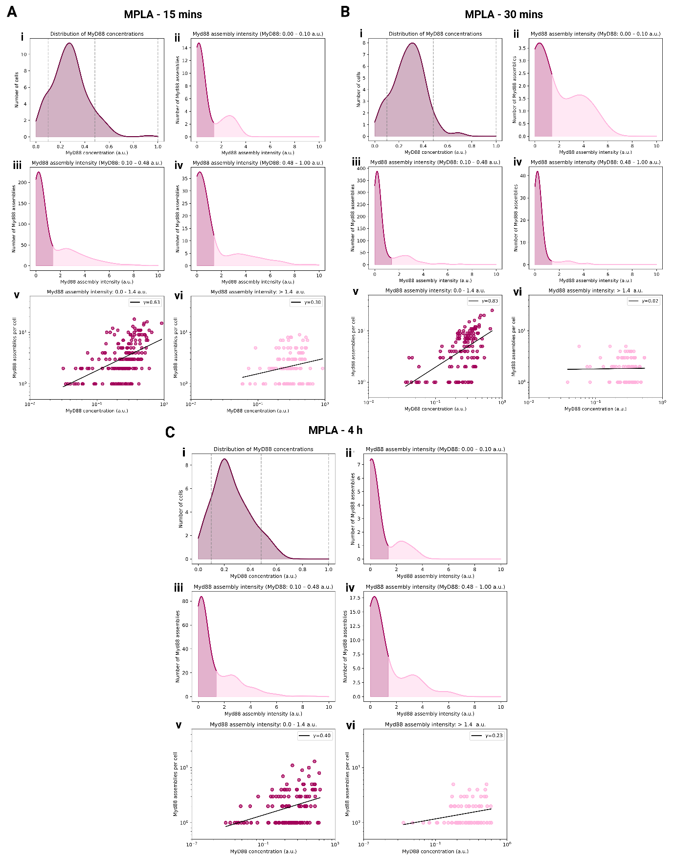

Figure SI 3. Additional coarse-grained scaling analysis of MyD88 assembly.
A–C) Additional scaling analyses of MyD88 assembly under the ligand and time-point conditions indicated in the figure. For each condition:
(i) Distribution of total normalized cellular MyD88 concentration, with dashed lines indicating the three empirically defined MyD88 concentration bins used for visualization.
(ii–iv) Distributions of MyD88 assembly intensities within the low, intermediate, and high MyD88 concentration bins defined in (i). These distributions illustrate how the assembly-size profile varies as a function of cellular MyD88 abundance.
(v) Double-logarithmic plot showing the dependence of small MyD88 assemblies per cell on cellular MyD88 concentration.
(vi) Double-logarithmic plot showing the dependence of large MyD88 assemblies per cell on cellular MyD88 concentration.
For the scaling analysis, small and large MyD88 assemblies were classified using the empirically defined assembly-intensity threshold described in Figure 3. Lines in (v) and (vi) indicate linear fits used to extract the scaling exponents (γ), which are shown in each panel.
These analyses show that, under all the timepoints, scaling exponent for MyD88 assemblies induced by MPLA scaling remains sublinear, particularly for large assemblies, consistent with the weaker amplification of productive assembly under these conditions.

Figure SI 4
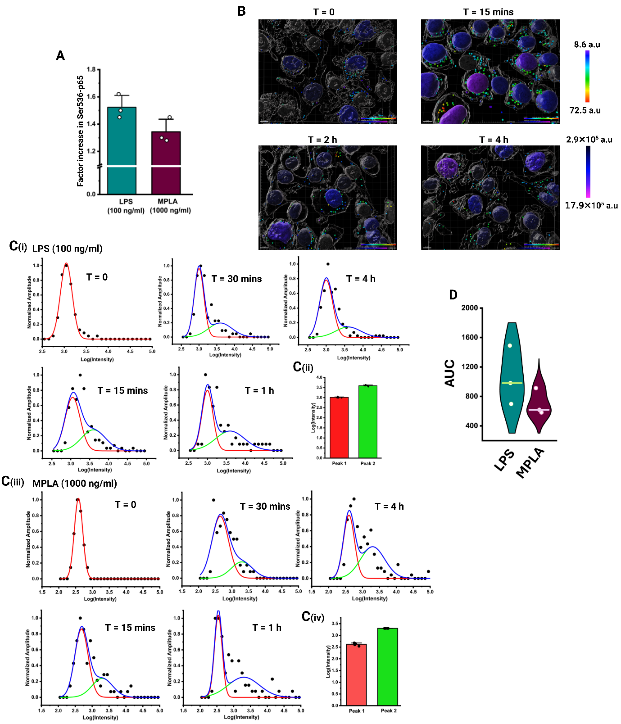

Figure SI 4. Validation and additional analysis of MyD88 assembly-associated NFκB activation.
A) Fold increase in whole cell Ser536-p65 intensity at 15 min after stimulation with LPS or MPLA, relative to the unstimulated condition. Data represent mean ± SD from 3 biological replicates.
B) Representative 3D reconstructions of MyD88-mNG cells with nuclei, and MyD88 assemblies at the indicated time points after LPS stimulation. Nuclear volumes are color-coded by total Ser536-p65 intensity, and MyD88 assemblies are color-coded by assembly intensity. Scale bar 7 μm.
C) Intensity-distribution analysis of MyD88 assemblies detected in fixed cells after LPS or MPLA stimulation. (i) Representative log-transformed MyD88 assembly intensity distributions in LPS-stimulated cells at the indicated time points. Distributions were fitted with sum of two Gaussian components except unstimulated cells, (ii) Fitted log-intensity values of the two major peaks detected in LPS-stimulated fixed-cell measurements, (iii) Representative log-transformed MyD88 assembly intensity distributions in MPLA-stimulated cells at the indicated time points. Distributions were fitted with a sum of two Gaussian components except unstimulated cells, (iv) Fitted log-intensity values of the two major peaks detected in MPLA-stimulated fixed-cell measurements. Peak 2 intensity across both LPS and MPLA stimulation forms the hexameric population, enabling Group A/B stratification in fixed-cells.
D) Area under the curve (AUC) analysis of NFKBIA mRNA from smFISH measurements. Data represent value over the time course measured after LPS or MPLA stimulation (based on figure 4H).
Sample sizes and replicate information are as described for Figure 4, unless otherwise indicated.

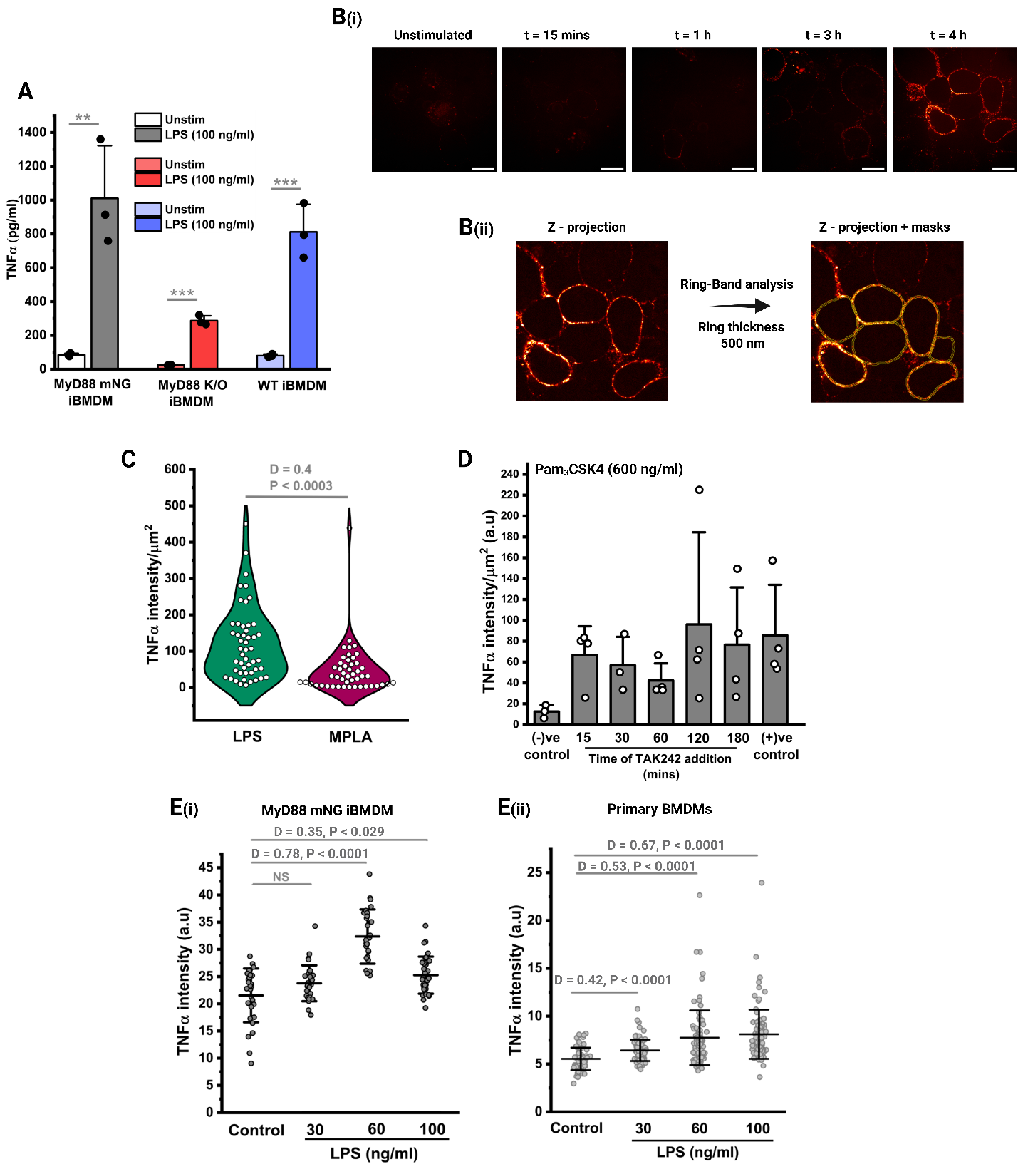
Figure SI 5

Figure SI 5. Validation of TNFα assays used to relate MyD88 assembly to cytokine output.
A) TNFα release from MyD88-mNG iBMDMs, MyD88 knockout iBMDMs, and WT iBMDMs under unstimulated and LPS-stimulated conditions. Cells were stimulated with LPS for 4 h, and TNFα release was measured in the supernatant. Data represent mean ± SD from 3 biological replicates. Significance was assessed using two-sided unpaired Student’s t test, **p < 0.01, ***p < 0.001.
B) Time-window assay for measuring membrane-retained TNFα after TAPI-0 and TAK-242 treatment. (i) Representative immunofluorescence images of membrane-associated TNFα in unstimulated cells and in LPS-stimulated cells in which TAK-242 was added at the indicated time points after stimulation. TNFα was measured at 4 h in all conditions. Scale bar 20 μm, (ii) Schematic example of ring-band analysis used to quantify membrane-associated TNFα from z-projected images. A 500 nm ring was generated at the cell boundary of a Z-stack image (depth 4.5 μm ) and used to quantify membrane-proximal TNFα intensity.
C) Single-cell distribution of membrane-associated TNFα intensity after LPS or MPLA stimulation in the presence of TAPI-0. Differences between distributions were assessed using Kolmogorov–Smirnov test.
D) TAK-242 time-window control using Pam3CSK4 stimulation. Because Pam3CSK4 activates TLR1/2 rather than TLR4, TNFα production was not inhibited by TAK-242 addition, confirming the specificity of the inhibitor-based time-window assay for TLR4-dependent signaling. Data represent mean ± SD from 4 independent measurements across 2 biological replicates.
E) LPS dose-dependent intracellular TNFα accumulation in the presence of Brefeldin A. (i) Quantification of intracellular TNFα intensity in MyD88-mNG iBMDMs after stimulation with 30, 60, and 100 ng/ml LPS. Data represent mean ± SD of the entire distribution from 3 independent measurements across 2 biological replicates, (ii) Quantification of intracellular TNFα intensity in primary BMDMs after stimulation with the indicated LPS concentrations. Data represent mean ± SD of the entire distribution from 4 animals. Differences across distributions were assessed using pairwise Kolmogorov–Smirnov test, NS, not significant.
Sample sizes and replicate information are as described for Figure 5, unless otherwise indicated.

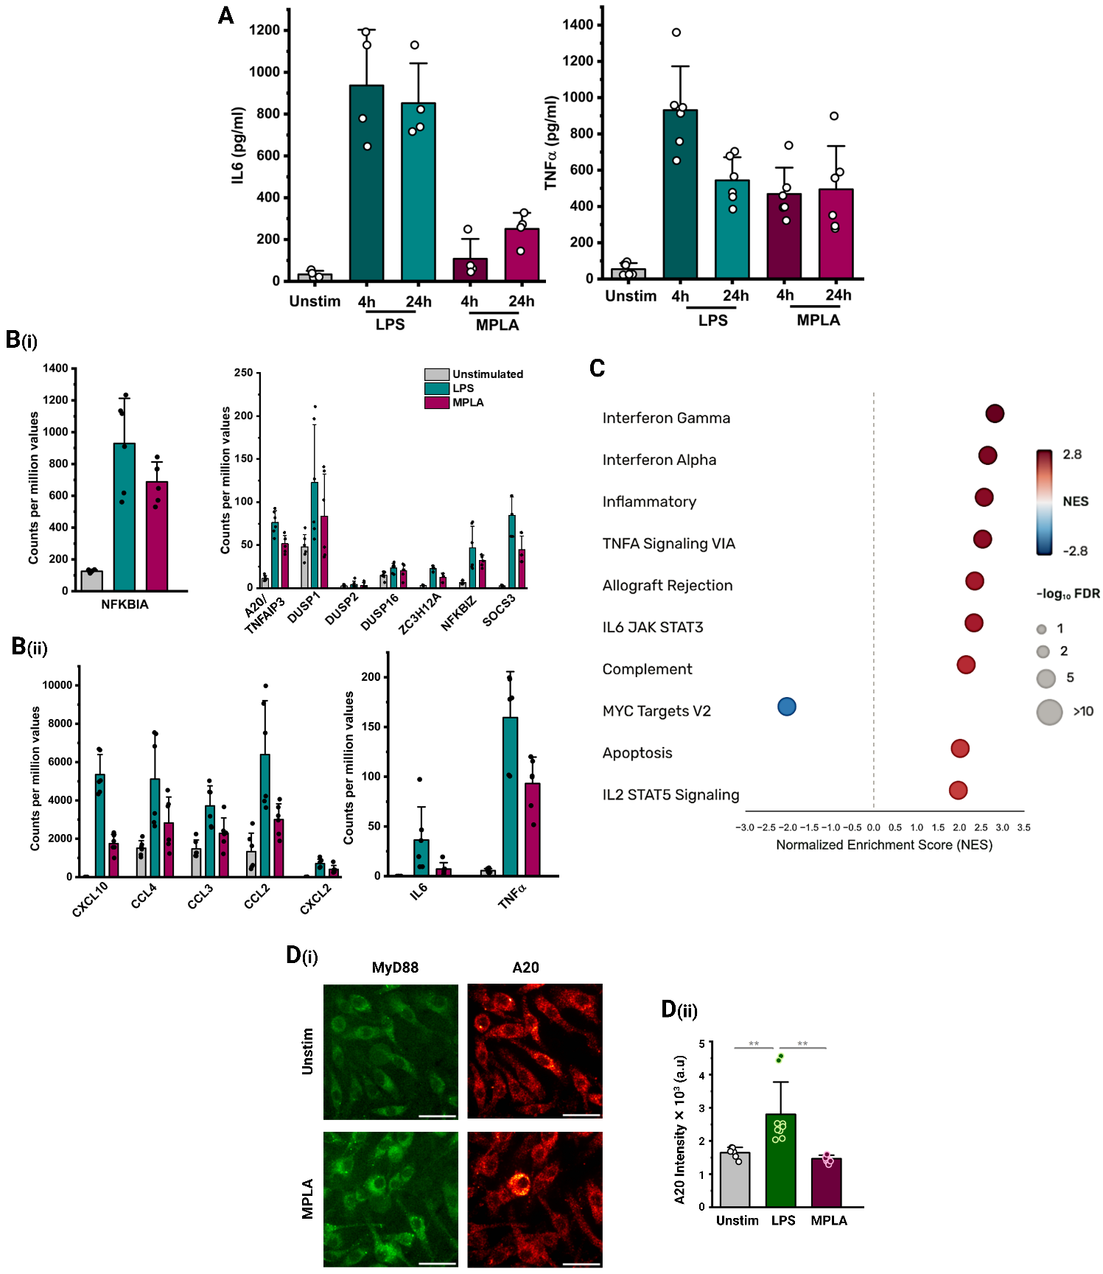
Figure SI 6

Figure SI 6. Ligand-dependent cytokine persistence and transcriptional activation of negative-regulatory genes.
A) Sandwich ELISA-based estimation of IL6 and TNFα concentrations in the supernatant of unstimulated cells and cells stimulated with LPS or MPLA for 4 h or 24 h. Data are shown as mean ± SD.
B) Scaled Bulk RNA-seq counts/per million (CPM) values for selected feedback regulators and inflammatory genes after stimulation with LPS or MPLA for 4 h, (i) CPM values for NFKBIA and selected negative-regulatory genes, including A20/TNFAIP3, DUSP family members, ZC3H12A, NFKBIZ, and SOCS3, (ii) CPM values for selected cytokine and chemokine genes, including CXCL10, CCL4, CCL5, CCL2, CXCL2, IL6, and TNFα. Data are shown as mean ± SD from 6 biological replicates.
C) Dot plot of gene set enrichment analysis comparing LPS, and MPLA-stimulated cells at 4 h. Dot colour indicates the normalized enrichment score (NES), and size indicates –log10 FDR.
D) A20 protein induction after ligand stimulation. (i) Representative immunofluorescence images of MyD88-mNG and A20 in unstimulated and MPLA-stimulated MyD88-mNG iBMDMs. MyD88-mNG is shown in green and A20 is shown in red. Scale bar 30 μm, (ii) Quantification of A20 immunofluorescence intensity in unstimulated, LPS-stimulated, and MPLA-stimulated cells. Data are shown as mean ± SD from biological replicates. Statistical comparisons are indicated in the figure. Significance was tested using unpaired Student’s t test, **p < 0.01.
Sample sizes and replicate information are as described for Figure 6, unless otherwise indicated.

Figure SI 7
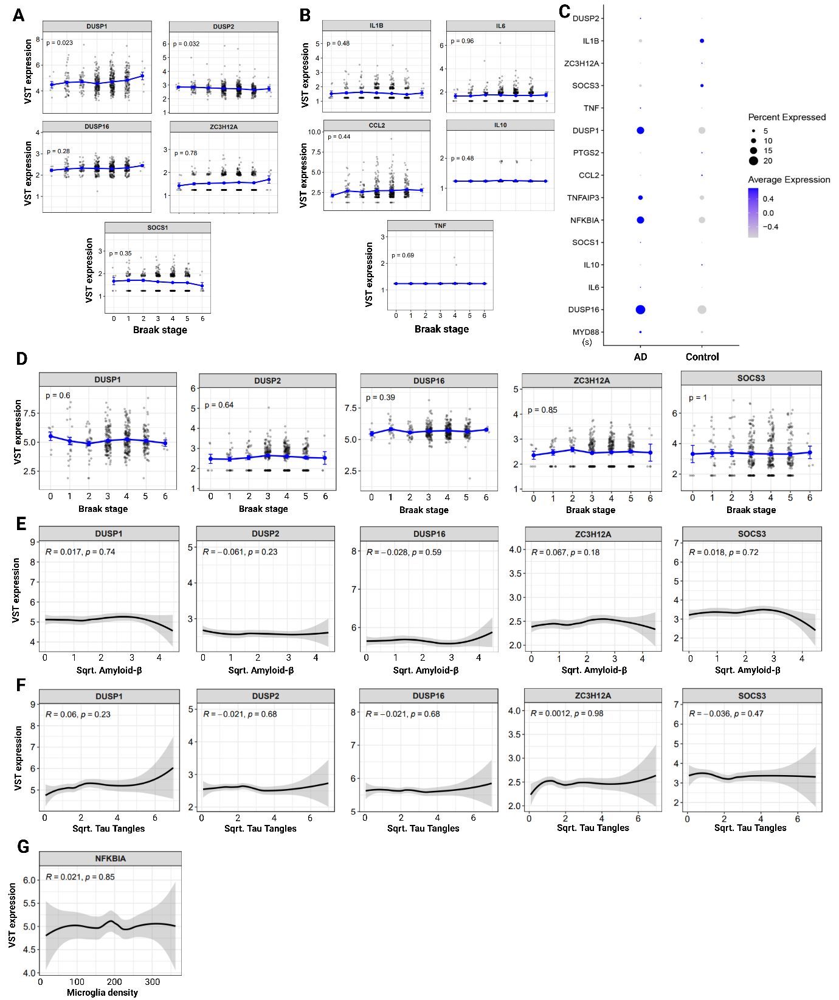

Figure SI 7. Additional transcriptomic analysis of inflammatory and feedback-regulatory genes from ROSMAP.
A) Bulk RNAseq analysis showing variance-stabilized expression of additional feedback-regulatory genes across Braak stages. Genes shown include DUSP1, DUSP2, DUSP16, ZC3H12A, and SOCS1. Differences in expression across Braak-stage groups were assessed by ANOVA, with p values indicated in each panel.
B) Bulk RNAseq analysis showing variance-stabilized expression of selected cytokine and chemokine transcripts across Braak stages. Genes shown include IL1B, IL6, CCL2, IL10, and TNF. Differences in expression across Braak-stage groups were assessed by ANOVA, with p-values indicated in each panel.
C) Dot plot showing microglial expression of inflammatory, cytokine/chemokine, and negative-regulatory transcripts (guided from in-vitro studies) in AD and control samples from snRNA-seq.
D) Microglia-specific single-nuclei RNAseq analysis showing variance-stabilized expression of additional feedback-regulatory genes across Braak stages. Genes shown include DUSP1, DUSP2, DUSP16, ZC3H12A, and SOCS3. Differences in expression across Braak-stage groups were assessed by ANOVA, with p-values indicated in each panel.
E, F) Microglial gene expression (single-nuclei) plotted against square-root-transformed amyloid-β burden, tau tangle burden respectively. Associations were assessed using Pearson’s correlation, with correlation coefficients and p-values indicated in each panel.
G) Microglial NFKBIA expression plotted against microglial density. Association was assessed using Pearson’s correlation, with the correlation coefficient and p value indicated.
Blue lines in B–D indicate group means across Braak stages, with error bars showing mean ± SEM. One-way ANOVA p-values were computed per gene across Braak stages using stat_compare_means from the ggpubr package. Continuous pathological burden variables (amyloid, tangles and mglia123_mf) were plotted against gene expression using LOESS smoothing curves with Pearson correlation coefficients computed via stat_cor.

Figure SI 8
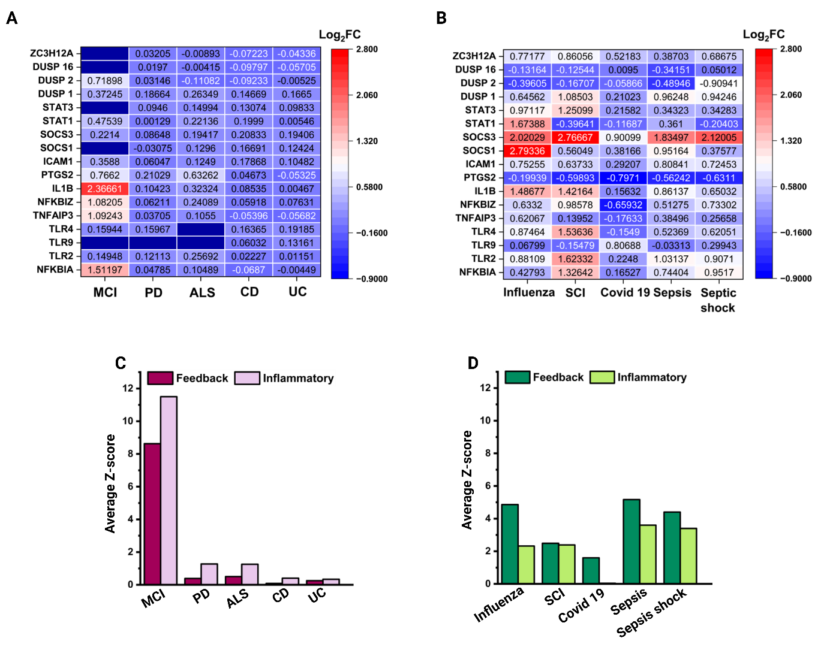

Figure SI 8. Disproportionate engagement of inflammatory and feedback-regulatory programmes in diseases associated with chronic inflammation.
A) Heat map plot of differential expression of selected genes in blood samples of patients with chronic inflammatory diseases over healthy controls.
B) Heat map plot of differential expression of selected genes in blood samples of patients with acute inflammatory diseases over healthy controls.
C) Scaled average Z-score comparison of the feedback and inflammatory modules in chronic inflammatory diseases.
D) Scaled average Z-score comparison of the feedback and inflammatory modules in acute inflammatory diseases.

