Grade 4-to-5 Joint Mathematics–Science Benchmark Transitions in Nine Systems: A Descriptive Common-Severity Analysis Using TIMSS 2023 Longitudinal Data
Table of contents
S1. Data files, systems, samples, and variable map 1
S1.1 Official source files and acquisition 1
S1.2 Variable map and terminal PV index 1
S2. Estimands and complete PV/JRR covariance derivation 1
S2.1 Joint states and transition estimands 1
S2.2 Matched four-dimensional plausible-value tuples 1
S2.3 JRR sampling covariance within a matched draw 1
S2.4 Primary common-severity standardization 1
S2.5 Full 168-parameter stacked standardization covariance 1
S3. Reproduction of official TIMSS-L statistics 1
S4. Full four-state transition matrices 1
S5. Six standardization specifications, decomposition, and overlap 1
S6. Alternative thresholds and crossing buffers 1
S7. Missing-data, IPW, and MNAR sensitivity analyses 1
S7.1 PV-completed, both-wave, and response-IPW targets 1
S7.2 Pattern-mixture shifts 1
S8. Descriptive Grade 8-to-9 extension 1
S9. Exploratory same-wave unequal-index classification-discordance diagnostic 1
S10. Computational reproducibility and artifact inventory 1
S10.1 Dependency-free execution order 1
S10.2 Anonymous software record 1
S10.3 Validation gates and publication inventory 1
References 1

This supplement accompanies the anonymous manuscript Grade 4-to-5 Joint Mathematics–Science Benchmark Transitions in Nine Systems: A Descriptive Common-Severity Analysis Using TIMSS 2023 Longitudinal Data. It documents the analytic files, joint estimands, matched four-dimensional plausible-value/jackknife repeated replication (PV/JRR) calculations, six standardization specifications, validation checks, robustness analyses, and a descriptive Grade 8-to-9 extension. Every displayed data-driven table is generated directly from the validated canonical objects that also produce outputs/tables/ and outputs/diagnostics/; complete-precision results remain in the cited machine-readable CSV files. BB denotes below both mathematics and science thresholds, MB mathematics below only, SB science below only, and AA at or above both thresholds. The focal estimand is the BB-to-AA transition to joint attainment, not a claim that students had attained previously.

S1. Data files, systems, samples, and variable map

S1.1 Official source files and acquisition
The reproducible acquisition script analysis/01_acquire_data.R downloads the official TIMSS 2023 Longitudinal Grade 4-to-5 and Grade 8-to-9 R archives, codebooks, official R programs, user guide, longitudinal technical-report addendum, TIMSS standard-error chapter, six official results workbooks, and two sampling/participation workbooks. Source URLs are declared in analysis/00_config.R. The acquisition step writes file size, acquisition status, and MD5 checksums to data/raw/download_manifest.csv. Raw archives and extracted public-use files are excluded from the distributable code package; users reacquire them from the official TIMSS site (Davier et al., 2025; Fishbein et al., 2025; Fishbein et al., 2026).
The reduced Grade 4-to-5 analytic file contains 44,325 students in nine systems: Georgia, Italy, Jordan, the Republic of Korea, Kosovo, Montenegro, North Macedonia, Slovenia, and Sweden. The separate Grade 8-to-9 file contains 16,764 students in Jordan, the Republic of Korea, and Sweden. Grade bands were never pooled.
Grade band | Systems | Students | System-specific school records | Weighted both-wave participation range
Grades 4–5 | 9 | 44,325 | 1,440 | 81.3%–91.6%
Grades 8–9 | 3 | 16,764 | 555 | 81.6%–86.7%
Note. Schools are counted within systems. Complete system-level counts, jackknife zones, participation patterns, and plausible-value completeness are in Table 1 and outputs/diagnostics/data_inventory.csv.
Participation at each wave was defined as at least one of the two relevant TIMSS process-participation flags being coded 1; the loader does not treat arbitrary positive values as participation. Fail-fast gates required every nonmissing source code to be in {1, 2}, where 1 denotes participation, and required the derived wave indicators to be binary. The linked files contained both-wave, baseline-only, and follow-up-only patterns but no students classified as participating in neither wave. Achievement files contained every longitudinal plausible-value cell used by the analyses, including for records whose process flags did not indicate both-wave participation. The primary analysis therefore uses the official PV-completed representation; Sections S7.1–S7.2 examine participation restrictions and departures from it.

S1.2 Variable map and terminal PV index
The loader requires one achievement record and one linked process record per country–student key. It retains the following fields.
Role | Grade 4–5 field or pattern | Grade 8–9 field or pattern
System, school, student identifiers | IDCNTRY, IDSCHOOL, IDSTUD | Same
Final student weight | TOTWGT | Same
JRR zone and member | JKZONE, JKREP | Same
Mathematics baseline PV, draw j | ASMMAT1j | BSMMAT1j
Mathematics follow-up PV, draw j | ASMMAT2j | BSMMAT2j
Science baseline PV, draw j | ASSSCI1j | BSSSCI1j
Science follow-up PV, draw j | ASSSCI2j | BSSSCI2j
Supplied mathematics change, draw j | ASMCHG0j | BSMCHG0j
Supplied science change, draw j | ASSCHG0j | BSSCHG0j
2023 process participation | ITPARTPT1_23, ITPARTPT2_23 | Same
2024 process participation | ITPARTPT1_24, ITPARTPT2_24 | Same
Here the terminal digit $j=1,…,5$ is the plausible-value index, as shown in User Guide Chapter 2, printed pp. 51–52 and Exhibit 2.5 (Fishbein et al., 2026). Continuous changes were calculated directly as follow-up minus baseline within matched draw; supplied change variables were retained for audit. Before any estimate was produced, the loader required finite TOTWGT, JKZONE, and JKREP, strictly positive TOTWGT, JKREP in {0, 1}, and both members represented within every system-specific jackknife zone. The complete mapping is outputs/diagnostics/variable_map.csv.

S2. Estimands and complete PV/JRR covariance derivation

S2.1 Joint states and transition estimands
For system $s$, PV draw $j$, wave $t$, and common threshold $c$, let $M_{itsj}$ and $S_{itsj}$ denote mathematics and science PVs. The four-state indicator is
$$Z_{itsj}=\left\{\begin{matrix}BB, & M_{itsj}<c, S_{itsj}<c, \\ MB, & M_{itsj}<c, S_{itsj}≥c, \\ SB, & M_{itsj}≥c, S_{itsj}<c, \\ AA, & M_{itsj}≥c, S_{itsj}≥c.\end{matrix}\right.$$
Define joint transition validity as
$$V_{isj}=I\{M_{i0sj},S_{i0sj},M_{i1sj},S_{i1sj} \text{are all finite}\}.$$
For origin $a$ and destination $b$, the draw-specific weighted transition implemented by transition_vector() is
θab,sj=i​wisVisjI(Zi0sj=a,Zi1sj=b)i​wisVisjI(Zi0sj=a).
The primary estimand uses $a=BB$, $b=AA$, and $c=475$. Each origin row has its own denominator restricted to records with jointly valid baseline and follow-up states; the implementation fails if that denominator is nonpositive and verifies that every row sums to one within ${10}^{-10}$. Additional estimands are baseline and follow-up state shares; $P(AA_{1}∣Z_{0}≠AA)$; BB persistence and exit; and mean changes among baseline-BB students in mathematics, science, and $min(M,S)$. These are population descriptions, not individual diagnoses or causal effects.

S2.2 Matched four-dimensional plausible-value tuples
The TIMSS 2023 Longitudinal Technical Report states that five achievement PVs were imputed simultaneously from country-specific four-dimensional models covering mathematics 2023, mathematics 2024, science 2023, and science 2024 (Section 6, printed p. 32 and pp. 36–37) (Fishbein et al., 2025). Together with the terminal-index evidence in the User Guide, this establishes Grade 4-to-5 draw $j$ as
$$(ASMMAT1j,ASMMAT2j,ASSSCI1j,ASSSCI2j),$$
and Grade 8-to-9 draw $j$ as the analogous B-prefix tuple
$$(BSMMAT1j,BSMMAT2j,BSSSCI1j,BSSSCI2j).$$
Except for the explicit same-wave diagnostic in Section S9, all inferential analyses used one of these five matched tuples. Unequal-index combinations were not treated as primary imputations, and PVs were not averaged into person-level scores before classification (Mislevy et al., 1992; Rutkowski et al., 2010; Wu, 2005).

S2.3 JRR sampling covariance within a matched draw
Input validation required finite design variables, positive final weights, JKREP in {0, 1}, and both replicate members in every system-zone. For each finite JKZONE, the code constructs two replicates. In the selected zone, the retained JKREP member receives factor 2 and the other member factor 0; observations outside that zone retain factor 1. If ${\hat{θ}}_{j}$ is a named full-weight vector and ${\hat{θ}}_{jr}$ its value in replicate $r$, the implemented covariance is
Uj=12r​(θjr-θj)(θjr-θj)⊤.
The divisor is 2, not the number of replicates. Deviations are from the full-sample estimate. Vector estimation retains off-diagonal covariance (Fishbein et al., 2024).
With $M=5$, pooled point, average sampling covariance, and sample between-PV covariance are
$$\overline{θ}=\frac{1}{M}\sum_{j=1}^{M}{{\hat{θ}}_{j}}, \overline{U}=\frac{1}{M}\sum_{j=1}^{M}{U_{j}},$$
$$B=\frac{1}{M-1}\sum_{j=1}^{M}{(}{\hat{θ}}_{j}-\overline{θ})({\hat{θ}}_{j}-\overline{θ})^{⊤}.$$
Total covariance is
$$T=\overline{U}+\left(1+\frac{1}{M}\right)B.$$
Standard errors are $\sqrt{diag(T)}$, and displayed 95% intervals are $\hat{θ}±1.96SE$ (Rubin, 1987).

S2.4 Primary common-severity standardization
Within each draw and system, the baseline-BB risk set defines scaled deficits
$$d_{M}=(475-M_{0})/100, d_{S}=(475-S_{0})/100.$$
The primary joint-attainment surface is
$$logit\{P(Y=1∣d_{M},d_{S},s)\}=β_{0s}+β_{1s}d_{M}+β_{2s}d_{S}+β_{3s}d_{M}^{2}+β_{4s}d_{S}^{2}+β_{5s}d_{M}d_{S},$$
where $Y=I(Z_{1}=AA)$. Positive survey weights are divided by their within-fit mean, a constant scaling that leaves weighted score equations unchanged. For numerical stability, prediction evaluates ${logit}^{-1}(η)$ after clamping $η=X\hat{β}$ to $[-30,30]$. Diagnostics retain the unclamped minimum and maximum and the pooled, own-system, and common-target counts and weighted shares for which clamping occurs.
For each system, weighted 1st and 99th percentiles are calculated separately for baseline mathematics and science in the BB set. Primary common support is the intersection of the nine marginal intervals. If $E_{isj}=1$ indicates that record $i$ lies in the rectangle, its equal-system reference weight is
qisj=19wisEisjh:sh=s​whsEhsj.
Each system contributes mass 1/9, regardless of represented population size. The standardized estimate for target system $s$ is
θsjstandardized common=i​qijlogit-1(Xijβsj).
Models use each target system’s complete BB risk set; integration uses the common target. The result is a modeled descriptive quantity under a synthetic one-system/one-vote severity distribution, not a world-student population or causal estimand. Its interpretation therefore requires an explicit target and adequate positivity/support (Keiding & Clayton, 2014; Lane & Nelder, 1982; Westreich & Cole, 2010).

S2.5 Full 168-parameter stacked standardization covariance
The implemented stack is not limited to the 18 primary raw/standardized quantities. Within each matched draw it contains:
- nine raw_full quantities shared across specifications;
- for each of the five specifications covering all nine systems, three quantities per system—raw_support, model_own_support, and standardized_common (5 × 9 × 3 = 135); and
- the same three quantities for eight systems under leave_korea_out (8 × 3 = 24).
The total is 9 + 135 + 24 = 168 parameters. The nine raw and nine primary standardized quantities form an exact 18-parameter subvector and covariance submatrix.
A perturbation in one system can alter common support or target weights used for multiple systems and specifications. For every system/zone/member perturbation, the implementation therefore:
- changes weights only for the selected system and zone;
- rebuilds affected 1st–99th percentile bounds and the common rectangle;
- rebuilds strict 4 × 4 cell boundaries, eligibility, and renormalized target when applicable;
- rebuilds equal-system or pooled represented-BB target weights;
- refits the perturbed system’s applicable response surfaces;
- recomputes every standardized quantity affected by the shared target; and
- adds one-half the outer product of the full 168-element replicate deviation.
Unperturbed system surfaces remain fixed when their weights do not change, but their standardized quantities are recomputed if the shared target changes. Zones with no BB records have exactly zero risk-set deviation. A replicate is never silently dropped: empty support, an invalid target, rank deficiency, nonconvergence, nonfinite values, or covariance failure stops canonical artifact replacement.
The five 168 × 168 draw-level covariance matrices are pooled as in S2.3. For any contrast vector $a$, $Var(a^{⊤}\hat{θ})=a^{⊤}Ta$. This supplies covariance-aware primary standardized-minus-raw contrasts and all 44 alternative-minus-primary contrasts. Cross-system pairwise standardized contrasts were retained as an unnumbered exploratory reproducibility diagnostic but excluded from the publication tables because multiplicity adjustment does not remove the risk of rank-oriented interpretation.

S3. Reproduction of official TIMSS-L statistics
The extraction/weighting audit used 24 official source rows spanning Grade 4-to-5 and Grade 8-to-9 means, growth, and available benchmark percentages. Those rows contain 108 scalar point estimates and 102 numeric standard errors; six additional benchmark standard errors are printed as ~ by TIMSS and were recorded as suppressed rather than numeric. All point and numeric-SE checks passed against published rounded values.
Validation | Value | Status
Official point estimates reproduced within rounding tolerance | 108 of 108 | PASS
Official numeric SEs reproduced and suppressed benchmark SEs handled | 102 of 102; 6 suppressed handled | PASS
Maximum absolute official mean/growth point discrepancy | 0.4945 TIMSS points | PASS
Maximum absolute official benchmark point discrepancy | 0.4924 percentage points | PASS
Maximum absolute official mean/growth SE discrepancy | 0.0479 TIMSS points | PASS
Maximum absolute official benchmark SE discrepancy | 0.0484 percentage points | PASS
Missing longitudinal plausible-value cells | 0 | PASS
Sensitivity validation checks passed | 13 of 13 | PASS
Standardization producer validation checks passed | 11 of 11 | PASS
Completed fail-fast standardization replicate stages | 7660 of 7660; attempted=7660 | PASS
Combined covariance minimum eigenvalue / tolerance | -4.275395e-18 vs -1e-8 | PASS
Maximum combined covariance-diagonal SE discrepancy | 0e+00 | PASS
Primary estimate and SE identity with transition pipeline | estimate=0e+00; SE=0e+00 | PASS
Publication-output gates | 17 of 17 | PASS
The source-row comparisons are in outputs/diagnostics/official_result_validation.csv and outputs/diagnostics/official_result_validation_long.csv. The compact audit is outputs/diagnostics/audit_summary.txt; the publication validation-summary file is outputs/tables/table_s16_validation_summary.csv and is catalogued in Section S10. Reproducing official marginals validates extraction and weights but not the new joint quantities.

S4. Full four-state transition matrices
Table S1, outputs/tables/table_s1_full_transition_matrices.csv, contains 12 system-by-grade-band matrices × 16 origin–destination cells (192 rows). Table S2, table_s2_state_distributions.csv, reports 96 baseline/follow-up state shares. Table S3, table_s3_continuous_changes.csv, reports 36 mathematics, science, and weakest-domain changes among baseline-BB students.
Figure S1. Complete Grade 4-to-5 transition matrices at 475 among below-both (BB), mathematics-below-only (MB), science-below-only (SB), and at/above-both (AA) states. Cells are matched-PV/JRR percentages; each baseline-state row sums to 100% apart from rounding, columns are follow-up states, and darker shading denotes a larger percentage.
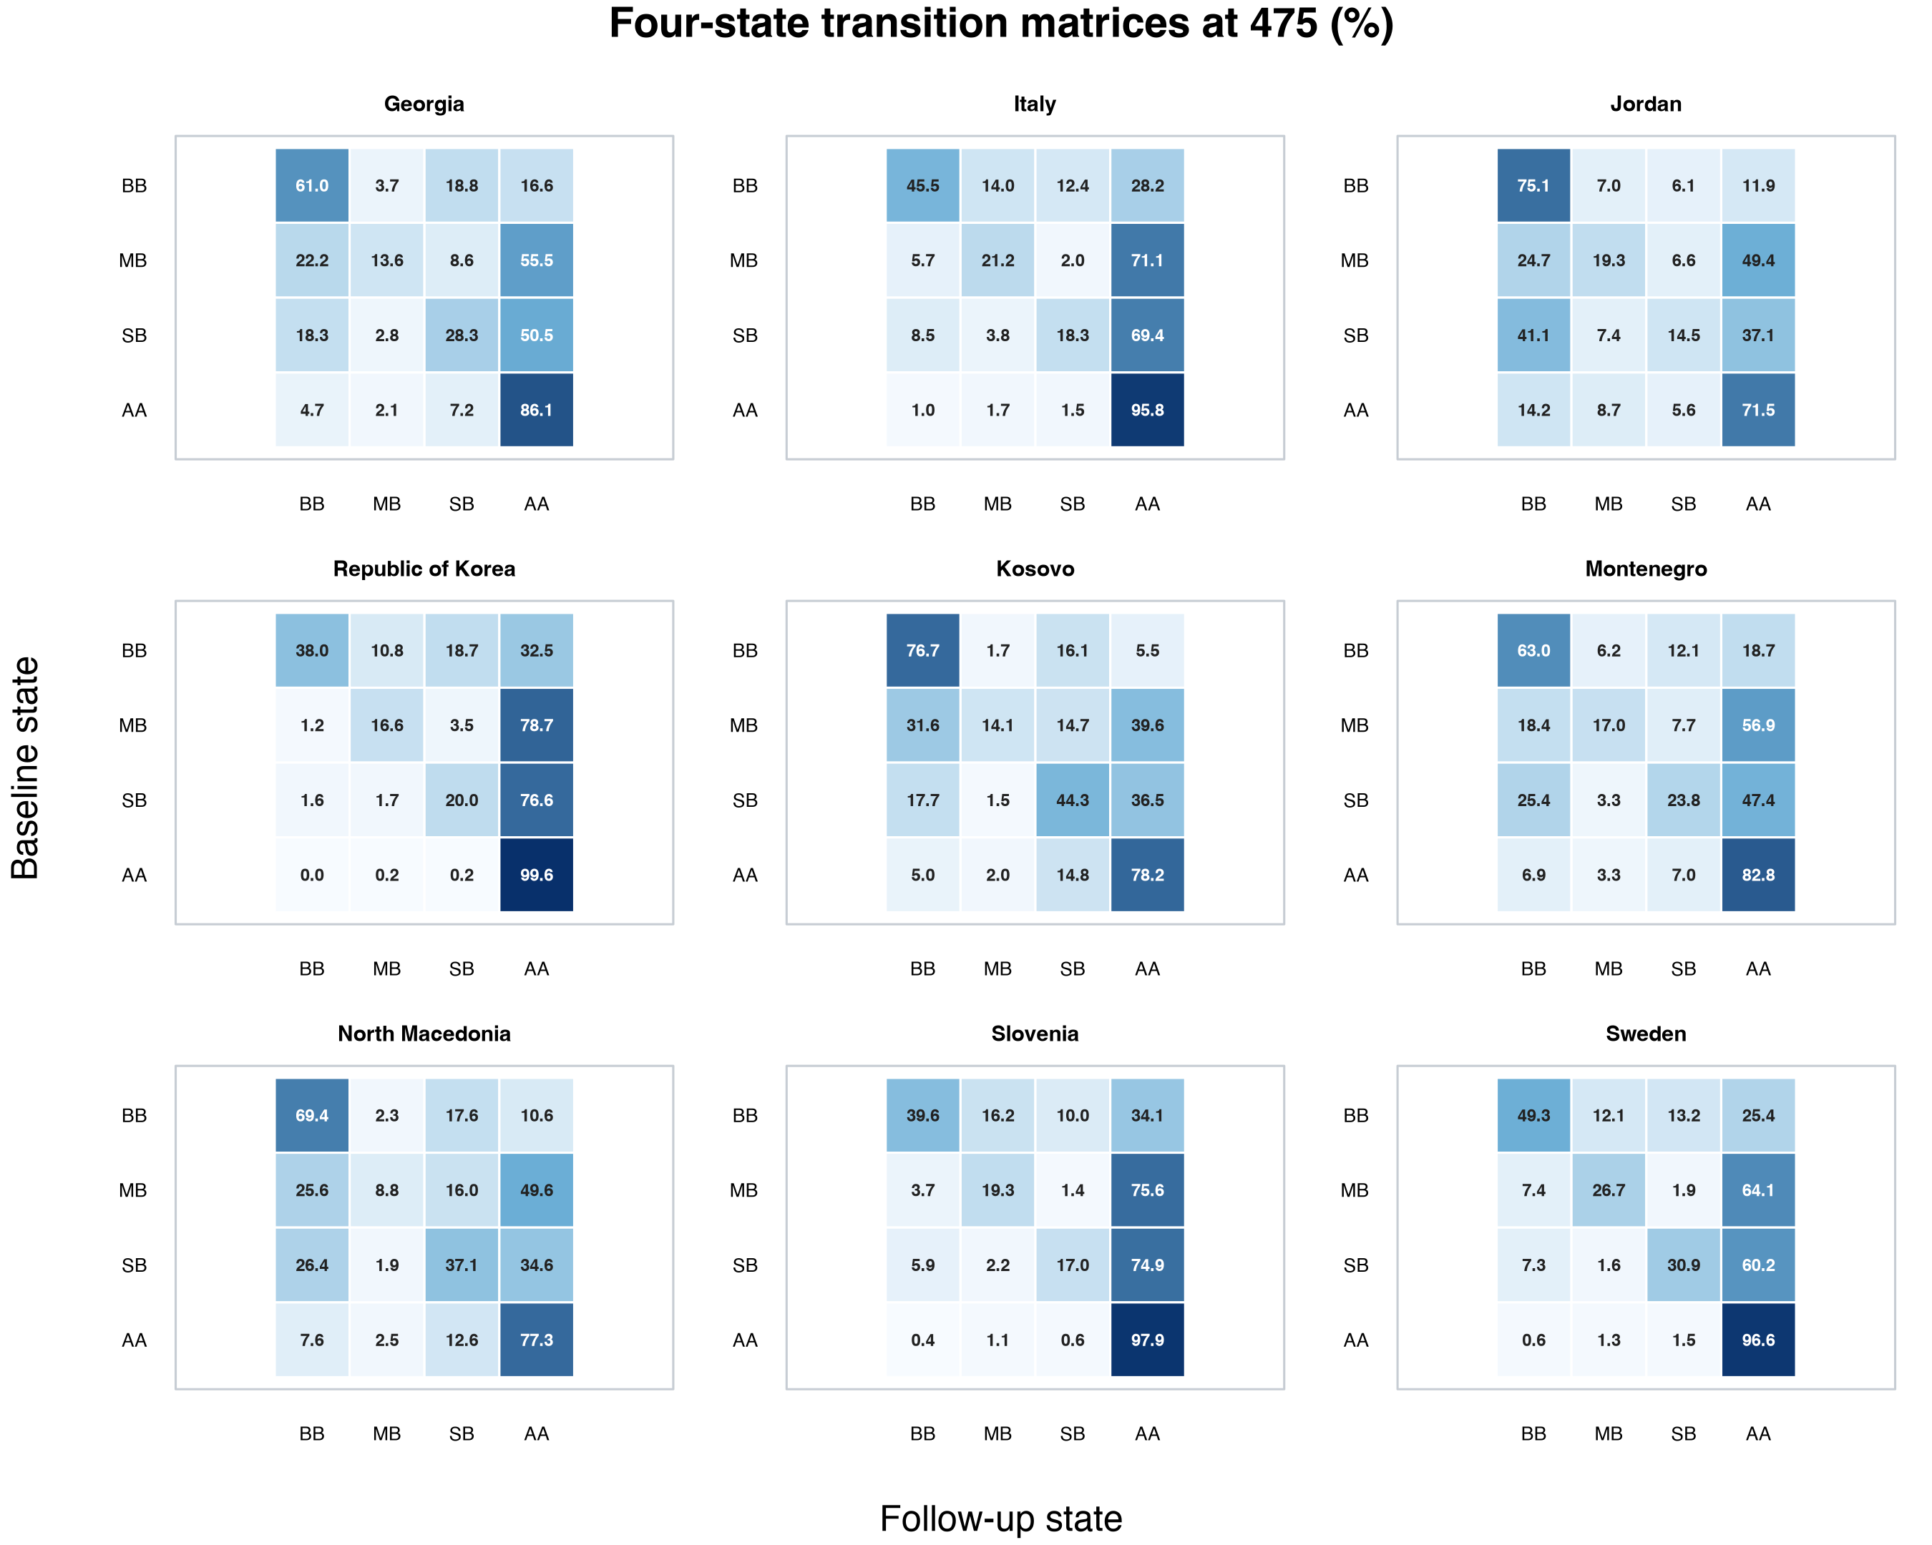
Each matrix row is conditional on its baseline state and sums to 100% apart from floating-point rounding. Point estimates remain in [0%, 100%]. Because intervals use an untransformed normal approximation, a limit for a sparse nonprimary cell can extend slightly outside that range; limits were not silently truncated. The focal BB-to-AA transition is only one cell: complete matrices distinguish BB persistence, one-domain movement, joint attainment, and movement out of AA.
Across Grade 4-to-5 systems, mean weakest-domain change among baseline-BB students was 18.7–50.0 TIMSS points, while BB-to-AA probabilities were 5.5%–34.1%. Continuous and categorical quantities answer different questions.

S5. Six standardization specifications, decomposition, and overlap
The primary specification uses all nine systems, equal system mass, the intersection of weighted 1st–99th percentile rectangles, and quadratic-interaction surfaces. Five one-factor sensitivity alternatives were internally frozen before their own estimates were examined, after the primary estimate had been obtained; this internal freeze was not an external preregistration:
- pooled represented-BB target using original retained student weights;
- eight-system target leaving the Republic of Korea out, with no Korea estimate;
- 4 × 4 strict common cells requiring unweighted $n≥5$ and Kish ESS $≥3$ in every system;
- additive linear surfaces; and
- linear-interaction surfaces without squared terms.
Table S4, table_s4_standardization_specification_decomposition.csv, reports all 53 applicable specification-system rows. For each it retains raw_full, raw_support, model_own_support, and standardized_common, with the exact identity
$$\begin{aligned}&standardized_common-raw_full \\ =​&(raw_support-raw_full) \\ &+(model_own_support-raw_support) \\ &+(standardized_common-model_own_support).\end{aligned}$$
The terms are labeled support restriction, in-support model calibration, and modeled target distribution. They are specification-dependent descriptive/model-based components, not causal effects or a pure composition decomposition.
Table S5, table_s5_standardization_alternative_contrasts.csv, reports 44 covariance-aware alternative-minus-primary contrasts. Point differences ranged from −1.0 to +3.7 percentage points, and none of the individual 95% intervals excluded zero. This does not establish equivalence: standard errors reached 7.9 points, and the widest strict-cell interval was −12.3 to +18.6 points. The strict-common-cell alternative retained 10–11 of 16 cells and 75.83%–85.89% of target mass before renormalization, but replicate-wise support rebuilding produced wide intervals. It is an instability sensitivity, not a preferred replacement.
Primary overlap diagnostics assess weighted risk-set retention, Kish ESS, reference mass within each target’s empirical convex hull, and reference mass in occupied cells of a 5 × 5 common-support grid.
System | Mean retained weight, % | Minimum retained weight, % | Minimum support ESS | Mean reference mass inside hull, % | Mean reference mass in cells with at least 5 cases, %
Georgia | 86.5 | 84.3 | 896.5 | 97.8 | 99.0
Italy | 83.8 | 81.8 | 642.0 | 96.9 | 98.3
Jordan | 68.0 | 64.1 | 1,285.9 | 99.2 | 100.0
Republic of Korea | 79.9 | 76.4 | 88.3 | 92.7 | 58.0
Kosovo | 82.1 | 78.4 | 1,419.5 | 97.6 | 98.5
Montenegro | 84.9 | 82.8 | 1,451.5 | 98.3 | 99.7
North Macedonia | 81.5 | 78.9 | 1,327.6 | 98.6 | 99.5
Slovenia | 85.1 | 81.7 | 642.5 | 97.5 | 98.5
Sweden | 84.3 | 80.3 | 418.5 | 97.5 | 99.3
Figure S2. Primary common-support diagnostics across five plausible-value draws. The four panels show retained baseline-BB weight, Kish effective sample size (ESS), equal-system reference mass inside each target system’s empirical convex hull, and reference mass in 5 × 5 cells containing at least five target-system cases; boxplots summarize the five draws.
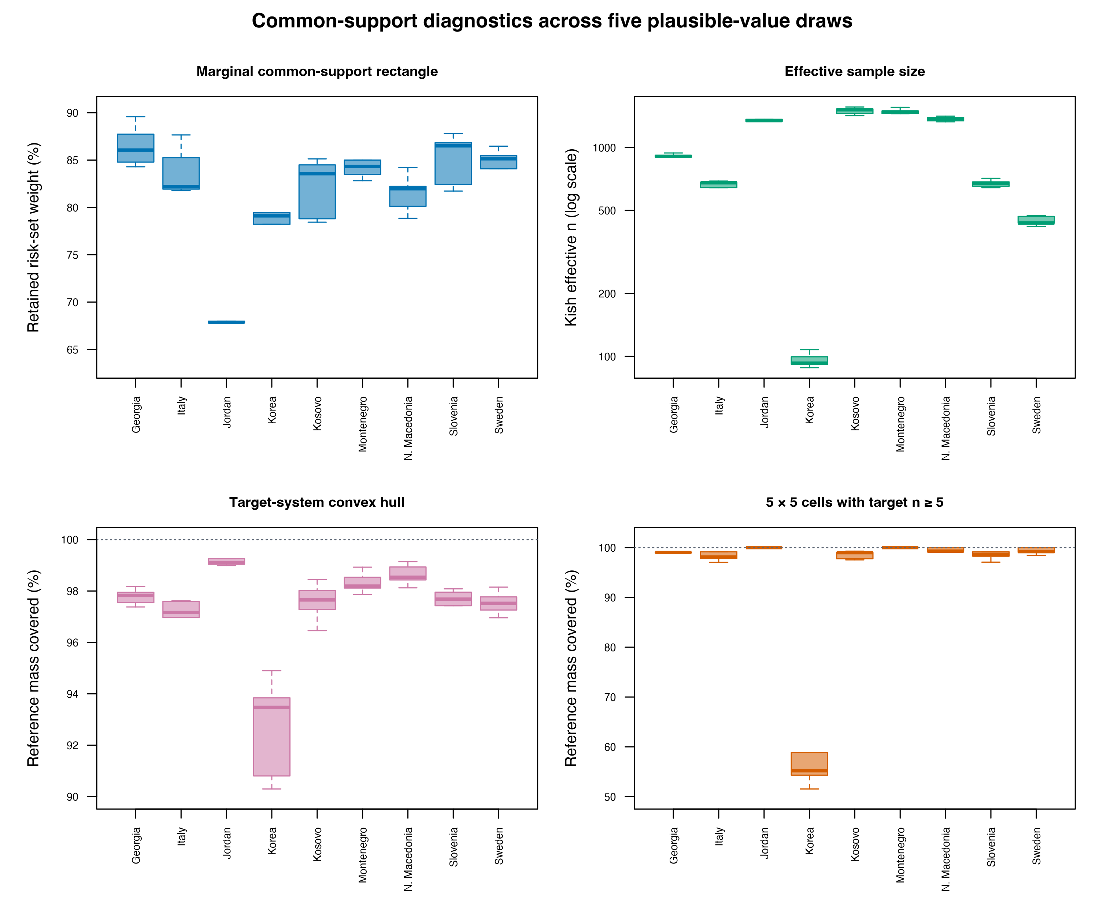
Figure S3. Five internally frozen one-factor common-severity standardization alternatives minus the primary estimate. Points are system-specific percentage-point contrasts, bars are covariance-aware 95% confidence intervals, the dashed vertical line marks no difference, and the Republic of Korea is absent only from the leave-Korea-out target.
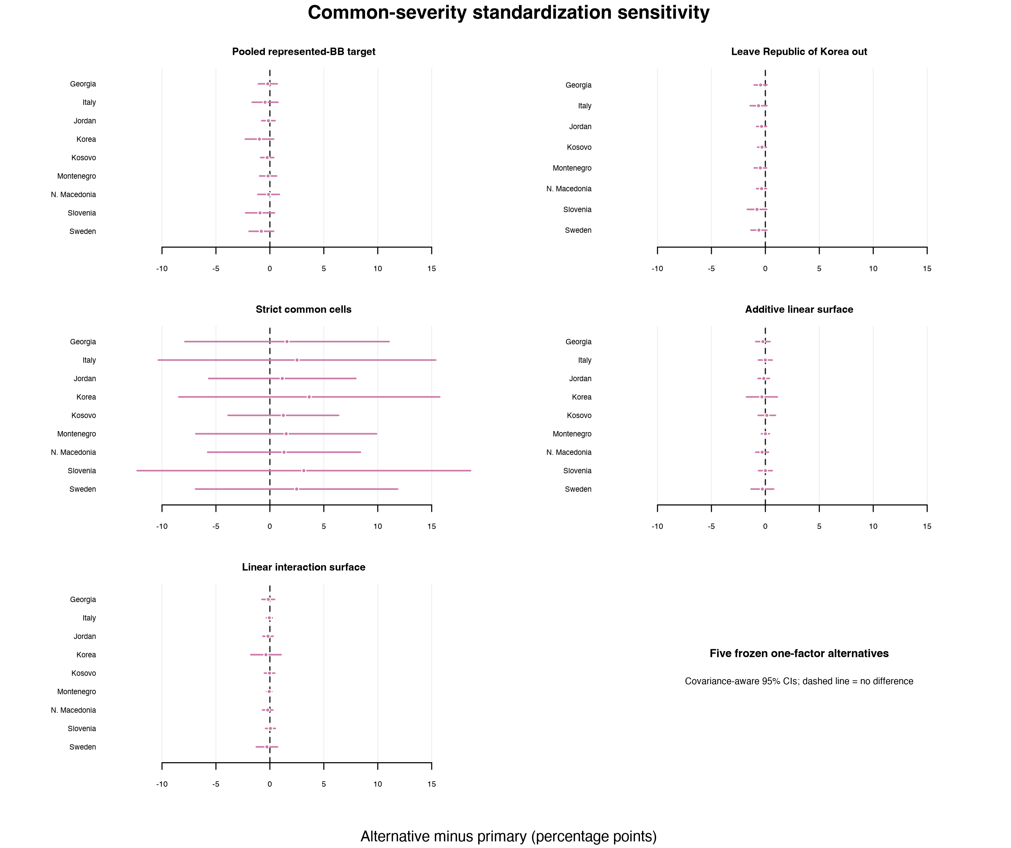
Korea is the weakest-overlap case: mean baseline-BB $n$ was 162.8, minimum support ESS 88.35, mean hull coverage 92.7%, and five-case-cell coverage 58.0%. Its raw estimate was 32.5% (95% CI 19.9%–45.1%) and standardized estimate 22.7% (12.9%–32.4%). These quantities require joint qualification and do not support ranking. Table S6, table_s6_standardization_overlap_by_draw.csv, contains draw-level primary diagnostics; Table S7, table_s7_standardization_overlap_summary.csv, contains the nine-system summary.
The unnumbered reproducibility-only standardized-pairwise-contrast CSV retains 36 covariance-aware pairwise standardized contrasts and Holm-adjusted p values for auditability. Its exact basename and SHA-256 digest are recorded in Additional file 3’s source manifest. The file is deliberately absent from Additional file 2, the numbered supplement, and the table inventory; it must not be used as a league table.

S6. Alternative thresholds and crossing buffers
The common-threshold grid was 390, 400, 410, 465, 475, and 485. For each threshold, PV/JRR estimation was repeated for BB-to-AA, BB persistence, BB exit, baseline BB share, mathematics change, science change, and weakest-domain change in both grade bands. Table S8 is the 504-row outputs/tables/table_s8_threshold_sensitivity.csv. Main Figure 3 displays Grade 4-to-5 BB-to-AA results and is referenced here rather than embedded again.
At 400, Grade 4-to-5 conditional BB-to-AA estimates were 14.0%–47.0%; at 475 they were 5.5%–34.1%. Korea’s mean baseline-BB count was approximately 26 at 400 and its standard error was 19.5 percentage points. Separately, differences between the published rounded official 400 at/above shares were 0–5 percentage points in mathematics and 1–9 in science. These differences are formed from rounded, whole-cohort, domain-specific marginals; the conditional joint transition uses the baseline-below-both denominator and requires follow-up attainment in both domains.
The 450-to-500 buffer produced Grade 4-to-5 estimates of 0.8%–8.0%. A lower buffer required baseline scores below 380 and follow-up scores at/above 420. Each buffer defines a new risk set and event, not an adjusted primary estimate. Table S9, table_s9_hysteresis_sensitivity.csv, contains full results. Korea’s lower-buffer risk set averaged only 15.8 students and is not suitable for stable comparison.

S7. Missing-data, IPW, and MNAR sensitivity analyses

S7.1 PV-completed, both-wave, and response-IPW targets
Three analyses have distinct targets:
- PV-completed primary: all sampled longitudinal records represented in public achievement files;
- both-wave observed: students indicated as participating at both waves; and
- response-IPW: baseline participants reweighted for observed follow-up response.
For response-IPW, each system and PV draw uses a weighted quadratic-logit model for follow-up participation with centered baseline mathematics, science, squares, and interaction. If $R_{i}$ indicates follow-up participation and ${\hat{π}}_{i}$ is fitted probability, respondents receive
$$w_{i}^{*}=w_{i}\frac{{\hat{P}}_{w}(R=1)}{max(.05,{\hat{π}}_{i})},$$
and nonrespondents receive zero analysis weight (Robins et al., 1994; Seaman & White, 2013). Models, stabilization, probabilities, weights, and the PV-completed/both-wave/IPW estimate stack are rebuilt within every JRR replicate. This joint stack supplies covariance-aware method-minus-primary standard errors and intervals in Table S10, the 252-row table_s10_observed_ipw_sensitivity.csv.
The diagnostic file outputs/diagnostics/response_ipw_diagnostics.csv reports, by system and PV draw, sample counts, weighted response rate, propensity minimum and weighted 1st/5th/50th/95th/99th percentiles and maximum, the fraction at the .05 floor, stabilized IPW-multiplier minimum and corresponding percentiles and maximum, original and reweighted ESS and their ratio, and maximum absolute standardized mean differences across the five non-intercept response-model terms before and after weighting. These checks assess practical positivity and observed-covariate balance; neither model convergence nor finite weights identifies response on unobserved outcomes (Westreich & Cole, 2010). All fitted models converged and no observed probability reached .05.
For Grade 4-to-5 BB-to-AA, response-IPW estimates differed from the primary by less than 1 percentage point in eight systems; Sweden differed by −1.29 points. These comparisons cannot address unobserved selection.

S7.2 Pattern-mixture shifts
Three score-shift scenarios were applied to the PV-completed representation:
- subtract $δ∈\{0,10,20,40\}$ from both follow-up-domain PVs for baseline-only records;
- subtract $δ$ from both baseline-domain PVs for follow-up-only records; and
- apply both changes under a combined scenario.
Every state, risk set, estimate, JRR covariance, and PV pool was recomputed. Delta zero exactly reproduced primary estimates and standard errors. Under the combined −40 scenario, Grade 4-to-5 BB-to-AA estimates were 5.3%–32.9%; the largest reduction was 2.2 percentage points in Sweden. No system reached half its delta-zero estimate or crossed its delta-zero lower 95% bound within the planned range.
Figure S4. Pattern-mixture sensitivity for baseline-only students. Both follow-up-domain plausible values are shifted by 0, −10, −20, or −40 TIMSS points before all states and estimates are recomputed; negative shifts are imposed missing-not-at-random scenarios, not estimated corrections. Vertical bars are 95% confidence intervals.
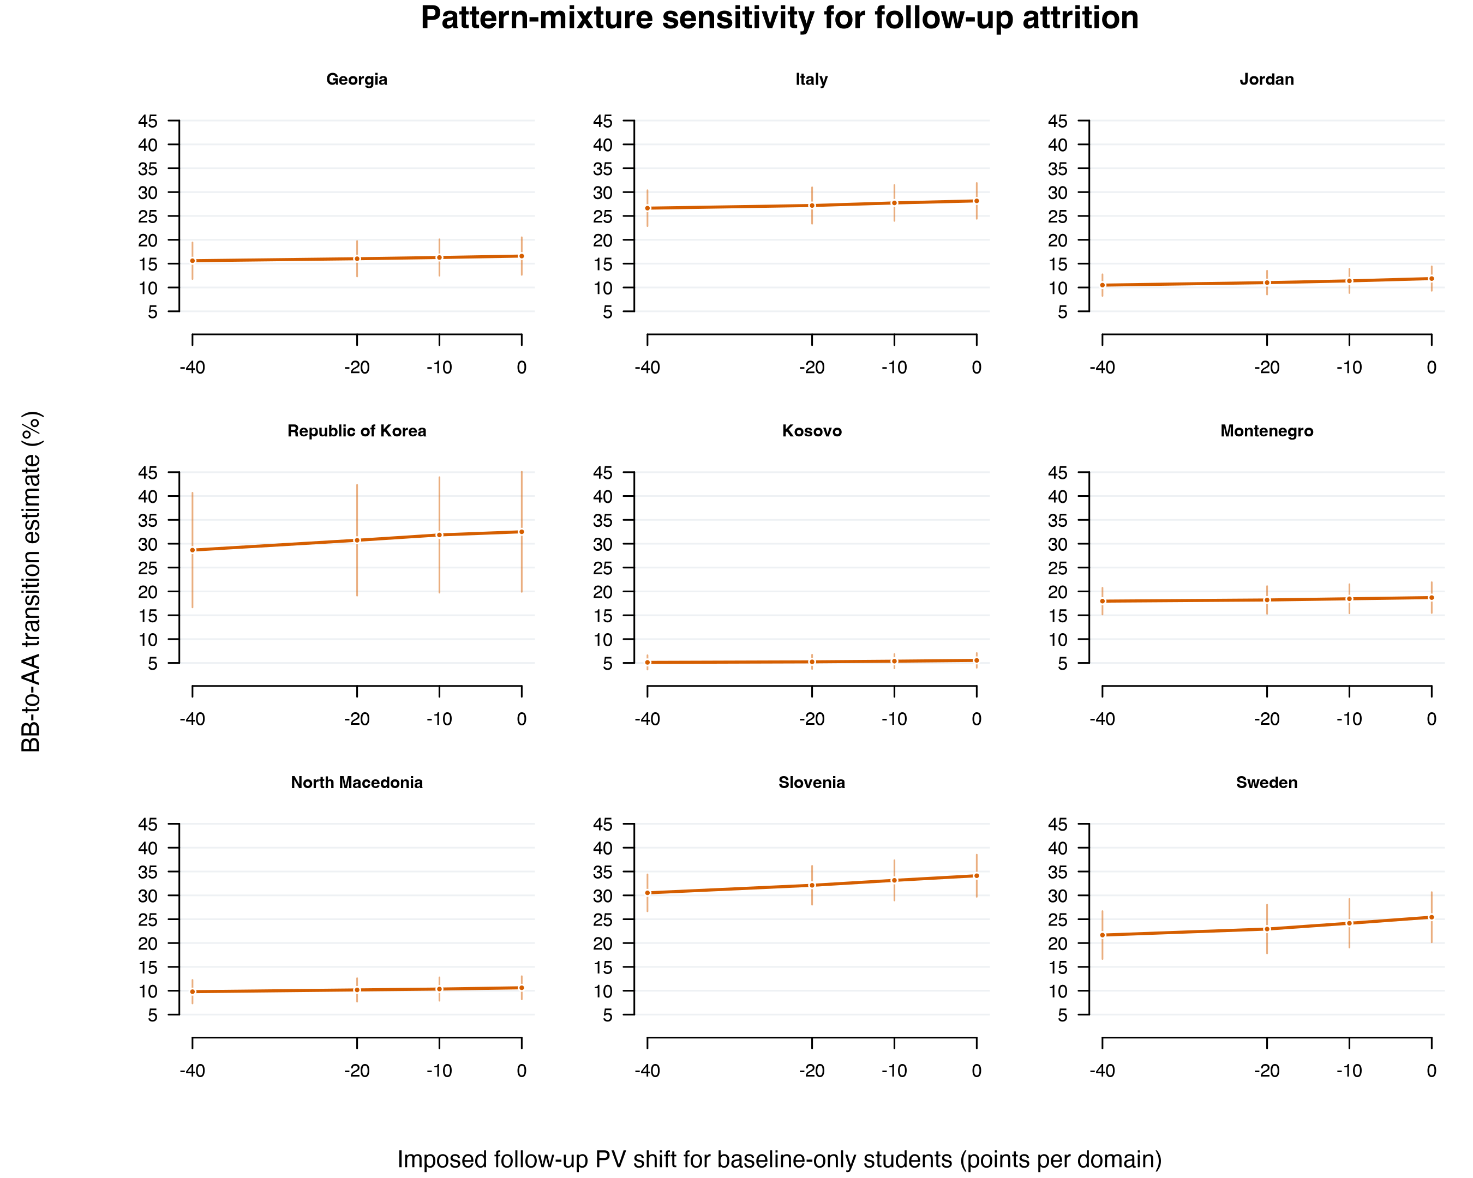
Table S11 is the 1,008-row table_s11_mnar_pattern_mixture.csv; Table S12 is the 36-row table_s12_mnar_tipping_diagnostics.csv. These are bounded imposed-shift diagnostics, not identified corrections or causal tipping points (Daniels & Hogan, 2008; Little & Rubin, 2019).

S8. Descriptive Grade 8-to-9 extension
Grade 8-to-9 analyses were run separately in three systems, were never pooled with Grades 4-to-5, and are not an independent replication of the nine-system Grade 4-to-5 estimand.
System | BB-to-AA, % | SE, pp | 95% CI, %
Jordan | 5.4 | 0.8 | 3.8–7.0
Republic of Korea | 6.8 | 1.9 | 3.0–10.6
Sweden | 8.1 | 1.1 | 5.9–10.3
Figure S5. Separate descriptive Grade 8-to-9 BB-to-AA extension at the 475-point threshold. Points combine five matched plausible-value draws and bars are JRR 95% confidence intervals. The three-system result is not an independent replication of the Grade 4-to-5 analysis, and Jordan science retains its documented cross-wave organization caution.
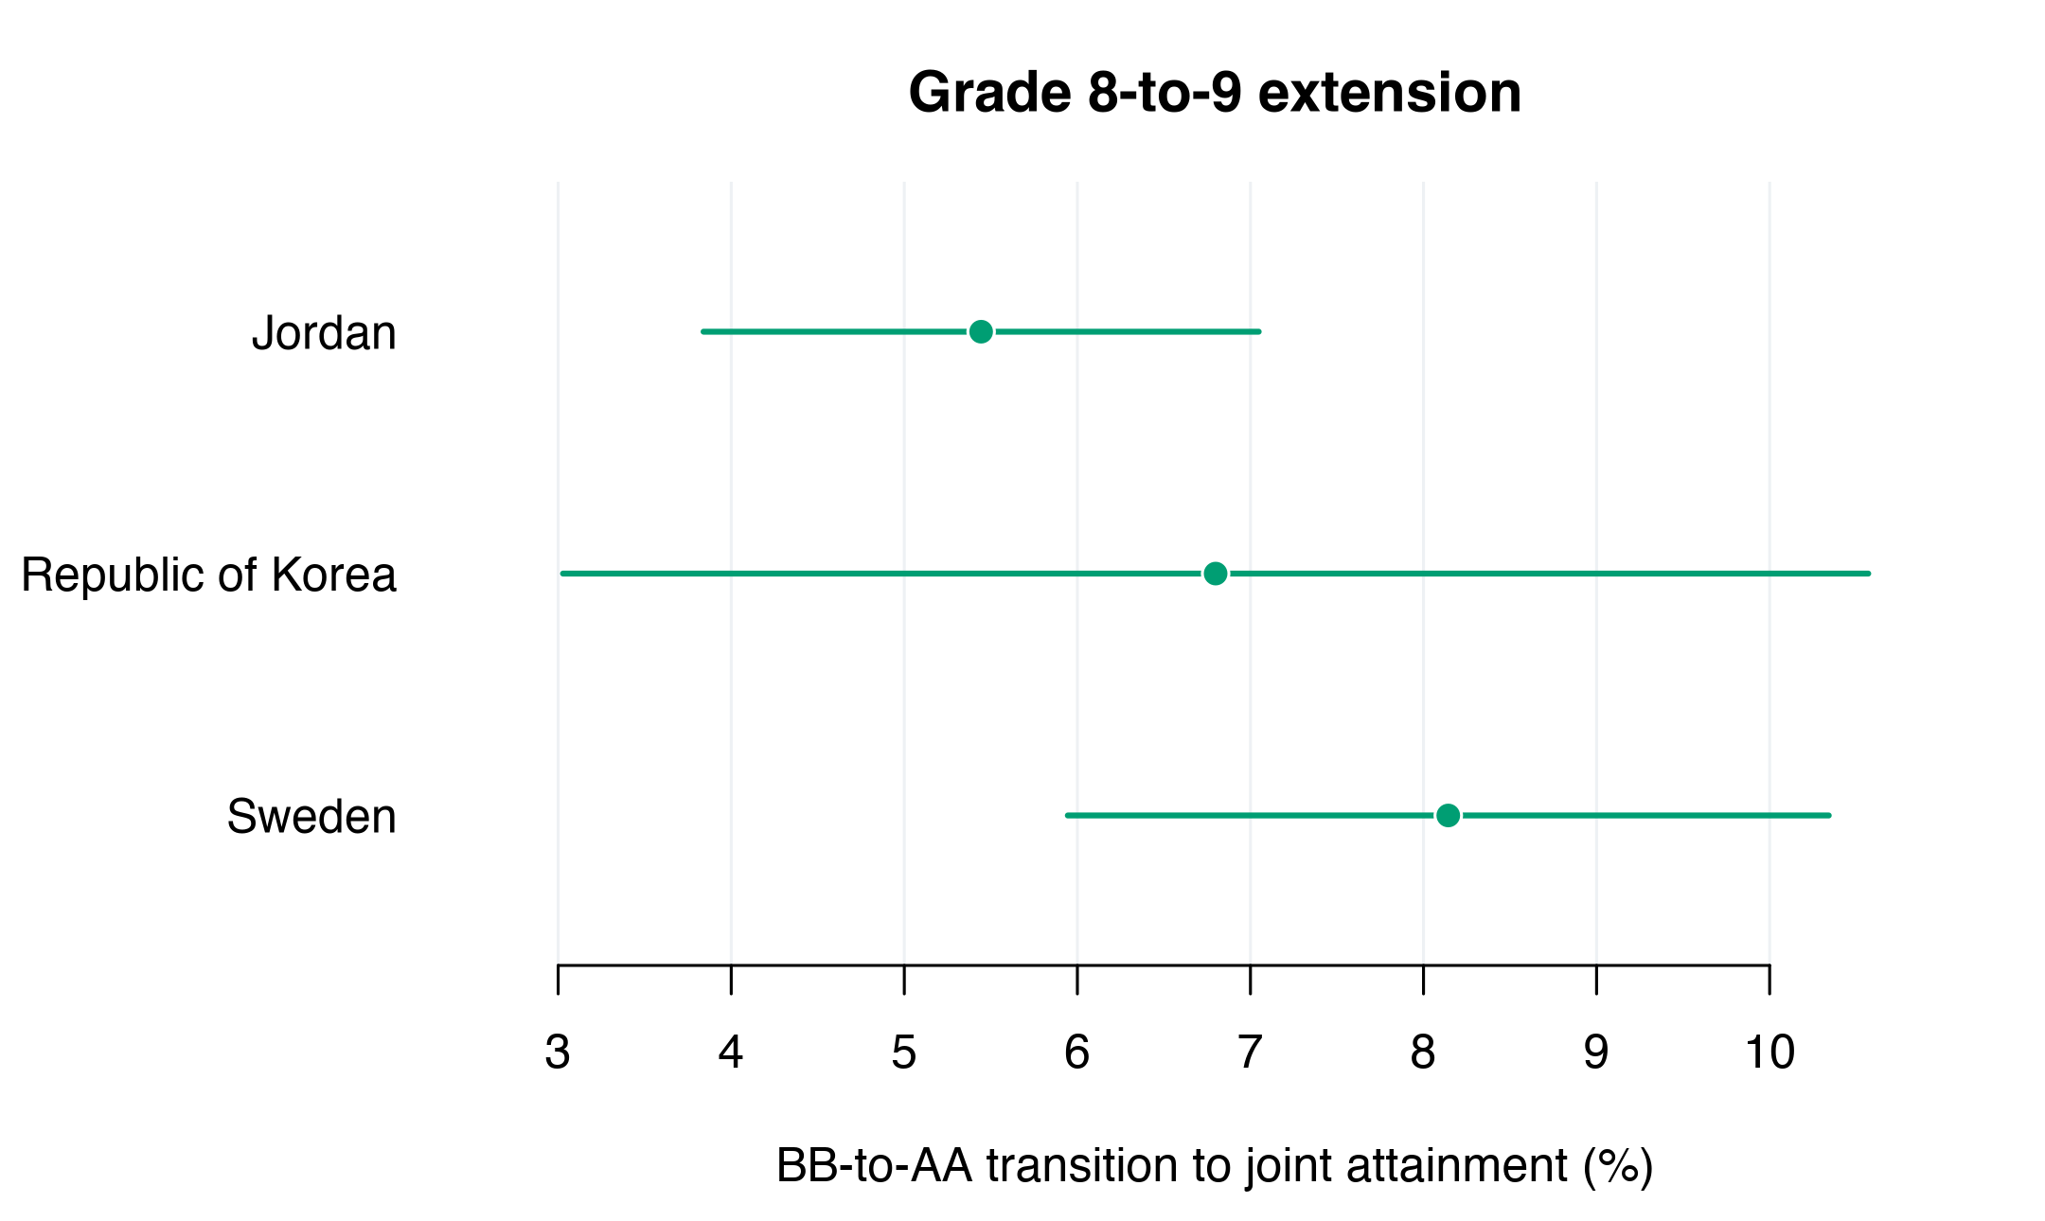
Table S13 is table_s13_grade89_joint_transitions.csv (48 matrix cells). Domain-specific below-to-at/above estimates were 12.2%, 30.8%, and 25.4% for mathematics and 13.8%, 22.1%, and 18.6% for science in Jordan, Korea, and Sweden. Table S14, table_s14_grade89_domain_extension.csv, includes baseline-below shares, persistence, score changes, standard errors, intervals, and cautions. Jordan science is interpreted separately because TIMSS documents changed assessment/instructional organization (Davier et al., 2025).

S9. Exploratory same-wave unequal-index classification-discordance diagnostic
For wave $t$, all ordered unequal PV-index pairs were used:
Dts=120j=15k≠j​Pw(Zt,k=AA∣Zt,j=BB).
Both domains use draw $j$ to define BB and draw $k$ to define AA. The 20 dependent values are averaged arithmetically. This is the sole exception to matched-tuple pooling. Its standard error and interval contain JRR sampling variance for the 20-pair mean only, conditional on the five released PVs; pair standard deviation, minimum, and maximum are separate descriptive quantities and are not a Rubin between-PV component.
Figure S6. Actual matched-PV longitudinal BB-to-AA transitions versus baseline and follow-up exploratory same-wave unequal-index classification-discordance means. Same-wave quantities diagnose classification discordance; they are neither longitudinal estimates nor subtractive corrections. Bars for the diagnostic represent JRR sampling-only 95% intervals conditional on the five released PVs.
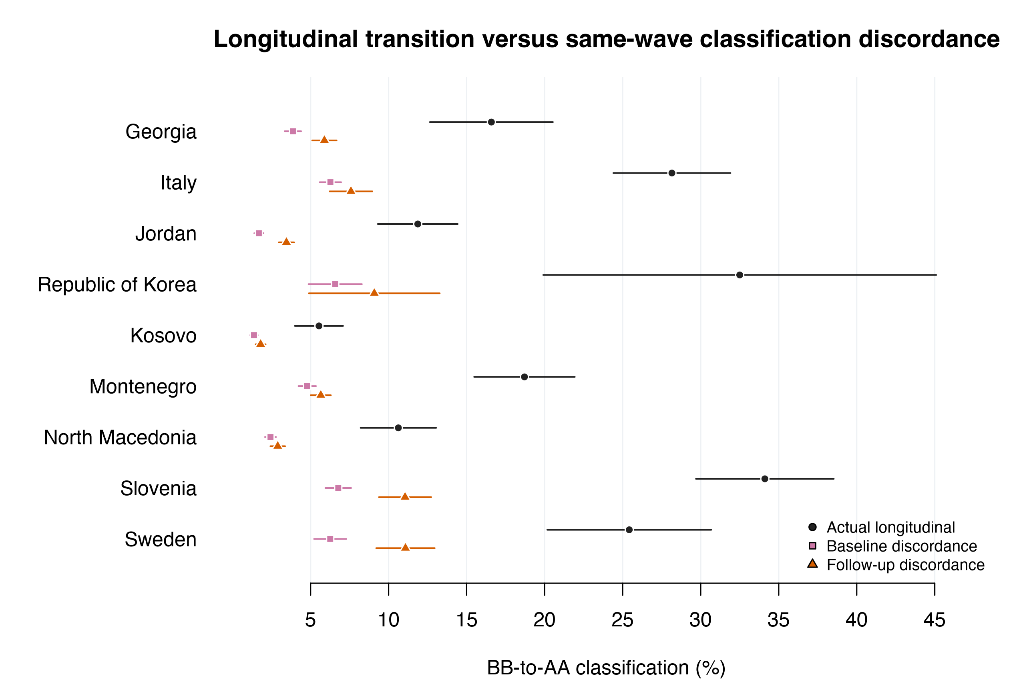
In Grades 4-to-5, baseline same-wave discordance was 1.4%–6.8% and follow-up discordance 1.8%–11.1%. Follow-up values were approximately 27%–44% of corresponding longitudinal transitions, which exceeded the diagnostic in every system. Plausible values are posterior population draws rather than repeat forms, so neither pair dispersion nor the same-wave mean is a classical measurement-error estimate. Subtraction would be unjustified (Barnett et al., 2005). Table S15 is table_s15_measurement_crossing_diagnostic.csv.

S10. Computational reproducibility and artifact inventory

S10.1 Dependency-free execution order
From the project root, the complete analysis pipeline is:
Rscript analysis/01_acquire_data.R
Rscript analysis/02_audit_data.R
Rscript analysis/03_primary_transitions.R
Rscript analysis/04_standardization.R
Rscript analysis/05_sensitivity.R
Rscript analysis/06_outputs.R
Equivalently, Rscript analysis/run_all.R executes those scripts. Acquisition requires internet access; subsequent steps use local official files. The analysis uses base R only, and analysis/xlsx_extract.py uses the Python standard library. The exact executable prerequisites and version-check commands are pinned in BUILD_RECIPE.txt. The validated toolchain is R 4.6.1, Python 3.14.3, Quarto 1.10.18, Pandoc 3.10 bundled with Quarto, and Tectonic 0.17.0; R must report capabilities("cairo") as TRUE. The complete document and replacement-package sequence is:
quarto render manuscript/manuscript.qmd --to docx
quarto render manuscript/manuscript.qmd --to latex
quarto render manuscript/manuscript.qmd --to pdf
quarto render manuscript/supplement.qmd --to docx
quarto render manuscript/supplement.qmd --to pdf
python3 tools/finalize_docx.py
python3 tools/finalize_docx.py --verify-only
python3 tools/build_additional_files.py \
--replace-generated
python3 tools/build_additional_files.py \
--verify-only
The explicit main LaTeX render writes manuscript/manuscript.tex; the subsequent main PDF render uses Tectonic, and the supplement PDF render does not retain an additional TeX deliverable. No HTML format is configured or produced.
For a first build in a clean submission/ directory, the package-builder command omits --replace-generated; that flag is reserved for replacing a complete, internally valid generated set. The publication stage creates all eight displayed table fragments from the same in-memory objects as the machine-readable tables, then installs tables, figures, fragments, and validation diagnostics as one rollback-protected set, with the publication-output validation record committed last. The document finalizer rejects a DOCX, PDF, or required main TeX file older than its QMD, bibliography, CSL, finalizer source, included table fragments, or referenced PNG figures. It requires exactly 8 main and 16 supplement source displays, exact nonempty OMML display counts and ordered semantic markers in both DOCX files, source-ordered equations in retained main TeX, and valid PDF signatures/trailers; it also rejects malformed or visibly mangled equations. It removes only canonical passive custom properties and the empty Pandoc comments scaffold, clears identifying and volatile document properties, rejects real comments, tracked revisions, active content, PII, and local paths, and then applies and verifies double spacing outside editable tables, continuous every-line numbering, page-number fields, and exact source-derived figure descriptions.
The package builder freezes one immutable byte snapshot before semantic validation, records every packaged source byte in provenance/source_snapshot_manifest.csv, applies deterministic allowlists and archive budgets, rejects active/review DOCX features and identifying or forbidden content, verifies internal and external SHA-256 manifests, and publishes the three Additional Files as one rollback-protected set with the external manifest committed last. Raw and derived student data are deliberately excluded.

S10.2 Anonymous software record
The validated analysis used exactly R 4.6.1 with base packages, Python 3.14.3 with the standard library, Quarto 1.10.18, its bundled Pandoc 3.10, and Tectonic 0.17.0. Cairo graphics capability was present and is a fail-fast requirement for publication figures. The package builder reconstructs the seven-line anonymous software record from the current executables and requires exact byte equality with the packaged software-version diagnostic; a runtime-version mismatch therefore stops packaging. The machine-specific session-information record is retained outside the anonymous review package. Operating-system build, architecture, numerical-library paths, local user paths, locale, and time-zone details are not needed for anonymous interpretation.

S10.3 Validation gates and publication inventory
The pipeline stops before replacing publication artifacts if official checks, covariance checks, convergence/rank checks, support or target checks, primary-identity checks, delta-zero identity checks, value-level table round-trips, generated-fragment equality checks, or figure/table artifact checks fail. The validated run reported 13/13 sensitivity checks, 11/11 standardization-producer checks, completion of 7,660 stacked replicate perturbations and 22,980 surface refits without dropping a replicate, a 168-parameter covariance minimum eigenvalue of −4.275395e−18 against −1e−8, and 17/17 publication-output gates.
outputs/tables/table_manifest.csv inventories three main and 16 supplemental publication tables. Table S16 is the validation summary and is the final numbered supplemental table. The unnumbered exploratory pairwise-contrast CSV is retained only in Additional file 3 and is absent from the following publication inventory:
Table | Rows | Scope
S1 | 192 | Full transition matrices
S2 | 96 | State distributions
S3 | 36 | Continuous score changes
S4 | 53 | Standardization specifications and decomposition
S5 | 44 | Alternative versus primary standardization contrasts
S6 | 45 | Standardization overlap by draw
S7 | 9 | Standardization overlap summary
S8 | 504 | Threshold sensitivity
S9 | 144 | Buffered crossing sensitivity
S10 | 252 | Observed and response-IPW sensitivity
S11 | 1,008 | MNAR pattern-mixture sensitivity
S12 | 36 | MNAR interpolation diagnostics
S13 | 48 | Grade 8-to-9 joint transitions
S14 | 24 | Grade 8-to-9 domain extension
S15 | 36 | Exploratory same-wave classification-discordance diagnostic
S16 | 13 | Validation summary
The four main and six supplemental figure pairs, captions, and relative PDF/300-dpi PNG paths are in outputs/figures/figure_manifest.csv. Artifact dimensions, sizes, exact file-set checks, declared row counts, role counts, and pass flags are in figure_artifact_validation.csv, table_artifact_validation.csv, and publication_output_validation.csv.
Raw data and regenerated .rds files are excluded from distribution. The anonymous reproducibility archive contains the allowlisted analysis/ and manuscript/ sources, generated table fragments, nonidentifying diagnostics, machine-readable result tables, figures, official-source checksums, and the source-snapshot manifest, but not data/raw/, data/derived/, machine-specific session-information diagnostics, author metadata, or local absolute paths.

References
Barnett, A. G., Pols, J. C. van der, & Dobson, A. J. (2005). Regression to the mean: What it is and how to deal with it. International Journal of Epidemiology, 34(1), 215–220. https://doi.org/10.1093/ije/dyh299
Daniels, M. J., & Hogan, J. W. (2008). Missing data in longitudinal studies: Strategies for bayesian modeling and sensitivity analysis. Chapman & Hall/CRC. https://doi.org/10.1201/9781420011180
Davier, M. von, Kennedy, A. M., Reynolds, K. A., Gonzalez, E., & Khorramdel, L. (2025). TIMSS 2023 longitudinal international results in mathematics and science. TIMSS & PIRLS International Study Center, Boston College. https://doi.org/10.6017/lse.tpisc.timss.dn2487
Fishbein, B., Gonzalez, E., & Davier, M. von (Eds.). (2025). TIMSS 2023 longitudinal technical report: Addendum to the TIMSS 2023 technical report. TIMSS & PIRLS International Study Center, Boston College. https://doi.org/10.6017/lse.tpisc.timss.de4812
Fishbein, B., Siegel, P., Atasever, U., & Cooney, D. (2024). Standard error estimation in TIMSS. In TIMSS 2023 technical report (Chapter 13). TIMSS & PIRLS International Study Center, Boston College. https://doi.org/10.6017/lse.tpisc.timss.rs6950
Fishbein, B., Taneva, M., & Kowolik, K. (2026). TIMSS 2023 longitudinal user guide for the international database. TIMSS & PIRLS International Study Center, Boston College. https://timss2023.org/wp-content/uploads/data/T23L_UG-International-Database.pdf
Keiding, N., & Clayton, D. (2014). Standardization and control for confounding in observational studies: A historical perspective. Statistical Science, 29(4), 529–558. https://doi.org/10.1214/13-STS453
Lane, P. W., & Nelder, J. A. (1982). Analysis of covariance and standardization as instances of prediction. Biometrics, 38(3), 613–621. https://doi.org/10.2307/2530043
Little, R. J. A., & Rubin, D. B. (2019). Statistical analysis with missing data (3rd ed.). John Wiley & Sons. https://doi.org/10.1002/9781119482260
Mislevy, R. J., Beaton, A. E., Kaplan, B., & Sheehan, K. M. (1992). Estimating population characteristics from sparse matrix samples of item responses. Journal of Educational Measurement, 29(2), 133–161. https://doi.org/10.1111/j.1745-3984.1992.tb00371.x
Robins, J. M., Rotnitzky, A., & Zhao, L. P. (1994). Estimation of regression coefficients when some regressors are not always observed. Journal of the American Statistical Association, 89(427), 846–866. https://doi.org/10.1080/01621459.1994.10476818
Rubin, D. B. (1987). Multiple imputation for nonresponse in surveys. John Wiley & Sons. https://doi.org/10.1002/9780470316696
Rutkowski, L., Gonzalez, E., Joncas, M., & Davier, M. von. (2010). International large-scale assessment data: Issues in secondary analysis and reporting. Educational Researcher, 39(2), 142–151. https://doi.org/10.3102/0013189X10363170
Seaman, S. R., & White, I. R. (2013). Review of inverse probability weighting for dealing with missing data. Statistical Methods in Medical Research, 22(3), 278–295. https://doi.org/10.1177/0962280210395740
Westreich, D., & Cole, S. R. (2010). Invited commentary: Positivity in practice. American Journal of Epidemiology, 171(6), 674–677. https://doi.org/10.1093/aje/kwp436
Wu, M. (2005). The role of plausible values in large-scale surveys. Studies in Educational Evaluation, 31(2–3), 114–128. https://doi.org/10.1016/j.stueduc.2005.05.005

