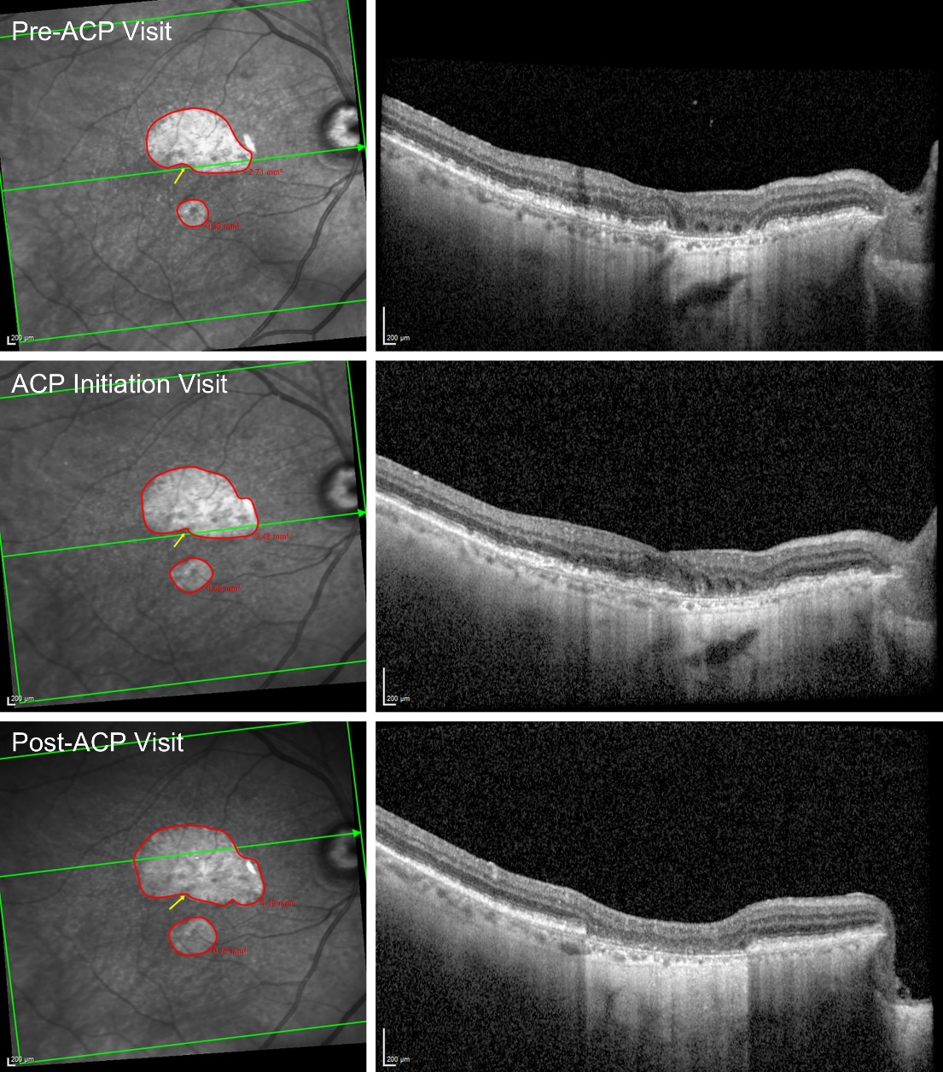
Supplementary Figure 1. Demonstration of geographic atrophy (GA) grading in a representative eye treated by avacincaptad pegol (ACP) at the pre-ACP (month −8), ACP initiation (month 0), and post-ACP (month 12) visits. GA lesions were manually delineated on near-infrared reflectance (NIR) images (red outlines) with reference to corresponding OCT B-scans to refine lesion borders when not clearly visible on NIR alone. The total GA area was calculated at each visit based on the delineated regions. The foveal centre (yellow marker) was identified using the corresponding horizontal OCT B-scan.

