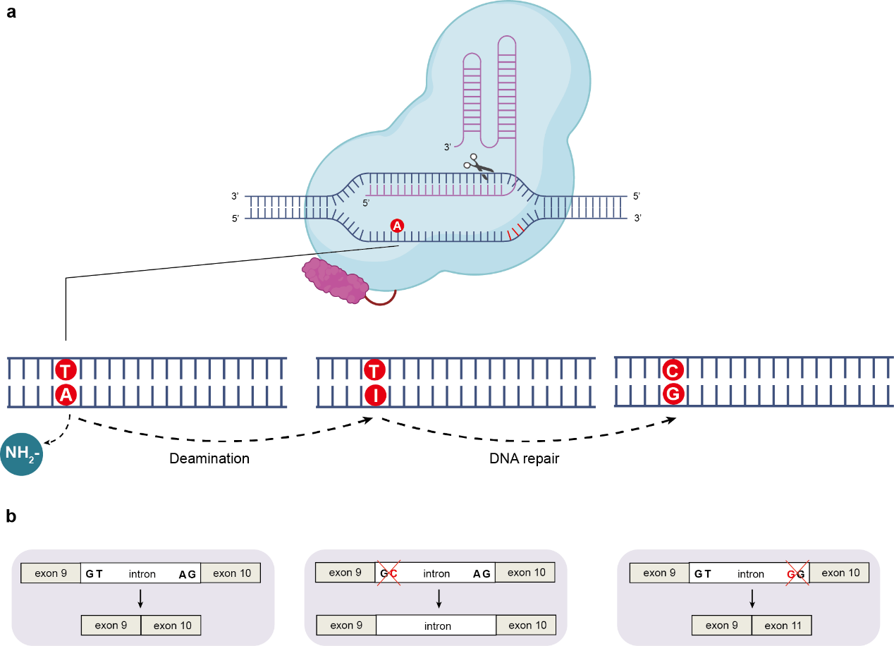
Extended Data Fig.1 | Overview of base-editing approach. a, Schematic of adenine base editing. b, Schematic showing potential splicing outcomes with disruption of splice donor or splice acceptor sequences. Other outcomes are possible, such as inclusion of part of the intron in the splicing product. c, Schematic with Sanger sequencing chromatogram, demonstrating editing of adenine base in the antisense strand at the splice donor at the end of CDC7 exon 9 (PCR amplification from the genomic DNA of the cells transfected with a dose of 2,500 ng ml−1 in Fig. 1a), portraying how splice-site disruption results in an in-frame stop codon. Heterozygosity for a naturally occurring single-nucleotide polymorphism (SNP) is evident downstream of the editing site.

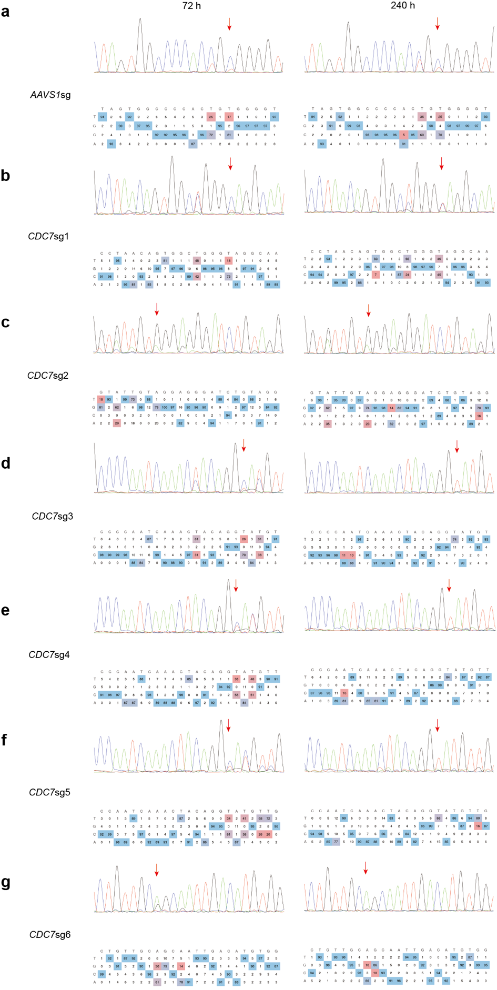
Extended Data Fig.2 | Editing of splice-site adenine bases throughout the
human CDC7 gene with six candidate sgRNAs. Huh7 cells were transfected at a dose of 2,500 ng ml⁻¹ RNA. The red arrow indicates the target splice-site adenine base. All panels were generated with EditR. a, AAVS1sg， ACCCCACAGTGGGGCCACTA/GGG. b, CDC7sg1, TTGCCTACCCAGCCACTGTT/AGG. c, CDC7sg2, GTATTGTAGGAGGGATCTGT/AGG. d, CDC7sg3, ACATACCTGTAGTTTGATTG/GGG. e, CDC7sg4, AACATACCTGTAGTTTGATT/GGG. f, CDC7sg5, CAACATACCTGTAGTTTGAT/TGG. g, CDC7sg6, CTGTTGCAGCAATTGACATG/TGG.

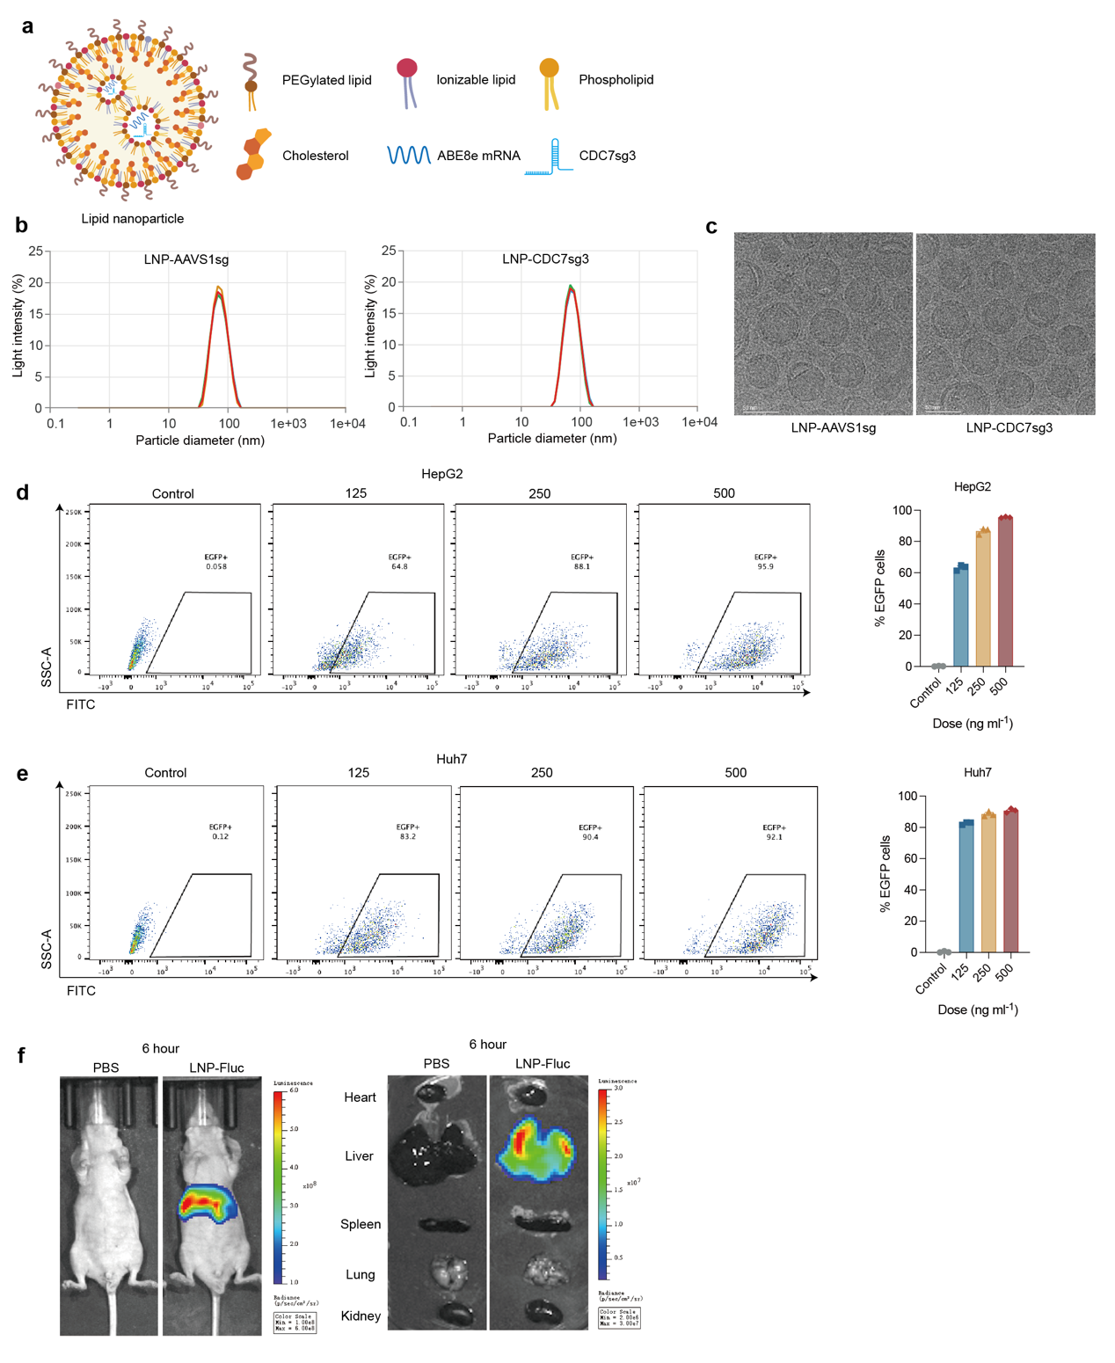
Extended Data Fig.3 | Characterization, biodistribution and genome-editing activity of LNP. a, Schematic diagram of lipid nanoparticles and structure of ionizable lipids. b, Nanosight analysis of LNP-ABE8e-AAVS1sg and LNP-ABE8e-CDC7sg3. c, Transmission electron microscopy of LNP-ABE8e-AAVS1sg and LNP-ABE8e-CDC7sg3. d, e, Cytosolic delivery of LNP-EGFP in HepG2 (d) and Huh7 (e) cell line at three different doses (n = 3 biological replicates). f, In vivo distribution of LNP-Firefly luciferase (n = 1 sample per group). g, In vivo editing efficiency of mouse endogenous gene Agxt at 1 mpk (mg RNA per kg body weight) (n = 3 biological replicates).
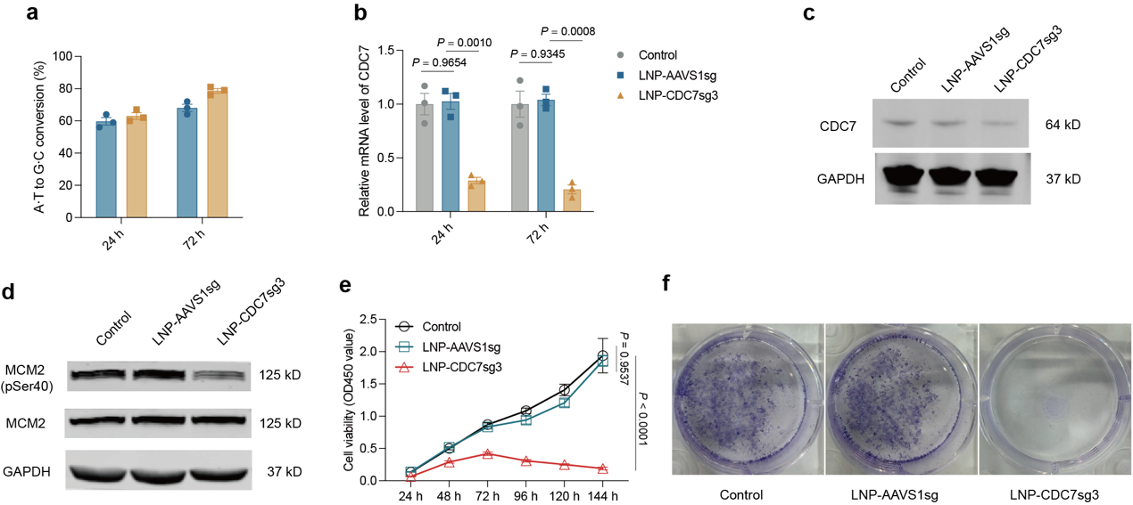
Extended Data Fig.4 | LNP-ABE8e-CDC7sg3 treatment inhibits the proliferation of Hep3B cells. a, Editing efficiency in Hep3B cells treated with LNP-ABE8e-AAVS1sg or LNP-ABE8e-CDC7sg3 at 72 h (n = 3 biological replicates). b, Relative human CDC7 mRNA expression measured by RT-qPCR in Hep3B cells treated with LNP-ABE8e-AAVS1sg or LNP-ABE8e-CDC7sg3 at 72 h (n = 3 biological replicates). c, d, Representative immunoblotting analysis of CDC7 (c) and p-MCM2 (Ser40) (d) in Hep3B cells at 72 h after LNP-ABE8e-AAVS1sg or LNP-ABE8e-CDC7sg3 treatment. e, CCK-8 analysis in Hep3B cells treated with LNP-ABE8e-AAVS1sg or LNP-ABE8e-CDC7sg3 compared to untreated (n = 5 biological replicates). f, Long-term colony formation assay was performed over 10–14 days in Hep3B cells treated with the indicated treatments (n = 3 biological replicates). Results are representative of two or three independent experiments. All bars in the graphs represent the mean ± s.e.m. Statistical comparisons were performed using a one-way analysis of variance (ANOVA) with Tukey’s multiple-comparison test (b and e).

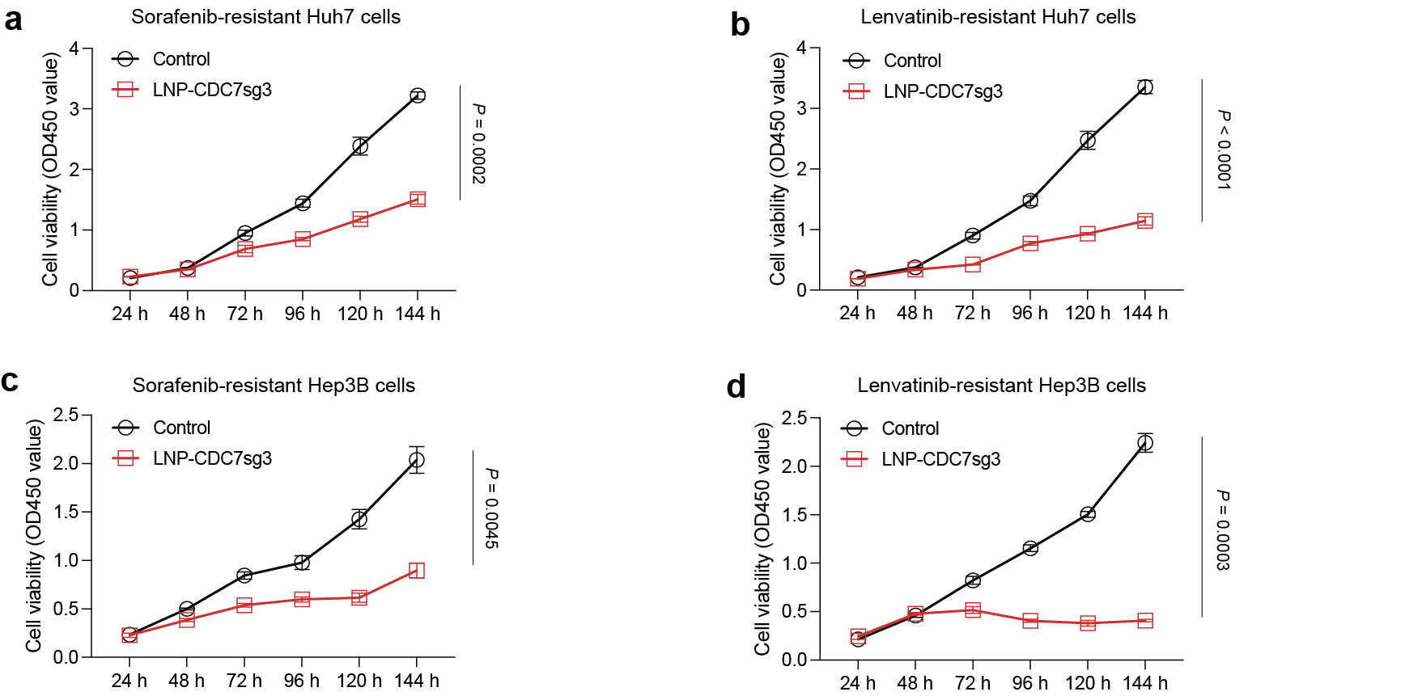
Extended Data Fig.5 | LNP-ABE8e-CDC7sg3 treatment inhibits the proliferation of Sorafenib- or Lenvatinib-resistant Huh7 and Hep3B cells. Drug-resistant hepatocellular carcinoma (HCC) cell lines were established via stepwise dose escalation. The final acquired resistance concentrations were 5 μM for sorafenib and 10 μM for lenvatinib. a, CCK-8 analysis in Sorafenib-resistant Huh7 cells with the indicated treatments (n = 5 biological replicates). b, CCK-8 analysis in Lenvatinib-resistant Huh7 cells with the indicated treatments (n = 5 biological replicates). c, CCK-8 analysis in Sorafenib-resistant Hep3B cells with the indicated treatments (n = 5 biological replicates). d, CCK-8 analysis in Lenvatinib-resistant Hep3B cells with the indicated treatments (n = 5 biological replicates). Results are representative of two or three independent experiments. All bars in the graphs represent the mean ± s.e.m. Statistical comparisons were performed using a two-way analysis of variance (ANOVA) with Sidak’s multiple-comparison test (a-d).

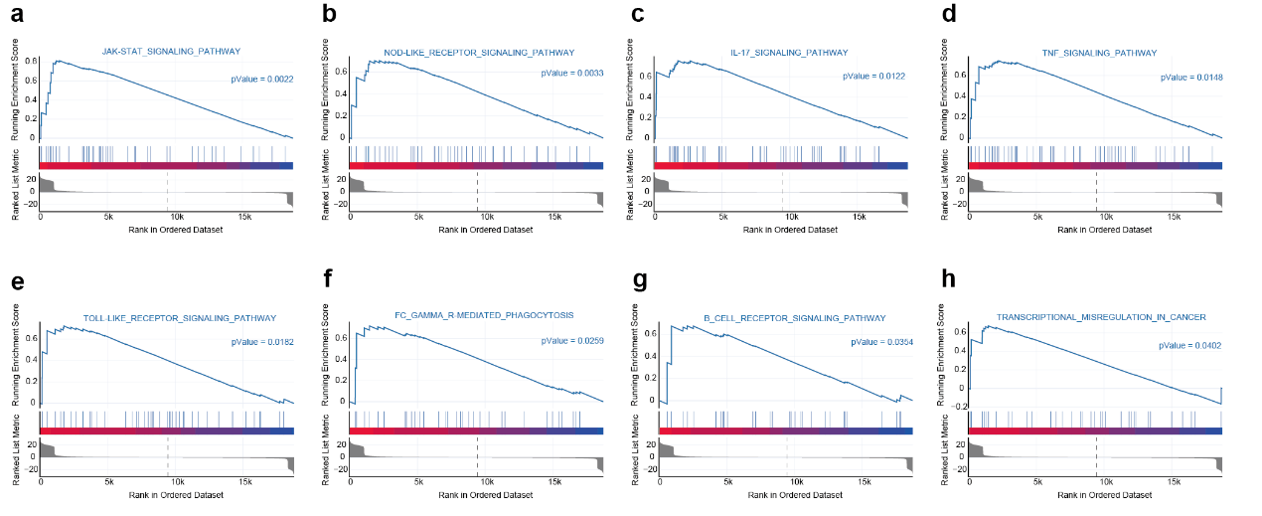
Extended Data Fig.6 | GSEA analysis of Huh7 cells treated with LNP-ABE8e-CDC7sg3 compared to control at 5 days. a-j, JAK-STAT signaling pathway (a), NOD-like receptor signaling pathway (b), IL17 signaling pathway (c), TNF signaling pathway (d), Toll like receptor signaling pathway (e), Fc gamma R mediated phagocytosis (f), B cell receptor signaling pathway (g) and Transcriptional misregulation in cancer (h).

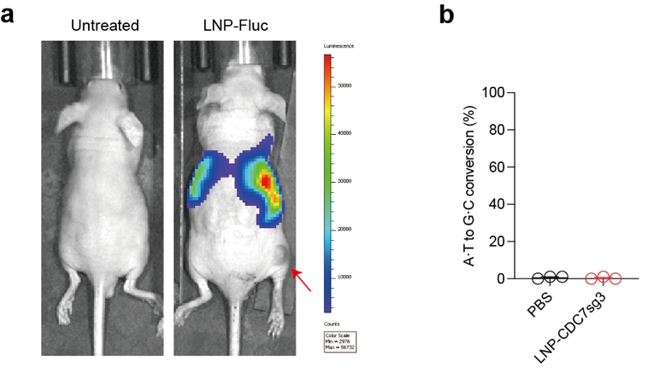
Extended Data Fig.7 | LNPs can not delivery mRNA into subcutaneous tumor. a, In vivo distribution of LNP-Firefly luciferase (n = 1 sample per group). The red arrow indicates the region of subcutaneous tumor. b, Editing efficiency in subcutaneous tumor treated with LNP-ABE8e-CDC7sg3 at 72 h (n = 3 biological replicates).

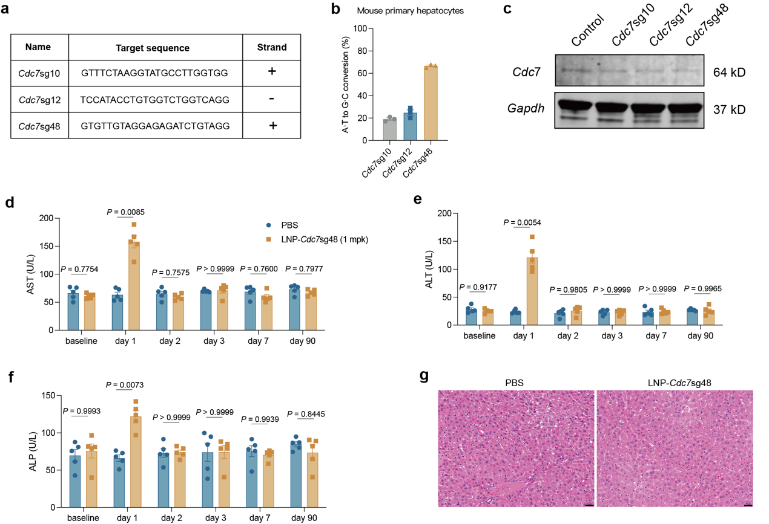
Extended Data Fig.8 | Long-term toxicity of knockout of Cdc7 protein in mouse liver. a, Sequences of three candidate sgRNAs. b, Editing efficiency in mouse primary hepatocytes at 72 h after transfection of ABE8e mRNA and sgRNAs (n = 3 biological replicates). c, Representative immunoblotting analysis of Cdc7 in mouse primary hepatocytes with the indicated treatments at 3 days. d-f, Absolute serum levels of AST (d), ALT (e) and ALP (f) at various time points in mice treated with PBS and LNP-ABE8e-Cdc7sg48 (1 mpk) (n = 5 biological replicates). g, Representative hematoxylin and eosin staining of liver tissue in mice with the indicated treatments at 90 days (scale bar = 100 μm) (n = 5 biological replicates). Results are representative of two or three independent experiments. All bars in the graphs represent the mean ± s.e.m. Statistical comparisons were performed using a two-tailed unpaired Student’s t-test (d-f).

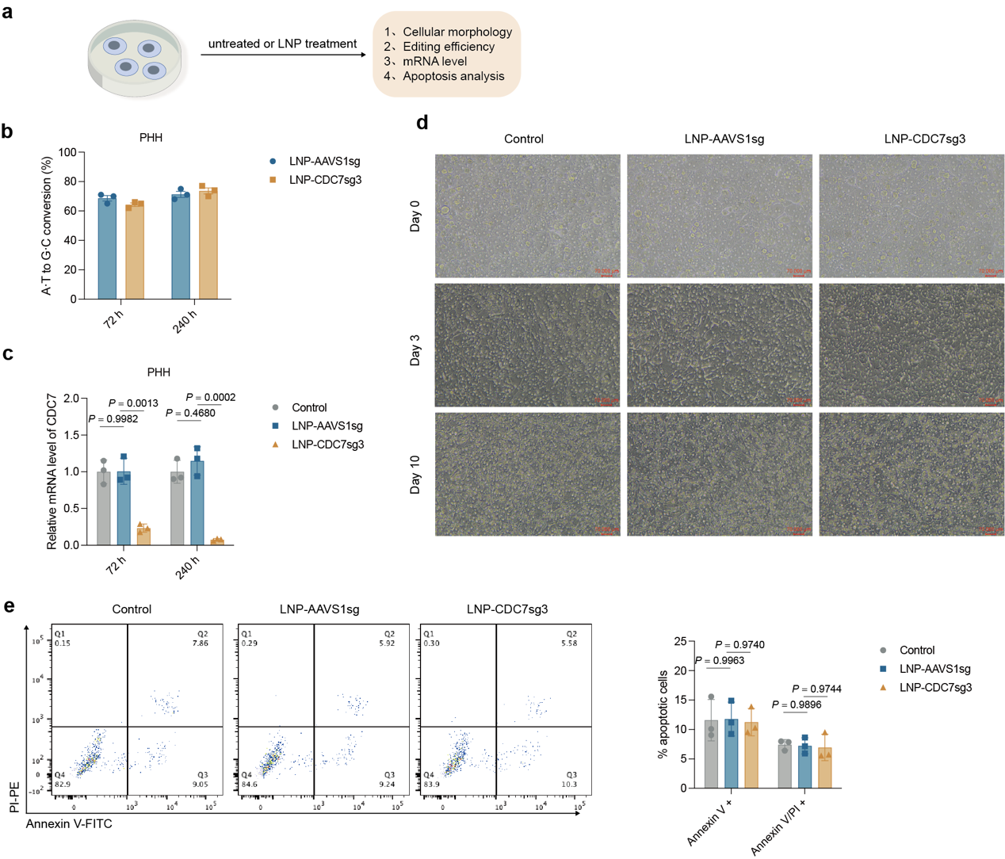
Extended Data Fig.9 | Short-term toxicity of LNP-ABE8e-CDC7sg3 in primary human hepatocytes. a, Schematic diagram of experimental design. b, Editing efficiency in primary human hepatocytes at 72 h and 240 h after treatments (n = 3 biological replicates). c, Relative human CDC7 mRNA expression measured by RT-qPCR in primary human hepatocytes with the indicated treatments at 72 h (n = 3 biological replicates). d, Phase-contrast microscopy images of primary human hepatocytes with the indicated treatments at various time points (scale bar = 100 μm). e, Apoptosis analysis of primary human hepatocytes at 72 h after LNPs treatment. Early (Annexin V⁺) and late (Annexin V/PI⁺) apoptosis are quantified by flow cytometry (n = 3 biological replicates). Results are representative of two or three independent experiments. All bars in the graphs represent the mean ± s.e.m. Statistical comparisons were performed using a one-way analysis of variance (ANOVA) with Tukey’s multiple-comparison test (c and e).

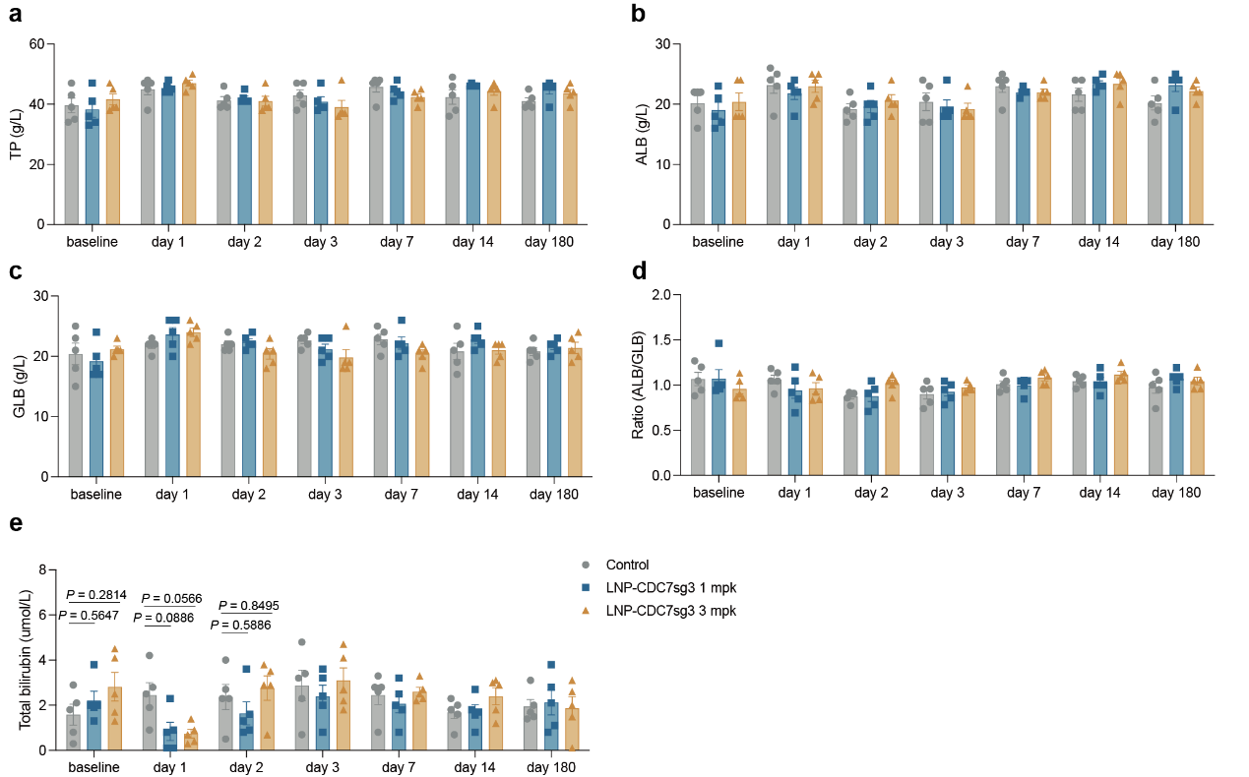
Extended Data Fig.10 | Liver function tests in short-term and long-term mice studies. a-e, Absolute values of blood levels of TP (a), ALB (b), GLB (c), Ratio (ALB/GLB) (d) and total bilirubin (e) in mice with the indicated treatments at various time points up to 180 days. Results are representative of two or three independent experiments. All bars in the graphs represent the mean ± s.e.m. Statistical comparisons were performed using a one-way analysis of variance (ANOVA) with Tukey’s multiple-comparison test (a-e).

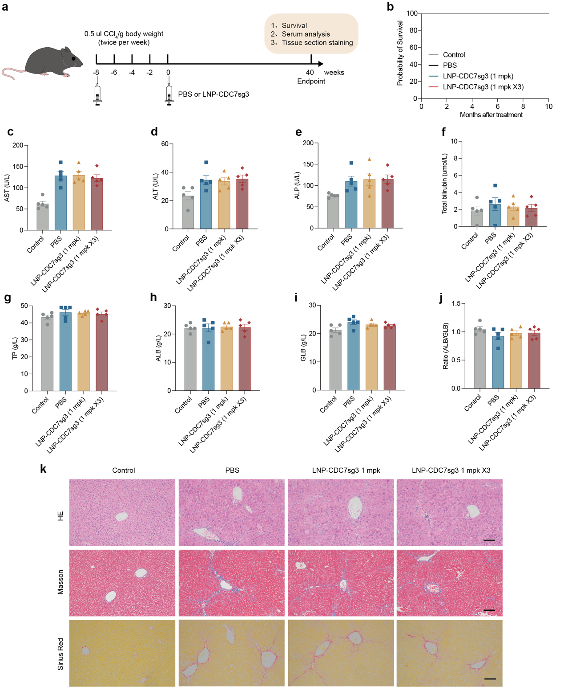
Extended Data Fig.11 | Toxicity assessment of LNP-ABE8e-CDC7sg3 in liver cirrhosis mouse model. a, Schematic diagram of experimental design. b, Kaplan–Meier survival curves of liver cirrhosis mice that were intravenously injected with PBS and LNP-ABE8e-CDC7sg3 (1 mpk or 1 mpk thrice) (n = 5 biological replicates). c-j, Absolute values of blood levels of AST (c), ALT (d), ALP (e), total bilirubin (f), TP (g), ALB (h), GLB (i) and Ratio (ALB/GLB) (j) in mice with the indicated treatments at end points (n = 5 biological replicates). k, Representative hematoxylin and eosin, Masson and Sirius Red staining of liver tissue in mice with the indicated treatments at end points (scale bar = 100 μm) (n = 5 biological replicates). Results are representative of two or three independent experiments. All bars in the graphs represent the mean ± s.e.m. Statistical comparisons were performed using a one-way analysis of variance (ANOVA) with Tukey’s multiple-comparison test (b-j).

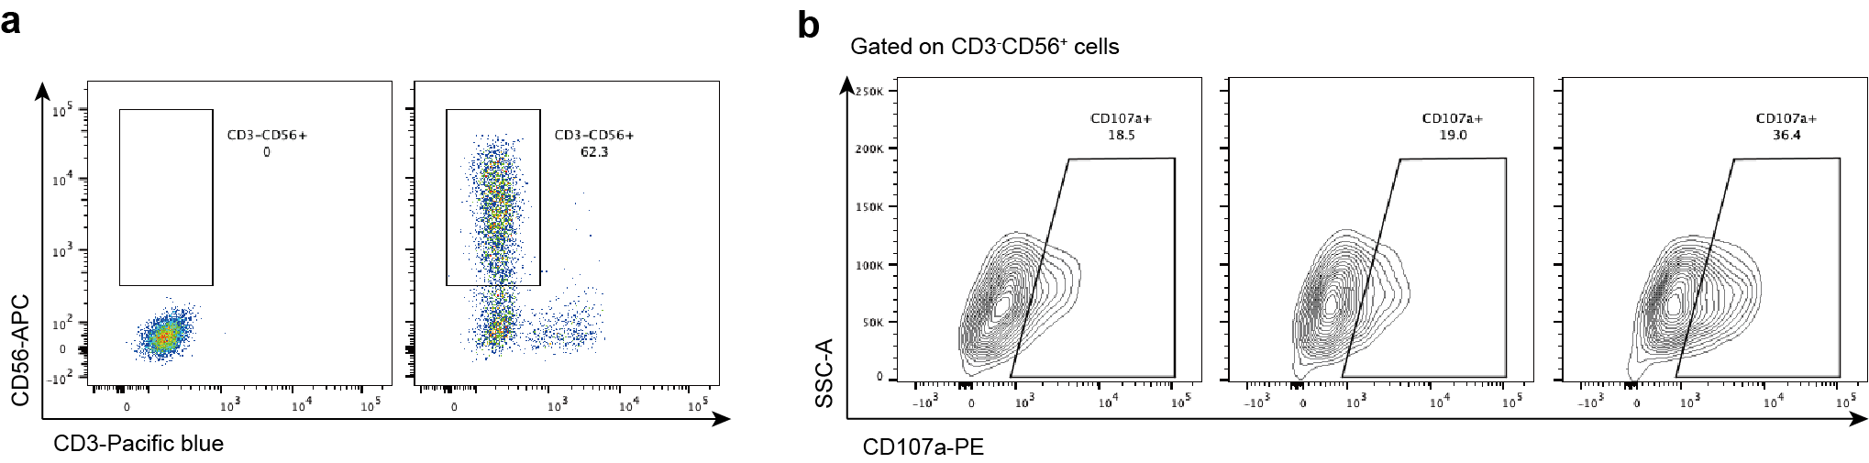
Extended Data Fig.12 | Gating strategies. a, Gating strategies for CD3⁻CD56⁺ primary human NK cells. b, Gating strategies for CD107a⁺ cells gated on CD3⁻CD56⁺ primary human NK cells.

