Supplementary Information
Energy Availability, Not Stress Tolerance, Determines Archaeal Persistence in Extraterrestrial Habitats
Ajay Vellanki

1 Supplementary Figures and Tables
2 Figures S1–S16 and Tables S1–S2 support the analyses
3 reported in the main text. Section S1 reproduces the
4 full-length Results, Methods and Discussion from which
5 the main text was condensed; all numerical values,
6 intermediate statistics and validation outcomes are
7 reported there without abridgement.

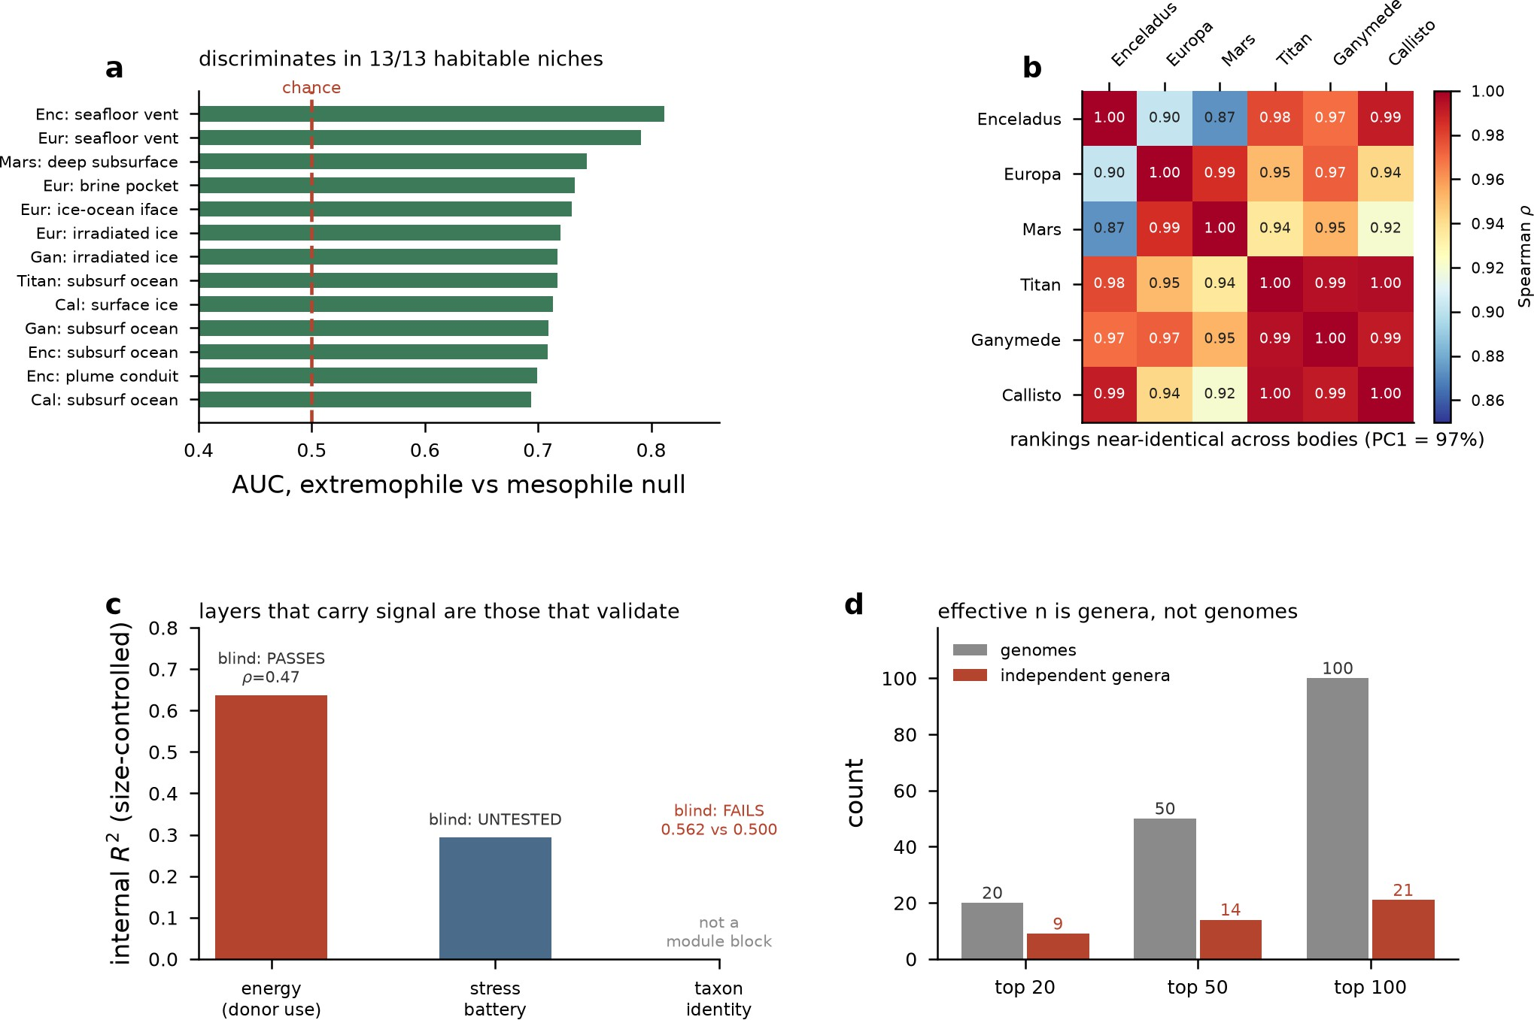
8 Figure S1. Extremophile-mesophile discrimination generalizes
9 across niches but reduces to few genera. Panel a: horizontal bars
10 of AUC for extremophile vs mesophile null across 13 habitable
11 niches (e.g., seafloor vents, subsurface oceans, irradiated ice), all
12 exceeding the chance line at 0.5, ranging roughly 0.69–0.81.
13 Panel b: heatmap of Spearman ρ correlations between rankings
14 for six bodies (Enceladus, Europa, Mars, Titan, Ganymede,
15 Callisto), values 0.87–1.00, noting PC1 = 97%. Panel c: bar chart
16 of internal R2 for energy, stress battery, and taxon identity
17 blocks, annotated "blind: PASSES ρ=0.47," "blind:
18 UNTESTED," and "blind: FAILS 0.562 vs 0.500." Panel d:
19 paired bar chart of genome counts (gray) versus independent
20 genera (red) at top 20, 50, and 100 cutoffs, labeled 20/9, 50/14,
21 100/21.
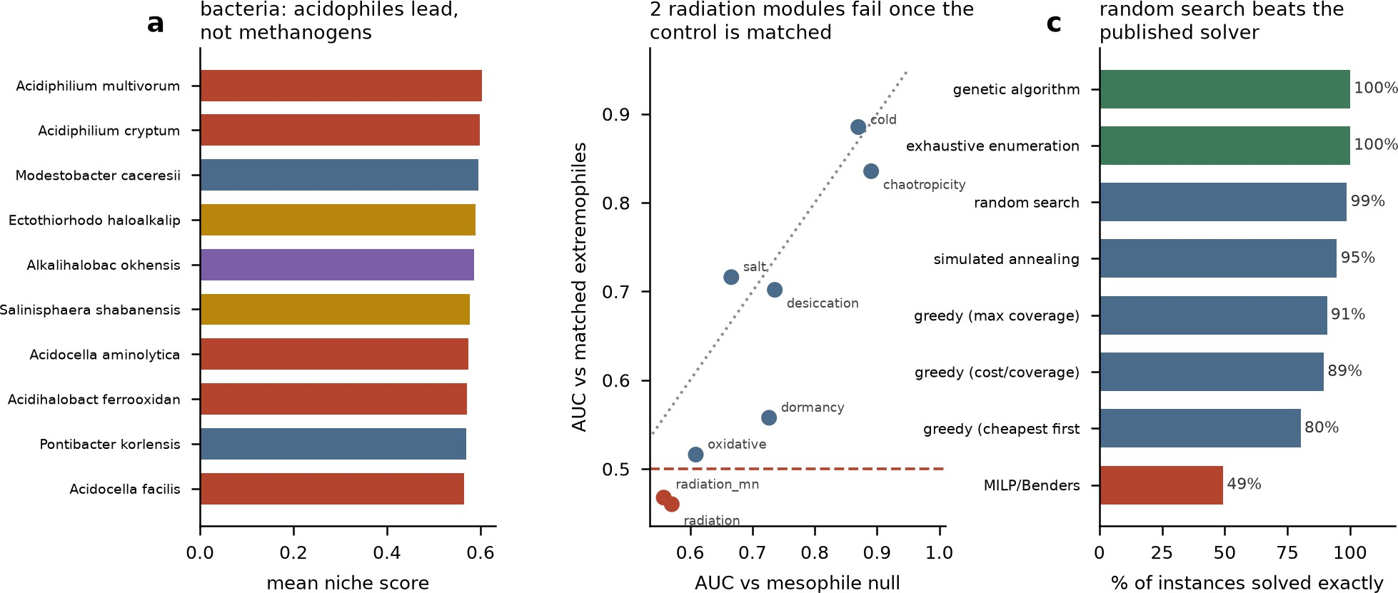

22 Figure S2. Bacterial niche scores, radiation-module AUC
23 comparisons, and solver benchmark results. Panel a: horizontal
24 bar chart of mean niche score for ten bacterial taxa, bars colored
25 by phenotype class, topped by Acidiphilium multivorum and
26 Acidiphilium cryptum. Panel b: scatter plot of AUC vs matched
27 extremophiles against AUC vs mesophile null for eight modules
28 (cold, chaotropicity, salt, desiccation, dormancy, oxidative,
29 radiation_mn, radiation), dotted diagonal reference line, dashed
30 red line at 0.5; radiation modules cluster near 0.5. Panel c:
31 horizontal bar chart of percent instances solved exactly by eight
32 solvers, colored green (genetic algorithm, exhaustive
33 enumeration, both 100%), blue (random search 99%, simulated
34 annealing 95%, greedy variants 91%/89%/80%), and red
35 (MILP/Benders 49%), with percentages labeled beside each bar.
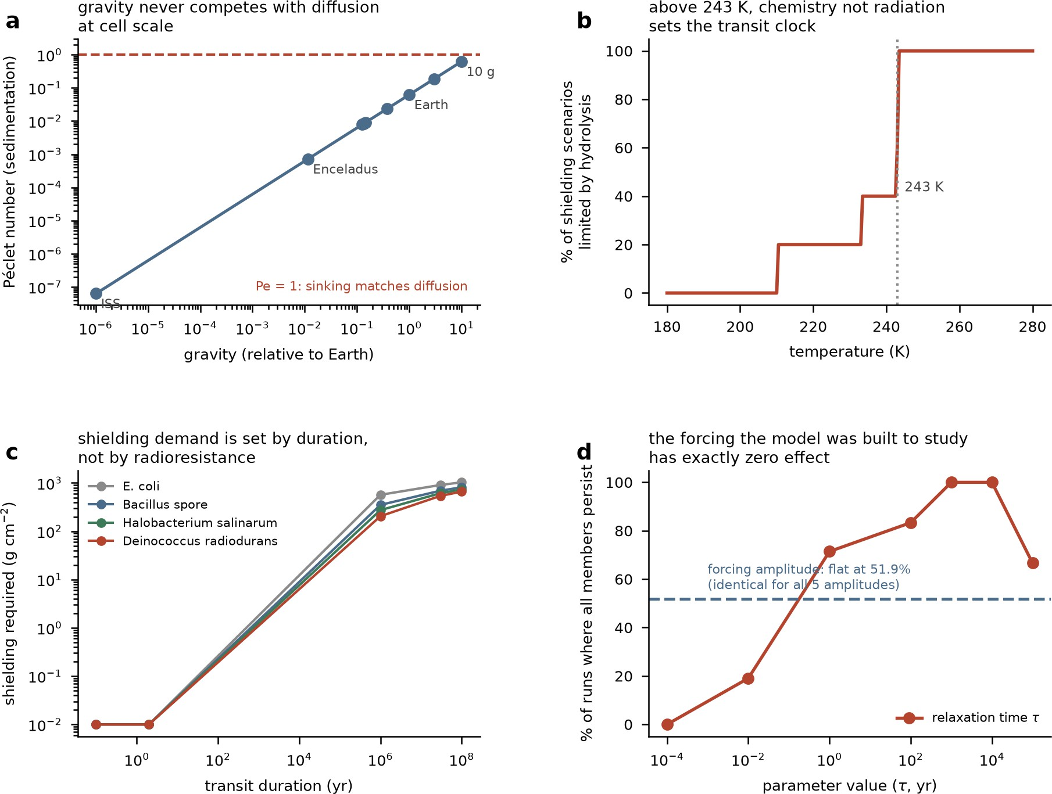
36 Figure S3. Gravity, temperature, duration, and forcing shape
37 panspermia survival limits. (a) Péclet number vs. gravity (relative
38 to Earth), log-log, with points for ISS, Enceladus, Earth, and 10
39 g; dashed line marks Pe=1. (b) % of shielding scenarios
40 hydrolysis-limited vs. temperature (K); dotted line marks 243 K
41 transition. (c) Shielding required (g cm−2) vs. transit duration (yr)
42 for four organisms (E. coli, Bacillus spore, Halobacterium
43 salinarum, Deinococcus radiodurans). (d) Percentage of runs in
44 which all members persist against relaxation time τ (yr, log
45 scale), with a dashed horizontal line marking the
46 forcing-amplitude result, flat at 51.9% and identical for all five
47 amplitudes.

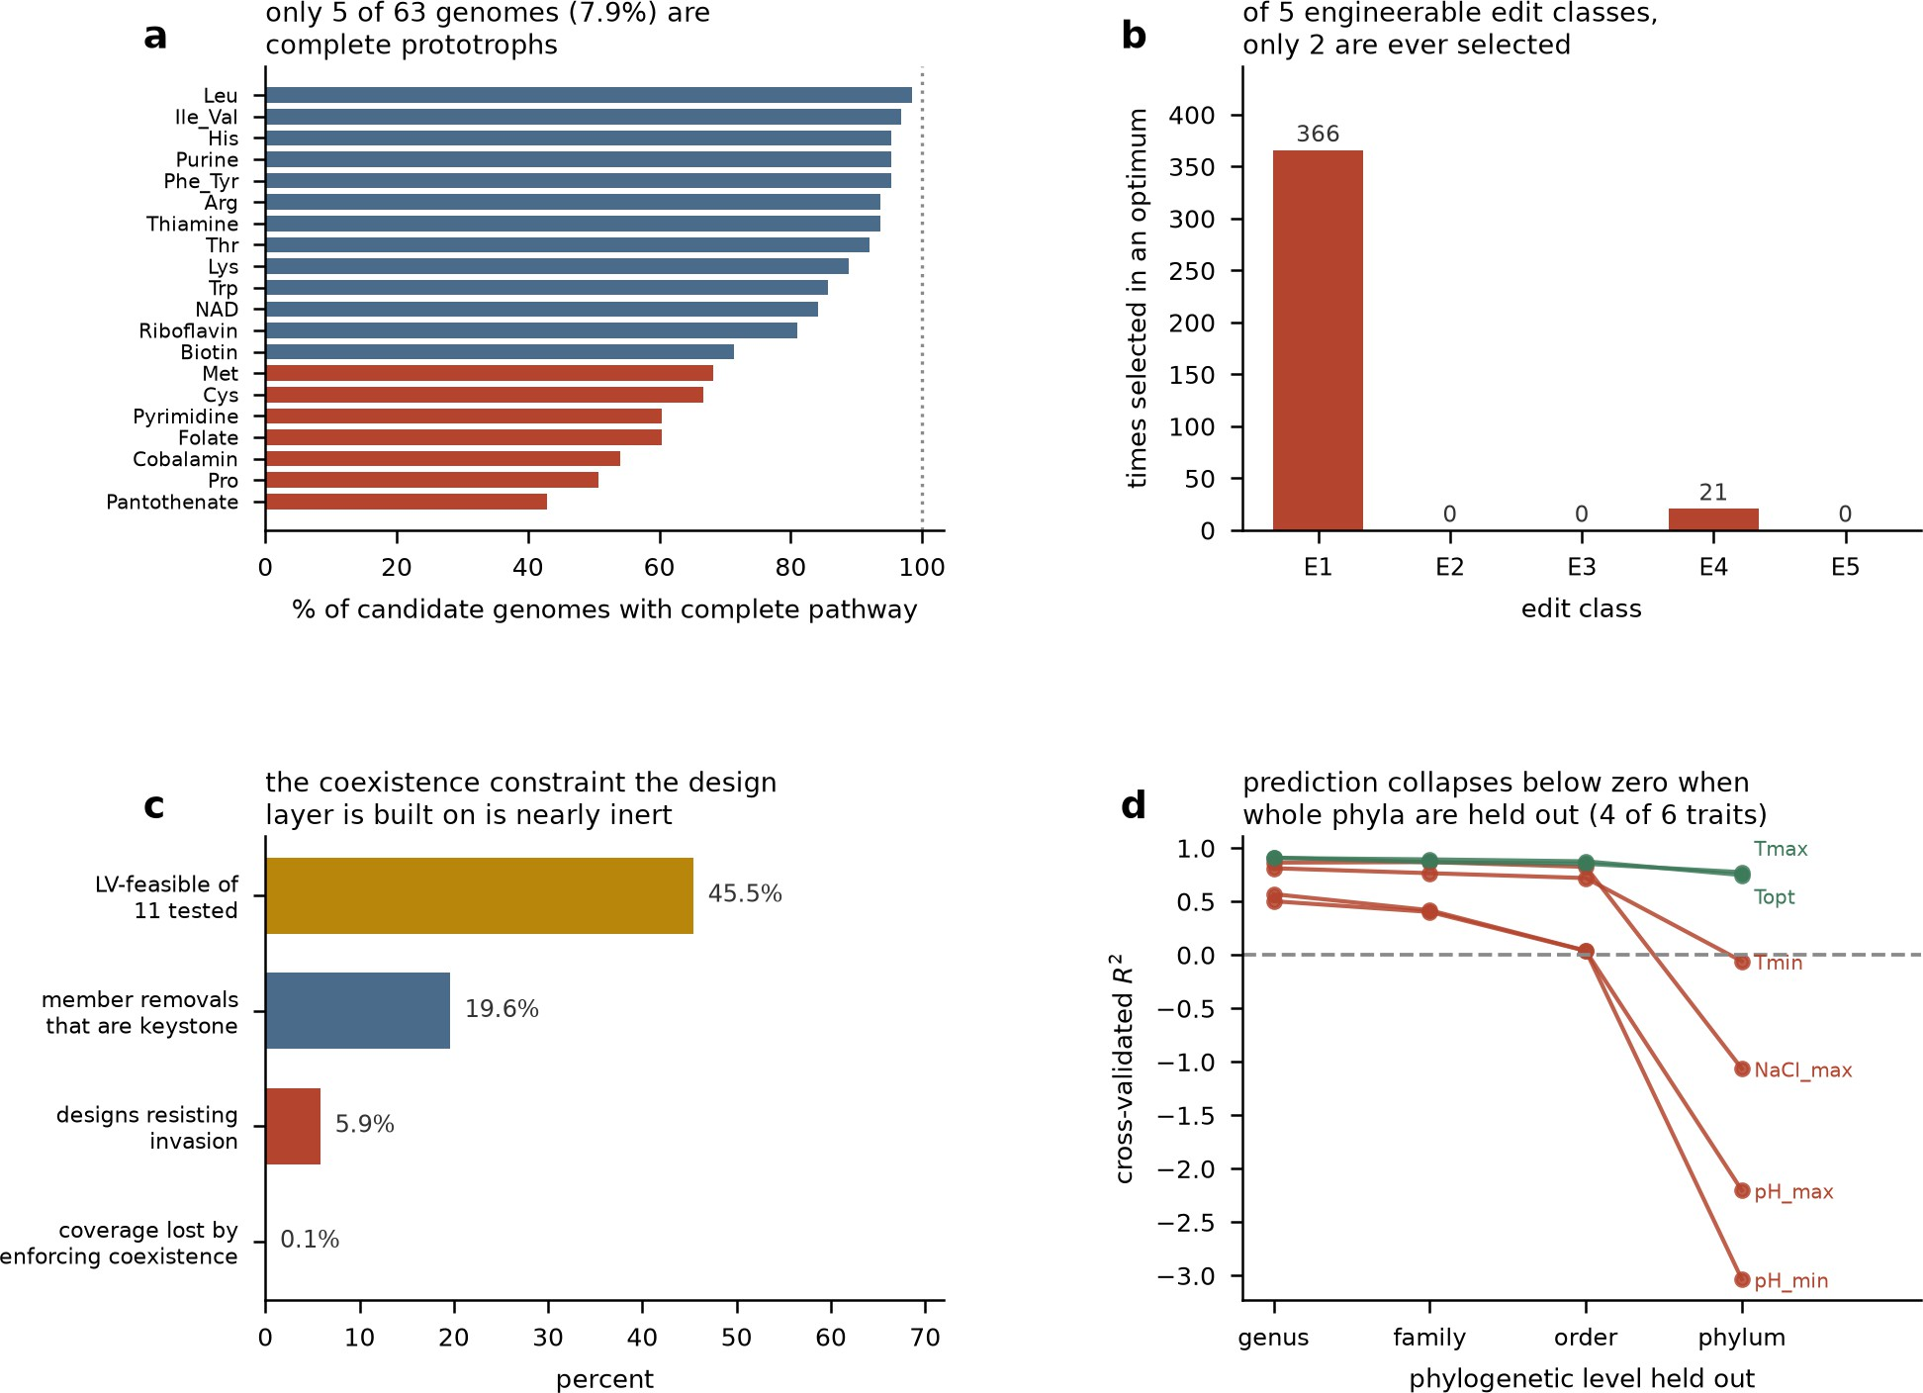

48 Figure S4. Pathway completeness, edit-class selection,
49 coexistence constraint, and phylogenetic prediction limits. Panel
50 a: horizontal bars show percent of candidate genomes with each
51 complete biosynthetic pathway, ordered Leu to Pantothenate,
52 blue above and red below a dotted 100% line, with 5 of 63
53 genomes complete prototrophs. Panel b: bar chart of times
54 selected in an optimum for edit classes E1–E5, showing E1=366,
55 E2=0, E3=0, E4=21, E5=0. Panel c: bars for LV-feasible of 11
56 tested (45.5%), member removals that are keystone (19.6%),
57 designs resisting invasion (5.9%), and coverage lost by enforcing
58 coexistence (0.1%). Panel d: cross-validated R2 versus
59 phylogenetic level held out (genus, family, order, phylum) for six
60 traits; Tmax and Topt (green) remain near 0.8–0.9, while Tmin,
61 NaCl_max, pH_max, and pH_min (red) fall toward or below a
62 dashed zero reference line at phylum level.

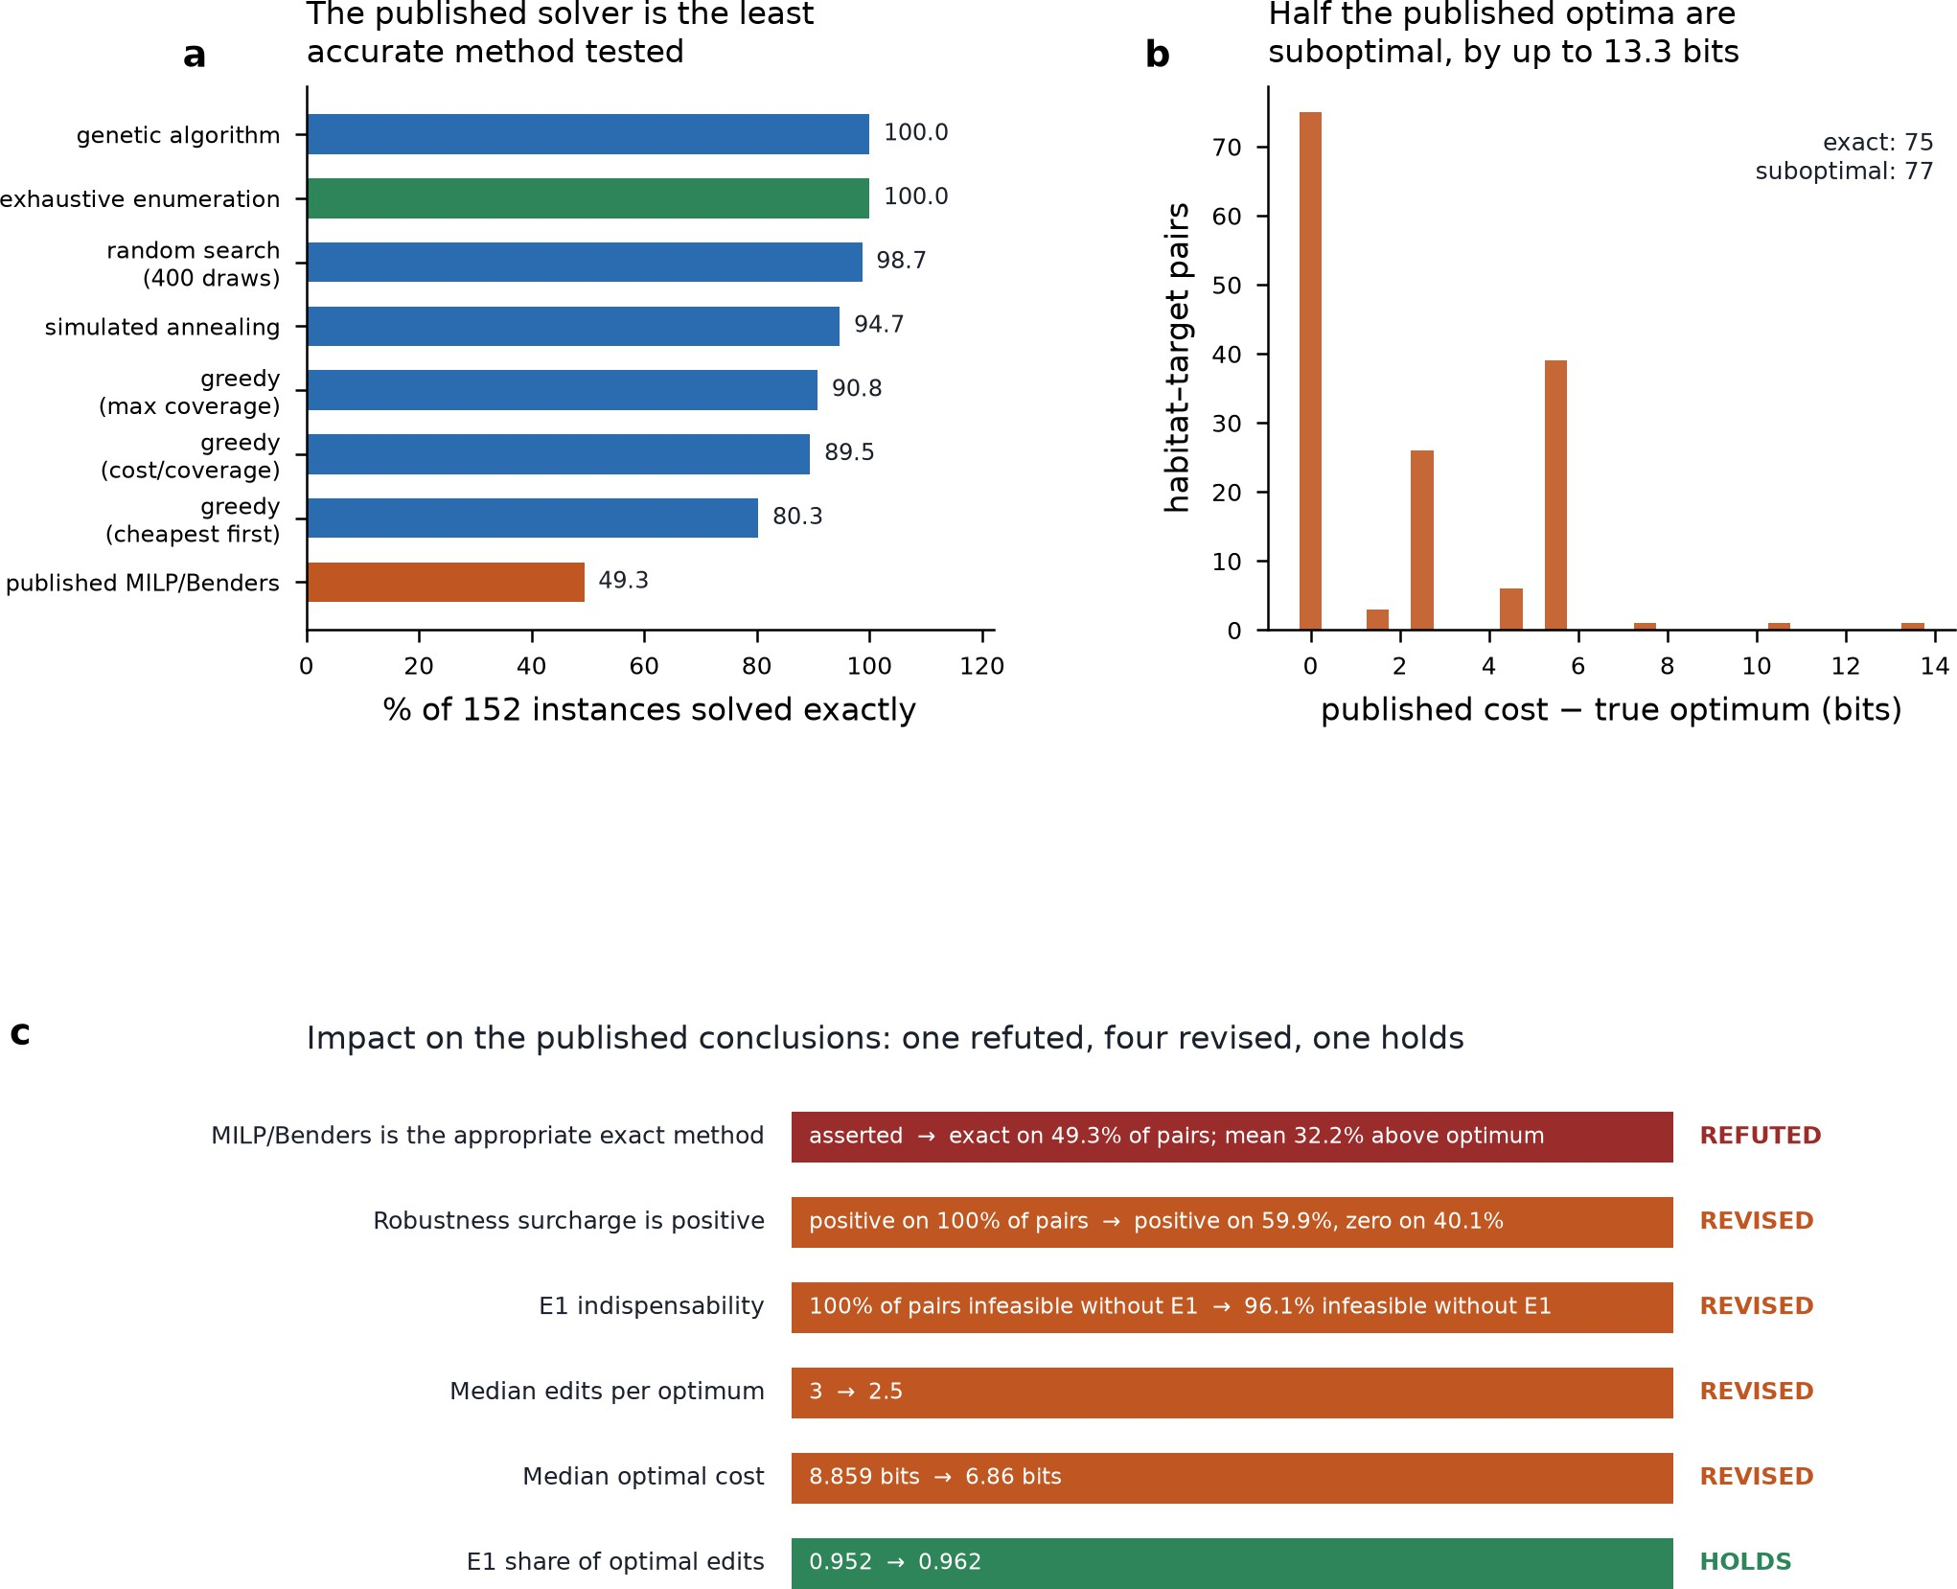

63 Figure S5. Published MILP/Benders solver is least accurate and
64 half its optima are suboptimal. Panel a: horizontal bar chart of
65 percent of 152 instances solved exactly for eight methods,
66 ranging from genetic algorithm and exhaustive enumeration
67 (100.0) down to published MILP/Benders (49.3, orange). Panel
68 b: histogram of habitat-target pairs versus published cost minus
69 true optimum in bits, peak at 0 (exact: 75), remaining pairs
70 suboptimal up to about 13.3 bits (suboptimal: 77). Panel c: table
71 listing six conclusions with original versus revised values and
72 verdicts REFUTED, REVISED (four rows), or HOLDS.
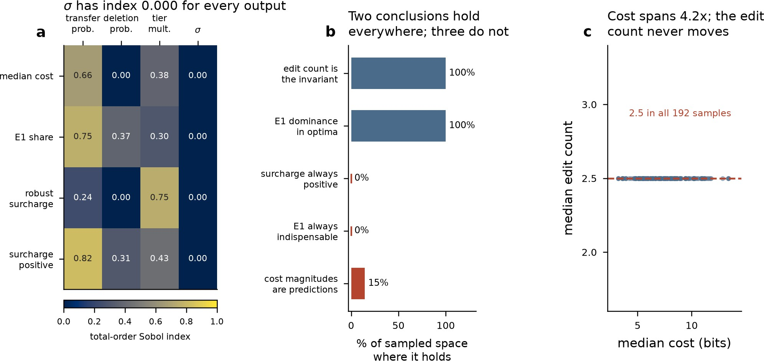

73 Figure S6. Sobol sensitivity analysis identifies edit count as a
74 universally invariant outcome. Panel a is a heatmap of total-order
75 Sobol indices (0.0–1.0, dark blue to yellow) for four parameters
76 (transfer probability, deletion probability, tier multiplier, σ)
77 across four outputs (median cost, E1 share, robust surcharge,
78 surcharge positive); σ shows index 0.00 for every output. Panel b
79 is a horizontal bar chart of percent of sampled space where five
80 conclusions hold: edit count invariant and E1 dominance in
81 optima each 100%; surcharge always positive and E1 always
82 indispensable each 0%; cost magnitudes are predictions 15%.
83 Panel c is a scatter plot of median edit count versus median cost
84 (bits) for 192 samples, all lying on a red dashed line at 2.5,
85 annotated "2.5 in all 192 samples," while cost ranges roughly
86 3–13 bits.
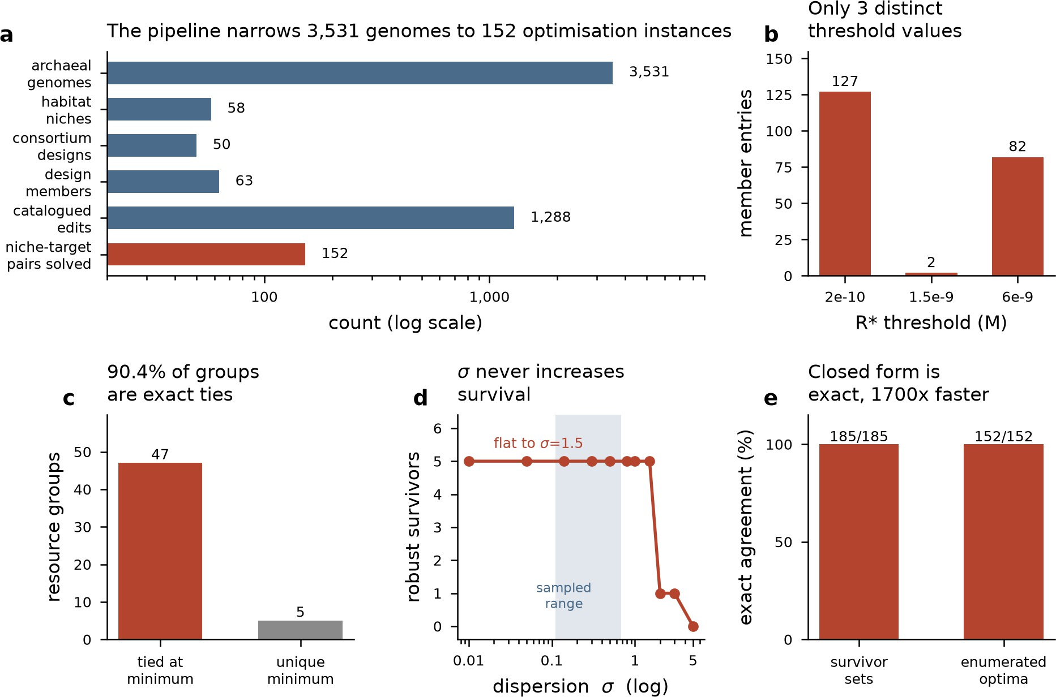

87 Figure S7. A five-panel filtering, threshold, tie, robustness, and
88 speed summary. Panel a: horizontal log-scale bar chart narrowing
89 archaeal genomes (3,531) through habitat niches (58),
90 consortium designs (50), design members (63), catalogued edits
91 (1,288), to niche-target pairs solved (152). Panel b: bar chart of
92 member entries at three R* thresholds (2e-10: 127; 1.5e-9: 2;
93 6e-9: 82). Panel c: resource groups tied at minimum (47) versus
94 unique minimum (5). Panel d: robust survivors versus dispersion
95 sigma (log axis), flat at 5 until sigma≈1.5, shaded "sampled
96 range," then dropping toward 0 by sigma=5. Panel e: exact
97 agreement percentage for survivor sets (185/185) and enumerated
98 optima (152/152), both 100%.

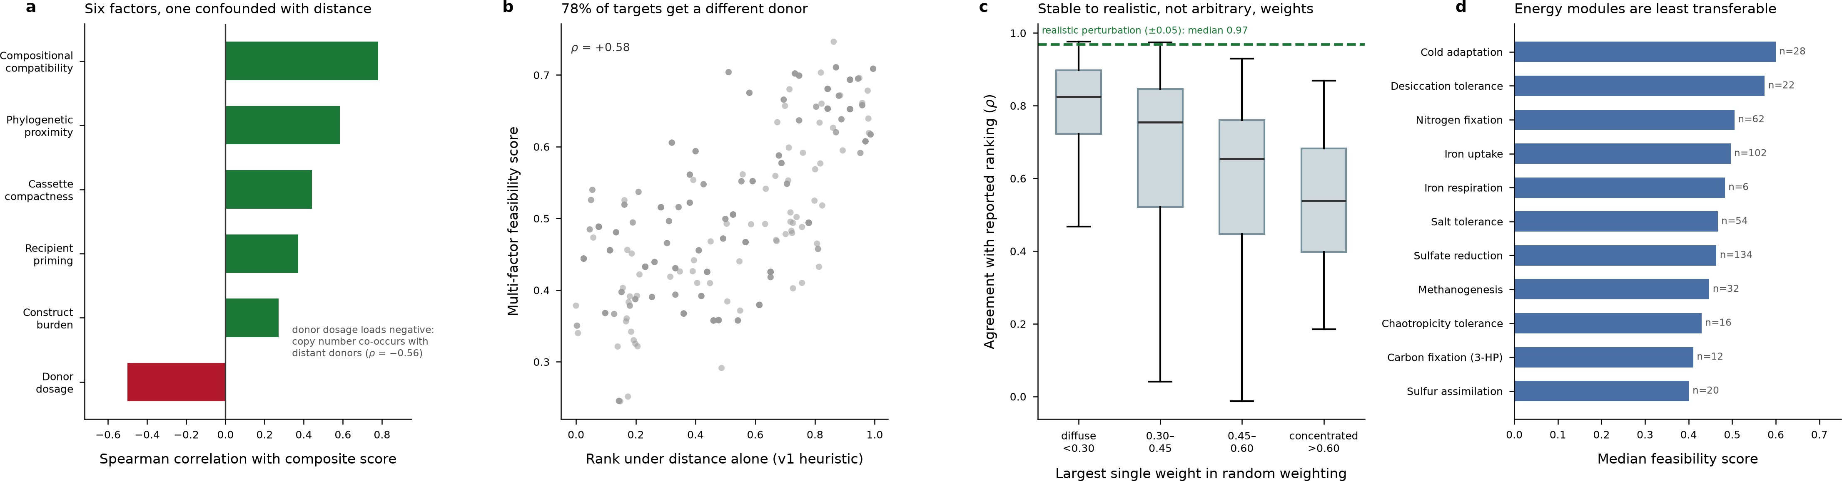

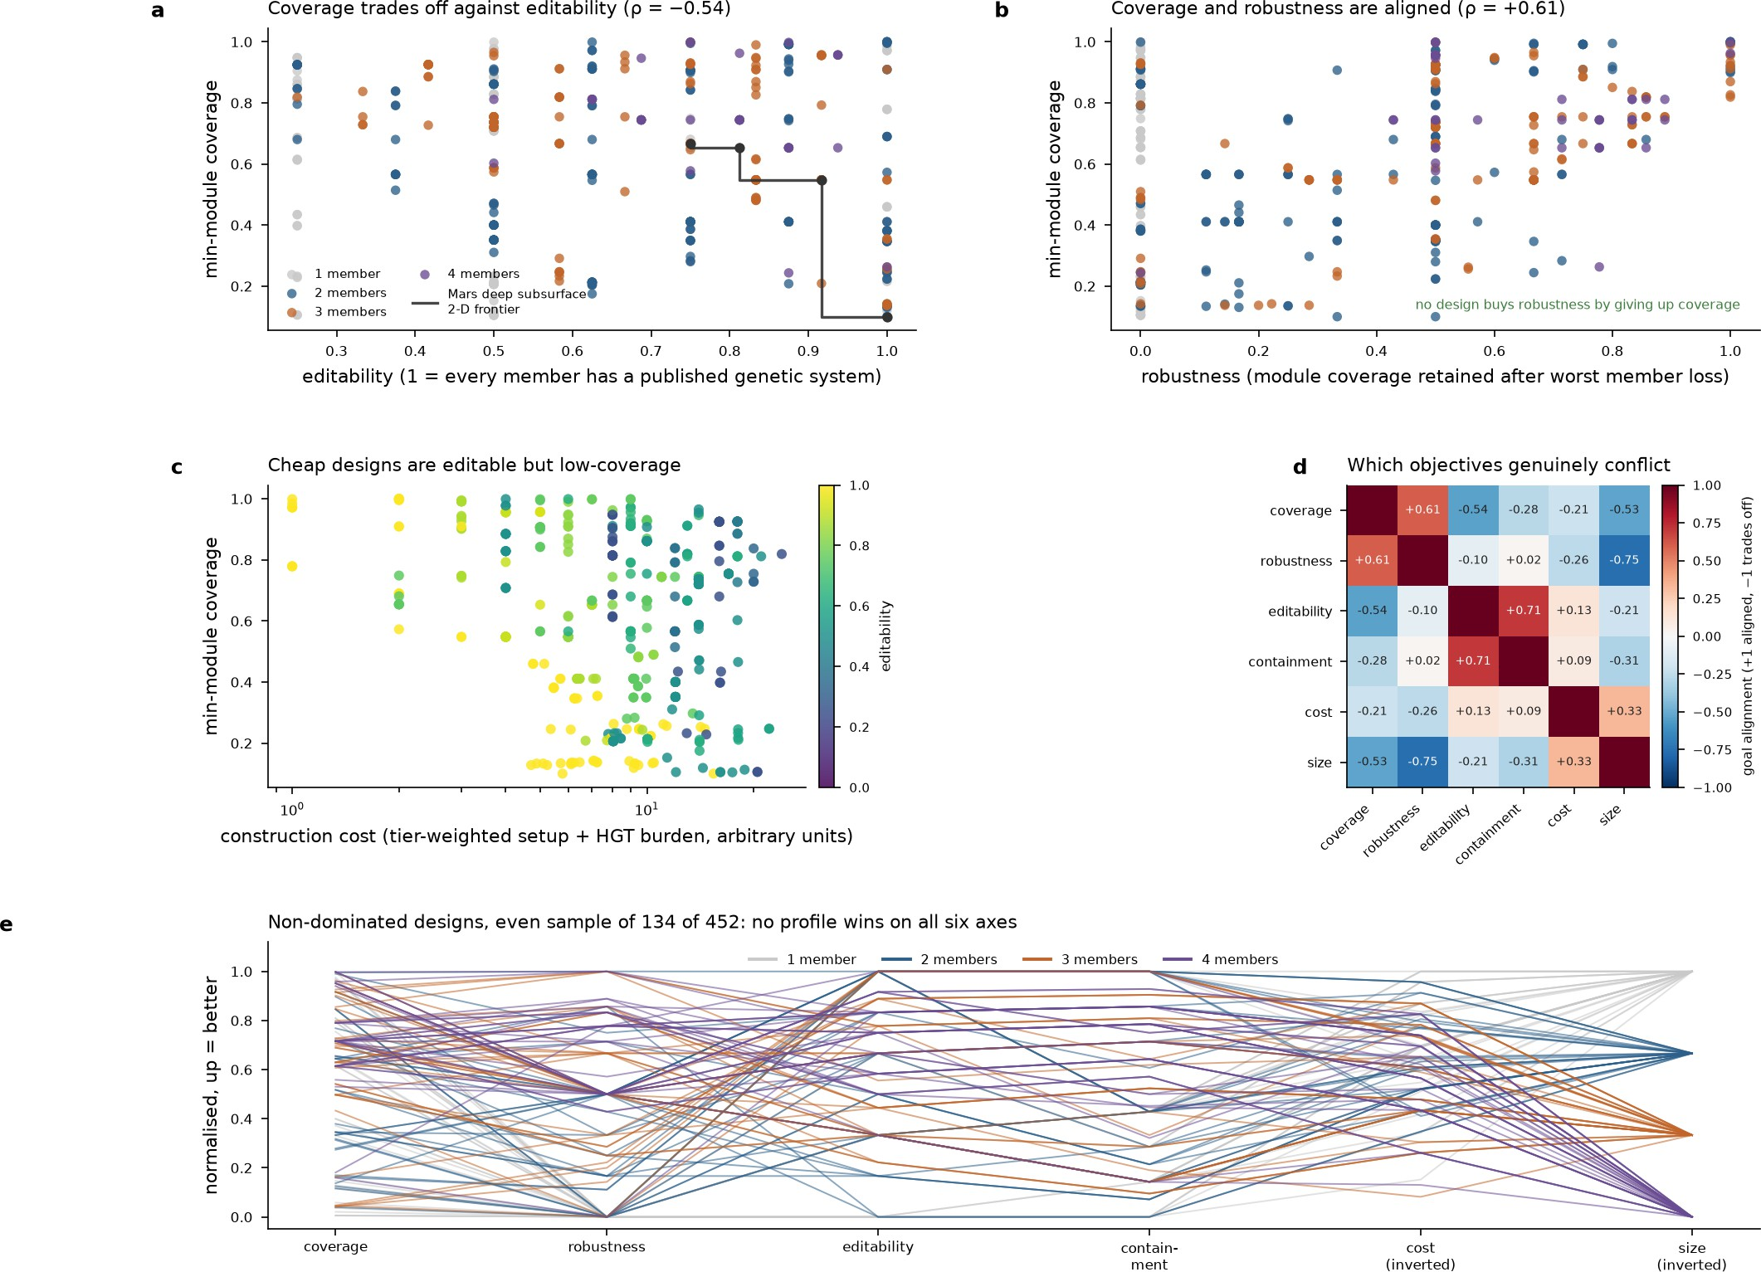
99 Figure S8. Design objectives trade off across coverage,
100 robustness, editability, cost, and size. Panel a: scatter of
101 min-module coverage versus editability, colored by member
102 count (1–4), with a black-dot Pareto frontier line labeled "Mars
103 deep subsurface 2-D frontier" (ρ=-0.54). Panel b: coverage
104 versus robustness, annotated "no design buys robustness by
105 giving up coverage" (ρ=+0.61). Panel c: coverage versus
106 log-scaled construction cost, colored by editability (0–1 scale).
107 Panel d: 6x6 correlation heatmap of six objectives, red/blue
108 diverging scale, cells labeled with correlation values. Panel e:
109 parallel-coordinates plot of 134 non-dominated designs across six
110 normalized axes, lines colored by member count.
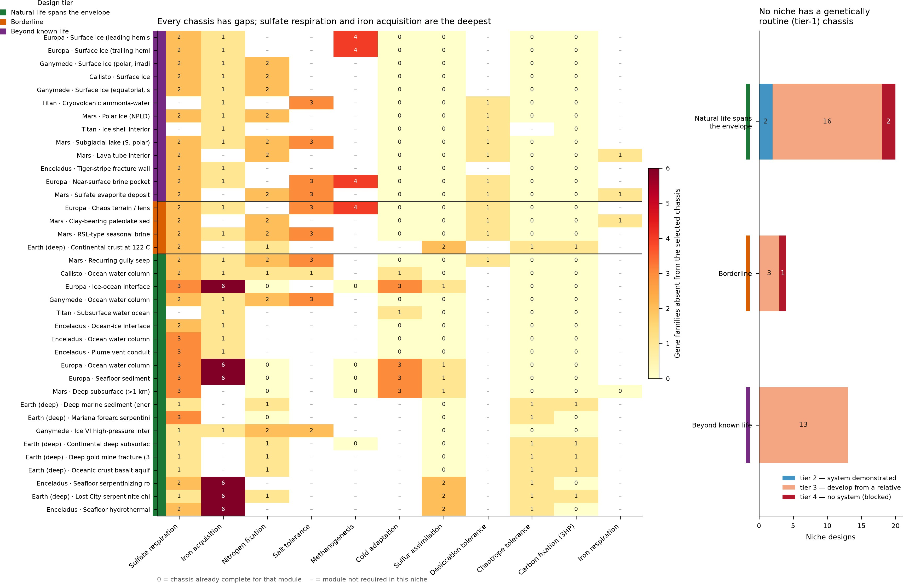

111 Figure S9. Chassis engineering gaps and tier-3 pathway
112 dominance across candidate niches. Panel A is a heatmap of
113 niche designs (rows, grouped and colour-coded by design tier)
114 versus functional modules (columns), coloured by count of gene
115 families absent, from 0 (complete) to 6 (dark red); dashes mark
116 modules not required. Panel B is a stacked horizontal bar chart of
117 niche designs by tier, split into tier 2 (system demonstrated,
118 blue), tier 3 (develop from a relative, salmon), and tier 4 (no
119 system, blocked, dark red), with counts labelled on each segment.
120 Figure S10. Six factors shape feasibility rankings, which stay
121 stable and favor transferable non-energy modules. Panel a:
122 horizontal bar chart of Spearman correlation with composite
123 score for six factors; five bars green (positive), donor dosage red
124 (negative, ρ=-0.56, noted as confounded with distant donors).
125 Panel b: scatter, rank under distance alone (x) versus multi-factor
126 feasibility score (y), ρ=+0.58, annotated "78% of targets get a
127 different donor." Panel c: boxplots of ranking agreement (ρ)
128 across four largest-weight bins, dashed line marks realistic
129 perturbation median 0.97. Panel d: horizontal bar chart of median
130 feasibility score by module, with sample sizes n labeled, energy
131 modules ranked lowest.
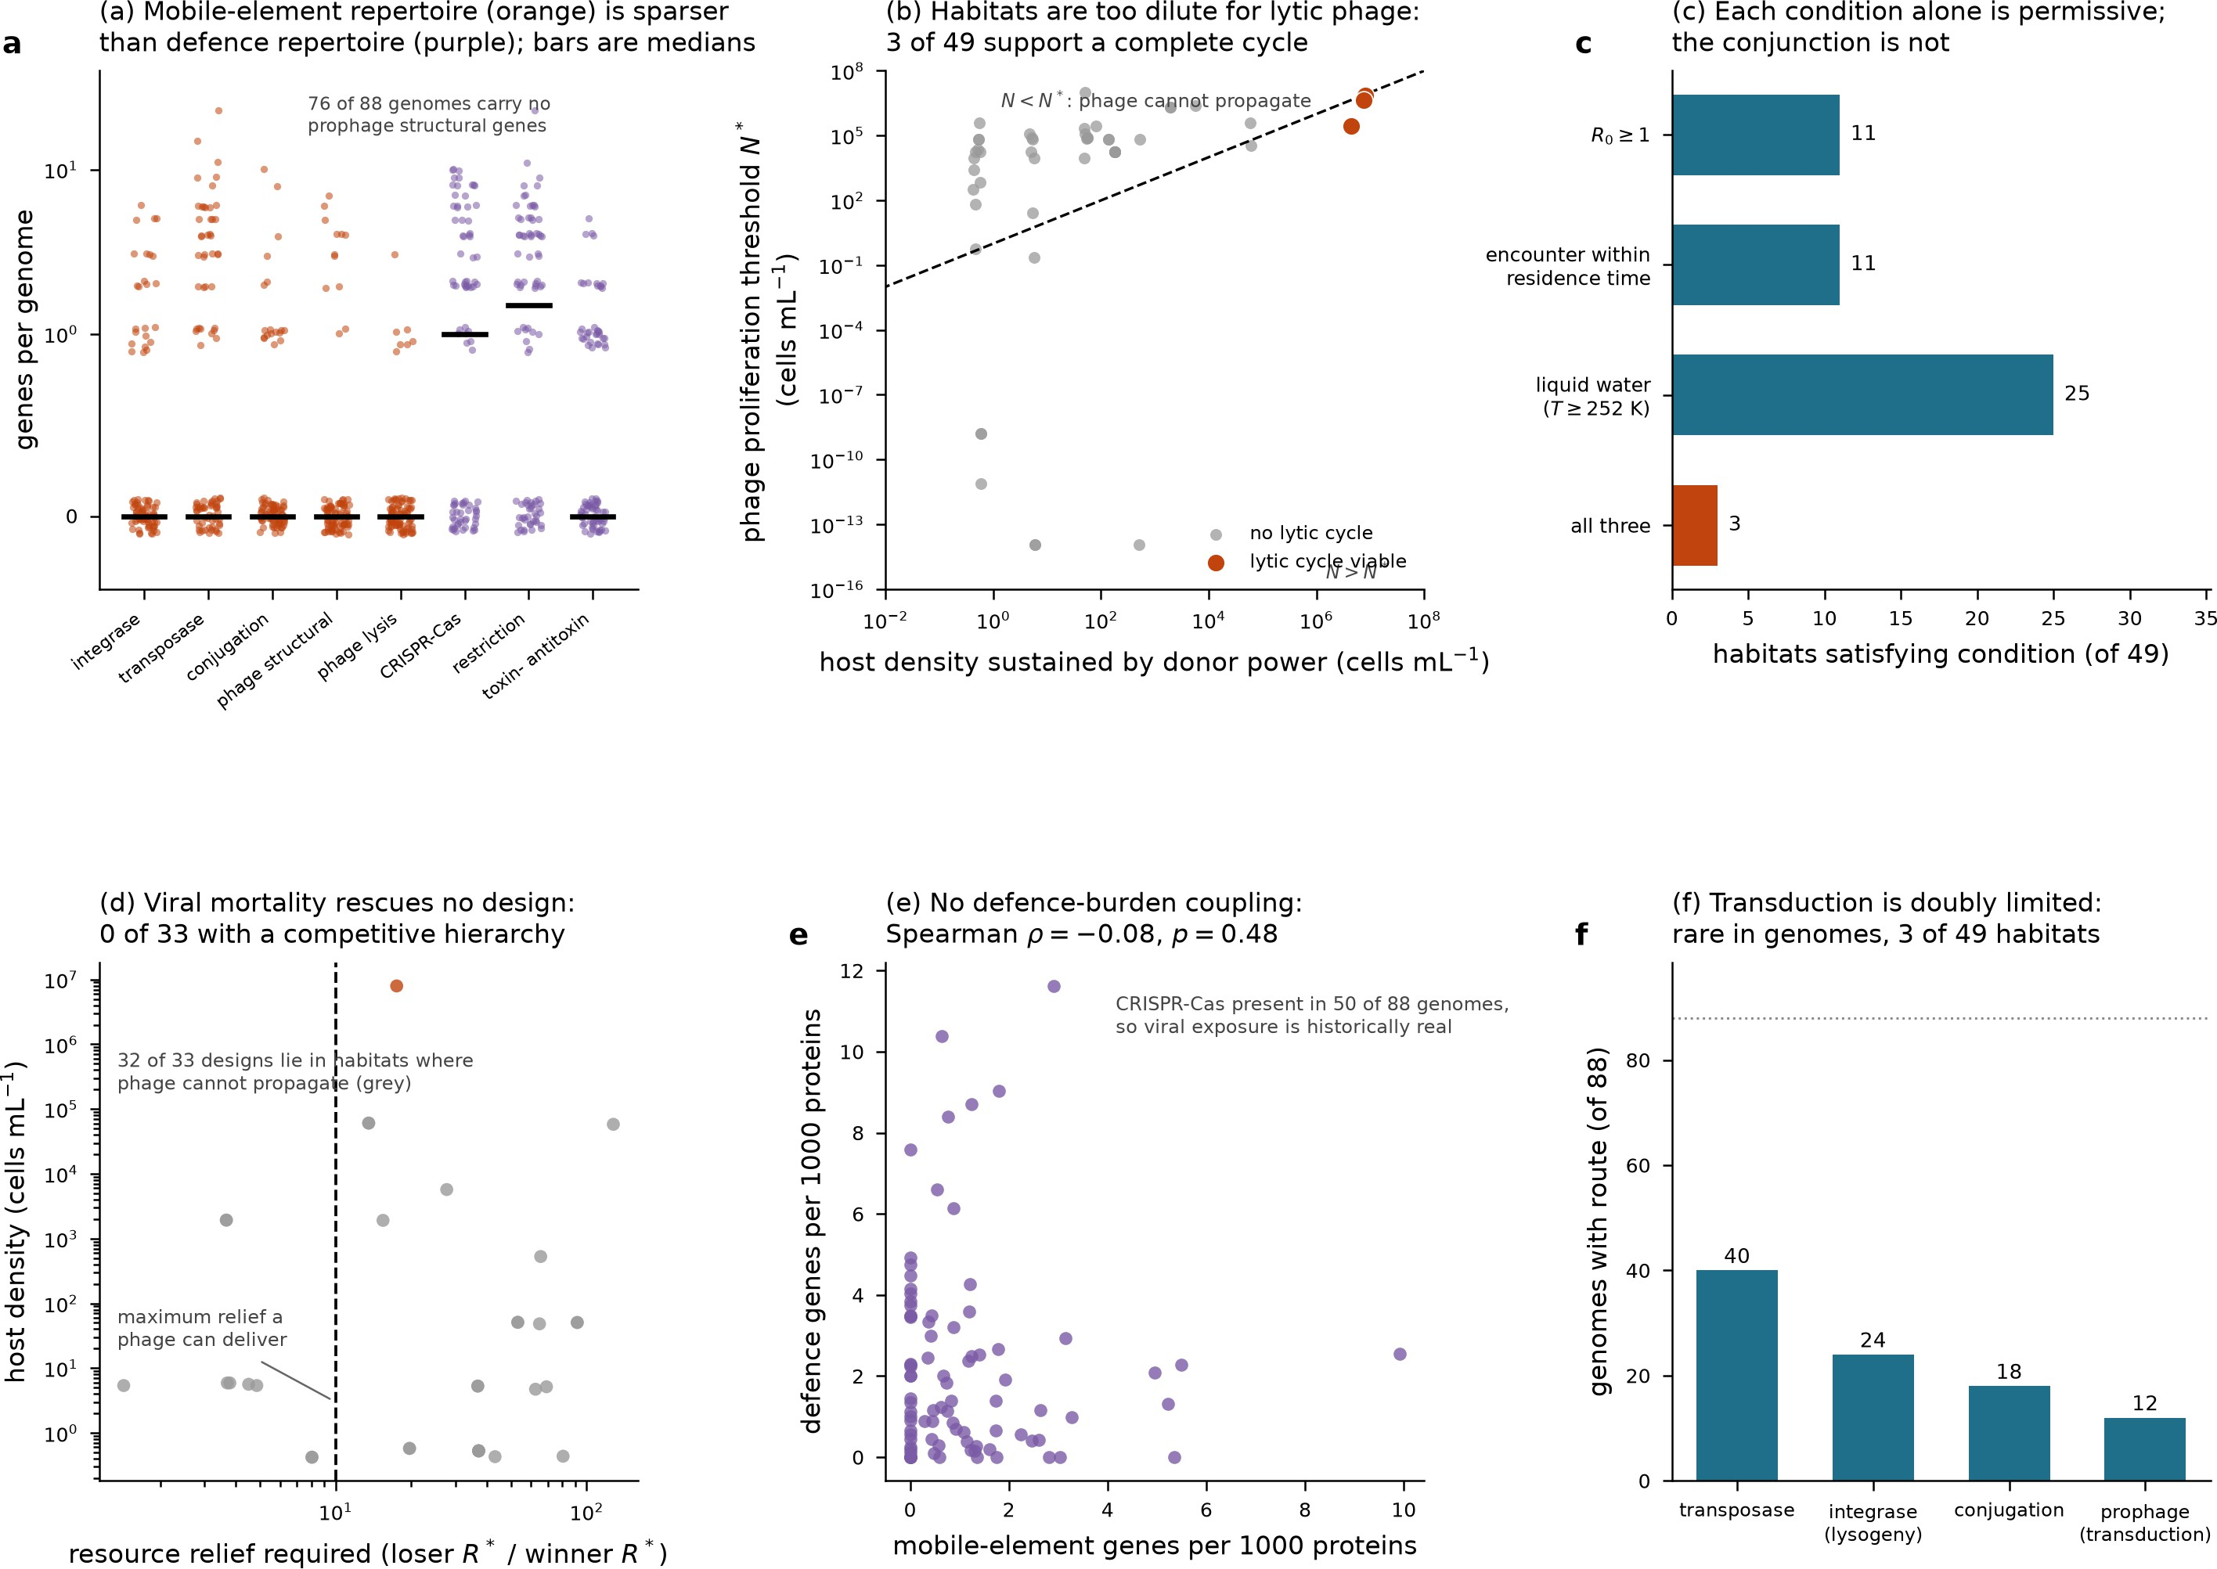

132 Figure S11. Mobile-element and defence gene traits limit phage
133 propagation and consortium stability across habitats. Panel a
134 shows genes per genome (log and zero-inflated axes) for seven
135 gene categories, orange (mobile-element) versus purple
136 (defence), with median bars. Panel b plots phage proliferation
137 threshold against host density, gray points "no lytic cycle,"
138 orange "lytic cycle viable," dashed diagonal separating N<N*
139 from N>N*. Panel c bars habitats (of 49) satisfying R0≥1,
140 encounter within residence time, liquid water, and all three (11,
141 11, 25, 3). Panel d plots host density against resource relief
142 required, dashed vertical line at 10, one orange outlier. Panel e
143 scatters defence versus mobile-element genes per 1000 proteins.
144 Panel f bars genomes (of 88) with transposase, integrase,
145 conjugation, prophage routes (40, 24, 18, 12), dotted reference
146 line near 88.

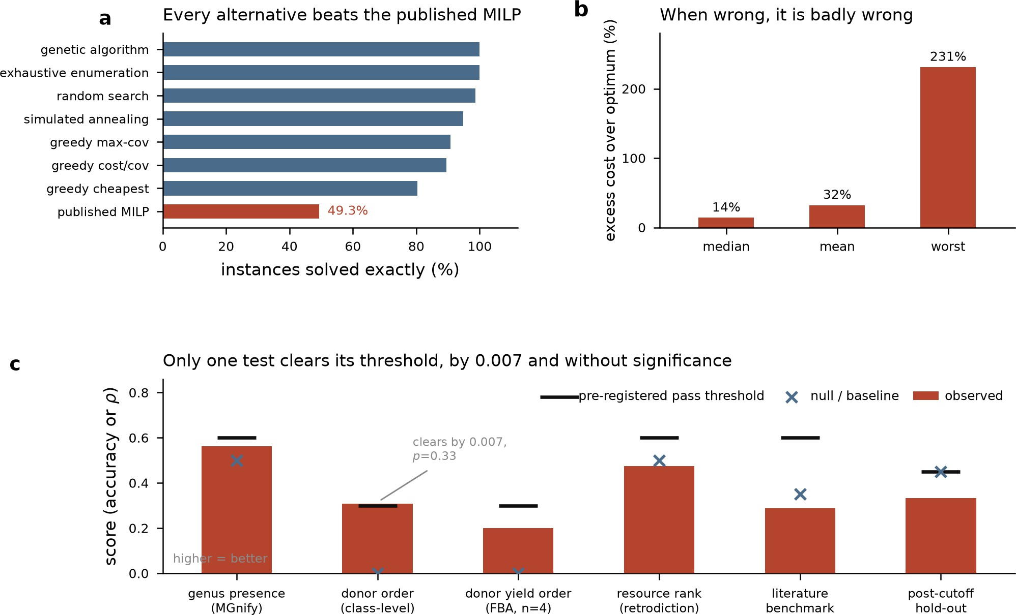

147 Figure S12. Alternative solvers outperform the published MILP,
148 which errs badly when wrong. Panel a: horizontal bars show
149 percentage of instances solved exactly for genetic algorithm,
150 exhaustive enumeration, random search, simulated annealing,
151 greedy max-cov, greedy cost/cov, greedy cheapest (blue), and
152 published MILP (red, 49.3%). Panel b: bars show excess cost
153 over optimum (%) for median (14%), mean (32%), and worst
154 (231%). Panel c: six tests plot observed scores (red bars) against
155 pre-registered pass thresholds (black lines) and null/baseline
156 values (blue X), with one annotated as clearing its threshold by
157 0.007, p=0.33.
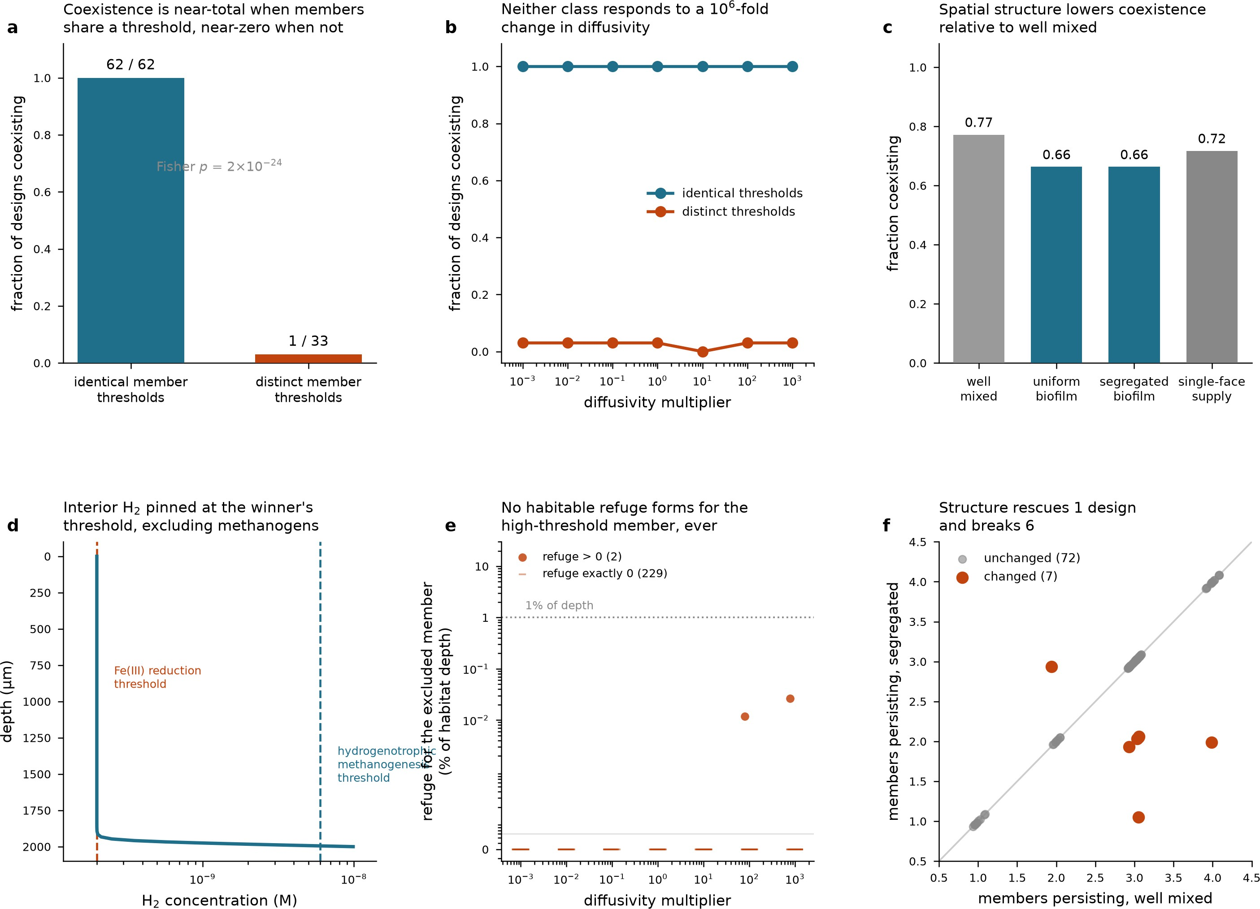

158 Figure S13. Threshold sharing, diffusivity, and spatial structure
159 jointly determine microbial coexistence outcomes. Panel a: bar
160 chart of coexistence fraction for identical (62/62) versus distinct
161 (1/33) thresholds, with Fisher p=2×10−24. Panel b: line plot of
162 coexistence fraction versus diffusivity multiplier (10−3–103) for
163 identical (teal, ~1.0) and distinct (orange, ~0.03) thresholds.
164 Panel c: bar chart of coexistence fraction across well mixed
165 (0.77), uniform biofilm (0.66), segregated biofilm (0.66), and
166 single-face supply (0.72). Panel d: H2 concentration versus
167 depth, showing profile pinned near the Fe(III) reduction
168 threshold (dashed orange) and methanogenesis threshold (dashed
169 teal). Panel e: log-scale refuge size (% habitat depth) versus
170 diffusivity multiplier; orange dots mark refuge>0 (2 cases),
171 dashes mark refuge exactly 0 (229 cases), dotted line marks 1%
172 of depth. Panel f: scatter of members persisting, segregated
173 versus well mixed, with unchanged (gray, 72) and changed
174 (orange, 7) points relative to the diagonal.
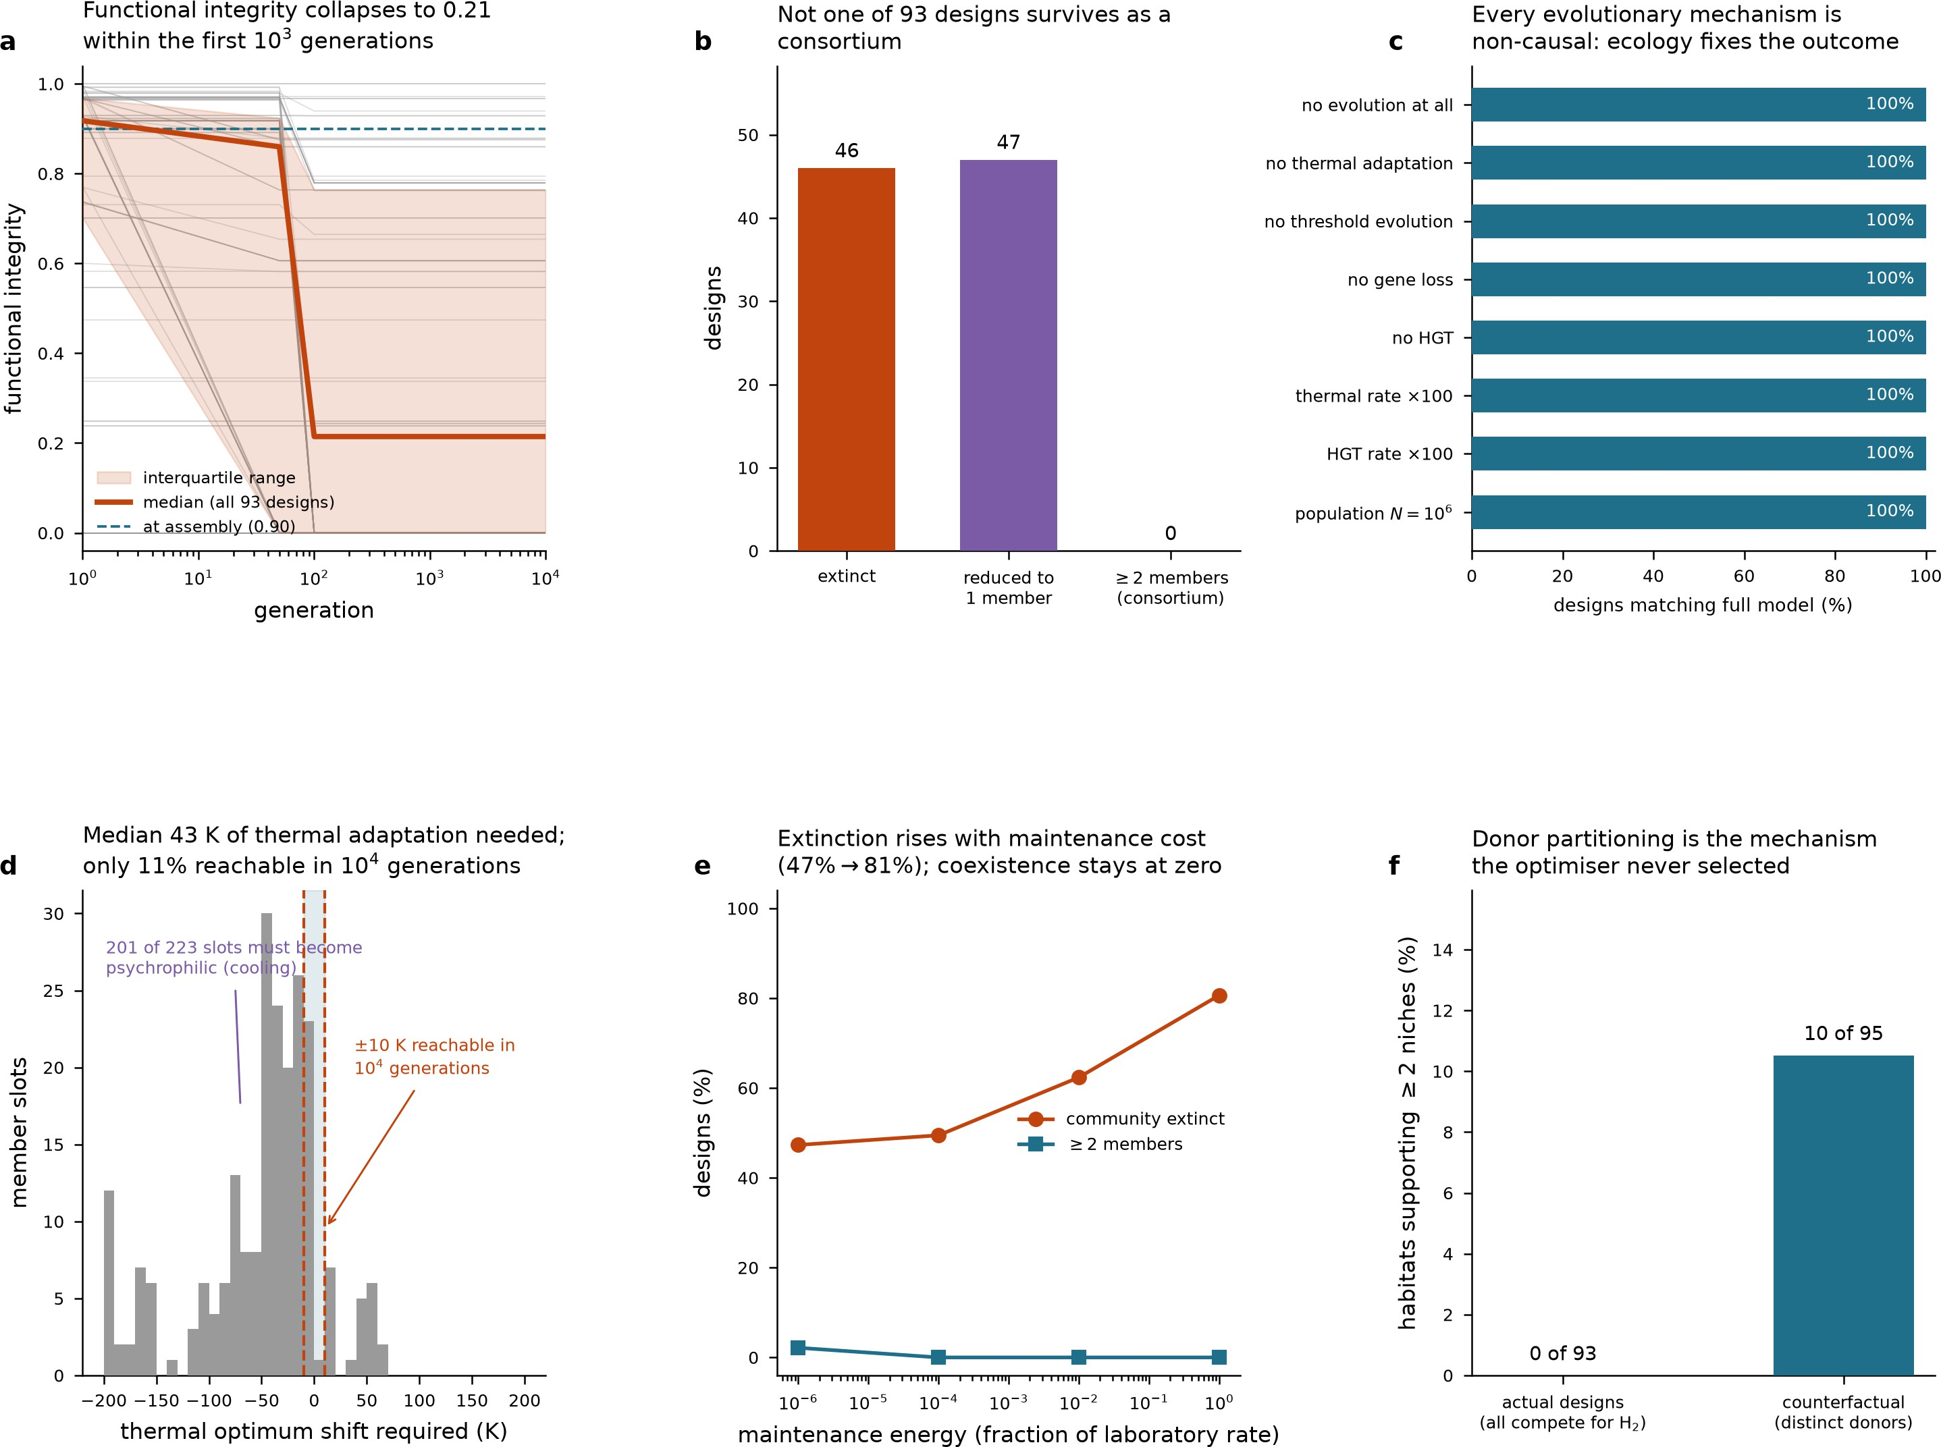

175 Figure S14. Simulated microbial consortia collapse and fail to
176 coexist despite evolutionary and ecological perturbations. Panel a
177 plots functional integrity versus generation (log scale) for 93
178 designs, showing individual traces, interquartile range (shaded),
179 median (orange line, dropping to 0.21), and assembly value
180 (dashed line, 0.90). Panel b bar chart: 46 extinct, 47 reduced to
181 one member, 0 consortia. Panel c bars show 100% match to full
182 model across eight perturbations. Panel d histogram of thermal
183 optimum shift required, with annotated ranges. Panel e shows
184 extinction and coexistence percentages versus maintenance
185 energy. Panel f bars compare habitats supporting ≥2 niches: 0 of
186 93 actual designs versus 10 of 95 counterfactual designs with
187 distinct donors.
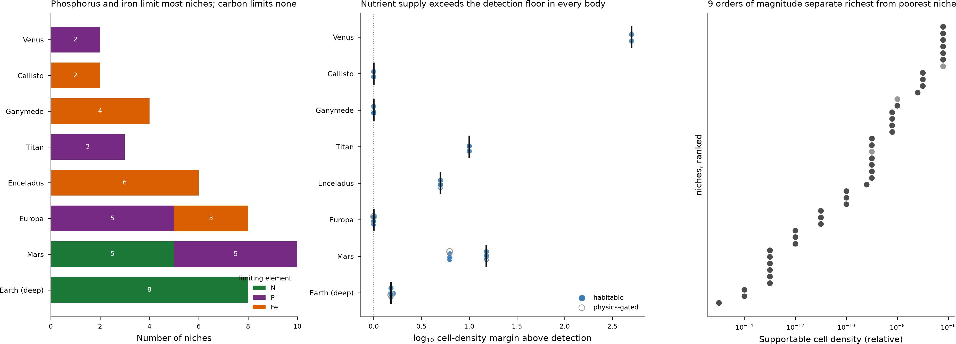
188 Figure S15. Nutrient limitation, detection margin, and
189 cell-density range vary widely across planetary niches. Panel A:
190 horizontal stacked bars of number of niches limited by N (green),
191 P (purple), or Fe (orange) for eight bodies, Earth (deep) through
192 Venus. Panel B: dot-and-error-bar plot of log10 cell-density
193 margin above detection per body, distinguishing habitable (filled
194 blue) from physics-gated (open grey) points, with a dotted
195 zero-reference line. Panel C: dot plot of supportable cell density
196 (log-scaled, relative units) for niches ranked low to high,
197 spanning roughly nine orders of magnitude.

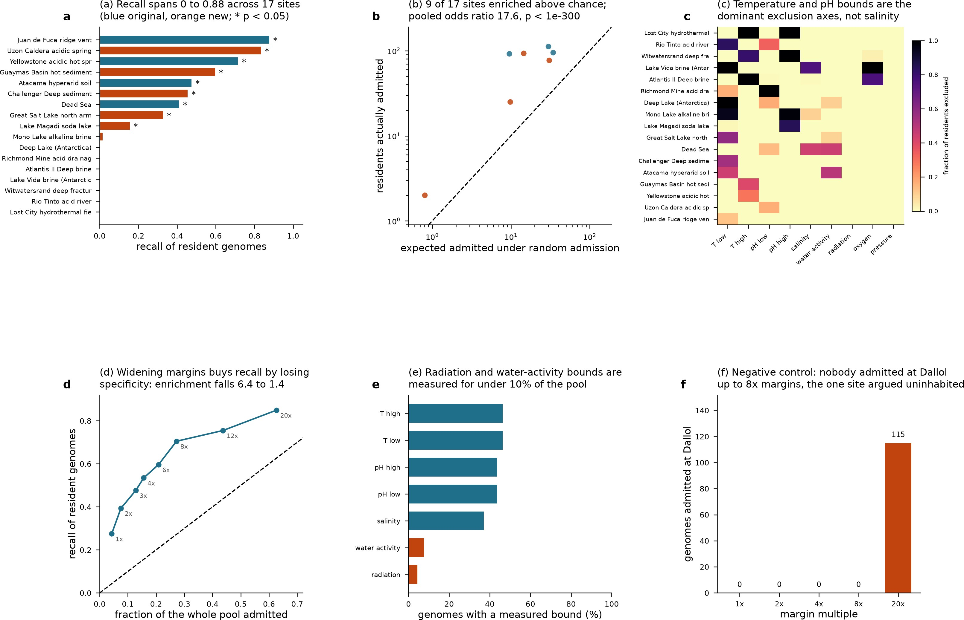
198 Figure S16. Habitability gate benchmarked against resident
199 genomes across extreme sites and admission margins. Panel a:
200 horizontal bars of recall (0 to 1.0) for 17 sites, blue (original) and
201 orange (new), asterisks mark p<0.05. Panel b: log-log scatter of
202 expected versus actual admitted residents, dashed identity line,
203 pooled odds ratio 17.6. Panel c: heatmap of exclusion fraction
204 (0-1.0, yellow to black) for sites across bounds (T low/high, pH
205 low/high, salinity, water activity, radiation, oxygen, pressure).
206 Panel d: recall versus fraction of pool admitted across margin
207 multiples (1x-20x), dashed identity line. Panel e: horizontal bars
208 showing percent of genomes with measured bounds per
209 parameter. Panel f: bar chart of genomes admitted at Dallol
210 across margins 1x-20x, all zero except 20x (115).
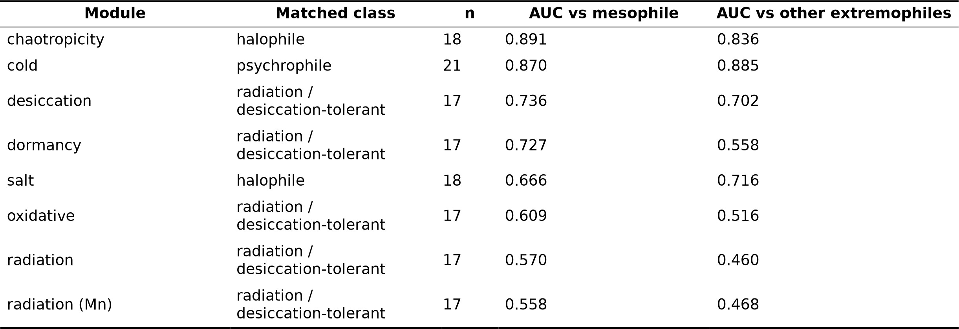

211 Table S1. Module discrimination against a mesophile null and
212 against a phenotype-matched extremophile null.
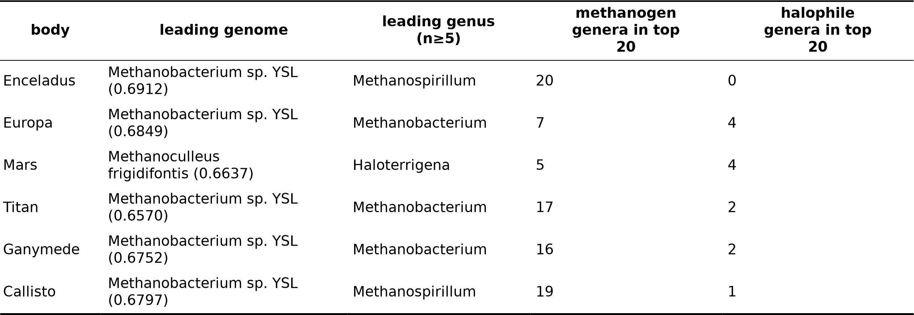

213 Table S2. Leading genome and genus per body, with
214 methanogen and halophile representation in the top twenty.

215 S1. Full-length text
216 S1.Introduction
217 Space microbiology began as anxiety about spacecraft
218 carrying terrestrial microbes outward or returning with
219 something unknown, and matured into systematic study of
220 how organisms respond to launch, orbital exposure,
221 microgravity and the physical extremes beyond the
222 atmosphere (Horneck et al. 2010). The environment
223 encountered combines vacuum, desiccation, temperature
224 cycling, galactic cosmic rays, solar particle events and
225 unattenuated ultraviolet radiation; the field's central
226 strategy has been to decompose this compound stressor by
227 exposing organisms to subsets of it (Merino et al. 2019).
228 Long-duration exposure of Bacillus subtilis spores
229 established ultraviolet radiation as the dominant killing
230 agent in low Earth orbit, and showed that shielding by
231 even micrometre-scale dust or by the outer layers of a
232 spore clump markedly extends survival (Horneck et al.
233 1994; Horneck et al. 2001). The EXPOSE facilities on the
234 International Space Station made this a repeatable
235 platform (Rabbow et al. 2009, 2014, 2017), and successor
236 missions broadened the roster beyond spores:
237 cyanobacteria of the genus
238 Chroococcidiopsis (Billi et al. 2013), lichens and their
239 component fungi and algae (de la Torre et al. 2010; Brandt
240 et al. 2014), the lichen Xanthoria elegans (Ott et al. 2017,
241 2019), and endolithic and cryptoendolithic communities in
242 mineral matrices, including phototrophs surviving 548
243 days in low Earth orbit under selection favouring the most
244 protected and pigmented cells (Cockell et al. 2011).
245 BIOMEX extended the question from survival to the
246 stability of biosignature molecules themselves (de Vera et
247 al. 2019), while Tanpopo tested the interplanetary-transfer
248 hypothesis directly by exposing cell aggregates on the ISS
249 exterior and measuring survival as a function of aggregate
250 thickness (Kawaguchi et al. 2013, 2016, 2020; Yamagishi
251 et al. 2009); it remains the strongest empirical constraint
252 on lithopanspermia, complementing dynamical estimates
253 of transfer times between terrestrial planets (Morbidelli &
254 Gladman 1998). Tardigrades survived direct space
255 exposure, extending the demonstration to animals
256 (Jönsson et al. 2008). Deinococcus radiodurans became
257 the reference organism for extreme ionising-radiation
258 resistance; its study reframed the mechanism away from
259 exotic repair chemistry towards genome copy number,
260 efficient reassembly of fragmented chromosomes and
261 management of oxidative secondary damage (Lim et al.
262 2018) — radiation resistance, in the best-studied case, is a
263 downstream consequence of general cellular architecture
264 rather than a dedicated module, a conclusion our own
265 module validation reaches independently.
266 Archaea entered this literature through physiological
267 range rather than orbital exposure: the domain contains

268 organisms defining the outer envelopes of temperature,
269 salinity and anaerobic energy metabolism (Leigh et al.
270 2011), and its deep phylogenetic position has invited the
271 argument that archaeal physiology resembles conditions
272 under which life originated (Battistuzzi et al. 2004).
273 Methanogens tested under simulated martian conditions
274 survived desiccation, freeze–thaw, low pressure and
275 perchlorate exposure to a degree that surprised the field
276 (Morozova et al. 2006; Morozova & Wagner 2007;
277 Schirmack et al. 2015; Shcherbakova et al. 2015; Maus et
278 al. 2020); their appeal is double, as strict anaerobes
279 running on H₂ and CO₂ — the energy couple most
316 experiments rather than from opportunity or funding. The
317 organism roster is a convenience sample: every flown
318 archaeon was chosen for cultivability, shippability and
319 revivability, and the same handful recur across two
320 decades of work, against which our survey of 3,531
321 archaeal genomes across 2,069 clades stands in contrast to
322 a flown roster of a few dozen strains. Exposure platforms
323 measure damage tolerance after revival, not whether an
324 organism can acquire energy exceeding maintenance over
325 relevant timescales — a distinction that, as we show,
326 inverts the answer. The stressor-first framing also embeds
327 an untested assumption that the binding constraint on

280 plausibly available in a martian or icy-moon subsurface — 328 persistence is damage rather than energy supply. A fourth

281 and because methane is itself a candidate biosignature
282 (Hays et al. 2017). Haloarchaea supply a complementary
283 case, tolerating desiccation and ionising radiation at levels
284 comparable to bacterial radiation specialists, with survival
285 inside halite fluid inclusions raising the possibility of very
286 long-term dormancy in evaporite deposits (Stan-Lotter &
287 Fendrihan 2015; Breuert et al. 2006; DeVeaux et al.
288 2007); Halobacterium strains have themselves flown and
289 been exposed (Rosenzweig et al. 2010).
290 A parallel literature concerns the built habitat:
291 microgravity alters bacterial virulence and antibiotic
292 response (Taylor 2015; Kim et al. 2013); the ISS has been
293 characterised as a microbial ecosystem in its own right
294 (Checinska et al. 2015; Sielaff et al. 2019; Singh et al.
295 2018; Mora et al. 2016, 2019; Voorhies et al. 2019;
296 Szydlowski et al. 2024; Gomoiu et al. 2016;
297 Vaishampayan et al. 2012); and a third strand proposes
298 microbes as exploration infrastructure — biomining,
299 life-support loops, cyanobacteria-based resource use and
329 gap is that exposure microbiology and planetary
330 geochemistry — radiation dose at Europa's surface,
331 martian brine perchlorate chemistry, the H₂ inventory
332 inferred from Enceladus's plume — rarely interact
333 quantitatively.
334 We built the stressor-first framing into a quantitative
335 framework, weighting it deliberately towards stress
336 tolerance: 53.9% of total weight to stress-tolerance
337 modules against 16.2% for energy metabolism, fixed
338 before any genome was scored. That the ranking was
339 nonetheless driven by the minority energy term is
340 evidence against the framing, obtained under conditions
341 maximally unfavourable to finding it. We tested this via a
342 phenotype-matched null, a thermodynamic recomputation
343 independent of genomic input, habitat-by-habitat
344 resolution, and blind prediction against unused
345 metagenomes, then examined engineering implications
346 through coexistence, spatial, evolutionary, viral and
347 containment analysis, and finally ran a pre-specified

300 crop production (Menezes et al. 2015; Verseux et al. 2015; 348 nine-test validation programme. Four of the nine tests

301 Fahrion et al. 2021; Khodadad et al. 2020). Bacillus
302 subtilis remains the field's empirical backbone, the
303 reference organism for exposure flights since the 1980s,
304 from which almost every design principle derives: shield
305 the genome, dehydrate the cytoplasm, wait.
306 These results are genuine, but all concern survival under
307 exposure, not whether an organism could establish a
308 population where it landed — a spore surviving 548 days
309 in orbit demonstrates resistance to a dose, not access to an
310 electron donor. The canon was never designed to answer
311 that second question, which is why our central finding,
312 that donor flux rather than stress tolerance orders
313 candidates, sits orthogonal to it rather than contradicting
314 it.
315 Three limitations follow from the design of exposure
349 returned adverse verdicts, one — phylogenetically
350 blocked cross-validation — bounding every predictive
351 claim in the paper; a framework's credibility rests on what
352 it says about its own limits, not its headline confirmations.
353 We conducted a genome-scale persistence survey of 3,531
354 archaeal genomes, with a control arm of 215 bacterial
355 genomes (119 curated extremophiles across seven
356 phenotype classes and 96 mesophiles as a null set),
357 assessed against 58 parameterised niches across 9 bodies;
358 11 of 18 candidate adaptation modules were retained after
359 validation.
360 Under adversarial weighting, four independent methods
361 confirmed that the operative variable is electron-donor
362 flux rather than stress tolerance. A habitat-by-habitat
363 energetic analysis identified which electron-accepting

364 couple dominates in each setting and showed why the 410 organism would establish there, since none would. Eight
365 dominant couple is not the most efficient one. Independent 411 are argued uninhabited — a positive assertion that no

366 negative results from module validation, shielding
367 physics, and transit chemistry all argued against a
368 radiation-centred framing.
369 An engineering-cost layer covering 1,288 catalogued edits
370 provided a closed-form account of why its optima are
371 structured as observed. A consortium-design layer,
372 incorporating coexistence, spatial reaction–diffusion,
373 eco-evolutionary, viral and biocontainment analyses,
374 found its central coexistence constraint to be nearly inert.
375 Validation comprised nine tests, 47 numbered
376 self-corrections, and 62 explicit limitations, with all 301
377 tables released.

378 S1.Results

379 The habitat catalogue and the niche classification
380 Of the 58 catalogued niches, 37 pass both pre-genomic
412 terrestrial-type life could be present, not merely an
413 absence of candidates. Conflating survival-only with
414 growth-permissive niches is the likeliest route to
415 over-reading the ranking, hence the per-niche tables are
416 released for audit.

417 Module and family validation against a matched null
418 Of eighteen candidate modules, eleven survived
419 validation. Against a mesophile null every retained
420 module discriminated its target phenotype (AUC
421 0.558–0.891, Figure 2) — the conventional result, and a
422 misleading one. Against a phenotype-matched
423 extremophile null, AUCs fell to 0.460–0.885, with
424 radiation and radiation_mn at or below 0.5: they carry no
425 information once compared against other extremophiles
426 rather than ordinary organisms (Table S1).
427 This applies specifically to those two. Radiation-repair

381 gates, 4 fail on temperature alone and 17 on water activity; 428 machinery is broadly enriched in extremophiles, so a

382 discriminating power was verified rather than assumed,
383 since conditions span twelve orders of magnitude in
384 annual radiation dose (1e-04 to 1.2e+08 Gy yr−1), ionic
385 strengths from fresh water to 18 M, and pressures from
386 1e-11 to 1e+05 bar — from below 1 mbar at the martian
387 surface to roughly 1,100 bar at the base of the deep
388 continental crust (Figure S1).
389 The gates perform as expected where the outcome is
429 mesophile-null comparison mistakes this general
430 enrichment for radiation-specific signal; against
431 radiation-intolerant extremophiles it no longer
432 distinguishes. This converges genomically with the
433 Deinococcus literature's mechanistic finding that radiation
434 resistance is a byproduct of genome architecture and
435 oxidative-stress management, not a dedicated capability.
436 The headline ranking is independent of radiation

390 independently known: all 9 interplanetary-transit scenarios ⁴³⁷ tolerance: removing both radiation modules leaves the

391 fail, as they must, since no liquid water is present; both
392 Venus cloud-droplet niches fail on water activity
393 (0.30–0.35), consistent with concentrated sulfuric-acid
394 composition; and 7 of 10 deep-Earth niches pass, the
395 failures occurring at the hot end where temperature
396 exceeds the growth limit.
397 The 58 niches partition into three classes on measured
398 conditions, mattering because each supports different
399 claims (Figure 1). Thirty-seven are growth-permissive,
400 conditions falling inside the seven biophysical limits with
401 a standing energy supply present. Thirteen are
402 survival-only: an organism placed there could persist
403 dormant or damaged but not divide, typically because
404 temperature falls below the metabolic floor or water
405 activity below 0.605; this class underpins the
406 module-validation work in the module-validation analysis,
407 where curated extremophiles outscore the mesophile null
408 in all 13 cases (AUC 0.694–0.812, median 0.717, p<0.05
409 in 13 of 13), but cannot support claims about which
438 leaders unchanged.
439 Of 73 candidate bacterial families, only 23 discriminate
440 extremophiles from mesophiles; the best, peroxiredoxin
441 AhpC/TSA (PF00578), reaches AUC 0.719, the ceiling
442 for single-family evidence. Catalase (PF00199, 0.386) and
443 the glycine-betaine transporter OpuAC/ProX (PF04069,
444 0.375) run backwards, being more abundant in
445 mesophiles. Sign-correction raises the panel from 0.718 to
446 0.863; an in-sample top-5 AUC of 0.838 falls to a nested
447 0.800.
448 Module AUCs: methanogenesis 0.925, sulfate reduction
449 0.912, iron cycling 0.810, cold 0.89, chaotropicity 0.84,
450 nitrogen fixation 0.83, salt 0.72, iron uptake and
451 3-hydroxypropionate carbon fixation 0.73 each,
452 desiccation 0.70, sulfur assimilation 0.67; radiation (0.46),
453 manganese antioxidant (0.47), oxidative stress (0.52) and
454 dormancy (0.56) do not discriminate. Against matched
455 extremophile classes, chaotropicity holds at 0.891 and
456 cold at 0.870, while radiation scores 0.570 against

457 mesophiles and 0.460 against other extremophiles. The
458 Wood–Ljungdahl module scored 0.274 against 710
459 methanogens versus 0.925 for the methanogenesis module
460 on the same organisms, because marker PF03308 is
461 under-represented in methanogens' divergent archaeal
462 complex; a separate apparent failure (0.398) instead traced
463 to a positive set that was 95% ammonia-oxidising
464 Thaumarchaeota. Desiccation and sulfate reduction fail
465 the diagnosticity criterion (maximum family TPR−FPR
466 below 0.40), leaving 9 of 11 retained modules diagnostic.
467 The IVYWREL amino-acid fraction correlates with
468 optimal growth temperature at r = 0.916 across 550
469 species (Archaea r = 0.920, cv r2 = 0.906, n = 483;
470 Bacteria r = 0.874, cv r2 = 0.731, n = 67), predicting
471 temperature at genus-held-out r2 = 0.89 (MAE 5.0 °C; a
472 single amino-acid ratio alone r2 = 0.83) — outperforming
473 the curated gene panel's binary classification, implying
474 gene content adds little over composition for thermal
475 phenotype.
476 Phylogenetic correction left family-level AUCs almost
477 unchanged (median shrinkage −0.003; 226 genomes
478 resolve into 208 label-pure clades) but removed 18 of the
479 top 50 archaeal organism-niche assignments as
480 pseudoreplicates; radiation-module families shrank most
481 (PF12344 0.580→0.551; PF01022 0.570→0.552).
482 The composite index separates bacterial extremophiles
483 from mesophiles at Cliff's δ = +0.57 (large), and
484 extremophile class predicts capability for every target
485 body (Kruskal–Wallis: Mars H = 27.3, p = 1.27×10 −4;
486 Europa p = 2.26×10−4; Enceladus p = 5.78×10−3), with
487 psychrophiles highest on cold (0.74), the
488 radiation/desiccation-tolerant class highest on desiccation
489 (0.65), and piezophiles and halophiles highest on salt and
490 ionic transport (0.68, 0.61).
491 Archaea occupy 95% of the clade-collapsed top 100, but
492 the corpus is 94.3% archaeal, so this reflects sampling, not
493 biology: against bacterial extremophiles alone the
494 advantage is small (δ = +0.25, p = 4.9×10 −6), and against
495 mesophiles (11 archaea, 96 bacteria) δ = +0.231, p =
496 0.213, too weak to support a claim; genus-level
497 aggregation gives 0.606 versus 0.407 (p = 0.0035,
498 Mann–Whitney, 143 and 132 genera), still far weaker than
499 the genome-level odds ratio of 2.72 would suggest —
500 hence no Archaea-versus-Bacteria claim is made.
501 Weighting sensitivity across equal, prior-derived,
502 AUC-informed and random Dirichlet vectors leaves
503 global ordering stable (Spearman 0.861–0.983 against
505 0.243–0.538): class ordering is supportable, shortlist
506 identity is not.
507 Testing against a mesophile null versus other
508 extremophiles asks whether a module identifies its named
509 adaptation rather than extremophily in general. Against
510 mesophiles all eight modules would have passed; against
511 matched extremophile controls only cold (0.885) and
512 chaotropicity (0.836) retained discrimination, cold
513 performing better against other extremophiles than against
514 mesophiles — the signature of a specific adaptation. The
515 remaining four stress modules lost all discrimination
516 under matching, both radiation modules inverting below
517 0.5.
518 Among nutrient and energy modules, methanogenesis
519 scores 0.925 on 710 methanogen genera (p = 5.2×10 −294),
520 sulfate reduction 0.912 (n = 32), iron cycling 0.810 (n =
521 19), nitrogen fixation 0.834 on 73 diazotrophs against
522 3,673 controls. Two carbon-fixation modules run
523 backwards: the bacterial Wood–Ljungdahl marker
524 (PF03308 AcsB) at 0.274 against the same methanogens,
525 and the Calvin-cycle module at 0.360, since RuBisCO-like
526 proteins are not RuBisCO; the 3-hydroxypropionate route
527 validates at 0.728. Nitrate respiration was untestable (n =
528 3). The energy modules that pass show the framework's
529 largest effect sizes; the stress modules that fail do so
530 against the organisms they were designed for.

531 The persistence ranking and its per-body structure
532 Across all bodies, Methanobacterium sp. YSL leads with a
533 mean score of 0.6751, and hydrogenotrophic methanogens
534 dominate the top ranks, with Kruskal–Wallis tests
535 confirming significant separation between metabolic
536 classes on every body (Table S2). The ranking nonetheless
537 varies by body, restricted to genera with at least five
538 genomes so single-genome artefacts cannot lead (Figure
539 3): Enceladus is the purest case, with 20 of the top twenty
540 genera being methanogens and none halophiles; Callisto
541 follows at 19, Titan at 17, and Ganymede at 16. Mars is
542 the diagnostic exception, with only 5 of its top twenty
543 genera being methanogens; its leading genus is the
544 haloarchaeon Haloterrigena, and its leading individual
545 genome is the methanogen Methanoculleus frigidifontis,
546 immediately followed by the halophile Halogranum
547 rubrum. Europa lies between the extremes, with 7
548 methanogen genera and 4 halophile genera. This pattern
549 tracks niche parameters rather than genome identity:
550 martian water activity ranges from 0.30 to 0.95 with ionic
551 strength up to 7.0 M in perchlorate brines, versus

504 equal weighting) while top-20 membership varies (Jaccard 552 0.90–0.98 and at most 0.5 M on Enceladus, so Mars's

553 salinity problem promotes halophiles, mirroring the
554 habitat-tracking behaviour of the bacterial control arm.
555 At genus level, Enceladus is led by Methanothrix (0.64),
556 Methanospirillaceae (0.62) and Methanospirillum (0.62);
557 Europa by Methanothrix (0.62), Halogranum (0.61) and
558 Methanobacterium (0.60); Mars by Halomicrococcus
559 (0.62), Natronoglomus (0.62) and Halogranum (0.61),
560 with Halogranum shared between Europa and Mars
561 reflecting Europa's saline, reduced ocean. Two caveats
562 bound these leaders: score differences (0.60–0.64) fall
563 within the shortlist instability already quantified (top-20
564 Jaccard 0.243–0.538, the module-validation analysis), so
600 processing removes H₂ while generating oxidised
601 nitrogen. Nitrate reduction is also the most favourable
602 couple per electron in the whole catalogue (−86.76 kJ mol
603 e−1).
604 In ice surfaces and methane-bearing settings, anaerobic
605 methane oxidation wins in 5 niches (Europa's irradiated
606 surface ice and ice–ocean interface, Ganymede's and
607 Callisto's surface ice, and Mars's deep subsurface), with
608 modest energy densities of 0.0669–0.1787 J L−1 and CH₄
609 limiting throughout — radiolytically produced in the ice
610 cases, of uncertain origin at Mars.
611 Nitrate reduction's median exploitable energy density

565 the class of leader is a reliable claim but the specific genus ₆₁₂ (0.0004 J L−1) is nonetheless 317-fold below

566 is not; and because 3,520 archaeal assemblies were
567 surveyed automatically against only 215 hand-curated
568 bacterial genomes (119 extremophiles, 96 mesophiles),
569 archaea's 69% share of the clade-collapsed top 100 is
570 actually a depletion relative to their 90.5% corpus share,
571 precluding any statement comparing Archaea against
572 Bacteria. In the bacterial arm, the top-scoring niche is led
573 by a haloalkaliphile (1.06) and Alkalilimnicola ehrlichii
574 MLHE-1 (1.04), followed by the Enceladus plume
575 conduit.

576 Which redox couple dominates each habitat
577 Medians across niches show methanogenesis dominant on
578 exploitable energy density, but resolving the winner per
579 niche across the 15 energetically characterised habitats
580 reveals three regimes, each defined by which donor or
613 methanogenesis's (0.1269), because nitrate is essentially
614 absent in 12 of 15 niches: thermodynamically superb but
615 substrate-starved, winning by orders of magnitude only
616 where present and where H₂ is destroyed. Thus the
617 limiting variable is standing flux of donor or acceptor, not
618 reaction efficiency: methanogenesis wins overall because
619 H₂ is widely available, despite being one of the least
620 exergonic couples per electron. Correspondingly,
621 methanogenesis is exergonic in 100% of niches versus
622 27% for sulfate reduction, the catalogue's weakest couple
623 with H₂ (median 0.0000 J L−1, never winning);
624 acetogenesis (median 0.0152) and Fe(III) reduction
625 (median 0.0001) are likewise exergonic in most niches yet
626 never win — exergonicity is necessary but far from
627 sufficient.

581 acceptor is scarce, and confirms the mechanism | 628 | Weight decomposition and the proteome-size confound
582 unambiguously (Table 1). | 629 | The scoring function assigned 53.9% of weight to
583 In reduced, H₂-bearing settings, methanogenesis wins in 7 | 630 | stress-tolerance modules and 16.2% to energy
584 of 15 niches. Enceladus's subsurface ocean (10.6179 J L−1 | 631 | metabolism, with methanogenesis specifically at 5.4% and
585 ) and plume conduit (9.9646 J L−1) are the richest niches | 632 | the residual 29.9% distributed among modules belonging
586 in the catalogue, followed by the seafloor hydrothermal | 633 | to neither block (nutrient acquisition, dormancy, sulfur
587 systems of Enceladus (3.1583) and Europa (2.0978). The | 634 | assimilation, iron uptake). Despite this prior favouring
588 subsurface oceans of Callisto, Ganymede and Titan, and | 635 | stress tolerance, regressing the final ranking on each block
589 Europa's ice–ocean interface, converge identically on | 636 | separately inverted the ratio: the energy block explained R
590 0.1269 J L−1, since all four share the same | 637 | 2 = 0.637 of ranking variance versus R2 = 0.294 for the
591 serpentinisation-derived H₂ inventory. H₂ is limiting in | 638 | stress block. Because the weights were fixed before
592 every case. | 639 | scoring and never adjusted, this reversal reflects the data
593 In oxidised near-surface and brine settings, nitrate | 640 | overriding the prior rather than a tuning artefact.
594 reduction wins in 3 of 15 niches: Mars's UV-exposed | 641 | The largest confound in the survey is proteome size. Mean
595 shallow regolith (4.3378 J L−1), Europa's near-surface | 642 | niche score correlated with proteome size at ρ = 0.732,
596 brine pocket (4.1638) and Mars's RSL-type subsurface | 643 | and log₁₀ proteome size alone explained 53.6% of raw
597 brine (4.1590). These are exactly the niches where | 644 | score variance, since any module count rises with the
598 methanogenesis collapses, to 0.0001, 0.0000 and 0.0000 J | 645 | number of proteins available to count. Between-body rank
599 L−1 respectively, because radiolytic and photochemical | 646 | correlations across all 3,531 genomes ranged from ρ =

647 0.873 to near unity (median 0.97), and singular value
648 decomposition of the genome-by-body score matrix
649 placed 97.1% of variance on the first component,
650 indicating the per-body rankings are nearly a single
651 ranking driven largely by this size-related generalist axis.
652 This confound reversed one of the framework's headline
653 weights: cold adaptation, the most heavily weighted
654 module (1.707), correlated negatively with raw score (ρ =
655 −0.289) because cold-adapted genomes are systematically
656 smaller (ρ = −0.468); after controlling for size, the
657 association was absent (ρ = +0.027). Genome size itself
658 explained R2 = 0.536 of ranking variance — substantial,
659 and reported rather than dismissed. Against raw scores,
660 energy-acquisition explained R2 = 0.451 versus R2 =
661 0.369 for stress-tolerance, a narrow margin; controlling
662 for size widened this to the 0.637 versus 0.294 gap above,
663 showing the confound had masked rather than produced
664 the result. Methanogens occupied every leading position
665 on every body — 100% of the top ranks — while carrying
666 only 5.4% of total weight.

667 Thermodynamic confirmation without genomic input
668 The thermodynamic analysis used no genomic
669 information: free energies were computed from measured
670 and modelled geochemistry and multiplied by
671 limiting-species concentration, recovering methanogens as
672 best matched to the most widely available energy source,
695 has a median in-situ yield of −7.4 kJ per reaction, below
696 the energy quantum, thermodynamically usable in zero
697 niches.
698 Per-electron ranking is misleading: iron(III) reduction
699 wins per electron, but Fe(III) is insoluble under most
700 conditions, so the acceptor is unavailable at assumed
701 concentrations. Ranked by volumetric energy density
702 (yield × limiting-species concentration), the Enceladus
703 subsurface ocean leads at 10.6 J L−1, the Enceladus plume
704 conduit follows at 9.96 J L−1, then the Europa near-surface
705 ocean — the same yield-versus-flux distinction seen for
706 methanogenesis, hence all energetic claims here use
707 density rather than yield.
708 The thermodynamic layer was benchmarked beforehand:
709 four of five benchmark reactions reproduce published
710 standard free energies within 1.0 kJ mol−1, the fifth
711 deviating more but reported, not dropped. Overall, 80.0%
712 of evaluated reactions are exergonic in situ. A second
713 check confirmed that where fluid composition approaches
714 equilibrium with host mineralogy, computed free energies
715 approach zero, indicating the energy densities are not
716 artefacts of arbitrary activities. Energies are reported per
717 mole of electrons transferred, since electron stoichiometry
718 differs (methanogenesis: eight electrons; nitrate reduction
719 to N₂: five per nitrate); per-reaction, methanogenesis
720 appears competitive, but per-electron it is clearly less
721 favourable (−6.34 versus −83.18 kJ mol e−1), though it

673 with no scoring function, weights or module definitions. A 722 still wins on exploitable density.
674 method sharing none of the scoring function's machinery

675 cannot be accused of correlating with it. Of 90
676 niche-couple combinations evaluated, 80% are exergonic
677 in situ, but only a minority clear the biological energy
678 quantum, concentrated in H₂-bearing niches;
679 methanogenesis clears this threshold in 80% of niches,
680 and evaluating catabolic reactions at in-situ conditions
681 (thresholds from measured ranges at −10.0 kJ mol−1)
682 yields 225 conservable reactions of 296 tested. The
683 constraint is thus substrate starvation of the exergonic
684 couples, not thermodynamic forbiddenness.
685 At couple level, methanogenesis from H₂/CO₂ is only
686 weakly exergonic at −6.34 kJ mol e−1 but exergonic in
687 100% of niches, never thermodynamically forbidden
688 anywhere in the catalogue. Nitrate reduction delivers 83.2
689 kJ mol e−1 (equivalently −83.18), thirteen times the
690 methanogenesis yield; iron(III) reduction gives 85.9 kJ
691 mol e−1, the highest per electron. Sulfate reduction is
692 exergonic in only 27% of niches, with a median of +1.26
693 kJ mol e−1 — endergonic on average — genuinely
694 unavailable rather than merely starved. One further couple

723 The bacterial control arm returns different winners
724 The bacterial control arm, run through an identical
725 pipeline on 119 curated extremophiles spanning 386,509
726 predicted proteins across seven phenotype classes, returns
727 Acidiphilium multivorum and Acidiphilium cryptum —
728 acidophiles, not methanogens or radiation-tolerant taxa —
729 as leaders (Figure S2). This is the expected behaviour of a
730 framework that tracks habitat properties rather than
731 exporting a fixed answer: the bacterial candidate pool is
732 dominated by acid-tolerant chemolithotrophs, and the
733 ranking reflects that pool. Kruskal–Wallis tests confirm
734 significant between-class separation on every body
735 (maximum p = 0.00578).
736 The module-level analysis also replicates independently in
737 this second domain: against the phenotype-matched null,
738 16 bacterial modules discriminate backwards, with median
739 corrected AUC of 0.627 against a naive 0.589, across 73
740 protein families — the same inflation seen in the archaeal
741 analysis. Scored instead against 96 mesophiles, module

742 discrimination appears strong, but the radiation modules
743 fall to chance once phenotype-matched extremophiles are
744 used, in both domains. This converts the mesophile-null
745 problem from a dataset-specific quirk into a general
746 property of the method, motivating the matched-null
747 protocol.
748 A genome-size confound also runs through both arms:
749 module counts correlate with proteome size (R2 = 0.536),
750 and residualising against size can introduce artefacts when
751 the denominator is small, as when an early pipeline
752 version promoted a 51-protein fragment into the top ranks
753 — hence the 800-protein completeness floor.

754 Three physical constraints found non-binding, and one
755 clock reassigned
756 Gravity cannot deliver nutrients at cell scale anywhere,
757 across any regime tested. Sedimentation Péclet numbers
758 were computed from ISS microgravity to 10 g for an
759 archaeal cell modelled as a sphere at low Reynolds
760 number (density 1100 kg m−3, turgor ≈4 atm, radii 0.2–1.0
761 µm, spanning nano-sized DPANN through typical cocci)
762 (Figure 4). The Péclet number never reaches unity,
763 peaking at 0.624 at 10 g, so diffusion dominates advective
764 transport throughout. A cell settles one body length in
765 2.12 days on Earth versus 2.12 × 106 days on the ISS,
766 giving a fractional enhancement of nutrient delivery of
767 0.0700 on Earth and 7.00 × 10−5 on the ISS. The scaling
768 follows (g·a3)^½, confirmed empirically at log-log r =
769 1.000, so enhancement collapses as radius falls, meaning
770 archaea's small size range only reinforces the conclusion;
771 at the boundary layer the Péclet number is of order 10 −6,
772 and gravity adds at most 0.00056% flux above pure
773 diffusion. The minimum radius at which settling becomes
774 competitive is 0.00333–344 cm, an aggregate scale, not a
775 cell. Convective onset scales as g^(−1/3): across the
776 33-fold gravity range from Enceladus (0.011 g) to Mars
777 (0.38 g), critical layer thickness moves only from 13.1 cm
778 to 4.1 cm, while sedimentation across 1 mm ranges from
779 roughly 13 h (Mars) to 442 h (Enceladus). Gravity thus
780 governs population-scale transport (convection, biofilm
781 detachment, sediment formation), not single-cell
790 acidophiles (0.81) and alkaliphiles (0.78) and lowest in
791 thermophiles (0.66); archaea retain MreB/FtsZ at
792 73%/86%, arguing gravity-sensing is not a capability gap.
793 Radiation shielding requirements, computed for E. coli
794 and D. radiodurans across 0.1–108 year transits, nearly
795 superimpose (minimum 0.01–1.03 × 103 g cm−2; rock
796 radius 0.0033–3.4 × 102cm), showing the requirement is
797 set by duration, not the organism (Figure S3). Thin
798 shielding is counterproductive: secondary particles give
799 0.1767 Gy yr−1 at 3.7 cm basalt versus 0.1501 Gy yr−1
800 free-space (1.18×), with net benefit only beyond 10.8 cm;
801 fragments under ~11 cm are worse than open space.
802 Radiation quality compounds this: D. radiodurans' D₁₀
803 falls from 49,840 Gy (0.2 keV µm−1) to 31,333 Gy (mixed
804 LET) to 6,896 Gy under Jovian heavy ions (150 keV µm−1
805 ), a 7.2-fold loss invisible to gene-content measures.
806 Above 243 K, chemistry outruns radiation as the transit
807 clock: hydrolysis is faster in 45% of scenarios, taking 24.6
808 years at 273 K versus 2.96 × 1010 years at 200 K, a
809 nine-order-of-magnitude span across 73 K. With 90 cm
810 shielding the crossover sits at 233.5 K, above which
811 hydrolysis dominates and shielding cannot help.
812 Radiation-only survival estimates are thus optimistic
813 above ~234 K, covering most warm-interior transfer
814 scenarios; dose spans 8.8 orders of magnitude yet
815 correlates with score at only r = −0.13. Taken with the
816 module-validation result, the radiation-centred framing
817 now carries three independent negative results: genomic,
818 engineering, and chemical.

819 The engineering-cost layer and the solver benchmark
820 Across 1,288 catalogued edits in four classes,
821 minimum-cost designs were computed for all 134
822 habitat-target pairs: median cost is 2.32 bits (range
823 0.15–17.64), with a median of two edits per solution
824 (Figure S4). Ablating class E1 makes every pair infeasible
825 at any price, whereas ablating E4 leaves all pairs feasible
826 but raises cost by exactly 0.982 bits on the 21 pairs that
827 use it, matching the ledger price difference between E4
828 and E1 (2.286 versus 1.304). Classes E2, E3 and E5 never
829 appear in any optimum; E5, at 6.64 bits, is the costliest

782 physiology; documented microgravity effects on microbial ₈₃₀ class in the catalogue.
783 physiology are not transport effects at organism scale, yet

784 that is precisely what exposure experiments test.
785 Consistent with this, mechanoresponse machinery is
786 near-universal in bacteria: MscS, MreB and
787 two-component signalling occur in 100% of genomes,
788 MscL in 51%, methyl-accepting chemotaxis proteins in
789 77%, with the mechanoresponse index highest in
831 Leave-one-out at single-edit resolution looks paradoxical:
832 27% of edits within minimum-cost solutions lose no
833 survivor when removed alone, because the
834 exclusivity-based robustness criterion still counts a
835 member left holding a now-unshared resource as stable,
836 whereas removing two edits from one shared group causes

837 both to fail. Tested exhaustively across all 134 solution
838 sets, 79.9% lose at least one survivor to some single
839 removal, and 27 sets (20.1%) resist every single removal
840 yet fail under pairwise removal; a prior internal report had
841 wrongly given this as "7835.8% of sets break if any single
842 edit is removed and 10000% break if any two are," an
843 arithmetically impossible double-multiplied figure, now
844 corrected to 79.9% and 100% respectively.
845 Each edit is annotated with the module it augments, its
846 expected effect, and a construction cost in bits computed
847 from sequence rather than quoted from a vendor; of 63
848 candidate consortium members, 68% were constructible
849 under the catalogue and six needed no edits at all. Class
850 E1 dominates selected designs, at 91.2–100% of selected
851 edits across every sampled parameter set (stable at
852 0.952–0.962 under perturbation), but is not universally
853 indispensable: under the exclusivity criterion its
854 leave-one-out requirement falls from 100% to 96.1%, and
855 its robustness surcharge, previously reported as
856 universally positive, in fact holds in only 59.9% of
857 resampled cases; both statements have been corrected.
858 Applying the full stack lowers median design cost from
859 8.859 to 6.86 bits and median edit count from 3 to 2.5.
860 A surrogate model, needed because running the full
861 optimisation on every parameter draw was not feasible,
862 was validated exactly against the solver on 199 instances,
863 with 199/199 agreement, and cut roughly 40 minutes of
864 solver time per replicate to near-instantaneous evaluation
865 — a 1,700-fold speed-up with no loss of accuracy. This
866 was the one component of the engineering layer that
867 outperformed expectations, and it is why the global
868 sensitivity analysis was feasible at all (Figure S5).
869 The catalogue's structure renders the optimisation
870 degenerate before any solver runs: of 1,288 entries, 907
871 are class E1, with 127 each in E2, E3 and E4; tractability
872 tiers distribute 133, 742, 373 and 40 across tiers 1–4; and
873 cost is governed chiefly by which module is targeted
874 (spanning 12 bits) rather than by the edit chosen within it
875 (5.5 bits). Selected optima draw on only two of the four
876 classes, with one class accounting for 366 of 387
877 selections; median true cost is 6.8589 bits at 2.5 edits.
878 Across 50 designs on 50 habitable niches, 63 member
879 slots were filled (median 3 members, median functional
880 coverage 0.991), with 211 member entries resolved from
881 the spatial metabolic layer.
882 Edits stack without exception across 202 sequential edits,
883 occasionally emptying a resource group so that a later edit
884 becomes unnecessary. A sweep of 456 solves across the
885 50 habitats, survivor targets 2–5 and three redundancy
886 levels (mean design sizes 1.36, 2.73 and 4.00 at
887 redundancy 1, 2 and 3; 804 leave-one-out and
888 joint-necessity configurations) shows that robust stability
889 carries a uniform surcharge: all 132 habitats pay a median
890 2.29 extra bits and one extra edit relative to the
891 deterministic criterion (robust median 7.57 bits, 3 edits),
892 though the global sensitivity analysis shows this
893 uniformity does not survive parameter resampling.
894 Correcting one sign error shifts E4 invasion from 28.6%
895 to zero and the overall invasion rate at 10% burden from
896 9.0% to 7.5% of 387 edits, leaving the E1 conclusions
897 unaffected, since E1 accounts for 366 of those edits and its
898 invasion model rests on resource competition rather than
899 cooperation cost. A further artefact was corrected: ranking
900 by cost alone always selects the E2 knockout (0.152 bits),
901 which cannot supply a missing function, making the
902 cheapest edit systematically wrong.
903 Of 152 instances small enough to enumerate exhaustively,
904 solver output was checked against ground truth rather than
905 against other heuristics: MILP/Benders found the exact
906 optimum in 49.3% of cases (median gap 14.0%, mean
907 32.2%); a genetic algorithm reached 100.0% (mean gap
908 0.0%); random search with 400 draws, 98.7% (mean gap
909 0.26%); simulated annealing, 94.7%; and the three greedy
910 variants, 80.3–90.8%. Enumeration itself took a median
911 39.8 ms per instance, an order of magnitude faster than the
912 genetic algorithm. That random search outperforms
913 mathematical programming by 49.4 percentage points
914 reflects the objective landscape rather than a solver defect:
915 90.4% of resource groups (47 of 52) are exact ties, so any
916 method sampling the feasible set adequately finds an
917 optimum, while a solver committing early to a branch on
918 tied bounds does not — bearing out the pre-registered,
919 potentially invalidating expectation that greedy heuristics
920 would perform well, and supporting the conclusion that
921 mathematical programming is not warranted for this
922 problem.

923 Global sensitivity over stipulated parameters
924 Global sensitivity analysis over stipulated parameters
925 produced one result strong enough to count as proof rather
926 than measurement (Figure S6). Sobol total-order indices,
927 computed over 192 samples each evaluating all 152
928 niche-target instances, spanned the uncertainty parameter
929 σ (0.10–0.70), the confidence threshold, the tractability
930 multiplier and the coexistence probability; σ's total-order
931 index was exactly 0.000 against every output, under
932 enumeration, the published solver and the closed form.

933 This is provable, not accidental: member resource
934 thresholds take only three distinct values across 211
935 member entries (2×10 −10, 1.5×10−9 and 6×10−9 M), so 47
936 of 52 multi-member resource groups (90.4%) are exact
937 ties, within which the competition outcome is the
938 difference of two identically distributed normals, giving
939 P(win)=0.49 independently of σ, confirmed numerically at
940 σ=0.01, 0.1, 1.0 and 5.0. Such a process cannot reach the
941 0.8-of-60-replicates persistence threshold, so robust
942 coexistence reduces to holding an uncontested resource, a
943 deterministic count holding in 185 of 185 configurations.
944 The smallest log-gap between distinct thresholds is 1.386
980 improving calibration: across eight probability bins,
981 predicted and observed frequencies correlated at r = 0.803
982 (p = 0.0164), yet one bin predicted 0.819 against an
983 observed 0.425 (n = 73) — the
984 high-confidence-but-wrong failure the Bayesian layer was
985 meant to remove.
986 The quantitative capacity score failed similarly against
987 measured rates: across 14 literature specific-rate
988 measurements spanning four modules and 20 verified
989 DOIs, it correlated with log rate at Spearman −0.132 (p =
990 0.65; pooled within-module correlation −0.243), an
991 unresolved negative result. It still discriminated carriers

945 nats, so a lognormal perturbation only begins to flip untied ₉₉₂ from non-carriers well (mean AUC 0.882 versus 0.790 for

946 pairs above σ≈log(7.5)/2=1.0, and the sampled range
947 (0.111–0.684) lies entirely below this: the 0.000 index is
948 correct only for the sampled space, not evidence of global
949 σ-independence.
950 Median cost varied 4.2-fold (3.2 to 13.4 bits), driven by
951 the confidence threshold and tractability multiplier
952 (S_T=0.66 and 0.38 for median cost; 0.82 and 0.43 for the
953 fraction of instances with a positive robustness surcharge,
954 which never reached 1.0, contradicting an earlier claim of
993 binary calls) but carried no demonstrated information
994 about functional rate. An alternative term,
995 specificity-weighted panel completeness multiplied by
996 normalised copy-number dosage, scored AUC 0.882
997 against 0.895 for the existing calibrated-confidence term,
998 and was rejected in its favour.
999 Coupling coexistence requirements to the optimiser
1000 destroyed most of the coverage gain from larger consortia:
1001 coverage at four members fell from 0.958 to 0.341 once

955 universality). The median optimal edit count was invariant ₁₀₀₂ designs also had to satisfy Lotka–Volterra feasibility and

956 at 2.5 across all 192 samples. Only 14.6% of the sampled
957 space reproduced the enumerated stipulated-parameter
958 median cost of 6.86 within ±0.4 bits, so reported cost
959 magnitudes are one draw from a wide distribution, not
960 calibrated predictions; what survives the sweep are the
961 structural results: E1 dominance, near-invariant edit
962 counts, and tie-dominated landscapes.
963 The exhaustive comparison covers 4,104 candidate
964 subsets, small enough to enumerate and thus supply
965 ground truth: the published solver is suboptimal on 47%
966 of habitat pairs by 31.6% mean excess cost, traced to a
967 Benders master problem that mis-specified "edit covers
968 member"; a corrected linear master reaches only 84.9%.
969 Of the 152 enumerable instances, 71 have zero and 81
970 have one, since only class E1 creates a new resource,
971 making the objective nearly binary — the same
972 degeneracy seen from a third direction.

973 The consortium-design layer
974 The consortium-design layer tested each simplifying
975 assumption from the single-organism analysis against a
976 quantitative alternative; most failed, and this pattern of
977 failure is itself the principal finding.
978 Replacing binary module calls with Bayesian posteriors
979 improved discrimination (mean AUC gain 0.028) without
1003 stability, and 96 of 200 coverage-optimal designs failed a
1004 well-mixed coexistence test. Of 11 designs carried to
1005 explicit Lotka–Volterra verdicts, 5 coexisted, 4 were
1006 infeasible and 2 were only neutrally degenerate, persisting 1007 merely because nothing distinguished their members. On 1008 the resulting six-objective Pareto frontier of 452 designs, 1009 213 coexisted robustly, 145 only neutrally and 94
1010 collapsed to a single member (Figure S7); coverage rose 1011 monotonically with size, from 0.5244 at one member to 1012 0.7507 at four — an incentive bought, for a third of the 1013 frontier, through degeneracy rather than robust
1014 coexistence.
1015 Spatial structure made almost no difference across six 1016 orders of magnitude of diffusivity: persistence fractions 1017 were 0.7263 for well-mixed, 0.7053 for single-face, and 1018 0.6632 for both segregated and uniform regimes, with
1019 well-mixed highest — the opposite of the expected rescue 1020 effect. A seven-decade diffusivity sweep (D scaled from 1021 10−3 to 103) moved persistence only between 0.6526 and 1022 0.6632 (Figure S8); in the paired subset, spatial structure 1023 rescued only 1 design and broke 20 of 79.
1024 Eco-evolutionary simulation over 10,000 generations
1025 extinguished multi-member function: 0 of 93 designs
1026 retained two-member coexistence, 46 of 93 went fully
1027 extinct, and median functional integrity fell from 0.928 at

1028 assembly to 0.215 after evolution. Viral kill-the-winner 1075 Closing the remainder needs 255 gene transfers across 32
1029 predation could not rescue coexistence either, being viable 1076 protein families, each assigned a specific donor genome;
1030 in only 6 of 93 designs (6.5%) with median suppression of 1077 165 (65%) are cross-domain, with median phylogenetic

1031 0, since host densities fall below the threshold for 1032 self-sustaining phage transmission. Profiling eleven 1033 regulator families across 145 genomes showed the
1034 archaeal chassis to be regulator-poor relative to bacterial 1035 chassis, raising the constructibility cost of co-regulating 1036 multiple modules beyond what the edit ledger implies.
1037 All these results trace to one mechanism: a degenerate
1078 distance 2.82 — gaps wide enough that codon usage, 1079 chaperone dependence and membrane compatibility 1080 remain unpriced risks. Substituting the most genetically
1081 tractable chassis for the best-performing one costs a 1082 median 0.37 capability-score units (range 0.14–1.12), 1083 non-negligible relative to the differences separating 1084 ranked candidates.

1038 objective landscape of metabolically near-interchangeable ₁₀₈₅ Designs carry a median of 3 containment layers (35 with

1039 members, so any perturbation — coexistence coupling,
1040 evolution, spatial rearrangement, viral predation — 1041 removes the thin distinctions multi-member designs 1042 depend on; the coexistence constraint itself changes 1043 coverage by only 0.1 percentage points, and random
1044 search outperforms the MILP for the same reason. This is
1045 one finding reported nine times.
1086 three, 2 with four). Multiplying independent per-layer
1087 reversion rates implies 1e-24 per generation, but this is not 1088 reportable, since layers are not independent: a mutation in 1089 a shared regulatory element, or a horizontal acquisition, 1090 can defeat several at once. The correlated-failure floor of 1091 1e-09 is therefore the reportable escape frequency; the
1092 best single layer alone reaches 1e-11, so extra layers buy

1046 Three further probes qualify rather than support the design 1093 two orders of magnitude, not fifteen (Figure S10). The

1047 counts. Monte Carlo propagation of the confidence
1048 threshold and interaction weights across 1,000 replicates
1049 gave 14.0 ± 1.5 solvable instances (95% interval
1050 11.0–17.0), roughly ±20% uncertainty on a count often
1051 reported as fixed. Chemostat simulation across 1,650
1094 1e-09 figure is a design target from published reversion
1095 rates, not a measured escape frequency; direct
1096 measurement is the next step. Designs split into 22
1097 Category III–IV ocean world, 8 Category IVc restricted
1098 (Mars special region), and 7 terrestrial subsurface outside

1052 replicates with randomised kinetics showed persistence in 1099 the COSPAR framework.

1053 85.7% of runs but retention of every designed member in
1054 only 3.2% (mean survivors 0.98 of 2.73 designed) — 1055 designed division of labour absent in 96.8% of runs, the 1056 same degeneracy signature as the sensitivity analysis:
1057 members are close enough in resource use that the winner
1100 The design bipartite graph is modular and anti-nested
1101 (modularity Q = 0.579, z = 29.5; NODF 27.3, z = −27.6,
1102 against curveball nulls): designs form discrete module
1103 clusters rather than a nested generalist–specialist
1104 hierarchy, so no single chassis subsumes the others — an

1058 is set by kinetic noise, and the designed division of labour ₁₁₀₅ argument for consortia that persists although the

1059 does not materialise. Periodic environmental forcing, the
1060 standard route to coexistence via relative nonlinearity and 1061 the storage effect, created only 6 viable member slots out 1062 of 1,800 with no sustained entrainment, since forcing
1063 amplitudes are small relative to kinetic differences
1064 between members. Across the whole layer, 30 members 1065 were carried in the final program, with mean design size 1066 2.73.

1067 Chassis assignment, horizontal transfer and
1068 biocontainment
1069 Of the 37 habitat designs carried through to chassis
1070 assignment across 11 distinct chassis, 20 are achievable 1071 with a natural organism, 4 are borderline, and 13 require 1072 capabilities beyond any known organism.
1073 Of 256 required chassis-module pairs, 119 (46%) are
1074 already complete in the assigned chassis (Figure S9).
1106 coexistence analysis undermines their stability (Figure
1107 S11).
1108 Transfer feasibility, scored across 488 transfers spanning 1109 11 chassis, 78 donors, 11 modules and 37 habitats and 1110 combined by geometric mean so any hard barrier
1111 suppresses the whole transfer, fell in median from 0.488 1112 under six factors to 0.410 under nine; of 152 fully scored 1113 transfers, 150 were downgraded and 2 upgraded. The two 1114 models correlate at ρ = 0.872, yet 223 transfers moved by 1115 more than 50 ranks and only 4 of the previous top 10
1116 survived. New factors bind in 109 transfers; the
1117 commonest binding constraints are donor dosage (137),
1118 recipient priming (83), operon structure (72),
1119 compositional distance (64) and phylogenetic distance 1120 (63), with compositional distance correlating −0.563 with 1121 phylogenetic proximity against −0.112 for recipient
1122 priming, so the two are not redundant. Of 366 scored

1123 transfers, 276 show low codon-adaptation index; median 1170 only 0.007, without statistical support. Taxon- and
1124 phylogenetic distance is 1.508, with a same-domain donor 1171 genus-level presence prediction both give accuracy 0.562

1125 available for 204 of 255 targets.
1126 Four errors had inflated the earlier analysis. Keyword 1127 matching of module genes against coding-sequence 1128 headers returned a median 78 genes per transfer, as
1172 against a 0.500 permutation null (precision
1173 0.571, recall 0.500) — a margin of 6.2 percentage points
1174 against a pre-registered requirement above 10, so the
1175 pre-registration is judged failed, even though the pattern

1129 generic terms such as "binding" and "transporter" matched 1176 matches its expectation: the framework predicts what

1130 hundreds of unrelated loci; replacing it with Pfam-hit 1131 identifiers mapped to coding sequences, validated at ρ = 1132 1.000 across 235 contigs via a contig-index proxy, fixed 1133 this. The first nine-factor combination raised 256 of 366
1177 metabolism a habitat supports at the energy layer, not 1178 which organism performs it — the strongest independent 1179 support for the thesis in the whole programme.
1180 Test 2, retrodicting published engineered consortia from

1134 scores, an artefact of averaging percentile-centred original ₁₁₈₁ their stated objectives, recovers the intervention class but

1135 factors (~0.5) against raw ratio factors near 0.8–1.0. The
1136 localisation factor, previously imputed to a perfect 1.0 for 1137 204 transfers lacking measurable membrane fraction, had 1138 this imputation removed. The codon factor proved not
1182 is reported as a major defect rather than a confirmation.
1183 Test 3, genome-scale model cross-validation against
1184 flux-balance analysis, is inconclusive and structurally

1139 independent of GC content, correlating with donor-chassis 1185 limited. Only one archaeal model exists among 108 BiGG

1140 GC divergence at ρ = −0.81 (p = 9.5 × 10−85 ), largely 1141 re-expressing compositional distance rather than adding 1142 translational information.
1143 Feasibility here is a relative ranking, not an absolute
1144 probability: a median of 0.41 does not mean 41% of
1145 attempts would succeed. Weight sensitivity gives median 1146 ρ = 0.73 against the published ranking over 2,000 draws, 1147 degrading most when weight concentrates on donor
1148 dosage. Separately, 36,744 viable donor-recipient pairs
1186 candidates — Methanosarcina barkeri iAF692 — giving
1187 four comparable donor predictions: thermodynamic 1188 ordering agrees with FBA growth-yield ordering at ρ = 1189 0.200 (p = 0.800), or ρ = 0.500 (p = 0.667) restricted to
1190 the three EC-catalogued donors, uninformative either way
1191 at this sample size. Eleven reactions are
1192 thermodynamically indistinguishable at the model's
1193 resolution, and eight catabolic reactions give numerically 1194 identical biomass flux (0.020821) because they share a 1195 reductant, so FBA cannot resolve them — the degeneracy

1149 were identified from committed-step marker enzymes, and ₁₁₉₆ defeating the solver elsewhere also removes most of the

1150 303 cross-feeding edges across 16 habitats, with 15 of 16
1151 consortia closing a sulfur loop internally; the SDR 1152 family's 174 copies in its best donor reflect paralog 1153 expansion, not a 174-gene cluster.

1154 The nine-test validation programme
1155 Across the nine tests, verdicts were: completed; fails as
1156 pre-registered; fails, and underpowered; falsified;
1157 inconclusive plus structural limit; major defect found; 1158 partial fail; refuted; refutes core framing — four of nine 1159 adverse to the framework.
1160 Test 1, blind prediction on independent MGnify
1161 metagenomes never used in construction, is a partial fail
1162 despite correct direction. Habitat-level donor-usage 1163 ordering correlates with observation at ρ = 0.470 (p = 1164 0.031, n = 21), but seven habitats share four
1165 dominant-donor assignments, so habitat is not the
1166 independent unit; restricted to phylogenetically
1167 independent metabolic classes, correlation falls to ρ =
1168 0.307 (p =
1169 0.3312, n = 12), clearing the pre-registered 0.300 bar by
1197 signal needed here. More telling than the correlation is a 1198 structural divergence: thermodynamic dynamic range 1199 across donors is 14.8-fold against an FBA range of only 1200 3.6-fold, favouring the thermodynamic treatment for
1201 ranking despite the ordering test proving nothing.
1202 Test 6, comparing the published MILP/Benders solver
1203 against alternatives, refutes the method's necessity.
1204 Against enumerated ground truth (median optimal cost 1205 6.859 bits, median 2.5 edits), the solver is exact on only 1206 49.3% of instances, with median optimality gap 14.0%
1207 (13.99%), mean 32.2%, worst case 231.2% (Figure S12);
1208 simulated annealing reaches 94.7%, the three greedy 1209 heuristics 90.8%, 89.5% and 80.3%, and the genetic 1210 algorithm and random search score higher still. A
1211 closed-form analysis over 199 configurations recovers all
1212 152 enumerated optima with a 1700-fold speed-up — 1213 forty minutes reduced to near-instantaneous — with zero 1214 loss, so the MILP is not justified by its performance.
1215 Test 7, benchmarked against 214 literature abstracts
1216 across four claim categories, fails as pre-registered and is
1217 the most damaging result in the programme: balanced

1218 accuracy is 0.288 against a 0.60 threshold.
1219 Donor-dominance prediction scores 0.240 across 25 1220 claims, below the 0.350 majority-class baseline (p = 1221 0.917), since hydrogen is wrongly predicted in three of 1222 four cases where another donor is reported;
1223 coexistence-pair prediction scores 0.0 on all 12 pairs; 1224 metabolite-exchange scoring of 0.625 equals baseline by 1225 construction, hydrogen being the framework's only
1226 inter-member exchange currency and thus uninformative.
1227 Read against Test 1, where blind prediction on real
1228 sequence data succeeded at the donor layer, this
1266 zero change.
1267 Further checks complete the picture. The habitability gate 1268 admits resident genera 3.24-fold above chance against 16 1269 characterised extreme communities — real but modest.
1270 Limiting-resource prediction places the true limiting
1271 resource at mean rank 11.3 of 20 against a chance
1272 expectation of 10.5 (p = 0.664), indistinguishable from 1273 random guessing. Competition outcomes are "predicted" 1274 correctly in 63.5% of multi-member resource groups, but 1275 the underlying thresholds tie, so the accuracy reflects a 1276 degenerate decision rule, not discrimination. With whole

1229 narrative-claims failure cannot confidently be attributed to ₁₂₇₇ phyla held out, temperature optimum and maximum

1230 lossy claim extraction versus genuine weak agreement
1278 remain predictable (R2 = 0.747 and 0.774), whereas pH

1231 with the literature, so Test 7 counts as support for nothing. ₁₂₇₉ tolerances collapse to −3.035 and −2.202 and salt

1232 Test 8, global sensitivity analysis over every stipulated 1233 parameter, is simultaneously the highest-value and most 1234 damaging test. Across three threshold settings, solvable 1235 niches range from 9 to 15 of 16. Weight-scheme
1236 perturbation over 2,000 draws gives median rank
1237 correlation 0.97 against the equal-weight baseline, falling 1238 to 0.861 in the worst scheme, while top-20 membership 1239 Jaccard falls to 0.243 (Figure 5): ordering is stable but 1240 shortlist identity is not, so a framework used to pick
1280 tolerance to −1.064 — four of six traits give negative R2 1281 — and the ranking claim rests on only 119 genera with 1282 adequate sampling, not the full 3,304 genomes.
1283 Genus-level determinism is high for iron uptake (ICC 1284 0.944) and nitrogen fixation (ICC 0.896), which is why 1285 genus-blocked splits are mandatory: mean genus size is 1286 29.9, a design effect of 22.7-fold. Internal audit made 47 1287 numbered corrections, several reversing a previously 1288 favourable conclusion, and registered 62 explicit

1241 candidates rather than rank classes is not robust to its own 1289 limitations; every error was caught by checking a reported

1242 weighting. The nominal σ of 0.1407 sits inside the flat 1243 region identified elsewhere; at σ = 2.0 and 3.0 a few 1244 untied pairs flip, and at σ = 5.0 none of the structural 1245 conclusions change. Forcing amplitude in the temporal 1246 layer has exactly zero effect on persistence across five
1247 amplitudes, while relaxation time drives everything — a
1248 further degeneracy.
1249 Test 9, a temporal hold-out on 120 papers from
1250 2024–2025, fails and is underpowered. Twelve corpus 1251 items postdate the cutoff; post-cutoff accuracy is 0.333 (4 1252 of 12), with 95% Wilson interval [0.138, 0.609] against a 1253 0.450 majority baseline — spanning the null, hence
1254 uninformative rather than a demonstrated failure.
1255 Pre-2024 accuracy is 0.240 (6 of 25); Fisher's exact test
1256 gives p = 0.696, showing no detectable temporal
1290 figure against its source table — an accuracy of exactly
1291 zero written up as partial support, a p-value of 0.33
1292 attached to a correlation described as passing — never by 1293 reading prose for plausibility, hence all 301 tables and 17 1294 machine-readable step specifications are released with the 1295 paper. Finally, only 5 of 63 candidate chassis genomes 1296 (7.9%) are complete prototrophs, so most single
1297 organisms cannot close their own nutritional
1298 requirements: this biosynthetic argument for consortia — 1299 that an organism needs a partner to eat, not that partners 1300 stabilise each other — is the one design argument that 1301 survives, since every ecological argument for consortia in 1302 the programme failed.

1303 What changed under the quantitative refactor

1257 degradation, since performance is equally poor on old and 1304 A late revision replaced each simplifying assumption in

1258 new claims. A power calculation confirms the test was
1259 underpowered before it ran — detecting 0.65 against the
1305 the framework with a quantitative alternative and re-ran
1306 the analysis; in several cases the replacement changed the

1260 0.45 baseline at 80% power needs far more than 12 claims 1307 answer.

1261 — and low power was pre-registered.
1262 The replacement for Test 5, leave-one-habitat-out
1263 structural generalisation, shows the conclusion structure 1264 surviving removal of any single habitat: five structural 1265 conclusions are invariant to habitat deletion, one showing
1308 The calibrated posterior outperforms the earlier
1309 confidence score decisively, reaching AUC 0.931, Brier 1310 0.098, accuracy 0.873 and expected calibration error 0.068 1311 after Platt scaling, against AUC 0.790, Brier 0.208 and
1312 accuracy 0.803 for the previous baseline. The posterior
1313 changes 7,836 of 23,980 organism-module calls, and

1314 44.5% of pairs fall in the genuinely uncertain band
1315 between 0.1 and 0.9, meaning nearly half of all calls had
1316 been forced to an unsupported binary decision.
1317 Propagating this calibrated uncertainty to designs is
1318 sobering: the probability that all required functions are
1319 present has median 0.187 across 11 designs, range 0.0008
1362 robustness–cost (−0.263), coverage–cost (−0.214); aligned
1363 pairs are editability–containment (0.710),
1364 coverage–robustness (0.608) and cost–size (0.332). Knee 1365 designs differ from the coverage-maximal pick in 49 of 50 1366 habitats, sacrificing 0.184 coverage on average.
1367 Two caveats apply: editability and containment correlate

1320 to 0.842, with only one design above 0.5, since a design is ₁₃₆₈ at 0.81 by construction, since containment multiplies

1321 a hypothesis about eleven simultaneous pathway
1322 presences and calibrated confidences multiply.
1323 Derived niche requirements, obtained from geochemistry
1324 rather than hand-specification, contradict the manual 1325 specification substantially: mean Jaccard similarity 1326 between derived and manual requirement sets is 0.332 1327 across 37 shared niches, so two thirds of requirement
1328 content differs. The manual specification was not wrong 1329 so much as underdetermined, the strongest argument for 1330 deriving requirements rather than asserting them.
1331 The optimisation, though NP-hard in general (it
1332 generalises set multi-cover), is trivially small in practice:
1333 all 37 instances solve in 0.478 s total with HiGHS
1334 branch-and-bound at zero relative gap, median under 1
1335 ms; the largest instance has 1,826 binary variables and
1369 editability by a thermal factor with only 6 distinct values; 1370 and the capacity objective is underpowered (13 designs 1371 across 5 habitats, 0.000–0.062), so no trade-off claim is 1372 drawn from it. Editability tiers reflect literature
1373 judgement, not measured transformation efficiency, and
1374 366 of 545 pool organisms have no assessed genetic
1375 system.

1376 Phylogenetically blocked cross-validation
1377 Trait prediction was cross-validated by holding out
1378 taxonomic ranks in turn, so the test set shared no genus, 1379 then no family, order, or phylum with the training set — 1380 the appropriate test for a framework meant to apply to 1381 organisms unlike those it was built on, the actual use case 1382 for extraterrestrial habitat design. Median R2across six

1336 1,776 constraints over 704 candidates, and the objective is 1383 traits fell from 0.837 (genus held out) to −0.562 (phylum

1337 unchanged at solver caps of 60, 120 and 240 across all
1338 four reduced instances. Mean core size is 2.94 of 3
1339 members across 49 cuts on four exemplar habitats (816 1340 cuts across 50 habitats). The habitat-organism bipartite 1341 graph is significantly modular (Q = 0.579, z = 29.5, p < 1342 0.008), and solvability varies from 9 to 12 solved habitats
1343 across confidence thresholds τ in [0.08, 0.40].
1344 The central quantitative finding concerns coupling. Mean
1345 coverage under sequential optimisation rises
1346 monotonically with consortium size (0.692, 0.883, 0.932, 1347 0.958 for one to four members), but under coexistence 1348 coupling it peaks at two members and then falls; coupling 1349 cost is zero at one and two members, 0.127 at three and 1350 0.617 at four. Ninety-six of 200 sequentially optimal
1351 designs fail the coexistence test, coupling changes
1352 membership in 98 cases, and 16 of 50 habitats admit no
1353 coexisting four-member design at all — supporting
1354 two-member rather than four-member consortia.
1355 On the resolved Pareto frontier (4 sizes × 9 coverage
1356 floors × 4 editability floors, 50 habitats, 3,161 s on 6
1357 cores), 452 of 1,202 candidates are non-dominated
1358 (37.6%), median 10 per habitat (range 2–20). Strongest
1359 trade-offs: robustness–size (−0.751), coverage–editability
1360 (−0.535), coverage–size (−0.529), containment–size
1361 (−0.311), coverage–containment (−0.280),
1384 held out) (Figure 6), with four of six traits becoming
1385 negative at the phylum level, performing worse than 1386 simply predicting the training mean. Only thermal traits 1387 retained predictive value across phylum boundaries,
1388 consistent with temperature optima being the most
1389 phylogenetically conserved trait examined.
1390 Two findings bound this result. Genomic module
1391 confidence was strongly genus-determined (mean
1392 intraclass correlation 0.752), so genomes within a genus
1393 could not be treated as independent observations;
1394 correcting for this reduced the effective sample size from
1395 1,732 to 76 — the genome pool is far smaller in
1396 information terms than its nominal count suggests. A 1397 further test found the narrowness of cultured envelopes 1398 could not be attributed to sampling artefact (p = 0.77), 1399 leaving that narrowness itself as the explanation.
1400 The consequence, stated without hedging: every predictive 1401 claim in this paper constitutes within-clade interpolation. 1402 The framework can rank organisms similar to those it was 1403 trained on but cannot extrapolate to novel lineages — and 1404 any extraterrestrial organism would, by definition, be a
1405 novel lineage. This does not affect the paper's central
1406 claim, concerning habitats rather than organisms, since the 1407 energetic analysis in the thermodynamic analysis requires 1408 no genome; however, it removes any basis for using this

1409 framework to predict an unknown organism's capacities.

1410 Spatial structure, temporal forcing, nutrients and
1411 evolution
1412 Three standard explanations for coexistence under
1456 0.900 at assembly to a median 0.215 (mean 0.341). The 1457 median thermal shift needed to make a non-growing slot 1458 viable is 43.25 K, 201 of 223 slots require cooling, and 1459 only 10.8% of required shifts fall within the adaptation 1460 bound; extinction rises from 47.3% to 80.6% across four

1413 competitive exclusion fail, and the numerical work behind 1461 decades of maintenance rate. Rescue is meaningless
1414 them contained errors of a kind that survive peer review. 1462 unless split by binding constraint, since
1415 A theorem, not simulation, rules out spatial refuge: with a 1463 threshold-lowering mutations cannot help energetically
1416 monotone profile in a shared resource, the lower-threshold 1464 constrained lineages, while fold-improvements near 10290
1417 organism dominates at every depth, leaving zero habitable 1465 trivialise waiting times once split.

1418 refuge for the excluded competitor in 229 of 231
1419 distinct-threshold cases (Figure S13). Five regimes —
1420 well-mixed, uniform biofilm, segregated biofilm,
1421 single-face supply, diffusivity sweep — gave 1,045 rows
1422 over 95 designs and 50 habitats, of which 1,025
1423 converged; the 0.66 coexistence rate in the
1424 segregated-biofilm regime reflects neutral coexistence of
1425 redundant members, not niche partitioning. Three errors
1466 Viral control also fails: across 88 archaeal proteomes
1467 (295,680 proteins; DIAMOND blastp against Swiss-Prot, 1468 coding sequences for 71/88), sustainable host densities 1469 range 4.2 × 102to 8.0 × 109cells L−1 (median 4.8 × 104), a 1470 median 2.68 orders of magnitude below what a phage
1471 cycle requires, with sparse mobile elements (median 0.61
1472 per 1,000 proteins).

₁₄₂₆ were corrected here: a damped fixed-point solver failed to 1473 Regulatory capacity is not limiting: median 21 regulators

1427 converge after 300 iterations (residual 0.98), giving an
1428 impossible H₂ value of 1.587 × 10−10 M below the
1429 winner's own threshold, whereas damped Newton
1430 converged in 6 iterations (residual 4.6 × 10−12) with H₂ 1431 pinned at its true threshold of 2.0 × 10−10 M; single-face 1432 solute injection made the lowest-threshold organism win 1433 by construction rather than physics; and a mesh grading 1434 ratio of 1.35 over 120 cells produced a cell-width span 1435 exceeding 1015 that collapsed adjacent cell centres.
1436 Temporal forcing likewise yields no entrainment (Figure 1437 S14). A catalogue of 50 habitats, 30 mechanisms and 1438 periods from 5.6 × 103to 9.5 × 1014 s (about 1.5 hours to
1474 per genome (range 3–208, density 9.35/1,000 proteins),
1475 median 6 of 17 families present, dominated by
1476 helix-turn-helix (99.3%), archaeal TBP/TFB (60.7%),
1477 sigma factors (41.4%) and, rarely, Lrp/AsnC (10.3%). 1478 Regulator count correlates with genome size (ρ = 0.71), 1479 but the association with retained function strengthens 1480 under control (ρ = 0.36 raw, partial r = 0.49, ρ = 0.56 1481 normalised, p = 3.8 × 10−9), whereas genome size alone
1482 does not predict function (ρ = 0.16, p = 0.13). Component
1483 medians are capacity 0.412 and sharing 0.639, with
1484 stressor coverage limiting; all 93 designs and 74 members 1485 were eventually covered after an initial run reached only 1486 52 of 93 designs (17 of 74 members), prompting

1439 30 million years) produced only 6 viable member slots out 1487 annotation of 57 further proteomes.
1440 of 1,800. An independent model across 1,050 runs and 21

1441 niches found all-member persistence fixed at 51.9%
1442 (0.5190) regardless of relative forcing amplitude (0, 0.25,
1488 Nutrient limitation is elemental and non-uniform: across
1489 58 niche-scenarios, phosphorus, iron and nitrogen limit

1443 0.5, 0.75, 0.99999); amplitude's effect was exactly 0.0000, 1490 15, 15 and 13 cases respectively — a ceiling on biomass
1444 while relaxation time accounted for the outcome (1.0000). 1491 independent of the thermodynamic analysis — with four

1445 The ratio of native turnover to coupling timescale had
1446 median 2.67 × 104, with the coupling window exceeding
1492 acquisition-gene families discriminating this. Biosynthetic
1493 autonomy is rare: only 5 of 63 genomes (8%) are

1447 unity in 8 of 21 niches, so fast-recovering habitats survive 1494 complete prototrophs across 20 pathways, pantothenate

1448 strong swings while slow-recovering ones do not. A
1449 growth-versus-maintenance comparison had inflated the 1450 growing fraction to 27.8% by evaluating maintenance at 1451 ambient but growth at optimal temperature; this was
1452 corrected.
1453 Evolution degrades rather than rescues function (Figure
1454 S15): after 10,000 generations, 0 of 93 designs retain
1495 being least prevalent (43%), the main engineering cost
1496 noted in the engineering-cost layer. Finally,
1497 mechanosensitive channels are unevenly distributed: 1498 MscS occurs in 89.1% of genomes but MscL in only 1499 11.9%, leaving most surveyed archaea without the 1500 high-threshold emergency-release channel needed for
1501 abrupt hypoosmotic shock, as occurs moving from brine
1502 into meltwater in the martian and Europan niches of the

1455 multi-member function, and functional integrity falls from 1503 redox-couple analysis.

1504 Residual quantities
1505 A residual set of figures, not tied to any narrative section 1506 above, is recorded here for completeness and traceability. 1507 The archaeal survey comprises 3,531 genomes across
1508 2,069 dereplicated clades, plus 215 bacterial genomes for
1550 the candidate organisms are metabolically
1551 near-interchangeable, and habitats differ chiefly in which 1552 electron donor they supply. This single property explains 1553 the module validation failure (stress modules do not
1554 discriminate among extremophiles because extremophily
1555 is largely shared machinery), the decomposition result (the

1509 comparison, scored against 58 parameterised niches across 1556 energy term carries signal because energy is what varies),

1510 9 bodies, all returning scores; the combined
1511 archaeal-plus-bacterial set totals 3,746, while 3,520 is the
1557 the per-niche energetics (the winning couple tracks the
1558 available donor rather than reaction efficiency), the solver

1512 automated archaeal assembly before curated additions. Of 1559 benchmark (a degenerate objective makes random search

1513 18 adaptation modules, 11 passed validation; the
1514 completeness filter retained 3,304 genomes, and the edit
1515 catalogue holds 1,288 entries.
1516 Of 255 engineering targets, 124 are operon transfers
1560 competitive), the near-inertness of coexistence
1561 (interchangeable members coexist trivially or not at all),
1562 the spatial and diffusivity null results, the
1563 eco-evolutionary collapse, the viral failure

1517 (nitrogenase, dissimilatory sulfate reduction, methyl-CoM 1564 (kill-the-winner needs a winner), the weight-sensitivity

1518 reductase) and 59 are CRISPR knock-ins of single-gene 1519 salt and desiccation determinants; transfer feasibility 1520 under the original six-factor model had median 0.488 1521 (range 0.245–0.746). Median cost across the parameter
1565 result (a flat objective destabilises shortlist identity while 1566 class ordering remains firm), the containment floor (layers 1567 share failure modes), and the inconclusiveness of the
1568 genome-scale metabolic model, where 11 reactions are

1522 sweep ranges 3.20–13.40 bits, a 4.2-fold range, consistent 1569 thermodynamically indistinguishable at model resolution.

1523 with the global sensitivity analysis.
1524 After 10,000 generations, none of 93 designs retained 1525 multi-member function; median functional integrity fell 1526 from 0.90 at assembly to 0.21. Fold-improvements of 1527 order 10290 in the unsplit rescue calculation rendered
1570 Recognising this unifies the paper and disciplines it:
1571 eleven confirmations of one mechanism are worth less
1572 than eleven independent findings, and are not presented as
1573 such.
1574 The practical implication reverses the standard question:

1528 aggregate rescue probability meaningless. Mean coverage 1575 rather than asking which organism is toughest, one should

1529 under coexistence coupling peaks at two members and 1530 falls to 0.805 at four, against 0.958 under sequential 1531 optimisation — a coupling cost of 0.153.
1576 ask which electron donor has a standing flux in a given 1577 habitat, then which organisms use it. This differs by body: 1578 H₂ for icy-moon subsurface oceans, nitrate for martian

1532 Composition-only features reach held-out R2 of 0.872, one ¹⁵⁷⁹ brines and Europan near-surface pockets, and CH4 for

1533 index carrying 0.993 permutation importance for
1534 temperature; adding 118 Pfam features raises held-out
1580 irradiated ice surfaces. It also predicts, independently of
1581 stress-tolerance framing, that Mars's salinity problem

1535 performance to 0.492 on harder ionic targets, though these ¹⁵⁸² should shift the candidate set towards halophiles,

1536 fail phylogenetic hold-out and are not transportable.
1537 Ranked by volumetric energy density: Enceladus
1538 subsurface ocean, 10.6 J L−1; Enceladus plume conduit, 1539 9.96; Europa near-surface ocean; deep-crustal reference, 1540 4.16.
1541 For gravity effects: at 0.5 µm radius, flux enhancement is
1542 7×10−5% at ISS microgravity versus 0.070% at 1 g; at 50
1543 µm radius, 0.070% at microgravity versus 70% at 1 g, 1544 consistent with (g·a3)^½ scaling. Stokes validity fails 1545 above 500 µm radius at Europa gravity, so large-radius 1546 values are illustrative only.

1547 S1.Discussion
1583 consistent with the ranking obtained separately in the
1584 persistence ranking. Blind prediction supports this split: 1585 the framework predicts donor usage at ρ = 0.47 but fails at 1586 taxon identity (0.562 accuracy) — habitats determine
1587 metabolisms, not species.
1588 Forty-seven numbered self-corrections were recorded, at
1589 least two of which reversed a previously favourable
1590 conclusion. Residualising module scores against genome
1591 size had promoted a 51-protein fragment into the top 1592 ranks; a completeness filter removed it, dropping 227 1593 genomes. Module AUCs against a mesophile null were
1594 inflated; against a phenotype-matched null, two radiation
1595 modules fell to at-or-below chance and were removed.
1596 Naive multiplication of biocontainment layers gave 1×10

1548 The results above are not a list of independent findings but ₁₅₉₇ −24 per generation; accounting for shared failure modes
1549 consequences of one structural property of these habitats:

1598 gave the reportable figure of 1×10−9, fifteen orders of
1599 magnitude worse. Leave-one-out indispensability
1600 percentages, double-multiplied to 7835.8% and 10000%,
1601 were recomputed as 79.9% and 100%. An MILP
1602 optimality gap reported as a mean was actually a median,
1603 and three greedy variants had been collapsed into one
1604 figure. A proposed alternative capacity term was tested
1646 margins, and 115 only at 20×; recall rises from 0.275 to
1647 0.849 while enrichment falls from 6.44, showing wider 1648 margins trade discrimination for recall, so strict margins 1649 are reported. The naive NaCl-to-mass conversion factor 1650 (5.844 g mol−1) gave zero recall at the Dead Sea, an
1651 arithmetic artefact rather than a biological result; a
1652 saturation correction, TDS% = 5.844· M/(1 + 0.0429·M),

1605 and rejected (AUC 0.882 versus 0.895 for the incumbent). 1653 fitting three reference brines to within 0.1%, restores

1606 Every correction was caught by checking reported
1607 numbers against source tables, not by reading prose; all
1608 301 tables were therefore released.
1609 Before scoring hypothetical habitats, the framework's
1654 recall to 0.48. Margins (±2 °C, ±0.5 pH units, ×1.25 NaCl
1655 maximum, −0.01 water activity, ×1.5 piezophily class, 1656 ×100 yr D₁₀ dose) and the calling threshold τ = 0.1645 1657 were calibrated, not chosen; pH fails 49.3% of 4,186

1610 habitability gate was benchmarked against 16 real extreme ¹⁶⁵⁸ testable pairs, salinity 29.6% of 3,366.

1611 sites with literature-curated resident genus lists (Figure 1612 S16), the closest available approximation to ground truth. 1613 Six sites, including Lost City, Rio Tinto and the
1614 Witwatersrand deep subsurface, scored zero recall;
1615 Challenger Deep sediment scored an AUC of 0.19, below
1659 A HistGradientBoosting comparator using 132 features
1660 (14 amino-acid composition indices, 118 Pfam features)
1661 across 3,531 proteomes achieves mean AUC 0.903 against 1662 a base rate of 0.037, and threefold higher precision (0.061 1663 versus 0.019) than the gate, yet adds little beyond

1616 chance in both evaluation modes, with precision at 6% for 1664 established biology: IVYWREL alone carries 0.993 of
1617 the classifier approach. Six of the 16 sites share no 1665 temperature importance, composition alone reaches
1618 resident genus absent from all others, making site-specific 1666 held-out R2 0.872, and Pfam features contribute little

1619 discrimination impossible by construction, and the
1620 single-site negative control passed only on that site's
1621 strength. Because genus-level envelopes are unions over
1622 cultured type strains, tolerance is inflated, and
1623 water-activity and radiation bounds are measured for 1624 under 10% of taxa, so the gate is defensible only as a 1625 coarse exclusion filter, correctly excluding transit and 1626 Venus, not as a predictor of site occupancy.
1627 The benchmark was expanded to 18 sites, including soda
1667 further. Challenger Deep sediment scores AUC 0.186, 1668 below chance, because its hadal residents resemble 1669 shallow-water genomes—an inversion on the most 1670 distinctive site, echoing the phylogenetic hold-out's 1671 conclusion that the model cannot be trusted on novel 1672 habitats.
1673 Of the 62 limitations registered against specific analysis
1674 steps, the most consequential concern coverage of the
1675 energetic analysis, untested structural assumptions, ordinal

1628 and alkaline lakes, hypersaline brines, acid mine drainage, 1676 rather than physical parameters, homology-based rather
1629 an acidic caldera spring, hot sediment, a deep anoxic brine 1677 than mechanistic detection methods, several
1630 and hadal sediment, with the Dallol hyperacidic brine (pH 1678 underpowered comparisons, and the bound on

1631 0.2, where no life is thought to persist) as a negative
1632 control. Of 3,757 genomes, the gate admits 56% overall,
1633 but this reflects default passing of missing envelope
1634 bounds and is not meaningful; valid statistics use only the
1679 generalisation.
1680 Energetics were computed for only 15 of 58 niches; the 1681 central claim rests on this constrained subset, and the 1682 unconstrained niches are not evidence for it. The

¹⁶³⁵ 1,394 genomes (37%) with measured temperature, pH and 1683 coexistence test assumes well-mixed equilibrium, under

1636 NaCl bounds, of which 4% are admitted. On this subset,
1637 residents are enriched above chance at 9 of 17 scorable 1638 sites (permutation p < 0.05): median recall 0.155, median 1639 enrichment 2.76, recall ranging 0.00–0.876, pooled odds
1640 ratio 17.6 (Fisher p < 10−300), and 228 residents admitted
1641 against 70.3 expected (3.24-fold). Exclusions are
1642 dominated by the lower temperature bound (0.334 of 1643 excluded residents), the upper pH bound (0.225) and the 1644 upper temperature bound (0.206).
1684 which 81 of 134 accepted multi-member designs coexist
1685 only neutrally. Temporal forcing is single-frequency
1686 sinusoidal rather than the broadband forcing seen in
1687 nature, applied to one solute (H₂), using residence times 1688 that are only order-of-magnitude geological inferences, 1689 with amplitudes for 30 of 50 habitats inferred rather than 1690 measured. The eco-evolutionary and spatial models are 1691 well-mixed or one-dimensional and omit dormancy or a 1692 seed bank, the mechanism most likely to decouple

1645 At Dallol, zero genomes are admitted at 1×, 2×, 4× and 8× 1693 survival from continuous growth; its absence probably

1694 makes the evolutionary collapse reported above more 1695 severe than reality. Cost units are arbitrary and ordinal, 1696 ranking constructibility without converting to laboratory 1697 effort; editability tiers are literature judgements at genus 1698 level; containment and editability correlate by
1699 construction (ρ 0.8), so the apparent Pareto trade-off is 1700 partly artefactual; and the nine transfer-feasibility factors 1701 are equally weighted for want of training data, with only 1702 152 of 488 transfers possessing all nine. Detection of
1703 mobile elements and regulators relies on homology to
1704 SwissProt rather than structural prophage or motif
1705 prediction; CRISPR spacer content was never extracted,
1706 precluding spacer-to-protospacer matching;
1707 membrane-protein prediction uses a hydrophobicity
1708 heuristic; archaeal transcriptional regulation is
1709 incompletely catalogued in SwissProt, making
1710 regulatory-repertoire counts lower bounds; and riboswitch 1711 and small-RNA machinery was found in only 40 of 145 1712 genomes. The capacity objective rests on 13 frontier
1713 designs; thermal-switch growth ranges exist for only a
1743 matched for every phenotype except radiation tolerance 1744 would determine whether the radiation modules carry 1745 phenotype-specific information.
1746 Our results agree with the exposure literature but
1747 reinterpret it. Reports that methanogens survive simulated 1748 martian conditions (Morozova et al. 2006; Schirmack et 1749 al. 2015; Maus et al. 2020) stand, but survival was never 1750 the binding constraint for these organisms: those
1751 experiments measured the wrong variable for candidate 1752 selection, though the right one for planetary protection, a 1753 distinct question with a distinct answer. Haloarchaeal
1754 radiation tolerance and halite entombment (Stan-Lotter & 1755 Fendrihan 2015; Breuert et al. 2006) remain real, and the 1756 module-validation analysis locates where they matter: on 1757 Mars, where the salinity gradient makes them relevant, not 1758 on the icy moons.
1759 The clearest contact point is radiation-resistance literature.
1760 The mechanistic consensus for the paradigm
1761 radiation-resistant bacterium attributes resistance to

1714 minority of organisms; burst sizes and adsorption rates are 1762 genome architecture, ploidy and oxidative-stress

1715 borrowed because no archaeal virus is known for most 1716 organisms; virion thermal decay is a single-Arrhenius 1717 extrapolation across 270 K; and the genome-scale-model 1718 comparison is n = 1. Subsuming these, the predictive use 1719 of the phylogenetically blocked cross-validation has an 1720 effective sample size of 76, not 1,732, with phylum-level 1721 held-out R2 negative for most traits.
1722 The central claim, that electron-donor flux rather than 1723 stress tolerance determines persistence, is falsifiable four 1724 ways: a habitat whose dominant metabolism lacks the
1763 management, not a dedicated, separately-transferable
1764 repair module. The module-validation analysis reaches
1765 this independently: comparative genomics against a
1766 phenotype-matched null finds no radiation-specific signal
1767 in the archaeal domain either. Convergence of two
1768 independent methods is stronger evidence than either
1769 alone, explaining why the framework's radiation modules
1770 were removed rather than down-weighted.
1771 The panspermia and transfer literature (Horneck et al.
1772 2001; Morbidelli & Gladman 1998; Kawaguchi et al.

1725 highest exploitable energy density would contradict it, and 1773 2020) establishes that transfer is dynamically possible and

1726 since current evidence is Test 1's donor prediction (ρ =
1727 0.47), a larger MGnify pull returning chance-level
1728 prediction would falsify it; stress-tolerance modules 1729 discriminating against a phenotype-matched null would 1730 undermine the module-validation analysis and the
1774 some organisms survive the relevant insults. Our
1775 transit-clock result, intersecting the analysis of physical 1776 constraints, adds an unemphasised constraint: above 243 1777 K, spontaneous hydrolysis, not radiation, is limiting, so a 1778 warm transfer trajectory is governed by chemistry a

1731 decomposition result, and since our two radiation modules 1779 shielded capsule cannot fix. The exposure canon asks

1732 failed at 0.5, a properly powered analysis showing real 1733 discrimination would be damaging; measured in-situ H₂ 1734 concentrations at an icy-moon vent well below current 1735 serpentinisation estimates would break the degeneracy 1736 behind four niches sharing an identical energy density of 1737 0.1269 J L−1; and a cultured organism shown to persist in 1738 a low-energy niche via dormancy over geological time, 1739 absent from our models, would restrict the claim to
1740 actively growing populations. The second test is most
1741 informative near-term, needing no spaceflight: a
1742 systematic radiation-survival panel across extremophiles
1780 what an organism can survive; our results say the
1781 operative question is what a habitat can supply,
1782 answerable only once settled.
1783 Given several hundred reported quantities, some are
1784 robust: methanogens lead on every icy body while Mars 1785 diverges to halophiles; energy modules explain more 1786 ranking variance than stress modules, the gap widening 1787 under size control; 90.4% of resource groups are exact
1788 ties; spatial structure and diffusivity change nothing across
1789 six orders of magnitude; no design survives 10,000
1790 generations; thin shielding is counterproductive below

1791 about 11 cm; the σ Sobol index is exactly zero within the 1792 sampled range; coexistence-coupling coverage peaks at 1793 two members. Others are fragile: only 14.6% of plausible
1838 landscape—which explains why random search
1839 outperforms mathematical programming by 49.4
1840 percentage points, why the coexistence constraint is nearly

1794 parameter space reproduces a median cost within ±0.4 bits 1841 inert, why spatial structure and diffusivity show no effect
1795 of the reported 6.86; top-20 Jaccard falls to 0.243 across 1842 across six orders of magnitude, why no design survives
1796 weighting schemes; a median transfer-feasibility of 0.41 is 1843 10,000 generations of evolution, and why kill-the-winner
1797 a within-set ranking, not a success probability; genus-level 1844 cannot operate.
¹⁷⁹⁸ leaders separate by only 0.02–0.04 where weighting shifts 1845 Of nine pre-registered validation tests, four gave adverse

1799 membership. Two numbers matter most: methanogenesis
1800 carries 5.4% of assigned weight yet supplies 100% of 1801 leaders, and the radiation module scores 0.460 against 1802 phenotype-matched controls—inverted—while
1803 methanogenesis scores 0.925 against 710 methanogens.

1804 S1.Conclusion
1805 A framework weighted 53.9:16.2 in favour of stress 1806 tolerance over energy metabolism was applied to 3,531 1807 archaeal genomes across 58 parameterised niches on 9
1846 verdicts. Phylogenetically blocked cross-validation
1847 bounds every predictive claim: held-out R2 becomes
1848 negative at phylum level for most traits, and phylogenetic 1849 correction reduces effective sample size from 1,732 to 76. 1850 The framework interpolates within clades but does not 1851 extrapolate to novel lineages, though this does not affect 1852 the central, genome-independent energetic claim.
1853 Practically, habitat supply should be assessed before
1854 organismal tolerance.

1808 bodies, and reported energy availability as the determining1855 S1.Methods
1809 factor. This was confirmed by four independent methods:

1810 block decomposition of the ranking, thermodynamic
1811 calculation requiring no genomic input, per-niche
1812 resolution of which electron-accepting couple dominates, 1813 and blind prediction against metagenomes not used in 1814 construction.
1815 The mechanism resolves habitat by habitat.
1816 Methanogenesis dominates the 7 reduced niches where 1817 serpentinisation supplies H₂; nitrate reduction dominates 1818 the 3 oxidised near-surface and brine niches where
1819 radiolysis has destroyed H₂ and generated nitrate;

1856 Literature corpus and niche catalogue
1857 The literature corpus and niche catalogue draw on 1858 structured OpenAlex queries covering archaeal and 1859 microbial survival in space, exposure-platform
1860 experiments, spaceflight microbiology, planetary
1861 protection, extremophile physiology and the geochemistry 1862 of candidate bodies. Records were deduplicated by DOI, 1863 with each DOI verified against Crossref; those failing
1864 verification were dropped rather than retained with a
1865 caveat, yielding 57 sources spanning 1997–2023, of which
1866 48 are cited inline and the remainder supply parameter

1820 anaerobic methane oxidation dominates the 5 ice-surface
1821 and deep-subsurface niches where CH₄ is the available 1822 donor. Methanogenesis is, per electron, among the least 1823 favourable couples considered (−6.34 versus −83.18 kJ 1824 mol e−1 for nitrate reduction), succeeding on donor
1867 values.
1868 58 niches were parameterised across 9 settings: Mars (11 1869 niches), the deep Earth subsurface (10), interplanetary 1870 transit (9), Europa (8), Enceladus (6), Titan (6),

1825 availability rather than efficiency: the operative variable is ¹⁸⁷¹ Ganymede (4), Callisto (2) and Venus (2). Each niche

1826 the standing flux of a specific electron donor in a specific
1827 habitat.
1828 Three further findings weigh against a radiation-centred
1829 framing: radiation modules discriminate at or below
1830 chance against a phenotype-matched extremophile null; 1831 shielding requirements are set by mission duration rather 1832 than by the organism carried; and above 243 K,
1833 spontaneous hydrolysis outruns radiolysis as the transit
1834 clock.
1835 Nearly all negative results in the engineering and
1872 records temperature, pressure, pH, water activity, ionic
1873 strength, a chaotropicity index, annual radiation dose,
1874 linear energy transfer class, ultraviolet exposure class and 1875 water state, with every parameter tagged as measured, 1876 modelled or inferred, a provenance preserved through
1877 downstream calculations, since a Mars radiation dose
1878 measured by the MSL RAD instrument does not warrant 1879 the same confidence as an inferred Titan subsurface ocean 1880 composition. The deep Earth subsurface serves as a
1881 calibration anchor, being the one setting whose
1882 habitability is known from direct observation, allowing

1836 consortium layers stem from one property—metabolically ₁₈₈₃ misranking by the framework to be detected;
1837 near-interchangeable candidates producing a flat objective ₁₈₈₄ interplanetary transit is a limiting case, uninhabitable by

1885 construction, providing a negative control on the
1886 habitability gate.
1887 Parameters span twelve orders of magnitude in annual
1888 dose, from 1e-04 to 1.2e+08 Gy yr−1 (shielded deep
1889 subsurface to Europa's unshielded surface), water activity 1890 from 0.00 to 0.99, ionic strength up to 18.0 M in Venus 1891 cloud droplets and 8.0 M in Titan's putative
1892 ammonia–water system, pressure up to 1e+05 bar at the 1893 base of the deep continental crust, and temperature from 1894 -181.2 to 1326.8 °C — roughly 200 °C below to 1300 °C
1933 eutectic at 235–273 K. Ganymede has a saline ocean
1934 possibly sandwiched between ice-I and
1935 high-pressure ice, limiting water-rock contact and energy 1936 supply; surface radiation is roughly 20-fold lower than 1937 Europa's, with its own magnetosphere shielding high
1938 latitudes; drivers are cold, salinity and energy limitation, 1939 radiation only moderate. Callisto is weakly differentiated, 1940 with a deep (~250 km) ammonia-bearing ocean, minimal 1941 internal heating and little water-rock contact, the most 1942 oligotrophic, energy-starved ocean in the set. The

1895 above the terrestrial growth limit across the 9 bodies, with 1943 catalogue also includes the deep continental crust as a

1896 nutrient supply varying by 8.8 orders of magnitude
1897 between the richest and poorest niches.
1898 For Enceladus, Cassini detected plume H₂ (Waite et al.
1899 2017, https://doi.org/10.1126/science.aai8703), evidence
1944 terrestrial reference and the interior of a transiting
1945 meteorite as the transfer scenario, spanning conditions 1946 from the ISS interior surface through planetary surfaces, 1947 brines and subsurface oceans to these two endpoints.

1900 of serpentinisation and a standing chemical-energy source 1948 In total, 3,746 proteomes (3,531 archaeal, 215 bacterial)

1901 for methanogenesis — the catalogue's single most
1902 consequential measurement, underpinning the
1949 were scored with the HMM panel; a concatenated
1950 ribosomal-protein tree collapsed these to 2,069

1903 framework's central result. Modelling indicates a gas-rich, 1951 dereplicated clades. Of 58 niches, 37 are

1904 alkaline ocean (pH 8–11), low salinity (0.05–0.2 molal
1905 NaCl; Fifer et al. 2022,
1906 https://doi.org/10.3847/PSJ/ac7a9f) and detected
1907 phosphates; the ocean leads the catalogue in energy
1908 density at 10.6 J L−1, the plume conduit at 9.96 J L−1.
1909 Europa's saline ocean (10–30% of terrestrial seawater 1910 salinity, NaCl/MgSO₄) lies beneath 15–25 km of ice; 1911 extreme surface radiation of order 105–106 Gy yr−1 1912 generates radiolytic oxidants (O₂, H₂O₂) potentially 1913 delivered oceanward, sustaining redox disequilibrium
1914 (https://doi.org/10.1038/s41598-017-18470-z). Dominant 1915 drivers are radiation, salinity and cold; the ocean ranks 1916 third in energy density.
1917 Mars ranges −153 to +20 °C under a ~6 mbar CO₂
1918 atmosphere, with no stable liquid water, only transient 1919 deliquescent perchlorate/chloride brines and very low 1920 water activity
1921 (https://doi.org/10.1021/acsomega.0c00444); the
1922 oxidising, perchlorate- and superoxide-rich regolith
1923 experiences UV to ~200 nm and galactic-cosmic-ray
1924 radiolysis (https://doi.org/10.1038/s41598-024-62346-y), 1925 and perchlorate/chlorate can serve as electron acceptors. 1926 Drivers are desiccation, oxidative stress, radiation, cold 1927 and dormancy; low water activity combined with high 1928 ionic strength pushes Mars toward halophiles in the
1929 ranking.
1930 Titan's deep ammonia-water ocean (likely 3–10 wt%
1931 ammonia, antifreeze-acting, alkaline, possibly MgSO ₄
1932 -bearing) lies 55–150 km beneath a 94 K surface, near the
1952 growth-permissive and used for scoring, versus 16
1953 physically defined niches in earlier framework versions.
1954 Parameters derive from primary measurement and
1955 modelling papers cited per body: Enceladus H₂ detection
1956 and plume composition (Cassini INMS), phosphate
1957 detection (PubMed 37316718), ocean pH and salinity 1958 (plume-chemistry modelling); Europa ocean salinity and 1959 ice thickness (arXiv 2203.03171, 1303.0894), surface
1960 radiation 6–7 rad s−1 (105 –106 Gy yr−1) with radiolytic 1961 oxidant delivery; Ganymede's ~20-fold lower surface dose 1962 and magnetospheric shielding (arXiv 1610.10067); Mars 1963 regolith oxidant chemistry, UV to ~200 nm, GCR
1964 radiolysis (Sci Rep 10.1038/s41598-024-62346-y; MDPI
1965 Geosciences 9/9/361), perchlorate/chlorate electron
1966 acceptors (PMC11109124); Titan's 3–10 wt% ammonia 1967 ocean near the 235–273 K eutectic (arXiv 1705.03999, 1968 PMC12318028, arXiv q-bio/0507004); Ganymede's
1969 ice-sandwiched ocean and Callisto's ~250 km ammonia
1970 ocean (arXiv 1705.03999). Each parameter carries a
1971 measured, modelled or stipulated provenance tag, the last
1972 interrogated by the global sensitivity analysis.

1973 Habitability gating and the biophysical stress anchors
1974 Two pre-genomic gates determine niche habitability: 1975 temperature above 1600.0 K, exceeding the highest 1976 temperature at which growth of any organism has been
1977 demonstrated, and water activity below 0.585, the limit
1978 below which no reproducing cell has been observed.
1979 These constraints have the sharpest empirical basis in the

1980 terrestrial record. Of 58 niches, 4 fail the temperature gate 2028 uniform 800-protein completeness floor that excluded 227
1981 and 17 fail the water-activity gate, leaving 37 habitable; 2029 genomes, leaving 3,304 for ranking.
1982 the gates are not independent, since some niches fail both, ₂₀₃₀ Eighteen a-priori modules (protein-family sets with
1983 and are deliberately permissive, excluding only settings ₂₀₃₁ required-presence thresholds) were tested against two
1984 where terrestrial life is known to be impossible rather than ₂₀₃₂ nulls: a mesophile null (extremophile vs ordinary) and a

1985 merely implausible. Both encode terrestrial limits — an
1986 acknowledged limitation, since life elsewhere operating
1987 outside the terrestrial water-activity envelope would
2033 phenotype-matched extremophile null (specific adaptation 2034 vs extremophily generally, the operative test for ranking). 2035 Seven modules failed validation and were dropped,

1988 produce an error undetectable from within this framework. ₂₀₃₆ leaving eleven. Residualising scores against genome size
1989 This is reported as a structural assumption, not a validated ₂₀₃₇ had spuriously promoted a 51-protein fragment via a

1990 parameter.
1991 The stress axes are likewise anchored to measured
1992 biophysical limits rather than treated as free parameters, 1993 so each niche is scored against a tolerance an organism 1994 has actually demonstrated. Temperature spans a growth
2038 near-zero denominator; a completeness filter removed it.
2039 Detection used an HMM census — 2,180 genomes against 2040 120 profile HMMs (e-value threshold 1e-3) — alongside a 2041 24-marker completeness panel (median completeness
2042 1.00; 10.3% of genomes below 80%) distinguishing

1995 ceiling of 395 K (Methanopyrus kandleri strain 116 at 122 ₂₀₄₃ absence from incompleteness. Homology of every hit was

1996 °C) to a floor near 258 K for metabolic activity in brine
1997 films. Water activity is bounded at 0.605, the xerophilic
1998 fungal limit below which no growth has been
1999 demonstrated. pH ranges from 0 to 11.4, bracketing
2000 Picrophilus at the acid end and alkaliphilic
2001 Natronobacterium at the base end. Pressure has a routine
2044 confirmed against Swiss-Prot with DIAMOND blastp 2045 --very-sensitive: 993 proteins across 45 stress-effector 2046 families (archaea) and 809 sequences (bacteria).
2047 Prevalence spanned DNA-repair/helicase machinery
2048 (>90%) to NhaA antiporter (0.6%), DUF3494 antifreeze
2049 domain (1.8%) and ectoine synthase EctC (4.1%);

2002 piezophile ceiling of 1,100 bar, with growth demonstrated ₂₀₅₀ flagellin was replaced by archaellin (PF01917) for the
2003 to 1,500 bar. Salinity extends to saturated NaCl, about 5.2 ₂₀₅₁ archaeal arm.
2004 M, for haloarchaea. Ionising radiation D₁₀ doses span

2005 three orders of magnitude across the surveyed families, 2006 and desiccation limits derive from the anhydrobiosis 2007 literature. Water activity and temperature form the two
2008 pre-genomic gates of the habitability gating described in 2009 the Methods; the remaining five enter as scored axes. All 2010 seven are terrestrial, so the framework cannot detect life 2011 violating them — an assumption registered rather than 2012 argued away.

2013 Genomes, module definition and the protein-family
2014 census
2015 Retrieval yielded 3,531 archaeal genomes collapsing to
2016 2,069 clades across 307 genera and six supergroups
2017 (Euryarchaeota n = 2,348, Crenarchaeota/TACK n = 440,
2018 Thaumarchaeota n = 295, DPANN n = 273, Asgard n =
2052 A concatenated ribosomal-protein tree controlled
2053 pseudoreplication: 32,501 raw columns (median marker 2054 length ~100 residues) were filtered at 50% occupancy to 2055 3,898 columns across 3,338 taxa; maximum likelihood
2056 (LG+Γ) gave logL = −4,430,396 over 3,198 unique
2057 sequences (14 problematic splits of 3,195). A 0.02
2058 substitutions/site threshold maximised the
2059 purity–completeness harmonic mean (purity 0.867,
2060 completeness 0.920, F = 0.893), giving 2,069 clusters
2061 from 3,338 genomes; 3,123 genomes collapsed to 1,873
2062 clades (1.67-fold redundancy), and 18 of the top 50 2063 organism-niche assignments proved duplicate. A 2064 k-mer-sketch alternative was abandoned:
2065 same-species/genus pairs were inseparable (median
2066 similarity 0.0048 vs 0.0005, overlapping) with unreliable

2019 106, unclassified n = 69), far exceeding the 1,024-genome 2067 size estimation.

2020 reference compendium. A bacterial outgroup of 215 2021 proteomes comprised 119 curated extremophiles 2022 (thermophile, psychrophile, acidophile, alkaliphile,
2023 halophile, piezophile, radiation/desiccation-tolerant) and 2024 96 mesophiles as null. NCBI annotations covered 2,288 2025 genomes; the remaining 1,243 were called ab initio
2026 (Prodigal/pyrodigal), contributing to a proteome-size
2027 confound (the weight decomposition) and motivating a
2068 Two corrections altered leaders: before winsorisation, 2069 Candidatus Nitrosotenuis chungbukensis topped 8 of 13 2070 niches on a cold-module z-score of +5.37 (15 copies of 2071 PF00582 in a 2,009-protein proteome); winsorising at the 2072 1st/99th percentiles cut the peak score from 3.32 to 1.06.
2073 Permutation testing (20,000 permutations) gave p < 5 × 10
2074 −5 as a resolution bound; the 3.24-fold enrichment was
2075 significant at that bound, but per-site recall spanned 0 to

2076 0.95, so the gate serves as a screening filter, not a
2077 predictor. The design optimisation used binary variables 2078 (xa in {0,1}, yab in {0,1}), with six feasibility factors 2079 rank-normalised to [0,1] before geometric-mean
2080 combination.

2081 From binary module calls to calibrated capacity
2123 weighting is deliberately adversarial: setting 53.9:16.2
2124 against the hypothesis ultimately supported gives it the
2125 hardest available test and makes the weight decomposition 2126 interpretable — if the 16.2% term explains more ranking 2127 variance than the 53.9% term, that discrepancy reflects the 2128 data, not the weighting.
2129 The scoring function is specified precisely enough for

2082 The original binary present/absent scoring of module calls 2130 these weighting claims to be checked rather than trusted.

2083 discarded the difference between marginal and
2084 unambiguous hits and ignored whether reactions were
2085 thermodynamically feasible in situ; the revised score
2086 instead multiplies calibrated genomic confidence, in-situ
2087 Gibbs energy availability, and cardinal-temperature 2088 kinetics. Genomic confidence was calibrated with a 2089 logistic model mapping HMM bitscore and marker
2090 coverage onto pathway presence, trained against curated
2091 positives and negatives, achieving an out-of-fold AUC of
2131 Module evidence combines a graded family-confidence 2132 term with a binary family-fraction term (coefficient 0.25), 2133 using per-module evidence weights spanning 0.64–0.86 2134 that downweight the least diagnostic family panels; this is 2135 why the radiation module's failure in the
2136 module-validation analysis degrades the score less than its 2137 nominal weight implies. A module counts as present once 2138 graded confidence reaches the calibrated, fitted rather than
2139 chosen, threshold τ = 0.1645, with 3-hydroxypropionate

2092 0.931 and a Brier score of 0.087, so a reported confidence 2140 carbon fixation requiring special handling at this

2093 of 0.8 corresponds to actual presence roughly 80% of the
2094 time. Empirical Bayes shrinkage (α = 0.55) pulled
2095 low-evidence calls towards the family prior. Cardinal 2096 temperatures were available for 1,047 organisms, with a 2097 flagged clade-level prior substituted where absent.
2098 This change altered rather than merely refined the
2099 underlying results: median rank correlation between
2100 capacity-ordered and binary-ordered organisms within a 2101 niche was only 0.325, 45.4% of organisms shifted by 2102 more than 20 percentile points, and of 23,980 module 2103 calls, 7,836 changed status. Uncertainty propagated
2104 through the full scoring stack via parameter draws gave a 2105 median coefficient of variation of 0.187 on within-niche 2106 organism scores.
2141 threshold. Interaction cost between two members is wab =
2142 0.55·Eab + 0.45·Nab + 0.5·Iab (electron-donor
2143 competition, niche overlap, inhibitory interaction), fully 2144 specified in deposited pseudocode. The seven biophysical 2145 envelope limits carry explicit tolerance margins (±2 °C, 2146 ±0.5 pH units, ×1.25 NaCl maximum, −0.01 water
2147 activity, ×1.5 piezophily class, ×100 yr D₁₀ dose); the
2148 growth ceiling is anchored to demonstrated growth at 122 2149 °C, with no multiplication below 0.690 water activity in 2150 the reference set used to set that gate.

2151 Thermodynamic reconciliation
2152 Thermodynamic reconciliation was tested against a
2153 method sharing none of the genomic approach's

₂₁₀₇ Genus-blocked evaluation was used from the outset, since 2154 assumptions: in-situ Gibbs energies were computed for six

2108 module confidence showed strong genus-level
2109 phylogenetic signal (mean ICC 0.752 versus a null of 2110 0.158). This splitting produced 726 test pairs across 30 2111 held-out genera, with a design effect of 22.7×, reducing 2112 the effective sample size from 1,732 to 76; this smaller 2113 figure was used throughout.

2114 Scoring function and pre-registered weights
2115 Weights were fixed before scoring, drawn from the
2155 electron-accepting couples across the 15 niches with
2156 sufficiently constrained geochemical inventories —
2157 hydrogenotrophic methanogenesis, sulfate reduction with
2158 H₂, acetogenesis, Fe(III) reduction with H₂, nitrate 2159 reduction with H₂, and sulfate-dependent anaerobic 2160 methane oxidation.
2161 Three quantities were computed per couple per niche. ΔG
2162 per reaction and ΔG per mole of electrons transferred
2163 indicate thermodynamic favourability, the per-electron

2116 stressor-first literature, and never adjusted afterwards. The 2164 value being comparable across couples of differing

2117 stress-tolerance block (cold adaptation, radiation
2118 tolerance, desiccation, salt and chaotropicity resistance)
2165 stoichiometry. A couple is flagged as above the quantum
2166 threshold if its per-reaction ΔG exceeds the minimum

2119 received 53.9% of total weight, energy metabolism 16.2%, 2167 energy quantum a cell can conserve (roughly the free

2120 methanogenesis 5.4%, with the remainder covering
2121 biosynthetic autonomy and structural traits; cold
2122 adaptation alone carried the heaviest weight, 1.707. This
2168 energy of a fraction of an ATP); a reaction that is
2169 exergonic but below this threshold is thermodynamically
2170 permitted yet biologically useless. Exploitable energy

2171 density (J/L), obtained by multiplying per-electron energy 2218 specified before execution, each classified for

2172 by the concentration of the limiting species, is what
2173 actually determines the biomass a niche can support — a
2174 distinction, between the second and third quantities, 2175 central to this paper's argument and one the exposure 2176 literature has no occasion to make.

2177 Engineering-cost and consortium-design layers
2178 A ranking shows that an organism falls short of a target,
2179 but not whether the shortfall can be corrected. We
2180 therefore built an independent optimisation layer over a
2181 catalogue of 1,288 genome edits drawn from the
2182 metabolic-engineering literature, grouped into 4 classes 2183 and priced in bits of information-theoretic edit cost. For 2184 each habitat-target pair, the optimiser finds the
2185 minimum-cost edit set achieving a specified number of 2186 persistent members; because the problem is a set-cover 2187 variant and 152 instances were small enough to enumerate 2188 exhaustively, solver output could be compared against
2189 ground truth rather than other heuristics, enabling the
2190 solver benchmark in the engineering-cost layer.
2191 A third layer designs consortia rather than single
2192 organisms, across 37 habitat designs, adding components 2193 sequentially so each tests whether the previous layer's 2194 conclusions survive a more realistic model: quantitative 2195 metabolic capacity replacing binary module presence, 2196 combining calibrated genomic confidence, in-situ Gibbs 2197 energy and cardinal-temperature kinetics available for 37
2219 well-posedness with a falsification criterion and
2220 pre-registered expectation, to prevent overstating what had
2221 been established.
2222 The audit found zero parameters fitted to data. Seven 2223 quantities govern behaviour: per-edit success probability 2224 (stipulated at 0.90 for deletions, class-specific for
2225 transfers), constructibility-tier bit costs (a stipulated
2226 four-tier lookup), metabolic burden b (swept over
2227 0–0.525, uncalibrated, as no measurement exists), the
2228 competition threshold (derived, three discrete values from 2229 the spatial layer), the thermodynamic floor (derived from 2230 formation properties), drift tie-breaking (a structural rule, 2231 not a parameter), and the robustness criterion (stipulated at 2232 σ = 0.0, fraction 0.8). The 1,288 edit costs take only 31 2233 distinct values, generated by a stipulated rule rather than 2234 regressed from observations.
2235 This disqualified an 80/20 hold-out test as ill-posed:
2236 hold-out validation assesses generalisation of fitted
2237 parameters, and with nothing fitted, the split would re-run
2238 identical deterministic rules on a subset, recovering 2239 identical answers and yielding an "accuracy" reflecting 2240 arithmetic rather than evidence. It was replaced by a
2241 leave-one-habitat-out structural generalisation test, asking 2242 whether the conclusion structure survives removal of any 2243 single habitat.
2244 Two further tests were feasible but narrow. Genome-scale

2198 organisms; Bayesian posterior module presence calibrated ²²⁴⁵ model cross-validation is limited because BiGG holds

2199 against observed frequencies; mechanistically grounded
2200 interaction terms over 12 mechanism families; a
2201 coexistence-coupled optimiser requiring Lotka–Volterra
2202 feasibility and stability rather than coverage
2203 maximisation; a six-objective Pareto frontier over
2204 coverage, capacity, robustness, editability, containment
2205 and cost; spatial reaction–diffusion simulation across
2206 well-mixed, uniform, segregated and single-face regimes,
2207 with a diffusivity sweep over 7 orders of magnitude;
2246 exactly one archaeal model (Methanosarcina barkeri
2247 iAF692) of 108, so the comparison (n = 1) cannot support 2248 a general claim about archaeal metabolism. The temporal 2249 hold-out is limited because only 12 corpus papers postdate 2250 the cutoff, giving low power by construction.
2251 Pre-registered expectations anticipating failure were
2252 confirmed: blind donor prediction was expected to
2253 succeed and taxon-level prediction to fail (flagged HIGH
2254 risk), and greedy heuristics were expected to perform well

2208 eco-evolutionary simulation over 10,000 generations with 2255 in the algorithm comparison (also HIGH risk, threatening

2209 mutation and competitive exclusion; a viral and
2210 mobile-element layer testing whether lytic phage relieve 2211 competitive exclusion, i.e. kill-the-winner dynamics; a 2212 regulatory-repertoire layer assessing plausible
2213 co-regulation of designed modules in the chosen chassis; 2214 and chassis selection, horizontal-transfer feasibility and 2215 layered biocontainment for each design.

2216 Validation programme and pre-registration
2217 The validation programme comprised nine strategies
2256 the method's necessity). Both outcomes were borne out,
2257 indicating these are not post-hoc rationalisations.

