Supplementary Table 1. Multimodal biomarkers included in the analysis by modality and treatment timepoint.

Modality | Organ | Biomarker | Baseline (PreTx) | Combined Baseline+ Mid-Treatment (PreTx + MidTx)
PET | Liver | SUVmax | ✓ | ✓
PET | Liver | TLG | ✓ | ✓
PET | Lung | SUVmax | ✓ | ✓
PET | Lung | TLG | ✓ | ✓
PET | MTV | SUVpeak | ✓ | ✓
PET | MTV | TLG | ✓ | ✓
TCR |  | Total Productive Templates | ✓ | ✓
TCR |  | Pielou Evenness | ✓ | ✓
TCR |  | Simpson Clonality | ✓ | ✓
TCR |  | Productive Rearrangements | ✓ | ✓
Cytokines |  | IFN gamma | ✓ | ✓
Cytokines |  | IL-6 | ✓ | ✓
Cytokines |  | MIP1 beta | ✓ | ✓
Cytokines |  | TGF beta1 | ✓ | ✓
Cytokines |  | GMCSF | ✓ | ✓

Abbreviations: SUVmax, maximum standardized uptake value; SUVpeak, peak standardized uptake value; TLG, total lesion glycolysis; MTV, metabolic tumor volume; TCR, T-cell receptor; IFN-γ, interferon gamma; IL-6, interleukin 6; MIP-1β, macrophage inflammatory protein 1-beta; TGF-β1, transforming growth factor beta 1; GM-CSF, granulocyte-macrophage colony-stimulating factor. Across modalities, candidate biomarkers were retained based on domain knowledge and variance inflation factor (VIF) filtering to mitigate multicollinearity.

Supplementary Table 2. Number of participants with available biomarker data by modality and timepoint. Values are participant counts among the 35 enrolled.
Modality | Baseline (PreTx) | Mid-treatment (MidTx)
PET | 35 | 31
TCR | 32 | 28
Cytokines | 32 | 28

Supplementary Figure 1. Feature selection stability across baseline and combined timepoint analyses. Bars represent the number of cross validation folds in which each feature was selected as the leading feature within its modality. The top panel shows baseline feature selection stability, while the bottom panel shows the combined baseline and mid treatment analysis. Consistent selection of SUVpeak (MTV) across all folds demonstrates stable predictive contribution of PET derived imaging features, while differential selection of immune biomarkers, including IL-6 at mid treatment, reflects temporal dynamics in circulating immune response. Colors indicate PET imaging, T cell receptor, and cytokine modalities.
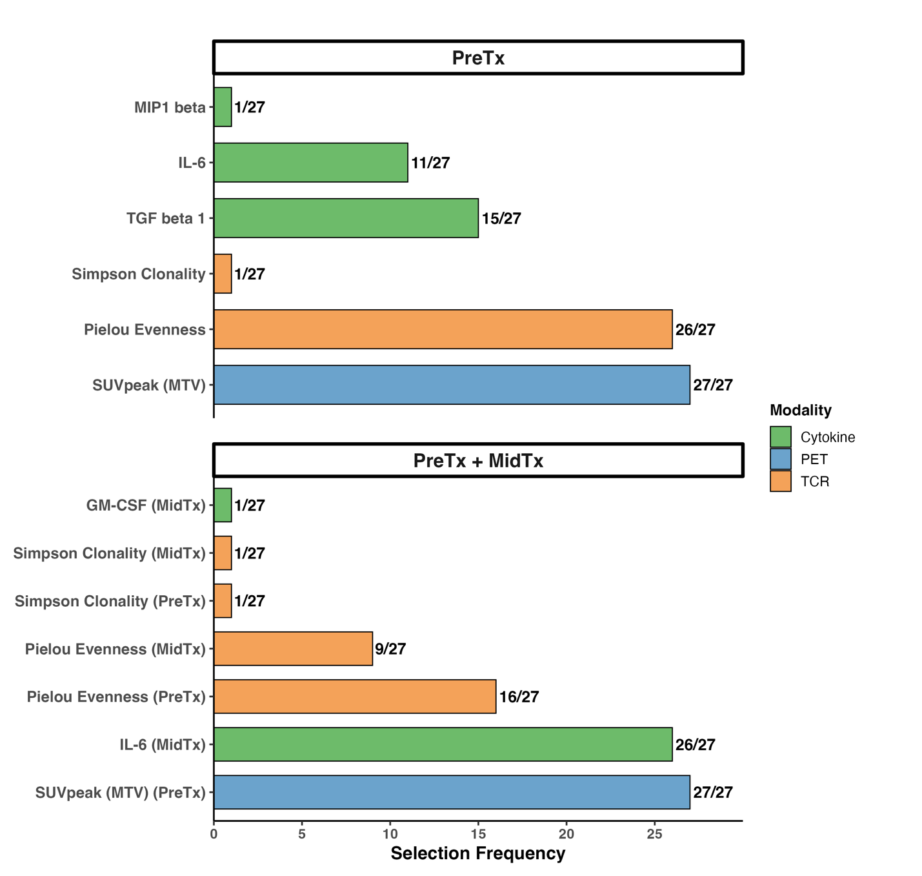

Supplementary Table 3. PD-L1 tumor proportion score, dichotomized at 1%, cross-tabulated against treatment response in the 27 evaluable participants. Sensitivity 0.500, specificity 0.667, AUROC 0.583 (95% CI 0.388–0.782). PD-L1 was evaluated directly on the cohort without cross-validation, as no model parameters are estimated.
 | Non-responder | Responder | Total | Response rate
PD-L1 > 1% | 3 | 9 | 12 | 75%
PD-L1 < 1% | 6 | 9 | 15 | 60%
Total | 9 | 18 | 27

Supplementary Table 4. Predictive performance of unimodal and multimodal biomarker models using early and late fusion strategies at baseline only analysis.

Modality | Combination | AUROC (95% CI)
Unimodal | PET | 0.759 [0.557, 0.928]
Unimodal | TCR | 0.796 [0.578, 0.978]
Unimodal | Cytokines | 0.543 [0.312, 0.802]
Early fusion | PET + TCR | 0.809 [0.582, 0.982]
Early fusion | PET+ Cytokines | 0.716 [0.486, 0.928]
Early fusion | TCR + Cytokines | 0.741 [0.493, 0.980]
Late fusion | PET + TCR | 0.846 [0.658, 0.987]
Late fusion | PET+ Cytokines | 0.716 [0.494, 0.929]
Late fusion | TCR + Cytokines | 0.765 [0.543, 0.980]
Early fusion | PET + TCR + Cytokines | 0.759 [0.518, 0.976]
Late fusion | PET + TCR + Cytokines | 0.802 [0.600, 0.979]
AUROC, area under the receiver operating characteristic curve. 95% CIs: percentile bootstrap, 1,000 resamples.

Supplementary Table 5. Predictive performance of unimodal and multimodal biomarker models using early and late fusion strategies at baseline + mid-treatment analysis.

Modality | Combination | AUROC (95% CI)
Unimodal | PET | 0.759 [0.557, 0.928]
Unimodal | TCR | 0.660 [0.414, 0.903]
Unimodal | Cytokines | 0.778 [0.593, 0.935]
Early fusion | PET + TCR | 0.704 [0.441, 0.939]
Early fusion | PET+ Cytokines | 0.815 [0.630, 0.955]
Early fusion | TCR + Cytokines | 0.710 [0.475, 0.911]
Late fusion | PET + TCR | 0.741 [0.500, 0.944]
Late fusion | PET+ Cytokines | 0.858 [0.700, 0.974]
Late fusion | TCR + Cytokines | 0.765 [0.555, 0.943]
Early fusion | PET + TCR + Cytokines | 0.790 [0.554, 0.965]
Late fusion | PET + TCR + Cytokines | 0.815 [0.600, 0.972]
AUROC, area under the receiver operating characteristic curve. 95% CIs: percentile bootstrap, 1,000 resamples.

Supplementary Figure 2. Observed model performance against the permutation null. Grey histograms show AUROC values obtained by randomly permuting response labels and re-executing the complete nested leave-one-out cross-validation pipeline, including inner-loop feature selection, preprocessing and model fitting, 500 times at each temporal setting. Red vertical lines indicate the observed AUROC; shaded regions indicate permutations at or beyond the observed value and correspond to the empirical p-value. Dashed vertical lines indicate chance discrimination (AUROC 0.50). Panels show the strongest unimodal model, unimodal FDG-PET, and the corresponding late-fusion model at each setting. Unimodal FDG-PET appears in both rows because the same pre-treatment feature (MTV SUVpeak) was selected in all cross-validation folds at both settings, giving identical models. The breadth of the null distributions reflects the variability of AUROC achievable by chance in a cohort of 27 participants. PreTx, pre-treatment; MidTx, mid-treatment (week 3); TCR, T-cell receptor.

Supplementary Table 6. Empirical p values from permutation testing for all 22 model and temporal-setting combinations.
Model | AUROC | p value
PreTx
PET | 0.76 | 0.078
TCR | 0.80 | 0.002
Cytokine | 0.54 | 0.393
PET + TCR (early) | 0.81 | 0.016
PET + cytokine (early) | 0.72 | 0.100
TCR + cytokine (early) | 0.74 | 0.046
PET + TCR + cytokine (early) | 0.76 | 0.040
PET + TCR (late) | 0.85 | 0.008
PET + cytokine (late) | 0.72 | 0.126
TCR + cytokine (late) | 0.77 | 0.024
PET + TCR + cytokine (late) | 0.80 | 0.028
PreTx + MidTx
PET | 0.76 | 0.096
TCR | 0.66 | 0.150
Cytokine | 0.78 | 0.040
PET + TCR (early) | 0.70 | 0.128
PET + cytokine (early) | 0.81 | 0.024
TCR + cytokine (early) | 0.71 | 0.104
PET + TCR + cytokine (early) | 0.79 | 0.040
PET + TCR (late) | 0.74 | 0.092
PET + cytokine (late) | 0.86 | 0.012
TCR + cytokine (late) | 0.77 | 0.042
PET + TCR + cytokine (late) | 0.81 | 0.022
Response labels were randomly permuted and the complete nested leave-one-out cross-validation pipeline re-executed on each permuted dataset, 500 times per temporal setting. The p value is one-sided, calculated as the number of permuted AUROC values greater than or equal to the observed value, plus one, divided by 501; the minimum attainable value is therefore 0.002. Values below 0.05 are shown in bold. AUROC values are those obtained on the unpermuted data. Early fusion concatenates modality-specific features before modelling; late fusion averages modality-specific predicted probabilities. PET, positron emission tomography; TCR, T-cell receptor; PreTx, before treatment; MidTx, after one cycle of chemoimmunotherapy.

Supplementary Table 7. Difference in AUROC between the best unimodal model and multimodal late fusion at PreTx.
Analysis | Comparison | AUROC (Model 1) | AUROC (Model 2) | ΔAUROC(95% CI)
Baseline | Unimodal TCR vs. Late Fusion PET+TCR | 0.796 | 0.846 | 0.049 (−0.061 to 0.171)
Baseline | Unimodal PET vs. Late Fusion PET+TCR | 0.759 | 0.846 | 0.086 (−0.130 to 0.289)
Differences in paired AUROC are shown with 95% percentile bootstrap confidence intervals from 1,000 resamples of the pooled cross-validated predictions. Intervals including zero indicate that the difference could not be established at this sample size. Late fusion averages modality-specific predicted probabilities.

Supplementary Table 8. Difference in AUROC between the best unimodal model and multimodal late fusion at PreTx + MidTx.
Analysis | Comparison | AUROC (Model 1) | AUROC (Model 2) | ΔAUROC (95% CI)
Combined | Unimodal Cytokines vs. Late Fusion PET+Cytokines | 0.778 | 0.858 | 0.080 (−0.029 to 0.200)
Combined | Unimodal PET vs. Late Fusion PET+Cytokines | 0.759 | 0.858 | 0.099 (−0.082 to 0.288)
Differences in paired AUROC are shown with 95% percentile bootstrap confidence intervals from 1,000 resamples of the pooled cross-validated predictions. Intervals including zero indicate that the difference could not be established at this sample size. Late fusion averages modality-specific predicted probabilities.

Supplementary Table 9. Comparison of discrimination under leave-one-out and repeated stratified five-fold cross-validation.

Model | LOOCV AUROC | Five-fold AUROC (95% interval) | Difference
PreTx
PET | 0.759 | 0.685 (0.562–0.772) | -0.074
TCR | 0.796 | 0.780 (0.699–0.840) | -0.016
Cytokine | 0.543 | 0.608 (0.519–0.710) | +0.065
PET+TCR (Early) | 0.809 | 0.759 (0.641–0.827) | -0.050
PET+Cytokine (Early) | 0.716 | 0.705 (0.586–0.815) | -0.011
TCR+Cytokine (Early) | 0.741 | 0.753 (0.668–0.817) | +0.012
PET+TCR+Cytokine (Early) | 0.759 | 0.737 (0.621–0.830) | -0.022
PET+TCR (Late) | 0.846 | 0.800 (0.719–0.864) | -0.046
PET+Cytokine (Late) | 0.716 | 0.714 (0.605–0.802) | -0.002
TCR+Cytokine (Late) | 0.765 | 0.788 (0.698–0.883) | +0.023
PET+TCR+Cytokine (Late) | 0.802 | 0.809 (0.713–0.908) | +0.007
PreTx + MidTx
PET | 0.759 | 0.690 (0.571–0.772) | -0.069
TCR | 0.660 | 0.685 (0.558–0.753) | +0.025
Cytokine | 0.778 | 0.770 (0.619–0.852) | -0.008
PET+TCR (Early) | 0.704 | 0.701 (0.608–0.765) | -0.003
PET+Cytokine (Early) | 0.815 | 0.779 (0.669–0.867) | -0.036
TCR+Cytokine (Early) | 0.710 | 0.741 (0.636–0.824) | +0.031
PET+TCR+Cytokine (Early) | 0.790 | 0.755 (0.660–0.843) | -0.035
PET+TCR (Late) | 0.741 | 0.733 (0.629–0.796) | -0.008
PET+Cytokine (Late) | 0.858 | 0.796 (0.685–0.889) | -0.062
TCR+Cytokine (Late) | 0.765 | 0.788 (0.641–0.858) | +0.023
PET+TCR+Cytokine (Late) | 0.815 | 0.812 (0.710–0.874) | -0.003
Values are areas under the receiver operating characteristic curve derived from pooled cross-validated predictions. Intervals show the 2.5th to 97.5th percentiles of AUROC across 100 repetitions of stratified five-fold cross-validation. Difference is the five-fold mean minus the leave-one-out estimate. Across all 22 model and temporal setting combinations the mean difference was −0.012 and the mean absolute difference 0.029 (range −0.074 to +0.065). LOOCV, leave-one-out cross-validation; PreTx, pre-treatment; MidTx, mid-treatment.

Supplementary Table 10. Conformal prediction performance and calibration metrics for unimodal and multimodal biomarker models using early and late fusion strategies at baseline only analysis.

Modality | Combination | Empirical coverage  (target 80%) | Average set  size | Singleton % | Brier score
Unimodal | PET | 85.2 | 1.333 | 66.7% | 0.211 [0.137, 0.289]
Unimodal | TCR | 81.5 | 1.222 | 77.8% | 0.192 [0.120, 0.278]
Unimodal | Cytokines | 77.8 | 1.444 | 55.6% | 0.270 [0.190, 0.359]
Early fusion | PET + TCR | 81.5 | 1.111 | 88.9% | 0.172 [0.088, 0.268]
Early fusion | PET+ Cytokines | 74.1 | 1.296 | 70.4% | 0.239 [0.142, 0.339]
Early fusion | TCR + Cytokines | 81.5 | 1.148 | 85.2% | 0.201 [0.094, 0.318]
Late fusion | PET + TCR | 77.8 | 1.111 | 88.9% | 0.175 [0.126, 0.227]
Late fusion | PET+ Cytokines | 70.4 | 1.259 | 74.1% | 0.208 [0.163, 0.252]
Late fusion | TCR + Cytokines | 74.1 | 1.111 | 88.9% | 0.206 [0.148, 0.267]
Early fusion | PET + TCR + Cytokines | 81.5 | 1.222 | 77.8% | 0.216 [0.106, 0.337]
Late fusion | PET + TCR + Cytokines | 77.8 | 1.185 | 81.5% | 0.187 [0.147, 0.226]

Supplementary Table 11. Conformal prediction performance and calibration metrics for unimodal and multimodal biomarker models using early and late fusion strategies at baseline + mid-treatment analysis.

Modality | Combination | Empirical coverage  (target 80%) | Average set  size | Singleton % | Brier score
Unimodal | PET | 85.2 | 1.333 | 66.7% | 0.211 [0.137, 0.289]
Unimodal | TCR | 77.8 | 1.296 | 70.4% | 0.254 [0.152, 0.363]
Unimodal | Cytokines | 77.8 | 1.148 | 85.2% | 0.202 [0.106, 0.313]
Early fusion | PET + TCR | 77.8 | 1.185 | 81.5% | 0.227 [0.125, 0.350]
Early fusion | PET+ Cytokines | 81.5 | 1.185 | 81.5% | 0.196 [0.099, 0.307]
Early fusion | TCR + Cytokines | 74.1 | 1.222 | 77.8% | 0.230 [0.122, 0.353]
Late fusion | PET + TCR | 74.1 | 1.185 | 81.5% | 0.202 [0.145, 0.266]
Late fusion | PET+ Cytokines | 81.5 | 1.148 | 85.2% | 0.170 [0.118, 0.225]
Late fusion | TCR + Cytokines | 74.1 | 1.074 | 92.6% | 0.196 [0.129, 0.270]
Early fusion | PET + TCR + Cytokines | 81.5 | 1.222 | 77.8% | 0.194 [0.096, 0.311]
Late fusion | PET + TCR + Cytokines | 81.5 | 1.074 | 92.6% | 0.178 [0.130, 0.229]

Supplementary Table 12. Reclassification of individual participants following the addition of FDG-PET to the leading blood biomarker model.
PreTx: TCR → PET + TCR

TCR alone | Correct | Ambiguous | Incorrect | Total
Correct | 14 | 1 | 1 | 16
Ambiguous | 3 | 2 | 1 | 6
Incorrect | 1 | 0 | 4 | 5
Total | 18 | 3 | 6 | 27
Moved to correct: 4. Moved away from correct: 2. Net gain: 2.
PreTx + MidTx: Cytokine → PET + cytokine
Cytokine alone | Correct | Ambiguous | Incorrect | Total
Correct | 14 | 3 | 0 | 17
Ambiguous | 3 | 1 | 0 | 4
Incorrect | 1 | 0 | 5 | 6
Total | 18 | 4 | 5 | 27
Moved to correct: 4. Moved away from correct: 3. Net gain: 1.
Rows show classification under the blood biomarker model alone; columns show classification after adding FDG-PET by late fusion. Bold diagonal entries are participants whose classification was unchanged. “Ambiguous” denotes a conformal prediction set containing both classes. Net gain is the number moving to a correct prediction minus the number moving away from one. PET, positron emission tomography; TCR, T-cell receptor; PreTx, before treatment; MidTx, after one cycle of chemoimmunotherapy.

Supplementary Figure 3. Patient level prediction outcomes for multimodal fusion models across timepoints. Tile plots display patient specific prediction outcomes generated using multimodal fusion models at baseline and after incorporation of mid-treatment biomarkers. Each tile represents an individual patient prediction, with colors indicating prediction status as correct, incorrect, or uncertain according to the conformal prediction set. Horizontal alignment facilitates comparison of prediction behavior across timepoints, highlighting changes in classification confidence following integration of mid-treatment information.

