Supporting Information
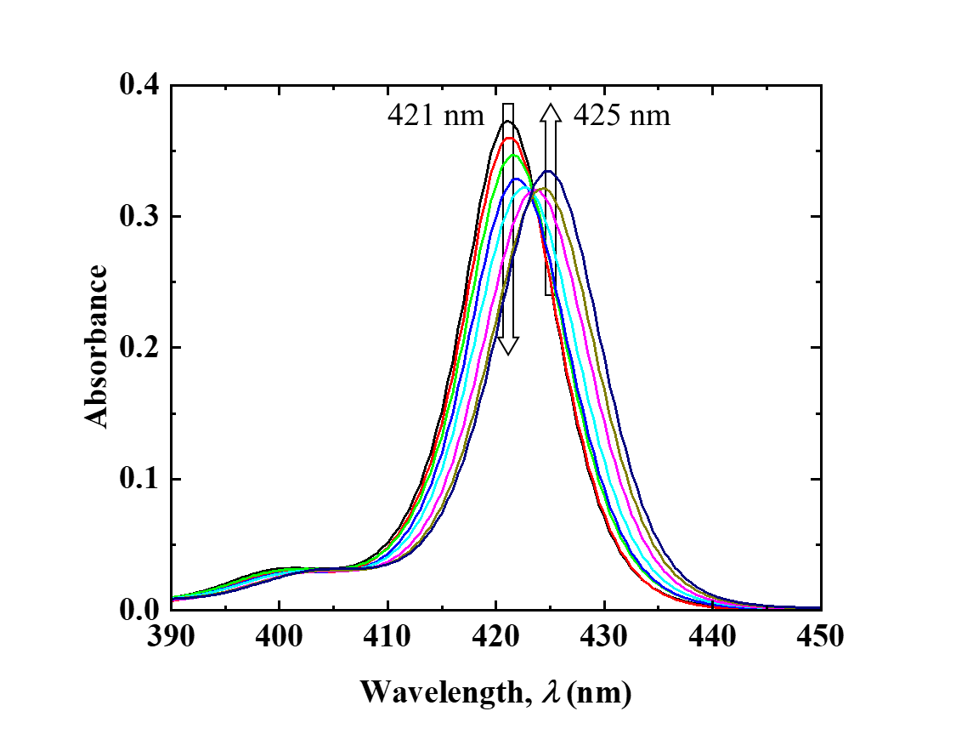
Figure S1. Absorption spectra of the ZnTPPS in aqueous solutions of various [Pyridine] (0 – 8.20 × 10⁻² mol/L).

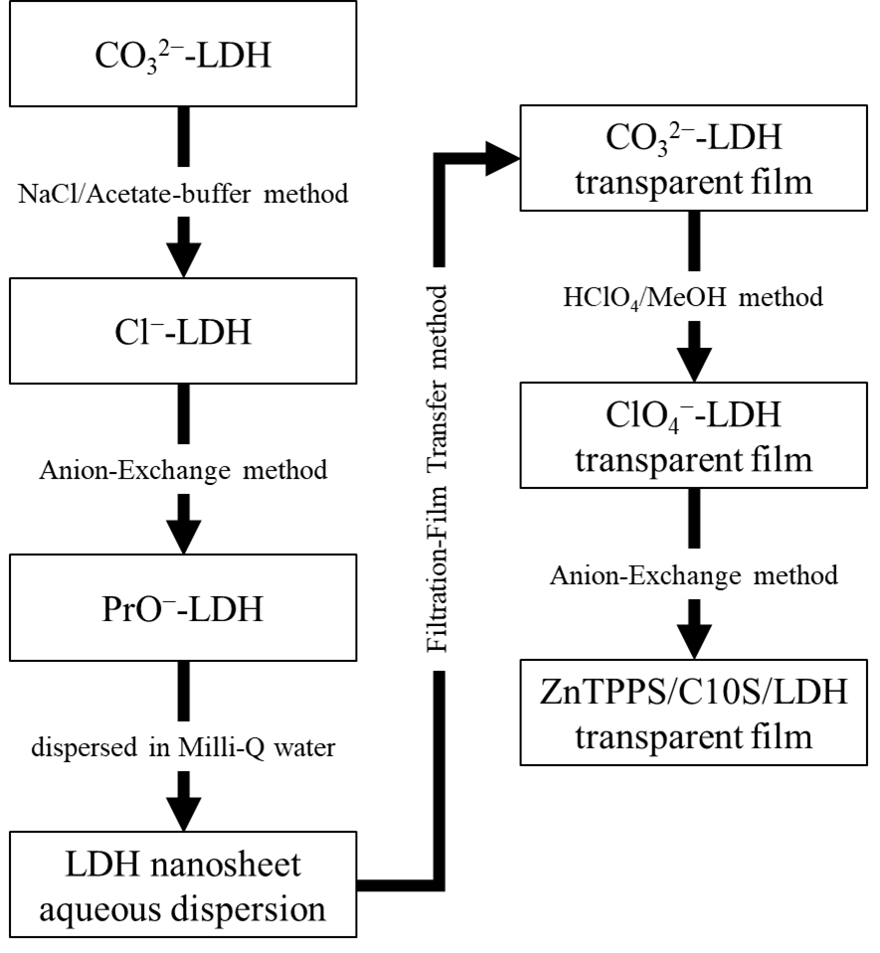
Figure S2. Flow chart representing the procedure employed to prepare the transparent ZnTPPS/C10S/LDH film

