Submit to Nature Communications

Supporting Information

Charge localized atomic Mo^{δ+} site boosting hydrogen evolution in alkaline solution

Maoqi Cao^{1,2,8}, Kang Liu^{1,8}, Yao Song^{3,8}, Chao Ma⁴, Yiyang Lin¹, HuangJingWei Li¹, Junwei Fu¹, Hongmei Li¹, Zhiyan Chen³, Xusheng Zheng⁵, Junhua Hu⁶, Haipeng Xie¹, Ying-Rui Lu⁷, Ting-Shan Chan⁷, and Min Liu¹*

¹ State Key Laboratory of Powder Metallurgy, Hunan Provincial Key Laboratory of Chemical Power Sources, School of Physics and Electronics, Shenzhen Institute of Central South University, Central South University, Changsha 410083, P. R. China.
² School of chemistry and chemical engineering, Qiannan Normal University for Nationalities, Duyun 558000, P. R. China.
³ School of Materials Science and Engineering, Central South University of Forestry and Technology, Changsha, 410004, P. R. China.
⁴ College of Materials Science and Engineering, Hunan University, Changsha 410082, P. R. China.
⁵ National Synchrotron Radiation Laboratory, University of Science & Technology of China, Hefei, 230029, P. R. China.
⁶ School of Materials Science and Engineering, Zhengzhou University, Zhengzhou, 450002, P. R. China.
⁷ National Synchrotron Radiation Research Center, Hsinchu 300, Taiwan.
⁸ These authors contributed equally: Maoqi Cao, Kang Liu, Yao Song.
Correspondence and requests for materials should be addressed to M. Liu. (E-mail: minliu@csu.edu.cn)

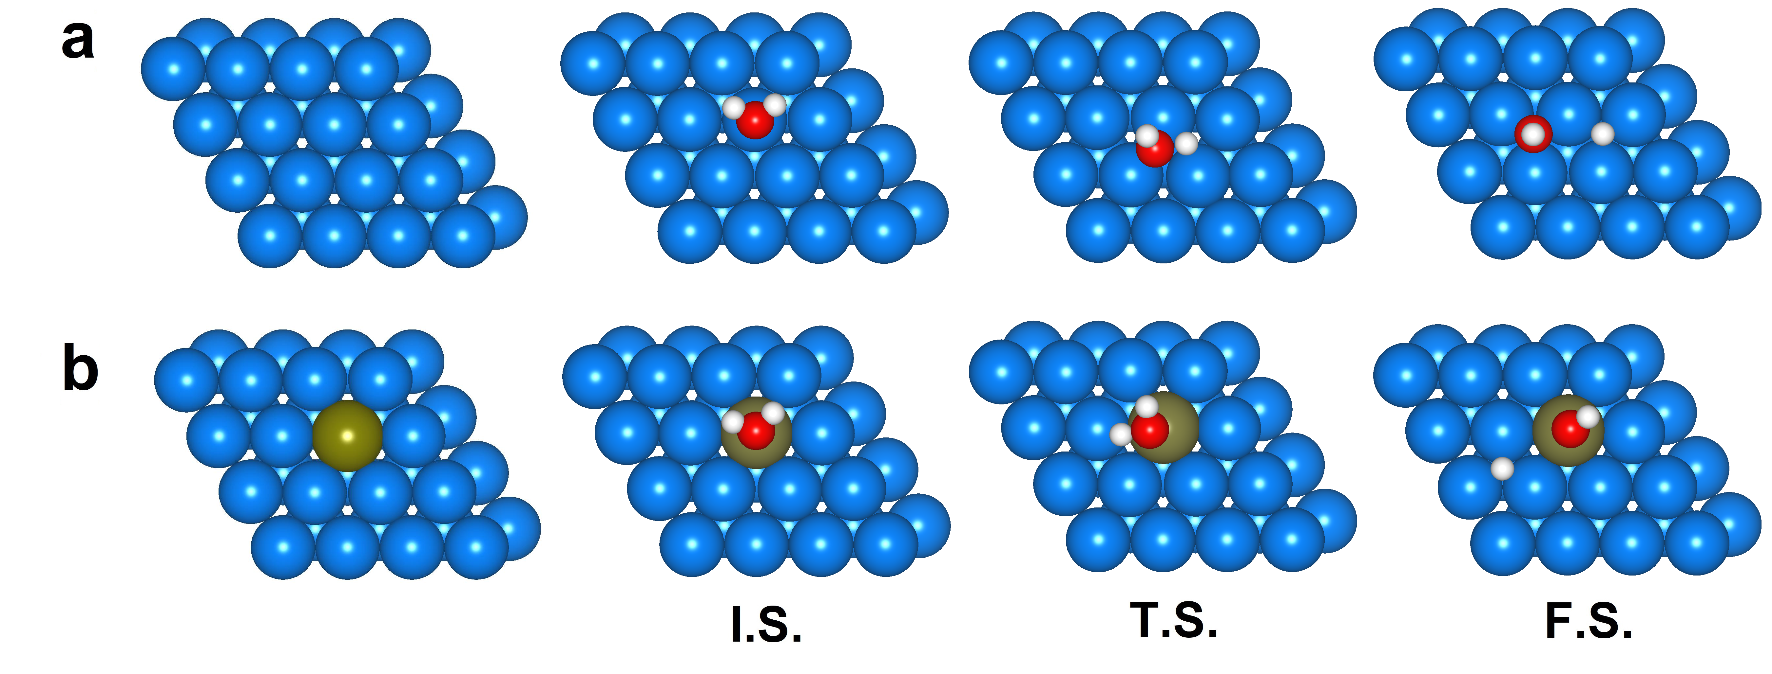
Figure S1. The optimized geometries for the reaction intermediates on the Co(001) (a) and Mo/Co (b) during the HER process.

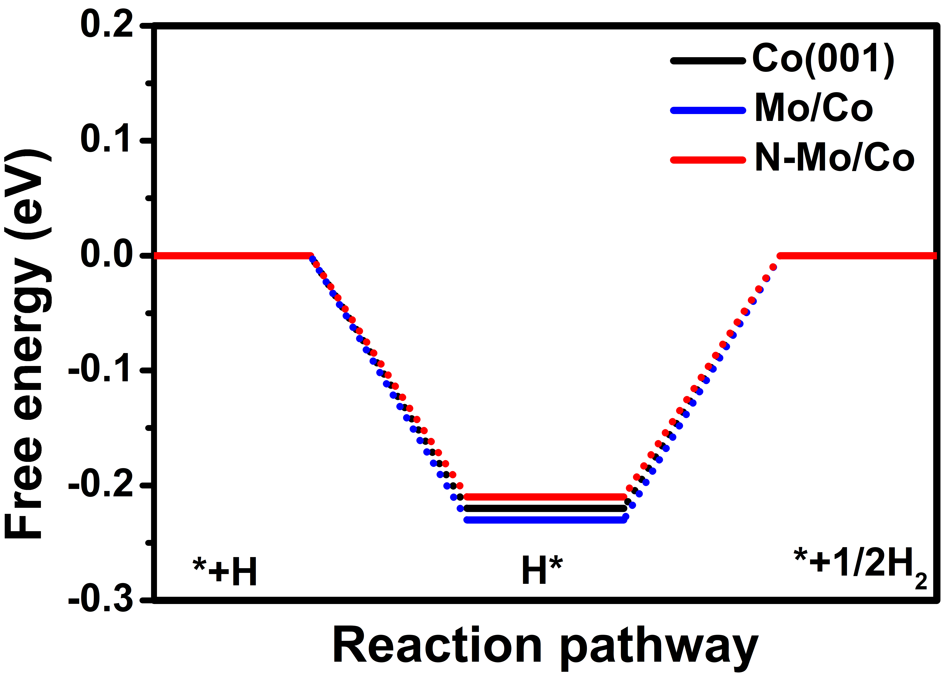
Figure S2. The free energy of H* on the Co(001), Mo/Co and N-Mo/Co.

Figure S3. (a) The configuration and the charge localization difference of Mo site on Mo/Co and N-Mo/Co. (b) The energy barrier of water dissociation on the Co(101), Mo/Co and N-Mo/Co. Initial state denote as I.S.. Transition state denote as T.S.. Final state denote as F.S.. (c) The relationship between Bader charge and energy barrier at the transition state. (d) The density of state of water adsorb on the Mo/Co and N-Mo/Co.

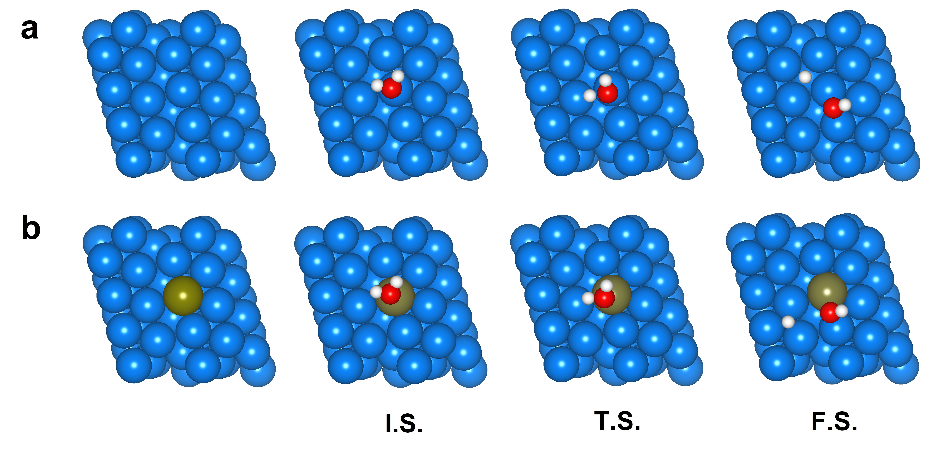
Figure S4. The optimized geometries for the reaction intermediates on the Co(101) (a) and Mo/Co (b) during the HER process.

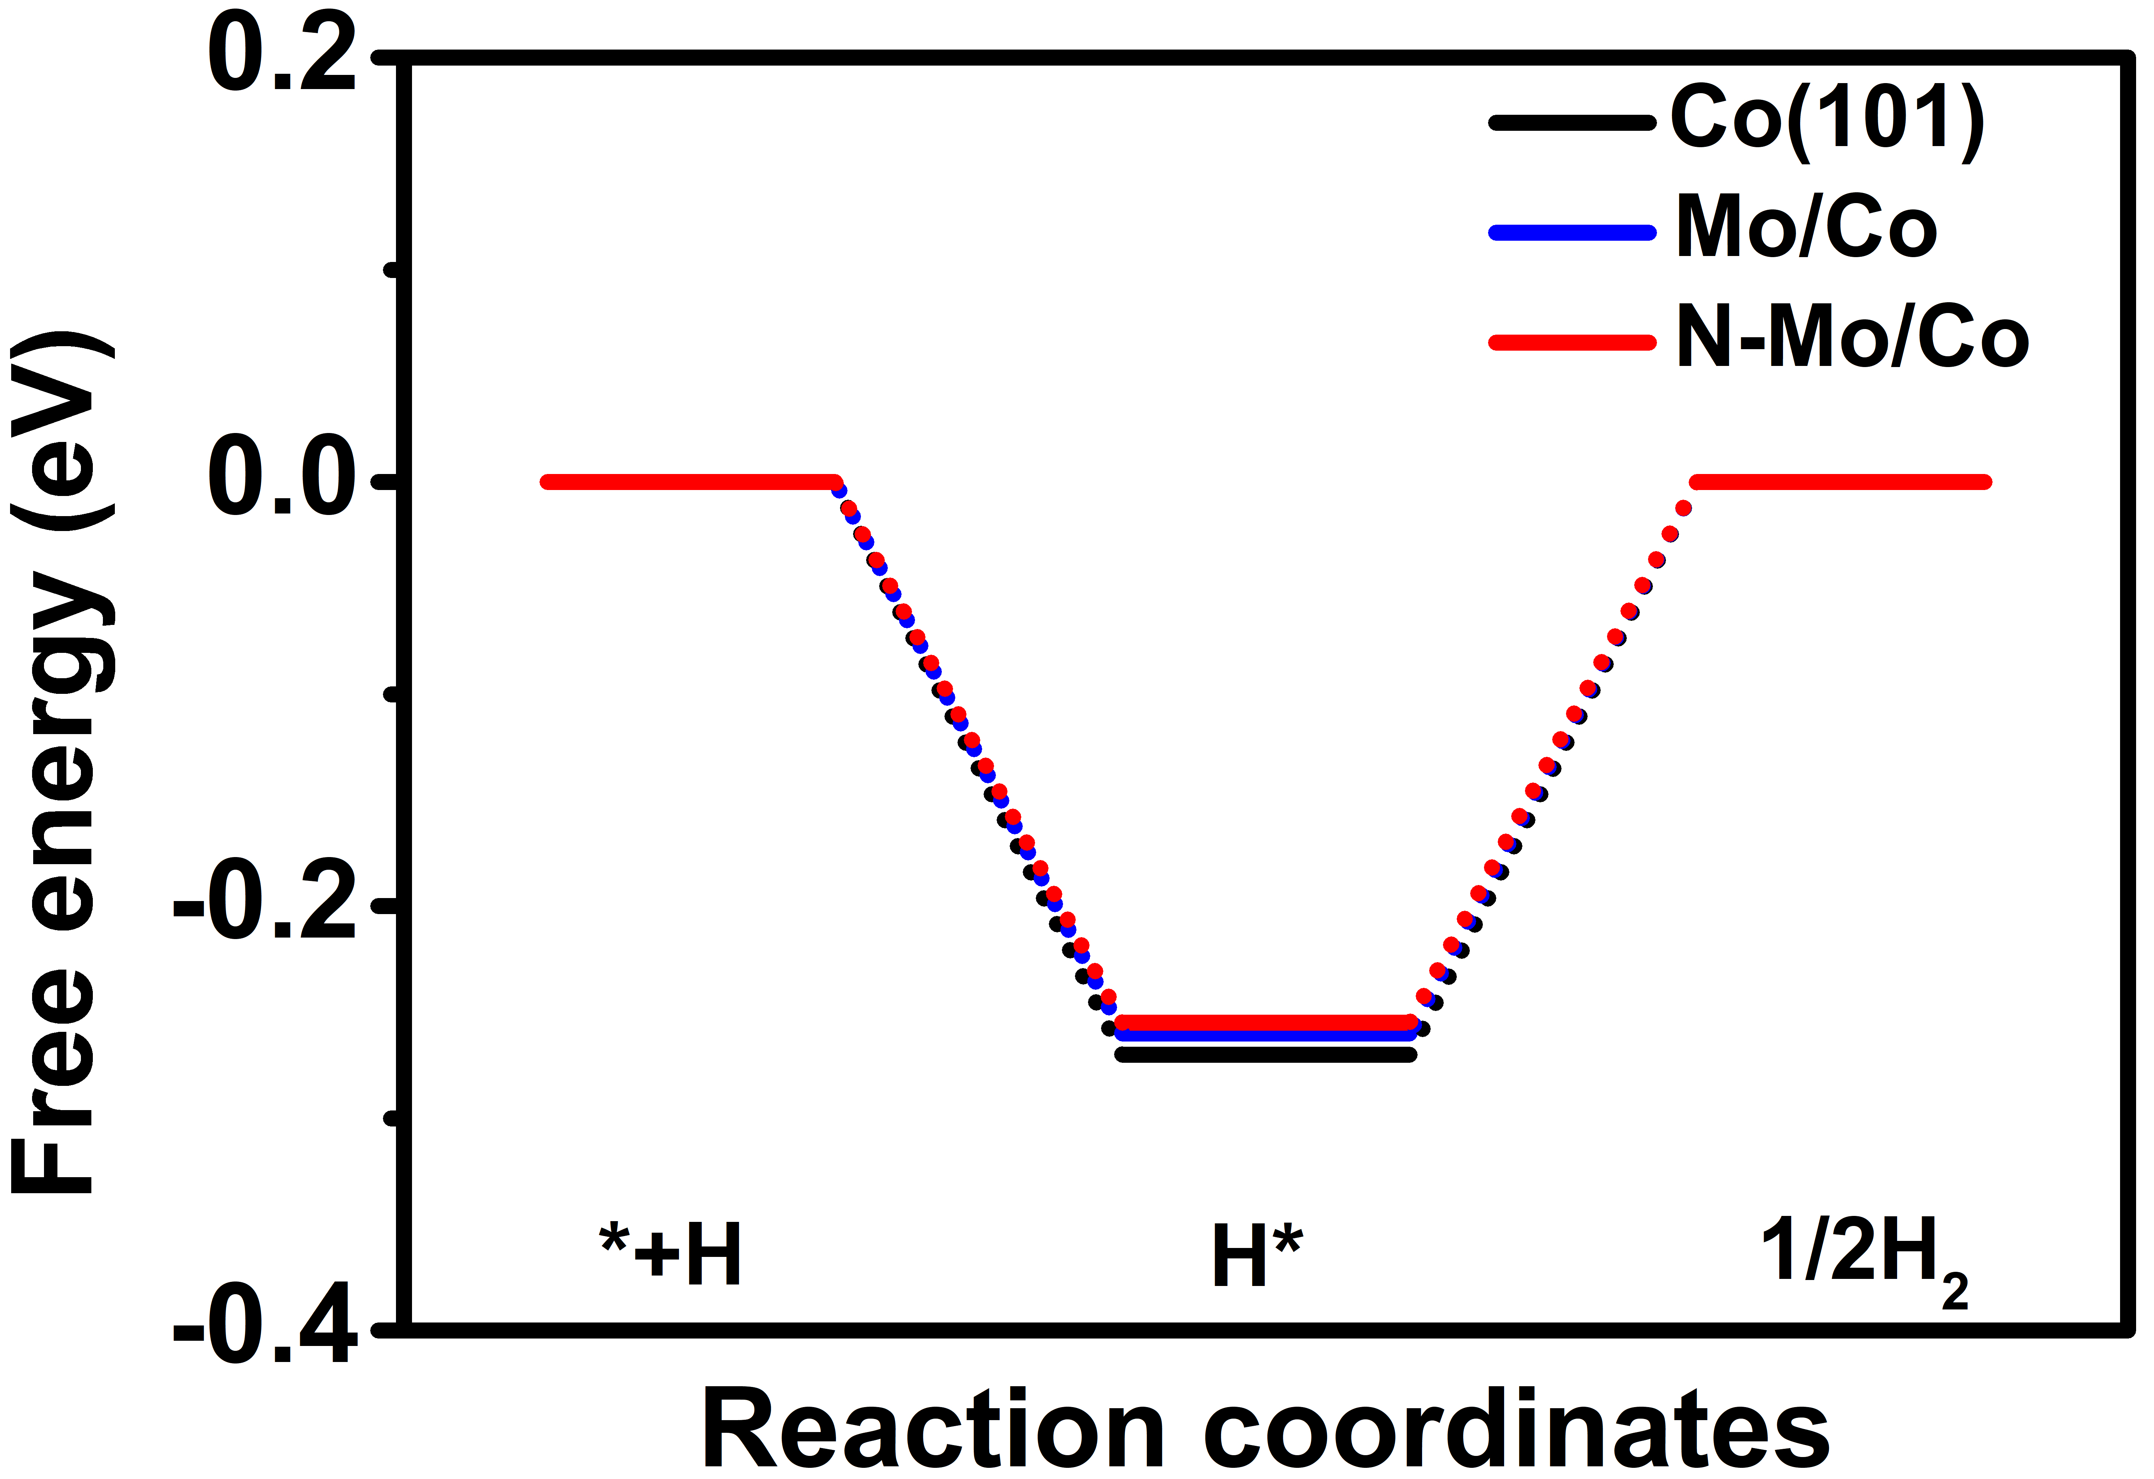
Figure S5. The free energy of H* on the Co(101), Mo/Co and N-Mo/Co.

Figure S6. SEM images of CoMoO₄ (a) and N-CoMoO₄ (b), Scale bars, 2 μm.

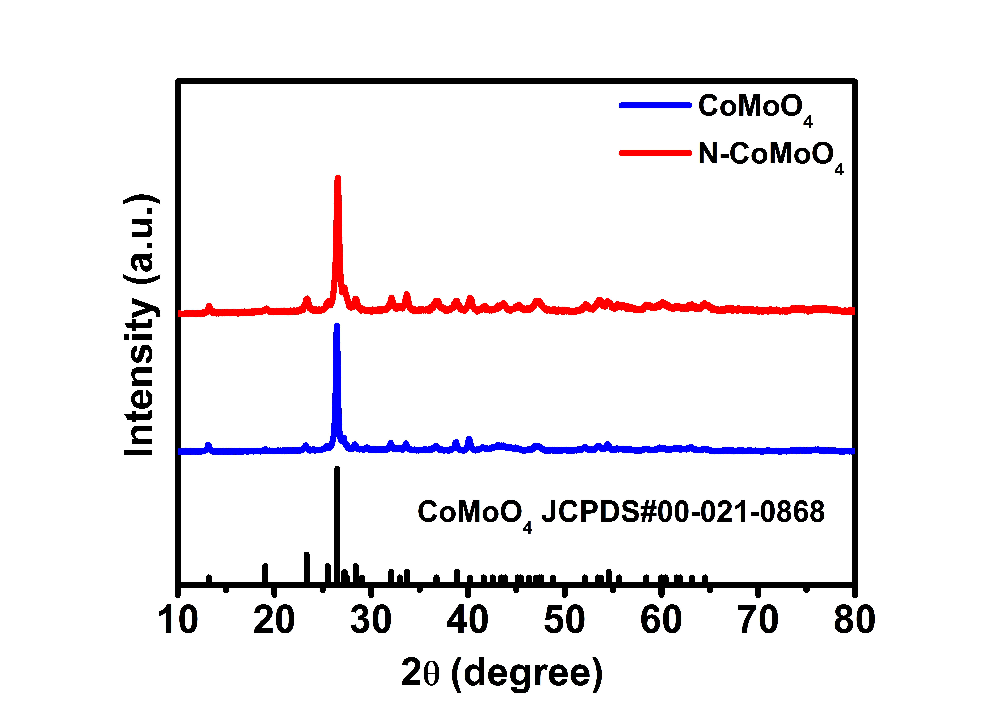
Figure S7. XRD pattern of CoMoO₄ and N-CoMoO₄.

Figure S8. Element mappings of Co, Mo, O and N in N-CoMoO₄ with a magnification. Scale bar is 20 nm.

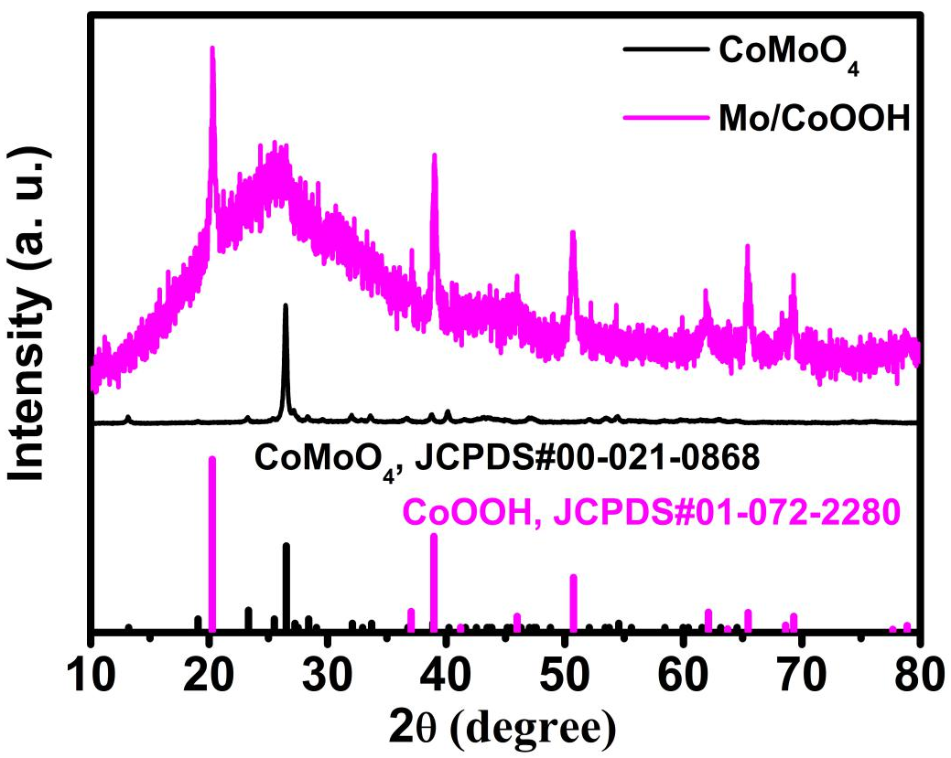
Figure S9. XRD pattern of Mo-CoOOH.

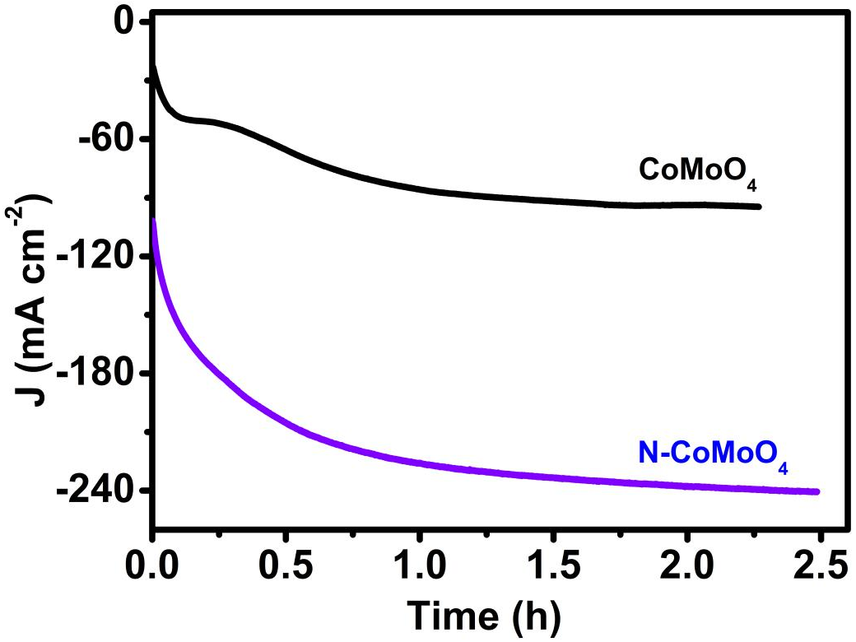
Figure S10. The cathodic currents of CoMoO₄ and N-CoMoO₄ at constant voltage of –0.5 V (RHE).

Figure S11. SEM images of Mo/Co with different magnifications. (a) Scale bars, 5 μm and (b) Scale bars, 2 μm.

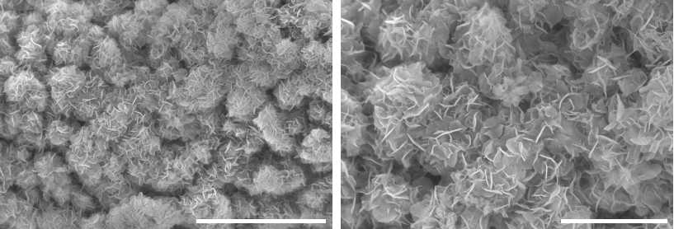
Figure S12. SEM images of N-Mo/Co with different magnifications. (a) Scale bars, 5 μm and (b) Scale bars, 2 μm.

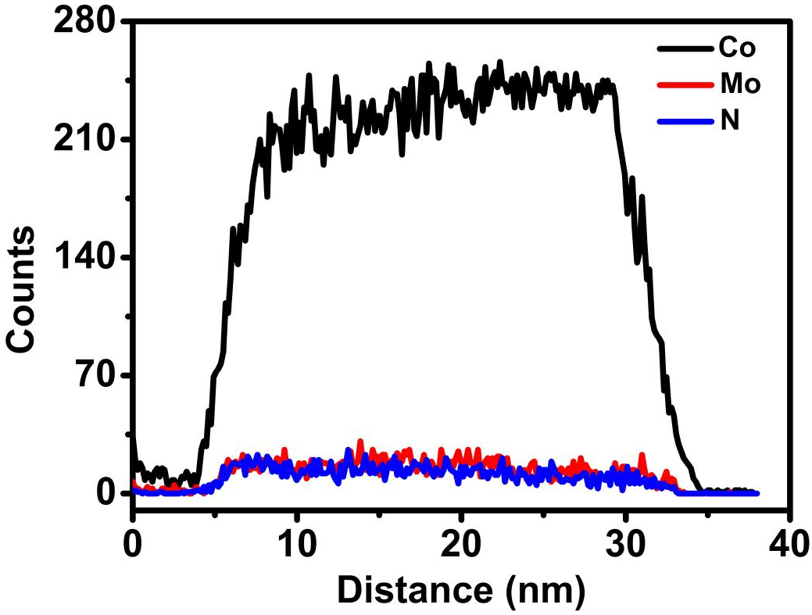
Figure S13. The EDS elemental line scan profiles along the black line shown in the HAADF image of N-Mo/Co.

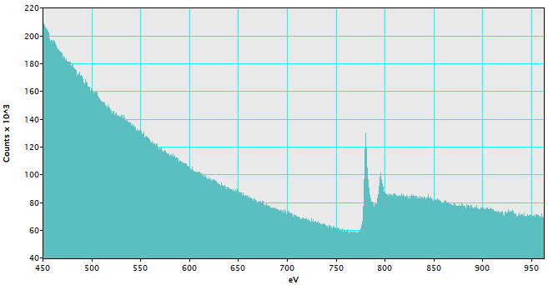
Figure S14. EELS of N-Mo/Co.

Figure S15. The Co K-edge XANES (a) and EXAFS (b) spectra of Co on Mo/Co and N-Mo/Co, respectively.

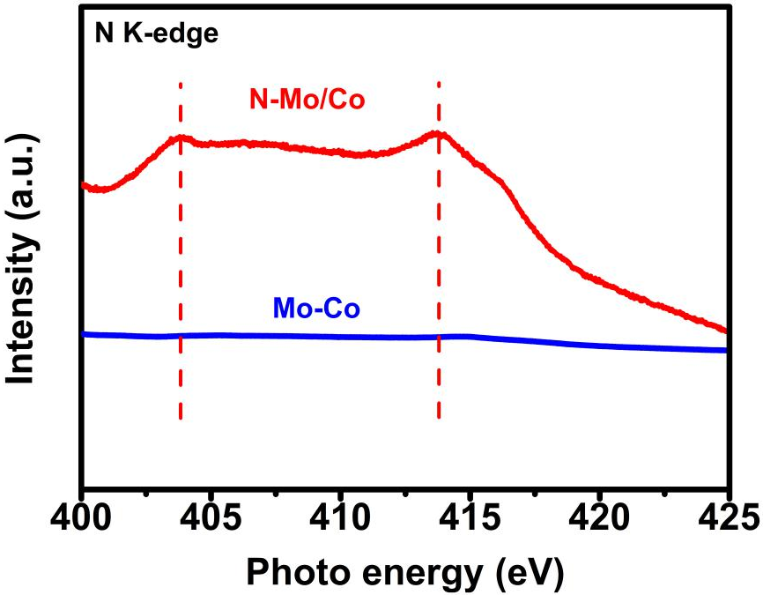
Figure S16. N K-edge of XAS spectra of N on the Co/Mo and N-Mo/Co.

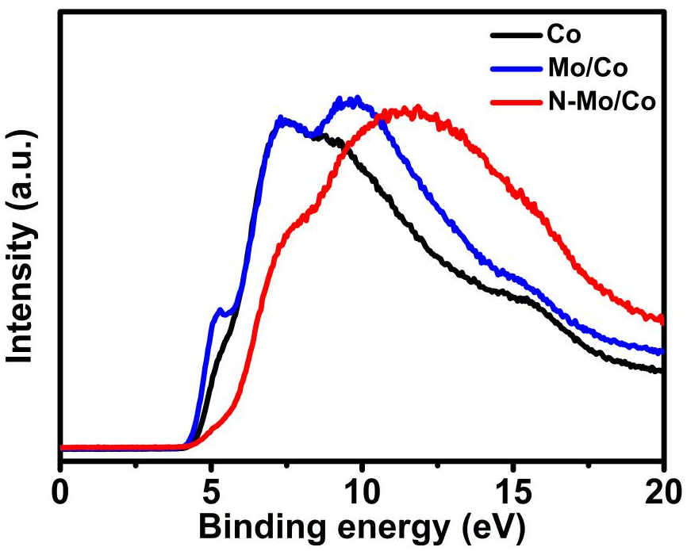
Figure S17. Valence-band spectra of Co, Co/Mo and N-Mo/Co.

Figure S18. Cyclic voltamogram curves of Co (a), Mo/Co (b), and N-Mo/Co (c) in the double layer capactive region at the scan rates of from 20 mV to 100 mV s⁻¹. (d) ECSA of Co, Mo/Co, and N-Mo/Co.

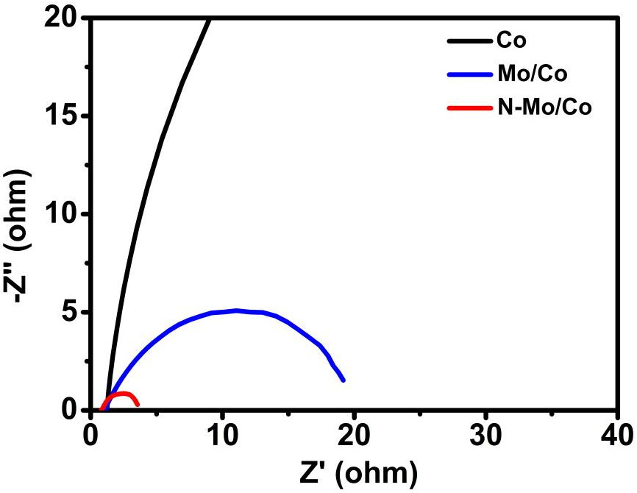
Figure S19. EIS of Co, Co/Mo and N-Mo/Co.

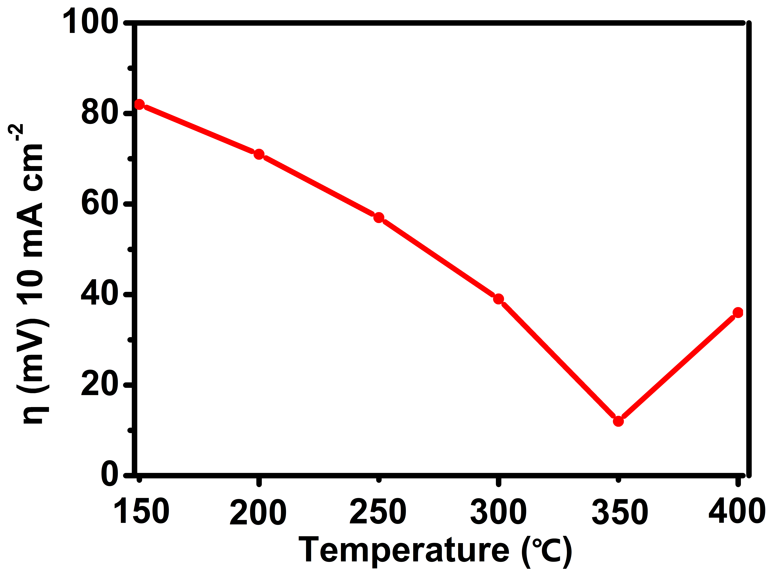
Figure S20. The temperature dependent HER activity of N-Mo/Co.

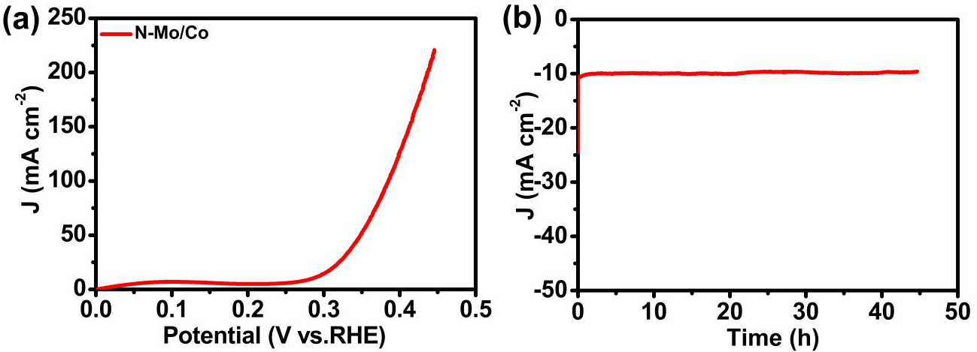
Figure S21. (a) LSV of N-Mo/Co for OER in 1 mol KOH. (b) Chronoamperometry curves obtained with the N-Mo/Co at constant voltage 1.50 V.

Table 1. Summary ICP-AES parameters of metallic elements of samples.
Samples | Elements | Atomic percentage (%)
CoMoO₄ | Co | 50.37
CoMoO₄ | Mo | 49.63
N-CoMoO₄ | Co | 50.48
N-CoMoO₄ | Mo | 49.52
Mo/Co | Co | 97.83
Mo/Co | Mo | 2.17
N-Mo/Co | Co | 97.89
N-Mo/Co | Mo | 2.11

Table 2. Comparison of HER performance on different catalysts.
Catalyst | Media | Electrode | Overpotential at -10 mA cm⁻² (mV) | Tafel slope (mV dec⁻¹) | Ref.
N-Mo/Co | 1 M KOH | CC | 12 | 31 | This work
CoNOCs | 0.5 M H₂SO₄ | CC | 93 | 49 | ¹
Co/Co₃O₄ | 1 M KOH | NF | 90 | 44 | ²
S-CoO NRs | 1 M KOH | CFP | 73 | 82 | ³
Co₃Mo@MoO_{x} | 1 M KOH | NF | 68 | 61 | ⁴
Co_{0.6}Mo_{1.4}N₂ | 0.1 M HClO₄ | GC | 200 | / | ⁵
Ni_{0.2}Mo_{0.8}N | 1 M KOH | CC | 109 | 95 | ⁶
Ni(OH)₂/MoS₂ | 1 M KOH | CC | 80 | 60 | ⁷
Ni-MoS₂ | 1 M KOH | CC | 98 | 60 | ⁸
Co₃FeN_{x} | 1 M KOH | NF | 23 | 94 | ⁹
FeNi₃N | 1 M KOH | NF | 75 | 98 | ¹⁰
V-Co₄N | 1 M KOH | NF | 37 | 41 | ¹¹

References
1. Wang, H. et al. Cobalt nanocrystals encapsulated in heteroatom-rich porous carbons derived from conjugated microporous polymers for efficient electrocatalytic hydrogen evolution. Small 14, 1803232 (2018).
2. Yan, X., Tian, L., He, M. & Chen, X. Three-dimensional crystalline/amorphous Co/Co₃O₄ core/shell nanosheets as efficient electrocatalysts for the hydrogen evolution reaction. Nano Lett. 15, 6015-6021 (2015).
3. Ling, T. et al. Activating cobalt(II) oxide nanorods for efficient electrocatalysis by strain engineering. Nat. Commun. 8, 1509 (2017).
4. Chen, J. et al. Nesting Co₃Mo binary alloy nanoparticles onto molybdenum oxide nanosheet arrays for superior hydrogen evolution reaction. ACS Appl. Mater. Inter. 11, 9002-9010 (2019).
5. Cao, B., Veith, G. M., Neuefeind, J. C., Adzic, R. R. & Khalifah, P. G. Mixed close-packed cobalt molybdenum nitrides as non-noble metal electrocatalysts for the hydrogen evolution reaction. J. Am. Chem. Soc. 135, 19186-19192 (2013).
6. Zhang, Y., Ouyang, B., Xu, J., Chen, S., Rawat, R. S. & Fan, H. J. 3D porous hierarchical nickel-molybdenum nitrides synthesized by RF plasma as highly active and stable hydrogen-evolution-reaction electrocatalysts. Adv. Energy Mater. 6, 1600221 (2016).
7. Zhang, B. et al. Interface engineering: The Ni(OH) 2 /MoS 2 heterostructure for highly efficient alkaline hydrogen evolution. Nano Energy 37, 74-80 (2017).
8. Zhang, J. et al. Engineering water dissociation sites in MoS₂ nanosheets for accelerated electrocatalytic hydrogen production. Energy Environ. Sci. 9, 2789-2793 (2016).
9. Wang, Y., Liu, D., Liu, Z., Xie, C., Huo, J. & Wang, S. Porous cobalt-iron nitride nanowires as excellent bifunctional electrocatalysts for overall water splitting. Chem. Commun. 52, 12614-12617 (2016).
10. Zhang, B., Xiao, C., Xie, S., Liang, J., Chen, X. & Tang, Y. Iron–nickel nitride nanostructures in situ grown on surface-redox-etching nickel foam: efficient and ultrasustainable electrocatalysts for overall water splitting. Chem. Mater. 28, 6934-6941 (2016).
11. Chen, Z. et al. Tailoring the d-band centers enables co4n nanosheets to be highly active for hydrogen evolution catalysis. Angew. Chem. Int. Ed. 57, 5076-5080 (2018).

