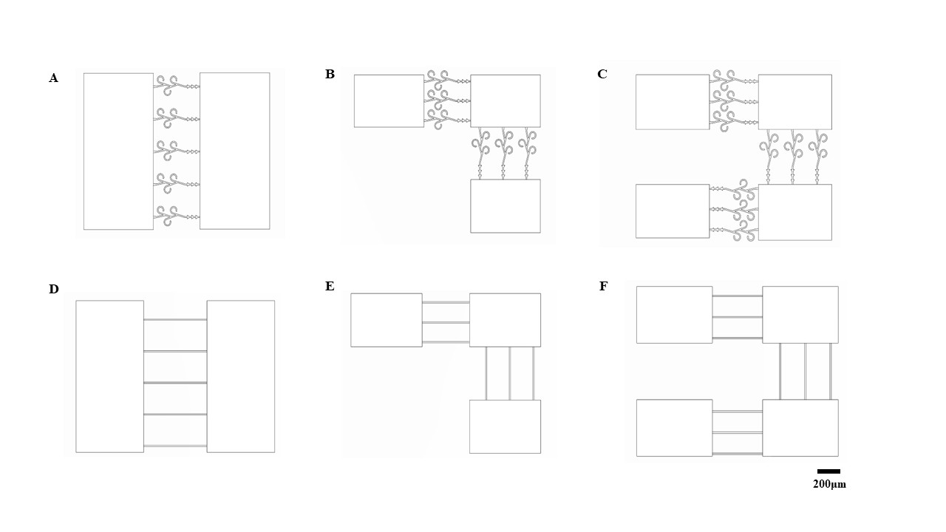
Supplementary Figure 1 | Structural designs of the six microfluidic-chip architectures.
(A–C) Structural designs of the two-, three-, and four-layer microfluidic chips used to construct the living deep reservoirs, in which adjacent modules are connected by unidirectional axon-routing channels. (D–F) Topology-matched structural designs of the corresponding two-, three-, and four-layer control-group chips, in which adjacent modules are connected by bidirectional straight channels. These paired designs preserve comparable module layouts and reservoir depths while differing primarily in intermodule connection topology, thereby enabling controlled comparison of the effects of directional axon routing. Scale bar, 200 μm.

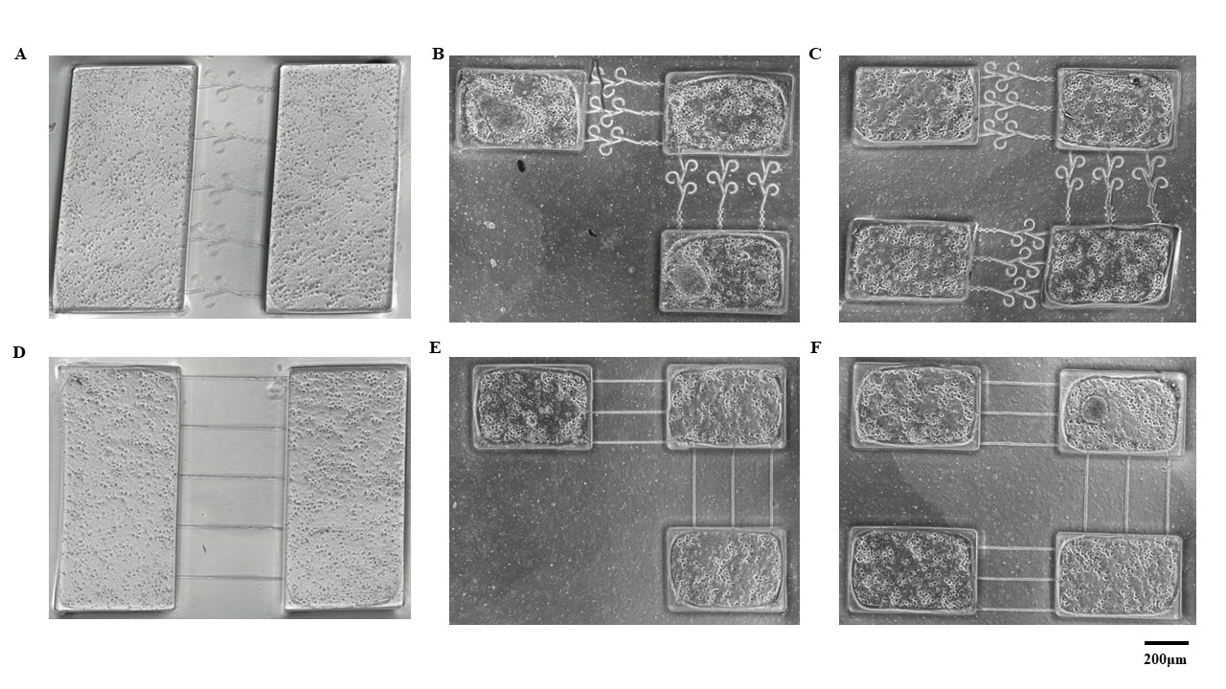
Supplementary Figure 2 | Representative bright-field images of neuronal cultures in the six microfluidic-chip architectures.
(A–C) Bright-field images of neurons cultured in the two-, three-, and four-layer living deep reservoir chips. (D–F) Bright-field images of neurons cultured in the topology-matched two-, three-, and four-layer control-group chips. Neuronal somata and extending neurites are visible in all six architectures, indicating successful neuronal survival and network formation after culture in the microfluidic chips. Scale bars, 200 μm.

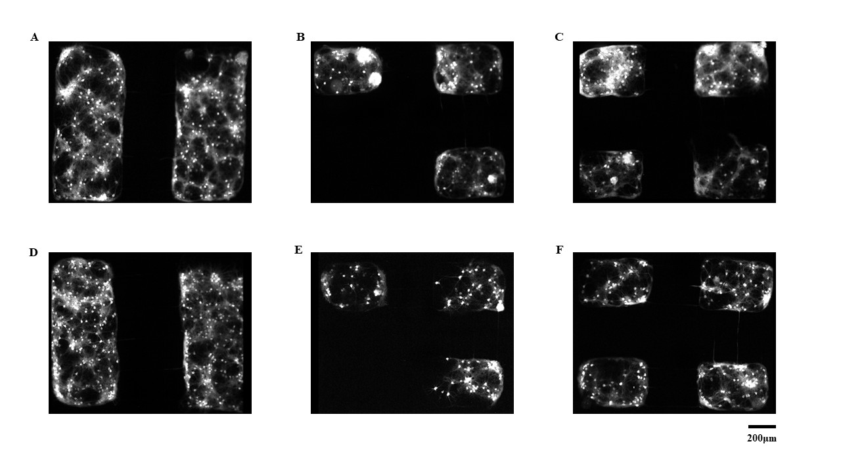
Supplementary Figure 3 | Representative fluorescence images of neuronal networks in the six microfluidic-chip architectures.
(A–C) Fluorescence images of neuronal cultures in the two-, three-, and four-layer living deep reservoir chips. (D–F) Fluorescence images of neuronal cultures in the corresponding topology-matched control-group chips. These images show successful fluorescent labeling of the neuronal networks and confirm that all six chip architectures supported the formation of interconnected living neuronal reservoirs. Scale bars, 200 μm.

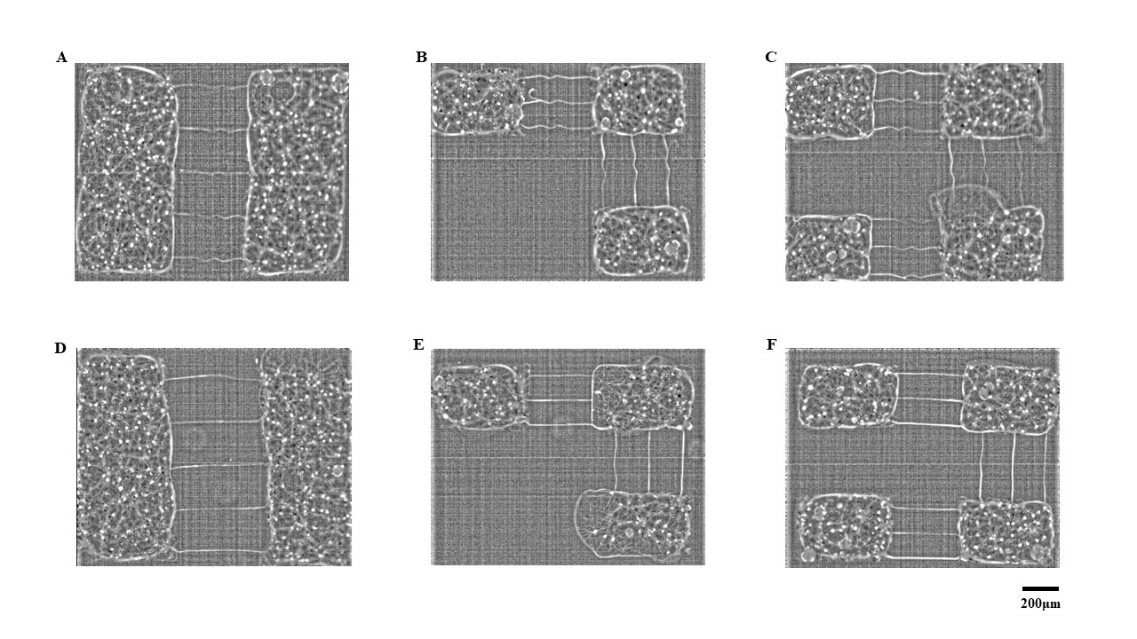
Supplementary Figure 4 | Contrast-enhanced fluorescence images of neuronal networks in the six microfluidic-chip architectures.
(A–C) Contrast-enhanced fluorescence images of neuronal cultures in the two-, three-, and four-layer living deep reservoir chips. (D–F) Contrast-enhanced fluorescence images of neuronal cultures in the corresponding topology-matched control-group chips. The enhanced images more clearly reveal the morphology of neuronal networks and the connections between adjacent modules, supporting the successful construction of multistage living reservoirs in vitro. Scale bars, 200 μm.

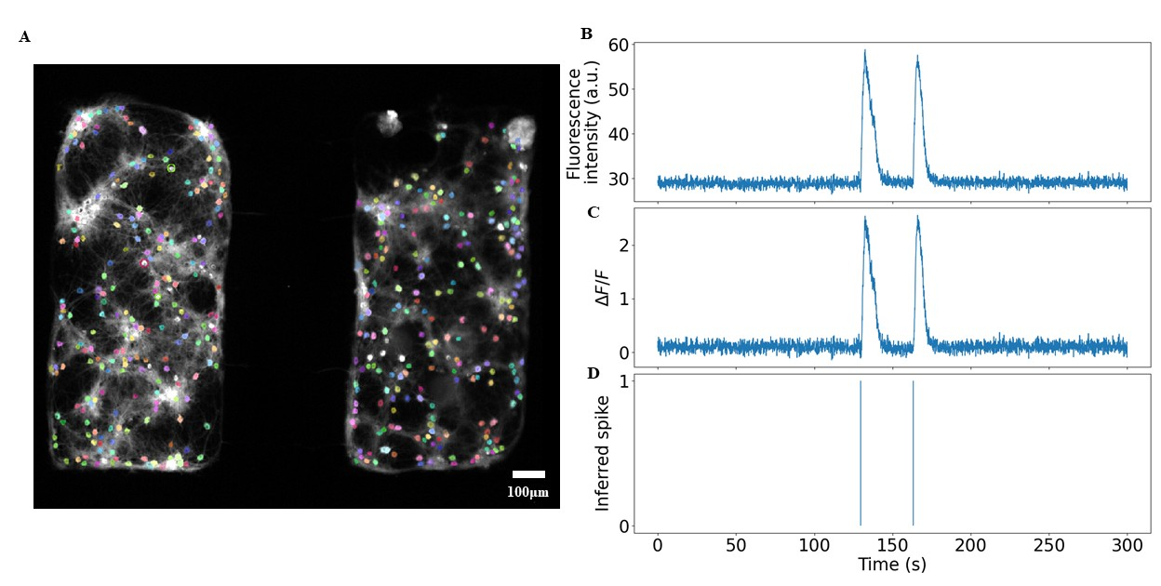
Supplementary Figure 5 | Calcium-imaging signal processing and inferred neuronal activity.
(A) Representative fluorescence image of a neuronal network with identified neuronal regions of interest. (B) Representative raw fluorescence-intensity trace, F(t), extracted from an individual neuronal region of interest. (C) Corresponding normalized calcium signal, calculated as ΔF/F=[F(t)−F0​]/F0, where F0 is the baseline fluorescence intensity. (D) Inferred neuronal spike events extracted from the ΔF/F signal. This processing workflow converts calcium-imaging recordings into temporally resolved neuronal activity representations for subsequent analyses of neuronal dynamics and intermodule signal propagation. Scale bar, 100 μm.

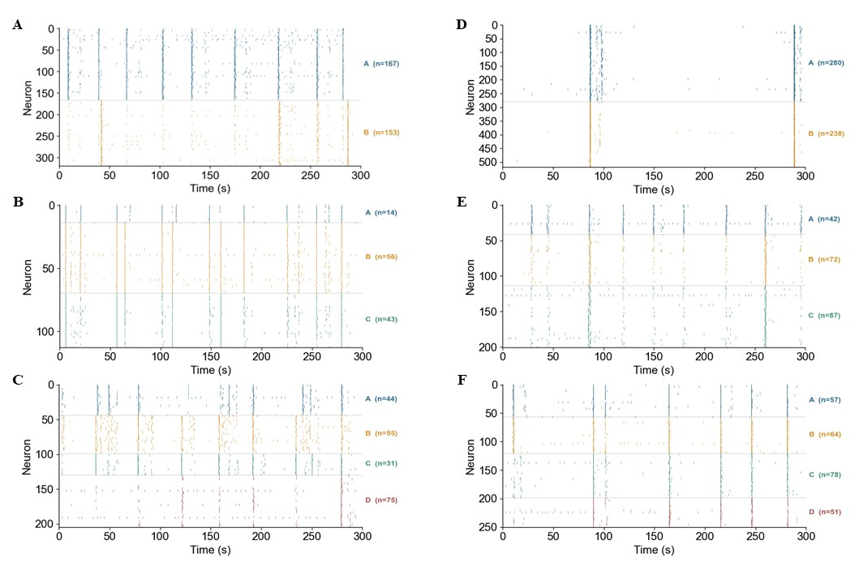
Supplementary Figure 6 | Representative spontaneous-state spike raster plots of the six neuronal networks.
(A–C) Spike raster plots of spontaneous activity in the two-, three-, and four-layer living deep reservoirs. (D–F) Spike raster plots of spontaneous activity in the corresponding topology-matched control-group networks. The left three panels represent the unidirectionally connected architectures, whereas the right three panels represent the corresponding bidirectionally connected control-group architectures. These data illustrate spontaneous population activity across different network depths and connection topologies.

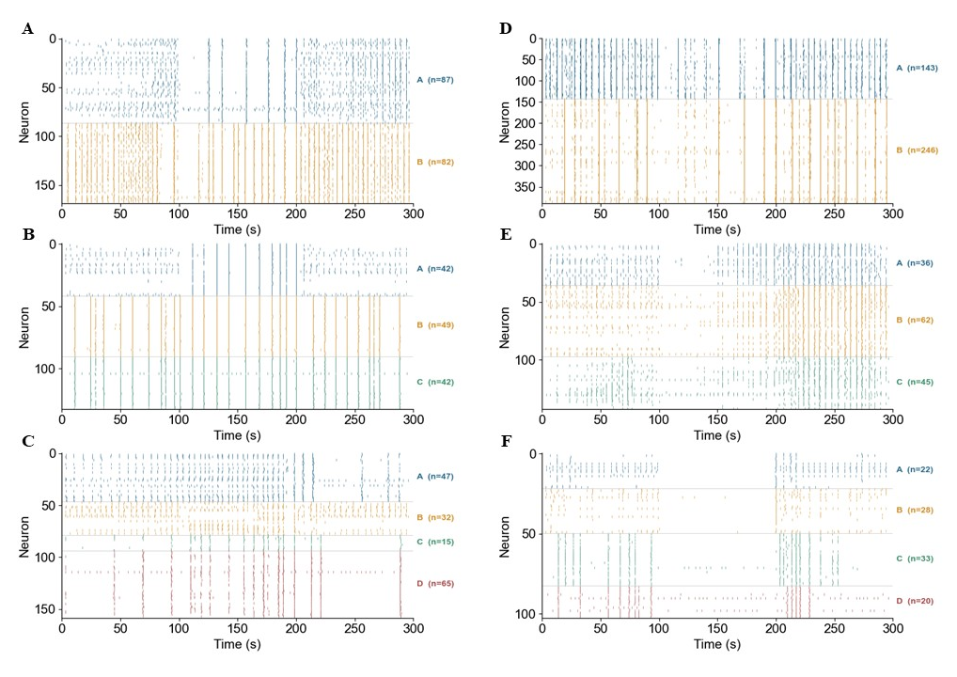
Supplementary Figure 7 | Representative spike raster plots under external stimulation in the same six neuronal networks shown in Supplementary Figure 6.
(A–C) Spike raster plots of the two-, three-, and four-layer living deep reservoirs under external stimulation. (D–F) Spike raster plots of the corresponding control-group networks under the same stimulation protocol. In each panel, the first 100 s and the last 100 s correspond to stimulation periods, whereas the middle 100 s corresponds to an idle period without external stimulation. These recordings illustrate how the different network architectures responded to external input and provide representative data for stimulation-state activity analysis.

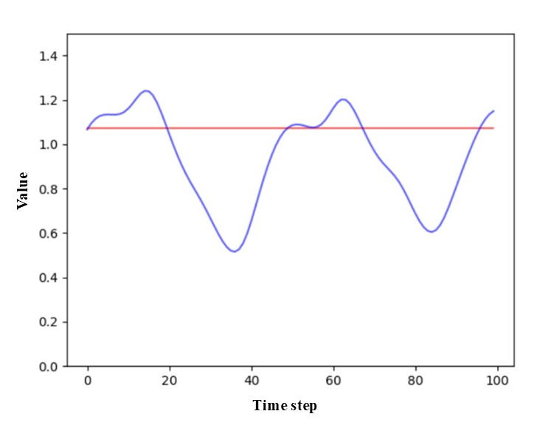
Supplementary Figure 8 | Control analysis without reservoir dynamics.
Representative prediction result obtained by training the readout directly on the encoded input without processing by the living reservoir. The blue curve denotes the target Mackey–Glass time series, and the red curve denotes the corresponding prediction. In this control condition, the predicted output failed to follow the temporal fluctuations of the target signal and remained close to a nearly constant value, indicating that the encoded input alone was insufficient for accurate prediction. This result supports the conclusion that nonlinear neuronal reservoir dynamics contributed substantially to the chaotic time-series prediction performance reported in the main text.

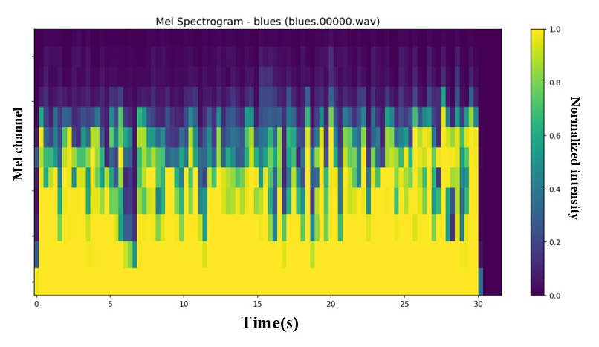
Supplementary Figure 9 | Representative mel-spectrogram representation used for music genre classification.
A representative GTZAN audio clip was transformed into a normalized 12-channel mel spectrogram before latency encoding. The spectrogram preserves the time-varying distribution of spectral energy across the 12 frequency channels, providing a structured spatiotemporal representation suitable for conversion into multichannel spike sequences.

