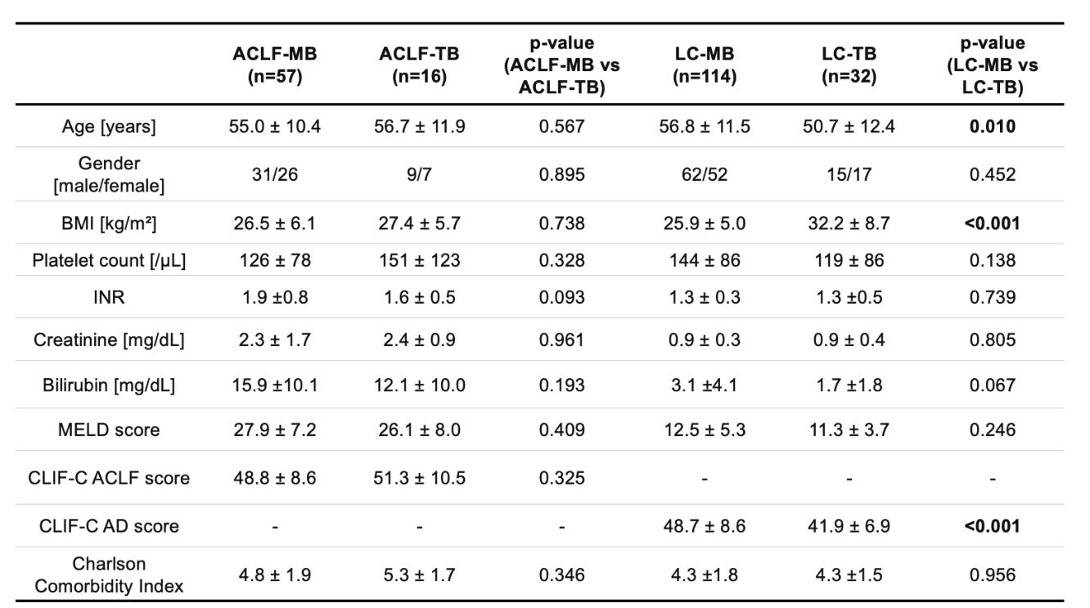
Table 1. Patient characteristics. All values are depicted as median ± standard deviation (SD), scores were assessed at the time of liver biopsy. MB=mini-laparoscopic liver biopsy. TB=transjugular liver biopsy.

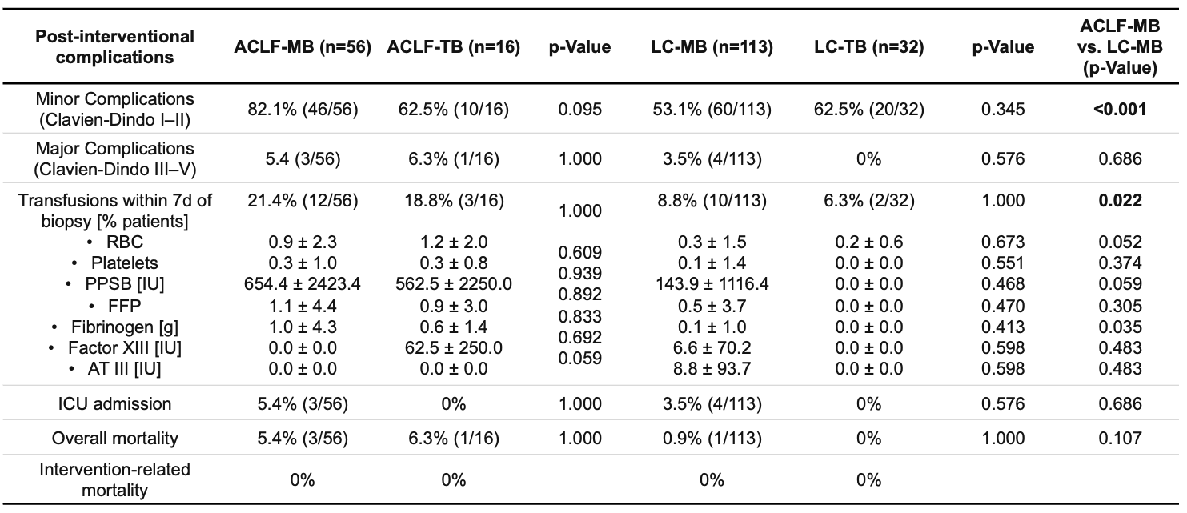
Table 2. Post-interventional complications and administered blood products. RBC = red blood cells. PPSB = prothrombin concentrate. FFP = fresh frozen plasma. AT = antithrombin. ICU = intensive care unit. IU = international units.
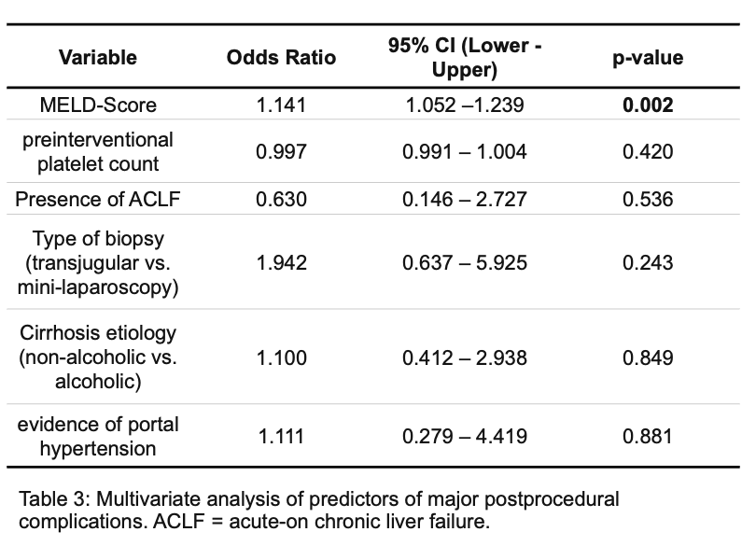
Table 3. Multivariate analysis of predictors of major postprocedural complications. ACLF = acute-on chronic liver failure.

