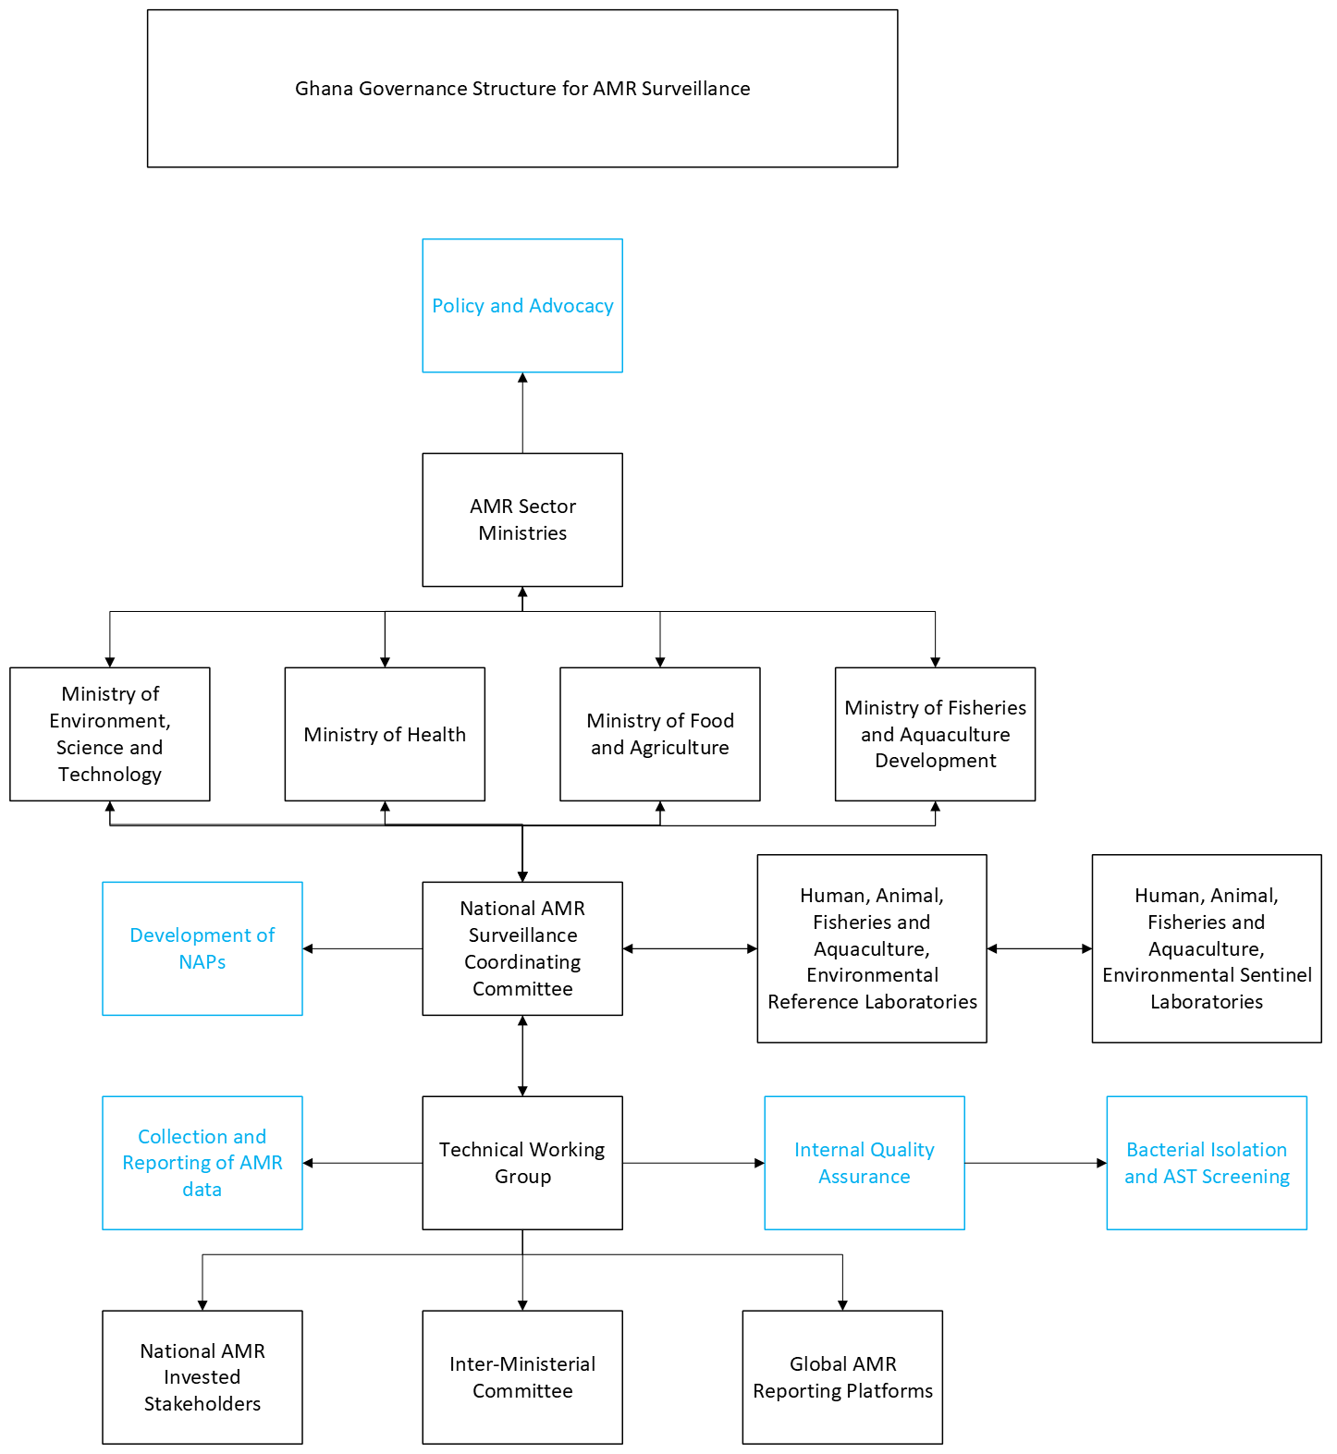
Supplementary Figure 1: AMR governance structure of Ghana. In Ghana, the AMR sector ministries comprise of the Ministry of Health (MOH), Ministry of Food and Agriculture (MOFA), Ministry of Fisheries and Aquaculture (MOFAD), Ministry of Environment, Science, and Technology (MEST) who all cooperated to develop an integrated AMR Surveillance Framework. Ghana also has an AMR Surveillance Technical Working group (TWG) consisting of subject matter and institutional experts participating on a voluntary basis.
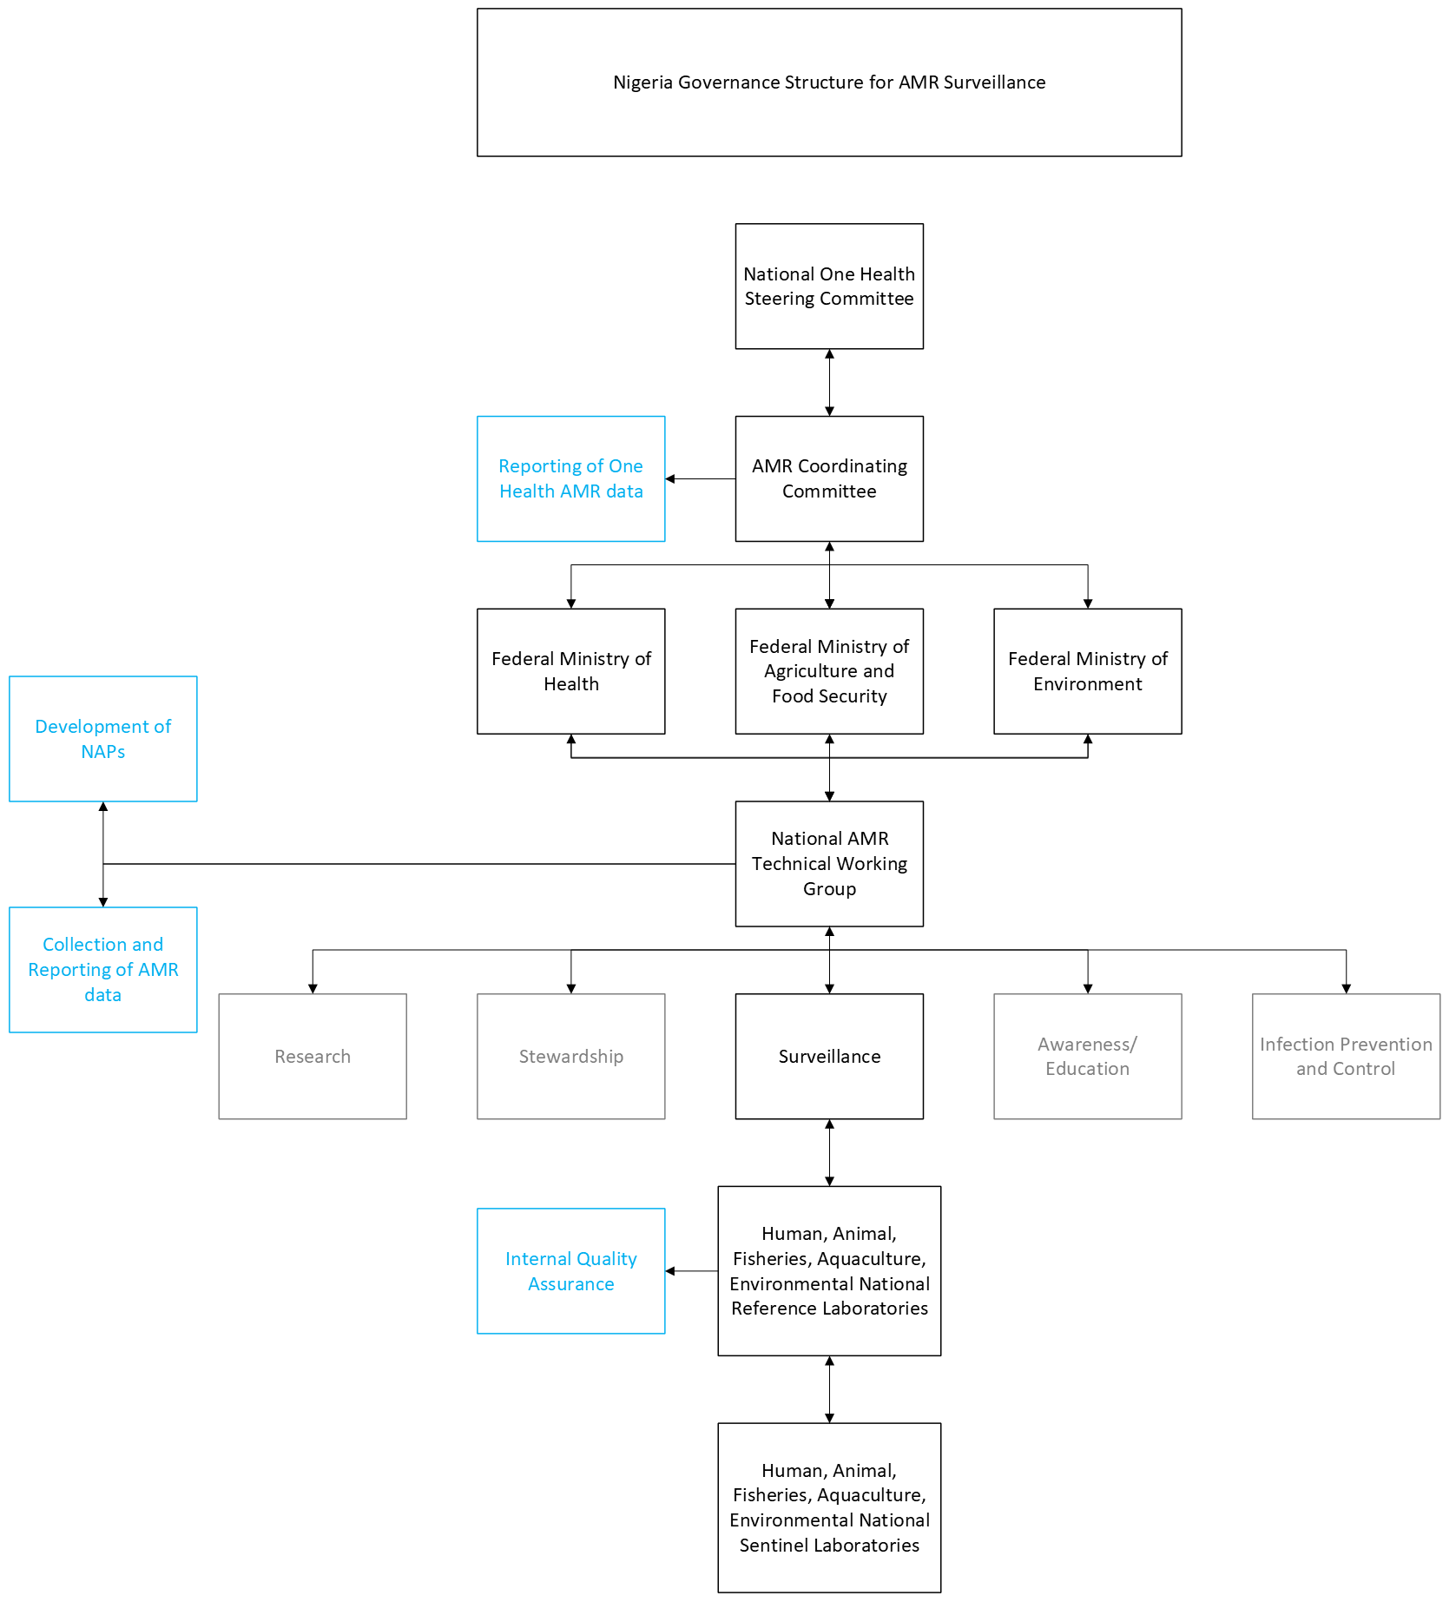
Supplementary Figure 2: AMR governance structure in Nigeria for AMR Surveillance. Nigeria has a well-defined AMR governance structure outlined in the AMR & AMU One Health Governance Manual. This multisectoral framework follows a One Health approach, featuring the National One Health Steering Committee (comprising all the Honourable Ministers of the One Health sectors) that serves as the overall decision-making and policy-setting body for AMR in Nigeria, the AMR Coordinating Committee (AMRCC) that provides direct leadership and coordination of interventions from multisectoral technical working groups, and the National AMR Technical Working Groups that comprised of five sub-technical working groups with focus on awareness/education, surveillance, stewardship, infection prevention and control (including vaccination) and research.

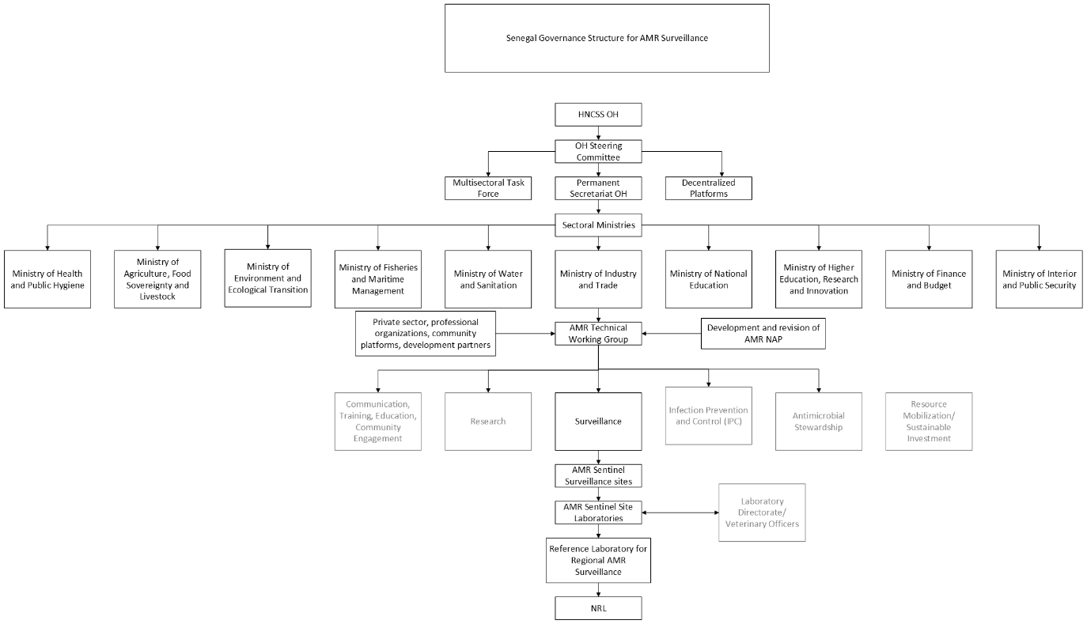
Supplementary Figure 3: Senegal governance structure for AMR Surveillance. The Global Health Security “One Health” organization sits in the High National Council of Global Health Security (HCNSSM) and has a prevention committee responsible for AMR issues. Senegal has created a Technical Steering Committee comprising of multisectoral and multidisciplinary specialists in AMR, to implement AMR surveillance

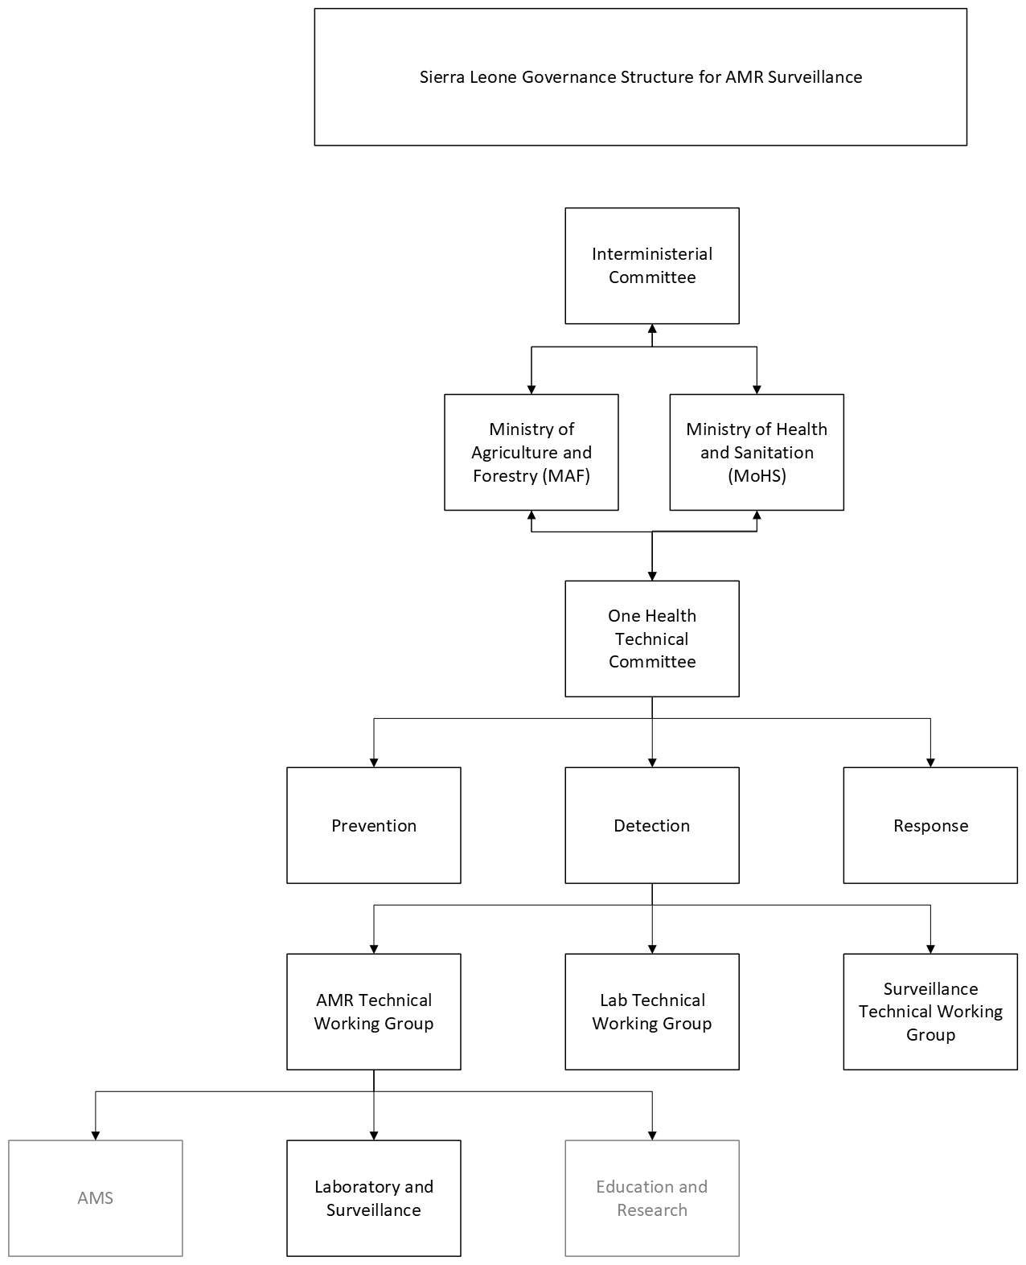
Supplementary Figure 4: AMR governance structure in Sierra Leone for AMR surveillance. Sierra Leone provided a separate document outlining the governance and legislation in Sierra Leone involving AMR (Kargbo and Van der Heijden, 2024). This document outlined the multisectoral coordination and legal framework, showing that Sierra Leone has an AMR Technical Working group embedded in the One Health Governance Structure to implement AMR activities. The One Health Interministerial Committee is the top governance organ and below is the One Health Coordinating Committee followed by the One health technical Committees consisting of 3 pillars, 1) Prevention (Immunization /Vaccination, Protection); 2) Detection (AMR TWG, Lab TWG, Surveillance TWG) and 3) Response (Emergency Operations Centre (EOC) (Prevention and Response (P&R), Rapid Response team (RT)). The AMR TWG, which is under the detection pillar, is comprised of 3 sub-technical working groups focusing on Antimicrobial Stewardship, laboratory and surveillance, education and research.
Supplementary Table 2. FAO Classification system for poultry production and selected sampling classifications for each country. Green ticks indicate the FAO classification sectors selected for sampling in each country; blank boxes indicate sector not selected. Note, the green ticks in Sierra Leone only account for Layers.
